**Android**

**Question:**  Core Android - What are SOLID Principles? How they are applicable in Android?

**Answer:**  A) SOLID unites all the best practices of software development over the years to deliver good quality apps. Understanding SOLID Principles will help us write clean and elegant code. It helps us write the code with SOC (Separation of Concerns). SOLID Principles is an acronym for:

S stands for Single Responsibility Principle(SRP) - A class should have only one reason to change

O stands for Open Closed Principle - Software entities such as classes, functions, modules should be open for extension but closed for modification.

L stands for Liskov Substitution Principle - Derived class must be usable through the base class interface, without the need for user to know the difference.

I stands for Interface Segregation - No client should be forced to depend on methods that it doesn't use.

D stands for Dependency Inversion -

High Level Modules should not directly depend on Low level modules. Instead both should depend on abstractions.

Abstractions should not depend on details. Details should depend on abstractions.

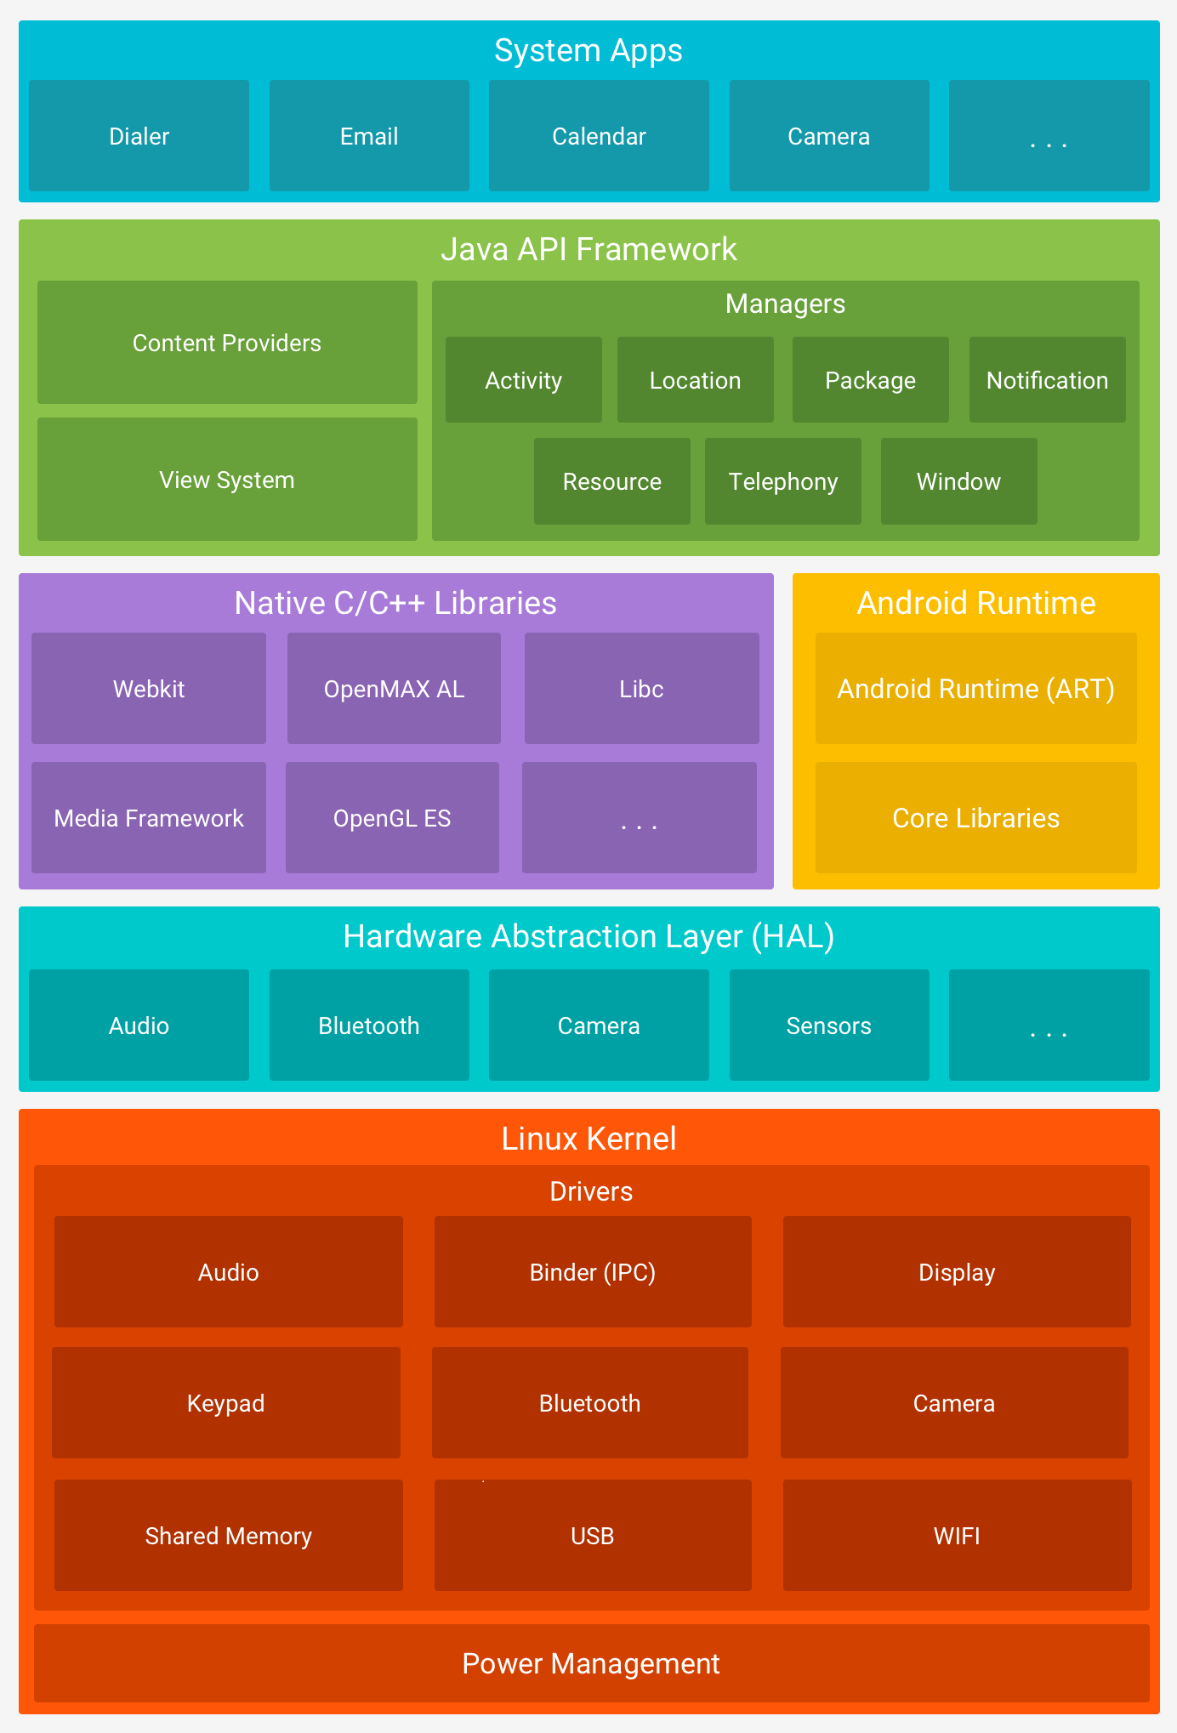

**Question:**  What are Android Components?

**Answer:**  A) 1) Activities, 2) Intent and broadcast receivers, 3) Services, 4) Content Providers, 5) Widgets and Notifications

**Question:**  What is an Application class?

**Answer:**  A) An Application class is a base class in your Application that starts before all other classes like Activities or services are called. You can maintain your application's global state here. While it is NOT mandatory that you need to extend Application class, you can do so by providing your own implementation by creating a subclass and specifying the fully-qualified name of this subclass as the "android:name" attribute in your AndroidManifest.xml's tag.

**Question:**  What is a Context? What are different types of Contexts?

**Answer:**  A) As the name says, its the context of the current application or object. Context is like a handle to the environment your application is currently running in. We mainly use two types of context. Application context - whose scope is throughout the application and Activity Context - whose scope depends on the Activity Lifecycle

**Question:**  What is an Activity?

**Answer:**  A) An activity provides the window in which the app draws its UI. This window typically fills the screen, but may be smaller than the screen and float on top of other windows. Generally, one activity implements one screen in an app. For instance, one of an app’s activities may implement a Preferences screen, while another activity implements a Select Photo screen.

**Question:**  Activity Lifecycle

**Answer:**

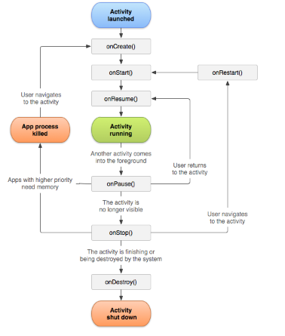

**Question:**  Fragment Lifecycle

**Answer:**

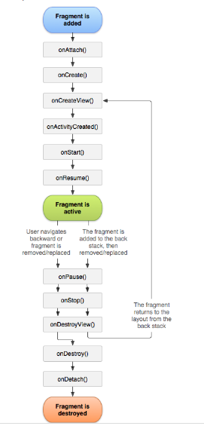

**Question:**  Service Lifecycle

**Answer:**

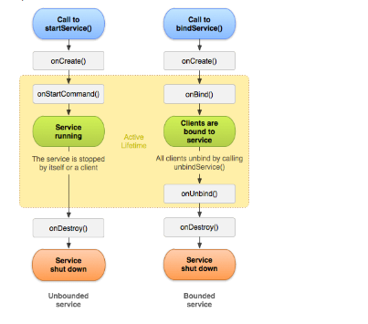

**Question:**  What is the correlation between activity and fragment life cycle?

**Answer:**  A) Here is how Activity's and Fragment's lifecyle are called together:

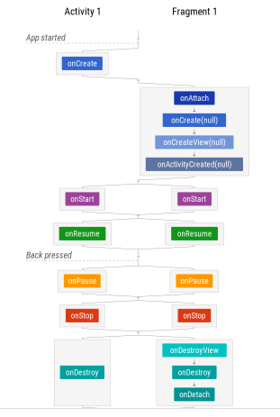

**Question:**  Is there any scenario where onDestoy() will be called without calling onPause() and onStop()?

**Answer:**  A) If we call finish() method inside onCreate() of our Activity, then onDestroy() will be called directly.

**Question:**  What are Processes in Android?

**Answer:**  A) Everytime an Android App starts, the Android System creates a New Process for this Application with a Single thread of Execution. By default all the components of the same application runs in the same process. While most apps donot change this behavior, some apps like games, might want to run in different processes. Then we can use android:process attribute in our AndroidManifest.xml to specify the process name.

**Question:**  How do we save and restore an activity's state during screen screen rotation?

**Answer:**  A) We can use onSavedInstanceState(bundle:Bundle) to save the activity's state inside a bundle. Then we can use onRestoreInstanceState(bundle) to restore the state of activity.

**Question:**  What is a Loader in Android?

**Answer:**  A) Note: (Loader is Deprecated. We Have to use combination of ViewModels and LiveData instead of using Loaders) A Loader is used to fetch the data from a Content provider and cache the results across the configuration changes to avoid duplicate queries. Loader does it by running on separate threads and handling the lifecycle changes (so no need of asynctasks or new thread creations or manual handling of life cycle changes). Few implementations of Loaders like CursorLoader can implement an observer (called ContentObserver) to monitor any data changes and can then trigger a reload.

**Question:**  What is an Intent Filter?

**Answer:**  A) Intent filters are a very powerful feature of the Android platform. They provide the ability to launch an activity based not only on an explicit request, but also an implicit one. For example, an explicit request might tell the system to “Start the Send Email activity in the Gmail app". By contrast, an implicit request tells the system to “Start a Send Email screen in any activity that can do the job." When the system UI asks a user which app to use in performing a task, that’s an intent filter at work. Here's an example of how to declare Intent Filter in AndroidManifest:

<activity android:name=".ExampleActivity" android:icon="@drawable/app_icon">

<intent-filter>

<action android:name="android.intent.action.SEND" />

<category android:name="android.intent.category.DEFAULT" />

<data android:mimeType="text/plain" />

</intent-filter>

</activity>

**Question:**  What is an Intent?

**Answer:**  A) It is a kind of message or information that is passed to the components. It is used to launch an activity, display a web page, send SMS, send email, etc. There are two types of intents in android: a)Implicit Intent b)Explicit Intent

**Question:**  What is AAPT?

**Answer:**  A) AAPT2 (Android Asset Packaging Tool) is a build tool that Android Studio and Android Gradle Plugin use to compile and package your app’s resources. AAPT2 parses, indexes, and compiles the resources into a binary format that is optimized for the Android platform.

**Question:**  What is an Intent?

**Answer:**  A) Intent is basically a message passing mechanism between different components of Android, except for Content Provider. You can use intent to start any component in Android.

**Question:**  What are the different types of Intents?

**Answer:**  A) There are two types of intents:

Explicit intents specify which application will satisfy the intent, by supplying either the target app's package name or a fully-qualified component class name. You'll typically use an explicit intent to start a component in your own app, because you know the class name of the activity or service you want to start. For example, you might start a new activity within your app in response to a user action, or start a service to download a file in the background. Implicit intents do not name a specific component, but instead declare a general action to perform, which allows a component from another app to handle it. For example, if you want to show the user a location on a map, you can use an implicit intent to request that another capable app show a specified location on a map.

**Question:**  What is HandlerThread?

**Answer:**  A) HandlerThread is a Handy class to start a thread that has a Looper.

**Question:**  What is a Looper?

**Answer:**  A) A Looper is a class used to loop through the Message Queue attached to the Thread. Any thread consists of only one looper.

You can access message queue of current thread by using Looper.myQueue().

By default, a thread halts when the execution completes. But, for Example, if we take Android's Main thread, it should not halt upon execution.

Normally thread cannot be reused once its job is completed. But thread with Looper is kept alive until you call quit method so you don’t need to create a new instance each time you want to run a job in background.

Rather it should loop through the runnables(Messages) that its assigned in order to work properly.

**Question:**  What is a Message Queue?

**Answer:**  A) MessageQueue is a queue that has list of messages which should be processed. Android maintains a MessageQueue on the main thread

**Question:**  What is a Message ?

**Answer:**  A) Message contains a description and arbitrary data object that can be sent to a Handler. Basically its used to process / send some data across threads.

**Question:**  What is a Service?

**Answer:**  A) A service is a component which doesn't have UI and can perform long running operations like downloading stuff, playing music etc.. which can run even exiting the application. By default service runs on main thread. This might cause ANR errors. To avoid this, we can Start service by creating a new background thread or use an IntentService that can do work in background

**Question:**  How to Stop a Service?

**Answer:**  A) To stop a service from an activity we can call stopService(Intent intent) method. To Stop a service from itself, we can call stopSelf() method.

**Question:**  What are different types of services?

**Answer:**  A) These are the three different types of services:

Foreground Service: A foreground service performs some operation that is noticeable to the user. For example, an audio app would use a foreground service to play an audio track. Foreground services must display a Notification. Foreground services continue running even when the user isn't interacting with the app.

Background Service: A background service performs an operation that isn't directly noticed by the user. For example, if an app used a service to compact its storage, that would usually be a background service. However there are restrictions to use background services from Android API 26 and above. We can use WorkManager to defer these background tasks.

Bound Service: A service is bound when an application component binds to it by calling bindService(). A bound service offers a client-server interface that allows components to interact with the service, send requests, receive results, and even do so across processes with interprocess communication (IPC). A bound service runs only as long as another application component is bound to it. Multiple components can bind to the service at once, but when all of them unbind, the service is destroyed by the system

**Question:**  Bound Service vs UnBounded service?

**Answer:**  A) A Bound service is started by using method bindService(). As mentioned above system destroys bound service when no application component is accessing it. Unbounded service (started service) is started by using a method called startService(). Once started, it will run indefinitely even if the application component that started it is destroyed.

**Question:**  When does a Bound Service stops?

**Answer:**  A) A Bound Service will stop automatically by the system when all the Application Components bound to it are unbinded.

**Question:**  How to start a Foreground Service?

**Answer:**  A) We can start a foreground service by using startForegroundService(Intent intent) or by internally calling startForeground() on the service.

**Question:**  What is Sticky Intent in Android?

**Answer:**  A) Sticks with Android, for future broadcast listeners. For example if BATTERY_LOW event occurs then that Intent will stick with Android so that any future requests for BATTERY_LOW, will return the Intent

**Question:**  What is Pending Intent in Android?

**Answer:**  A) Pending Intent is an intent which you want to trigger at some time in future, even when your application is not alive. This intent can be used by other application which allows it to execute that intent with the same permissions as of our application.

Intent intent = new Intent(this, AnyActivity.class);

// Creating a pending intent and wrapping our intent

PendingIntent pendingIntent = PendingIntent.getActivity(this, 1, intent, PendingIntent.FLAG_UPDATE_CURRENT);

try {

// Perform the operation associated with our pendingIntent

pendingIntent.send();

} catch (PendingIntent.CanceledException e) {

e.printStackTrace();

}

PendingIntent uses the following methods to handle the different types of intents:

PendingIntent.getActivity();//Retrieves a PendingIntent to start an Activity

PendingIntent.getBroadcast();// Retrieves a PendingIntent to perform a Broadcast

PendingIntent.getService();// Retrieves a PendingIntent to start a Service

**Question:**  What is the difference between START_NOT_STICKY, START_STICKY AND START_REDELIVER_INTENT?

**Answer:**  A) START_NOT_STICKY:

If the system kills the service after onStartCommand() returns, do not recreate the service unless there are pending intents to deliver. This is the safest option to avoid running your service when not necessary and when your application can simply restart any unfinished jobs.

START_STICKY:

If the system kills the service after onStartCommand() returns, recreate the service and call onStartCommand(), but do not redeliver the last intent. Instead, the system calls onStartCommand() with a null intent unless there are pending intents to start the service. In that case, those intents are delivered. This is suitable for media players (or similar services) that are not executing commands but are running indefinitely and waiting for a job.

START_REDELIVER_INTENT:

If the system kills the service after onStartCommand() returns, recreate the service and call onStartCommand() with the last intent that was delivered to the service. Any pending intents are delivered in turn. This is suitable for services that are actively performing a job that should be immediately resumed, such as downloading a file.

**Question:**  What is Pending Intent?

**Answer:**  A)A PendingIntent is a token that you give to a foreign application (e.g. NotificationManager, AlarmManager, Home Screen AppWidgetManager, or other 3rd party applications), which allows the foreign application to use your application's permissions to execute a predefined piece of code. It specifies a task that requires to be performed in future.

**Question:**  What is an Intent Service? What is the method that differentiates it to make Service run in background?

**Answer:**  A) IntentService is a subclass of Service that can perform tasks using worker thread unlike service that blocks main thread. The additional method of IntentService is - onHandleIntent(Intent) which helps the IntentService to run a particular code block declared inside it, in worker/background thread. The speciality of Intent Service is if there are more tasks given to it, IntentService will pass those intents one by one to the Worker thread. So if there are multiple download operations to be handled, They will be performed in a sequential order. Only one request will be processed at a time.

Note: IntentService is deprecated from API 30. This is due to background restrictions imposed from API level 26. It is now recommended to use WorkManager or JobIntentService.

**Question:**  How to Stop an IntentService?

**Answer:**  A) An IntentService automatically stops itself after its job is done. We do not need to explicitly call any methods to stop an IntentService unlike Service which requires stopSelf() or StopService(intent:Intent).

**Question:**  When Intent Service is Useful?

**Answer:**  A) The IntentService can be used in long tasks usually with no communication to Main Thread. If communication is required, can use Main Thread handler or broadcast intents. Another case of use is when callbacks are needed (Intent triggered tasks).

**Question:**  Advantage of Retrofit over Volley?

**Answer:**  A) Retrofit is type-safe. Type safety means that the compiler will validate request and response objects' variable types while compiling, and throw an error if you try to assign the wrong type to a variable.

**Question:**  Advantage of Volley over Retrofit?

**Answer:**  A) Android Volley has a very elaborate and flexible cache mechanism. When a request is made through Volley, first the cache is checked for Response. If it is found, then it is fetched and parsed, else, it will hit Network to fetch the data. Retrofit does not support cache by default.

**Question:**  What are different launch modes available in Android?

**Answer:**  A) There are four launch modes for an Activity in Android as follows:

**standard** : Creates a new instance of an activity in the task from which it is started every single time. It is the default mode if not declared.

Eg: If we have an activity stack of A->B->C, If we launch Activity C again using standard Mode, the activity stack will now be A->B->C->C. We can see that two instances of C are present in the activity stack.

**singleTop** : Same as standard except that if the activity is at the top of the stack, then the same instance will be used. Now the existing Activity at the top will receive the intent through a call to its onNewIntent() method.

Eg: If we have an activity stack of A->B->C, If we launch Activity C again using singleTop Mode, the activity stack remains to be A->B->C. However if we launch B, then B will be added as new Instance to the stack (A->B->C->B).

**singleTask** : A new task will be created and activity will be created at the root of this new task whenever we use launch mode as singleTask. However, if there is already a separate task with same instance, the system will call that activity's onNewIntent() method to route the intent. There can only be one instance of activity existing at a time.

Eg: If our activity stack is A->B->C and if we launch D using singleTask, it will be A->B->C->[D]. Here braces represents the stack in separate task. If we call E using standard mode, then it will be A->B->C->[D->E].

If we have A->B->C and if we call B again using singleTask launch Mode, the stack will now be A->[B] with B in a separate task. Activity C will be destroyed.

**singleInstance** : Same as Single Task except it creates a new activity in a task and no other activities can then launched into that task. That task will forever contains only that activity. If we use standard or singleTop to launch another activities, they are launched into another tasks.

Eg: if the Activity stack is A->B and now we launched C using singleInstance Launch Mode, the new stack will be A->B->[C]. Now if we call a new activity D from C, it will be launched into separate task. Now the new stack will be A->B->[C]->[D]. Now if we launch E from activity B, Then new stack will be A->B->E [C]->[D]. If we call C again, onNewIntent() of C will be called and new stack will be A->B->E->[C] [D].

**Question:**  How do you declare the launch mode in your application?

**Answer:**  A) via manifest, in activity's tag. For Eg., -> android:launchMode="singleTask"

**Question:**  How to handle crashing of AsyncTask during screen rotation?

**Answer:**  A) One way is by cancelling the AsyncTask by using cancel() method on its instance. It will call onCancelled() method of AsyncTask where we can do some clean-up activities like hiding progress bar etc. The best way to handle AsyncTask crash is to create a RetainFragment, i.e., a fragment without UI as shown in the gist below: https://gist.github.com/vamsitallapudi/26030c15829d7be8118e42b1fcd0fa42 We can also avoid this crash by using 2 Alternatives - 1) Using RxJava by subscribing and unsubscribing at onResume() and onPause() methods respectively, 2) Using LiveData - lifecycle aware component.

**Question:**  What is a RetainFragment / Headless Fragment?

**Answer:**  Generally, Fragments are destroyed and recreated along with their parent Activity’s whenever a configuration change occurs. Calling setRetainInstance(true) allows us to bypass this destroy-and-recreate cycle, notifying the system to retain the current instance of the fragment when the activity is recreated.

**Question:**  Difference between serializable and parcelable? Why android introduced Parcelable?

**Answer:**  A) Serializable uses reflection while for parcelable, developers from android team wrote custom code that performs manual marshalling(converting data into byte stream) and unmarshalling(converting the byte stream back to their original data). Usually Parcelable is considered faster than Serializable

**Question:**  What is Reflection?

**Answer:**  A) Reflection is an API that is used to examine or modify the behaviour of methods, classes and interfaces at runtime. The required classes for reflection are present in java.lang.reflect package.

**Question:**  How to reduce your app size?

**Answer:**  setting minifyEnabled to true

setting shrinkResources to true

using bundle instead of apk in developer console

converting the images to vector drawables.

**Question:**  What is the advantage of using Retrofit over AsyncTask?

**Answer:**  A) Retrofit reduces boiler plate code by internally using GSON library which helps parsing the json file automatically. Retrofit is a type safe library. This means - it checks if wrong data type is assigned to variables at compilation time itself.

**Question:**  How to handle multiple network calls using Retrofit?

**Answer:**  A) In Retrofit, we can call the operations asynchronously by using enqueue() method where as to call operations synchronously, we can use execute() method. In addition, we can use zip() operator from RxJava to perform multiple network calls using Retrofit library.

**Question:**  What is the role of Presenter in MVP?

**Answer:**  A) The Presenter is responsible to act as the middle man between View and Model. It retrieves data from the Model and returns it formatted to the View. But unlike the typical MVC, it also decides what happens when you interact with the View.

**Question:**  What is the advantage of MVVM over MVP?

**Answer:**  A) In MVP, Presenter is responsible for view data updates as well as data operations where as in MVVM, ViewModel does not hold any reference to View. It is the View's responsibility to pick the changes from ViewModel. This helps in writing more maintainable test cases since ViewModel does not depend upon View.

**Question:**  When to use AsyncTask and when to use services?

**Answer:**  A) Services are useful when you want to run code even when your application's Activity isn't open. AsyncTask is a helper class used to run some code in a separate thread and publish results in main thread. Usually AsyncTask is used for small operations and services are used for long running operations

**Question:**  When to use a service and when to use a thread?

**Answer:**  A) We will use a Thread when we want to perform background operations when application is running in foreground. We will use a service even when the application is not running.

**Question:**  What is a Handler?

**Answer:**  A) A Handler allows you to send and process Message and Runnable objects associated with a thread's MessageQueue. Each Handler instance is associated with a single thread and that thread's message queue. When you create a new Handler, it is bound to the thread / message queue of the thread that is creating it -- from that point on, it will deliver messages and runnables to that message queue and execute them as they come out of the message queue. We will generally use handler class when we want to repeat task every few seconds.

**Question:**  How to save password safely in Android?

**Answer:**  A) Using Android Keystore https://medium.com/@josiassena/using-the-android-keystore-system-to-store-sensitive-information-3a56175a454b

**Question:**  What is Alarm Manager?

**Answer:**  A) AlarmManager is a class which helps scheduling your Application code to run at some point of time or at particular time intervals in future. When an alarm goes off, the Intent that had been registered for it is broadcast by the system, automatically starting the target application if it is not already running. Registered alarms are retained while the device is asleep (and can optionally wake the device up if they go off during that time), but will be cleared if it is turned off and rebooted.

**Question:**  How can I get continuous location updates in android like in Google Maps?

**Answer:**  A) We can use Fused location provider in Android set our interval in that. https://stackoverflow.com/a/41500910/3424919

**Question:**  How do you know if the device is rooted?

**Answer:**  A) We can check if superUser apk is installed in the device or if it contains su file or xbin folder. Alternatively you can use RootBeer library available in GitHub.

**Question:**  What is Symmetric Encryption?

**Answer:**  A) Symmetric encryption deals with creating a passphrase and encrypting the file with it. Then the server needs to send this passphrase(key) to the client so that the client can decrypt. Here the problem is sending that key to decrypt the file. If Hackers can access that key, they can misuse the data.

**Question:**  What is Asymmetric Encryption?

**Answer:**  A) Using algorithms like RSA, AES256, etc., the server generates 2 keys - public key and private key. The server then gives public key to clients. Client then encrypts the sensitive data with that public key and send it back to server. Now as the server alone has the private key, only it can decrypt the data. This is the most efficient way of sending data across the client and server.

Example of this Asymmetric encryption are HTTPS using SSL certificate, Blockchain technologies like Bitcoin, etc

**Question:**  How do you encrypt the Data in Java?

**Answer:**  A) Using javax.crypto package's Cipher class. We can call the methods such as encrypt() or decrypt() from the Cipher class to encode or decode our data.

**Question:**  What is SSL Pinning?

**Answer:**  A)Generally SSL Certificates are issued by CAs (Certificate Authorities). SSL Certificates are used to secure a connection between a Client and a Server. But there might be some chances that if any CA is breached, our app becomes vulnerable to MITM (Man in the Middle Attack). To mitigate this problem, we can pin our Server's SSL Certificate in our Application as an additional security layer so that we can check if the certificate is really from our server or not. In few words, SSL Pinning is to increase security. Disadvantages is if the server changes the certificate, Client app needs a software update.

**Question:**  How do you implement it in Android?

**Answer:**  A) SSL Pinning can be done using OkHttpClient's Builder methods as follows:

val certificatePinner = CertificatePinner.Builder()

.add(

"www.coderefer.com",

"sha256/ZCOF65ADBWPDK8P2V7+mqodtvbsTRR/D74FCU+CEEA="

)

.build()

val okHttpClient = OkHttpClient.Builder()

.certificatePinner(certificatePinner)

.build()

Then you supply this generated okHttpClient object to Retrofit.

**Question:**  Android Memory Related

**Answer:**  How do you create a Memory Leak in Android?

A) By passing the context to static block (class or method), we can create a Memory Leak.

How do you avoid a Memory Leak in Android?

A) By making the objects eligible for GC (Garbage Collection) after a class (Activity or Fragment) is destroyed. We can also use Weak References like WeakHashMaps to loosely hold the data and make it easily available to GC.

How do you identify a Memory Leak in Android?

A) By using Profiler in Android Studio or by using LeakCanary Library in Android.

**Question:**  How do you reduce battery consumption?

**Answer:**  Never poll the server for updates.

Sync only when required. Ideally, sync when phone is on Wi-Fi and plugged in.

Defer your work using WorkManager.

Compress your data

Defer non immediate requests until the phone is plugged in or wifi is turned on. The Wi-Fi radio uses significantly less battery than the mobile radio.

**Question:**  How do you improve battery while fetching location for an app?

**Answer:**  By changing Accuracy -> we can use setPriority() to PRIORITY_LOW_POWER

By changing Frequency of fetching location -> we can use setInterval() to specify the time interval

By increasing latency -> After our call, we can wait for longer time - we can use setMaxWaitTime() to set large timeout.

**Question:**  What is Dependency Injection Pattern?

**Answer:**  A) Dependency Injection pattern is where if our object requires other object, it will be passed to our object instead of us having to create that object. This other object is called as dependency.

**Question:**  What is Service Locator Pattern?

**Answer:**  A) Service Locator Pattern uses central Registry known as Service Locator which upon request provides objects for our class. This pattern has severe criticism that its an Anti-Pattern.

**Question:**  What is Anti-Pattern?

**Answer:**  A) An anti-pattern are certain patterns in software development that are considered bad programming practices

**Question:**  What is the use-case of @BindsInstance Annotation?

**Answer:**

A) @BindsInstance is used to bind the available data at the time of building the Component. For example, while I needed to build dagger graph and username is already available to me, then I can bind that username to that dagger dependency graph as follows:

@Component.Builder

interface Builder {

@BindsInstance Builder userName(@UserName String userName);

AppComponent build();

}

**Question:**  What is the use-case of @Module Annotation?

**Answer:**  A) @Module is the Annotation used on the class for the Dagger to look inside it, to provide dependencies. We may be declaring methods inside the module class that are enclosed with @Provides annotation.

**Question:**  What is the use-case of @Provides Annotation?

**Answer:**  A) @Provides annotation is used on a method in Module class and can return / provide a Dependency object.

**Question:**  What is the use-case of @Component Annotation?

**Answer:**  A) @Component is used on Interface or abstract class. Dagger uses this interface to generate an implementation class with fully formed, dependency injected implementation, using the modules declared along with it. This generated class will be preceded by Dagger. For example if i create an interface named ProgramComponent with @Component annotation, Dagger will generate a Class named 'DaggerProgramComponent' implementing the ProgramComponent interface.

**Question:**  What is the use-case of @Scope Annotation?

**Answer:**  A) @Scope is an annotation used on Interface to create a new Custom Scope. A Scope declaration helps to keep single instance of a class as long as its scope exists. For example, in Android, we can use @ApplicationScope for the object to live as long as the Application is live or @ActivityScope for the object to be available till the activity is killed.

**Question:**  What is the use of Qualifier in Dagger?

**Answer:**  A) We are often in a situation where we will be needing multiple objects with different instance values. For example, we need declare Student("Vamsi") and Student("Krishna"). In such case we can use a Qualifier to tell Dagger that we need multiple instances of same class. The default implementation of Qualifier is using @Named annotation, for eg., @Named("student_vamsi") and @Named("student_krishna") If we want to create a Custom Qualifier we would be using @Qualifier to declare a custom Qualifier interface

**Question:**  What is the use-case of @Inject Annotation in Dagger?

**Answer:**  A) @Inject annotation is used to request dagger to provide the respective Object. We use @Inject on Constructor, Fields (mostly where constructor is not accessible like Activities, Fragments, etc.) and Methods.

**Question:**  What is an Observable in RXJava2?

**Answer:**  A) An Observable simply emits the data to those which subscribed to it. All the emission is done asynchronously to the subscribers. A simple Observable can be created as follows:

// RxAndroid Tutorial - Adding Observable

Observable<String> stringObservable = Observable.just("Hello Reactive Programming!");

**Question:**  What is an Observer in RXJava2?

**Answer:**  A) Observer consumes the data emitted by the Observable. To do this, Observer needs to subscribe to the Observable. Example shows how to create an Observable in RxJava2.

// RxAndroid Tutorial - Adding observer

Observer<String> stringObserver = new Observer<String>() {

@Override

public void onSubscribe(Disposable d) {

}

@Override

public void onNext(String s) {

Toast.makeText(MainActivity.this, s, Toast.LENGTH_SHORT).show();

}

@Override

public void onError(Throwable e) {

}

@Override

public void onComplete() {

}

};

**Question:**  How to Subscribe / Unsubscribe in RXJava?

**Answer:**  A) We can make an Observer to subscribe to Observable as follows:

// RxAndroid tutorial - observer subscribing to observable

stringObservable.subscribe(stringObserver);

**Question:**  What are the different types of Observables in RxJava?

**Answer:**  A)1) single 2) Maybe 3) Completable 4) Observable 5) Flowable

**Question:**  What is a Single in RxJava?

**Answer:**  A) A Single in RxJava is an Observable which emits only one item if completed or returns error.

**Question:**  What is Maybe in RxJava?

**Answer:**  A) A Maybe in RxJava is used when the Observable needs to emit a value or a no value or an error.

**Question:**  What is Completable in RxJava?

**Answer:**  A) A Completable in RxJava is an Observable which just completes the task and does not emit anything if completed. It returns an error if anything fails. It is similar to reactive concept of runnable.

**Question:**  What is Back Pressure in RxJava?

**Answer:**  A) Back Pressure is the state where your observable (publisher) is creating more events than your subscriber can handle.

**Question:**  What is Flowable in RxJava?

**Answer:**  A) A Flowable in RxJava is used when the Observable emits more data than the Observer can consume. In Other words, Flowable can handle back pressure where as an Observable cannot.

**Question:**  What is a Cold Observable?

**Answer:**  A) A Cold Observable is an Observable that does not emit items until a Subscriber subscribes. If we have more than one Subscriber, then the Cold Observable will emit each sequence of items to all Subscribers one by one.

**Question:**  What is a Hot Observable?

**Answer:**  A) A Hot observable is an Observer that will emit items

**Question:**  Explain the build process in Android.

**Answer:**  The build process in Android has three steps:

The first step consists of the compilation of the resources folder using the Android Asset Packaging Tool (AAPT). These are compiled into a single class file known as R.java, which only holds constants.

In the second step, the java source code needs to be compiled to .class files using javac, which are then converted to Dalvik bytecode using the ‘dx’ tool, which is one of the tools in the software development kit. The final output file is classes.ex.

In the third and final step, the Android apk builder is required to take all the inputs and build the Android Packaging Key (APK) file.

**Question:**  Name some Android programming languages.

**Answer:**  The following is a list of the most popular programming languages that can be used to develop applications for Android:

Java: One of the most popular programming languages, Java has always been a starting point for new developers and is used by many who work with Android development.

Kotlin: Kotlin is a relatively new, modern, safe, and object-oriented cross-platform programming language. When Android Studio 3.0 was released in Oct 2017, Kotlin was announced as the official programming language for Android. Many popular applications such as Trello, Square, and Corda have since then shifted to Kotlin.

C#: Using the C# language developers can build native iOS and Android mobile applications.

Python: Python has emerged as one of the most popular programming languages in recent times. A dynamic and object-oriented programming language, Python is very popular in machine learning.

**Question:**  What are the different tools available in Android development? Explain their functions.

**Answer:**  Android Software Development Kit (SDK) and Virtual Device Manager: This tool is used to generate and handle Android Virtual Devices (AVD) and SDKs. Through the emulator in the AVD, you can specify the supported SDK version, storage in the SD card, screen resolution, and other abilities such as GPS and touch screen.

The Android Emulator: The AE is the implementation of the Android Virtual Machine, designed to run processes within a virtual device itself, which can be used on a development computer. The main use of this tool is in testing and debugging Android applications.

Android Debug Bridge (ADB): The ADB is a command-line debugging application doled out with the SDK. It enables developers to communicate with the device, and facilitates actions such as the installation and debugging of an application.

Android Asset Packaging Tool (AAPT): The AAPT builds the ‘.apk’ distributable Android package file.

**Question:**  Explain the Android Interface Definition Language.

**Answer:**  Android Interface Definition Language or AIDL facilitates the communication between the client and service. For the procedure of communication between processes, the data is split into small portions which are easily recognized by the Android platform.

**Question:**  Describe Folder, File & Description of Android Applications

**Answer:**  The following are brief explanations of these concepts:

gen: gen contains the compiler-generated .R file which references all the resources in the project

src: src holds the .java source files in our project

bin: bin contains the .apk file built by the ADT during the build process, along with all the other things needed to run an Android application

AndroidManifest.xml: This file is the manifest file that explains the basic features of the application and defines all its components

res/values: res/values is a directory for other various XML files that contain resources such as strings, color definitions and more

res/drawable-hdpi: This is a directory for objects that are drawable and designed for high-density screens

res/layout: It is a directory of files that define the UI for your application

**Question:**  What are ‘activities’? Describe the lifecycle of an activity.

**Answer:**  Activities are referred to as a window to the user interface. It helps in the display of output or could even ask for inputs so that the dialog boxes and other roles can be performed to create a user interface. The lifecycle of an activity is as follows

OnCreate(): The views are created and data is collected from bundles

OnStart(): Called if the activity is visible to the user. It may be succeeded by onResume() if the activity reaches the foreground and onStop() if it converts into hidden.

OnResume(): Called when the activity starts an interaction with the user

OnPause(): Called when the activity is going to the background but hasn’t been killed yet

OnStop(): Called when you are no longer visible to the user

OnDestroy(): Called when the activity is finishing

OnRestart(): Called after the activity has been stopped, prior to it being started again

**Question:**  State some advantages of Android.

**Answer:**  These are some advantages of Android:

Low investment and better returns: Android development has a low entry barrier and is suitable for new developers looking to become proficient in the programming field

Free SDK: One of the most prominent features of Android is that the Software Development Kit is open source and is provided free of charge, which eradicates the cost of licensing distribution and development fee

Easy Adoption: Android applications are scripted in Java, which is one of the most used programming languages in the world

Reusable: Android components can be reused and even replaced by the framework

Multi-Platform Support: The Android platform supports major OSs such as Linux, Mac OS, and Windows

Support for Wearable Devices: The market is now flooded with wearable devices and Android has emerged as leading support for such devices that are now readily available in the market

**Question:**  What are some of the disadvantages of Android?

**Answer:**  The following are some disadvantages of the Android Operating System

Fake Applications: There are thousands of fake apps available on the market at any given time, which when installed may try to steal your data.

Streamlining issues: There are a variety of Android devices available in the market, with different screen sizes and dimensions, but more importantly, different Android Operating Systems. Every application developer has to constantly work towards updating their application for the new OS but with various OS versions and upgrades, the process is quite difficult. An application that runs smoothly on one version of the Android OS might crash on a different Android OS.

Background Processes: The abundance of running processes in the background is always an issue, as they eat up the battery quickly.

9. Define the architecture of Android.

The Android architecture consists of five components. These are:

Linux Kernel: The Linux Kernel forms the basis of the Android platform, and this powers features such as memory and power management, and various drivers. It serves as an abstraction layer before the other layers.

Platform Libraries: Android’s platform libraries are native C and C++ libraries that provide support for graphics and media, and a WebKit library. This allows developers to implement graphic functionality and display web content, among other things.

Android Runtime: Android Runtime (ART) and the core libraries are among the most significant parts of the architecture. It serves as the foundation for the application framework, and has features like optimized garbage collection.

Android applications: This is what you see when you use your phone, and is the top level of the architecture. Core apps like email, SMS, and contacts come pre-installed.

Application Framework: The application framework contains classes that are used in the creation of an application. They provide the building blocks with which you can create apps, and provide services such as a resource manager, notification manager, and activity manager.

**Question:**  What is an “Emulator”?

**Answer:**  An "Emulator" in Android helps the developers play around with an interface that acts as a real mobile device. This way, it becomes easier for the developers to write and test different codes for the application. The process of debugging also becomes possible through emulators. Thus, emulators provide a safe platform for testing codes in their early phases as well as in the later stage when the bugs need to be dealt with.

**Question:**  What is an Activitycreator?

**Answer:**  An Activitycreator is an initial step towards the creation of the Android project. It consists of the shell script that can be used for creating a new file system that is necessary for writing codes within the Android system.

**Question:**  What is Android Runtime?

**Answer:**  Android Runtime (ART) is an application used by the Android OS as a runtime environment. It has now replaced Dalvik, a discontinued Virtual Machine (VM). ART translates the bytecode of the application into native instructions, which are carried out by the device’s runtime environment.

**Question:**  Explain the term ANR.

**Answer:**  The term ANR is short for Application Not Responding. It is displayed as a notification by the Android OS every time the application stops responding to the user's action for a considerable amount of time.

**Question:**  Explain the dialog boxes supported on Android.

**Answer:**  Android supports four dialog boxes:

AlertDialog: AlertDialog supports 0-3 buttons, along with a list of selectable items, such as radio buttons and checkboxes

DatePickerDialog: Used for the selection of date by the user

TimePickerDIalog: Used for the selection of time by the user

ProgressDialog: Used to display a progress bar and is an extension of the AlertDialog. It also supports the addition of buttons.

**Question:**  What are Android Frameworks?

**Answer:**  Android frameworks are a set of APIs that make the development process easier. Developers can write apps quickly because APIs provide tools like intents, text fields, and more. It is essentially a software tool kit that allows for quick construction of the skeleton of an application

**Question:**  What is an API in Android?

**Answer:**  An Application Programming Interface (API) is simply a set of specifications or rules that determine how software components can interact with each other. Companies that release an API do so to let developers design products around the services it provides.

**Question:**  What are Sensors in Android?

**Answer:**  Android-based devices have an assortment of built-in sensors in them, which measure certain parameters such as motion, orientation, and more. These sensors help to monitor the positioning and movement of the device with high accuracy. They can be both software and hardware-based on nature. The three prominent categories of sensors in Android devices are:

Position Sensor: It is used to measure the physical position of the Android device. This includes orientation sensors and magnetometers

Motion Sensors: These sensors include gravity, rotational activity, and acceleration sensors which measure the rotation of the device or the acceleration and much more.

Environmental Sensor: It includes sensors that measure temperature, pressure, humidity, and other environmental factors

**Question:**  Name some testing scenarios for real devices, not on emulators.

**Answer:**  Emulators are devices that are used to perform tasks comparable to that of real Android devices, and are used to decrease the cost of testing.

But some scenarios can only be performed on real devices. These scenarios include:

Messaging

Bluetooth

Mounting and unmounting the memory card

Validation of battery scenarios

Memory related issues

Validation of the performance

**Question:**  What is Context?

**Answer:**  Context in Android, as its name suggests, is the context of the current state of your application or object. The context comes with services such as giving access to databases and preferences, resolving resources, and much more.

There are two types of context:

Activity Context: This context is attached to the lifecycle of an activity. It should be used when you are passing the context in the scope of an activity or you need the context whose lifecycle is attached to the current context.

Application Context: This context is attached to the lifecycle of an application. The application context can be used where you need a context whose lifecycle is separate from the current context or when you are passing a context beyond the scope of activity.

**Question:**  How do you find memory leaks in an application on the Android platform?

**Answer:**  The Android Device Manager (ADM) helps find memory leaks in an application on Android. When you open ADM in Android Studio, you can see parameters such as heap size and memory analysis along with many others while you run an application.

**Question:**  State the architecture of an Android application.

**Answer:**  Any Android application has the following components:

Notification: Offers features such as light, sound, icons, etc.

Services: Performs background functionalities

Intent: Performs inter-connection between activities and mechanisms that pass on data

Resource Externalization: Offers features such as strings and graphics

Content Providers: Shares data between applications

**Question:**  How do you troubleshoot an application that crashes frequently?

**Answer:**  The following actions can help diagnose an Android application that crashes frequently:

Free Memory: As there is a limited amount of space on mobile devices, you can try by freeing up memory space for the application to function properly

Compatibility Check: It may not be a hardware problem, but more of a software issue. It is not always possible to test an application for all devices and Operating Systems. There might be a chance that the application is not compatible with your OS, so check the compatibility on the application’s Google Play Store page.

Memory Management: Some applications run perfectly on one mobile device but may crash on other devices. This is where processing power, memory management, and CPU speed come into play. Check the application memory requirements if the application crashes constantly.

App Data Usage: You can delete the application’s data, which will clear its cache memory and allow some free space on your device and might boost the app’s performance

**Question:**  Explain DDMS in brief.

**Answer:**  The Dalvik Debug Monitor Server (DDMS) is a debugging tool in Android Studio. It has a wide range of debugging features, such as:

Port forwarding

Location data spoofing

Screen capture

Logcat

Radio state information

Thread and Heap information

The DDMS tool is now deprecated and Android now suggests the users use Android Profiler instead.

**Question:**  Explain the difference between implicit and explicit intent.

**Answer:**  Below is the difference between the two intents

Explicit Intent: An explicit intent is where you inform the system about which activity or system component it should use to generate a response to this intent.

Implicit Intent: An implicit intent allows you to declare the action you wish to carry out, after which the Android system will check which components are registered to handle that specific action.

**Question:**  What is the AndroidManifest.xml file and why do you need this?

**Answer:**  The AndroidManifest.xml file contains information about the application, which is then provided to the Android system. This data may include the package name, components such as activity, services, content providers, and more. This file executes the following tasks:

Providing a unique name to the Java package

Describing various components of the application, such as activity, services, and more. It also defines the classes which will implement these components.

Declaring the Android API which will be used by the application

Holding the library file details linked to the application

**Question:**  Explain the different launch modes in Android.

**Answer:**  These are the different launch modes in Android:

Standard: This launch mode generates a new instance of the activity in the task from which it originated. It is possible to create multiple instances of the same activity, which can be added to the same or different tasks.

SingleTop: This launch mode is similar to the Standard launch mode, except if there exists a previous instance of the activity on the top of the stack, then a new instance will not be created, but the intent will be sent to the existing instance of the activity.

SingleTask: This launch mode will always create a new task and push a new instance to the task as the root one.

SingleInstance: This launch mode is the same as the SingleTask launch mode but the system doesn’t launch any new activities in the same task. In a scenario where the new activity is launched, it is launched in a separate task.

**Question:**  State the components which are necessary for a New Android Project

**Answer:**  When a new Android project is created, the following components are required:

Manifest: Contains the XML file

Build/: Contains build output

Res/: Contains non-code resources such as bitmap images, UI strings and more

Src/: Contains the code and resources

Assets/: Contains a file which can be converted into an .apk file

**Question:**  What is the importance of setting up permission in Android application development?

**Answer:**  If the code is accessible to anyone and without restrictions, there may be a scenario where the code is compromised, resulting in defect leakage. Once the permissions are set, the code becomes available to authorized users only.

**Question:**  What are the different data types supported by AIDL?

**Answer:**  AIDL or Android Interface Definition Language facilitates the communication between the client and service. Data Types supported by AIDL are as follows:

String

List

Map

charSequence

INT, Long, Char, Boolean (Java data types)

**Question:**  Name the different data storage options available on the Android platform.

**Answer:**  Android platform provides a variety of data storage options that can be used depending on the need of the user. The storage options are:

SharedPreference: Stores data in XML files

SQLite: Stores structured data in the private database

Internal Storage: Stores data in the device file system where it cannot be read by other applications

External Storage: Stores data in the file system but it can be accessed to all apps in the device

**Question:**  Is there any difference between activities and services?

**Answer:**  Yes, there are a lot of differences between activities and services. These differences are stated as under:

| **Activities** | **Services** |
| --- | --- |
| Closed | Open |
| Can be terminated at any time | Cannot be terminated at any time |
| Not designed to run behind the scenes | Designed to run behind the scenes |
| Does not act independently | Act independently |

**Question:**  What is the use of XML-based layouts?

**Answer:**  The XML-based layouts help inconsistent and standard format for setting up of GUI definition format. The layout details are placed in XML files, and the other items are put in source files.

**Question:**  Explain what containers are in the Android system.

**Answer:**  The containers in the Android system help hold objects and widgets together so that the specific items and arrangements can be fulfilled. These containers include labels, buttons, fields, etc.

**Question:**  What is ADB?

**Answer:**  ADB is Android Debug Bridge, which helps developers create remote shell commands. The main function of ADB is to allow and control the communication process towards the emulator port and get a response from it.

**Question:**  What are the states in an activity?

**Answer:**  There are four states in an activity. These include the following.

Active state: The activity is in the foreground

Paused state: The activity is in the background and visible

Stopped state: The activity is in the background but not visible, even hidden or obscuring other activities

Destroyed state: The activity is completely terminated or killed/removed

**Question:**  What are the permissions in the application development process?

**Answer:**  Permissions in the application development process include restrictions that are imposed to protect the data and code. These permissions are applied to protect the application from getting compromised, attacked by viruses, stealing users' information, and causing bugs.

**Question:**  What are the intent filters?

**Answer:**  Intent filters are the vital components of the Android system because it helps in responding, filtering, and receiving information inputs.

**Question:**  Are there any critical loops while monitoring an activity?

**Answer:**  Yes, there are three key loops when monitoring an activity. These are:

Loop 1, Entire Lifetime: The activity happens between onCreate and onDestroy.

Loop 2, Visible Lifetime: The activity happens between onStart and onStop

Loop 3, Foreground Lifetime: The activity happens between onResume and onPause

**Question:**  What are the possible states in which a process is based?

**Answer:**  The possible states in which a process is based include the following:

State 1: Foreground activity

State 2: Visible activity

State 3: Background activity

State 4: Empty activity

**Question:**  Can we prevent ANR in the Android system?

**Answer:**  Yes, we can prevent ANR in the Android system. ANR hinders the Android system from ending code that has been responsive for a long time. The prevention can be made by creating a child thread wherein most of the actual workings of the codes can be applied, and the minimum period of unresponsive times can be revealed.

**Question:**  What are Default Resources? How are they useful?

**Answer:**  The default resources include the default strings and files. Their absence will result in creating errors on the screen and could also hinder the running of the downloaded application. They are useful as they are placed as subdirectories under the project directory, which supports the running of the downloaded application.

**Question:**  What is a Fragment in Android?

**Answer:**  A Fragment in the Android system is a part of the activity, which is modular in a sense. They can move around and could even combine with other fragments to form a single activity. Fragments are reusable.

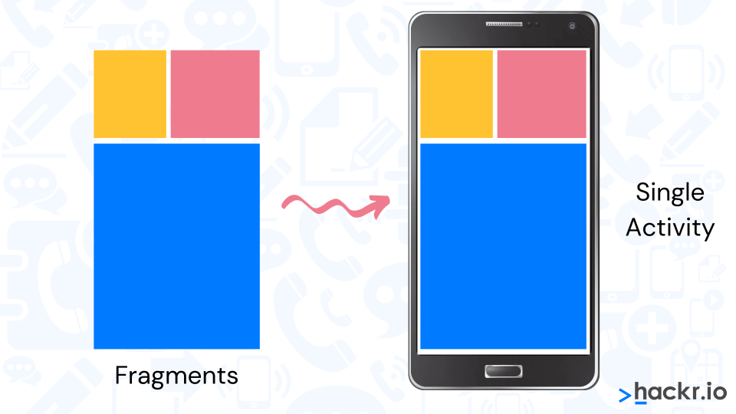

**Question:**  What are the advantages of Android?

**Answer:**

| **Advantage** | **Description** |
| --- | --- |
| ***Modest & Potent*** | It is modest and potent SDK (Software Development Kit) and importantly it is open source, meaning that Licensing, Distribution or Development fee is not required. |
| ***Easy*** | Easy to Import third party Java library. |
| ***Multi-platform Support*** | Android Supports platforms such as Linux, Mac Os, Windows. |
| ***Useful Products*** | Ground-breaking products like Location-Aware services, location of a nearby convenience store etc. are quite helpful. |
| ***Reusable*** | Components of Android can be reused and replaced by the application framework. Has optimized DVM for mobile devices. SQLite enables to store the data in a structured manner. |
| ***Technology Support*** | Android Supports GSM telephone and Bluetooth, WI-Fi, 3G and EDGE technologies. The development is a combination of a device emulator, debugging tools, memory profiling and plug-in for Eclipse IDE. |

**Question:**  What is an Explicit Intent?

**Answer:**  In an explicit intent, the activity that is required to respond to the intent is specified. To be precise, the target components are explicitly designated. This is typically used for application internal messages.

**Question:**  What is an Implicit Intent?

**Answer:**  In an implicit intent, only the intent is declared and the activity that can respond to the intent is left to the platform. Here the target component is not declared, hence it is usually used for activating components of other applications as well.

**Question:**  What is an AndroidManifest file?

**Answer:**  Applications confirm their components like the .apk file that also holds the application’s code, files, and resources in a manifest file that’s bundled into the Android package. The manifest is a structured XML file and is always named AndroidManifest.xml for all applications. It is also used for naming libraries the application that needs to be linked and identifying any permissions the application expects to be granted.

**Question:**  What’s the difference between a file, a class and an activity in android?

**Answer:**  File – It is a chunk of arbitrary information, or resource for storing information.

Class – It’s a compiled form of Java file. Android uses the .class files to produce an executable apk

Activity – An activity is the comparable to a Frame/Window in GUI toolkits. It is not a file or a file type it is just a class that can be extended in Android for loading UI elements on view.

**Question:**  What is the significance of the .dex files?

**Answer:**  Android programs are compiled into ‘.dex’ (Dalvik Executable) files, which are zipped into a single .apk file on the device. ‘.dex’ files can be created by translating compiled applications written in Java.

**Question:**  What does ADT stand for?

**Answer:**  ADT stands for Android Development Tools. The Android SDK contains several tools and utilities to help create, test and debug your projects.

**Question:**  What is Dalvik Virtual Machine?

**Answer:**  Dalvik is the name of Android’s virtual machine. The Dalvik VM is an interpreter-only virtual machine that executes files in the Dalvik Executable (.dex) format, a format that is optimized for effective storage and memory-mappable executions. The virtual machine is register-based and can run classes compiled by Java language compiler that have been altered into its native format using the included ‘dx’ tool. The VM runs on top of Posix-compliant operating systems depending on it for performing threading and low level memory management functionalities. The Dalvik core class library is envisioned to provide a familiar development base for those used to programming with Java Standard Edition, but is geared explicitly for the needs of a small mobile device.

**Question:**  What is Android Runtime?

**Answer:**  Android comprises of a set of core libraries that provides most of the functionality available in the core libraries of the Java. All Android application runs in its own process, with its own instance of the Dalvik virtual machine. Dalvik has been written in order for the device to run multiple VMs competently. The Dalvik VM executes files in the Dalvik Executable (.dex) format which is boosted for minimal memory footprint. The VM is register-based, and runs classes compiled by a Java language compiler that have been transformed into the ‘.dex’ format by the included ‘dx’ tool.

**Question:**  What is the Open Handset Alliance?

**Answer:**  The OHA is a conglomerate of 84 technologies and mobile companies that have joined hands to fast-track innovation in mobile technology and at the same time, offer the end users an improved, cost-effective and richer mobile experience. Members of this alliance include Google, HTC, Sony, Dell, Intel, Motorola, Qualcomm, Texas Instruments, Samsung, LG, T-Mobile, Nvidia. The OHA was started on 5th November, 2007 by Google and 34 other companies. Android is the main software of this alliance.

**Question:**  What is a Service?

**Answer:**  A Service is an application component representing either an application’s intent to perform a longer-running operation without interacting with the user or to provide functionality for other applications to use. Services run without a dedicated GUI, but like Activities and Broadcast Receivers, they are executable in the main thread of the application’s process. A Service could be a facility for an application to expose some of its functionality to other applications.

**Question:**  What is the difference between Service and Thread?

**Answer:**  Service is like an Activity but has no interface. For example, for fetching information on weather, blank activity will not be created. Here Service will be used. It is also known as Background Service because it performs tasks in background. A Thread is a concurrent unit of execution. Take note that the UI cannot be updated from a Thread. For this a Handler must be used.

**Question:**  What is a Toast Notification?

**Answer:**  Toast notification is a message that pops up on the window. It only covers the expanse of space required for the message and the user’s recent activity remains visible and interactive. The notification automatically fades in and out and does not accept interaction events.

**Question:**  What are the other Notifications?

**Answer:**  The other notifications are:

Status Bar Notification: Used for persistent reminders that originate from the background and request for user’s response.

Dialog Notification: Used for Activity-related notifications.

**Question:**  What is the significance of XML-based layouts?

**Answer:**  XML-based layouts provides consistent and somewhat a standard means of setting GUI definition format. As a general practice, the layout details are placed in XML files, whereas other items are placed in source files.

**Question:**  What are Containers?

**Answer:**  Containers hold objects and widgets together, depending on which specific items are needed and in what particular arrangement. Containers may hold labels, fields, buttons, e.t.c

**Question:**  What are the drawbacks of Android?

**Answer:**  Android is an open-source platform and at the same time different Operating Systems have been released for different mobile devices. This provides no clear picture on how applications can adapt with different OS versions and upgrades. An app that runs on a particular version of Android OS may or may not run on another.

Another limitation is that, mobile devices comes in different size and forms. Here it becomes a challenge for developers to create apps that can auto-correct to the right screen and other feature of that particular mobile device.

**Question:**  What is ADB?

**Answer:**  ADB is abbreviation of Android Debug Bridge. It provides developers the power to execute remote shell commands. Its basic function is to allow and control communication, to and fro from the emulator port.

**Question:**  What are the four essential states of an activity?

**Answer:**  Active – If the Activity is in the foreground.

Paused – If the Activity is in the background and is still visible.

Stopped – If the Activity is not visible, therefore is hidden or concealed by another Activity.

Destroyed – When the Activity process is completed terminated.

**Question:**  What is ANR?

**Answer:**  ANR is the acronym for Application Not Responding. This is a dialog that appears to the user whenever an application has been unresponsive for an extended period of time.

**Question:**  How are escape characters used as attribute?

**Answer:**  Escape characters when preceded by double backslashes can be used as an attribute. For example, a newline character is created using ‘n’

**Question:**  When does other qualifiers in multiple source take precedence over Locale?

**Answer:**  This happens at two instances: MCC (mobile country code) and MNC (mobile network code) qualifiers.

**Question:**  What is the correct way of setting up an Android-powered device for app development?

**Answer:**  The following are steps need to be followed prior to actual application development in an Android-powered device:

Declare application as “debuggable” in Android Manifest.

Turn on “USB Debugging” on your device.

Set up system to detect your device.

**Question:**  What are the steps involved in creating a bounded service through AIDL?

**Answer:**  Create the ‘.aidl’ file which defines the programming interface

Implement the interface by extending the inner abstract Stub class as well as embedding its methods.

Describe the interface by implementing the Service to the clients.

**Question:**  What are the different data types supported by AIDL?

**Answer:**  String, CharSequence, List and Map. All built-in Java data types like Int, Long, Char and Boolean are also supported by AIDL

**Question:**  What is a Fragment?

**Answer:**  A fragment is a portion of an activity. It is flexible in a sense that it can moved around or combined with other fragments in a single activity. Fragments are also reusable.

**Question:**  Can Fragments be added without using a User Interface?

**Answer:**  Yes, this can be done when creating a background behaviour for a particular activity. This can be done by using add (Fragment, string) method to add a fragment from the activity.

**Question:**  How to remove icons and widgets from the main screen of an Android device?

**Answer:**  To remove an icon, press and hold that icon. Then drag it towards the lower part of the screen where the remove button appears.

**Question:**  Do all mobile phones support the latest Android Operating System?

**Answer:**  Some Android phones lets you to upgrade to higher Operating System version. However, not all upgrades allows you to get the latest version. It depends mainly on whether it can support the newer features available in the latest version.

**Question:**  What is a Portable Wi-Fi Hotspot?

**Answer:**  Portable Wi-Fi Hotspots allow you to share your mobile internet connection with other wireless devices. For example, your Android-powered phone can be used as a Wi-Fi Hotspot to make your laptop connect to the internet.

**Question:**  What is the variance between a regular Bitmap and a Nine-Patch image?

**Answer:**  A Nine-patch image allows resizing. The Nine-patch refers to the way you can resize the image: 4 corners that are unscaled, 4 edges that are scaled in 1 axis, and the middle one that can be scaled into both axes.

**Question:**  What are the exemptions in Android?

**Answer:**  InflateException : When an error conditions occur this exception is thrown.

Surface.OutOfResourceException: When a Surface is not created or resized, this exception is thrown.

SurfaceHolder.BadSurfaceTypeException: When invoked on a Surface ‘SURFACE_TYPE_PUSH_BUFFERS’, this exception is thrown from lockCanvas() method.

WindowManager.BadTokenException: This exception is thrown at the time of trying to view an invalid WindowManager.LayoutParamstoken.

**Question:**  How can I get the context in a fragment?

**Answer:**  You can use getActivity(), which returns the activity associated with a fragment. The activity is a context (since Activity extends Context).

You can also override the onAttach method of fragment:

public static class DummySectionFragment extends Fragment{

@Override

public void onAttach(Activity activity) {

super.onAttach(activity);

DBHelper = new DatabaseHelper(activity);

}

}

**Question:**  Is it possible to implement the model–view–controller pattern in Java for Android?

**Answer:**  In Android you don't have MVC, but you have the following:

You define your user interface in various XML files by resolution, hardware, etc.

You define your resources in various XML files by locale, etc.

You extend clases like ListActivity, TabActivity and make use of the XML file by inflaters.

You can create as many classes as you wish for your business logic.

A lot of Utils have been already written for you - DatabaseUtils, Html.

**Question:**  What is an Intent in Android?

**Answer:**  An Intent is basically a message that is passed between components (such as Activities, Services, Broadcast Receivers, and Content Providers).So, it is almost equivalent to parameters passed to API calls. The fundamental differences between API calls and invoking components via intents are:

API calls are synchronous while intent-based invocations are asynchronous.

API calls are compile-time binding while intent-based calls are run-time binding.

To listen for an broadcast intent (like the phone ringing, or an SMS is received), you implement a broadcast receiver, which will be passed the intent. To declare that you can handle another's app intent like "take picture", you declare an intent filter in your app's manifest file.

If you want to fire off an intent to do something, like pop up the dialer, you fire off an intent saying you will.

An Intent provides a facility for performing late runtime binding between the code in different applications.

**Question:**  What is the most appropriate way to store user settings in Android application?

**Answer:**  In general SharedPreferences are your best bet for storing preferences, so in general I'd recommend that approach for saving application and user settings.

The only area of concern here is what you're saving. Passwords are always a tricky thing to store, and I'd be particularly wary of storing them as clear text. The Android architecture is such that your application's SharedPreferences are sandboxed to prevent other applications from being able to access the values so there's some security there, but physical access to a phone could potentially allow access to the values.

**Question:**  In what situation should one use RecyclerView over ListView?

**Answer:**  RecyclerView was created as a ListView improvement, so yes, you can create an attached list with ListView control, but using RecyclerView is easier as it:

Reuses cells while scrolling up/down - this is possible with implementing View Holder in the ListView adapter, but it was an optional thing, while in the RecycleView it's the default way of writing adapter.

Decouples list from its container - so you can put list items easily at run time in the different containers (linearLayout, gridLayout) with setting LayoutManager.

To conclude, RecyclerView is a more flexible control for handling "list data" that follows patterns of delegation of concerns and leaves for itself only one task - recycling items.

**Question:**  Tell about Constraint Layout

**Answer:**  ConstraintLayout allows you to create large and complex layouts with a flat view hierarchy (no nested view groups). It's similar to RelativeLayout in that all views are laid out according to relationships between sibling views and the parent layout, but it's more flexible than RelativeLayout and easier to use with Android Studio's Layout Editor.

Intention of ConstraintLayout is to optimize and flatten the view hierarchy of your layouts by applying some rules to each view to avoid nesting.

**Question:**  What is Dalvik?

**Answer:**  Dalvik is a Just In Time (JIT) compiler. By the term JIT, we mean to say that whenever you run your app in your mobile device then that part of your code that is needed for execution of your app will only be compiled at that moment and rest of the code will be compiled in the future when needed. The JIT or Just In Time compiles only a part of your code and it has a smaller memory footprint and due to this, it uses very less physical space on your device.

**Question:**  What is a difference between Spannable and String?

**Answer:**  A Spannable allows to attach formatting information like bold, italic, ... to sub-sequences ("spans", thus the name) of the characters. It can be used whenever you want to represent "rich text"

**Question:**  How does the OutOfMemory happens?

**Answer:**  Out of memory error is very common error when you are developing for a application that deals with multiple images sets or large bitmaps or some Animation stuff. In Android, every application runs in a Linux Process. Each Linux Process has a Virtual Machine (Dalvik Virtual Machine) running inside it. There is a limit on the memory a process can demand and it is different for different devices and also differs for phones and tablets. When some process demands a higher memory than its limit it causes a error i.e Out of memory error.

There are number of reasons why we get a Out of memory errors. Some of those are:

You are doing some operation that continuously demands a lot of memory and at some point it goes beyond the max heap memory limit of a process.

You are leaking some memory i.e you didn’t make the previous objects you allocated eligible for Garbage Collection (GC). This is called Memory leak.

You are dealing with large bitmaps and loading all of them at run time. You have to deal very carefully with large bitmaps by loading the size that you need not the whole bitmap at once and then do scaling.

**Question:**  How to persist data in an Android app?

**Answer:**  There are basically four different ways to store data in an Android app:

Shared Preferences - to save primitive data in key-value pairs

Internal Storage - you need to store data to the device filesystem, but you do not want any other app (even the user) to read this data

External Storage - you might want the user to view the files and data saved by your app

SQLite database

**Question:**  Explain Android notification system

**Answer:**  A notification is a message that Android displays outside your app's UI to provide the user with reminders, communication from other people, or other timely information from your app. Users can tap the notification to open your app or take an action directly from the notification.

Notifications appear to users in different locations and formats, such as an icon in the status bar, a more detailed entry in the notification drawer, as a badge on the app's icon, and on paired wearables automatically. Beginning with Android 5.0, notifications can appear on the lock screen.

Starting in Android 8.0 (API level 26), all notifications must be assigned to a channel or it will not appear. By categorizing notifications into channels, users can disable specific notification channels for your app (instead of disabling all your notifications), and users can control the visual and auditory options for each channel—all from the Android system settings.

**Question:**  Why is it recommended to use only the default constructor to create a Fragment?

**Answer:**  In short, Fragments need to have a no-args constructor for the Android system to instantiate them. Your Fragment subclasses need a public empty constructor as this is what's being called by the framework. It is used in the case when device has to restore the state of a fragment. No data will be passed and a default fragment will be created and then the state will be restored. Since the system has no way to know what you passed in your constructor or your newInstance, default constructor will be used and saved bundle should be passed via onCreate after the fragment is actually instantiated with the default constructor.

**Question:**  What is the difference between Bitmap and Drawable in Android?

**Answer:**  A Bitmap is a representation of a bitmap image (something like java.awt.Image).

A Drawable is an abstraction of "something that can be drawn". It could be a Bitmap (wrapped up as a BitmapDrawable), but it could also be a solid color, a collection of other Drawable objects, or any number of other structures.

**Question:**  Mention the difference between RelativeLayout and LinearLayout?

**Answer:**  Linear Layout — Arranges elements either vertically or horizontally. i.e. in a row or column.

Relative Layout — Arranges elements relative to parent or other elements.

**Question:**  What is the actual differences between a activity context and application context?

**Answer:**  They are both instances of Context, but the application instance is tied to the lifecycle of the application, while the Activity instance is tied to the lifecycle of an Activity. Thus, they have access to different information about the application environment.

If you read the docs at getApplicationContext it notes that you should only use this if you need a context whose lifecycle is separate from the current context.

In general, use the activity context unless you have a good reason not to.

**Question:**  What is the difference between Activity and Context?

**Answer:**  Context is the Base Object. So every Activity same as Application derives from Context. This means that every Activity and every Application IS a Context.

An Application context lasts, as long as your app is alive, while the Activity context dies with your Activity (it is not valid after onDestroy of that Activity).

So if you need the Context across Activities (i.e. in a Singleton) you will be better off using an Application context.

**Question:**  How could you pass data between activities without Intent?

**Answer:**  The Application object is a way to go, and it is sometimes easier when dealing with the same state across multiple activities (as opposed to having to get/put it everywhere), or objects more complex than primitives and Strings.

You can extend Application, and then set/get whatever you want there and access it from any Activity (in the same application) with getApplication().

Also keep in mind that other approaches you might see, like statics, can be problematic because they can lead to memory leaks. Application helps solve this too.

**Question:**  When to use Fragments vs Activities?

**Answer:**  Activities are designed to represent a single screen of my application, while Fragments are designed to be reusable UI layouts with logic embedded inside of them.

Google advises you to always use Fragments. In the simplest case, Fragments are used like containers of activities.Android 4 (ICS) supports both Smartphones and Tablets. This means the same application will be running on a smartphone and a tablet and they are likely to be very different.

Historically each screen in an Android app was implemented as a separate Activity. This creates a challenge in passing information between screens because the Android Intent mechanism does not allow passing a reference type (i.e. object) directly between Activities. By making each screen a separate Fragment, this data passing headache is completely avoided. Fragments always exist within the context of a given Activity and can always access that Activity. By storing the information of interest within the Activity, the Fragment for each screen can simply access the object reference through the Activity.

**Question:**  Explain key differences between Service and IntentService

**Answer:**  When to use?

The Service can be used in tasks with no UI, but shouldn't be too long. If you need to perform long tasks, you must use threads within Service.

The IntentService can be used in long tasks usually with no communication to Main Thread. If communication is required, can use Main Thread handler or broadcast intents. Another case of use is when callbacks are needed (Intent triggered tasks).

How to trigger?

The Service is triggered by calling method startService().

The IntentService is triggered using an Intent, it spawns a new worker thread and the method onHandleIntent() is called on this thread.

Triggered From

The Service and IntentService may be triggered from any thread, activity or other application component.

Runs On

The Service runs in background but it runs on the Main Thread of the application.

The IntentService runs on a separate worker thread.

Limitations / Drawbacks

The Service may block the Main Thread of the application.

The IntentService cannot run tasks in parallel. Hence all the consecutive intents will go into the message queue for the worker thread and will execute sequentially.

When to stop?

If you implement a Service, it is your responsibility to stop the service when its work is done, by calling stopSelf() or stopService(). (If you only want to provide binding, you don't need to implement this method).

The IntentService stops the service after all start requests have been handled, so you never have to call stopSelf().

**Question:**  How to declare global variables in Android?

**Answer:**  The way to do this is to create your own subclass of android.app.Application, and then specify that class in the application tag in your manifest.

public class MyApp extends Application {

String foo;

}

In the AndroidManifest.xml add android:name

<application android:name=".MyApp"

android:icon="@drawable/icon"

android:label="@string/app_name">

**Question:**  What is an Android PendingIntent?

**Answer:**  Intents are the standard messaging mechanism in Android that expresses the user’s intention to perform some work.

A PendingIntent specifies an action to take in the future. It lets you pass a future Intent to another application and allow that application to execute that Intent as if it had the same permissions as your application.

By giving a PendingIntent to another application, you are granting it the right to perform the operation you have specified as if the other application was yourself (with the same permissions and identity).

**Question:**  What is the difference between compileSdkVersion and targetSdkVersion?

**Answer:**  The compileSdkVersion is the version of the API the app is compiled against. This means you can use Android API features included in that version of the API (as well as all previous versions, obviously). If you try and use API 16 features but set compileSdkVersion to 15, you will get a compilation error. If you set compileSdkVersion to 16 you can still run the app on a API 15 device as long as your app's execution paths do not attempt to invoke any APIs specific to API 16.

The targetSdkVersion has nothing to do with how your app is compiled or what APIs you can utilize. The targetSdkVersion is supposed to indicate that you have tested your app on (presumably up to and including) the version you specify. This is more like a certification or sign off you are giving the Android OS as a hint to how it should handle your app in terms of OS features.

**Question:**  Why fragments, and when to use fragments instead of activities?

**Answer:**  In short, fragments live inside activities, and each activity can host many fragments. Like activities, they have a specific lifecycle, unlike activities, they are not top-level application components.

Advantages of fragments include code reuse and modularity (e.g., using the same list view in many activities), including the ability to build multi-pane interfaces (mostly useful on tablets). A fragment can be used in multiple activities. By making each screen a separate Fragment, this data passing headache is completely avoided. Fragments always exist within the context of a given Activity and can always access that Activity. By storing the information of interest within the Activity, the Fragment for each screen can simply access the object reference through the Activity.

The main disadvantage is (some) added complexity. You can generally achieve the same thing with (custom) views in a non-standard and less robust way.

**Question:**  What is the difference between invisible and gone for the View visibility status?

**Answer:**  Invisible - this view is invisible, but it still takes up space for layout purposes.

Gone - this view is invisible, and it doesn't take any space for layout purposes.

Looks like analogous to display:none & visibility:hidden in HTML/CSS

**Question:**  What is the difference between AsyncTask and Thread/Runnable?

**Answer:**  AsyncTask is a convenience class for doing some work on a new thread and use the results on the thread from which it got called (usually the UI thread) when finished. It's just a wrapper which uses a couple of runnables but handles all the intricacies of creating the thread and handling messaging between the threads. AsyncTask is designed to be a helper class around Thread and Handler and does not constitute a generic threading framework.

The Runnable interface is at the core of Java threading. The Runnable interface should be implemented by any class whose instances are intended to be executed by a thread.

**Question:**  What is Parcelable in Android?

**Answer:**  A Parcelable is the Android implementation of the Java Serializable. It assumes a certain structure and way of processing it. This way a Parcelable can be processed relatively fast, compared to the standard Java serialization. To allow your custom object to be parsed to another component they need to implement the android.os.Parcelable interface.

You can use Parcelable in Activity like:

intent.putExtra("student", new Student("1")); //size which you are storing

And to get this object :

Bundle data = getIntent().getExtras();

Student student = (Student) data.getParcelable("student");

In short use Parcelable to convert an object into a sequence of bytes which can be read/transferred between Activities.

**Question:**  What is an AsyncTask?

**Answer:**  AsyncTask is one of the easiest ways to implement parallelism in Android without having to deal with more complex methods like Threads. Though it offers a basic level of parallelism with the UI thread, it should not be used for longer operations (of, say, not more than 2 seconds).

AsyncTask has four methods

onPreExecute()

doInBackground()

onProgressUpdate()

onPostExecute()

where doInBackground() is the most important as it is where background computations are performed.

**Question:**  What is a ContentProvider and what is it typically used for?

**Answer:**  A content provider manages access to a central repository of data. A provider is part of an Android application, which often provides its own UI for working with the data. However, content providers are primarily intended to be used by other applications, which access the provider using a provider client object.

Typically you work with content providers in one of two scenarios;

you may want to implement code to access an existing content provider in another application, or

you may want to create a new content provider in your application to share data with other applications.

**Question:**  What is ADB and what is it used for?

**Answer:**  ADB is the acronym for Android Debug Bridge, which is part of the Android SDK (Software Development Kit). It uses a client-server-model (i.e. adbd, the ADB daemon, is running on the device and can be connected to), and in most cases is used via an USB connection. It is also possible to use it via WiFi (wireless adb).

There's nothing you need to install on your Android device, as the ADB daemon (adbd) is already integrated into the Android OS. It is usually accessed via a command line interface from the PC, where either the full Android SDK is installed (several 30 MB download archive currently), or a massively stripped-down version for "non-developers", sometimes referred to as "Mini ADB" or "ADB essentials" (for Linux, this is only the adb executable; for Windows it's adb.exe plus two or three .dll files).

**Question:**  What is Armv7?

**Answer:**  There are 3 CPU architectures in Android:

ARMv7 is the most common as it is optimised for battery consumption.

ARM64 is an evolved version of that that supports 64-bit processing for more powerful computing.

ARMx86, is the least used for these three, since it is not battery friendly. It is more powerful than the other two.

**Question:**  Explain the build process in Android

**Answer:**  First step involves compiling the resources folder (/res) using the aapt (android asset packaging tool) tool. These are compiled to a single class file called R.java. This is a class that just contains constants.

Second step involves the java source code being compiled to .class files by javac, and then the class files are converted to Dalvik bytecode by the “dx” tool, which is included in the sdk ‘tools’. The output is classes.dex.

The final step involves the android apkbuilder which takes all the input and builds the apk (android packaging key) file.

**Question:**  What’s the difference between onCreate() and onStart()?

**Answer:**  The onCreate() method is called once during the Activity lifecycle, either when the application starts, or when the Activity has been destroyed and then recreated, for example during a configuration change.

The onStart() method is called whenever the Activity becomes visible to the user, typically after onCreate() or onRestart()

**Question:**  What is View Group? How are they different from Views?

**Answer:**  View: View objects are the basic building blocks of User Interface(UI) elements in Android. View is a simple rectangle box which responds to the user’s actions. Examples are EditText, Button, CheckBox etc. View refers to the android.view.View class, which is the base class of all UI classes.

ViewGroup: ViewGroup is the invisible container. It holds View and ViewGroup. For example, LinearLayout is the ViewGroup that contains Button(View), and other Layouts also. ViewGroup is the base class for Layouts.

**Question:**  What is the difference between Handler vs AsyncTask vs Thread?

**Answer:**  The Handler class can be used to register to a thread and provides a simple channel to send data to this thread. A Handler allows you communicate back with the UI thread from other background thread.

The AsyncTask class encapsulates the creation of a background process and the synchronization with the main thread. It also supports reporting progress of the running tasks.

And a Thread is basically the core element of multithreading which a developer can use with the following disadvantage:

Handle synchronization with the main thread if you post back results to the user interface

No default for canceling the thread

No default thread pooling

No default for handling configuration changes in Android

**Question:**  What is Handler and what is it used for?

**Answer:**  When we install an application in Android, then it creates a thread for that application called MAIN UI Thread. All activities run inside that thread. By the android single thread model rule, we can not access UI elements (bitmap , textview etc..) directly for another thread defined inside that activity.

A Handler allows you communicate back with the UI thread from other background thread. This is useful in android as android doesn’t allow other threads to communicate directly with UI thread. Handler can send and process Message and Runnable objects associated with a thread’s MessageQueue. Each Handler instance is associated with a single thread and that thread’s message queue. When a new Handler is created, it is bound to the thread/message queue of the thread that is creating it. To use a handler you have to subclass it and override handleMessage() to process messages.

There are two main uses for a Handler:

To schedule messages and runnables to be executed as some point in the future;

To enqueue an action to be performed on a different thread than your own.

**Question:**  What is Explicit Intent?

**Answer:**  Explicit Intents used to call a specific component. When you know which component you want to launch and you do not want to give the user free control over which component to use. For example, you have an application that has 2 activities. Activity A and activity B. You want to launch activity B from activity A. In this case you define an explicit intent targeting activity B and then use it to directly call it.

**Question:**  What is Implicit Intent?

**Answer:**  Implicit Intents used when you have an idea of what you want to do, but you do not know which component should be launched. Or if you want to give the user an option to choose between a list of components to use.

If these Intents are send to the Android system it searches for all components which are registered for the specific action and the data type. If only one component is found, Android starts the component directly.

For example, you have an application that uses the camera to take photos. One of the features of your application is that you give the user the possibility to send the photos he has taken. You do not know what kind of application the user has that can send photos, and you also want to give the user an option to choose which external application to use if he has more than one. In this case you would not use an explicit intent. Instead you should use an implicit intent that has its action set to ACTION_SEND and its data extra set to the URI of the photo.

**Question:**  What is Intent Filter?

**Answer:**  If an Intents is send to the Android system, it will determine suitable applications for this Intents. If several components have been registered for this type of Intents, Android offers the user the choice to open one of them.

This determination is based on IntentFilters. An IntentFilters specifies the types of Intent that an activity, service, orBroadcast Receiver can respond to. An Intent Filter declares the capabilities of a component. It specifies what anactivity or service can do and what types of broadcasts a Receiver can handle. It allows the corresponding component to receive Intents of the declared type. IntentFilters are typically defined via the AndroidManifest.xml file. For BroadcastReceiver it is also possible to define them in coding. An IntentFilters is defined by its category, action and data filters. It can also contain additional metadata.

If a component does not define an Intent filter, it can only be called by explicit Intents.

**Question:**  What does LayoutInflater in Android do?

**Answer:**  The LayoutInflater class is used to instantiate the contents of layout XML files into their corresponding View objects.

In other words, it takes an XML file as input and builds the View objects from it.

**Question:**  Android Log.v(), Log.d(), Log.i(), Log.w(), Log.e(). When to use each one?

**Answer:**  Let's go in reverse order:

Log.e: This is for when bad stuff happens. Use this tag in places like inside a catch statement. You know that an error has occurred and therefore you're logging an error.

Log.w: Use this when you suspect something shady is going on. You may not be completely in full on error mode, but maybe you recovered from some unexpected behavior. Basically, use this to log stuff you didn't expect to happen but isn't necessarily an error. Kind of like a "hey, this happened, and it's weird, we should look into it."

Log.i: Use this to post useful information to the log. For example: that you have successfully connected to a server. Basically use it to report successes.

Log.d: Use this for debugging purposes. If you want to print out a bunch of messages so you can log the exact flow of your program, use this. If you want to keep a log of variable values, use this.

Log.v: Use this when you want to go absolutely nuts with your logging. If for some reason you've decided to log every little thing in a particular part of your app, use the Log.v tag.

And as a bonus...

Log.wtf: Use this when stuff goes absolutely, horribly, holy-crap wrong. You know those catch blocks where you're catching errors that you never should get...yeah, if you wanna log them use Log.wtf

**Question:**  What are the differences between onCreate(), onCreateView(), and onActivityCreated() in fragments and what would they each be used for?

**Answer:**  They are all called in the Fragment but are called at different times. The onCreate() is called first, for doing any non-graphical initialisations. Next, you can assign and declare any View variables you want to use in onCreateView(). Afterwards, use onActivityCreated() to do any final initialisations you want to do once everything has completed.

Also check this two diagrams:

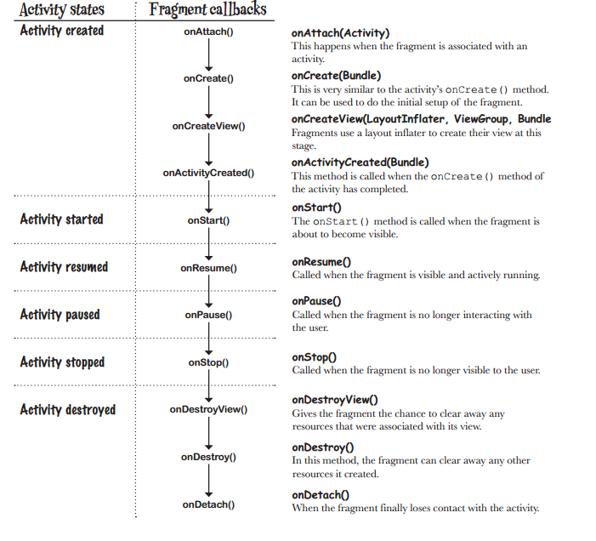

And,

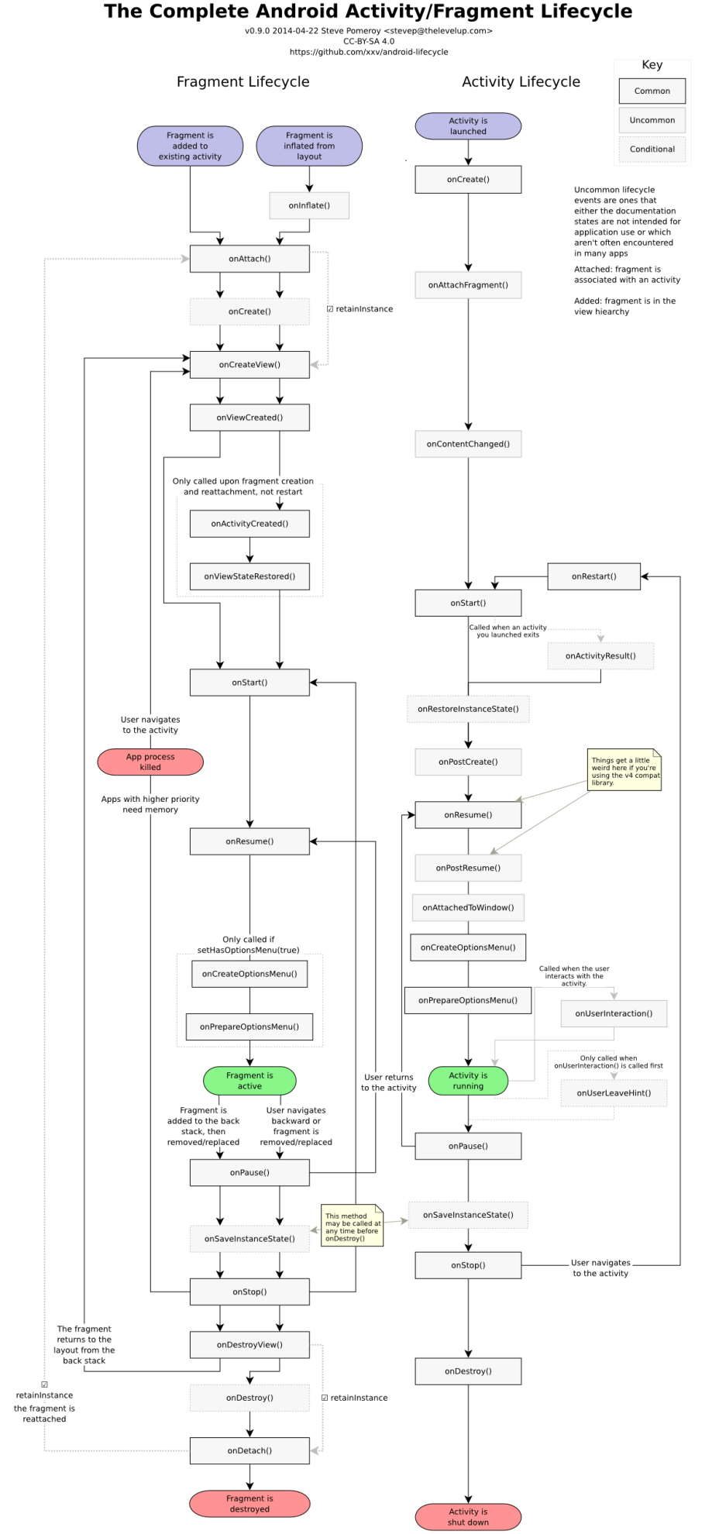

**Question:**  What is the difference between onCreate() and onCreateView() lifecycle methods in Fragment?

**Answer:**  onCreate is called on initial creation of the fragment. You do your non graphical initializations here. It finishes even before the layout is inflated and the fragment is visible.

onCreateView is called to inflate the layout of the fragment i.e graphical initialization usually takes place here. It is always called sometimes after the onCreate method.

**Question:**  When to use Android's ArrayMap instead of a HashMap?

**Answer:**  ArrayMap uses way less memory than HashMap and is recommended for up to a few hundred items, especially if the map is not updated frequently. Spending less time allocating and freeing memory may also provide some general performance gains.

Update performance is a bit worse because any insert requires an array copy. Read performance is comparable for a small number of items and uses binary search.

**Question:**  What are the differences between ArrayList and ArrayMap?

**Answer:**  ArrayMap keeps its mappings in an array data structure — an integer array of hash codes for each item, and an Object array of the key -> value pairs.

Where ArrayList is a List. Resizable-array implementation of the List interface. Implements all optional list operations, and permits all elements, including null.

**Question:**  Explain how HashMap works

**Answer:**  HashMap is basically an Array of HashMap.Entry objects (Entry is an inner class of HashMap).

What happens when a key/value is inserted in HashMap ?

HashCode of the key is calculated, and that value is assigned to the hashCode variable of EntryClass.

Then, using hashCode we get the index of the bucket where it will be stored.

If the bucket is having a pre-existing element, the new element is inserted with the last element pointing to new one — essentially making the bucket a LinkedList.

Now, when you query it to get the value for a key, it comes in O(1). But most important thing is that it comes at the cost of more space(memory).

**Question:**  What are Android Annotations and what are they used for?

**Answer:**  Android Annotations is an annotation-driven framework that allows you to simplify the code in your applications and reduces the boilerplate of common patterns, such as setting click listeners, enforcing ui/background thread executions, etc.

I don't recommend using it; it's buggy, and unstable. In my current job I am working on a project and my task is to remove Android Annotations. I would suggest using Dagger 2, Butterknife, and RxJava.

**Question:**  What is ART?

**Answer:**  ART or Android Runtime is an Android runtime that uses Ahead Of Time (AOT). By using AOT, what is does is it converts or compiles the whole High-level language code into Machine level code and at the time of installation of the app and not dynamically as the application runs (like in case of Dalvik). By compiling the whole code during installation results in no lag that we see when we run our app on our device.

**Question:**  What is RenderScript and when should we (really) use it?

**Answer:**  RenderScript is a framework for running computationally intensive tasks at high performance on Android. RenderScript is primarily oriented for use with data-parallel computation, although serial workloads can benefit as well. The RenderScript runtime parallelizes work across processors available on a device, such as multi-core CPUs and GPUs. This allows you to focus on expressing algorithms rather than scheduling work. RenderScript is especially useful for applications performing image processing, computational photography, or computer vision.

If your application is doing a lot of cpu based data processing (i.e. in Dalvik or the NDK), and you would like a speedup, you should look at RS.

**Question:**  Explain String vs StringBuilder vs SpannedString vs SpannableString vs SpannableStringBuilder vs CharSequence

**Answer:**  A String is immutable (ie, the text can't change). It also doesn't have any spans associated with it. (Spans are ranges over the text that include styling information like color, highlighting, italics, links, etc.) So you can use a String when your text doesn't need to be changed and doesn't need any styling.

A StringBuilder has mutable text, so you can modify it without creating a new object. However, it doesn't have any span information. It is just plain text. So use a StringBuilder when you need to change the text, but you don't care about styling it.

A SpannedString has immutable text (like a String) and immutable span information. It is a concrete implementation of the requirements defined by the Spanned interface. Use a SpannedString when your text has style but you don't need to change either the text or the style after it is created.

Note: There is no such thing as a SpannedStringBuilder because if the text changed then the span information would also very likely have to change.

A SpannableString has immutable text, but its span information is mutable. It is a concrete implementation of the requirements defined by the Spannable interface. Use a SpannableString when your text doesn't need to be changed but the styling does.

A SpannableStringBuilder has both mutable text and span information. It is a concrete implementation of the requirements defined by the Spannable and Editable interfaces (among others). Use a SpannableStringBuilder when you will need to update the text and its style.

A CharSequence is an interface and not a concrete class. That means it just defines a list of rules to follow for any class that implements it. And all of the classes mentioned above implement it. So you can use a CharSequence when you want to generalize the type of object that you have for maximum flexibility. You can always downcast it to a String or SpannableStringBuilder or whatever later if you need to.

**Question:**  What is the best way to update the screen periodically?

**Answer:**  Use Handler. Timer on the other hand will execute on another thread so it cannot update the views.

Handler handler = new Handler();

Runnable runnable = new Runnable() {

public void run() {

doStuff();

}

};

**Question:**  What is the ViewHolder pattern? Why should we use it?

**Answer:**  Every time when the adapter calls getView() method, the findViewById() method is also called. This is a very intensive work for the mobile CPU and so affects the performance of the application and the battery consumption increases. ViewHolder is a design pattern which can be applied as a way around repeated use of findViewById().

A ViewHolder holds the reference to the id of the view resource and calls to the resource will not be required after you "find" them: Thus performance of the application increases.

private static class ViewHolder {

final TextView text;

final TextView timestamp;

final ImageView icon;

final ProgressBar progress;

ViewHolder(TextView text, TextView timestamp, ImageView icon, ProgressBar progress) {

this.text = text;

this.timestamp = timestamp;

this.icon = icon;

this.progress = progress;

}

}

public View getView(int position, View convertView, ViewGroup parent) {

View view = convertView;

if (view == null) {

view = // inflate new view

ViewHolder holder = createViewHolderFrom(view);

view.setTag(holder);

}

ViewHolder holder = view.getTag();

// TODO: set correct data for this list item

// holder.icon.setImageDrawable(...)

// holder.text.setText(...)

// holder.timestamp.setText(...)

// holder.progress.setProgress(...)

return view;

}

private ViewHolder createViewHolderFrom(View view) {

ImageView icon = (ImageView) view.findViewById(R.id.listitem_image);

TextView text = (TextView) view.findViewById(R.id.listitem_text);

TextView timestamp = (TextView) view.findViewById(R.id.listitem_timestamp);

ProgressBar progress = (ProgressBar) view.findViewById(R.id.progress_spinner);

return new ViewHolder(text, timestamp, icon, progress);

}

View.setTag(Object) allows you to tell the View to hold an arbitrary object. If we use it to hold an instance of our ViewHolder after we do our findViewById(int) calls, then we can use View.getTag() on recycled views to avoid having to make the calls again and again.

**Question:**  What is the difference between ListView and RecyclerView?

**Answer:**  For list views to have good performance you'll need to implement the View Holder pattern, and that's easy to mess up especially when you want to populate the list with several different kinds of views.

The RecyclerView bakes this pattern in, making it more difficult to mess up. It's also more flexible, making it easier to handle different layouts, that aren't straight linear, like a grid.

**Question:**  What is the difference between Adapter and Loader in Android?

**Answer:**  An Adapter object acts as a bridge between an AdapterView and the underlying data for that view. The Adapter provides access to the data items.

Loaders make it easy to asynchronously load data in an Activity or Fragment.

Both provide an abstraction for data access, but the Loader performs the query in the background whereas an Adapter executes in the current (presumably UI) thread.

**Question:**  How to avoid reverse engineering of an APK file?

**Answer:**  AFAIK, there is not any trick for complete avoidance of reverse engineering. However, there are steps you can take to protect your source code, or at least what it does if not everything:

Use tools like ProGuard. These will obfuscate your code.

Move the most critical parts of the service out of the app, and into a webservice, hidden behind a server side.

When storing values on the device, don't store them in a raw format.

Use SSL and properly validate the server certificate.

Insert random useless source code into your app, so that the hacker is looking for a needle in a haystack.

**Question:**  Discuss Singletons vs. Application Context for app-global state

**Answer:**  According Android documentation there is normally no need to subclass Application. In most situation, static singletons can provide the same functionality in a more modular way. If your singleton needs a global context (for example to register broadcast receivers), the function to retrieve it can be given a Context which internally uses Context.getApplicationContext() when first constructing the singleton.

On the other hand singletons are a nightmare for testing and, if lazily initialized, will introduce "state indeterminism" with subtle side effects. Visibility has been mentioned as another problem, and since singletons imply "global" (= random) access to shared state, subtle bugs may arise when not properly synchronized in concurrent applications.

Although the app context can be considered a singleton itself, it is framework-managed and has a well defined life-cycle, scope, and access path. Hence I believe that if you do need to manage app-global state, it should go here, nowhere else.

**Question:**  What is the difference between getContext() , getApplicationContext() , getBaseContext() , and "this"?

**Answer:**  View.getContext(): Returns the context the view is currently running in. Usually the currently active Activity.

Activity.getApplicationContext(): Returns the context for the entire application (the process all the Activities are running inside of). Use this instead of the current Activity context if you need a context tied to the lifecycle of the entire application, not just the current Activity.

ContextWrapper.getBaseContext(): If you need access to a Context from within another context, you use a ContextWrapper. The Context referred to from inside that ContextWrapper is accessed via getBaseContext().

this is refer current class object always. this and getContext() are not always same e.g. in Activity class, you can use this because Activity inherits from Context but method getContext() is not in Activity class.

**Question:**  When to use Android Loaders?

**Answer:**  Loaders are best option when we want to observe a data source and change our view so it will display the new data if your data source is constantly updating. For example, like a stock-ticker app. If your data isn't constantly updating, then don't use a loader. For example, if your data source is only retrieved once, then there's no need for a Loader.

**Question:**  How would you communicate between two Fragments?

**Answer:**  All Fragment-to-Fragment communication is done either through a shared ViewModel or through the associated Activity. Two Fragments should never communicate directly.

The recommended way to communicate between fragments is to create a shared ViewModel object. Both fragments can access the ViewModel through their containing Activity. The Fragments can update data within the ViewModel and if the data is exposed using LiveData the new state will be pushed to the other fragment as long as it is observing the LiveData from the ViewModel.

public class SharedViewModel extends ViewModel {

private final MutableLiveData < Item > selected = new MutableLiveData < Item > ();

public void select(Item item) {

selected.setValue(item);

}

public LiveData < Item > getSelected() {

return selected;

}

}

public class MasterFragment extends Fragment {

private SharedViewModel model;

public void onCreate(Bundle savedInstanceState) {

super.onCreate(savedInstanceState);

model = ViewModelProviders.of(getActivity()).get(SharedViewModel.class);

itemSelector.setOnClickListener(item -> {

model.select(item);

});

}

}

public class DetailFragment extends Fragment {

public void onCreate(Bundle savedInstanceState) {

super.onCreate(savedInstanceState);

SharedViewModel model = ViewModelProviders.of(getActivity()).get(SharedViewModel.class);

model.getSelected().observe(this, {

item ->

// Update the UI.

});

}

}

Another way is to define an interface in your Fragment A, and let your Activity implement that Interface. Now you can call the interface method in your Fragment, and your Activity will receive the event. Now in your activity, you can call your second Fragment to update the textview with the received value.

**Question:**  How can two distinct Android apps interact?

**Answer:**  At the simplest level there are two different ways for apps to interact on Android: via Intents, passing data from one application to another; and through Services, where one application provides functionality for others to use.

**Question:**  Isn't android's Bundle functionally equivalent with a Map?

**Answer:**  First, a Map does not necessarily have String keys.

Second, while a Map can hold arbitrary objects, it cannot do so in a typesafe fashion. IOW, if you want the Map to hold strings, integers, and so forth, you will need to keep casting the results of get() calls, because your Map would have to be Map<String, Object>.

Third, Bundle implements Parcelable, which is very important for Android IPC. Map is an interface and does not extend Parcelable. This allows Bundles to be used as service parameters and to be attached to intents / passed into activities.

**Question:**  What is the difference between a Bundle and an Intent?

**Answer:**  A Bundle is a collection of key-value pairs.

However, an Intent is much more. It contains information about an operation that should be performed. This new operation is defined by the action it can be used for, and the data it should show/edit/add. The system uses this information for finding a suitable app component (activity/broadcast/service) for the requested action.

Think of the Intent as a Bundle that also contains information on who should receive the contained data, and how it should be presented.

**Question:**  What is a LocalBroadcastManager?

**Answer:**  It is good practice to use broadcast receivers when you want to send or receive data between different applications. But if the communication is limited to your application then it is not good to use the global broadcast.

In this case Android provides local broadcasts with the LocalBroadcastManager class. Using global broadcast, any other application can also send and receives broadcast messages to and from our application. This can be a serious security thread for our application. Also global broadcast is sent system-wide, so it is not performance efficient.

The LocalBroadcastManager is much more efficient as it doesn’t need inter-process communication. Below are some of its benefits:

Broadcast data won’t leave your app, so don’t need to worry about leaking private data.

It is not possible for other applications to send these broadcasts to your app, so you don’t need to worry about having security holes they can exploit.

It is more efficient than sending a global broadcast through the system.

No overhead of system-wide broadcast.

**Question:**  What is a JobScheduler?

**Answer:**  The JobScheduler API performs an operation for your application when a set of predefined conditions are met (such as when a device is plugged into a power source or connected to a Wi-Fi network). This allows your app to perform the given task while being considerate of the device's battery at the cost of timing control.

Unlike the AlarmManager class, the timing isn't exact. Compared to a custom SyncAdapter or the AlarmManager, the JobScheduler supports batch scheduling of jobs. The Android system can combine jobs so that battery consumption is reduced. JobManager makes handling uploads easier as it handles automatically the unreliability of the network. It also survives application restarts. Here are example when you would use this job scheduler:

Tasks that should be done once the device is connect to a power supply

Tasks that require network access or a Wi-Fi connection.

Task that are not critical or user facing

Tasks that should be running on a regular basis as batch where the timing is not critical

**Question:**  What is DDMS and what can you do with it?

**Answer:**  The Dalvik Debug Monitor Service (DDMS) is a debugging tool used in the Android platform. The Dalvik Debug Monitor Service is downloaded as part of the Android SDK. Some of the services provided by the DDMS are port forwarding, on-device screen capture, on-device thread and heap monitoring, and radio state information.

The main services provided by Dalvik Debug Monitor Server are:

App memory usage statistics (total heap and object allocation statistics)

App thread statistics

Device screen capture

Device file explorer

Incoming call and SMS spoofing

Location data spoofing

Logcat

**Question:**  What is the support library? Why was it introduced?

**Answer:**  The Support Library is generally used when you want to easily support a wider range of OS versions with less version specific source - with it you can use features introduced in higher version of the OS on older platforms without having to worry and check whether this platform has that feature and do something in case it doesn't.

You should use one of the support libraries when you need specific framework features that are newer than the minSdkVersion of your app or that are not available in the standard framework.

The compatibility libraries largely use shims to back port features. These compatibility shims are thin wrappers around components that pass calls through to the underlying framework implementation if used on a release that supports the API. On older releases, the shims instead call the support implementation, perhaps with slightly different or reduced functionality.

**Question:**  What is Android Data Binding?

**Answer:**  The Data Binding Library is a support library that allows you to bind UI components in your layouts to data sources in your app using a declarative format rather than programmatically.

Layouts are often defined in activities with code that calls UI framework methods. For example, the code below calls findViewById() to find a TextView widget and bind it to the userName property of the viewModel variable:

TextView textView = findViewById(R.id.sample_text);

textView.setText(viewModel.getUserName());

The following example shows how to use the Data Binding Library to assign text to the widget directly in the layout file. This removes the need to call any of the Java code shown above.

<TextView

android:text="@{viewmodel.userName}" />

The pros of using Android Data Binding:

Reduces boilerplate code which in turns brings

Less coupling

Stronger readability

Powerful, easy to implement custom attribute and custom view

Even faster than findViewById - The binding does a single pass on the View hierarchy, extracting the Views with IDs. This mechanism can be faster than calling findViewById for several Views.

**Question:**  What are dex files are used for?

**Answer:**  A .java file is given to the java compiler (javac) to generate the .class file. All .class files are given to dx tool to generate a single dex file. The dex file is given to the Dalvik VM to generate the final machine code. The final machine code is given to the CPU to execute.

.apk file contains .dex file in zip format which can be run on Dalvik VMs

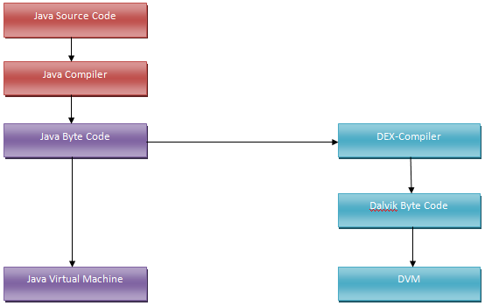

**Question:**  How would you preserve Activity state during a screen rotation?

**Answer:**  When your orientation changes, you don't have to manually change to the landscape layout file. Android does this automatically for you. When orientation changes, Android destroys your current activity and creates a new activity again, this is why you are losing the text.

Basically, whenever Android destroys and recreates your Activity for orientation change, it calls onSaveInstanceState() before destroying and calls onCreate() after recreating. Whatever you save in the bundle in onSaveInstanceState, you can get back from the onCreate() parameter.

private TextView mTextView;

private static final String KEY_TEXT_VALUE = "textValue";

@Override

protected void onCreate(Bundle savedInstanceState) {

super.onCreate(savedInstanceState);

mTextView = (TextView) findViewById(R.id.main);

if (savedInstanceState != null) {

CharSequence savedText = savedInstanceState.getCharSequence(KEY_TEXT_VALUE);

mTextView.setText(savedText);

}

}

@Override

protected void onSaveInstanceState (Bundle outState) {

super.onSaveInstanceState(outState);

outState.putCharSequence(KEY_TEXT_VALUE, mTextView.getText());

}

**Question:**  Describe Different Types of Services in Android

**Answer:**  A Service is an application component that can perform long-running operations in the background, and it doesn't provide a user interface. It can run in the background, even when the user is not interacting with your application. These are the three different types of services:

Foreground Service: A foreground service performs some operation that is noticeable to the user. For example, we can use a foreground service to play an audio track.

Background Service: A background service performs an operation that isn’t directly noticed by the user. In Android API level 26 and above, there are restrictions to using background services and it is recommended to use WorkManager in these cases.

Bound Service: A service is bound when an application component binds to it by calling bindService(). A bound service offers a client-server interface that allows components to interact with the service, send requests, receive results. A bound service runs only as long as another application component is bound to it.

**Question:**  What is the difference between Service & Intent Service?

**Answer:**  Service is the base class for Android services that can be extended to create any service. A class that directly extends Service runs on the main thread so it will block the UI (if there is one) and should therefore either be used only for short tasks or should make use of other threads for longer tasks.

IntentService is a subclass of Service that handles asynchronous requests (expressed as “Intents”) on demand. Clients send requests through startService(Intent) calls. The service is started as needed, handles each Intent in turn using a worker thread, and stops itself when it runs out of work.

**Question:**  What are retained fragments?

**Answer:**  By default, Fragments are destroyed and recreated along with their parent Activity’s when a configuration change occurs. Calling setRetainInstance(true) allows us to bypass this destroy-and-recreate cycle, signaling the system to retain the current instance of the fragment when the activity is recreated.

**Question:**  How would you support different screen sizes?

**Answer:**  Create a flexible layout — The best way to create a responsive layout for different screen sizes is to use ConstraintLayout as the base layout in your UI. ConstraintLayout allows you to specify the position and size for each view according to spatial relationships with other views in the layout. This way, all the views can move and stretch together as the screen size changes.

Create stretchable nine-patch bitmaps

Avoid hard-coded layout sizes — Use wrap\content or match\parent. Create alternative layouts — The app should provide alternative layouts to optimise the UI design for certain screen sizes. For eg: different UI for tablets

Use the smallest width qualifier — For example, you can create a layout named main\activity that’s optimised for handsets and tablets

The smallest width qualifier specifies the smallest of the screen’s two sides, regardless of the device’s current orientation, so it’s a simple way to specify the overall screen size available for your layout.

**Question:**  What are the permission protection levels in Android?

**Answer:**  Normal — A lower-risk permission that gives requesting applications access to isolated application-level features, with minimal risk to other applications, the system, or the user. The system automatically grants this type of permission to a requesting application at installation, without asking for the user’s explicit approval.

Dangerous — A higher-risk permission. Any dangerous permissions requested by an application may be displayed to the user and require confirmation before proceeding, or some other approach may be taken to avoid the user automatically allowing the use of such facilities.

Signature — A permission that the system grants only if the requesting application is signed with the same certificate as the application that declared the permission. If the certificates match, the system automatically grants the permission without notifying the user or asking for the user’s explicit approval.

SignatureOrSystem — A permission that the system grants only to applications that are in the Android system image or that are signed with the same certificate as the application that declared the permission.

**Question:**  What are some best practices to avoid memory leaks on Android?

**Answer:**  To avoid context-related memory leaks, remember the following:

Do not keep long-lived references to a context-activity (a reference to an activity should have the same life cycle as the activity itself)

Try using the context-application instead of a context-activity

Avoid non-static inner classes in an activity if you don't control their life cycle, use a static inner class and make a weak reference to the activity inside. The solution to this issue is to use a static inner class with a WeakReference to the outer class, as done in ViewRoot and its W inner class for instance

A garbage collector is not an insurance against memory leaks

**Question:**  What are some difference between Parcelable and Serializable?

**Answer:**  In Android we cannot just pass objects to activities. To do this the objects must either implement Serializable or Parcelable interface.

Serializable is a standard Java interface. You can just implement Serializable interface and add override methods. The problem with this approach is that reflection is used and it is a slow process.

Parcelable process is much faster than Serializable. One of the reasons for this is that we are being explicit about the serialization process instead of using reflection to infer it. It also stands to reason that the code has been heavily optimized for this purpose.

Also consider:

Parcelable is faster than Serializable interface

Parcelable interface takes more time to implement compared to Serializable interface

Serializable interface is easier to implement

Serializable interface creates a lot of temporary objects and causes quite a bit of garbage collection

Parcelable array can be passed via Intent

**Question:**  What are best practices for storing and protecting private API keys in applications?

**Answer:**  Assuming I have something similar to this, how can I protect the secret key:

public class DropboxService {

private final static String APP_KEY = "jk433g34hg3";

private final static String APP_SECRET = "987dwdqwdqw90";

private final static AccessType ACCESS_TYPE = AccessType.DROPBOX;

// SOME MORE CODE HERE

}

What is in your opinion the best and most secure way to store the private key? Obfuscation, encryption, what do you think?

Answer: If you want to protect your secret, not having it in your app in the first place is a pretty good way to go. Few ideas, in my opinion only first one gives some guarantee:

Create server-side API for all 3-rd party requests. When your client wants to make an API call, it asks the app auth service to authenticate it (using strong remote attestation techniques), and it receives a time limited (usually JWT) token signed by the secret.The token is sent with each API call where the endpoint can verify its signature before acting on the request.

Keep your secrets on some server on internet, and when needed just grab them and use. If user is about to use dropbox then nothing stops you from making request to your site and get your secret key.

Put your secrets in jni code, add some variable code to make your libraries bigger and more difficult to decompile. You might also split key string in few parts and keep them in various places.

Use obfuscator, also put in code hashed secret and later on unhash it when needed to use.

ut your secret key as last pixels of one of your image in assets. Then when needed read it in your code. Obfuscating your code should help hide code that will read it.

**Question:**  Provide some tips to reduce battery usage in an android application

**Answer:**  Tips for improving battery usage in an android application:

Reduce network calls as much as you can: Cache your data and retrieve it from the cache when required next time.

Avoid wake lock as much as possible: A wake lock is a mechanism to indicate that your application needs to have the device stay on.

Use AlarmManager carefully: Wrong use of AlarmManager can easily drain the battery.

Batch the network calls: You should batch the network calls if possible so that you can prevent the device from waking every second.

A Different logic for Mobile Data and Wifi: You should write different logic for mobile data and wifi as one logic may be optimized for mobile data and other may be optimized for wifi.

Check all background processes: You should check all the background processes.

Use GPS carefully: Do not use it frequently, use it only when actually required.

Use JobScheduler: This is an API for scheduling various types of jobs against the framework that will be executed in your application’s own process. The framework will be intelligent about when you receive your callbacks and attempt to batch and defer them as much as possible.

**Question:**  When to use SparseArray vs HashMap?

**Answer:**  SparseArray can be used to replace HashMap when the key is a primitive type. A Sparse array in Java is a data structure which maps keys to values. Same idea as a Map, but different implementation:

A Sparse Array is simply made of two arrays: an arrays of (primitives) keys and an array of (objects) values. There can be gaps in these arrays indices, hence the term “sparse” array.

class SparseIntArray {

int[] keys;

int[] values;

int size;

}

The main interest of the SparseArray is that it saves memory by using primitives instead of objects as the key.

Benefits are:

Allocation-free

No boxing

Drawbacks:

Generally slower, not indicated for large collections

They won't work in a non-Android project

HashMap can be replaced by the following:

SparseArray <Integer, Object>

SparseBooleanArray <Integer, Boolean>

SparseIntArray <Integer, Integer>

SparseLongArray <Integer, Long>

LongSparseArray <Long, Object>

LongSparseLongArray <Long, Long> //this is not a public class

//but can be copied from Android source code

**Question:**  What is the difference between ArrayMap vs HashMap?

**Answer:**  ArrayMap is a generic key->value mapping data structure that is designed to be more memory efficient than a traditional Java HashMap. It keeps its mappings in an array data structure — an integer array of hash codes for each item, and an Object array of the key/value pairs. This allows it to avoid having to create an extra object for every entry put into the map, and it also tries to control the growth of the size of these arrays more aggressively (since growing them only requires copying the entries in the array, not rebuilding a hash map).

That this implementation is not intended to be appropriate for data structures that may contain large numbers of items. It is generally slower than a traditional HashMap since lookups require a binary search and add and removes require inserting and deleting entries in the array. For containers holding up to hundreds of items, the performance difference is not significant, less than 50%.

**Question:**  Explain how ArrayMap works

**Answer:**  ArrayMap uses 2 arrays. The instance variables used internally are Object[ ] mArray to store the objects and the int[] mHashes to store hashCodes. When a key/value is inserted :

Key/Value is autoboxed.

The key object is inserted in the mArray where on the index in which it needs to pushed is searched using the binary search. (Thanks Or Gilad for correcting it).

A value object is also inserted in the position next to key’s position in mArray[ ].

The hashCode of the key is calculated and placed in mHashes[ ] at the next available position.

For searching a key :

Key’s hashCode is calculated

Binary search is done for this hashCode in the mHashes array. This implies time complexity increases to O(logN).

Once we get the index of hash, we know that key is at 2*index position in mArray and value is at 2*index+1 position.

Here the time complexity increases from O(1) to O(logN), but it is memory efficient. Whenever we play on a dataset of around 100,

there will no problem of time complexity, it will be non-noticeable. As we have the advantage of memory efficient application.

**Question:**  Why to consider FlatBuffers over JSON?

**Answer:**  FlatBuffers are an efficient cross platform serialization library. They were originally created at Google for game development, and other performance-critical applications.

Why use FlatBuffers?

Access to serialized data without parsing/unpacking — What sets FlatBuffers apart is that they represent hierarchical data in a flat binary buffer, in such a way that they can still be accessed directly without parsing and unpacking, while also still supporting data structure evolution (forwards/backwards compatibility).

Memory efficiency and speed — The only memory needed to access your data is that of the buffer. It requires zero additional allocations (at least in C++. Other languages may vary). FlatBuffers are also suitable for use with mmap (or streaming), requiring only part of the buffer to be in memory.

Tiny code footprint — FlatBuffers require only small amounts of generated code, and just a single small header as the minimum dependency, which is very easy to integrate.

Strongly typed — Errors happen at compile time rather than manually having to write repetitive and error prone run-time checks. Useful code can be generated for you.

I have tried to parse 4 mb of JSON file with both FlatBuffer and JSON. FlatBuffer tooks 1–5 ms and JSON took around 2000ms.And no GC was called in android app during FlatBuffer use. But GC was called so many time while using JSON. So, UI was freezing in case of JSON (only option left with JSON is to parse it in background thread).

**Question:**  What are some differences between ART and Dalvik?

**Answer:**  Approach: ART uses AOT(Ahead Of Time) approach and compiles the whole code during the installation time but the Dalvik uses JIT(Just In Time) approach and complies only a part of the code during installation and rest of the code will be compiled dynamically.

Booting time: As compare to Dalvik, ART takes more time to reboot because the cache is built at the first time. So, the booting is slow.

Space: Since ART uses the AOT approach, so it needs more space during installation. While Dalvik uses the JIT approach, so for mobile phones having less storage can use the Dalvik.

Battery: ART increases battery performance to a large extent because of the AOT approach. While the Dalvik uses the JIT approach and this results in more battery utilization.

Garbage Collection: ART has better garbage collection than Dalvik.

**Question:**  What is Broadcast Receiver?

**Answer:**  Android apps can send or receive broadcast messages from the Android system and other Android apps, similar to the publish-subscribe design pattern. Broadcast Receiver which is also known as receiver is a component of android application. With this component we can register receivers for any system-level or application-level event. Once that event occurs, android system will notify the registered receivers about the execution of events respectively.

There are two types of broadcasts received by receivers and they are:

Normal Broadcasts

Ordered Broadcasts

**Question:**  What is the difference between Android timer and a Handler to do action every N seconds?

**Answer:**  android.os.Handler is part of Android framework, the job will execute on the UI or main thread if you have created the Handler in the UI or main thread. Note that in Android you can only update views from the UI thread.

java.util.Timer on the other hand will execute on another thread so it cannot update the views.

So Handler is the recommended here. If you really want to use Timer you have to use runOnUiThread like:

new Timer().schedule(new TimerTask() {

@Override

public void run() {

runOnUiThread(new Runnable() {

@Override

public void run() {

//this will run on UI thread so you can update views here

}

});

}

}, 2000, 2000);

**Question:**  Can you manually call the Garbage collector?

**Answer:**  It is never a good practice to call the GC manually. Dalvik or ART simply knows better than us. If you are facing memory issues, try to find memory leaks in your app using MAT.

Also invoking System.gc() is not a guarantee of garbage collection actually being performed. It's more of a hint than anything else.

**Question:**  When is it necessary, or better to use a SurfaceView instead of a View?

**Answer:**  Views are all drawn on the same GUI thread which is also used for all user interaction. The main difference is that SurfaceView can be drawn on by background theads but Views can't. SurfaceViews contain a nice rendering mechanism that allows threads to update the surface's content without using a handler (good for animation).

There are more you might care.

surfaceView has dedicate surface buffer while all the view shares one surface buffer that is allocated by ViewRoot. In another word, surfaceView cost more resources.

surfaceView cannot be hardware accelerated (as of JB4.2) while 95% operations on normal View are HW accelerated using openGL ES.

More work should be done to create your customized surfaceView. You need to listener to the surfaceCreated/Destroy Event, create an render thread, more importantly, synchronized the render thread and main thread. However, to customize the View, all you need to do is override onDraw method.

The timing to update is different. Normal view update mechanism is constraint or controlled by the framework:You call view.invalidate in the UI thread or view.postInvalid in other thread to indicate to the framework that the view should be updated. However, the view won't be updated immediately but wait until next VSYNC event arrived. The easy approach to understand VSYNC is to consider it is as a timer that fire up every 16ms for a 60fps screen. In Android, all the normal view update (and display actually but I won't talk it today), is synchronized with VSYNC to achieve better smoothness. Now,back to the surfaceView, you can render it anytime as you wish. However, I can hardly tell if it is an advantage, since the display is also synchronized with VSYNC, as stated previously.

**Question:**  What is the StrictMode?

**Answer:**  StrictMode is a special class for verifying that your Android application is not doing things like disk I/O, Network access from the UI thread. This is a debugging feature introduced in Android 2.3. This developer tool detect things done accidentally and bring them to your attention so that you can fix them so as to avoid ANR dialogs(Activity Not Responding dialogs).

StrictMode is used to setup thread and virtual machine policies for your application and report violations of such policies. You will get an alert if a policy is violated. You can instruct Android to crash your application with the alert or you can just log the alert and let your application carry on.

**Question:**  What is the Android NDK? How can one use it? Why should one use it?

**Answer:**  The NDK (Native Development Kit) is a tool that allows you to program in C/C++ for Android devices. It's intended to integrate with the SDK (it's described as a "companion tool") and used only for performance-critical portions of a project. Many multimedia applications and video games use native code for processor-intensive tasks.

The performance improvements can come from three sources:

Firstly, the native code is compiled to a binary code and run directly on OS, while Java code is translated into Java byte-code and interpreted by Dalvik Virtual Machine (VM). At Android 2.2 or higher, a Just-In-Time (JIT) compiler is added to Dalvik VM to analyze and optimize the Java byte-code while the program is running (for example, JIT can compile a part of the byte-code to binary code before its execution). But in many cases, native code still runs faster than Java code.

The second source for performance improvements at NDK is that native code allows developers to make use of some processor features that are not accessible at Android SDK, such as NEON, a Single Instruction Multiple Data (SIMD) technology, allowing multiple data elements to be processed in parallel.

The third aspect is that we can optimize the critical code at an assembly level, which is a common practice in desktop software development.

**Question:**  What is Doze? What about App Standby?

**Answer:**  Starting from Android 6.0 (API level 23), Android introduces two power-saving features that extend battery life for users by managing how apps behave when a device is not connected to a power source.

Doze reduces battery consumption by deferring background CPU and network activity for apps when the device is unused for long periods of time. In Doze mode, the system attempts to conserve battery by restricting apps' access to network and CPU-intensive services. It also prevents apps from accessing the network and defers their jobs, syncs, and standard alarms.

Periodically, the system exits Doze for a brief time to let apps complete their deferred activities. During this maintenance window, the system runs all pending syncs, jobs, and alarms, and lets apps access the network.

App Standby defers background network activity for apps with which the user has not recently interacted. App Standby allows the system to determine that an app is idle when the user is not actively using it. The system makes this determination when the user does not touch the app for a certain period of time. When the user plugs the device into a power supply, the system releases apps from the standby state, allowing them to freely access the network and to execute any pending jobs and syncs. If the device is idle for long periods of time, the system allows idle apps network access around once a day.

**Question:**  What are Android Architecture Components?

**Answer:**  Android architecture components are a collection of libraries that help you design robust, testable, and maintainable apps. Android Architecture Components are a part of Android Jetpack.

All the Android Architecture Components are as follows:

Data Binding: It helps in declaratively binding UI elements to in our layout to data sources of our app.

Lifecycles: It manages activity and fragment lifecycles of our app, survives configuration changes, avoids memory leaks and easily loads data into our UI.

LiveData: It notifies views of any database changes. Use LiveData to build data objects that notify views when the underlying database changes.

Navigation: It handles everything needed for in-app navigation in Android application.

Paging: It helps in gradually loading information on demand from our data source.

Room: It is a SQLite object mapping library. Use it to Avoid boilerplate code and easily convert SQLite table data to Java objects. Room provides compile time checks of SQLite statements and can return RxJava, Flowable and LiveData observables.

ViewModel: It manages UI-related data in a lifecycle-conscious way. It stores UI-related data that isn't destroyed on app rotations.

WorkManager: It manages every background jobs in Android with the circumstances we choose.

**Question:**  What is the difference between ANR and crash in Android?

**Answer:**  ANR stands for Application Not Responding.

An ANR will occur if you are running a process on the UI thread which takes a long time, usually around 5 seconds. During this time the GUI (Graphical User Interface) will lock up which will result in anything the user presses will not be actioned. After the 5 seconds approx has occurred, if the thread still hasn't recovered then an ANR dialogue box is shown informing the user that the application is not responding and will give the user the choice to either wait, in the hope that the app will eventually recover, or to force close the app.

A crash is when an exception within the app has been thrown which has not been handled. For example, if you try to set the text of an EditText component, but the EditText is null and there is no try catch statement to catch the exception that your app will crash and will be force closed. The user will not see what caused the crash, they will be shown a dialogue telling that the app has force closed unexpectedly and will give them the option to send a bug report. In this example if you were to look in the bug report you would see the error caused by java.lang.NullPointerException.

**Question:**  How do you handle Bitmaps in Android as it takes too much memory?

**Answer:**  There are a number of reasons why loading bitmaps in your Android app is tricky:

Bitmaps can very easily exhaust an app's memory budget.

Loading bitmaps on the UI thread can degrade your app's performance, causing slow responsiveness or even ANR messages.

If your app is loading multiple bitmaps into memory, you need to skillfully manage memory and disk caching.

For most cases, we recommend that you use the Glide library to fetch, decode, and display bitmaps in your app. Glide abstracts out most of the complexity in handling these and other tasks related to working with bitmaps and other images on Android.

**Question:**  Is a Dalvik virtual machine instance created for each application?

**Answer:**  Every Android application runs in its own process, with its own instance of the Dalvik virtual machine. Dalvik has been written so that a device can run multiple VMs efficiently.

The Dalvik VM executes files in the Dalvik Executable (.dex) format which is optimised for minimal memory footprint.

The VM is register-based, and runs classes compiled by a Java language compiler that have been transformed into the .dex format by the included dx tool.

**Question:**  Explain when would you call getApplicationContext() and why?

**Answer:**  You only use getApplicationContext() when you know you need a Context for something that may live longer than any other likely Context you have at your disposal. Scenarios include:

Use getApplicationContext() if you need something tied to a Context that itself will have global scope. I use getApplicationContext(), for example, in WakefulIntentService, for the static WakeLock to be used for the service. Since that WakeLock is static, and I need a Context to get at PowerManager to create it, it is safest to use getApplicationContext().

Use getApplicationContext() when you bind to a Service from an Activity, if you wish to pass the ServiceConnection (i.e., the handle to the binding) between Activity instances via onRetainNonConfigurationInstance(). Android internally tracks bindings via these ServiceConnections and holds references to the Contexts that create the bindings. If you bind from the Activity, then the new Activity instance will have a reference to the ServiceConnection which has an implicit reference to the old Activity, and the old Activity cannot be garbage collected.

Some developers use custom subclasses of Application for their own global data, which they retrieve via getApplicationContext(). That's certainly possible.

**Question:**  Explain reasons why not to use getApplicationContext()?

**Answer:**  Here are reasons why not to use getApplicationContext() wherever you go:

It's not a complete Context, supporting everything that Activity does. Various things you will try to do with this Context will fail, mostly related to the GUI.

It can create memory leaks, if the Context from getApplicationContext() holds onto something created by your calls on it that you don't clean up. With an Activity, if it holds onto something, once the Activity gets garbage collected, everything else flushes out too. The Application object remains for the lifetime of your process.

See this table as a guidance for when to use the different types of Context:

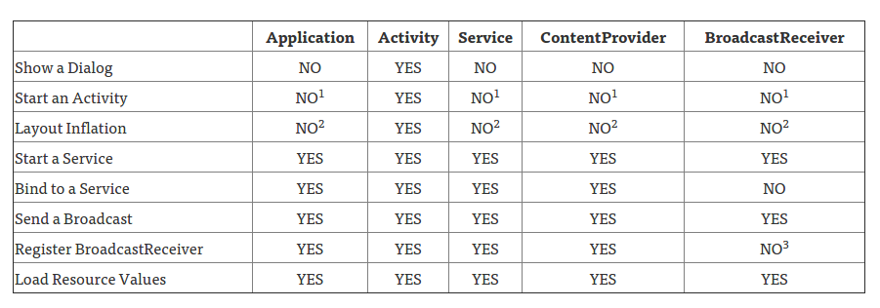

**Question:**  What is the relationship between Looper, Handler and MessageQueue in Android?

**Answer:**  A Looper is a message handling loop: it reads and processes items from a MessageQueue. The Looper class is usually used in conjunction with a HandlerThread (a subclass of Thread).

A Handler is a utility class that facilitates interacting with a Looper—mainly by posting messages and Runnable objects to the thread's MessageQueue. When a Handler is created, it is bound to a specific Looper (and associated thread and message queue).

In typical usage, you create and start a HandlerThread, then create a Handler object (or objects) by which other threads can interact with the HandlerThread instance. The Handler must be created while running on the HandlerThread, although once created there is no restriction on what threads can use the Handler's scheduling methods (post(Runnable), etc.)

The main thread (a.k.a. UI thread) in an Android application is set up as a handler thread before your application instance is created.

The relationships between Looper, Handler and MessageQueue is shown below:

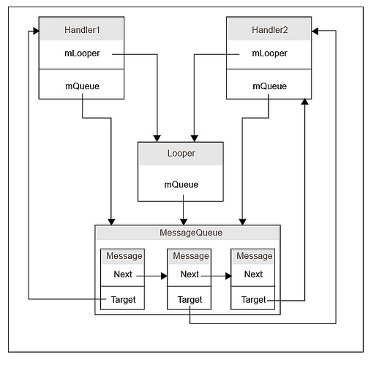

**Question:**  What is the onTrimMemory method?

**Answer:**  Android can reclaim memory from your app in several ways or kill your app entirely if necessary to free up memory for critical tasks. To further help balance the system memory and avoid the system's need to kill your app process, you can implement the ComponentCallbacks2 interface in your Activity classes.

onTrimMemory() callback method allows your app to listen for memory related events when your app is in either the foreground or the background, and then release objects in response to app lifecycle or system events that indicate the system needs to reclaim memory.

Sometimes to improve performance you have to increase memory usage, such as caching some data used by your activities. That's the type of resource you should release when onTrimMemory is called, so your app uses less memory, even if it affects performance.

**Question:**  What happens if the user navigates away or closes the app while I still have a reference to the Activity the user just closed in my AsyncTask?

**Answer:**  Short answer - Memory Leaks. As long as some part of the app like an AsyncTask still holds a reference to the Activity it will not be destroyed. It will stick around until the AsyncTask is done or releases its reference in some other way. This can have very bad consequences like your app crashing, but the worst consequences are the ones you don't notice: your app may keep reference to Activities which should have been released ages ago and each time the user does whatever leaks the Activity the memory on the device might get more and more full until seemingly out of nowhere Android kills your app for consuming too much memory.

**Question:**  What is Intent vs Sticky Intent vs Pending Intent?

**Answer:**  Intent - is a message passing mechanism between components of Android, except for Content Provider. You can use Intent to start any component.

Sticky Intent - Sticks with Android, for future broadcast listeners. For example if BATTERY_LOW event occurs then that Intent will stick with Android so that any future requests for BATTERY_LOW, will return the Intent. the Intent you are sending stays around after the broadcast is complete, so that others can quickly retrieve that data through the return value of registerReceiver(BroadcastReceiver, IntentFilter).

One example of a sticky broadcast sent via the operating system is ACTION_BATTERY_CHANGED. When you call registerReceiver() for that action — even with a null BroadcastReceiver — you get the Intent that was last Broadcast for that action.

Pending Intent - If you want some one to perform any Intent operation at future point of time on behalf of you, then we will use Pending Intent.

**Question:**  What is a Sticky Broadcast?

**Answer:**  A normal broadcast Intent is not available anymore after is was send and processed by the system. If you use the sendStickyBroadcast(Intent) method, the Intent is sticky, meaning the Intent you are sending stays around after the broadcast is complete.

The value of a sticky broadcast is the value that was last broadcast and is currently held in the sticky cache. This is not the value of a broadcast that was received right now. I suppose you can say it is like a browser cookie that you can access at any time.

**Question:**  What is the difference between Local, Normal, Ordered and Sticky broadcasts?

**Answer:**  **Normal Broadcast**

use sendBroadcast()

asynchronous broadcast

any receiver receives broadcast not any particular order

**Ordered Broadcast**

use sendOrderedBroadcast()

synchronous broadcast

receiver receives broadcast in priority base

we can also simply abort broadcast in this type

**Local Broadcast**

use only when broadcast is used only inside same process

**Sticky Broadcast**

normal broadcast intent is not available any more after this was send and processed by the system.

use sendStickyBroadcast(Intent)

the corresponding intent is sticky, meaning the intent you are sending stays around after the broadcast is complete.

because of this others can quickly retrieve that data through the return value of registerReceiver(BroadcastReceiver, IntentFilter)

apart from this same as sendBroadcast(Intent)

**Question:**  How can I use AsyncTask in different Activities?

**Answer:**  One of the methods using AsynTask in different Activities, creating a callback interface.

Create a callback interface

interface AsyncTaskListener<T> {

public void onComplete(T result);

}

Then in your MainActivity and TestActivity:

public class MainActivity extends AppCompatActivity

implements AsyncTaskListener<String> {

public void onComplete(String result) {

// your staff here

}

}

public class TestActivity extends AppCompatActivity

implements AsyncTaskListener<String> {

public void onComplete(String result) {

// your staff here

}

}

And add to your AsyncTask class:

public class JSONTask extends AsyncTask < String, String, String >

private AsyncTaskListener < String > listener;

public JSONTask(AsyncTaskListener < String > callback) {

this.listener = callback;

}

protected void onPostExecute(String result) {

listener.onComplete(result); // calling onComplate interface

}

**Question:**  What is AIDL?

**Answer:**  The Android Interface Definition Language (AIDL) allows you to define the programming interface that both the client and service agree upon in order to communicate with each other using interprocess communication (IPC). On Android, one process cannot normally access the memory of another process. So to talk, they need to decompose their objects into primitives that the operating system can understand, and marshall the objects across that boundary for you. The code to do that marshalling is tedious to write, so Android handles it for you with AIDL.

**Question:**  When would you use AIDL?

**Answer:**  AIDL does nothing but lets the system to generate the boilerplate code that hides the binder IPC details, so that you can invoke the remote service API as a local method call. Using AIDL is necessary only if you allow clients from different applications to access your service for IPC and want to handle multithreading in your service. So,

If you don't need IPC (i.e., your client and server stay in the same process), you don't need AIDL;

If you want to write the boilerplate code yourself for IPC, you don't need AIDL;

If your service is not complicated enough (i.e., does not require concurrent multithreaded accesses), you can use system provided Messenger API for IPC. You don't need your own AIDL, because the Messenger API hides the AIDL usage;

To extend the case 3, if you can use any existing lib or existing API to access a service in another process, you don't need your own AIDL. For example, you can access ActivityManagerService with existing system API, and all the AIDL stuff for IActivityManager is hidden by the system API.

**Question:**  When to use AIDL vs Messenger Queue?

**Answer:**  AIDL is for the purpose when you’ve to go application level communication for data and control sharing, a scenario depicting it can be: An app requires list of all contacts from Contacts app (content part lies here) plus it also wants to show the call’s duration and you can also disconnect it from that app (control part lies here).

In Messenger Queues you’re more IN the application and working on threads and processes to manage the queue having messages so no Outside services interference here.

Messenger is needed if you want to bind a remote service (e.g. running in another process).

**Question:**  What is a ThreadPool? And is it more effective than using several separate Threads?

**Answer:**  Creating and destroying threads has a high CPU usage, so when we need to perform lots of small, simple tasks concurrently, the overhead of creating our own threads can take up a significant portion of the CPU cycles and severely affect the final response time. ThreadPool consists of a task queue and a group of worker threads, which allows it to run multiple parallel instances of a task.

Using ThreadPool is more efficient than having multiple operations waiting to run on a single thread, but it also helps you avoid the considerable overhead of creating and destroying a thread every time you require a worker thread.

**Question:**  Is there a size limit for a Bundle?

**Answer:**  It depends on the purpose of the bundle. The bundle itself is only limited by the amount of memory.

The two main uses for bundles are to pass information between components using intents and to save the state of activities.

Intents / Binders When used to pass information between Android components the bundle is serialized into a binder transaction. The total size for all binder transactions in a process is 1MB. If you exceed this limit you will receive this fatal error "!!! FAILED BINDER TRANSACTION !!!"

It's recommend that you keep the data in these bundles as small as possible because it's a shared buffer, anything more than a few kilobytes should be written to disk.

Reference: https://android.googlesource.com/platform/frameworks/base/+/jb-release/core/jni/android_util_Binder.cpp

ALOGE("!!! FAILED BINDER TRANSACTION !!!"); // TransactionTooLargeException is a checked exception, only throw from certain methods. // FIXME: Transaction too large is the most common reason for FAILED_TRANSACTION // but it is not the only one. The Binder driver can return BR_FAILED_REPLY // for other reasons also, such as if the transaction is malformed or // refers to an FD that has been closed. We should change the driver // to enable us to distinguish these cases in the future. Reference: http://developer.android.com/reference/android/os/TransactionTooLargeException.html

The Binder transaction buffer has a limited fixed size, currently 1Mb, which is shared by all transactions in progress for the process. Consequently this exception can be thrown when there are many transactions in progress even when most of the individual transactions are of moderate size.

Saved Instance State ( Activity onSaveInstanceState, onPause etc. ) I found no limit in the size I could store in the bundle used to preserve Activity state. I did some tests and could successfully store about 175mb before I received an out of memory exception trying to allocate the data I was attempting to save.

Update: This research was performed in 2014, newer versions of Android may crash with bundles over 500kb

**Question:**  Which class is useful in managing a long-running data load in a way that works correctly with the lifecycle of an Activity or Fragment?

**Answer:**  android.app.LoaderManager

**Question:**  When creating a content provider, where is the provider authority specified?

**Answer:**  The provider element of the app manifest.

**Question:**  Which method accesses the context tied to the lifecycle of the entire application?

**Answer:**  Activity.getApplicationContext()

**Question:**  How many emulators can be running at the same time on a single host computer?

**Answer:**  No predefined limit

**Question:**  What is the result of placing a TextView within a RelativeLayout without providing any layout-related attributes on the TextView?

**Answer:**  The TextView will be positioned at the top-left of the RelativeLayout.

**Question:**  What is the result of placing a TextView within a RelativeLayout without providing any layout-related attributes on the TextView?

**Answer:**  The TextView will be positioned at the top-left of the RelativeLayout.

**Question:**  When an emulator image is configured to have a secure digital (SD) card, what normally happens to the content of the SD card when the emulator is shut down?

**Answer:**  Content is saved to the host computer's disk

**Question:**  Which attribute value(s) need(s) to be added to the WebView element in a layout resource to disable the WebViews scrollbars?

**Answer:**  android:scrollbars="none"

**Question:**  Which attribute is required for all component types defined in the application manifest?

**Answer:**  name

**Question:**  Which Activity lifecycle event method is called immediately when the Activity comes to the foreground?

**Answer:**  onResume

**Question:**  When using the Android Material theme, which of the following color palette values affects the color of the action bar?

**Answer:**  colorPrimary

**Question:**  Which folder is the best choice for storing the application icon?

**Answer:**  res/mipmap

**Question:**  If you have an existing application in the Play Store with a package name of com.pluralsight.example01, what will happen if you upload an Android application package (apk) with the package name com.pluralsight.example02?

**Answer:**  The new package will be considered a different application

**Question:**  In an Android app, which class allows an Android component to request that an action be performed by another component?

**Answer:**  Intent

**Question:**  What is the appropriate way to request permissions for your application?

**Answer:**  in the android manifest.

**Question:**  Which permission is automatically granted by the system to your app if it is added in the app manifest?

**Answer:**  VIBRATE

**Question:**  When specifiying the android:id attribute value for a widget within a layout file, sometimes the android:id attribute value begins with "@id/" and other times it begins with "@+id/". What's the difference?

**Answer:**  Using "@+id/" will create the identifier if it does not already exist

**Question:**  When a new version of your application is uploaded to the Google Play Store, how long does it normally take for the new version to become available for updates and downloads?

**Answer:**  A few hours.

**Question:**  In the case of a custom view that supports attributes, what must the custom view provide to allow the custom attributes to be used within a layout resource?

**Answer:**  A declare-styleable resource

**Question:**  Which action should be supported to allow a user to scroll a list through multiple screens of content with a single finger motion?

**Answer:**  Fling

**Question:**  Build Type, Product Flavor, Build Variant

## Answer: Build Type

**Build Types** controls how to build and package your app, for example whether or not ProGuard is run, how the resulting application package is signed and whether debug symbols are to be included. By default, the build system defines two build types: debug and release.

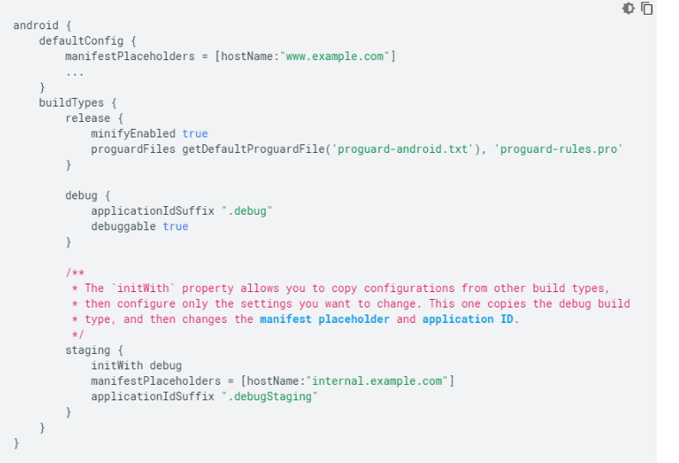

## Product Flavor

**Product Flavor** configuration defines a customized version of the application build. It can be used to specify custom features, minimum and target API levels, device and API requirements like layout, drawable and custom code. This can help create different label apps as well. Flavours can vary in adding different features or customizing exisitng features, different icons and resources, different styles and strings etc.

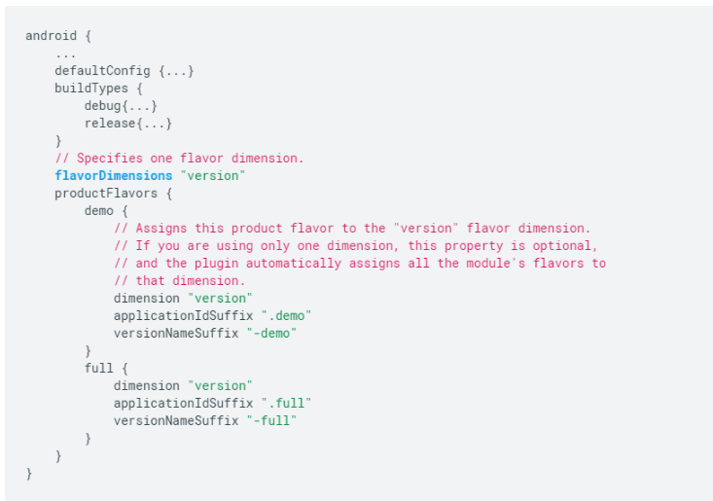

## Build Variant

The combination of **Build Type** and **Product Flavor** is known as **Build Variant**. For example, for above build types (debug and release) and product flavours (demo and full versions), build variants can be: demoDebug, demoRelease, fullDebug, fullRelease.

**Question:**  Room vs SQLite

**Answer:**  SQLite is an in-process library that implements a self-contained, serverless, zero-configuration, transactional SQL database engine.

SQLite is an embedded SQL database engine. Unlike most other SQL databases, SQLite does not have a separate server process. SQLite reads and writes directly to ordinary disk files. A complete SQL database with multiple tables, indices, triggers, and views, is contained in a single disk file. The database file format is cross-platform - you can freely copy a database between 32-bit and 64-bit systems or between big-endian and little-endian architectures

The Room persistence library provides an abstraction layer over SQLite to allow for more robust database access while harnessing the full power of SQLite.

The library helps you create a cache of your app's data on a device that's running your app. This cache, which serves as your app's single source of truth, allows users to view a consistent copy of key information within your app, regardless of whether users have an internet connection.

Room is an ORM, Object Relational Mapping library. In other words, Room will map our database objects to Java objects. Room provides an abstraction layer over SQLite to allow fluent database access while harnessing the full power of SQLite.

Difference between SQLite and Room persistence library:

In the case of SQLite, There is no compile-time verification of raw SQLite queries. But in Room, there is SQL validation at compile time.

You need to use lots of boilerplate code to convert between SQL queries and Java data objects. But, Room maps our database objects to Java Object without boilerplate code.

As your schema changes, you need to update the affected SQL queries manually. Room solves this problem.

Room is built to work with LiveData and RxJava for data observation, while SQLite does not.

**Question:**  Raw folder vs Assets folder

**Answer:**  The files in both directories will be stored intact in the APK package after being packaged and will not be compiled into binary systems.

The differences between res/raw and assets:

Since raw is a subfolder of Resources (res), Android will automatically generate an ID for any file located inside it. This ID is then stored an the R class that will act as a reference to a file, meaning it can be easily accessed from other Android classes and methods and even in Android XML files. Using the automatically generated ID is the fastest way to have access to a file in Android.

The Assets folder is an “appendix” directory. The R class does not generate IDs for the files placed there, so its less compatible with some Android classes and methods. Also, it’s much slower to access a file inside it, since you will need to get a handle to it based on a String. However some operations are more easily done by placing files in this folder, like copying a database file to the system’s memory. There’s no (easy) way to create an Android XML reference to files inside the Assets folder.

**Question:**  @id vs @+id

**Answer:**  The at-symbol (@) at the beginning of the string indicates that the XML parser should parse and expand the rest of the ID string and identify it as an ID resource. The plus-symbol (+) means that this is a new resource name that must be created and added to our resources (in the R.java file). In other words, the + symbol tells Android build tools that you are declaring a new resource, @id/ you are referring to an existing resource (predefined by @+id/ and already exists in R.java.

**Question:**  How does RecyclerView differ from ListView

**Answer:**  With the advent of Android Lollipop, the RecyclerView made its way officially. The RecyclerView is much more powerful, flexible and a major enhancement over ListView.

ViewHolder Pattern In a ListView, it was recommended to use the ViewHolder pattern but it was never a compulsion. In case of RecyclerView, this is mandatory using the RecyclerView.ViewHolder class.

LayoutManager This is another massive enhancement brought to the RecyclerView. In a ListView, the only type of view available is the vertical ListView. There is no official way to even implement a horizontal ListView. Now using a RecyclerView, we can have a

LinearLayoutManager - which supports both vertical and horizontal lists,

StaggeredLayoutManager - which supports Pinterest like staggered lists,

GridLayoutManager - which supports displaying grids as seen in Gallery apps.

Item Animator ListViews are lacking in support of good animations, but the RecyclerView brings a whole new dimension to it. Using the RecyclerView.ItemAnimator class, animating the views becomes so much easy and intuitive.

Item Decoration In case of ListViews, dynamically decorating items like adding borders or dividers was never easy. But in case of RecyclerView, the RecyclerView.ItemDecorator class gives huge control to the developers but makes things a bit more time consuming and complex.

**Question:**  How to support different screen sizes in Android?

**Answer:**  Android devices come in all shapes and sizes, so your app's layout needs to be flexible. That is, instead of defining your layout with rigid dimensions that assume a certain screen size and aspect ratio(width to the height of a screen), your layout should gracefully respond to different screen sizes and orientations.

By supporting as many screens as possible, your app can be made available to the greatest number of users with different devices, using a single APK. Additionally, making your app flexible for different screen sizes ensures that your app can handle window configuration changes on the device, such as when the user enables multi-window mode.

You can provide support to different screen sizes by the following techniques:-

(The following won't necessarily support Android form factors as Android Wear, TV, Auto, and Chrome OS devices)

Use view dimensions that allow the layout to resize

Use ConstraintLayout

The best way to create a responsive layout for different screen sizes is to use ConstraintLayout as the base layout in your UI. ConstraintLayout allows you to specify the position and size for each view according to spatial relationships with other views in the layout. This way, all the views can move and stretch together as the screen size changes.

The easiest way to build a layout with ConstraintLayout is to use the Layout Editor in Android Studio. It allows you to drag new views to the layout, attach their constraints to the parent view and other sibling views, and edit the view's properties, all without editing any XML by hand.

Constraint Layout (no matter what layout you use, you should always avoid hard-coding layout sizes)

note:-

To ensure that your layout is flexible and adapts to different screen sizes, you should use "wrap_content" and "match_parent" for the width and height of most view components, instead of hard-coded sizes. "wrap_content" tells the view to set its size to whatever is necessary to fit the content within that view. "match_parent" makes the view expand to as much as possible within the parent view

Create alternative layouts

If the above option doesn't meet your needs,say you need to support a much larger device like tabs,then your app should also provide alternative layout resources to optimize the UI design for certain screen sizes.(As indicated in the image below)

You can provide screen-specific layouts by creating additional res/layout/ directories—one for each screen configuration that requires a different layout—and then append a screen configuration qualifier to the layout directory name (such as layout-w600dp for screens that have 600dp of available width). These configuration qualifiers represent the visible screen space available for your app UI. The system takes into account any system decorations (such as the navigation bar) and window configuration changes (such as when the user enables multi-window mode) when selecting the layout from your app.

To create an alternative layout in Android Studio (using version 3.0 or higher), proceed as follows:

Open your default layout and then click Orientation for Preview in the toolbar.

In the drop-down list, click to create a suggested variant such as Create Landscape Variant or click Create Other.

If you selected Create Other, the Select Resource Directory appears. Here, select a screen qualifier on the left and add it to the list of Chosen qualifiers. When you're done adding qualifiers, click OK.

This creates a duplicate layout file in the appropriate layout directory so you can begin customizing the layout for that screen variant.

Use the smallest width qualifier

The "smallest width" screen size qualifier allows you to provide alternative layouts for screens that have a minimum width measured in density-independent pixels(dp or dip). for example

res/layout/main_activity.xml # For handsets (smaller than 600dp available width)

res/layout-sw600dp/main_activity.xml # For 7” tablets (600dp wide and bigger)

Use the available width qualifier

Instead of changing the layout based on the smallest width of the screen, you might want to change your layout based on how much width or height is currently available. For example, if you have a two-pane layout, you might want to use that whenever the screen provides at least 600dp of width, which might change depending on whether the device is in landscape or portrait orientation for example res/layout/main_activity.xml # For handsets (smaller than 600dp available width)

res/layout-w600dp/main_activity.xml # For 7” tablets or any screen with 600dp available width (possibly landscape handsets)

(If the available height is a concern for you, then you can do the same using the "available height" qualifier. For example, layout-h600dp for screens with at least 600dp of screen height.)

Modularize UI components with fragments

When designing your app for multiple screen sizes you want to make sure you aren't needlessly duplicating your UI behavior across your activities. So you should use fragments to extract your UI logic into separate components. Then, you can then combine fragments to create multi-pane layouts when running on a large screen or place in separate activities when running on a handset.

For example, a news app on a tablet might show a list of articles on the left side and a full article on the right side—selecting an article on the left updates the article view on the right. On a handset, however, these two components should appear on separate screens—selecting an article from a list changes the entire screen to show that article.

Create stretchable nine-patch bitmaps

If you use a bitmap as the background in a view that changes size, you will notice Android scales your images as the view grows or shrinks based on the size of the screen or content in the view. This often leads to blurring of the images.Therefore we solve this problem using nine-patch bitmaps(specially formatted PNG files that indicate which areas can and cannot be stretched with a .9.png extension)

A nine-patch bitmap is basically a standard PNG file, but with an extra 1px border that indicates which pixels should be stretched.As shown in figure below,the intersection between the black lines on the left and top edge is the area of the bitmap that can be stretched.

When you apply a nine-patch as the background to a view, the framework stretches the image correctly to accommodate it.For more information refer this.

Further on an ending note one should test his/her app on a variety of devices with different screen sizes.

**Question:**  Launch modes

**Answer:**  There are four different launch modes:

standard

singleTop

singleTask

singleInstance

Standard

Default. The system creates a new instance of the activity in the task from which it was started and routes the intent to it. The activity can be instantiated multiple times, each instance can belong to different tasks, and one task can have multiple instances.

SingleTop

It acts almost the same as standard one which means that singleTop Activity instance could be created as many as we want. Only difference is if there already is an Activity instance with the same type at the top of stack in the caller Task, there would not be any new Activity created, instead an Intent will be sent to an existed Activity instance through onNewIntent() method.

In singleTop mode, you have to handle an incoming Intent in both onCreate() and onNewIntent() to make it works for all the cases.

SingleTask

The system creates a new task and instantiates the activity at the root of the new task. However, if an instance of the activity already exists in a separate task, the system routes the intent to the existing instance through a call to its onNewIntent() method, rather than creating a new instance. Only one instance of the activity can exist at a time (a.k.a. Singleton).

SingleInstance

Same as singleTask, except that the system doesn't launch any other activities into the task holding the instance. The activity is always the single and only member of its task; any activities started by this one open in a separate task.

**Question:**  Main components of android application

**Answer:**  Application components are the essential building blocks of an Android application. These components are loosely coupled by the application manifest file AndroidManifest.xml that describes each component of the application and how they interact.

Main components of android application are:

Activities

Services

Broadcast Receivers

Content Providers

A Activity represents a single screen with a user interface, in-short Activity performs actions on the screen. An activity provides the window in which the app draws its UI. This window typically fills the screen, but may be smaller than the screen and float on top of other windows. Generally, one activity implements one screen in an app. For instance, one of an app’s activities may implement a Preferences screen, while another activity implements a Select Photo screen. In new architectural approaches, there is only one activity for the entire application, and it controls the fragments that interact with the user.

A Service is an application component that can perform long-running operations in the background, and it doesn't provide a user interface. Another application component can start a service, and it continues to run in the background even if the user switches to another application. Additionally, a component can bind to a service to interact with it and even perform interprocess communication (IPC). For example, a service can handle network transactions, play music, perform file I/O, or interact with a content provider, all from the background.

A Broadcast Receivers (receiver) is an Android component which allows you to register for system or application events. Android apps can send or receive broadcast messages from the Android system and other Android apps, similar to the publish-subscribe design pattern. These broadcasts are sent when an event of interest occurs. For example, the Android system sends broadcasts when various system events occur, such as when the system boots up or the device starts charging. Apps can also send custom broadcasts, for example, to notify other apps of something that they might be interested in (for example, some new data has been downloaded).

A Content Provider manages access to a central repository of data. You implement a provider as one or more classes in an Android application, along with elements in the manifest file. One of your classes implements a subclass ContentProvider, which is the interface between your provider and other applications. Although content providers are meant to make data available to other applications, you may of course have activities in your application that allow the user to query and modify the data managed by your provider.

**Question:**  Service vs IntentService

**Answer:**  A Service is an application component that can perform long-running operations in the background, and it doesn't provide a user interface. Another application component can start a service, and it continues to run in the background even if the user switches to another application. Additionally, a component can bind to a service to interact with it and even perform interprocess communication (IPC).

The Service class is the base class for all services. When you extend this class, it's important to create a new thread in which the service can complete all of its work; the service uses your application's main thread by default, which can slow the performance of any activity that your application is running.

The Android framework also provides the IntentService subclass of Service that uses a worker thread to handle all of the start requests, one at a time. IntentService is very similura to queue where it handles request (intents) from clients. Client can send the request to IntentService by using command - Context.startService(Intent). For implements IntentService you should extend IntentService class and implements method - onHandleIntent(Intent)

Using IntentService is not recommended for new apps as it will not work well starting with Android 8 Oreo, due to the introduction of Background execution limits. Moreover, it's deprecated starting with Android 11. You can use JobIntentService as a replacement for IntentService that is compatible with newer versions of Android.

| **Service** | **IntentService** |
| --- | --- |
| Is invoked using startService() | Is invoked using Intent |
| Can be invoked from any thread | Can in invoked from the Main thread only |
| Runs background operations on the Main Thread of the Application by default. Hence it can block your Application’s UI | Creates a separate worker thread to run background operations |
| Invoked multiple times would create multiple instances. | Invoked multiple times won’t create multiple instances |
| Needs to be stopped using stopSelf() or stopService() | Automatically stops after the queue is completed. No need to trigger stopService() or stopSelf() |
| Can run parallel operations | Multiple intent calls are automatically queued and they would be executed sequentially |

**Question:**  View lifecycle

**Answer:**  View class represents the basic building block for user interface components. A View occupies a rectangular area on the screen and is responsible for drawing and event handling. View is the base class for widgets, which are used to create interactive UI components (buttons, text fields, etc.). Every Activity has it’s own lifecycle similarly Views also have a lifecycle. A view which was rendered on the screen must undergo these lifecycle methods to get drawn on the screen correctly.

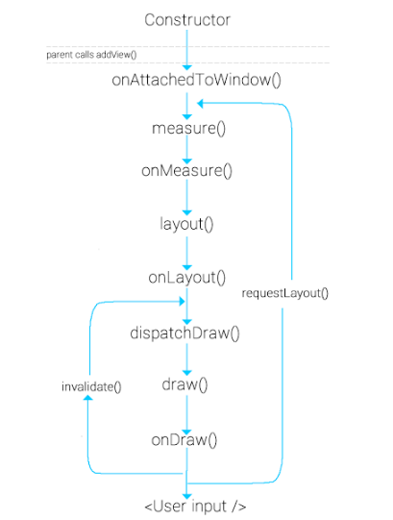

onAttachedToWindow() - Called when the view is attached to a window. This is the phase where the view knows it can be active and has a surface for drawing. So we can start allocating any resources or set up listeners.

onFinishInflate() - Called after a view and all of its children has been inflated from XML.

onMeasure(int, int) - Called to determine the size requirements for this view and all of its children.

onLayout(boolean, int, int, int, int) - Called when this view should assign a size and position to all of its children.

onSizeChanged(int, int, int, int) - Called when the size of this view has changed.

onDraw(android.graphics.Canvas) - Canvas object generated (or updates) has a list of OpenGL-ES commands (displayList) to send to the GPU. Never create objects in onDraw() as it gets called a number of times.

invalidate() - method that insists on force reDrawing of a particular view that we wish to show changes. Needs to be called when there was a change in view’s appearance.

requestLayout() - At some point, there is a state change in the view. requestLayout() is the signal to the view system that it needs to recalculate the Measure and Layout phase of the views (measure → layout → draw).

onDetachedFromWindow() - This is called when the view is detached from a window. At this point, it no longer has a surface for drawing. This place where you need to stop doing any kind of work that is scheduled or clean up resources that are allocated. This method is called when we call remove view on the ViewGroup or when the Activity is destroyed etc.

**Question:**  Sticky Intent

**Answer:**  Sticky Intent - Sticks with Android, for future broadcast listeners. For example if BATTERY_LOW event occurs then that intent will stick with Android so that any future requests for BATTERY_LOW, will return the intent. Sticky Intent is also a type of Intent which allows communication between a function and a service sendStickyBroadcast(), performs a sendBroadcast(Intent), the Intent you are sending stays around after the broadcast is complete, so that others can quickly retrieve that data through the return value of registerReceiver(BroadcastReceiver, IntentFilter). In all other ways, this behaves the same as sendBroadcast(Intent).

**Question:**  Protection levels in permission

**Answer:**  Normal - The default value. A lower-risk permission that gives requesting applications access to isolated application-level features, with minimal risk to other applications, the system, or the user. The system automatically grants this type of permission to a requesting application at installation, without asking for the user's explicit approval (though the user always has the option to review these permissions before installing).

Dangerous - A higher-risk permission that would give a requesting application access to private user data or control over the device that can negatively impact the user. Because this type of permission introduces potential risk, the system may not automatically grant it to the requesting application. For example, any dangerous permissions requested by an application may be displayed to the user and require confirmation before proceeding, or some other approach may be taken to avoid the user automatically allowing the use of such facilities.

Signature - A permission that the system grants only if the requesting application is signed with the same certificate as the application that declared the permission. If the certificates match, the system automatically grants the permission without notifying the user or asking for the user's explicit approval.

SignatureOrSystem - Old synonym for "signature|privileged". Deprecated in API level 23.

A permission that the system grants only to applications that are in a dedicated folder on the Android system image or that are signed with the same certificate as the application that declared the permission. Avoid using this option, as the signature protection level should be sufficient for most needs and works regardless of exactly where apps are installed. The "signatureOrSystem" permission is used for certain special situations where multiple vendors have applications built into a system image and need to share specific features explicitly because they are being built together.

**Question:**  Activity Result APIs

**Answer:**  While the underlying startActivityForResult() and onActivityResult() APIs are available on the Activity class on all API levels, it is strongly recommended to use the Activity Result APIs introduced in AndroidX Activity and Fragment.

## [Registering a callback for an Activity Result](https://developer.android.com/training/basics/intents/result#register)

When starting an activity for a result, it is possible (and, in cases of memory-intensive operations such as camera usage, almost certain) that your process and your activity will be destroyed due to low memory.

For this reason, the Activity Result APIs decouple the result callback from the place in your code where you launch the other activity. As the result callback needs to be available when your process and activity are recreated, the callback must be unconditionally registered every time your activity is created, even if the logic of launching the other activity only happens based on user input or other business logic.

When in a ComponentActivity or a Fragment, the Activity Result APIs provide a registerForActivityResult() API for registering the result callback. registerForActivityResult() takes an ActivityResultContract and an ActivityResultCallback and returns an ActivityResultLauncher which you’ll use to launch the other activity.

An ActivityResultContract defines the input type needed to produce a result along with the output type of the result. The APIs provide default contracts for basic intent actions like taking a picture, requesting permissions, and so on. You can also create your own custom contracts.

ActivityResultCallback is a single method interface with an onActivityResult() method that takes an object of the output type defined in the ActivityResultContract:

val getContent = registerForActivityResult(GetContent()) { uri: Uri? ->

// Handle the returned Uri

}

If you have multiple activity result calls that either use different contracts or want separate callbacks, you can call registerForActivityResult() multiple times to register multiple ActivityResultLauncher instances. You must always call registerForActivityResult() in the same order for each creation of your fragment or activity to ensure that the inflight results are delivered to the correct callback.

registerForActivityResult() is safe to call before your fragment or activity is created, allowing it to be used directly when declaring member variables for the returned ActivityResultLauncher instances.

## [Launching an activity for result](https://developer.android.com/training/basics/intents/result#launch)

While registerForActivityResult() registers your callback, it does **not** launch the other activity and kick off the request for a result. Instead, this is the responsibility of the returned ActivityResultLauncher instance.

If input exists, the launcher takes the input that matches the type of the ActivityResultContract. Calling launch() starts the process of producing the result. When the user is done with the subsequent activity and returns, the onActivityResult() from the ActivityResultCallback is then executed, as shown in the following example:

val getContent = registerForActivityResult(GetContent()) { uri: Uri? ->

// Handle the returned Uri

}

override fun onCreate(savedInstanceState: Bundle?) {

// ...

val selectButton = findViewById<Button>(R.id.select_button)

selectButton.setOnClickListener {

// Pass in the mime type you'd like to allow the user to select

// as the input

getContent.launch("image/*")

}

}

An overloaded version of launch() allows you to pass an ActivityOptionsCompat in addition to the input.

## [Receiving an activity result in a separate class](https://developer.android.com/training/basics/intents/result#separate)

While the ComponentActivity and Fragment classes implement the ActivityResultCaller interface to allow you to use the registerForActivityResult() APIs, you can also receive the activity result in a separate class that does not implement ActivityResultCaller by using ActivityResultRegistry directly.

For example, you might want to implement a LifecycleObserver that handles registering a contract along with launching the launcher:

class MyLifecycleObserver(private val registry : ActivityResultRegistry)

: DefaultLifecycleObserver {

lateinit var getContent : ActivityResultLauncher<String>

override fun onCreate(owner: LifecycleOwner) {

getContent = registry.register("key", owner, GetContent()) { uri ->

// Handle the returned Uri

}

}

fun selectImage() {

getContent.launch("image/*")

}

}

class MyFragment : Fragment() {

lateinit var observer : MyLifecycleObserver

override fun onCreate(savedInstanceState: Bundle?) {

// ...

observer = MyLifecycleObserver(requireActivity().activityResultRegistry)

lifecycle.addObserver(observer)

}

override fun onViewCreated(view: View, savedInstanceState: Bundle?) {

val selectButton = view.findViewById<Button>(R.id.select_button)

selectButton.setOnClickListener {

// Open the activity to select an image

observer.selectImage()

}

}

}

When using the ActivityResultRegistry APIs, it's strongly recommended to use the APIs that take a LifecycleOwner, as the LifecycleOwner automatically removes your registered launcher when the Lifecycle is destroyed. However, in cases where a LifecycleOwner is not available, each ActivityResultLauncher class allows you to manually call unregister() as an alternative.

**Question:**  App Startup

**Answer:**  The App Startup library provides a straightforward, performant way to initialize components at application startup. Both library developers and app developers can use App Startup to streamline startup sequences and explicitly set the order of initialization.

Instead of defining separate content providers for each component you need to initialize, App Startup allows you to define component initializers that share a single content provider. This can significantly improve app startup time.

## [Initialize components at app startup](https://developer.android.com/topic/libraries/app-startup#startup-initialize)

Apps and libraries often rely on having components initialized right away when the app starts up. You can meet this need by using content providers to initialize each dependency, but content providers are expensive to instantiate and can slow down the startup sequence unnecessarily. Additionally, Android initializes content providers in an undetermined order. App Startup provides a more performant way to initialize components at app startup and explicitly define their dependencies.

To use App Startup to initialize components automatically at startup, you must define a component initializer for each component that the app needs to initialize.

## [Implement component initializers](https://developer.android.com/topic/libraries/app-startup#implement-initializers)

You define each component initializer by creating a class that implements the Initializer<T> interface. This interface defines two important methods:

* The create() method, which contains all of the necessary operations to initialize the component and returns an instance of T.
* The dependencies() method, which returns a list of the other Initializer<T> objects that the initializer depends on. You can use this method to control the order in which the app runs the initializers at startup.

For example, suppose that your app depends on WorkManager and needs to initialize it at startup. Define a WorkManagerInitializer class that implements Initializer<WorkManager>:

// Initializes WorkManager.

class WorkManagerInitializer : Initializer<WorkManager> {

override fun create(context: Context): WorkManager {

val configuration = Configuration.Builder().build()

WorkManager.initialize(context, configuration)

return WorkManager.getInstance(context)

}

override fun dependencies(): List<Class<out Initializer<*>>> {

// No dependencies on other libraries.

return emptyList()

}

}

The dependencies() method returns an empty list because WorkManager does not depend on any other libraries.

Suppose that your app also depends on a library called ExampleLogger, which in turn depends on WorkManager. This dependency means that you need to make sure that App Startup initializes WorkManager first. Define an ExampleLoggerInitializer class that implements Initializer<ExampleLogger>:

// Initializes ExampleLogger.

class ExampleLoggerInitializer : Initializer<ExampleLogger> {

override fun create(context: Context): ExampleLogger {

// WorkManager.getInstance() is non-null only after

// WorkManager is initialized.

return ExampleLogger(WorkManager.getInstance(context))

}

override fun dependencies(): List<Class<out Initializer<*>>> {

// Defines a dependency on WorkManagerInitializer so it can be

// initialized after WorkManager is initialized.

return listOf(WorkManagerInitializer::class.java)

}

}

Because you include WorkManagerInitializer in the dependencies() method, App Startup initializes WorkManager before ExampleLogger.

## [Set up manifest entries](https://developer.android.com/topic/libraries/app-startup#manifest-entries)

App Startup includes a special content provider called InitializationProvider that it uses to discover and call your component initializers. App Startup discovers component initializers by first checking for a <meta-data> entry under the InitializationProvider manifest entry. Then, App Startup calls the dependencies() methods for any initializers that it has already discovered.

This means that in order for a component initializer to be discoverable by App Startup, one of the following conditions must be met:

* The component initializer has a corresponding <meta-data> entry under the InitializationProvider manifest entry.
* The component initializer is listed in the dependencies() method from an initializer that is already discoverable.

Consider again the example with WorkManagerInitializer and ExampleLoggerInitializer. To make sure App Startup can discover these initializers, add the following to the manifest file:

<provider

android:name="androidx.startup.InitializationProvider"

android:authorities="${applicationId}.androidx-startup"

android:exported="false"

tools:node="merge">

<!-- This entry makes ExampleLoggerInitializer discoverable. -->

<meta-data android:name="com.example.ExampleLoggerInitializer"

android:value="androidx.startup" />

</provider>

You don't need to add a <meta-data> entry for WorkManagerInitializer, because WorkManagerInitializer is a dependency of ExampleLoggerInitializer. This means that if ExampleLoggerInitializer is discoverable, then so is WorkManagerInitializer.

## [Manually initialize components](https://developer.android.com/topic/libraries/app-startup#manual)

Ordinarily when you use App Startup, the InitializationProvider object uses an entity called AppInitializer to automatically discover and run component initializers at application startup. However, you can also use AppInitializer directly in order to manually initialize components that your app doesn't need at startup. This is called *lazy initialization*, and it can help minimize startup costs.

You must first disable automatic initialization for any components that you want to initialize manually.

## [Manually call component initializers](https://developer.android.com/topic/libraries/app-startup#manual-initialization)

If automatic initialization is disabled for a component, you can use AppInitializer to manually initialize that component and its dependencies.

For example, the following code calls AppInitializer and manually initializes ExampleLogger:

AppInitializer.getInstance(context)

.initializeComponent(ExampleLoggerInitializer::class.java)

As a result, App Startup also initializes WorkManager because WorkManager is a dependency of ExampleLogger.

**Question:**  ArrayMap

**Answer:**  ArrayMap is a generic key->value mapping data structure that is designed to be more memory efficient than a traditional HashMap. It keeps its mappings in an array data structure - an integer array of hash codes for each item, and an Object array of the key/value pairs. This allows it to avoid having to create an extra object for every entry put in to the map, and it also tries to control the growth of the size of these arrays more aggressively (since growing them only requires copying the entries in the array, not rebuilding a hash map).

Note that this implementation is not intended to be appropriate for data structures that may contain large numbers of items. It is generally slower than a traditional HashMap, since lookups require a binary search and adds and removes require inserting and deleting entries in the array. For containers holding up to hundreds of items, the performance difference is not significant, less than 50%.

Because this container is intended to better balance memory use, unlike most other standard Java containers it will shrink its array as items are removed from it. Currently you have no control over this shrinking - if you set a capacity and then remove an item, it may reduce the capacity to better match the current size. In the future an explicit call to set the capacity should turn off this aggressive shrinking behavior.

This structure is **NOT** thread-safe.

## How ArrayMap works

ArrayMap uses 2 arrays. The instance variables used internally are Object[] mArray to store the objects and the int[] mHashes to store hashCodes. When a key/value is inserted:

* Key/Value is autoboxed;
* The key object is inserted in the mArray where on the index in which it needs to pushed is searched using the binary search;
* A value object is also inserted in the position next to key’s position in mArray[];
* The hashCode of the key is calculated and placed in mHashes[] at the next available position.

For searching a key:

* Key’s hashCode is calculated;
* Binary search is done for this hashCode in the mHashes array. This implies time complexity increases to O(logN);
* Once we get the index of hash, we know that key is at 2*index position in mArray and value is at 2*index+1 position;
* Here the time complexity increases from O(1) to O(logN), but it is memory efficient. Whenever we play on a dataset of around 100, there will no problem of time complexity, it will be non-noticeable. As we have the advantage of memory efficient application.

## Example of usage

import androidx.collection.ArrayMap

class ArrayMapExample {

fun example() {

val arrayMap = ArrayMap<String, String>()

arrayMap["USA"] = "Washington"

arrayMap["Germany"] = "Berlin"

arrayMap["France"] = "Paris"

arrayMap["Italy"] = "Rome"

arrayMap["Australia"] = "Canberra"

for (i in 0 until arrayMap.size) {

println("Country = " + arrayMap.keyAt(i) + ", Capital = " + arrayMap.valueAt(i))

}

}

}

Output:

Country = Australia, Capital = Canberra

Country = USA, Capital = Washington

Country = Italy, Capital = Rome

Country = Germany, Capital = Berlin

Country = France, Capital = Paris

**Question:**  Chrome custom tabs

**Answer:**  App developers face a choice when a user taps a URL to either launch a browser, or build their own in-app browser using WebViews.

Both options present challenges - launching the browser is a heavy context switch for users that isn't customizable, while WebViews don't support all features of the web platform, don't share state with the browser and add maintenance overhead.

Custom Tabs is a browser feature, introduced by Chrome, that is now supported by most major browsers on Android. It give apps more control over their web experience, and make transitions between native and web content more seamless without having to resort to a WebView.

Custom Tabs allow an app to customize how the browser looks and feels. An app can change things like:

* Toolbar color;
* Enter and exit animations;
* Add custom actions to the browser toolbar, overflow menu and bottom toolbar.

Custom Tabs also allow the developer to pre-start the browser and pre-fetch content for faster loading. Custom Tabs is a feature supported by browsers on the Android platform. It was originally introduced by Chrome, on version 45. Currentely, the protocol is supported by most Android browsers.

## [When should I use Custom Tabs vs WebView?](https://developers.google.com/web/android/custom-tabs#when_should_i_use_custom_tabs_vs_webview)

The WebView is good solution if you are hosting your own content inside your app. If your app directs people to URLs outside your domain, we recommend that you use Custom Tabs for these reasons:

* Support for the same web platform features and capabilities as the browsers;
* Simple to implement. No need to build code to manage requests, permission grants or cookie stores;
* UI customization:
  + Toolbar color
  + Action button
  + Custom menu items
  + Custom in/out animations
  + Bottom toolbar
* Navigation awareness: the browser delivers a callback to the application upon an external navigation;
* Security: the browser uses Google's Safe Browsing to protect the user and the device from dangerous sites;
* Performance optimization:
  + Pre-warming of the Browser in the background, while avoiding stealing resources from the application.
  + Providing a likely URL in advance to the browser, which may perform speculative work, speeding up page load time.
* Lifecycle management: the browser prevents the application from being evicted by the system while on top of it, by raising its importance to the "foreground" level;
* Shared cookie jar and permissions model so users don't have to sign-in to sites they are already connected to, or re-grant permissions they have already granted;
* If the user has turned on Data Saver, they will still benefit from it;
* Synchronized AutoComplete across devices for better form completion;
* Simple customization model;
* Quickly return to app with a single tap;
* You want to use the latest browser implementations on devices pre-Lollipop (auto updating WebView) instead of older WebViews.

**Question:**  Converters in Room

**Answer:**  Sometimes, you need your app to store a custom data type in a single database column. You support custom types by providing *type converters*, which are methods that tell Room how to convert custom types to and from known types that Room can persist. You identify type converters by using the @TypeConverter annotation.

Suppose you need to persist instances of Date in your Room database. Room doesn't know how to persist Date objects, so you need to define type converters:

class Converters {

@TypeConverter

fun fromTimestamp(value: Long?): Date? {

return value?.let { Date(it) }

}

@TypeConverter

fun dateToTimestamp(date: Date?): Long? {

return date?.time?.toLong()

}

}

This example defines two type converter methods: one that converts a Date object to a Long object, and one that performs the inverse conversion from Long to Date. Because Room knows how to persist Long objects, it can use these converters to persist Date objects.

Next, you add the @TypeConverters annotation to the AppDatabase class so that Room knows about the converter class that you have defined:

@Database(entities = arrayOf(User::class), version = 1)

@TypeConverters(Converters::class)

abstract class AppDatabase : RoomDatabase() {

abstract fun userDao(): UserDao

}

With these type converters defined, you can use your custom type in your entities and DAOs just as you would use primitive types:

@Entity

data class User(private val birthday: Date?)

@Dao

interface UserDao {

@Query("SELECT * FROM user WHERE birthday = :targetDate")

fun findUsersBornOnDate(targetDate: Date): List<User>

}

In this example, Room can use the defined type converter everywhere because you annotated AppDatabase with @TypeConverters. However, you can also scope type converters to specific entities or DAOs by annotating your @Entity or @Dao classes with @TypeConverters.

## [Control type converter initialization](https://developer.android.com/training/data-storage/room/referencing-data#converter-initialization)

Ordinarily, Room handles instantiation of type converters for you. However, sometimes you might need to pass additional dependencies to your type converter classes, which means that you need your app to directly control initialization of your type converters. In that case, annotate your converter class with @ProvidedTypeConverter:

@ProvidedTypeConverter

class ExampleConverter {

@TypeConverter

fun StringToExample(string: String?): ExampleType? {

...

}

@TypeConverter

fun ExampleToString(example: ExampleType?): String? {

...

}

}

Then, in addition to declaring your converter class in @TypeConverters, use the RoomDatabase.Builder.addTypeConverter() method to pass an instance of your converter class to the RoomDatabase builder:

val db = Room.databaseBuilder(...)

.addTypeConverter(exampleConverterInstance)

.build()

## [Understand why Room doesn't allow object references](https://developer.android.com/training/data-storage/room/referencing-data#understand-no-object-references)

Mapping relationships from a database to the respective object model is a common practice and works very well on the server side. Even when the program loads fields as they're accessed, the server still performs well.

However, on the client side, this type of lazy loading isn't feasible because it usually occurs on the UI thread, and querying information on disk in the UI thread creates significant performance problems. The UI thread typically has about 16 ms to calculate and draw an activity's updated layout, so even if a query takes only 5 ms, it's still likely that your app will run out of time to draw the frame, causing noticeable visual glitches. The query could take even more time to complete if there's a separate transaction running in parallel, or if the device is running other disk-intensive tasks. If you don't use lazy loading, however, your app fetches more data than it needs, creating memory consumption problems.

Object-relational mappings usually leave this decision to developers so that they can do whatever is best for their app's use cases. Developers usually decide to share the model between their app and the UI. This solution doesn't scale well, however, because as the UI changes over time, the shared model creates problems that are difficult for developers to anticipate and debug.

For example, consider a UI that loads a list of Book objects, with each book having an Author object. You might initially design your queries to use lazy loading to have instances of Book retrieve the author. The first retrieval of the author field queries the database. Some time later, you realize that you need to display the author name in your app's UI, as well. You can access this name easily enough, as shown in the following code snippet:

authorNameTextView.text = book.author.name

However, this seemingly innocent change causes the Author table to be queried on the main thread.

If you query author information ahead of time, it becomes difficult to change how data is loaded if you no longer need that data. For example, if your app's UI no longer needs to display Author information, your app effectively loads data that it no longer displays, wasting valuable memory space. Your app's efficiency degrades even further if the Author class references another table, such as Books.

To reference multiple entities at the same time using Room, you instead create a POJO that contains each entity, then write a query that joins the corresponding tables. This well-structured model, combined with Room's robust query validation capabilities, allows your app to consume fewer resources when loading data, improving your app's performance and user experience.

**Question:**  DiffUtil

**Answer:**  DiffUtil is a utility class that calculates the difference between two lists and outputs a list of update operations that converts the first list into the second one.

It can be used to calculate updates for a RecyclerView Adapter. See [ListAdapter](https://developer.android.com/reference/androidx/recyclerview/widget/ListAdapter) and [AsyncListDiffer](https://developer.android.com/reference/androidx/recyclerview/widget/AsyncListDiffer) which can simplify the use of DiffUtil on a background thread.

DiffUtil uses Eugene W. Myers's difference algorithm to calculate the minimal number of updates to convert one list into another. Myers's algorithm does not handle items that are moved so DiffUtil runs a second pass on the result to detect items that were moved.

Note that DiffUtil, ListAdapter, and AsyncListDiffer require the list to not mutate while in use. This generally means that both the lists themselves and their elements (or at least, the properties of elements used in diffing) should not be modified directly. Instead, new lists should be provided any time content changes. It's common for lists passed to DiffUtil to share elements that have not mutated, so it is not strictly required to reload all data to use DiffUtil.

If the lists are large, this operation may take significant time so you are advised to run this on a background thread, get the DiffUtil.DiffResult then apply it on the RecyclerView on the main thread.

## DiffUtil.Callback

DiffUtil.Callback class used by DiffUtil while calculating the diff between two lists.

| **Method** | **Description** |
| --- | --- |
| abstract Boolean areContentsTheSame(oldItemPosition: Int, newItemPosition: Int) | Called by the DiffUtil when it wants to check whether two items have the same data. |
| abstract Boolean areItemsTheSame(oldItemPosition: Int, newItemPosition: Int) | Called by the DiffUtil to decide whether two object represent the same Item. |
| open Any? getChangePayload(oldItemPosition: Int, newItemPosition: Int) | When areItemsTheSame(int, int) returns true for two items and areContentsTheSame(int, int) returns false for them, DiffUtil calls this method to get a payload about the change. |
| abstract Int getNewListSize() | Returns the size of the new list. |
| abstract Int getOldListSize() | Returns the size of the old list. |

**Question:**  FileProvider

**Answer:**  FileProvider is a special subclass of ContentProvider that facilitates secure sharing of files associated with an app by creating a content:// Uri for a file instead of a file:/// Uri.

A content URI allows you to grant read and write access using temporary access permissions. When you create an Intent containing a content URI, in order to send the content URI to a client app, you can also call Intent.setFlags() to add permissions. These permissions are available to the client app for as long as the stack for a receiving Activity is active. For an Intent going to a Service, the permissions are available as long as the Service is running.

In comparison, to control access to a file:/// Uri you have to modify the file system permissions of the underlying file. The permissions you provide become available to *any* app, and remain in effect until you change them. This level of access is fundamentally insecure.

The increased level of file access security offered by a content URI makes FileProvider a key part of Android's security infrastructure.

## [Defining a FileProvider](https://developer.android.com/reference/androidx/core/content/FileProvider#ProviderDefinition)

Since the default functionality of FileProvider includes content URI generation for files, you don't need to define a subclass in code. Instead, you can include a FileProvider in your app by specifying it entirely in XML. To specify the FileProvider component itself, add a <provider> element to your app manifest. Set the android:name attribute to androidx.core.content.FileProvider. Set the android:authorities attribute to a URI authority based on a domain you control; for example, if you control the domain mydomain.com you should use the authority com.mydomain.fileprovider. Set the android:exported attribute to false; the FileProvider does not need to be public. Set the android:grantUriPermissions attribute to true, to allow you to grant temporary access to files. For example:

<manifest>

...

<application>

...

<provider

android:name="androidx.core.content.FileProvider"

android:authorities="com.mydomain.fileprovider"

android:exported="false"

android:grantUriPermissions="true">

...

</provider>

...

</application>

</manifest>

## [Specifying Available Files](https://developer.android.com/reference/androidx/core/content/FileProvider#SpecifyFiles)

A FileProvider can only generate a content URI for files in directories that you specify beforehand. To specify a directory, specify its storage area and path in XML, using child elements of the <paths> element. For example, the following paths element tells FileProvider that you intend to request content URIs for the images/ subdirectory of your private file area.

<paths xmlns:android="http://schemas.android.com/apk/res/android">

<files-path name="my_images" path="images/"/>

...

</paths>

The <paths> element must contain one or more of the following child elements:

<files-path name="name" path="path" />

These child elements all use the same attributes:

name="name". A URI path segment. To enforce security, this value hides the name of the subdirectory you're sharing. The subdirectory name for this value is contained in the path attribute.

path="path". The subdirectory you're sharing. While the name attribute is a URI path segment, the path value is an actual subdirectory name. Notice that the value refers to a **subdirectory**, not an individual file or files. You can't share a single file by its file name, nor can you specify a subset of files using wildcards.

You must specify a child element of <paths> for each directory that contains files for which you want content URIs. For example, these XML elements specify two directories:

<paths xmlns:android="http://schemas.android.com/apk/res/android">

<files-path name="my_images" path="images/"/>

<files-path name="my_docs" path="docs/"/>

</paths>

## [Generating the Content URI for a File](https://developer.android.com/reference/androidx/core/content/FileProvider#GetUri)

To share a file with another app using a content URI, your app has to generate the content URI. To generate the content URI, create a new File for the file, then pass the File to getUriForFile(). You can send the content URI returned by getUriForFile() to another app in an Intent. The client app that receives the content URI can open the file and access its contents by calling ContentResolver.openFileDescriptor to get a ParcelFileDescriptor.

For example, suppose your app is offering files to other apps with a FileProvider that has the authority com.mydomain.fileprovider. To get a content URI for the file default_image.jpg in the images/ subdirectory of your internal storage add the following code:

File imagePath = new File(Context.getFilesDir(), "images");

File newFile = new File(imagePath, "default_image.jpg");

Uri contentUri = getUriForFile(getContext(), "com.mydomain.fileprovider", newFile);

As a result of the previous snippet, getUriForFile() returns the content URI content://com.mydomain.fileprovider/my_images/default_image.jpg.

## [Granting Temporary Permissions to a URI](https://developer.android.com/reference/androidx/core/content/FileProvider#Permissions)

To grant an access permission to a content URI returned from getUriForFile(), you can either grant the permission to a specific package or include the permission in an intent, as shown in the following sections.

### [Grant Permission to a Specific Package](https://developer.android.com/reference/androidx/core/content/FileProvider#grant-permission-to-a-specific-package)

Call the method Context.grantUriPermission(package, Uri, mode_flags) for the content:// Uri, using the desired mode flags. This grants temporary access permission for the content URI to the specified package, according to the value of the the mode_flags parameter, which you can set to Intent.FLAG_GRANT_READ_URI_PERMISSION, Intent.FLAG_GRANT_WRITE_URI_PERMISSION or both. The permission remains in effect until you revoke it by calling revokeUriPermission() or until the device reboots.

### [Include the Permission in an Intent](https://developer.android.com/reference/androidx/core/content/FileProvider#include-the-permission-in-an-intent)

To allow the user to choose which app receives the intent, and the permission to access the content, do the following:

* Put the content URI in an Intent by calling setData().
* Call the method Intent.setFlags() with either Intent.FLAG_GRANT_READ_URI_PERMISSION or Intent.FLAG_GRANT_WRITE_URI_PERMISSION or both.
* Send the Intent to another app. Most often, you do this by calling setResult().

Permissions granted in an Intent remain in effect while the stack of the receiving Activity is active. When the stack finishes, the permissions are automatically removed. Permissions granted to one Activity in a client app are automatically extended to other components of that app.

**Question:**  Lint

**Answer:**  Android Studio provides a code scanning tool called lint that can help you to identify and correct problems with the structural quality of your code without your having to execute the app or write test cases. Each problem detected by the tool is reported with a description message and a severity level, so that you can quickly prioritize the critical improvements that need to be made. Also, you can lower the severity level of a problem to ignore issues that are not relevant to your project, or raise the severity level to highlight specific problems. The lint tool helps find poorly structured code that can impact the reliability and efficiency of your Android apps and make your code harder to maintain.

The lint tool checks your Android project source files for potential bugs and optimization improvements for correctness, security, performance, usability, accessibility, and internationalization. When using Android Studio, configured lint and IDE inspections run whenever you build your app.

For example, if your XML resource files contain unused namespaces, this takes up space and incurs unnecessary processing. Other structural issues, such as use of deprecated elements or API calls that are not supported by the target API versions, might lead to code failing to run correctly. Lint can help you clean up these issues.

In the image below we can see how lint tool processes the application source files:

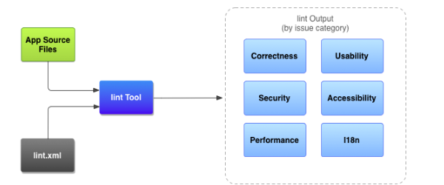

* **Application source files**. The source files consist of files that make up your Android project, including Java, Kotlin, and XML files, icons, and ProGuard configuration files.
* **The lint.xml file**. A configuration file that you can use to specify any lint checks that you want to exclude and to customize problem severity levels.
* **The lint tool**. A static code scanning tool that you can run on your Android project either from the command line or in Android Studio (see [Manually run inspections](https://developer.android.com/studio/write/lint#manuallyRunInspections)). The lint tool checks for structural code problems that could affect the quality and performance of your Android application. It is strongly recommended that you correct any errors that lint detects before publishing your application.
* **Results of lint checking**. You can view the results from lint either in the console or in the Inspection Results window in Android Studio.

## [Configure lint to suppress warnings](https://developer.android.com/studio/write/lint#config)

By default when you run a lint scan, the tool checks for all issues that lint supports. You can also restrict the issues for lint to check and assign the severity level for those issues. For example, you can suppress lint checking for specific issues that are not relevant to your project and, you can configure lint to report non-critical issues at a lower severity level.

You can configure lint checking for different levels:

* Globally (entire project);
* Project module;
* Production module;
* Test module;
* Open files;
* Class hierarchy;
* Version Control System (VCS) scopes.

## [Configure the lint file](https://developer.android.com/studio/write/lint#pref)

You can specify your lint checking preferences in the lint.xml file. If you are creating this file manually, place it in the root directory of your Android project.

The lint.xml file consists of an enclosing <lint> parent tag that contains one or more children <issue> elements. Lint defines a unique id attribute value for each <issue>.

<?xml version="1.0" encoding="UTF-8"?>

<lint>

<!-- list of issues to configure -->

</lint>

You can change an issue's severity level or disable lint checking for the issue by setting the severity attribute in the <issue> tag.

The following example shows the contents of a lint.xml file.

<?xml version="1.0" encoding="UTF-8"?>

<lint>

<!-- Disable the given check in this project -->

<issue id="IconMissingDensityFolder" severity="ignore" />

<!-- Ignore the ObsoleteLayoutParam issue in the specified files -->

<issue id="ObsoleteLayoutParam">

<ignore path="res/layout/activation.xml" />

<ignore path="res/layout-xlarge/activation.xml" />

</issue>

<!-- Ignore the UselessLeaf issue in the specified file -->

<issue id="UselessLeaf">

<ignore path="res/layout/main.xml" />

</issue>

<!-- Change the severity of hardcoded strings to "error" -->

<issue id="HardcodedText" severity="error" />

</lint>

## [Configure lint options with Gradle](https://developer.android.com/studio/write/lint#gradle)

The Android plugin for Gradle allows you to configure certain lint options, such as which checks to run or ignore, using the lintOptions {} block in your module-level build.gradle file. The following code snippet shows you some of the properties you can configure:

android {

...

lintOptions {

// Turns off checks for the issue IDs you specify.

disable 'TypographyFractions','TypographyQuotes'

// Turns on checks for the issue IDs you specify. These checks are in

// addition to the default lint checks.

enable 'RtlHardcoded','RtlCompat', 'RtlEnabled'

// To enable checks for only a subset of issue IDs and ignore all others,

// list the issue IDs with the 'check' property instead. This property overrides

// any issue IDs you enable or disable using the properties above.

check 'NewApi', 'InlinedApi'

// If set to true, turns off analysis progress reporting by lint.

quiet true

// if set to true (default), stops the build if errors are found.

abortOnError false

// if true, only report errors.

ignoreWarnings true

}

}

...

**Question:**  Parcelable

**Answer:**  Parcelable used for pass data between components. Parcelable is the analog of Java Serializable interface with optimization for mobile devices. It assumes a certain structure and way of processing it.

Classes implementing the Parcelable interface must also have a non-null static field called CREATOR of a type that implements the Parcelable.Creator interface.

A typical implementation of Parcelable is:

public class MyParcelable implements Parcelable {

private int mData;

public int describeContents() {

return 0;

}

public void writeToParcel(Parcel out, int flags) {

out.writeInt(mData);

}

public static final Parcelable.Creator<MyParcelable> CREATOR

= new Parcelable.Creator<MyParcelable>() {

public MyParcelable createFromParcel(Parcel in) {

return new MyParcelable(in);

}

public MyParcelable[] newArray(int size) {

return new MyParcelable[size];

}

};

private MyParcelable(Parcel in) {

mData = in.readInt();

}

}

We can now pass the parcelable data between activities within an intent:

MyParcelable info = new MyParcelable();

Intent i = new Intent(this, NewActivity.class);

i.putExtra("parcelableKey", info);

startActivity(i);

For obtaining information in NewActivity should do next:

public class NewActivity extends Activity {

@Override

protected void onCreate(Bundle savedInstanceState) {

MyParcelable info = (MyParcelable) getIntent().getParcelableExtra("parcelableKey");

}

}

Resources for simplified generate the boilerplate code for creating Parcelables:

* [parcelabler](http://www.parcelabler.com/)
* [Android studio plugin](https://github.com/mcharmas/android-parcelable-intellij-plugin)
* [Kotlin @Parcelize](https://kotlinlang.org/docs/reference/compiler-plugins.html#parcelable-implementations-generator)

**Question:**  PendingIntent

**Answer:**  A PendingIntent specifies an action to take in the future. It lets you pass a future Intent to another application and allow that application to execute that Intent as if it had the same permissions as your application, whether or not your application is still around when the Intent is eventually invoked.

By giving a PendingIntent to another application, you are granting it the right to perform the operation you have specified as if the other application was yourself (with the same permissions and identity). As such, you should be careful about how you build the PendingIntent: often, for example, the base Intent you supply will have the component name explicitly set to one of your own components, to ensure it is ultimately sent there and nowhere else.

It is an Intent action that you want to perform but at a later time. The reason it’s needed is because an Intent must be created and launched from a valid context in your application, but there are certain cases where one is not available at the time you want to run the action because you are technically outside the application’s context.

## Example of usage

The most common, and most basic, way to use a PendingIntent is as the action associated with a notification:

val intent = Intent(applicationContext, MainActivity::class.java).apply {

action = NOTIFICATION_ACTION

data = deepLink

}

val pendingIntent = PendingIntent.getActivity(

applicationContext,

NOTIFICATION_REQUEST_CODE,

intent,

PendingIntent.FLAG_IMMUTABLE

)

val notification = NotificationCompat.Builder(

applicationContext,

NOTIFICATION_CHANNEL

).apply {

// ...

setContentIntent(pendingIntent)

// ...

}.build()

notificationManager.notify(

NOTIFICATION_TAG,

NOTIFICATION_ID,

notification

)

We can see that we’re constructing a standard type of Intent that will open our app, and then simply wrapping that in a PendingIntent before adding it to our notification.

In this case, since we have an exact action we know we want to perform, we construct a PendingIntent that cannot be modified by the app we pass it to by utilizing a flag called FLAG_IMMUTABLE.

## Updating an immutable PendingIntent

If an app needs to update a PendingIntent that it needs to be mutable, but that’s not always the case! The app that creates a PendingIntent can always update it by passing the flag FLAG_UPDATE_CURRENT:

val updatedIntent = Intent(applicationContext, MainActivity::class.java).apply {

action = NOTIFICATION_ACTION

data = differentDeepLink

}

// Because we're passing `FLAG_UPDATE_CURRENT`, this updates

// the existing PendingIntent with the changes we made above.

val updatedPendingIntent = PendingIntent.getActivity(

applicationContext,

NOTIFICATION_REQUEST_CODE,

updatedIntent,

PendingIntent.FLAG_IMMUTABLE or PendingIntent.FLAG_UPDATE_CURRENT

)

// The PendingIntent has been updated.

## Details on flags

* FLAG_IMMUTABLE: Indicates the Intent inside the PendingIntent cannot be modified by other apps that pass an Intent to PendingIntent.send(). An app can always use FLAG_UPDATE_CURRENT to modify its own PendingIntents . Prior to Android 12, a PendingIntent created without this flag was mutable by default. On Android versions prior to Android 6 (API 23), PendingIntents are always mutable.
* FLAG_UPDATE_CURRENT: Requests that the system update the existing PendingIntent with the new extra data, rather than storing a new PendingIntent. If the PendingIntent isn’t registered, then this one will be.
* FLAG_ONE_SHOT: Only allows the PendingIntent to be sent once (via PendingIntent.send()). This can be important when passing a PendingIntent to another app if the Intent inside it should only be able to be sent a single time. This may be related to convenience, or to prevent the app from performing some action multiple times.
* FLAG_CANCEL_CURRENT: Cancels an existing PendingIntent, if one exists, before registering this new one. This can be important if a particular PendingIntent was sent to one app, and you’d like to send it to a different app, potentially updating the data. By using FLAG_CANCEL_CURRENT, the first app would no longer be able to call send on it, but the second app would be.

**Question:**  RecyclerView.ItemDecoration

**Answer:**  An ItemDecoration allows the application to add a special drawing and layout offset to specific item views from the adapter's data set. This can be useful for drawing dividers between items, highlights, visual grouping boundaries and more.

All ItemDecorations are drawn in the order they were added, before the item views(in onDraw() and after the items (in onDrawOver(Canvas, RecyclerView, RecyclerView.State).

Multiple ItemDecorations can be added to a single RecyclerView.

A few examples of ItemDecoration:

ItemDecoration for set top and bottom margins:

import android.graphics.Rect

import android.view.View

import androidx.recyclerview.widget.RecyclerView

class TopBottomMarginItemDecoration(

private val topMargin: Int,

private val bottomMargin: Int

) : RecyclerView.ItemDecoration() {

override fun getItemOffsets(

outRect: Rect,

view: View,

parent: RecyclerView,

state: RecyclerView.State

) {

with(outRect) {

top = topMargin

bottom = bottomMargin

}

}

}

ItemDecoration for set right and left margins:

import android.graphics.Rect

import android.view.View

import androidx.recyclerview.widget.RecyclerView

class EdgesMarginItemDecoration(private val edgesMargin: Int) : RecyclerView.ItemDecoration() {

override fun getItemOffsets(

outRect: Rect,

view: View,

parent: RecyclerView,

state: RecyclerView.State

) {

with(outRect) {

val position = parent.getChildAdapterPosition(view)

when (position) {

0 -> {

left = edgesMargin

right = edgesMargin / 2

}

parent.adapter!!.itemCount - 1 -> {

right = edgesMargin

left = edgesMargin / 2

}

else -> {

left = edgesMargin / 2

right = edgesMargin / 2

}

}

}

}

}

**Question:**  SparseArray

**Answer:**  SparseArray maps integers to Objects and, unlike a normal array of Objects, its indices can contain gaps. SparseArray is intended to be more memory-efficient than a HashMap, because it avoids auto-boxing keys and its data structure doesn't rely on an extra entry object for each mapping.

Note that this container keeps its mappings in an array data structure, using a binary search to find keys. The implementation is not intended to be appropriate for data structures that may contain large numbers of items. It is generally slower than a HashMap because lookups require a binary search, and adds and removes require inserting and deleting entries in the array. For containers holding up to hundreds of items, the performance difference is less than 50%.

To help with performance, the container includes an optimization when removing keys: instead of compacting its array immediately, it leaves the removed entry marked as deleted. The entry can then be re-used for the same key or compacted later in a single garbage collection of all removed entries. This garbage collection must be performed whenever the array needs to be grown, or when the map size or entry values are retrieved.

It is possible to iterate over the items in this container using keyAt(int) and valueAt(int). Iterating over the keys using keyAt(int) with ascending values of the index returns the keys in ascending order. In the case of valueAt(int), the values corresponding to the keys are returned in ascending order.

Benefits to use SparseArray over HashMap is:

* More memory efficient by using primitives;
* No auto-boxing;
* Allocation-free.

Drawbacks:

* For large collections, it is slower;
* It only available for Android.

## Example of usage

import android.util.SparseArray

import androidx.core.util.set

import androidx.core.util.size

class SparseArrayExample {

fun example() {

val sparseArray = SparseArray<String>()

sparseArray[0] = "First item"

sparseArray[10] = "Second item"

sparseArray[24] = "Third item"

sparseArray[50] = "Fourth item"

for (i in 0 until sparseArray.size) {

println("Index = " + sparseArray.keyAt(i) + ", Item = " + sparseArray.valueAt(i))

}

if (sparseArray[100] == null) {

println("SparseArray not contains item with index 100")

}

}

}

Output:

Index = 0, Item = First item

Index = 10, Item = Second item

Index = 24, Item = Third item

Index = 50, Item = Fourth item

SparseArray not contains item with index 100

**Question:**  View Binding

**Answer:**  View binding is a feature that allows you to more easily write code that interacts with views. Once view binding is enabled in a module, it generates a binding class for each XML layout file present in that module. An instance of a binding class contains direct references to all views that have an ID in the corresponding layout.

In most cases, view binding replaces findViewById.

# [Setup instructions](https://developer.android.com/topic/libraries/view-binding#setup)

View binding is enabled on a module by module basis. To enable view binding in a module, set the viewBinding build option to true in the module-level build.gradle file, as shown in the following example:

android {

...

buildFeatures {

viewBinding true

}

}

# [Usage](https://developer.android.com/topic/libraries/view-binding#usage)

If view binding is enabled for a module, a binding class is generated for each XML layout file that the module contains. Each binding class contains references to the root view and all views that have an ID. The name of the binding class is generated by converting the name of the XML file to Pascal case and adding the word "Binding" to the end.

For example, given a layout file called result_profile.xml:

<LinearLayout ... >

<TextView android:id="@+id/name" />

<ImageView android:cropToPadding="true" />

<Button android:id="@+id/button"

android:background="@drawable/rounded_button" />

</LinearLayout>

The generated binding class is called ResultProfileBinding. This class has two fields: a TextView called name and a Button called button. The ImageView in the layout has no ID, so there is no reference to it in the binding class.

Every binding class also includes a getRoot() method, providing a direct reference for the root view of the corresponding layout file. In this example, the getRoot() method in the ResultProfileBinding class returns the LinearLayout root view.

# [Use view binding in activities](https://developer.android.com/topic/libraries/view-binding#activities)

To set up an instance of the binding class for use with an activity, perform the following steps in the activity's onCreate() method:

* Call the static inflate() method included in the generated binding class. This creates an instance of the binding class for the activity to use;
* Get a reference to the root view by either calling the getRoot() method or using Kotlin property syntax.
* Pass the root view to setContentView() to make it the active view on the screen.

private lateinit var binding: ResultProfileBinding

override fun onCreate(savedInstanceState: Bundle?) {

super.onCreate(savedInstanceState)

binding = ResultProfileBinding.inflate(layoutInflater)

val view = binding.root

setContentView(view)

}

You can now use the instance of the binding class to reference any of the views:

binding.name.text = viewModel.name

binding.button.setOnClickListener { viewModel.userClicked() }

# [Use view binding in fragments](https://developer.android.com/topic/libraries/view-binding#fragments)

To set up an instance of the binding class for use with a fragment, perform the following steps in the fragment's onCreateView() method:

* Call the static inflate() method included in the generated binding class. This creates an instance of the binding class for the fragment to use;
* Get a reference to the root view by either calling the getRoot() method or using Kotlin property syntax;
* Return the root view from the onCreateView() method to make it the active view on the screen.

private var _binding: ResultProfileBinding? = null

// This property is only valid between onCreateView and

// onDestroyView.

private val binding get() = _binding!!

override fun onCreateView(

inflater: LayoutInflater,

container: ViewGroup?,

savedInstanceState: Bundle?

): View? {

_binding = ResultProfileBinding.inflate(inflater, container, false)

val view = binding.root

return view

}

override fun onDestroyView() {

super.onDestroyView()

_binding = null

}

You can now use the instance of the binding class to reference any of the views:

binding.name.text = viewModel.name

binding.button.setOnClickListener { viewModel.userClicked() }

**Note**: Note: Fragments outlive their views. Make sure you clean up any references to the binding class instance in the fragment's onDestroyView() method.

# [Differences from findViewById](https://developer.android.com/topic/libraries/view-binding#findviewbyid)

View binding has important advantages over using findViewById:

* **Null safety**: Since view binding creates direct references to views, there's no risk of a null pointer exception due to an invalid view ID. Additionally, when a view is only present in some configurations of a layout, the field containing its reference in the binding class is marked with @Nullable.
* **Type safety**: The fields in each binding class have types matching the views they reference in the XML file. This means that there's no risk of a class cast exception.

**Question:**  Lifecycle

**Answer:**  Lifecycle-aware components perform actions in response to a change in the lifecycle status of another component, such as activities and fragments. These components help you produce better-organized, and often lighter-weight code, that is easier to maintain.

A common pattern is to implement the actions of the dependent components in the lifecycle methods of activities and fragments. However, this pattern leads to a poor organization of the code and to the proliferation of errors. By using lifecycle-aware components, you can move the code of dependent components out of the lifecycle methods and into the components themselves.

The androidx.lifecycle package provides classes and interfaces that let you build lifecycle-aware components—which are components that can automatically adjust their behavior based on the current lifecycle state of an activity or fragment.

## Lifecycle

Lifecycle is a class that holds the information about the lifecycle state of a component (like an activity or a fragment) and allows other objects to observe this state.

Lifecycle uses two main enumerations to track the lifecycle status for its associated component:

* **Event**. The lifecycle events that are dispatched from the framework and d fragments.
* **State**. The current state of the component tracked by the Lifecycle object.

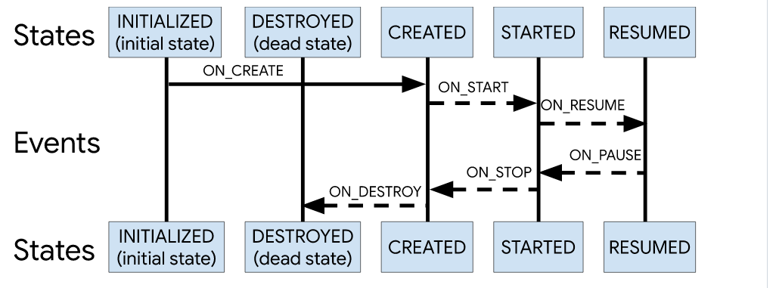

A class can monitor the component's lifecycle status by adding annotations to its methods. Then you can add an observer by calling the addObserver() method of the Lifecycle class and passing an instance of your observer, as shown in the following example:

class MyObserver : LifecycleObserver {

@OnLifecycleEvent(Lifecycle.Event.ON_RESUME)

fun connectListener() {

...

}

@OnLifecycleEvent(Lifecycle.Event.ON_PAUSE)

fun disconnectListener() {

...

}

}

myLifecycleOwner.getLifecycle().addObserver(MyObserver())

## LifecycleOwner

LifecycleOwner is a single method interface that denotes that the class has a Lifecycle. It has one method, getLifecycle(), which must be implemented by the class. If you're trying to manage the lifecycle of a whole application process instead, see ProcessLifecycleOwner.

This interface abstracts the ownership of a Lifecycle from individual classes, such as Fragment and AppCompatActivity, and allows writing components that work with them. Any custom application class can implement the LifecycleOwner interface.

Components that implement LifecycleObserver work seamlessly with components that implement LifecycleOwner because an owner can provide a lifecycle, which an observer can register to watch.

For the location tracking example, we can make the MyLocationListener class implement LifecycleObserver and then initialize it with the activity's Lifecycle in the onCreate() method. This allows the MyLocationListener class to be self-sufficient, meaning that the logic to react to changes in lifecycle status is declared in MyLocationListener instead of the activity. Having the individual components store their own logic makes the activities and fragments logic easier to manage.

class MyActivity : AppCompatActivity() {

private lateinit var myLocationListener: MyLocationListener

override fun onCreate(...) {

myLocationListener = MyLocationListener(this, lifecycle) { location ->

// update UI

}

Util.checkUserStatus { result ->

if (result) {

myLocationListener.enable()

}

}

}

}

A common use case is to avoid invoking certain callbacks if the Lifecycle isn't in a good state right now. For example, if the callback runs a fragment transaction after the activity state is saved, it would trigger a crash, so we would never want to invoke that callback.

To make this use case easy, the Lifecycle class allows other objects to query the current state.

fun enable() {

enabled = true

if (lifecycle.currentState.isAtLeast(Lifecycle.State.STARTED)) {

// connect if not connected

}

}

With this implementation, our LocationListener class is completely lifecycle-aware. If we need to use our LocationListener from another activity or fragment, we just need to initialize it. All of the setup and teardown operations are managed by the class itself.

## Use cases for lifecycle-aware components

* Switching between coarse and fine-grained location updates. Use lifecycle-aware components to enable fine-grained location updates while your location app is visible and switch to coarse-grained updates when the app is in the background;
* Stopping and starting video buffering. Use lifecycle-aware components to start video buffering as soon as possible, but defer playback until app is fully started. You can also use lifecycle-aware components to terminate buffering when your app is destroyed;
* Starting and stopping network connectivity. Use lifecycle-aware components to enable live updating (streaming) of network data while an app is in the foreground and also to automatically pause when the app goes into the background;
* Pausing and resuming animated drawables. Use lifecycle-aware components to handle pausing animated drawables when while app is in the background and resume drawables after the app is in the foreground.

**Question:**  Notification

**Answer:**  A notification is a message that Android displays outside your app's UI to provide the user with reminders, communication from other people, or other timely information from your app. Users can tap the notification to open your app or take an action directly from the notification.

## [Usage](https://material.io/design/platform-guidance/android-notifications.html#usage)

Notifications are intended to inform users about events in your app. These two types of notifications are the most effective:

* Communication from other users;
* Well-timed and informative task reminders.

**Notification Anatomy**:

* Header area;
* Content area;
* Action area.

**How notifications may be noticed**:

* Showing a status bar icon;
* Appearing on the lock screen;
* Playing a sound or vibrating;
* Peeking onto the current screen;
* Blinking the device's LED.

## Notification drawer

The notification drawer in Android typically shows notifications in reverse-chronological order, with adjustments influenced by:

* The app's stated notification priority or importance;
* Whether the notification recently alerted the user with a sound or vibration;
* Any people attached to the notification and whether they are starred contacts;
* Whether the notification represents an important ongoing activity, such as a phone call in progress or music playing.

Starting in Android O, the Android system may alter the appearance of some notifications at the top and bottom of the list by adding emphasis or deemphasis, to help the user scan content.

## Grouping

Your app can present multiple notifications according to hierarchy:

* A parent notification displays a summary of its child notifications;
* If the parent notification is expanded by the user, all child notifications are revealed;
* A child notification may be expanded to reveal its entire content.

Child notifications are presented without duplicate header information. For example, if a child notification has the same app icon as its parent, then the child’s header doesn’t include an icon.

Child notifications should be understandable if they appear solo, as the system may show them outside of the group when they arrive.

## [Types of notifications](https://material.io/design/platform-guidance/android-notifications.html#types-of-notifications)

Notifications are considered either transactional or non-transactional.

### Transactional

Transactional notifications provide content that a user must receive at a specific time in order to do one of the following:

* Enable human-to-human interaction;
* Function better in daily life;
* Control or resolve transient device states.

If none of the above situations describe your notification, then it is non-transactional.

### Non-transactional opt-out and opt-in

Non-transactional notifications should be optional, as they may not appeal to all users. You can make them optional in one of two ways:

* Opt-out: Users receive opt-out notifications by default, but they may stop receiving them by turning off a setting;
* Opt-in: Users only receive opt-in notifications by turning on a setting in your app.

## [Settings](https://material.io/design/platform-guidance/android-notifications.html#settings)

### Channels in Android O

When you upgrade your app to Android O, you'll be required to define channels for your notifications – one for each type of notification you want to send.

Users control app notifications in Android O with channels. If a user doesn't want a certain notification from your app, they can block that channel rather than all notifications.

### Channel importance levels

For each channel you define, you'll assign it an importance level. Starting in Android O, importance levels control the behavior of each channel (taking the place of priority levels).

Importance levels have the following restrictions:

* The importance level you assign will be the channel’s default. Users can change a channel’s importance level in Android Settings;
* Once you choose an importance level, you're limited in how you can change it: you may only lower the importance, and only if the user hasn't explicitly changed it.

Channel importance should be chosen with consideration for the user's time and attention. When an unimportant notification is disguised as urgent, it can produce unnecessary alarm.

| **Importance** | **Behavior** | **Usage** | **Examples** |
| --- | --- | --- | --- |
| HIGH | Makes a sound and appears on screen | Time-critical information that the user must know, or act on, immediately | Text messages, alarms, phone calls |
| DEFAULT | Makes a sound | Information that should be seen at the user’s earliest convenience, but not interrupt what they're doing | Traffic alerts, task reminders |
| LOW | No sound | Notification channels that don't meet the requirements of other importance levels | New content the user has subscribed to, social network invitations |
| MIN | No sound or visual interruption | Non-essential information that can wait or isn’t specifically relevant to the user | Nearby places of interest, weather, promotional content |

## [Create a basic notification](https://developer.android.com/training/notify-user/build-notification#SimpleNotification)

A notification in its most basic and compact form (also known as collapsed form) displays an icon, a title, and a small amount of content text. In this section, you'll learn how to create a notification that the user can click on to launch an activity in your app.

### [Set the notification content](https://developer.android.com/training/notify-user/build-notification#builder)

To get started, you need to set the notification's content and channel using a NotificationCompat.Builder object. The following example shows how to create a notification with the following:

* A small icon, set by setSmallIcon(). This is the only user-visible content that's required;
* A title, set by setContentTitle();
* The body text, set by setContentText();
* The notification priority, set by setPriority(). The priority determines how intrusive the notification should be on Android 7.1 and lower.

Example:

var builder = NotificationCompat.Builder(this, CHANNEL_ID)

.setSmallIcon(R.drawable.notification_icon)

.setContentTitle(textTitle)

.setContentText(textContent)

.setPriority(NotificationCompat.PRIORITY_DEFAULT)

Notice that the NotificationCompat.Builder constructor requires that you provide a channel ID. This is required for compatibility with Android 8.0 (API level 26) and higher, but is ignored by older versions.

## [Update a notification](https://developer.android.com/training/notify-user/build-notification#Updating)

To update this notification after you've issued it, call NotificationManagerCompat.notify() again, passing it a notification with the same ID you used previously. If the previous notification has been dismissed, a new notification is created instead.

You can optionally call setOnlyAlertOnce() so your notification interupts the user (with sound, vibration, or visual clues) only the first time the notification appears and not for later updates.

## [Remove a notification](https://developer.android.com/training/notify-user/build-notification#Removing)

Notifications remain visible until one of the following happens:

* The user dismisses the notification;
* The user clicks the notification, and you called setAutoCancel() when you created the notification;
* You call cancel() for a specific notification ID. This method also deletes ongoing notifications;
* You call cancelAll(), which removes all of the notifications you previously issued;
* If you set a timeout when creating a notification using setTimeoutAfter(), the system cancels the notification after the specified duration elapses. If required, you can cancel a notification before the specified timeout duration elapses.

## When not to use a notification

Notifications should not be the primary communication channel with your users, as frequent interruptions may cause irritation. The following cases do not warrant notification:

* Cross-promotion, or advertising another product within a notification, which is strictly prohibited by the Play Store;
* An app that a user has never opened;
* Messages that encourage the user to return to an app, but provide no direct value, such as "Haven't seen you in a while";
* Requests to rate an app;
* Operations that don't require user involvement, like syncing information;
* Error states from which the app may recover without user interaction.

**Question:**  Paging library

**Answer:**  The Paging Library helps you load and display small chunks of data at a time. Loading partial data on demand reduces usage of network bandwidth and system resources.

The Paging Library supports the following data architectures:

* Served only from a backend server;
* Stored only in an on-device database;
* A combination of the other sources, using the on-device database as a cache.

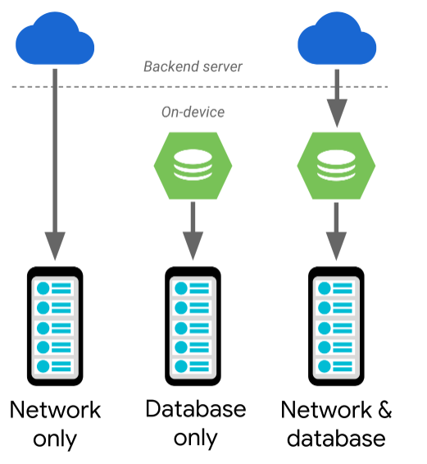

In the case of a network-only or database-only solution, the data flows directly to your app's UI model. If you're using a combined approach, data flows from your backend server, into an on-device database, and then to your app's UI model. Every once in a while, the endpoint of each data flow runs out of data to load, at which point it requests more data from the component that provided the data. For example, when an on-device database runs out of data, it requests more data from the server.

## Library architecture

### PagedList

The Paging Library's key component is the PagedList class, which loads chunks of your app's data, or *pages*. As more data is needed, it's paged into the existing PagedList object. If any loaded data changes, a new instance of PagedList is emitted to the observable data holder from a LiveData or RxJava2-based object. As PagedList objects are generated, your app's UI presents their contents, all while respecting your UI controllers' lifecycles.

The following code snippet shows how you can configure your app's view model to load and present data using a LiveData holder of PagedList objects:

class ConcertViewModel(concertDao: ConcertDao) : ViewModel() {

val concertList: LiveData<PagedList<Concert>> =

concertDao.concertsByDate().toLiveData(pageSize = 50)

}

### Data

Each instance of PagedList loads an up-to-date snapshot of your app's data from its corresponding DataSource object. Data flows from your app's backend or database into the PagedList object.

The following example uses the Room persistence library to organize your app's data, but if you want to store your data using another means, you can also [provide your own data source factory](https://developer.android.com/topic/libraries/architecture/paging/data#custom-data-source).

@Dao

interface ConcertDao {

// The Int type parameter tells Room to use a PositionalDataSource object.

@Query("SELECT * FROM concerts ORDER BY date DESC")

fun concertsByDate(): DataSource.Factory<Int, Concert>

}

### UI

The PagedList class works with a PagedListAdapter to load items into a RecyclerView. These classes work together to fetch and display content as it's loaded, prefetching out-of-view content and animating content changes.

## Benefits of using the Paging library

* In-memory caching for your paged data. This ensures that your app uses system resources efficiently while working with paged data.
* Built-in request deduplication, ensuring that your app uses network bandwidth and system resources efficiently.
* Configurable RecyclerView adapters that automatically request data as the user scrolls toward the end of the loaded data.
* First-class support for Kotlin coroutines and Flow, as well as LiveData and RxJava.
* Built-in support for error handling, including refresh and retry capabilities.

**Question:**  AndroidManifest

**Answer:** The AndroidManifest.xml file contains information of your package, including components of the application such as activities, services, broadcast receivers, content providers etc.

## Responsibilities

* Protect the application to access any protected parts by providing the permissions.
* Declares the android api that the application is going to use.
* Declares lists the instrumentation classes. The instrumentation classes provides profiling and other informations.
* Specify whether app should be install on an SD card of the internal memory.

## Nodes

* **uses-sdk** - It is used to define a minimum and maximum SDK version that must be available on a device so that our application function properly. However, beware that attributes in the element are overridden by corresponding properties in the build.gradle
* **uses-configuration** - The uses-configuration nodes are used to specify the combination of input mechanisms that are supported by our application.
* **uses-features** - It is used to specify which hardware and software features your app needs.
* **supports-screens** - It is used to describe the screen support for application.
* **permission** - It is used to create permissions to restrict access to shared application components. Also used the existing platform permissions for this purpose or define your own permissions in the manifest.
* **application** - The declaration of the application. This element contains subelements that declare each of the application's components (such as *Activity*, *Service*, *Content Provider*, and *Broadcast Receiver*) and has attributes that can affect all the components.

**Question:**  Overdraw

**Answer:**  An app may draw the same pixel more than once within a single frame, an event called overdraw. Overdraw is usually unnecessary, and best eliminated. It manifests itself as a performance problem by wasting GPU time to render pixels that don't contribute to what the user sees on the screen.

**Question:**  Spannable

**Answer:**  This is the interface for text to which markup objects can be attached and detached. It used for styling text. Can be applied to whole paragraphs or to parts of the text. Used for:

* Change the color
* Make text clickable
* Scale text size
* Draw custom points
* Change line height

## Applying Spans

When using spans, you will work with one of the following classes: SpannedString, SpannableString or SpannableStringBuilder. The difference between them lies in whether the text or the markup objects are mutable or immutable and in the internal structure they use: SpannedString and SpannableString use linear arrays to keep records of added spans, whereas SpannableStringBuilder uses an interval tree. Which one to use:

* Just reading and not setting the text nor the spans? -> SpannedString
* Setting the text and the spans? -> SpannableStringBuilder
* Setting a small number of spans (<~10)? -> SpannableString
* Setting a larger number of spans (>~10) -> SpannableStringBuilder

## 

## Framework spans

The Android framework defines several interfaces and abstract classes that are checked at measure and render time. These classes have methods that allow a span to access objects like the TextPaint or the Canvas. The Android framework provides 20+ spans in the android.text.style package, subclassing the main interfaces and abstract classes. We can categorize spans in several ways:

* Based on whether span changes only appearance or also the text metric/layout
* Based on whether they affect text at character or at paragraph level

### Appearance vs metric affecting spans

The first category affects character-level text in a way that modifies their appearance: text or background colour, underline, strikethrough, etc., that triggers a redraw without causing a relayout of the text. These spans implement UpdateAppearance and extend CharacterStyle. CharacterStyle subclasses define how to draw text by providing access to update the TextPaint.

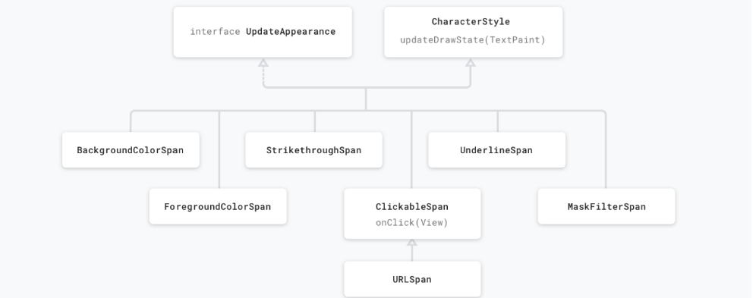

Metric affecting spans modify text metrics and layout, therefore the object that observes the span change will re-measure the text for correct layout and rendering. For example, a span that affects the text size will require re-measure and layout, as well as re-drawing. These spans usually extend the MetricAffectingSpan class. This abstract class allows subclasses to define how the span affects text measurement, by providing access to the TextPaint. Since MetricAffectingSpan extends CharacterSpan, subclasses affect the appearance of the text at character level.

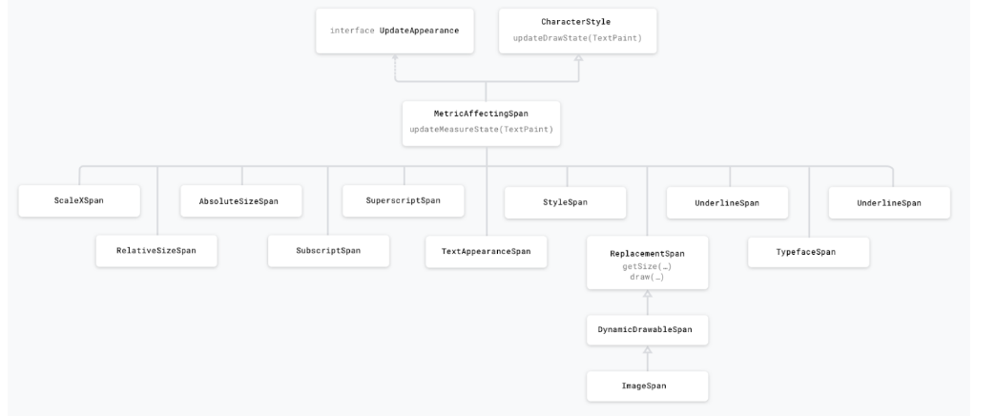

### Character vs paragraph affecting spans

A span can either affect the text at the character level, updating elements like background colour, style or size, or a the paragraph level, changing the alignment or the margin of the entire block of text. Depending on the needed styling, spans either extend CharacterStyle or implement ParagraphStyle. Spans that extend ParagraphStyle must be attached from the first character to the last character of a single paragraph, otherwise the span will not be displayed. On Android paragraphs are defined based on new line (\n) character. A ParagraphStyle span, like QuoteSpan, can only be attached from the start of a paragraph, otherwise the line and the text margin don’t appear.

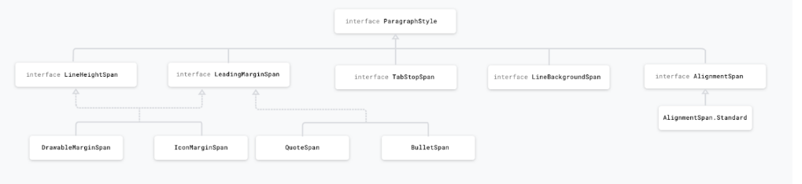

**Question:**  SurfaceView

**Answer:**  SurfaceView can be updated on the background thread.

* SurfaceView has dedicate surface buffer while all the view share one surface buffer that is allocated by ViewRoot. In another word, SurfaceView cost more resources.
* SurfaceView cannot be hardware accelerated (as of JB4.2) while 95% operations on normal View are HW accelerated using openGL ES.
* More work should be done to create your customized SurfaceView. You need to listener to the surfaceCreated/Destroy Event, create a render thread, more importantly, synchronized the render thread and main thread.
* The timing to update is different. Normal view update mechanism is constraint or controlled by the framework: You call view.invalidate() in the UI thread or view.postInvalidate() in other thread to indicate to the framework that the view should be updated. However, the view won't be updated immediately but wait until next VSYNC event arrived. The easy approach to understand VYSNC is to consider it is as a timer that fire up every 16ms for a 60fps screen. In Android, all the normal view update, is synchronized with VSYNC to achieve better smoothness.

**Question:**  installLocation tag

**Answer:**  installLocation is the tag in AndroidManifest that configure default install location for the app. The following keyword strings are accepted:

| **Value** | **Description** |
| --- | --- |
| internalOnly | The app must be installed on the internal device storage only. If this is set, the app will never be installed on the external storage. If the internal storage is full, then the system will not install the app. This is also the default behavior if you do not define android:installLocation. |
| auto | The app may be installed on the external storage, but the system will install the app on the internal storage by default. If the internal storage is full, then the system will install it on the external storage. Once installed, the user can move the app to either internal or external storage through the system settings. |
| preferExternal | The app prefers to be installed on the external storage (SD card). There is no guarantee that the system will honor this request. The app might be installed on internal storage if the external media is unavailable or full. Once installed, the user can move the app to either internal or external storage through the system settings. |

When an app is installed on the external storage:

* The .apk file is saved to the external storage, but any app data (such as databases) is still saved on the internal device memory.
* The container in which the .apk file is saved is encrypted with a key that allows the app to operate only on the device that installed it. (A user cannot transfer the SD card to another device and use apps installed on the card.) Though, multiple SD cards can be used with the same device.
* At the user's request, the app can be moved to the internal storage.

The user may also request to move an app from the internal storage to the external storage. However, the system will not allow the user to move the app to external storage if this attribute is set to internalOnly, which is the default setting.

**Question:**  What is savedInstanceState bundle

1. **Answer:**  **Bundle savedInstanceState** is a reference to the Bundle object that is passed to the onCreate() in an Activity. Activities have capability to restore themselves to a previous state using the stored in the Bundle.
2. First time the bundle object is always null. If some data is stored in the bundle object during the Activity lifecycle and Activity is recreated due to rotation then the bundle object will be non-null.

During the Activity Lifecycle save the data in onSaveInstanceState()

int scrolledPosition = 0;

@Override

public void onSaveInstanceState(Bundle outState) {

super.onSaveInstanceState(outState);

outState.putInt("scrolled_position",scrolledPosition);

}

After the orientation when the Activity is recreated and onCreate() is called

int scrolledPosition = 0;

@Override

public void onCreate(Bundle savedInstanceState) {

super.onCreate(savedInstanceState);

if(savedInstanceState == null){

scrolledPosition = 0;

}else{

scrolledPosition = savedInstanceState.getInt("scrolled_position",0);

}

}

There is an alternative way of restoring state , onRestoreInstanceState() which system calls after onStart(). The system calls onRestoreInstanceState() only if there is a state to restore. So there is no need to check if bundle object is null.

int scrolledPosition = 0;

public void onRestoreInstanceState(Bundle savedInstanceState) {

// Always call the superclass so it can restore the view hierarchy

super.onRestoreInstanceState(savedInstanceState);

// Restore state members from saved instance

scrolledPosition = savedInstanceState.getInt("scrolled_position",0);

}

**Note:** Always call the superclass implementation of onRestoreInstanceState()so the default implementation can restore the state of the view hierarchy.

**What kind of data should be stored in bundle object**

* 1. User selections
  2. Scroll positions
  3. User submitted data

**What kind of data shouldn't be stored in bundle object**

* 1. Bitmap
  2. File
  3. Big Model classes(POJO)

**Question:**  Dialog vs DialogFragment

**Answer:**  The Dialog class is the base class for dialogs, but you should avoid instantiating Dialog directly. Instead, use one of it's subclasses. Dialogs are entirely dependent on Activities. If the screen is rotated, the dialog is dismissed.

A DialogFragment is a fragment that displays a dialog window, floating on top of its activity's window. This fragment contains a Dialog object, which it displays as appropriate based on the fragment's state. Using DialogFragment to manage the dialog ensures that it correctly handles lifecycle events such as when the user presses the Back button or rotates the screen.

**Question:**  Serializable vs Parcelable

## Answer: Serializable

Serializable is a standard Java interface. For the serializable class just implement the Serializable interface and add override methods. This approach is a slow process. Its create a lot of temporary objects and a bit of garbage collection but the serializable interface is easier to implement. Java will automatically serialize it in certain situations.

## Parcelable

Parcelable is another interface. Despite its rival (Serializable in case you forgot), it is a part of the Android SDK. Now, Parcelable was specifically designed in such a way that there is no reflection when using it. That is because we are being really explicit for the serialization process.

## Conclusion

* **Parcelable** is faster than **Serializable** interface
* **Parcelable** interface takes more time to implement compared to **Serializable** interface (with Kotlin this is not true)
* **Serializable** interface is easier to implement
* **Serializable** interface creates a lot of temporary objects and causes quite a bit of garbage collection

**Question:**  View binding vs Data binding

**Answer:**  **View binding** is a feature that allows you to more easily write code that interacts with views. Once view binding is enabled in a module, it generates a *binding class* for each XML layout file present in that module. An instance of a binding class contains direct references to all views that have an ID in the corresponding layout.

In most cases, view binding replaces findViewById.

The **Data Binding Library** is a support library that allows you to bind UI components in your layouts to data sources in your app using a declarative format rather than programmatically.

Binding components in the layout file lets you remove many UI framework calls in your activities, making them simpler and easier to maintain. This can also improve your app's performance and help prevent memory leaks and null pointer exceptions.

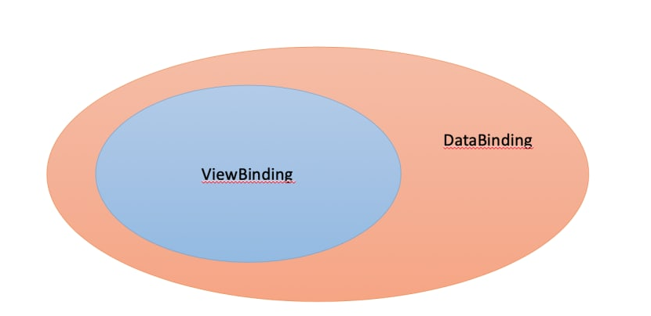

We can represent the view binding as a part of data binding library which means view binding and data binding can do the same jobs for binding views and layouts. But data binding has much more functionality then view binding. If you are using data binding primarily to replace findViewById() calls, than you should use view binding.

## Conclusion

**Differences View Binding and Data Binding**:

* View Binding library is faster than Data Binding library as it is not utilising annotation processors underneath, and when it comes to compile time speed View Binding is more efficient;
* The one and only function of View Binding is to bind the views in the code. While Data Binding offers some more options like Binding Expressions, which allows us to write expressions the connect variables to the views in the layout;
* Data Binding library works with Observable Data objects, you don't have to worry about refreshing the UI when underlying data changes;
* Data Binding library provides us with Binding Adapters;
* Data Binding library provides us with Two way Data Binding, this is a technique of binding your objects to xml layouts, so that both object and layout can send data to each other.

s

**Question:**  What security best practices you know

# Answer: Security best practices

## Show an app chooser

If an implicit intent can launch at least two possible apps on a user's device, explicitly show an app chooser. This interaction strategy allows users to transfer sensitive information to an app that they trust.

val intent = Intent(ACTION_SEND)

val possibleActivitiesList: List<ResolveInfo> =

queryIntentActivities(intent, PackageManager.MATCH_ALL)

// Verify that an activity in at least two apps on the user's device

// can handle the intent. Otherwise, start the intent only if an app

// on the user's device can handle the intent.

if (possibleActivitiesList.size > 1) {

// Create intent to show chooser.

// Title is something similar to "Share this photo with".

val chooser = resources.getString(R.string.chooser_title).let { title ->

Intent.createChooser(intent, title)

}

startActivity(chooser)

} else if (intent.resolveActivity(packageManager) != null) {

startActivity(intent)

}

## Apply signature-based permissions

When sharing data between two apps that you control or own, use *signature-based* permissions. These permissions don't require user confirmation and instead check that the apps accessing the data are signed using the same signing key. Therefore, these permissions offer a more streamlined, secure user experience.

<manifest xmlns:android="http://schemas.android.com/apk/res/android"

package="com.example.myapp">

<permission android:name="my_custom_permission_name"

android:protectionLevel="signature" />

## Disallow access to your app's content providers

Unless you intend to send data from your app to a different app that you don't own, you should explicitly disallow other developers' apps from accessing the ContentProvider objects that your app contains. This setting is particularly important if your app can be installed on devices running Android 4.1.1 (API level 16) or lower, as the android:exported attribute of the <provider> element is true by default on those versions of Android.

<manifest xmlns:android="http://schemas.android.com/apk/res/android"

package="com.example.myapp">

<application ... >

<provider

android:name="android.support.v4.content.FileProvider"

android:authorities="com.example.myapp.fileprovider"

...

android:exported="false">

<!-- Place child elements of <provider> here. -->

</provider>

...

</application>

</manifest>

## Use SSL traffic

If your app communicates with a web server that has a certificate issued by a well-known, trusted CA, the HTTPS request is very simple:

val url = URL("https://www.google.com")

val urlConnection = url.openConnection() as HttpsURLConnection

urlConnection.connect()

urlConnection.inputStream.use {

...

}

## Add a network security configuration

If your app uses new or custom CAs, you can declare your network's security settings in a configuration file. This process allows you to create the configuration without modifying any app code.

To add a network security configuration file to your app, follow these steps:

1. Declare the configuration in your app's manifest:

<manifest ... >

<application

android:networkSecurityConfig="@xml/network_security_config"

... >

<!-- Place child elements of <application> element here. -->

</application>

</manifest>

1. Add an XML resource file, located at res/xml/network_security_config.xml. Specify that all traffic to particular domains should use HTTPS by disabling clear-text:

<network-security-config>

<domain-config cleartextTrafficPermitted="false">

<domain includeSubdomains="true">secure.example.com</domain>

...

</domain-config>

</network-security-config>

## Create your own trust manager

Your SSL checker shouldn't accept every certificate. You may need to set up a trust manager and handle all SSL warnings that occur if one of the following conditions applies to your use case:

* You're communicating with a web server that has a certificate signed by a new or custom CA.
* That CA isn't trusted by the device you're using.
* You cannot use a network security configuration.

## WebView

Whenever possible, load only allowlisted content in WebView objects. In other words, the WebView objects in your app shouldn't allow users to navigate to sites that are outside of your control.

In addition, you should never enable JavaScript interface support unless you completely control and trust the content in your app's WebView objects.

If your app must use JavaScript interface support on devices running Android 6.0 (API level 23) and higher, use HTML message channels instead of communicate between a website and your app, as shown in the following code snippet:

val myWebView: WebView = findViewById(R.id.webview)

// messagePorts[0] and messagePorts[1] represent the two ports.

// They are already tangled to each other and have been started.

val channel: Array<out WebMessagePort> = myWebView.createWebMessageChannel()

// Create handler for channel[0] to receive messages.

channel[0].setWebMessageCallback(object : WebMessagePort.WebMessageCallback() {

override fun onMessage(port: WebMessagePort, message: WebMessage) {

Log.d(TAG, "On port $port, received this message: $message")

}

})

// Send a message from channel[1] to channel[0].

channel[1].postMessage(WebMessage("My secure message"))

## User data

* **Store private data within internal storage**. Store all private user data within the device's internal storage, which is sandboxed per app. Your app doesn't need to request permission to view these files, and other apps cannot access the files. As an added security measure, when the user uninstalls an app, the device deletes all files that the app saved within internal storage.
* **Store data in external storage based on use case**. Use external storage for large, non-sensitive files that are specific to your app, as well as files that your app shares with other apps.
* **Check validity of data**. If your app uses data from external storage, make sure that the contents of the data haven't been corrupted or modified. Your app should also include logic to handle files that are no longer in a stable format.
* **Store only non-sensitive data in cache files**. To provide quicker access to non-sensitive app data, store it in the device's cache. For caches larger than 1 MB in size, use getExternalCacheDir(); otherwise, use getCacheDir(). Each method provides you with the File object that contains your app's cached data.
* **Use SharedPreferences in private mode**. When using getSharedPreferences() to create or access your app's SharedPreferences objects, use MODE_PRIVATE. That way, only your app can access the information within the shared preferences file.

## Other

* **Code Obfuscation**. Protect the source code by making it unintelligible for both humans and decompiler. All this, while preserving its entire operations during the compilation. The purpose of the obfuscation process is to give an impenetrable code. It promotes the confidentiality of all intellectual properties against reverse engineering.
* **Data encryption**. Mobile app security involves securing all kinds of stored data on the mobile device. It includes the source code as well as the data transmitted between the application and the back-end server. The execution of certificate pinning helps affirm the backend Web service certificate for the application. High-level data encryption is one of the best android mobile app security practices. It protects the valuable data from hackers.
* **Regular Updation And Testing**. Hackers detect vulnerabilities in software and exploit, while developers repair the breach, which causes hackers to discover another weakness. Although Google cannot avoid the development of these vulnerabilities, it effectively updates the Android OS to counter the detected problems. However, these measures will not be useful if the software is not up-to-date. Penetration testing is another method for server-side checks.

**Question:**  DataStore

**Answer:**  Jetpack DataStore is a data storage solution that allows you to store key-value pairs or typed objects with protocol buffers. DataStore uses Kotlin coroutines and Flow to store data asynchronously, consistently, and transactionally.

## [Preferences DataStore and Proto DataStore](https://developer.android.com/topic/libraries/architecture/datastore#prefs-vs-proto)

DataStore provides two different implementations: Preferences DataStore and Proto DataStore.

* **Preferences DataStore** stores and accesses data using keys. This implementation does not require a predefined schema, and it does not provide type safety.
* **Proto DataStore** stores data as instances of a custom data type. This implementation requires you to define a schema using protocol buffers, but it provides type safety.

## [Store key-value pairs with Preferences DataStore](https://developer.android.com/topic/libraries/architecture/datastore#preferences-datastore)

The Preferences DataStore implementation uses the DataStore and Preferences classes to persist simple key-value pairs to disk.

### [Create a Preferences DataStore](https://developer.android.com/topic/libraries/architecture/datastore#preferences-create)

Use the property delegate created by preferencesDataStore to create an instance of Datastore<Preferences>. Call it once at the top level of your kotlin file, and access it through this property throughout the rest of your application. This makes it easier to keep your DataStore as a singleton. The mandatory name parameter is the name of the Preferences DataStore.

// At the top level of your kotlin file:

val Context.dataStore: DataStore<Preferences> by preferencesDataStore(name = "settings")

### [Read from a Preferences DataStore](https://developer.android.com/topic/libraries/architecture/datastore#preferences-read)

Because Preferences DataStore does not use a predefined schema, you must use the corresponding key type function to define a key for each value that you need to store in the DataStore<Preferences> instance. For example, to define a key for an int value, use intPreferencesKey(). Then, use the DataStore.data property to expose the appropriate stored value using a Flow.

val EXAMPLE_COUNTER = intPreferencesKey("example_counter")

val exampleCounterFlow: Flow<Int> = context.dataStore.data

.map { preferences ->

// No type safety.

preferences[EXAMPLE_COUNTER] ?: 0

}

### [Write to a Preferences DataStore](https://developer.android.com/topic/libraries/architecture/datastore#preferences-write)

Preferences DataStore provides an edit() function that transactionally updates the data in a DataStore. The function's transform parameter accepts a block of code where you can update the values as needed. All of the code in the transform block is treated as a single transaction.

suspend fun incrementCounter() {

context.dataStore.edit { settings ->

val currentCounterValue = settings[EXAMPLE_COUNTER] ?: 0

settings[EXAMPLE_COUNTER] = currentCounterValue + 1

}

}

## [Store typed objects with Proto DataStore](https://developer.android.com/topic/libraries/architecture/datastore#proto-datastore)

The Proto DataStore implementation uses DataStore and protocol buffers to persist typed objects to disk.

### [Define a schema](https://developer.android.com/topic/libraries/architecture/datastore#proto-schema)

Proto DataStore requires a predefined schema in a proto file in the app/src/main/proto/ directory. This schema defines the type for the objects that you persist in your Proto DataStore.

syntax = "proto3";

option java_package = "com.example.application";

option java_multiple_files = true;

message Settings {

int32 example_counter = 1;

}

### [Create a Proto DataStore](https://developer.android.com/topic/libraries/architecture/datastore#proto-create)

There are two steps involved in creating a Proto DataStore to store your typed objects:

1. Define a class that implements Serializer<T>, where T is the type defined in the proto file. This serializer class tells DataStore how to read and write your data type. Make sure you include a default value for the serializer to be used if there is no file created yet.
2. Use the property delegate created by dataStore to create an instance of DataStore<T>, where T is the type defined in the proto file. Call this once at the top level of your kotlin file and access it through this property delegate throughout the rest of your app. The filename parameter tells DataStore which file to use to store the data, and the serializer parameter tells DataStore the name of the serializer class defined in step 1.

object SettingsSerializer : Serializer<Settings> {

override val defaultValue: Settings = Settings.getDefaultInstance()

override suspend fun readFrom(input: InputStream): Settings {

try {

return Settings.parseFrom(input)

} catch (exception: InvalidProtocolBufferException) {

throw CorruptionException("Cannot read proto.", exception)

}

}

override suspend fun writeTo(

t: Settings,

output: OutputStream) = t.writeTo(output)

}

val Context.settingsDataStore: DataStore<Settings> by dataStore(

fileName = "settings.pb",

serializer = SettingsSerializer

)

### [Read from a Proto DataStore](https://developer.android.com/topic/libraries/architecture/datastore#proto-read)

Use DataStore.data to expose a Flow of the appropriate property from your stored object.

val exampleCounterFlow: Flow<Int> = context.settingsDataStore.data

.map { settings ->

// The exampleCounter property is generated from the proto schema.

settings.exampleCounter

}

### [Write to a Proto DataStore](https://developer.android.com/topic/libraries/architecture/datastore#proto-write)

Proto DataStore provides an updateData() function that transactionally updates a stored object. updateData() gives you the current state of the data as an instance of your data type and updates the data transactionally in an atomic read-write-modify operation.

suspend fun incrementCounter() {

context.settingsDataStore.updateData { currentSettings ->

currentSettings.toBuilder()

.setExampleCounter(currentSettings.exampleCounter + 1)

.build()

}

}

## [Use DataStore in synchronous code](https://developer.android.com/topic/libraries/architecture/datastore#synchronous)

One of the primary benefits of DataStore is the asynchronous API, but it may not always be feasible to change your surrounding code to be asynchronous. This might be the case if you're working with an existing codebase that uses synchronous disk I/O or if you have a dependency that doesn't provide an asynchronous API.

Kotlin coroutines provide the runBlocking() coroutine builder to help bridge the gap between synchronous and asynchronous code. You can use runBlocking() to read data from DataStore synchronously. The following code blocks the calling thread until DataStore returns data:

val exampleData = runBlocking { context.dataStore.data.first() }

Performing synchronous I/O operations on the UI thread can cause ANRs or UI jank. You can mitigate these issues by asynchronously preloading the data from DataStore:

override fun onCreate(savedInstanceState: Bundle?) {

lifecycleScope.launch {

context.dataStore.data.first()

// You should also handle IOExceptions here.

}

}

This way, DataStore asynchronously reads the data and caches it in memory. Later synchronous reads using runBlocking() may be faster or may avoid a disk I/O operation altogether if the initial read has completed.

**Question:**  Activity

**Answer:**  The Activity class is a crucial component of an Android app, and the way activities are launched and put together is a fundamental part of the platform's application model. Unlike programming paradigms in which apps are launched with a main() method, the Android system initiates code in an Activity instance by invoking specific callback methods that correspond to specific stages of its lifecycle.

When one app invokes another, the calling app invokes an activity in the other app, rather than the app as an atomic whole. In this way, the activity serves as the entry point for an app's interaction with the user. You implement an activity as a subclass of the Activity class.

An activity provides the window in which the app draws its UI. This window typically fills the screen, but may be smaller than the screen and float on top of other windows. Generally, one activity implements one screen in an app. For instance, one of an app’s activities may implement a *Preferences screen*, while another activity implements a *Select Photo screen*.

Most apps contain multiple screens, which means they comprise multiple activities. Typically, one activity in an app is specified as the *main activity*, which is the first screen to appear when the user launches the app. Each activity can then start another activity in order to perform different actions. For example, the main activity in a simple e-mail app may provide the screen that shows an e-mail inbox. From there, the main activity might launch other activities that provide screens for tasks like writing e-mails and opening individual e-mails.

Although activities work together to form a cohesive user experience in an app, each activity is only loosely bound to the other activities; there are usually minimal dependencies among the activities in an app. In fact, activities often start up activities belonging to other apps. For example, a browser app might launch the Share activity of a social-media app.

To use activities in your app, you must register information about them in the app’s manifest, and you must manage activity lifecycles appropriately. The rest of this document introduces these subjects.

## [Configuring the manifest](https://developer.android.com/guide/components/activities/intro-activities#ctm)

For your app to be able to use activities, you must declare the activities, and certain of their attributes, in the manifest.

### [Declare activities](https://developer.android.com/guide/components/activities/intro-activities#da)

To declare your activity, open your manifest file and add an <activity> element as a child of the <application> element. For example:

<manifest ... >

<application ... >

<activity android:name=".ExampleActivity" />

...

</application ... >

...

</manifest >

The only required attribute for this element is android:name, which specifies the class name of the activity. You can also add attributes that define activity characteristics such as label, icon, or UI theme.

## [Configuration Changes](https://developer.android.com/reference/android/app/Activity#configuration-changes)

If the configuration of the device (as defined by the Resources.Configuration class) changes, then anything displaying a user interface will need to update to match that configuration. Because Activity is the primary mechanism for interacting with the user, it includes special support for handling configuration changes.

Unless you specify otherwise, a configuration change (such as a change in screen orientation, language, input devices, etc) will cause your current activity to be *destroyed*, going through the normal activity lifecycle process of onPause(), onStop(), and onDestroy() as appropriate. If the activity had been in the foreground or visible to the user, once onDestroy() is called in that instance then a new instance of the activity will be created, with whatever savedInstanceState the previous instance had generated from onSaveInstanceState(Bundle).

This is done because any application resource, including layout files, can change based on any configuration value. Thus the only safe way to handle a configuration change is to re-retrieve all resources, including layouts, drawables, and strings. Because activities must already know how to save their state and re-create themselves from that state, this is a convenient way to have an activity restart itself with a new configuration.

In some special cases, you may want to bypass restarting of your activity based on one or more types of configuration changes. This is done with the android:configChanges attribute in its manifest. For any types of configuration changes you say that you handle there, you will receive a call to your current activity's onConfigurationChanged(Configuration) method instead of being restarted. If a configuration change involves any that you do not handle, however, the activity will still be restarted and onConfigurationChanged(Configuration) will not be called.

## [Starting Activities and Getting Results](https://developer.android.com/reference/android/app/Activity#starting-activities-and-getting-results)

The startActivity(Intent) method is used to start a new activity, which will be placed at the top of the activity stack. It takes a single argument, an Intent, which describes the activity to be executed.

Sometimes you want to get a result back from an activity when it ends. For example, you may start an activity that lets the user pick a person in a list of contacts; when it ends, it returns the person that was selected. To do this, you call the startActivityForResult(Intent, int) version with a second integer parameter identifying the call. The result will come back through your onActivityResult(int, int, Intent) method.

When an activity exits, it can call setResult(int) to return data back to its parent. It must always supply a result code, which can be the standard results RESULT_CANCELED, RESULT_OK, or any custom values starting at RESULT_FIRST_USER. In addition, it can optionally return back an Intent containing any additional data it wants. All of this information appears back on the parent's Activity.onActivityResult(), along with the integer identifier it originally supplied.

If a child activity fails for any reason (such as crashing), the parent activity will receive a result with the code RESULT_CANCELED.

public class MyActivity extends Activity {

...

static final int PICK_CONTACT_REQUEST = 0;

public boolean onKeyDown(int keyCode, KeyEvent event) {

if (keyCode == KeyEvent.KEYCODE_DPAD_CENTER) {

// When the user center presses, let them pick a contact.

startActivityForResult(

new Intent(Intent.ACTION_PICK,

new Uri("content://contacts")),

PICK_CONTACT_REQUEST);

return true;

}

return false;

}

protected void onActivityResult(int requestCode, int resultCode,

Intent data) {

if (requestCode == PICK_CONTACT_REQUEST) {

if (resultCode == RESULT_OK) {

// A contact was picked. Here we will just display it

// to the user.

startActivity(new Intent(Intent.ACTION_VIEW, data));

}

}

}

}

**Question:**  BroadcastReceiver

**Answer:**  A broadcast receiver (receiver) is an Android component which allows you to register for system or application events. Android apps can send or receive broadcast messages from the Android system and other Android apps, similar to the publish-subscribe design pattern. These broadcasts are sent when an event of interest occurs. For example, the Android system sends broadcasts when various system events occur, such as when the system boots up or the device starts charging. Apps can also send custom broadcasts, for example, to notify other apps of something that they might be interested in (for example, some new data has been downloaded).

Apps can register to receive specific broadcasts. When a broadcast is sent, the system automatically routes broadcasts to apps that have subscribed to receive that particular type of broadcast. Unlike activities, android BroadcastReceiver doesn’t contain any user interface. Broadcast receiver is generally implemented to delegate the tasks to services depending on the type of intent data that’s received.

## Receiving broadcasts

Apps can receive broadcasts in two ways:

* Manifest-declared receivers
* Context-registered receivers

### Manifest-declared receivers

If you declare a broadcast receiver in your manifest, the system launches your app (if the app is not already running) when the broadcast is sent.

**Note**: If your app targets API level 26 or higher, you cannot use the manifest to declare a receiver for *implicit* broadcasts (broadcasts that do not target your app specifically), except for a few implicit broadcasts that are [exempted from that restriction](https://developer.android.com/guide/components/broadcast-exceptions)

To declare a broadcast receiver in the manifest, perform the following steps:

1. Specify the <receiver> element in your app's manifest.

<receiver android:name=".MyBroadcastReceiver" android:exported="true">

<intent-filter>

<action android:name="android.intent.action.BOOT_COMPLETED"/>

<action android:name="android.intent.action.INPUT_METHOD_CHANGED" />

</intent-filter>

</receiver>

The intent filters specify the broadcast actions your receiver subscribes to.

1. Subclass BroadcastReceiver and implement onReceive(Context, Intent). The broadcast receiver in the following example logs and displays the contents of the broadcast:

private const val TAG = "MyBroadcastReceiver"

class MyBroadcastReceiver : BroadcastReceiver() {

override fun onReceive(context: Context, intent: Intent) {

StringBuilder().apply {

append("Action: ${intent.action}\n")

append("URI: ${intent.toUri(Intent.URI_INTENT_SCHEME)}\n")

toString().also { log ->

Log.d(TAG, log)

Toast.makeText(context, log, Toast.LENGTH_LONG).show()

}

}

}

}

The system package manager registers the receiver when the app is installed. The receiver then becomes a separate entry point into your app which means that the system can start the app and deliver the broadcast if the app is not currently running.

The system creates a new BroadcastReceiver component object to handle each broadcast that it receives. This object is valid only for the duration of the call to onReceive(Context, Intent). Once your code returns from this method, the system considers the component no longer active.

### Context-registered receivers

Context-registered receivers receive broadcasts as long as their registering context is valid. For an example, if you register within an Activity context, you receive broadcasts as long as the activity is not destroyed. If you register with the Application context, you receive broadcasts as long as the app is running.

To register a receiver with a context, perform the following steps:

1. Create an instance of BroadcastReceiver:

val br: BroadcastReceiver = MyBroadcastReceiver()

1. Create an IntentFilter and register the receiver by calling registerReceiver(BroadcastReceiver, IntentFilter):

val filter = IntentFilter(ConnectivityManager.CONNECTIVITY_ACTION).apply {

addAction(Intent.ACTION_AIRPLANE_MODE_CHANGED)

}

registerReceiver(br, filter)

To stop receiving broadcasts, call unregisterReceiver(android.content.BroadcastReceiver). Be sure to unregister the receiver when you no longer need it or the context is no longer valid.

Be mindful of where you register and unregister the receiver, for example, if you register a receiver in onCreate(Bundle) using the activity's context, you should unregister it in onDestroy() to prevent leaking the receiver out of the activity context. If you register a receiver in onResume(), you should unregister it in onPause() to prevent registering it multiple times (If you don't want to receive broadcasts when paused, and this can cut down on unnecessary system overhead). Do not unregister in onSaveInstanceState(Bundle), because this isn't called if the user moves back in the history stack.

## Effects on process state

The state of your BroadcastReceiver (whether it is running or not) affects the state of its containing process, which can in turn affect its likelihood of being killed by the system. For example, when a process executes a receiver (that is, currently running the code in its onReceive() method), it is considered to be a foreground process. The system keeps the process running except under cases of extreme memory pressure.

However, once your code returns from onReceive(), the BroadcastReceiver is no longer active. The receiver's host process becomes only as important as the other app components that are running in it. If that process hosts only a manifest-declared receiver (a common case for apps that the user has never or not recently interacted with), then upon returning from onReceive(), the system considers its process to be a low-priority process and may kill it to make resources available for other more important processes.

For this reason, you should not start long running background threads from a broadcast receiver. After onReceive(), the system can kill the process at any time to reclaim memory, and in doing so, it terminates the spawned thread running in the process. To avoid this, you should either call goAsync() (if you want a little more time to process the broadcast in a background thread) or schedule a JobService from the receiver using the JobScheduler, so the system knows that the process continues to perform active work.

## Security considerations and best practices

* If you don't need to send broadcasts to components outside of your app, then send and receive local broadcasts with the LocalBroadcastManager which is available in the Support Library. The LocalBroadcastManager is much more efficient (no interprocess communication needed) and allows you to avoid thinking about any security issues related to other apps being able to receive or send your broadcasts. Local Broadcasts can be used as a general purpose pub/sub event bus in your app without any overheads of system wide broadcasts.
* If many apps have registered to receive the same broadcast in their manifest, it can cause the system to launch a lot of apps, causing a substantial impact on both device performance and user experience. To avoid this, prefer using context registration over manifest declaration.
* Do not broadcast sensitive information using an implicit intent. The information can be read by any app that registers to receive the broadcast.
* The namespace for broadcast actions is global. Make sure that action names and other strings are written in a namespace you own, or else you may inadvertently conflict with other apps.
* Because a receiver's onReceive(Context, Intent) method runs on the main thread, it should execute and return quickly. If you need to perform long running work, be careful about spawning threads or starting background services because the system can kill the entire process after onReceive() returns.
* Do not start activities from broadcast receivers because the user experience is jarring; especially if there is more than one receiver. Instead, consider displaying a notification.

**Question:**  Content Provider

**Answer:**  A content provider manages access to a central repository of data. You implement a provider as one or more classes in an Android application, along with elements in the manifest file. One of your classes implements a subclass ContentProvider, which is the interface between your provider and other applications. Although content providers are meant to make data available to other applications, you may of course have activities in your application that allow the user to query and modify the data managed by your provider.

You need to build a content provider if you want to provide one or more of the following features:

* You want to offer complex data or files to other applications.
* You want to allow users to copy complex data from your app into other apps.
* You want to provide custom search suggestions using the search framework.
* You want to expose your application data to widgets.
* You want to implement the AbstractThreadedSyncAdapter, CursorAdapter, or CursorLoader classes.

You don't need a provider to use databases or other types of persistent storage if the use is entirely within your own application and you don’t need any of the features listed above.

To understand how it works, consider the following diagram:

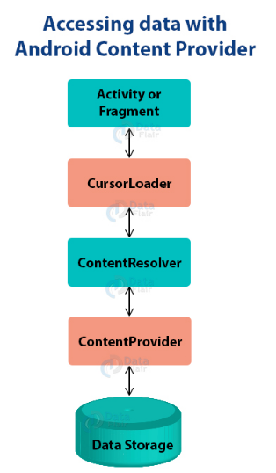

## Content URIs

Content URIs are the uniform resource identifiers that identify the data in the content providers. A content URI includes two things: *Authority* that is the symbolic name of the Provider and a *Path* that is a name that points towards the data. Every content provider methods have an argument which is URI. URIs for content providers look like this:

content://<authority>/<path>/<optional_id>

* **content://** – It’s always present, and is the scheme portion of the URI.
* **authority** – It is the unique name of the content provider, like photos, contacts. It’s a string that can identify the whole content provider.
* **path** – It is often used to identify some or the other data of the provider. The path is mostly used to identify individual tables.
* **optional_id** – id is used to access a single particular record of a file. We use this only in cases where we need to access only a particular record and not the complete file. It’s a numeric identifier to access a particular row of the data table.

**Question:**  Context

**Answer:**  Interface to global information about an application environment. This is an abstract class whose implementation is provided by the Android system. It allows access to application-specific resources and classes, as well as up-calls for application-level operations such as launching activities, broadcasting and receiving intents, etc.

**Context** is abstract class, all of the methods are abstarct (only getSystemService(Class) has an implementation and that invokes an abstract method). Implementation for abstract methods provided by the implementing classes, which include:

* ContextWrapper
* Application
* Activity
* Service
* IntentService

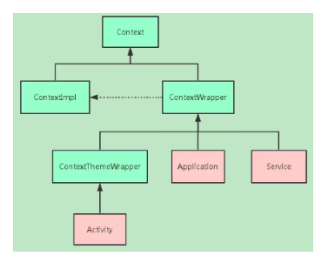

## Get Context methods

There are 3 most used function for getting Context:

* getContext() — returns the Context which is linked to the Activity from which is called.
* getApplicationContext() - returns the Context which is linked to Application
* getBaseContext() - returns which ever context is being wrapped by ContextWrapper.

## What Context can do?

Context is powerful, but it still has some restrictions. Since context is implemented by ContextImpl, so in most situations we can use activity, service and application context in common. However, in some situation like start a Activity or pop up a dialog, it must use Activity context since a new Activity is based on another Activity to form a stack, also a popup dialog need to show on top of Activity except some system alert dialog.

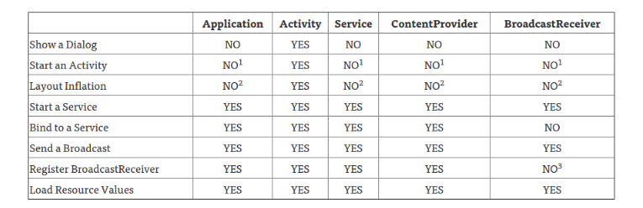

1. An application CAN start an Activity from here, but it requires that a new task be created. This may fit specific use cases, but can create non-standard back stack behaviors in your application and is generally not recommended or considered good practice.
2. This is legal, but inflation will be done with the default theme for the system on which you are running, not what’s defined in your application.
3. Allowed if the receiver is null, which is used for obtaining the current value of a sticky broadcast, on Android 4.2 and above.

**Question:**  Jetpack

**Answer:**  Jetpack encompasses a collection of Android libraries that incorporate best practices and provide backwards compatibility in your Android apps. The Android Jetpack components bring together the existing Support Library and Architecture Components and arranges them into four categories:

[Android Jetpack](https://android-developers.googleblog.com/2018/05/use-android-jetpack-to-accelerate-your.html)

Android Jetpack components are provided as "unbundled" libraries that are not part of the underlying Android platform. This means that you can adopt each component at your own speed, at your own time. When new Android Jetpack functionality is available, you can add it to your app.

In addition, your app can run on various versions of the platform because Android Jetpack components are built to provide their functionality independent of any specific version, providing backwards compatibility.

Further, Android Jetpack is built around modern design practices like separation of concerns and testability as well as productivity features like Kotlin integration. This makes it far easier for you to build robust, high quality apps with less code. While the components of Android Jetpack are built to work together, e.g. lifecycle awareness and live data, you don't have to use all of them -- you can integrate the parts of Android Jetpack that solve your problems while keeping the parts of your app that are already working great.

## [Use a Jetpack library in your app](https://developer.android.com/jetpack/getting-started#use_a_jetpack_library_in_your_app)

All Jetpack components are available on the [Google Maven repository](https://maven.google.com/web/index.html).

Open the build.gradle file for your project and add the google() repository as shown below:

allprojects {

repositories {

google()

jcenter()

}

}

You can then add Jetpack components, such as architecture components like LiveData and ViewModel, as shown here:

dependencies {

def lifecycle_version = "2.2.0"

implementation "androidx.lifecycle:lifecycle-livedata-ktx:$lifecycle_version"

implementation "androidx.lifecycle:lifecycle-viewmodel-ktx:$lifecycle_version"

...

}

Many Jetpack libraries provide [Android KTX extensions](https://developer.android.com/kotlin/ktx) as shown above with lifecycle-livedata-ktx and lifecycle-viewmodel-ktx. The KTX extensions build upon the Java-based API, taking advantage of Kotlin-specific language features.

## Main libraries

### WorkManager

The WorkMananager component is a powerful new library that provides a one-stop solution for constraint-based background jobs that need guaranteed execution, replacing the need to use things like jobs or SyncAdapters. WorkManager provides a simplified, modern API, the ability to work on devices with or without Google Play Services, the ability to create graphs of work, and the ability to query the state of your work.

### Navigation

The [Navigation Architecture Component](https://developer.android.com/guide/navigation) simplifies implementing navigation, while also helping you visualize your app's navigation flow. The library provides a number of benefits, including:

* Automatic handling of fragment transactions
* Correctly handling up and back by default
* Default behaviors for animations and transitions
* Deep linking as a first class operation
* Implementing navigation UI patterns (like navigation drawers and bottom nav) with little additional work
* Type safety when passing information while navigating
* Android Studio tooling for visualizing and editing the navigation flow of an app

### Paging

The Paging Library helps you load and display small chunks of data at a time. Loading partial data on demand reduces usage of network bandwidth and system resources.

The Paging Library supports the following data architectures:

* Served only from a backend server;
* Stored only in an on-device database;
* A combination of the other sources, using the on-device database as a cache.

### Room

The Room persistence library provides an abstraction layer over SQLite to allow for more robust database access while harnessing the full power of SQLite.

The library helps you create a cache of your app's data on a device that's running your app. This cache, which serves as your app's single source of truth, allows users to view a consistent copy of key information within your app, regardless of whether users have an internet connection.

### ViewModel

The ViewModel class is designed to store and manage UI-related data in a lifecycle conscious way. The ViewModel class allows data to survive configuration changes such as screen rotations.

The Android framework manages the lifecycles of UI controllers, such as activities and fragments. The framework may decide to destroy or re-create a UI controller in response to certain user actions or device events that are completely out of your control.

### Lifecycle

Lifecycle-aware components perform actions in response to a change in the lifecycle status of another component, such as activities and fragments. These components help you produce better-organized, and often lighter-weight code, that is easier to maintain.

A common pattern is to implement the actions of the dependent components in the lifecycle methods of activities and fragments. However, this pattern leads to a poor organization of the code and to the proliferation of errors. By using lifecycle-aware components, you can move the code of dependent components out of the lifecycle methods and into the components themselves.

The androidx.lifecycle package provides classes and interfaces that let you build lifecycle-aware components—which are components that can automatically adjust their behavior based on the current lifecycle state of an activity or fragment.

**Question:**  LiveData

**Answer:**  LiveData is an observable data holder class. Unlike a regular observable, LiveData is lifecycle-aware, meaning it respects the lifecycle of other app components, such as activities, fragments, or services. This awareness ensures LiveData only updates app component observers that are in an active lifecycle state.

LiveData considers an observer, which is represented by the Observer class, to be in an active state if its lifecycle is in the STARTED or RESUMED state. LiveData only notifies active observers about updates. Inactive observers registered to watch LiveData objects aren't notified about changes.

You can register an observer paired with an object that implements the LifecycleOwner interface. This relationship allows the observer to be removed when the state of the corresponding Lifecycle object changes to DESTROYED. This is especially useful for activities and fragments because they can safely observe LiveData objects and not worry about leaks—activities and fragments are instantly unsubscribed when their lifecycles are destroyed.

## Work with LiveData objects

Follow these steps to work with LiveData objects:

* Create an instance of LiveData to hold a certain type of data. This is usually done within your ViewModel class.
* Create an Observer object that defines the onChanged() method, which controls what happens when the LiveData object's held data changes. You usually create an Observer object in a UI controller, such as an activity or fragment.
* Attach the Observer object to the LiveData object using the observe() method. The observe() method takes a LifecycleOwner object. This subscribes the Observer object to the LiveData object so that it is notified of changes. You usually attach the Observer object in a UI controller, such as an activity or fragment.

When you update the value stored in the LiveData object, it triggers all registered observers as long as the attached LifecycleOwner is in the active state.

LiveData allows UI controller observers to subscribe to updates. When the data held by the LiveData object changes, the UI automatically updates in response.

### Create LiveData objects

LiveData is a wrapper that can be used with any data, including objects that implement Collections, such as List. A LiveData object is usually stored within a ViewModel object and is accessed via a getter method, as demonstrated in the following example:

class NameViewModel : ViewModel() {

// Create a LiveData with a String

val currentName: MutableLiveData<String> by lazy {

MutableLiveData<String>()

}

// Rest of the ViewModel...

}

Initially, the data in a LiveData object is not set.

### Observe LiveData objects

In most cases, an app component’s onCreate() method is the right place to begin observing a LiveData object for the following reasons:

* To ensure the system doesn’t make redundant calls from an activity or fragment’s onResume() method.
* To ensure that the activity or fragment has data that it can display as soon as it becomes active. As soon as an app component is in the STARTED state, it receives the most recent value from the LiveData objects it’s observing. This only occurs if the LiveData object to be observed has been set.

Generally, LiveData delivers updates only when data changes, and only to active observers. An exception to this behavior is that observers also receive an update when they change from an inactive to an active state. Furthermore, if the observer changes from inactive to active a second time, it only receives an update if the value has changed since the last time it became active.

The following sample code illustrates how to start observing a LiveData object:

class NameActivity : AppCompatActivity() {

// Use the 'by viewModels()' Kotlin property delegate

// from the activity-ktx artifact

private val model: NameViewModel by viewModels()

override fun onCreate(savedInstanceState: Bundle?) {

super.onCreate(savedInstanceState)

// Other code to setup the activity...

// Create the observer which updates the UI.

val nameObserver = Observer<String> { newName ->

// Update the UI, in this case, a TextView.

nameTextView.text = newName

}

// Observe the LiveData, passing in this activity as the LifecycleOwner and the observer.

model.currentName.observe(this, nameObserver)

}

}

After observe() is called with nameObserver passed as parameter, onChanged() is immediately invoked providing the most recent value stored in mCurrentName. If the LiveData object hasn't set a value in mCurrentName, onChanged() is not called.

### Update LiveData objects

LiveData has no publicly available methods to update the stored data. The MutableLiveData class exposes the setValue(T) and postValue(T) methods publicly and you must use these if you need to edit the value stored in a LiveData object. Usually MutableLiveData is used in the ViewModel and then the ViewModel only exposes immutable LiveData objects to the observers.

After you have set up the observer relationship, you can then update the value of the LiveData object, as illustrated by the following example, which triggers all observers when the user taps a button:

button.setOnClickListener {

val anotherName = "John Doe"

model.currentName.setValue(anotherName)

}

Calling setValue(T) in the example results in the observers calling their onChanged() methods with the value John Doe. The example shows a button press, but setValue() or postValue() could be called to update mName for a variety of reasons, including in response to a network request or a database load completing; in all cases, the call to setValue() or postValue() triggers observers and updates the UI.

**Note**: Note: You must call the setValue(T) method to update the LiveData object from the main thread. If the code is executed in a worker thread, you can use the postValue(T) method instead to update the LiveData object.

## The advantages of using LiveData

* **Ensures your UI matches your data state**. LiveData follows the observer pattern. LiveData notifies Observer objects when the lifecycle state changes. You can consolidate your code to update the UI in these Observer objects. Instead of updating the UI every time the app data changes, your observer can update the UI every time there's a change.
* **No memory leaks**. Observers are bound to Lifecycle objects and clean up after themselves when their associated lifecycle is destroyed.
* **No crashes due to stopped activities**. If the observer's lifecycle is inactive, such as in the case of an activity in the back stack, then it doesn’t receive any LiveData events.
* **No more manual lifecycle handling**. UI components just observe relevant data and don’t stop or resume observation. LiveData automatically manages all of this since it’s aware of the relevant lifecycle status changes while observing.
* **Proper configuration changes**. If an activity or fragment is recreated due to a configuration change, like device rotation, it immediately receives the latest available data.
* **Sharing resources**. You can extend a LiveData object using the singleton pattern to wrap system services so that they can be shared in your app. The LiveData object connects to the system service once, and then any observer that needs the resource can just watch the LiveData object.

**Question:**  Navigation component

**Answer:**  The [Navigation Architecture Component](https://developer.android.com/guide/navigation) simplifies implementing navigation, while also helping you visualize your app's navigation flow. The library provides a number of benefits, including:

* Automatic handling of fragment transactions
* Correctly handling *up* and *back* by default
* Default behaviors for animations and transitions
* Deep linking as a first class operation
* Implementing navigation UI patterns (like navigation drawers and bottom nav) with little additional work
* Type safety when passing information while navigating
* Android Studio tooling for visualizing and editing the navigation flow of an app

The Navigation component consists of three key parts that are described below:

* Navigation graph: An XML resource that contains all navigation-related information in one centralized location. This includes all of the individual content areas within your app, called *destinations*, as well as the possible paths that a user can take through your app.
* NavHost: An empty container that displays destinations from your navigation graph. The Navigation component contains a default NavHost implementation, NavHostFragment, that displays fragment destinations.
* NavController: An object that manages app navigation within a NavHost. The NavController orchestrates the swapping of destination content in the NavHost as users move throughout your app. As you navigate through your app, you tell the NavController that you want to navigate either along a specific path in your navigation graph or directly to a specific destination. The NavController then shows the appropriate destination in the NavHost.

To include Navigation support in your project, add the following dependencies to your app's build.gradle file:

dependencies {

def nav_version = "2.3.0"

// Java language implementation

implementation "androidx.navigation:navigation-fragment:$nav_version"

implementation "androidx.navigation:navigation-ui:$nav_version"

// Kotlin

implementation "androidx.navigation:navigation-fragment-ktx:$nav_version"

implementation "androidx.navigation:navigation-ui-ktx:$nav_version"

// Feature module Support

implementation "androidx.navigation:navigation-dynamic-features-fragment:$nav_version"

// Testing Navigation

androidTestImplementation "androidx.navigation:navigation-testing:$nav_version"

}

**navigation-runtime**: This core library powers the navigation graph, which provides the structure of your in-app navigation: the screens or destinations that make up your app and the actions that link them. You can control how you navigate to destinations with a simple navigate() call. These destinations may be fragments, activities or custom destinations.

**navigation-fragment**: This library builds upon navigation-runtime and provides out-of-the-box support for fragments as destinations. With this library, fragment transactions are now handled for you automatically.

**navigation-ui**: This library allows you to easily add navigation drawers, menus and bottom navigation to your app consistent with the Material Design guidelines.

**Question:**  Proguard

**Answer:**  Proguard is free Java class file shrinker, optimizer, obfuscator, and preverifier. It detects and removes unused classes, fields, methods, and attributes. It optimizes bytecode and removes unused instructions. It renames the remaining classes, fields, and methods using short meaningless names.

When you build you project using Android Gradle plugin 3.4.0 or higher, the plugin no longer uses ProGuard to perform compile-time code optimization. Instead, the plugin works with the R8 compiler to handle the following compile-time tasks:

* **Code shrinking (or tree-shaking)**: detects and safely removes unused classes, fields, methods, and attributes from your app and its library dependencies (making it a valuable tool for working around the 64k reference limit). For example, if you use only a few APIs of a library dependency, shrinking can identify library code that your app is not using and remove only that code from your app.
* **Resource shrinking**: Removes unused resources from your packaged app, including unused resources in your app’s library dependencies. It works in conjunction with code shrinking such that once unused code has been removed, any resources no longer referenced can be safely removed as well.
* **Obfuscation**: Shortens the name of classes and members, which results in reduced DEX file sizes.
* **Optimization**: Inspects and rewrites your code to further reduce the size of your app’s DEX files. For example, if R8 detects that the else {} branch for a given if/else statement is never taken, R8 removes the code for the else {} branch.

When building the release version of your app, by default, R8 automatically performs the compile-time tasks described above for you. However, you can disable certain tasks or customize R8’s behavior through ProGuard rules files. In fact, R8 works with all of your existing ProGuard rules files, so updating the Android Gradle plugin to use R8 should not require you to change your existing rules.

To enable shrinking, obfuscation, and optimization, include the following in your project-level build.gradle file:

android {

buildTypes {

release {

// Enables code shrinking, obfuscation, and optimization for only

// your project's release build type.

minifyEnabled true

// Enables resource shrinking, which is performed by the

// Android Gradle plugin.

shrinkResources true

// Includes the default ProGuard rules files that are packaged with

// the Android Gradle plugin. To learn more, go to the section about

// R8 configuration files.

proguardFiles getDefaultProguardFile(

'proguard-android-optimize.txt'),

'proguard-rules.pro'

}

}

...

}

## Customize which code to keep

For most situations, the default ProGuard rules file (proguard-android- optimize.txt) is sufficient for R8 to remove only the unused code. However, some situations are difficult for R8 to analyze correctly and it might remove code your app actually needs. Some examples of when it might incorrectly remove code include:

* When your app calls a method from the Java Native Interface (JNI)
* When your app looks up code at runtime (such as with reflection)

To fix errors and force R8 to keep certain code, add a -keep line in the ProGuard rules file. For example:

-keep public class MyClass

Alternatively, you can add the @Keep annotation to the code you want to keep. Adding @Keep on a class keeps the entire class as-is. Adding it on a method or field will keep the method/field (and its name) as well as the class name intact. **Note** that this annotation is available only when using the AndroidX Annotations Library and when you include the ProGuard rules file that is packaged with the Android Gradle plugin

## Conclusion

Benefits:

Proguard (or R8 compiler) obfuscates your code by removing unused code and renaming classes, fields, and methods with semantically obscure names which make the code base, smaller and more efficient. The result is a smaller sized .apk file that is more difficult to reverse engineer.

Drawbacks:

* Potential misconfiguration causes the app to get crash.
* Additional testing is required
* Stacktraces are difficult to read with obfuscated method names.
* ClassNotFoundExceptions, which happens when Proguard strips away an entire class that application calls.

**Question:**  RecyclerView

**Answer:**  The RecyclerView class supports the display of a collection of data. You supply the data and define how each item looks, and the RecyclerView library dynamically creates the elements when they're needed.

RecyclerView *recycles* those individual elements. When an item scrolls off the screen, RecyclerView doesn't destroy its view. Instead, RecyclerView reuses the view for new items that have scrolled onscreen. This reuse vastly improves performance, improving your app's responsiveness and reducing power consumption.

## Key classes

Several different classes work together to build your dynamic list.

* RecyclerView is the ViewGroup that contains the views corresponding to your data. It's a view itself, so you add RecyclerView into your layout the way you would add any other UI element.
* Each individual element in the list is defined by a *view holder* object. When the *view holder* is created, it doesn't have any data associated with it. After the view holder is created, the RecyclerView binds it to its data. You define the view holder by extending RecyclerView.ViewHolder.
* The RecyclerView requests those views, and binds the views to their data, by calling methods in the *adapter*. You define the adapter by extending RecyclerView.Adapter.
* The *layout manager* arranges the individual elements in your list. You can use one of the layout managers provided by the RecyclerView library, or you can define your own. Layout managers are all based on the library's LayoutManager abstract class.

## Steps for implementing your RecyclerView

* Decide what the list or grid is going to look like. Ordinarily you'll be able to use one of the RecyclerView library's standard layout managers.
* Design how each element in the list is going to look and behave. Based on this design, extend the ViewHolder class. Your version of ViewHolder provides all the functionality for your list items. Your view holder is a wrapper around a View, and that view is managed by RecyclerView.
* Define the Adapter that associates your data with the ViewHolder views.

## Modifying the layout

The RecyclerView uses a layout manager to position the individual items on the screen and determine when to reuse item views that are no longer visible to the user. To reuse (*or recycle*) a view, a layout manager may ask the adapter to replace the contents of the view with a different element from the dataset. Recycling views in this manner improves performance by avoiding the creation of unnecessary views or performing expensive findViewById() lookups. The Android Support Library includes three standard layout managers, each of which offers many customization options:

* LinearLayoutManager arranges the items in a one-dimensional list. Using a RecyclerView with LinearLayoutManager provides functionality like the older ListView layout.
* GridLayoutManager arranges the items in a two-dimensional grid, like the squares on a checkerboard. Using a RecyclerView with GridLayoutManager provides functionality like the older GridView layout.
* StaggeredGridLayoutManager arranges the items in a two-dimensional grid, with each column slightly offset from the one before, like the stars in an American flag.

If none of these layout managers suits your needs, you can create your own by extending the RecyclerView.LayoutManager abstract class.

## Implementing your adapter and view holder

Once you've determined your layout, you need to implement your Adapter and ViewHolder. These two classes work together to define how your data is displayed. The ViewHolder is a wrapper around a View that contains the layout for an individual item in the list. The Adapter creates ViewHolder objects as needed, and also sets the data for those views. The process of associating views to their data is called *binding*.

When you define your adapter, you need to override three key methods:

* onCreateViewHolder(): RecyclerView calls this method whenever it needs to create a new ViewHolder. The method creates and initializes the ViewHolder and its associated View, but does not fill in the view's contents—the ViewHolder has not yet been bound to specific data.
* onBindViewHolder(): RecyclerView calls this method to associate a ViewHolder with data. The method fetches the appropriate data and uses the data to fill in the view holder's layout. For example, if the RecyclerView dislays a list of names, the method might find the appropriate name in the list and fill in the view holder's TextView widget.
* getItemCount(): RecyclerView calls this method to get the size of the data set. For example, in an address book app, this might be the total number of addresses. RecyclerView uses this to determine when there are no more items that can be displayed.

Here's a typical example of a simple adapter with a nested ViewHolder that displays a list of data (Kotlin):

class CustomAdapter(private val dataSet: Array<String>) :

RecyclerView.Adapter<CustomAdapter.ViewHolder>() {

/**

* Provide a reference to the type of views that you are using

* (custom ViewHolder).

*/

class ViewHolder(view: View) : RecyclerView.ViewHolder(view) {

val textView: TextView

init {

// Define click listener for the ViewHolder's View.

textView = view.findViewById(R.id.textView)

}

}

// Create new views (invoked by the layout manager)

override fun onCreateViewHolder(viewGroup: ViewGroup, viewType: Int): ViewHolder {

// Create a new view, which defines the UI of the list item

val view = LayoutInflater.from(viewGroup.context)

.inflate(R.layout.text_row_item, viewGroup, false)

return ViewHolder(view)

}

// Replace the contents of a view (invoked by the layout manager)

override fun onBindViewHolder(viewHolder: ViewHolder, position: Int) {

// Get element from your dataset at this position and replace the

// contents of the view with that element

viewHolder.textView.text = dataSet[position]

}

// Return the size of your dataset (invoked by the layout manager)

override fun getItemCount() = dataSet.size

}

The layout for the each view item is defined in an XML layout file, as usual. In this case, the app has a text_row_item.xml file like this:

<FrameLayout xmlns:android="http://schemas.android.com/apk/res/android"

android:layout_width="match_parent"

android:layout_height="@dimen/list_item_height"

android:layout_marginLeft="@dimen/margin_medium"

android:layout_marginRight="@dimen/margin_medium"

android:gravity="center_vertical">

<TextView

android:id="@+id/textView"

android:layout_width="wrap_content"

android:layout_height="wrap_content"

android:text="@string/element_text"/>

</FrameLayout>

**Question:**  Room

**Answer:**  The Room persistence library provides an abstraction layer over SQLite to allow for more robust database access while harnessing the full power of SQLite.

The library helps you create a cache of your app's data on a device that's running your app. This cache, which serves as your app's single source of truth, allows users to view a consistent copy of key information within your app, regardless of whether users have an internet connection.

To use Room in your app, add the following dependencies to your app's build.gradle file:

dependencies {

def room_version = "2.2.5"

implementation "androidx.room:room-runtime:$room_version"

annotationProcessor "androidx.room:room-compiler:$room_version" // For Kotlin use kapt instead of annotationProcessor

// optional - Kotlin Extensions and Coroutines support for Room

implementation "androidx.room:room-ktx:$room_version"

// optional - RxJava support for Room

implementation "androidx.room:room-rxjava2:$room_version"

// optional - Guava support for Room, including Optional and ListenableFuture

implementation "androidx.room:room-guava:$room_version"

// Test helpers

testImplementation "androidx.room:room-testing:$room_version"

}

## Components of Room DB

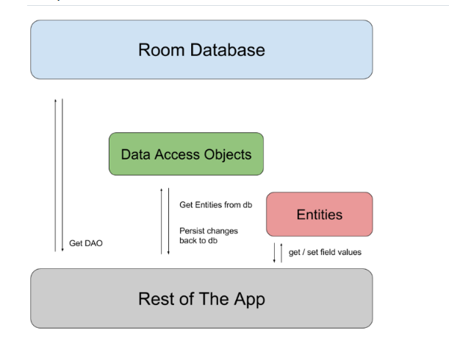

The three major components of Room are:

* **Database**: It represents the DB, it is an object that holds a connection to the SQLite DB and all the operations are executed through it. It is annotated with @Database.
* **Entity**: Represents a table within the Room Database. It should be annotated with @Entity.
* **DAO**: An interface that contains the methods to access the Database. It is annotated with @Dao.

## [Sample implementation](https://developer.android.com/training/data-storage/room#sample-implementation)

This section presents an example implementation of a Room database with a single data entity and a single DAO.

### [Data entity](https://developer.android.com/training/data-storage/room#data-entity)

The following code defines a User data entity. Each instance of User represents a row in a user table in the app's database.

@Entity

data class User(

@PrimaryKey val uid: Int,

@ColumnInfo(name = "first_name") val firstName: String?,

@ColumnInfo(name = "last_name") val lastName: String?

)

### [Data access object (DAO)](https://developer.android.com/training/data-storage/room#dao)

The following code defines a DAO called UserDao. UserDao provides the methods that the rest of the app uses to interact with data in the user table.

@Dao

interface UserDao {

@Query("SELECT * FROM user")

fun getAll(): List<User>

@Query("SELECT * FROM user WHERE uid IN (:userIds)")

fun loadAllByIds(userIds: IntArray): List<User>

@Query("SELECT * FROM user WHERE first_name LIKE :first AND " +

"last_name LIKE :last LIMIT 1")

fun findByName(first: String, last: String): User

@Insert

fun insertAll(vararg users: User)

@Delete

fun delete(user: User)

}

### [Database](https://developer.android.com/training/data-storage/room#database)

The following code defines an AppDatabase class to hold the database. AppDatabase defines the database configuration and serves as the app's main access point to the persisted data. The database class must satisfy the following conditions:

* The class must be annotated with a @Database annotation that includes an entities array that lists all of the data entities associated with the database;
* The class must be an abstract class that extends RoomDatabase;
* For each DAO class that is associated with the database, the database class must define an abstract method that has zero arguments and returns an instance of the DAO class.

@Database(entities = arrayOf(User::class), version = 1)

abstract class AppDatabase : RoomDatabase() {

abstract fun userDao(): UserDao

}

### [Usage](https://developer.android.com/training/data-storage/room#usage)

After you have defined the data entity, the DAO, and the database object, you can use the following code to create an instance of the database:

val db = Room.databaseBuilder(

applicationContext,

AppDatabase::class.java, "database-name"

).build()

You can then use the abstract methods from the AppDatabase to get an instance of the DAO. In turn, you can use the methods from the DAO instance to interact with the database:

val userDao = db.userDao()

val users: List<User> = userDao.getAll()

## Configuring Compiler Options

Room has the following annotation processor options:

* room.schemaLocation: Configures and enables exporting database schemas into JSON files in the given directory.
* room.incremental: Enables Gradle incremental annotation proccesor.
* room.expandProjection: Configures Room to rewrite queries such that their top star projection is expanded to only contain the columns defined in the DAO method return type.

**Question:**  Service

**Answer:**  A Service is an application component that can perform long-running operations in the background, and it doesn't provide a user interface. Another application component can start a service, and it continues to run in the background even if the user switches to another application. Additionally, a component can bind to a service to interact with it and even perform interprocess communication (IPC). For example, a service can handle network transactions, play music, perform file I/O, or interact with a content provider, all from the background.

By default, a service runs in the same process as the main thread of the application. If we have to implement complex logic, with longtime processing, we have to take care of creating a new thread, otherwise, the Android service runs on the main thread and it could cause ANR problem.

Services run with a higher priority than inactive or invisible activities and therefore it is less likely that the Android system terminates them. Services can also be configured to be restarted if they get terminated by the Android system once sufficient system resources are available again.

These are the three different types of services: Foreground, Background, Bound.

* **Background**: A background service performs an operation that isn't directly noticed by the user. For example, if an app used a service to compact its storage, that would usually be a background service.
* **Bound**: A service is bound when an application component binds to it by calling bindService(). A bound service offers a client-server interface that allows components to interact with the service, send requests, receive results, and even do so across processes with interprocess communication (IPC). A bound service runs only as long as another application component is bound to it. Multiple components can bind to the service at once, but when all of them unbind, the service is destroyed.
* **Foreground**: A foreground service performs some operation that is noticeable to the user. For example, an audio app would use a foreground service to play an audio track. Foreground services must display a Notification. Foreground services continue running even when the user isn't interacting with the app.

You must declare all services in your application's manifest file, just as you do for activities and other components.

To declare your service, add a <service> element as a child of the <application> element. Here is an example:

<manifest ... >

...

<application ... >

<service android:name=".ExampleService" />

...

</application>

</manifest>

## The basics

To create a service, you must create a subclass of Service or use one of its existing subclasses. In your implementation, you must override some callback methods that handle key aspects of the service lifecycle and provide a mechanism that allows the components to bind to the service, if appropriate. These are the most important callback methods that you should override:

* onStartCommand() - The system invokes this method by calling startService() when another component (such as an activity) requests that the service be started. When this method executes, the service is started and can run in the background indefinitely. If you implement this, it is your responsibility to stop the service when its work is complete by calling stopSelf() or stopService(). If you only want to provide binding, you don't need to implement this method.
* onBind() - The system invokes this method by calling bindService() when another component wants to bind with the service (such as to perform RPC). In your implementation of this method, you must provide an interface that clients use to communicate with the service by returning an IBinder. You must always implement this method; however, if you don't want to allow binding, you should return null.
* onCreate() - The system invokes this method to perform one-time setup procedures when the service is initially created (before it calls either onStartCommand() or onBind()). If the service is already running, this method is not called.
* onDestroy() - The system invokes this method when the service is no longer used and is being destroyed. Your service should implement this to clean up any resources such as threads, registered listeners, or receivers. This is the last call that the service receives.

If a component starts the service by calling startService() (which results in a call to onStartCommand()), the service continues to run until it stops itself with stopSelf() or another component stops it by calling stopService().

If a component calls bindService() to create the service and onStartCommand() is not called, the service runs only as long as the component is bound to it. After the service is unbound from all of its clients, the system destroys it.

The Android system stops a service only when memory is low and it must recover system resources for the activity that has user focus. If the service is bound to an activity that has user focus, it's less likely to be killed; if the service is declared to run in the foreground, it's rarely killed.

onStartCommand() requires we return an Integer as result. This integer represents how the Service should be handled by the OS:

* **START_NOT_STICKY** - If the system kills the service afteronStartCommand() returns, do not recreate the service unless there are pending intents to deliver. This is the safest option to avoid running your service when not necessary and when your application can simply restart any unfinished jobs.
* **START_STICKY** - If the system kills the service after onStartCommand() returns, recreate the service and call onStartCommand(), but do not redeliver the last intent. Instead, the system calls onStartCommand() with a null intent unless there are pending intents to start the service. In that case, those intents are delivered. This is suitable for media players (or similar services) that are not executing commands but are running indefinitely and waiting for a job.
* **START_REDELIVER_INTENT** - If the system kills the service after onStartCommand() returns, recreate the service and call onStartCommand() with the last intent that was delivered to the service. Any pending intents are delivered in turn. This is suitable for services that are actively performing a job that should be immediately resumed, such as downloading a file.

## Service lifecycle

The lifecycle of a service is much simpler than that of an activity. However, it's even more important that you pay close attention to how your service is created and destroyed because a service can run in the background without the user being aware.

The service lifecycle—from when it's created to when it's destroyed—can follow either of these two paths:

* A started service. The service is created when another component calls startService(). The service then runs indefinitely and must stop itself by calling stopSelf(). Another component can also stop the service by calling stopService(). When the service is stopped, the system destroys it.
* A bound service. The service is created when another component (a client) calls bindService(). The client then communicates with the service through an IBinder interface. The client can close the connection by calling unbindService(). Multiple clients can bind to the same service and when all of them unbind, the system destroys the service. The service does not need to stop itself.

These two paths aren't entirely separate. You can bind to a service that is already started with startService(). For example, you can start a background music service by calling startService() with an Intent that identifies the music to play. Later, possibly when the user wants to exercise some control over the player or get information about the current song, an activity can bind to the service by calling bindService(). In cases such as this, stopService() or stopSelf() doesn't actually stop the service until all of the clients unbind.

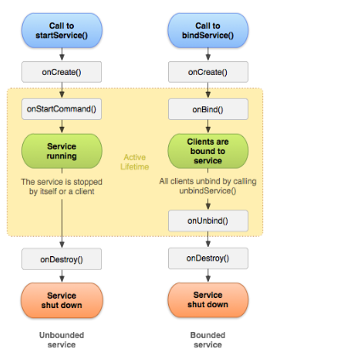

**Question:**  View

**Answer:**

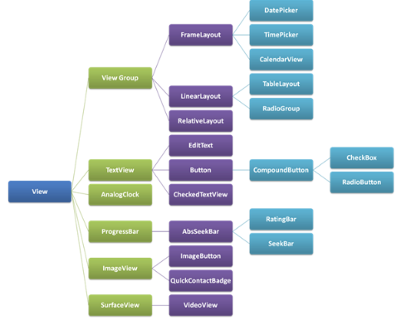

View represents the basic building block for user interface components. A View occupies a rectangular area on the screen and is responsible for drawing and event handling. View is the base class for widgets, which are used to create interactive UI components (buttons, text fields, etc.).

All of the views in a window are arranged in a single tree. You can add views either from code or by specifying a tree of views in one or more XML layout files. There are many specialized subclasses of views that act as controls or are capable of displaying text, images, or other content.

## Using Views

Once you have created a tree of views, there are typically a few types of common operations you may wish to perform:

* **Set properties**: for example setting the text of a TextView. The available properties and the methods that set them will vary among the different subclasses of views. Note that properties that are known at build time can be set in the XML layout files.
* **Set focus**: The framework will handle moving focus in response to user input. To force focus to a specific view, call requestFocus().
* **Set up listeners**: Views allow clients to set listeners that will be notified when something interesting happens to the view. For example, all views will let you set a listener to be notified when the view gains or loses focus. You can register such a listener using setOnFocusChangeListener(android.view.View.OnFocusChangeListener). Other view subclasses offer more specialized listeners. For example, a Button exposes a listener to notify clients when the button is clicked.
* **Set visibility**: You can hide or show views using setVisibility(int).

*Note: The Android framework is responsible for measuring, laying out and drawing views. You should not call methods that perform these actions on views yourself unless you are actually implementing a* ViewGroup.

## IDs

Views may have an integer id associated with them. These ids are typically assigned in the layout XML files, and are used to find specific views within the view tree. A common pattern is to:

* Define a Button in the layout file and assign it a unique ID.

<Button

android:id="@+id/my_button"

android:layout_width="wrap_content"

android:layout_height="wrap_content"

android:text="@string/my_button_text"/>

* From the onCreate method of an Activity, find the Button

Button myButton = findViewById(R.id.my_button);

View IDs need not be unique throughout the tree, but it is good practice to ensure that they are at least unique within the part of the tree you are searching.

## Event Handling and Threading

The basic cycle of a view is as follows:

* An event comes in and is dispatched to the appropriate view. The view handles the event and notifies any listeners.
* If in the course of processing the event, the view's bounds may need to be changed, the view will call requestLayout().
* Similarly, if in the course of processing the event the view's appearance may need to be changed, the view will call invalidate().
* If either requestLayout() or invalidate() were called, the framework will take care of measuring, laying out, and drawing the tree as appropriate.

*Note: The entire view tree is single threaded. You must always be on the UI thread when calling any method on any view.* If you are doing work on other threads and want to update the state of a view from that thread, you should use a Handler.

**Question:**  ViewGroup

**Answer:**

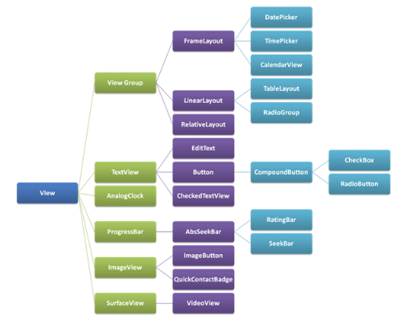

A ViewGroup is a special view that can contain other views (called children.) The view group is the base class for layouts and views containers. This class also defines the ViewGroup.LayoutParams class which serves as the base class for layouts parameters.

ViewGroups is invisible container in which other Views can be placed. The class ViewGroup extends the class View Popular ViewGroups:

* LineraLayout
* RelativeLayout
* RelativeLayout
* MotionLayout
* ConstraintLayout

View represents the basic building block for user interface components. A View occupies a rectangular area on the screen and is responsible for drawing and event handling.

Popular Views:

* TextView
* ImageView
* EditText
* Button
* SeekBar

Summary:

View:

* View objects are the basic building blocks of User Interface(UI) elements in Android.
* View is a simple rectangle box which responds to the user's actions.
* View refers to the android.view.View class, which is the base class of all UI classes.

ViewGroup:

* ViewGroup is the invisible container. It holds View and ViewGroup
* ViewGroup is the base class for Layouts.

**Question:**  ViewModel

**Answer:**  The ViewModel class is designed to store and manage UI-related data in a lifecycle conscious way. The ViewModel class allows data to survive configuration changes such as screen rotations.

The Android framework manages the lifecycles of UI controllers, such as activities and fragments. The framework may decide to destroy or re-create a UI controller in response to certain user actions or device events that are completely out of your control.

If the system destroys or re-creates a UI controller, any transient UI-related data you store in them is lost. For example, your app may include a list of users in one of its activities. When the activity is re-created for a configuration change, the new activity has to re-fetch the list of users. For simple data, the activity can use the onSaveInstanceState() method and restore its data from the bundle in onCreate(), but this approach is only suitable for small amounts of data that can be serialized then deserialized, not for potentially large amounts of data like a list of users or bitmaps.

Another problem is that UI controllers frequently need to make asynchronous calls that may take some time to return. The UI controller needs to manage these calls and ensure the system cleans them up after it's destroyed to avoid potential memory leaks. This management requires a lot of maintenance, and in the case where the object is re-created for a configuration change, it's a waste of resources since the object may have to reissue calls it has already made.

UI controllers such as activities and fragments are primarily intended to display UI data, react to user actions, or handle operating system communication, such as permission requests. Requiring UI controllers to also be responsible for loading data from a database or network adds bloat to the class. Assigning excessive responsibility to UI controllers can result in a single class that tries to handle all of an app's work by itself, instead of delegating work to other classes. Assigning excessive responsibility to the UI controllers in this way also makes testing a lot harder.

## Implement a ViewModel

Architecture Components provides ViewModel helper class for the UI controller that is responsible for preparing data for the UI. ViewModel objects are automatically retained during configuration changes so that data they hold is immediately available to the next activity or fragment instance.

Example:

class MyViewModel : ViewModel() {

private val users: MutableLiveData<List<User>> by lazy {

MutableLiveData().also {

loadUsers()

}

}

fun getUsers(): LiveData<List<User>> {

return users

}

private fun loadUsers() {

// Do an asynchronous operation to fetch users.

}

}

You can then access the list from an activity as follows:

class MyActivity : AppCompatActivity() {

override fun onCreate(savedInstanceState: Bundle?) {

// Create a ViewModel the first time the system calls an activity's onCreate() method.

// Re-created activities receive the same MyViewModel instance created by the first activity.

// Use the 'by viewModels()' Kotlin property delegate

// from the activity-ktx artifact

val model: MyViewModel by viewModels()

model.getUsers().observe(this, Observer<List<User>>{ users ->

// update UI

})

}

}

If the activity is re-created, it receives the same MyViewModel instance that was created by the first activity. When the owner activity is finished, the framework calls the ViewModel objects's onCleared() method so that it can clean up resources.

## The lifecycle of a ViewModel

ViewModel objects are scoped to the Lifecycle passed to the ViewModelProvider when getting the ViewModel. The ViewModel remains in memory until the Lifecycle it's scoped to goes away permanently: in the case of an activity, when it finishes, while in the case of a fragment, when it's detached.

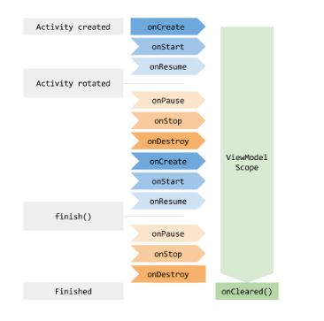

You usually request a ViewModel the first time the system calls an activity object's onCreate() method. The system may call onCreate() several times throughout the life of an activity, such as when a device screen is rotated. The ViewModel exists from when you first request a ViewModel until the activity is finished and destroyed.

**Question:**  ViewStub

**Answer:**  A ViewStub is an invisible, zero-sized View that can be used to lazily inflate layout resources at runtime. When a ViewStub is made visible, or when inflate() is invoked, the layout resource is inflated. The ViewStub then replaces itself in its parent with the inflated View or Views. Therefore, the ViewStub exists in the view hierarchy until setVisibility(int) or inflate() is invoked. The inflated View is added to the ViewStub's parent with the ViewStub's layout parameters. Similarly, you can define/override the inflate View's id by using the ViewStub's inflatedId property. For instance:

<ViewStub

android:id="@+id/stub"

android:inflatedId="@+id/subTree"

android:layout="@layout/mySubTree"

android:layout_width="120dip"

android:layout_height="40dip" />

The ViewStub thus defined can be found using the id "stub." After inflation of the layout resource "mySubTree," the ViewStub is removed from its parent. The View created by inflating the layout resource "mySubTree" can be found using the id "subTree," specified by the inflatedId property. The inflated View is finally assigned a width of 120dip and a height of 40dip. The preferred way to perform the inflation of the layout resource is the following:

ViewStub stub = findViewById(R.id.stub); View inflated = stub.inflate();

When inflate() is invoked, the ViewStub is replaced by the inflated View and the inflated View is returned. This lets applications get a reference to the inflated View without executing an extra findViewById().

**Question:**  Widget

**Answer:**  Home screen widgets are broadcast receivers which provide interactive components. They are primarily used on the Android home screen. They typically display some kind of data and allow the user to perform actions with them.

Widgets typically fall into one of the following categories:

* **Information widgets**. Typically display a few crucial information elements that are important to a user and track how that information changes over time. Good examples for information widgets are weather widgets, clock widgets or sports score trackers.
* **Collection widgets**. Specialize in displaying multitude elements of the same type, such as a collection of pictures from a gallery app, a collection of articles from a news app or a collection of emails/messages from a communication app.
* **Control widgets**. The main purpose of a control widget is to display often used functions that the user can trigger right from the home screen without having to open the app first. A typical example of control widgets are music app widgets that allow the user to play, pause or skip music tracks from outside the actual music app.
* **Hybrid widgets**. Combine elements of different types. For example a music player widget is primarily a control widget, but also keeps the user informed about what track is currently playing. It essentially combines a control widget with elements of an information widget type.

Steps to create a Widget:

* Define a layout file
* Create an XML file which describes the properties of the widget, e.g. size or the fixed update frequency.
* Create a BroadcastReceiver which is used to build the user interface of the widget.
* Enter the *Widget* configuration in the *AndroidManifest.xml* file.
* Optional you can specify a configuration *activity* which is called once a new instance of the widget is added to the widget host

Lifecycle method:

| **Method** | **Description** |
| --- | --- |
| onEnabled() | Called the first time an instance of your widget is added to the home screen. |
| onDisabled() | Called once the last instance of your widget is removed from the home screen. |
| onUpdate() | Called for every update of the widget. Contains the ids of appWidgetIds for which an update is needed. |
| onDeleted() | Widget instance is removed from the home screen. |
| onReceive() | This is called for every broadcast and before each of the above callback methods. You normally don't need to implement this method because the default AppWidgetProvider implementation filters all App Widget broadcasts and calls the above methods as appropriate. |

## Widget limirations

1. Because widgets live on the home screen, they have to co-exist with the navigation that is established there. This limits the gesture support that is available in a widget compared to a full-screen app. The only gestures available for widgets are:

* Touch
* Vertical swipe

1. Creating the App Widget layout is simple if you're familiar with Layouts. However, you must be aware that App Widget layouts are based on RemoteViews, which do not support every kind of layout or view widget. A RemoteViews object (and, consequently, an App Widget) can support the following layout classes:

* FragmeLayout
* LinearLayout
* RelativeLayout
* GridLayout

And the following widget classes:

* AnalogClock
* Button
* Chronometer
* ImageButton
* ImageView
* ProgressBar
* TextView
* ViewFlipper
* ListView
* GridView
* StackView
* AdapterViewFlipper

1. A widget has the same runtime restrictions as a normal broadcast receiver, i.e., it has only 5 seconds to finish its processing. A receive (widget) should therefore perform time consuming operations in a service and perform the update of the widgets from the service.

**Question:**  WorkManager

**Answer:**  WorkManager is an API that makes it easy to schedule deferrable, asynchronous tasks that are expected to run even if the app exits or the device restarts. The WorkManager API is a suitable and recommended replacement for all previous Android background scheduling APIs, including *FirebaseJobDispatcher*, *GcmNetworkManager*, and *Job Scheduler*. WorkManager incorporates the features of its predecessors in a modern, consistent API that works back to API level 14 while also being conscious of battery life.

WorkManager handles background work that needs to run when various constraints are met, regardless of whether the application process is alive or not. Background work can be started when the app is in the background, when the app is in the foreground, or when the app starts in the foreground but goes to the background. Regardless of what the application is doing, background work should continue to execute, or be restarted if Android kills its process.

Under the hood WorkManager uses an underlying job dispatching service based on the following criteria:

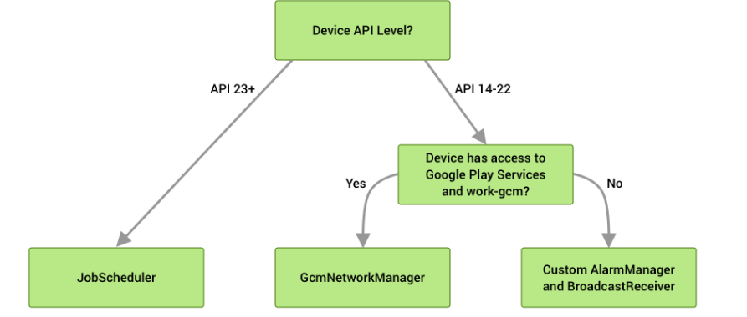

For using WorkManager we have to add dependency in app/build.gradle file.

implementation "android.arch.work:work-runtime:1.0.0"

## Features

WorkManager has a number of other key benefits, including:

**Work Constraints**. Declaratively define the optimal conditions for your work to run using Work Constraints. (For example, run only when the device is Wi-Fi, when the device idle, or when it has sufficient storage space, etc.)

**Robust Scheduling**. WorkManager allows you to schedule work to run one- time or repeatedly using flexible scheduling windows. Work can be tagged and named as well, allowing you to schedule unique, replaceable, work and monitor or cancel groups of work together. Scheduled work is stored in an internally managed SQLite database and WorkManager takes care of ensuring that this work persists and is rescheduled across device reboots. In addition, WorkManager adheres to power-saving features and best practices like Doze mode, so you don’t have to worry about it.

**Flexible Retry Policy**. WorkManager offers flexible retry policies, including a configurable exponential backoff policy.

**Work Chaining**. For complex related work, chain individual work tasks together using a fluent, natural, interface that allows you to control which pieces run sequentially and which run in parallel.

WorkManager.getInstance(...)`

.beginWith(listOf(workA,workB))

.then(workC)

.enqueue()

For each work task, you can define input and output data for that work. When chaining work together, WorkManager automatically passes output data from one work task to the next.

**Built-In Treading Interoperability**. WorkManager integrates seamlessly with RxJava and Coroutines and provides the flexibility to plug in your own asynchronous APIs.

## How it works

Worker - It specifies what task to perform, The WorkManager API include an abstract worker class and You need to extends this class and perform the work.

WorkRequest - represents an individual task that is to be performed. Now this WorkRequest, you can add values details for the work. Such as constraint or you can also add data while creating the request. WorkRequest can be of two types:

* OneTimeWorkRequest - That means you requesting for non-repetitive work.
* PeriodicWorkRequest - This class is used for creating a request for repetitive work

WorkManager - class in enqueues and manages all the work request. Pass work request object to this WorkManager to enqueue the task.

WorkInfo - contains the information about a particular task, The work manager provides LiveData for each of the work request objects, We can observe this and get the current status of the task.

Step for implementation WorkManager to Schedule Tasks:

* Create a base class of Worker
* Create WorkRequest
* Enqueue the request with WorkManager.
* Fetch the particular task status

**Question:**  Dark theme

**Answer:**  Dark theme is available in Android 10 (API level 29) and higher. It has many benefits:

* Can reduce power usage by a significant amount (depending on the device’s screen technology).
* Improves visibility for users with low vision and those who are sensitive to bright light.
* Makes it easier for anyone to use a device in a low-light environment.

Dark theme applies to both the Android system UI and apps running on the device.

## Supporting Dark theme in your app

In order to support Dark theme, you must set your app's theme (usually found in res/values/styles.xml) to inherit from a DayNight theme:

<style name="AppTheme" parent="Theme.AppCompat.DayNight">

You can also use MaterialComponents' dark theming:

<style name="AppTheme" parent="Theme.MaterialComponents.DayNight">

This ties the app's main theme to the system-controlled night mode flags and gives the app a default Dark theme (when it is enabled).

## Themes and styles

This ties the app's main theme to the system-controlled night mode flags and gives the app a default Dark theme (when it is enabled).

Here are the two most important theme attributes to know about:

* ?android:attr/textColorPrimary This is a general purpose text color. It is near-black in Light theme and near-white in Dark themes. It contains a disabled state.
* ?attr/colorControlNormal A general-purpose icon color. It contains a disabled state.

## Changing themes in-app

You might want to allow users to change the app's theme while the app is running. Your app can let the user choose between themes. The recommended options are:

* Light
* Dark
* System default (*the recommended default option*)

Each of the options map directly to one of the AppCompat.DayNight modes:

* Light - MODE_NIGHT_NO
* Dark - MODE_NIGHT_YES
* System default - MODE_NIGHT_FOLLOW_SYSTEM

## Configuration changes

When the app’s theme changes (either through the system setting or AppCompat) it triggers a uiMode configuration change. This means that Activities will be automatically recreated.

In some cases you might want an app to handle the configuration change. For example, you might want to delay a configuration change because a video is playing.

An app can handle the implementation of Dark theme itself by declaring that each Activity can handle the uiMode configuration change:

<activity

android:name=".MyActivity"

android:configChanges="uiMode" />

When an Activity declares it handles configuration changes, its onConfigurationChanged() method will be called when there is a theme change.

## Best Practices

### Notifications and Widgets

For UI surfaces that you display on the device but do not directly control, it is important to make sure that any views you use reflect the host app’s theme. Two good examples are notifications and launcher widgets.

### Notifications

Use the system-provided notification templates (such as MessagingStyle). This means that the system is responsible for ensuring the correct view styling is applied.

### Widgets and custom notification views

For launcher widgets, or if your app uses custom notification content views, it is important to make sure you test the content on both the Light and Dark themes.

Common pitfalls to look out for:

* Assuming that the background color is always light
* Hardcoding text colors
* Setting a hardcoded background color, while using the default text color
* Using a drawable icon which is a static color

In all of these cases, use appropriate theme attributes instead of hardcoded colors.

### Launch screens

If your app has a custom launch screen, it may need to be modified so that it reflects the selected theme.

Remove any hardcoded colors, for example any background colors pointing may be white. Use the ?android:attr/colorBackground theme attribute instead.

Note that dark-themed android:windowBackground drawables only work on Android Q.

**Question:**  Data binding

**Answer:**  Data binding is a general technique that binds data sources from the provider and consumer together and synchronizes them. In a data binding process, each data change is reflected automatically by the elements that are bound to the data. The term data binding is also used in cases where an outer representation of data in an element changes, and the underlying data is automatically updated to reflect this change.

The Data Binding Library is a support library that allows you to bind UI components in your layouts to data sources in your app using a declarative format rather than programmatically.

Layouts are often defined in activities with code that calls UI framework methods. For example, the code below calls findViewById() to find a TextView widget and bind it to the userName property of the viewModel variable:

findViewById<TextView>(R.id.sample_text).apply {

text = viewModel.userName

}

With helping of data binding library we can simplify code showed above by moving such logic to XML:

<TextView

android:text="@{viewmodel.userName}" />

Binding components in the layout file lets you remove many UI framework calls in your activities, making them simpler and easier to maintain. This can also improve your app's performance and help prevent memory leaks and null pointer exceptions.

## [Layouts and binding expressions](https://developer.android.com/topic/libraries/data-binding/expressions)

The expression language allows you to write expressions that connect variables to the views in the layout. The Data Binding Library automatically generates the classes required to bind the views in the layout with your data objects. The library provides features such as imports, variables, and includes that you can use in your layouts.

These features of the library coexist seamlessly with your existing layouts. For example, the binding variables that can be used in expressions are defined inside a data element that is a sibling of the UI layout's root element. Both elements are wrapped in a layout tag, as shown in the following example:

<layout xmlns:android="http://schemas.android.com/apk/res/android"

xmlns:app="http://schemas.android.com/apk/res-auto">

<data>

<variable

name="viewmodel"

type="com.myapp.data.ViewModel" />

</data>

<ConstraintLayout... /> <!-- UI layout's root element -->

</layout>

## [Work with observable data objects](https://developer.android.com/topic/libraries/data-binding/observability)

The Data Binding Library provides classes and methods to easily observe data for changes. You don't have to worry about refreshing the UI when the underlying data source changes. You can make your variables or their properties observable. The library allows you to make objects, fields, or collections observable.

## [Binding adapters](https://developer.android.com/topic/libraries/data-binding/binding-adapters)

For every layout expression, there is a binding adapter that makes the framework calls required to set the corresponding properties or listeners. For example, the binding adapter can take care of calling the setText() method to set the text property or call the setOnClickListener() method to add a listener to the click event. The most common binding adapters, such as the adapters for the android:text property used in the examples in this page, are available for you to use in the android.databinding.adapters package. You can also create custom adapters, as shown in the following example:

@BindingAdapter("app:goneUnless")

fun goneUnless(view: View, visible: Boolean) {

view.visibility = if (visible) View.VISIBLE else View.GONE

}

## [Two-way data binding](https://developer.android.com/topic/libraries/data-binding/two-way)

The Data Binding Library supports two-way data binding. The notation used for this type of binding supports the ability to receive data changes to a property and listen to user updates to that property at the same time.

**Question:**  Mention the difference between RelativeLayout and LinearLayout?

**Answer:**

* **Linear Layout** — Arranges elements either vertically or horizontally. i.e. in a row or column.
* **Relative Layout** — Arranges elements relative to parent or other elements.

**Question:**  What is the difference between Bitmap and Drawable in Android?

**Answer:**  A Bitmap is a representation of a bitmap image (something like java.awt.Image).

A Drawable is an abstraction of "something that can be drawn". It could be a Bitmap (wrapped up as a BitmapDrawable), but it could also be a solid color, a collection of other Drawable objects, or any number of other structures.

**Question:**  What is a difference between Spannable and String?

**Answer:**  A Spannable allows to attach formatting information like bold, italic, ... to sub-sequences ("spans", thus the name) of the characters. It can be used whenever you want to represent "rich text".

**Question:**  What is an Activity?

**Answer:**  An activity provides the window in which the app draws its UI. This window typically fills the screen, but may be smaller than the screen and float on top of other windows. Generally, one activity implements one screen in an app. For instance, one of an app’s activities may implement a Preferences screen, while another activity implements a Select Photo screen.

**Question:**  Why is it recommended to use only the default constructor to create a Fragment?

**Answer:**  In short, Fragments need to have a no-args constructor for the Android system to instantiate them. Your Fragment subclasses need a public empty constructor as this is what's being called by the framework.

It is used in the case when device has to restore the state of a fragment. No data will be passed and a default fragment will be created and then the state will be restored. Since the system has no way to know what you passed in your constructor or your newInstance, default constructor will be used and saved bundle should be passed via onCreate after the fragment is actually instantiated with the default constructor.

**Question:**  How to persist data in an Android app?

**Answer:**  There are basically four different ways to store data in an Android app:

Shared Preferences - to save primitive data in key-value pairs

Internal Storage - you need to store data to the device filesystem, but you do not want any other app (even the user) to read this data

External Storage - you might want the user to view the files and data saved by your app

SQLite database

**Question:**  Explain briefly all the Android application components

**Answer:**  **App components** are the essential building blocks of an Android app. Each component is an entry point through which the system or a user can enter your app.

There are four different types of app components:

* **Activities** - An activity is the entry point for interacting with the user. It represents a single screen with a user interface.
* **Services** - A service is a general-purpose entry point for keeping an app running in the background for all kinds of reasons. It is a component that runs in the background to perform long-running operations or to perform work for remote processes.
* **Broadcast receivers** - A broadcast receiver is a component that enables the system to deliver events to the app outside of a regular user flow, allowing the app to respond to system-wide broadcast announcements.
* **Content providers** - A content provider manages a shared set of app data that you can store in the file system, in a SQLite database, on the web, or on any other persistent storage location that your app can access.

**Question:**  How do I pass data between Activities in Android application?

**Answer:**  Problem

I have a scenario where, after logging in through a login page, there will be a sign-out button on each activity. Can you guide me on how to keep session id available to all activities?

The easiest way to do this would be to pass the session id to the signout activity in the Intent you're using to start the activity:

Intent intent = new Intent(getBaseContext(), SignoutActivity.class);

intent.putExtra("EXTRA_SESSION_ID", sessionId);

startActivity(intent);

Access that intent on next activity:

String sessionId = getIntent().getStringExtra("EXTRA_SESSION_ID");

**Question:**  What is Dalvik?

**Answer:**  Dalvik is a Just In Time (JIT) compiler. By the term JIT, we mean to say that whenever you run your app in your mobile device then that part of your code that is needed for execution of your app will only be compiled at that moment and rest of the code will be compiled in the future when needed. The JIT or Just In Time compiles only a part of your code and it has a smaller memory footprint and due to this, it uses very less physical space on your device.

**Question:**  Explain activity lifecycle

**Answer:**  As a user navigates through, out of, and back to your app, the Activity instances in your app transition through different states in their lifecycle.

To navigate transitions between stages of the activity lifecycle, the Activity class provides a core set of six callbacks: onCreate(), onStart(), onResume(), onPause(), onStop(), and onDestroy(). The system invokes each of these callbacks as an activity enters a new state.

**Question:**  What is an AsyncTask?

**Answer:**  AsyncTask is one of the easiest ways to implement parallelism in Android without having to deal with more complex methods like Threads. Though it offers a basic level of parallelism with the UI thread, it should not be used for longer operations (of, say, not more than 2 seconds).

AsyncTask has four methods

onPreExecute()

doInBackground()

onProgressUpdate()

onPostExecute()

where doInBackground() is the most important as it is where background computations are performed.

**Question:**  Explain the build process in Android

**Answer:**  First step involves compiling the resources folder (/res) using the aapt (android asset packaging tool) tool. These are compiled to a single class file called R.java. This is a class that just contains constants.

Second step involves the java source code being compiled to .class files by javac, and then the class files are converted to Dalvik bytecode by the “dx” tool, which is included in the sdk ‘tools’. The output is classes.dex.

The final step involves the android apkbuilder which takes all the input and builds the apk (android packaging key) file.

**Question:**  What is ADB and what is it used for?

**Answer:**  ADB is the acronym for Android Debug Bridge, which is part of the Android SDK (Software Development Kit). It uses a client-server-model (i.e. adbd, the ADB daemon, is running on the device and can be connected to), and in most cases is used via an USB connection. It is also possible to use it via WiFi (wireless adb).

There's nothing you need to install on your Android device, as the ADB daemon (adbd) is already integrated into the Android OS. It is usually accessed via a command line interface from the PC, where either the full Android SDK is installed (several 30 MB download archive currently), or a massively stripped-down version for "non-developers", sometimes referred to as "Mini ADB" or "ADB essentials" (for Linux, this is only the adb executable; for Windows it's adb.exe plus two or three .dll files).

**Question:**  What’s the difference between onCreate() and onStart()?

**Answer:**  The onCreate() method is called once during the Activity lifecycle, either when the application starts, or when the Activity has been destroyed and then recreated, for example during a configuration change.

The onStart() method is called whenever the Activity becomes visible to the user, typically after onCreate() or onRestart().

**Question:**  In what situation should one use RecyclerView over ListView?

**Answer:**  RecyclerView was created as a ListView improvement, so yes, you can create an attached list with ListView control, but using RecyclerView is easier as it:

Reuses cells while scrolling up/down - this is possible with implementing View Holder in the ListView adapter, but it was an optional thing, while in the RecycleView it's the default way of writing adapter.

Decouples list from its container - so you can put list items easily at run time in the different containers (linearLayout, gridLayout) with setting LayoutManager.

To conclude, RecyclerView is a more flexible control for handling "list data" that follows patterns of delegation of concerns and leaves for itself only one task - recycling items.

**Question:**  What is View Group? How are they different from Views?

**Answer:**  View: View objects are the basic building blocks of User Interface(UI) elements in Android. View is a simple rectangle box which responds to the user’s actions. Examples are EditText, Button, CheckBox etc. View refers to the android.view.View class, which is the base class of all UI classes.

ViewGroup: ViewGroup is the invisible container. It holds View and ViewGroup. For example, LinearLayout is the ViewGroup that contains Button(View), and other Layouts also. ViewGroup is the base class for Layouts.

**Question:**  How can I get the context in a fragment?

**Answer:**  You can use getActivity(), which returns the activity associated with a fragment. The activity is a context (since Activity extends Context).

You can also override the onAttach method of fragment:

public static class DummySectionFragment extends Fragment{

...

@Override

public void onAttach(Activity activity) {

super.onAttach(activity);

DBHelper = new DatabaseHelper(activity);

}

}

**Question:**  What is Armv7?

**Answer:**  There are 3 CPU architectures in Android:

ARMv7 is the most common as it is optimised for battery consumption.

ARM64 is an evolved version of that that supports 64-bit processing for more powerful computing.

ARMx86, is the least used for these three, since it is not battery friendly. It is more powerful than the other two.

**Question:**  What is the Dalvik Virtual Machine?

**Answer:**  The Dalvik Virtual Machine (DVM) is an android virtual machine optimized for mobile devices. It optimizes the virtual machine for memory, battery life and performance.

The Dex compiler converts the class files into the .dex file that run on the Dalvik VM. Multiple class files are converted into one dex file.

**Question:**  How does the OutOfMemory happens?

**Answer:**  Out of memory error is very common error when you are developing for a application that deals with multiple images sets or large bitmaps or some Animation stuff. In Android, every application runs in a Linux Process. Each Linux Process has a Virtual Machine (Dalvik Virtual Machine) running inside it. There is a limit on the memory a process can demand and it is different for different devices and also differs for phones and tablets. When some process demands a higher memory than its limit it causes a error i.e Out of memory error.

There are number of reasons why we get a Out of memory errors. Some of those are:

You are doing some operation that continuously demands a lot of memory and at some point it goes beyond the max heap memory limit of a process.

You are leaking some memory i.e you didn’t make the previous objects you allocated eligible for Garbage Collection (GC). This is called Memory leak.

You are dealing with large bitmaps and loading all of them at run time. You have to deal very carefully with large bitmaps by loading the size that you need not the whole bitmap at once and then do scaling.

**Question:**  What is an Intent in Android?

**Answer:**  An Intent is basically a message that is passed between components (such as Activities, Services, Broadcast Receivers, and Content Providers).So, it is almost equivalent to parameters passed to API calls. The fundamental differences between API calls and invoking components via intents are:

API calls are synchronous while intent-based invocations are asynchronous.

API calls are compile-time binding while intent-based calls are run-time binding.

To listen for an broadcast intent (like the phone ringing, or an SMS is received), you implement a broadcast receiver, which will be passed the intent. To declare that you can handle another's app intent like "take picture", you declare an intent filter in your app's manifest file.

If you want to fire off an intent to do something, like pop up the dialer, you fire off an intent saying you will.

An Intent provides a facility for performing late runtime binding between the code in different applications.

**Question:**  Tell about Constraint Layout

**Answer:**  ConstraintLayout allows you to create large and complex layouts with a flat view hierarchy (no nested view groups). It's similar to RelativeLayout in that all views are laid out according to relationships between sibling views and the parent layout, but it's more flexible than RelativeLayout and easier to use with Android Studio's Layout Editor.

Intention of ConstraintLayout is to optimize and flatten the view hierarchy of your layouts by applying some rules to each view to avoid nesting.

**Question:**  What is a ContentProvider and what is it typically used for?

**Answer:**  A content provider manages access to a central repository of data. A provider is part of an Android application, which often provides its own UI for working with the data. However, content providers are primarily intended to be used by other applications, which access the provider using a provider client object.

Typically you work with content providers in one of two scenarios;

you may want to implement code to access an existing content provider in another application, or

you may want to create a new content provider in your application to share data with other applications.

**Question:**  What types of Context do you know?

**Answer:**  The are mainly two types of context:

Application Context: It is an instance that is the singleton and can be accessed in activity via getApplicationContext(). This context is tied to the lifecycle of an application. The application context can be used where you need a context whose lifecycle is separate from the current context or when you are passing a context beyond the scope of activity.

Activity Context: This context is tied to the lifecycle of an activity. The activity context should be used when you are passing the context in the scope of an activity or you need the context whose lifecycle is attached to the current context.

**Question:**  Explain Android notification system

**Answer:**  A notification is a message that Android displays outside your app's UI to provide the user with reminders, communication from other people, or other timely information from your app. Users can tap the notification to open your app or take an action directly from the notification.

Notifications appear to users in different locations and formats, such as an icon in the status bar, a more detailed entry in the notification drawer, as a badge on the app's icon, and on paired wearables automatically. Beginning with Android 5.0, notifications can appear on the lock screen.

Starting in Android 8.0 (API level 26), all notifications must be assigned to a channel or it will not appear. By categorizing notifications into channels, users can disable specific notification channels for your app (instead of disabling all your notifications), and users can control the visual and auditory options for each channel—all from the Android system settings.

**Question:**  What is the most appropriate way to store user settings in Android application?

**Answer:**  In general **SharedPreferences** are your best bet for storing preferences, so in general I'd recommend that approach for saving application and user settings.

The only area of concern here is what you're saving. Passwords are always a tricky thing to store, and I'd be particularly wary of storing them as clear text. The Android architecture is such that your application's SharedPreferences are sandboxed to prevent other applications from being able to access the values so there's some security there, but physical access to a phone could potentially allow access to the values.

**Question:**  What is 'Context' on Android?

**Answer:**  The documentation itself provides a rather straightforward explanation: The Context class is an “Interface to global information about an application environment".

We may assume a Context is a handle to the system; it provides services like resolving resources, obtaining access to databases and preferences, and so on. An Android app has activities. Context is like a handle to the environment your application is currently running in. The activity object inherits the Context object.

**Question:**  Is it possible to implement the model–view–controller pattern in Java for Android?

**Answer:**  In Android you don't have MVC, but you have the following:

You define your user interface in various XML files by resolution, hardware, etc.

You define your resources in various XML files by locale, etc.

You extend clases like ListActivity, TabActivity and make use of the XML file by inflaters.

You can create as many classes as you wish for your business logic.

A lot of Utils have been already written for you - DatabaseUtils, Html.

**Question:**  What is the difference between Handler vs AsyncTask vs Thread?

**Answer:**  The Handler class can be used to register to a thread and provides a simple channel to send data to this thread. A Handler allows you communicate back with the UI thread from other background thread.

The AsyncTask class encapsulates the creation of a background process and the synchronization with the main thread. It also supports reporting progress of the running tasks.

And a Thread is basically the core element of multithreading which a developer can use with the following disadvantage:

Handle synchronization with the main thread if you post back results to the user interface

No default for canceling the thread

No default thread pooling

No default for handling configuration changes in Android

**Question:**  What do you mean by Open Source Software?

**Answer:**  Open-source software (OSS) is a type of computer software in which source code is released under a license in which the copyright holder grants users the rights to study, change, and distribute the software to anyone and for any purpose. Open source software is usually developed as a public collaboration and made freely available.

**Question:**  What is process in OS ? And what is diff b/w process and thread ?

**Answer:**  A process is an instance of a program running in a computer. It is close in meaning to task , a term used in some operating systems. A process is basically a program in execution. The execution of a process must progress in a sequential fashion.

Threads are used for small tasks, whereas processes are used for more 'heavyweight' tasks

Threads within the same process share the same address space, whereas different processes do not.

Threads share the address space of the process that created it; processes have their own address space.

Threads have direct access to the data segment of its process; processes have their own copy of the data segment of the parent process.

Threads can directly communicate with other threads of its process; processes must use interprocess communication to communicate with sibling processes.

Threads have almost no overhead; processes have considerable overhead.

New threads are easily created; new processes require duplication of the parent process.

Threads can exercise considerable control over threads of the same process; processes can only exercise control over child processes.

Changes to the main thread (cancellation, priority change, etc.) may affect the behavior of the other threads of the process; changes to the parent process do not affect child processes.

**Question:**  What happens when activity rotated ?

**Answer:**  Activity is recreated after each rotation by default and onCreate() method of activity called again. You can override this behaviour with configChanges attribute of the activity tag in AndroidManifest. Calling setRetainInstance(true) on a Fragment is similar to setting the android:configChanges flag on an Activity. It signals to Android that you want to continue using the same instance of the current Fragment, so all of your member variables will remain untouched.

Life Cycle of orientation:-

onPause();

onSaveInstanceState();

onStop();

onDestroy();

onCreate();

onStart();

onResume();

**Question:**  Explain about GCM implementation?

**Answer:**

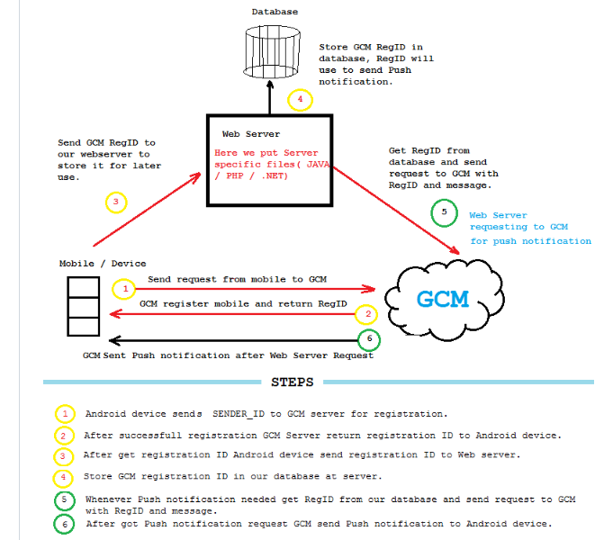

**Question:**  Difference between add and replace in fragment ? and What do you mean by addToBackStack() in fragment?

**Answer:**  fragmentTransaction.replace(int containerViewId, Fragment fragment, String tag)

Description - Replace an existing fragment that was added to a container. This is essentially the same as calling remove(Fragment) for all currently added fragments that were added with the same containerViewId and then add(int, Fragment, String) with the same arguments given here.

fragmentTransaction.add(int containerViewId, Fragment fragment, String tag)

Description - Add a fragment to the activity state. This fragment may optionally also have its view (if Fragment.onCreateView returns non-null) into a container view of the activity.

One more important difference between add and replace is: replace removes the existing fragment and adds a new fragment. This means when you press back button the fragment that got replaced will be created with its onCreateView being invoked. Whereas add retains the existing fragments and adds a new fragment that means existing fragment will be active and they wont be in 'paused' state hence when a back button is pressed onCreateView is not called for the existing fragment(the fragment which was there before new fragment was added). In terms of fragment's life cycle events onPause, onResume, onCreateView and other life cycle events will be invoked in case of replace but they wont be invoked in case of add.

When we press back button after in case of add()... onCreateView is never called, but in case of replace(), when we press back button ... oncreateView is called every time.

Case1:- Add a fragment to an activity without backstack, and press back button.

MainActivity onCreate

FirstFragment onAttach

FirstFragment onCreate

FirstFragment onCreateView

FirstFragment onActivityCreated

MainActivity onStart

FirstFragment onStart

MainActivity onResume

FirstFragment onResume

—-> Back button pressed, activity destroyed

FirstFragment onPause

MainActivity onPause

FirstFragment onStop

MainActivity onStop

FirstFragment onDestroyView

FirstFragment onDestroy

FirstFragment onDetach

MainActivity onDestroy

Case2:- Add a fragment to an activity with backstack, and press back button.

MainActivity onCreate

FirstFragment onAttach

FirstFragment onCreate

FirstFragment onCreateView

FirstFragment onActivityCreated

MainActivity onStart

FirstFragment onStart

MainActivity onResume

FirstFragment onResume

—-> Back button pressed, fragment removed, activity visible

FirstFragment onPause

FirstFragment onStop

FirstFragment onDestroyView

FirstFragment onDestroy

FirstFragment onDetach

—-> Back button pressed again, activity dismissed

MainActivity onPause

MainActivity onStop

MainActivity onDestroy

Case3:- Add a fragment on top of another ADDED fragment with backstack,

MainActivity onCreate

FirstFragment onAttach

FirstFragment onCreate

FirstFragment onCreateView

FirstFragment onActivityCreated

MainActivity onStart

FirstFragment onStart

MainActivity onResume

FirstFragment onResume

—> Add the another fragment

SecondFragment onAttach

SecondFragment onCreate

SecondFragment onCreateView

SecondFragment onActivityCreated

SecondFragment onStart

SecondFragment onResume

—> Now back press, second fragment popped, first showing now.

SecondFragment onPause

SecondFragment onStop

SecondFragment onDestroyView

SecondFragment onDestroy

SecondFragment onDetach

—> back press again, activity dismissed

FirstFragment onPause

MainActivity onPause

FirstFragment onStop

MainActivity onStop

FirstFragment onDestroyView

FirstFragment onDestroy

FirstFragment onDetach

MainActivity onDestroy

Case4:- Replaced a fragment on top of another ADDED fragment with backstack,

MainActivity onCreate 73

FirstFragment onAttach

FirstFragment onCreate

FirstFragment onCreateView

FirstFragment onActivityCreated

MainActivity onStart

FirstFragment onStart

MainActivity onResume

FirstFragment onResume

—-> Replace second fragment with backstack

SecondFragment onAttach

SecondFragment onCreate

SecondFragment onCreateView

SecondFragment onActivityCreated

SecondFragment onStart

SecondFragment onResume

FirstFragment onPause

FirstFragment onStop

FirstFragment onDestroyView

—-> Back press, pop second fragment and show first one.

FirstFragment onCreateView

FirstFragment onActivityCreated

FirstFragment onStart

FirstFragment onResume

SecondFragment onPause

SecondFragment onStop

SecondFragment onDestroyView

SecondFragment onDestroy

SecondFragment onDetach

—-> back press again activity dismissed.

FirstFragment onPause

MainActivity onPause

FirstFragment onStop

MainActivity onStop

FirstFragment onDestroyView

FirstFragment onDestroy

FirstFragment onDetach

MainActivity onDestroy

**Question:**  What are third party library you have integrated ?

**Answer:**  Gson: Gson is a Java library used for serializing and deserializing Java objects from and into JSON.

Retrofit: "Retrofit turns your REST API into a Java interface

EventBus

Universal Image Loader

Volley

Picasso

ExoPlayer

many more...

**Question:**  Difference between service, thread, AsyncTask and intent service ?

**Answer:**

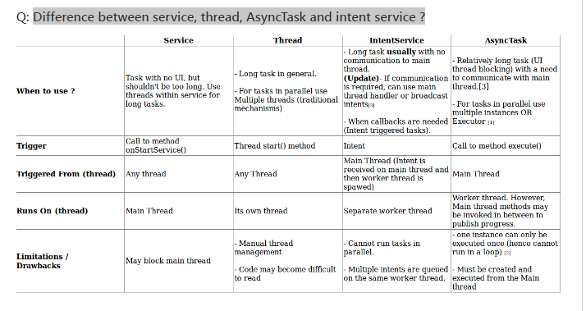

**Question:**  Difference between COARSE & FINE_LOCATION?

**Answer:**  Location can be determined by two ways:

Using NETWORK_PROVIDER - ACCESS_COARSE_LOCATION or ACCESS_FINE_LOCATION

Using GPS_PROVIDER - ACCESS_FINE_LOCATION

**Question:**  Which of the following is the immediate base class for Activity and Service classes?

**Answer:**  Context

**Question:**  Webservice in android?

**Answer:**  A web service is a standard for exchanging information between different types of applications irrespective of language and platform. For example, an android application can interact with java or .net application using web services. Web services are open standard (XML, SOAP, HTTP etc.) based Web applications that interact with other web applications for the purpose of exchanging data.

**Question:**  How RecyclerView works with Android ?

**Answer:**  Google released RecyclerView alongside CardView and Design Support Library in 2014 with the launch of Android Lollipop. The other benefits that RecyclerView provides over ListView include Layout Manager, Item Decoration and Item Animator.

RecyclerView handles a View by marking it either recycled or scraped. A recycled view is the view that has already been inflated and can be put in the cache for later reuse with or without new data binding. A scrap view on the other hand is the view that was detached from the layout at the time of creating, or rather a view that didn't become dirty during previous use. Think of it as a static view. Now, if there is a need for it, RecyclerView will use it with or without data binding. The benefit that a scrap view offers is that we can have a view in the system but there isn't any performance overhead with it when it's not being used

**Question:**  Alarm Manager ?

**Answer:**  This class provides access to the system alarm services. These allow you to schedule your application to be run at some point in the future. Registered alarms are retained while the device is asleep (and can optionally wake the device up if they go off during that time), but will be cleared if it is turned off and rebooted. The Alarm Manager holds a CPU wake lock as long as the alarm receiver's onReceive() method is executing. Alarms do not fire when the device is idle in Doze mode To start an Alarm Manager you need to first get the instance from the System. Then pass the PendingIntent which would get executed at a future time that you specify.

Disadvantage:-

Consume battery

**Question:**  Job scheduler?

**Answer:**  JobScheduler is an API for scheduling various types of jobs against the framework that will be executed in your application's own process. While a job is running, the system holds a wakelock on behalf of your app. For this reason, you do not need to take any action to guarantee that the device stays awake for the duration of the job. Apps can schedule jobs while letting the system optimize based on memory, power, and connectivity conditions. The Android 5.0 Lollipop (API 21) release introduces a job scheduler API via the JobScheduler class.

the JobScheduler supports batch scheduling of jobs.

It also survives application restarts.

Jobs can be done when Wifi, power connect etc constraints conditions

JobService will run on the main thread

Your JobService is actually going to be a Service that extends the JobService class.

onStartJob() is called by the system when it is time for your job to execute.

jobFinished() requires two parameters: the current job, so that it knows which wakelock can be released, and a boolean indicating whether you’d like to reschedule the job.

There’s only three things you need to do:

Create a JobService to handle your job

Add that JobService to the manifest

Schedule your job using a JobInfo object to define your conditions

a. To create JobService, you need to extend JobService class and implement its methods onStartJob and onStopJob. These call back methods return boolean value, false indicates that the job is complete and true tells that job is still running in the background, in this case you need to call jobFinished method to inform job scheduler about the finished state after the job is complete.

b. To schedule a job, first you need to get JobScheduler instance by calling getSystemService on the context object passing JOB_SCHEDULER_SERVICE argument to it. JobScheduler jobScheduler = (JobScheduler)getApplicationContext() .getSystemService(JOB_SCHEDULER_SERVICE);

ComponentName componentName = new ComponentName(this, DownloadJobService.class);

JobInfo jobInfoObj = new JobInfo.Builder(1, componentName) .setPeriodic(50000).setRequiresBatteryNotLow(true).build();

jobScheduler.schedule(jobInfo);

c. To create a job that needs to be rerun if it fails, you need to use setBackOffCriteria() method passing time interval for the first time retry and retry policy which is used to calculate time interval for retries after first retry. JobInfo jobInfoObj = new JobInfo.Builder(1, componentName) .setBackoffCriteria(6000, JobInfo.BACKOFF_POLICY_LINEAR).build();

d. To create a job that stays as scheduled even after device reboots, you need call setPersisted() method on JobInfo.Builder passing true as value to it. This setting requires RECEIVE_BOOT_COMPLETED permission.

**Question:**

**Answer:**

**Question:**  What is doze mode?

**Answer:**  Doze mode is a feature in Marshmallow, which prevents certain tasks from running if your device is in idle state. Doze in devices reduces power consumption by deferring background CPU and Network activity for applications.

**Question:**  How to create your own Event bus?

**Answer:**  Useing the Observer pattern you can design your event bus.

**Question:**  Problem with Alarm Manager?

**Answer:**  More battery consuming

not accurate or doesn't gurantee

on some API it doesn't work properly.

**Question:**  A & B two fragment in same activity same time. How to pass the data?

**Answer:**  Using interface callbacks.

Event bus

ViewModel

**Question:**  What is Alarm Manager ? Q: Advantages of Alarm Manager ?Disadvantages?

**Answer:**  Android AlarmManager allows you to access system alarm. AlarmManager has access to the system alarm services. With the help of AlarmManager you can schedule execution of code in future. AlarmManager object can’t instantiate directly however it can be retrieved by calling Context.getSystemService(Context.ALARM_SERVICE).

AlarmManager is always registered with intent. When an alarm goes off, the Intent which has been registered with AlarmManager, is broadcasted by the system automatically. This intent starts the target application if it is not running. It is recommended to use AlarmManager when you want your application code to be run at a specific time, even if your application is not currently running. For other timing operation handler should be used because it is easy to use.

Intent intent = new Intent(this, MyBroadcastReceiver.class);

PendingIntent pendingIntent = PendingIntent.getBroadcast(

this.getApplicationContext(), 234324243, intent, 0);

AlarmManager alarmManager = (AlarmManager) getSystemService(ALARM_SERVICE);

alarmManager.set(AlarmManager.RTC_WAKEUP, System.currentTimeMillis()

+ (i * 1000), pendingIntent);

Toast.makeText(this, "Alarm set in " + i + " seconds",Toast.LENGTH_LONG).show();

Advantages of Alarm Manager ?

It will run even when the device is on sleep mode. Handler will not work on standby. may need to run or repeat beyond the scope of its lifecycle. This allows the application to perform some function even after the application process or all of its Android components have been cleaned up by the system. have the ability to wake up the device when it is asleep if the alarm is urgent. The benefits of the AlarmManager come into play when using inexact intervals or times to fire off Services. The Android system tries to batch alarms with similar intervals or times together in order to preserve battery life. AlarmManager is a great candidate for scheduling if an application needs to perform a local event at an exact time or inexact interval.

Disadvantages of Alarm Manager ?

consume more battery because it will wake up CPU and other chips Some time fired multiple times. One concern to consider while using the AlarmManager is that alarms are wiped out during device reboots. Applications need to register the RECEIVE_BOOT_COMPLETE permission in their Android Manifest and reschedule their alarms in a BroadcastReceiver. setting an exact time for an application to sync with a server could put high strain on a server documentation discourages using AlarmManager for scheduling network-related tasks.

**Question:**  Job scheduler ? Advantages?

**Answer:**  The JobScheduler supports batch scheduling of jobs. The Android system can combine jobs so that battery consumption is reduced. JobManager makes handling uploads easier as it handles automatically the unreliability of the network. It also survives application restarts. Here are example when you would use this job scheduler: Tasks that should be done once the device is connect to a power supply Tasks that require network access or a Wi-Fi connection. Task that are not critical or user facing Tasks that should be running on a regular basis as batch where the timing is not critical. Implementation : To implement a Job, extend the JobService class and implement the onStartJob and onStopJob. If the job fails for some reason, return true from on the onStopJob to restart the job. The onStartJob is performed in the main thread, if you start asynchronous processing in this method, return true otherwise false. The new JobService must be registered in the Android manifest with the BIND_JOB_SERVICE permission. // schedule the start of the service every 10 - 30 seconds public static void scheduleJob(Context context) { ComponentName serviceComponent = new ComponentName(context, TestJobService.class); JobInfo.Builder builder = new JobInfo.Builder(0, serviceComponent); builder.setMinimumLatency(1 * 1000); // wait at least builder.setOverrideDeadline(3 * 1000); // maximum delay //builder.setRequiredNetworkType(JobInfo.NETWORK_TYPE_UNMETERED); // require unmetered network //builder.setRequiresDeviceIdle(true); // device should be idle //builder.setRequiresCharging(false); // we don't care if the device is charging or not JobScheduler jobScheduler = context.getSystemService(JobScheduler.class); jobScheduler.schedule(builder.build()); } Util.scheduleJob(context); public class TestJobService extends JobService { private static final String TAG = "SyncService";

@Override

public boolean onStartJob(JobParameters params) {

Intent service = new Intent(getApplicationContext(), LocalWordService.class);

getApplicationContext().startService(service);

Util.scheduleJob(getApplicationContext()); // reschedule the job

return true;

}

@Override

public boolean onStopJob(JobParameters params) {

return true;

}

}

**Question:**  What is handler ? & Handler Vs Thread?

**Answer:**  both execute task asynchronously without blocking your current code,

The difference: Imagine you have a Runnable r = new Runnable{...}

When you use new Thread(r).start(), you actually created a new thread and run task asynchronously.

When you use new Handler().post(r) (or Message), you added the Runnable object to Looper and execute the code later in the same thread.

A Thread, generally MainThread or UIThread contains a Looper. When MainThread runs, it will loop the Looper and execute Runnable one by one.

When Thread is preferred:

When you're doing a heavy work like network communication, or decoding large bitmap files, a new thread is preferred. If a lot of thread is needed, maybe ExecutorService is preferred further. https://developer.android.com/reference/java/util/concurrent/ExecutorService.html

When Handler is preferred:

When you want to update UI objects (like TextView text) from other thread, it is necessary that UI objects could only be updated in UI Thread. Also, when you just want to run some light code later (like the delay for 300ms) you can use Handler because it's lighter and faster. With handler you can also have things like MessageQueuing, scheduling and repeating.

Please also refer to Handler vs AsyncTask vs Thread

**Question:**  difference between Thread and service?

**Answer:**  Service - if it is destroyed while performing its job, in the middle by Android due to low memory scenario. Then android will make sure that it will restart your service, if you have returned START_STICKY or START_REDELIVER_INTENT from onStartCommand().

Thread - if it is destroyed by android in middle due to low memory, then android will not guarantee to restart it again. That means user lost his half work.

Service - is a component of android, so it has priority levels to be considered while destroying an application due to low memory.

Thread - is not a component of android, so android will not take thread priority into consideration while killing an application due to low memory. I will try to explain this 3rd point. Lets, say you have a requirement of connecting to internet from your activity. You can do it by using a service(with thread) or directly by creating a thread in activity. Consider the second scenario where you are connecting to internet in a thread. Then i. What will happen if user closes the activity, while still thread is running in the background. Will that thread continue to run in back ground ? Answer is you can't really predict.

ii. Assume that in continuation for above scenario, even after killing activity your thread continued to do its intended operation. Then there is a low memory situation arises in your phone. Then this application will be the first susceptible app to be killed as there is no priority for this application.

So bottom line is: If you want to do some heavy background functionality then it is always better to have a service with thread. If you feel that that background functionality to be alive as long as your activity is alive, then go for activity with thread or activity with async task.

**Question:**  What is START_STICKY, START_NOT_STICKTY, START_REDELIVER_INTENT?

**Answer:**  These are related to services. We all know that services keeps on running in the background and they also consume some memory to execute.

So, as more of the application runs on android device, the device memory keeps on getting low and when the time arises, when the device memory gets critically low, the android system starts terminating processes, so as to release the memory occupied by the processes.

But you might be doing some important task with the services, that could also get terminated as the service stops. so these concepts are to tell the android system what action you want to perform when the device memory gets stable and when it is ready to relaunch the services.

The simplest explanation of these could be,

START_STICKY- tells the system to create a fresh copy of the service, when sufficient memory is available, after it recovers from low memory. Here you will lose the results that might have computed before.

START_NOT_STICKY- tells the system not to bother to restart the service, even when it has sufficient memory.

START_REDELIVER_INTENT- tells the system to restart the service after the crash and also redeliver the intents that were present at the time of crash.

**Question:**  What is the difference between Picaso and Glid ?

**Answer:**

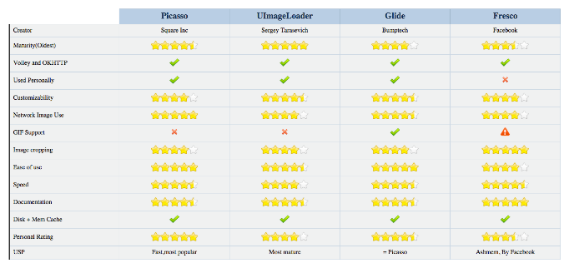

**Question:**  Explain about video streaming ?

**Answer:**  Some commons topics used in video streaming ExoPLayer, HLS, .m3u8, DASH, WebRTC, Bitrate, ts, akamai,CDN,

**Question:**  Ad SDK integration ?

**Answer:**  FAN, AdMob, IMA

**Question:**  How to pass data from activity to fragment and fragment to activity ?

**Answer:**  Using Interface callback, Event Bus ViewModel

**Question:**  How to handle memory leak using handler?

**Answer:**  Make handler null on destroy else it can throw memory leak.

**Question:**  How to pass data from one fragment to another?

**Answer:**  Using Interface callback, Event Bus ViewModel

**Question:**  Components of Android ?

**Answer:**  Activity, Service, Broadcast reciver, content provider.

**Question:**  Difference between Volley and Retrofit?

**Answer:**

Volley-

No automatic parsing

Caching Mechanism

Retry policy

inbuilt image loading support

Retrofit-

Automatic JSON parsing

No Caching mechanism

no retry policy

no Image loading

**Question:**  If no column found then which exception ?

**Answer:**  android.database.sqlite.SQLiteException: table RejectList has no column named Number

**Question:**  Batch count for number of messages like whatsapp or Facebook?

**Answer:**  It is launcher property.

**Question:**  How to pass data between fragments using callbacks?

**Answer:**  Create an interface and implement to activity and throw callback from one fragment to another using interface callback.

**Question:**  What is service? Difference types of services ? Life CycleWhat is bound service?

**Answer:**  A service is a component that runs in the background to perform long-running operations without needing to interact with the user and it works even if application is destroyed. or Android service is a component that is used to perform operations on the background such as playing music, handle network transactions, interacting content providers etc. It doesn't has any UI (user interface).

**Question:**  JSON parsing?

**Answer:**  Manual parsing by JSONObejct and JSOnArray etc

GSON

Other parsing libraries..

**Question:**  What is Eventbus ? How eventbus works internally?

**Answer:**  EventBus is an open-source Android library that simplifies communication between Activities, Fragments, Threads, and Services, with less code and better quality.

**Question:**  Difference between StringBuffer and StringBuilder ?

**Answer:**  https://www.journaldev.com/538/string-vs-stringbuffer-vs-stringbuilder

https://www.geeksforgeeks.org/stringbuffer-class-in-java/

https://www.geeksforgeeks.org/stringbuilder-class-in-java-with-examples/

StringBuffer was the only choice for String manipulation till Java 1.4 but it has one disadvantage that all of its public methods are synchronized. StringBuffer provides Thread safety but on a performance cost.

In most of the scenarios, we don’t use String in a multithreaded environment, so Java 1.5 introduced a new class StringBuilder that is similar to StringBuffer except thread safety and synchronization.

So if you are in a single threaded environment or don’t care about thread safety, you should use StringBuilder else use StringBuffer.

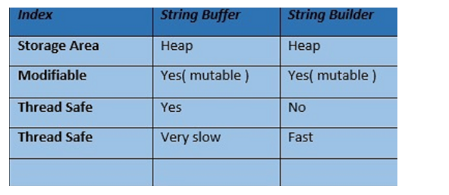

**Question:**  Difference between sleep and wait ?

**Answer:**  A wait can be "woken up" by another thread calling notify on the monitor which is being waited on whereas a sleep cannot. Also a wait (and notify) must happen in a block synchronized on the monitor object whereas sleep does not.

you call wait on Object itself (i.e. you wait on an object's monitor) whereas you call sleep on Thread.

while sleeping a Thread does not release the locks it holds, while waiting releases the lock on the object that wait() is called on.

synchronized(LOCK)

{ Thread.sleep(1000); // LOCK is held

}

synchronized(LOCK)

{ LOCK.wait(); // LOCK is not held

}

sleep(n) says “I’m done with my timeslice, and please don’t give me another one for at least n milliseconds.” The OS doesn’t even try to schedule the sleeping thread until requested time has passed. .wait() says “I’m done with my timeslice. Don’t give me another timeslice until someone calls notify().” As with sleep(), the OS won’t even try to schedule your task unless someone calls notify() (or one of a few other wakeup scenarios occurs).

### wait()

* wait() method releases the lock.

* wait() is the method of Object class.

* wait() is the non-static method - public final void wait() throws InterruptedException { //...}

* wait() should be notified by notify() or notifyAll() methods.

* wait() method needs to be called from a loop in order to deal with false alarm.

* wait() method must be called from synchronized context (i.e. synchronized method or block), otherwise it will throw IllegalMonitorStateException

### sleep()

* sleep() method doesn't release the lock.

* sleep() is the method of java.lang.Thread class.

* sleep() is the static method - public static void sleep(long millis, int nanos) throws InterruptedException { //... }

* after the specified amount of time, sleep() is completed.

* sleep() better not to call from loop(i.e. see code below).

* sleep() may be called from anywhere. there is no specific requirement.

**Question:**  What is synchronization in multithreading in java ? Give real time example ?

**Answer:**  When we start two or more threads within a program, there may be a situation when multiple threads try to access the same resource and finally they can produce unforeseen result due to concurrency issues.

Synchronization in java is the capability to control the access of multiple threads to any shared resource. It allow only one thread to access the shared resource.

### Why use Synchronization

The synchronization is mainly used to

To prevent thread interference. (fight between threads)

To prevent consistency problem. (abnormal and unexpected value change of resource)

Thread Synchronization

There are two types of thread synchronization.

* Mutual Exclusive

* Cooperation (Inter-thread communication in java)

### Mutual Exclusive

Mutual Exclusive helps keep threads from interfering with one another while sharing data. This can be done by three ways in java:

* by synchronized method

* by synchronized block

* by static synchronization

Example : Multiple threads on single file. Opening,closing and writing etc.

### Lock in Java

Synchronization is built around an internal entity known as the lock or monitor. Every object has an lock associated with it. By convention, a thread that needs consistent access to an object's fields has to acquire the object's lock before accessing them, and then release the lock when it's done with them.

When a thread invokes a synchronized method, it automatically acquires the lock for that object and releases it when the thread completes its task.

When a thread acquires a lock, it is said to have entered the monitor. All other threads attempting to enter the locked monitor will be suspended until the first thread exits the monitor.

**Question:**  There are four Java classes related to the use of sensors on the Android platform. List them and explain the purpose of each.

**Answer:**  The four Java classes related to the use of sensors on the Android platform areL

Sensor: Provides methods to identify which capabilities are available for a specific sensor.

SensorManager: Provides methods for registering sensor event listeners and calibrating sensors.

SensorEvent: Provides raw sensor data, including information regarding accuracy.

SensorEventListener: Interface that defines callback methods that will receive sensor event notifications.

**Question:**  What is a ContentProvider and what is it typically used for?

**Answer:**  A ContentProvider manages access to a structured set of data. It encapsulates the data and provide mechanisms for defining data security. ContentProvider is the standard interface that connects data in one process with code running in another process.

**Question:**  Under what condition could the code sample below crash your application? How would you modify the code to avoid this potential problem? Explain your answer.

Intent sendIntent = new Intent();

sendIntent.setAction(Intent.ACTION_SEND);

sendIntent.putExtra(Intent.EXTRA_TEXT, textMessage);

sendIntent.setType(HTTP.PLAIN_TEXT_TYPE); // "text/plain" MIME type

startActivity(sendIntent);

**Answer:**  An implicit intent specifies an action that can invoke any app on the device able to perform the action. Using an implicit intent is useful when your app cannot perform the action, but other apps probably can. If there is more than one application registered that can handle this request, the user will be prompted to select which one to use.

However, it is possible that there are no applications that can handle your intent. In this case, your application will crash when you invoke startActivity(). To avoid this, before calling startActivity() you should first verify that there is at least one application registered in the system that can handle the intent. To do this use resolveActivity() on your intent object:

// Verify that there are applications registered to handle this intent

// (resolveActivity returns null if none are registered)

if (sendIntent.resolveActivity(getPackageManager()) != null) {

startActivity(sendIntent);

}

**Question:**  Normally, in the process of carrying out a screen reorientation, the Android platform tears down the foreground activity and recreates it, restoring each of the view values in the activity’s layout. In an app you’re working on, you notice that a view’s value is not being restored after screen reorientation. What could be a likely cause of the problem that you should verify, at a minimum, about that particular view?

**Answer:**  You should verify that it has a valid id. In order for the Android system to restore the state of the views in your activity, each view must have a unique ID, supplied by the android:id attribute.

**Question:**  The last callback in the lifecycle of an activity is onDestroy(). The system calls this method on your activity as the final signal that your activity instance is being completely removed from the system memory. Usually, the system will call onPause() and onStop() before calling onDestroy(). Describe a scenario, though, where onPause() and onStop() would not be invoked.

**Answer:**  onPause() and onStop() will not be invoked if finish() is called from within the onCreate() method. This might occur, for example, if you detect an error during onCreate() and call finish() as a result. In such a case, though, any cleanup you expected to be done in onPause() and onStop() will not be executed.

Although onDestroy() is the last callback in the lifecycle of an activity, it is worth mentioning that this callback may not always be called and should not be relied upon to destroy resources. It is better have the resources created in onStart() and onResume(), and have them destroyed in onStop() and onPause(), respectively.

**Question:**  Which of the code snippets below is the correct way to check if a Compass sensor is present on the system? Explain your answer.

Answer 1:

PackageManager m = getPackageManager();

if (!m.hasSystemFeature(PackageManager.FEATURE_SENSOR_COMPASS)) {

// This device does not have a compass, turn off the compass feature

}

Answer 2:

SensorManager m = getSensorManager();

if (!m.hasSystemFeature(SensorManager.FEATURE_SENSOR_COMPASS)) {

// This device does not have a compass, turn off the compass feature

}

Answer 3:

Sensor s = getSensor();

if (!s.hasSystemFeature(Sensor.FEATURE_SENSOR_COMPASS)) {

// This device does not have a compass, turn off the compass feature

}

**Answer:**  The correct answer is Answer 1, the version that uses PackageManager.

SensorManager and Sensor are part of Android Sensor Framework and are used for direct access and acquisition of raw sensor data. These classes do not provide any method like hasSystemFeature() which is used for evaluation of system capabilities.

Android defines feature IDs, in the form of ENUMs, for any hardware or software feature that may be available on a device. For instance, the feature ID for the compass sensor is FEATURE_SENSOR_COMPASS.

If your application cannot work without a specific feature being available on the system, you can prevent users from installing your app with a <uses-feature> element in your app’s manifest file to specify a non-negotiable dependency.

However, if you just want to disable specific elements of your application when a feature is missing, you can use the PackageManager class. PackageManager is used for retrieving various kinds of information related to the application packages that are currently installed on the device.

**Question:**  Describe three common use cases for using an Intent.

**Answer:**  Common use cases for using an Intent include:

To start an activity: You can start a new instance of an Activity by passing an Intent to startActivity() method.

To start a service: You can start a service to perform a one-time operation (such as download a file) by passing an Intent to startService().

To deliver a broadcast: You can deliver a broadcast to other apps by passing an Intent to sendBroadcast(), sendOrderedBroadcast(), or sendStickyBroadcast().

**Question:**  Suppose that you are starting a service in an Activity as follows:

Intent service = new Intent(context, MyService.class);

startService(service);

where MyService accesses a remote server via an Internet connection.

If the Activity is showing an animation that indicates some kind of progress, what issue might you encounter and how could you address it?

**Answer:**  Responses from a remote service via the Internet can often take some time, either due to networking latencies, or load on the remote server, or the amount of time it takes for the remote service to process and respond to the request.

As a result, if such a delay occurs, the animation in the activity (and even worse, the entire UI thread) could be blocked and could appear to the user to be “frozen” while the client waits for a response from the service. This is because the service is started on the main application thread (or UI thread) in the Activity.

The problem can (and should) be avoided by relegating any such remote requests to a background thread or, when feasible, using an an asynchronous response mechanism.

**Question:**  What is DDMS? Describe some of its capabilities.

**Answer:**  DDMS is the Dalvik Debug Monitor Server that ships with Android. It provides a wide array of debugging features including:

port-forwarding services

screen capture

thread and heap information

network traffic tracking

incoming call and SMS spoofing

simulating network state, speed, and latency

location data spoofing

**Question:**  What is the relationship between the life cycle of an AsyncTask and an Activity? What problems can this result in? How can these problems be avoided?

**Answer:**  An AsyncTask is not tied to the life cycle of the Activity that contains it. So, for example, if you start an AsyncTask inside an Activity and the user rotates the device, the Activity will be destroyed (and a new Activity instance will be created) but the AsyncTask will not die but instead goes on living until it completes.

Then, when the AsyncTask does complete, rather than updating the UI of the new Activity, it updates the former instance of the Activity (i.e., the one in which it was created but that is not displayed anymore!). This can lead to an Exception (of the type java.lang.IllegalArgumentException: View not attached to window manager if you use, for instance, findViewById to retrieve a view inside the Activity).

There’s also the potential for this to result in a memory leak since the AsyncTask maintains a reference to the Activty, which prevents the Activity from being garbage collected as long as the AsyncTask remains alive.

For these reasons, using AsyncTasks for long-running background tasks is generally a bad idea . Rather, for long-running background tasks, a different mechanism (such as a service) should be employed.

**Question:**  What is an Intent? Can it be used to provide data to a ContentProvider? Why or why not?

**Answer:**  The Intent object is a common mechanism for starting new activity and transferring data from one activity to another. However, you cannot start a ContentProvider using an Intent.

When you want to access data in a ContentProvider, you must instead use the ContentResolver object in your application’s Context to communicate with the provider as a client. The ContentResolver object communicates with the provider object, an instance of a class that implements ContentProvider. The provider object receives data requests from clients, performs the requested action, and returns the results.

**Question:**  What is the difference between a fragment and an activity? Explain the relationship between the two.

**Answer:**  An activity is typically a single, focused operation that a user can perform (such as dial a number, take a picture, send an email, view a map, etc.). Yet at the same time, there is nothing that precludes a developer from creating an activity that is arbitrarily complex.

Activity implementations can optionally make use of the Fragment class for purposes such as producing more modular code, building more sophisticated user interfaces for larger screens, helping scale applications between small and large screens, and so on. Multiple fragments can be combined within a single activity and, conversely, the same fragment can often be reused across multiple activities. This structure is largely intended to foster code reuse and facilitate economies of scale.

A fragment is essentially a modular section of an activity, with its own lifecycle and input events, and which can be added or removed at will. It is important to remember, though, that a fragment’s lifecycle is directly affected by its host activity’s lifecycle; i.e., when the activity is paused, so are all fragments in it, and when the activity is destroyed, so are all of its fragments.

**Question:**  What is difference between Serializable and Parcelable ? Which is best approach in Android ?

**Answer:**  Serializable is a standard Java interface. You simply mark a class Serializable by implementing the interface, and Java will automatically serialize it in certain situations.

Parcelable is an Android specific interface where you implement the serialization yourself. It was created to be far more efficient than Serializable, and to get around some problems with the default Java serialization scheme.

**Question:**  What are “launch modes”? What are the two mechanisms by which they can be defined? What specific types of launch modes are supported?

**Answer:**  A “launch mode” is the way in which a new instance of an activity is to be associated with the current task.

Launch modes may be defined using one of two mechanisms:

Manifest file. When declaring an activity in a manifest file, you can specify how the activity should associate with tasks when it starts. Supported values include:

standard (default). Multiple instances of the activity class can be instantiated and multiple instances can be added to the same task or different tasks. This is the common mode for most of the activities.

singleTop. The difference from standard is, if an instance of the activity already exists at the top of the current task and the system routes the intent to this activity, no new instance will be created because it will fire off an onNewIntent() method instead of creating a new object.

singleTask. A new task will always be created and a new instance will be pushed to the task as the root. However, if any activity instance exists in any tasks, the system routes the intent to that activity instance through the onNewIntent() method call. In this mode, activity instances can be pushed to the same task. This mode is useful for activities that act as the entry points.

singleInstance. Same as singleTask, except that the no activities instance can be pushed into the same task of the singleInstance’s. Accordingly, the activity with launch mode is always in a single activity instance task. This is a very specialized mode and should only be used in applications that are implemented entirely as one activity.

Intent flags. Calls to startActivity() can include a flag in the Intent that declares if and how the new activity should be associated with the current task. Supported values include:

FLAG_ACTIVITY_NEW_TASK. Same as singleTask value in Manifest file (see above).

FLAG_ACTIVITY_SINGLE_TOP. Same as singleTop value in Manifest file (see above).

FLAG_ACTIVITY_CLEAR_TOP. If the activity being started is already running in the current task, then instead of launching a new instance of that activity, all of the other activities on top of it are destroyed and this intent is delivered to the resumed instance of the activity (now on top), through onNewIntent(). There is no corresponding value in the Manifest file that produces this behavior.

**Question:**  What is the difference between Service and IntentService? How is each used?

**Answer:**  Service is the base class for Android services that can be extended to create any service. A class that directly extends Service runs on the main thread so it will block the UI (if there is one) and should therefore either be used only for short tasks or should make use of other threads for longer tasks.

IntentService is a subclass of Service that handles asynchronous requests (expressed as “Intents”) on demand. Clients send requests through startService(Intent) calls. The service is started as needed, handles each Intent in turn using a worker thread, and stops itself when it runs out of work. Writing an IntentService can be quite simple; just extend the IntentService class and override the onHandleIntent(Intent intent) method where you can manage all incoming requests.

**Question:**  How do you supply construction arguments into a Fragment?

**Answer:**  Construction arguments for a Fragment are passed via Bundle using the Fragment#setArgument(Bundle) method. The passed-in Bundle can then be retrieved through the Fragment#getArguments() method in the appropriate Fragment lifecycle method.

It is a common mistake to pass in data through a custom constructor. Non-default constructors on a Fragment are not advisable because the Fragment may be destroyed and recreated due to a configuration change (e.g. orientation change). Using #setArguments()/getArguments() ensures that when the Fragment needs to be recreated, the Bundle will be appropriately serialized/deserialized so that construction data is restored.

**Question:**  What is ANR, and why does it happen?

**Answer:**  ‘ANR’ in Android is ‘Application Not Responding.’ It means when the user is interacting with the activity, and the activity is in the onResume() method, a dialog appears displaying “application not responding.”

It happens because we start a heavy and long running task like downloading data in the main UI thread. The solution of the problem is to start your heavy tasks in the backbround using Async Task class.

**Question:**  What is a broadcast receiver?

**Answer:**  The broadcast receiver communicates with the operation system messages such as “check whether an internet connection is available,” what the battery label should be, etc.

**Question:**  Which method is called only once in a fragment life cycle?

**Answer:**  onAttached()

**Question:**  Is it possible to create an activity in Android without a user interface ?

**Answer:**  Yes, an activity can be created without any user interface. These activities are treated as abstract activities.

**Question:**  What are the various types of mobile operating systems?

**Answer:**  Android OS – Developed by Google Inc.

iOS – Developed by Apple Inc.

Series 40 [S40] OS – Developed by Nokia Inc.

BlackBerry OS – Developed by BlackBerry Limited

**Question:**  What is the latest version of the Android mobile operating system?

**Answer:**  Android 11 is the eleventh major release and the 18th version of Android, a mobile operating system developed by the Google-led Open Handset Alliance. It was released on September 8, 2020, and is the latest Android version to date.

**Question:**  List of earlier versions of the Android operating system?

**Answer:**  Android 1.0

Android 1.1

Android 1.5 Cupcake

Android 1.6 Donut

Android power 2.0

Android 2.2 Froyo

Android 2.3 Gingerbread

Android 3.0 Honeycomb

Android 4.0 Ice Cream Sandwich

Android 4.1 Jelly Bean

Android 4.4 KitKat

Android 5.0 Lollipop

Android 6.0 Marshmallow

Android Nougat 7.0

Android 8.0 Oreo

Android 9 Pie

Android 10

**Question:**  What are the different types of mobile devices?

**Answer:**  Mobile devices are usually handheld computers. They have many types depending on their characteristics such as physical dimensions, hardware and software capabilities, what they mean, and more.

Tablets

Mobile

**Question:**  Distinguishes tablets and smartphones based on their features.

**Answer:**  Tablets: What it is, tablets are portable computer devices. Unlike traditional computers, they do not have a keyboard or mouse, however, the entire screen is touch-sensitive.

Smartphone: A smartphone is a powerful mobile phone designed to run a wide variety of applications in addition to providing phone service.

**Question:**  What are the types of mobile testing?

**Answer:**  There are 2 types of mobile testing:

Automated testing

Manual test

**Question:**  When are manual testing and automation testing done?

**Answer:**  Manual testing is performed when new functionality is developed for the application and only a few times testing is required.

Automatic testing is used on applications in critical scenarios where regression tests have to be repeated.

**Question:**  What are the 2 types of automation devices?

**Answer:**  The 2 types of automation tools are image-recognition-based automation tools and object-recognition-based automation tools.

**Question:**  What are the various types of mobile applications?

**Answer:**  There are three types of mobile applications: mobile web, native app, and hybrid app. The classification is based on development efforts and app redistribution strategy. Let us understand each of them in detail.

**Question:**  Difference between a web app, native app, and hybrid app?

**Answer:**  Web Apps:

Web applications are not real applications; They are websites that open on your smartphone with the help of a web browser. Mobile websites have a wide audience of all primary types of applications.

Example – Great Education

Benefits – Easy access.

Easy development.

Easy update

Downside – Access to file systems and local resources is not available on websites.

Many existing websites do not support offline capabilities.

The website only needs to be opened in a web browser.

While native and hybrid apps appear on the App Store and Google Play, web apps will not. Therefore, redistribution is not so sensible.

Native Apps:

A native app has been developed specifically for one platform. It can be installed through an application store (such as the Google Play Store or Apple’s App Store).

Examples – Whatsapp, Facebook.

Benefits – Can be accessed via the original application icon.

They can take full advantage of all device features – camera, GPS, accelerometer, compass, list of contacts, and so on.

Can use the device’s notification system and work offline.

The best user experience.

As it is found in the App Store, redistribution is easy.

Downsides:

High cost for the creation of the app.

Maintenance is high.

Hybrid App:

These apps are a way of exposing content from existing websites in an app format. They can be described as a mixture of web apps and native apps.

Examples – Instagram, Wikipedia.

Benefit –

It is cheaper to develop a hybrid app than to develop a native app. It can be built for cross-platform use.

Maintenance is simple, as there are not many versions to maintain.

It can take advantage of some features available on the device.

It can be found in the App Store, making delivery easier.

It only has a browser embedded within the app.

Downside:

Graphics are less accustomed to operating systems than native apps.

Hybrid apps are slower than native apps.

**Question:**  What is Mobile Device Testing?

**Answer:**  This type of testing is usually being done to ensure the quality of the mobile device. Testing includes hardware and software testing for mobile. We will discuss here the different types of tests that are typically being done on mobile devices.

unit-testing

Factory testing

Mobile app testing

Hardware testing

Battery (charging) test

Receiving signal

network test

Protocol test

Mobile game testing

Mobile software compatibility test

Certification testing before going into the mobile device market.

**Question:**  What is Mobile App Testing?

**Answer:**  Mobile application testing is a process by which application software developed for handheld mobile devices is tested for its functionality, usability, and stability. The different types of tests performed on mobile devices are as follows:

functional testing

laboratory testing

Performance test

Memory leak test

Trial interruption

Usability test

Installation test

Certification test

Security test

main point

**Question:**  What is the difference between device testing and application testing?

**Answer:**  While device testing is typically being done to test mobile devices, mobile app testing will include testing an app that will be running on the selected device.

When we call it instrument testing, hardware becomes a part of testing. In the case of mobile application testing, it depends, that is, if hardware integration is required for the application under test, then hardware testing will be involved.

Automation is possible for mobile device testing as well as mobile application testing.

**Question:**  What are a simulator and an emulator?

**Answer:**  Simulator: It is an electronic network simulation tool or base station tool for CDMA / CMA mobile phones. It can and does help with home network latching without roaming services; Data call, SMS,

Emulator: This is software for testing mobile apps without a live handset

**Question:**  Why do we need an emulator/simulator?

**Answer:**  If we are developing an application. Once the product is fully developed, as a part of mobile testing, we need to see if the application works with all major devices such as Android phones, iOS, Blackberry phones, and other different types of tablets and iPads. Is working as expected. To perform this type of investigation, we need to obtain each device which is very expensive to purchase and test such a large number of mobile devices. To solve this problem, we need a simulator/emulator.

**Question:**  How is testing done on an emulator/simulator different from testing on a real device?

**Answer:**  Real Device:

You have to spend a lot to get a real device

It has a fast processing speed

Network latency may be normal

Debugging is not so easy

Web applications can be tested in the usual way

It always gives accurate results

Emulator / Emulation:

It is almost free

It is slower than real devices

It has lower latency than actual devices

It provides step-by-step debugging of the application

Web applications are very easy to test

It cannot simulate all types of user interactions; So it can sometimes give wrong results.

It scores low when it comes to reliability.

**Question:**  What features cannot we test on a simulator/emulator?

**Answer:**  A simulator/emulator cannot mimic the following features –

Mobile device battery

Mobile device camera

Interruptions such as incoming calls and SMS

Not so realistic simulation for mobile device memory usage.

**Question:**  What is cloud-based mobile testing?

**Answer:**  Testing mobile applications with cloud-based devices seem to be the optimal option. This can help you overcome the disadvantages of real devices and simulators.

What are the benefits of using cloud-based devices?

Easy Availability

Ability to run mobile devices on multiple systems and networks

Not only does the cloud have the ability to test apps, but also the ability to update and manage

effective cost

High scalability

The same script can be run on multiple devices in parallel.

**Question:**  What are the disadvantages of cloud-based devices?

**Answer:**  Less Control

There is no high level of protection

Internet connection dependency

Some useful cloud-based tools – Zamarin Test Cloud, Perfecto Mobile Continuous Quality Laboratory, Core Mobile Testing.

**Question:**  What is an interruption test?

**Answer:**  An application, while working, may face many interruptions such as incoming calls or network coverage outages and recovery. For this, it can be distinguished again –

Incoming and outgoing SMS and MMS

Incoming and outgoing calls

Incoming notifications

Battery drain

Cable Entry and Removal for Data Transfer

**Question:**  What is a usability test?

**Answer:**  Usability testing evaluates the application based on the following criteria for the efficiency of the target audience.:

Effectiveness

Satisfaction

It is very important to get usability testing in place from the initial stage of application design, and this should not be done only when the application is completed. Usability testing requires excessive involvement of users, and output can affect application design, which is very difficult to change in later stages of the project.

**Question:**  What are installation tests and uninstall tests?

**Answer:**  Installation testing verifies that the installation process goes smoothly without the user experiencing any difficulty. The uninstall test can be summarized in one line because “uninstalling should sweep the app-related data only once”.

**Question:**  What is an update test?

**Answer:**  We need to be very cautious about mobile app updates. People often complain about applications not working satisfactorily after an update. Therefore, it is very important that under update testing, we ensure that the app was working before. In short, it should not break anything. Mobile application updates can occur in two ways – automatic update and manual update.

**Question:**  What is a certification test?

**Answer:**  To obtain a certificate of compliance, each mobile device needs to be tested against the guidelines set by various mobile platforms.

**Question:**  What is a UI test?

**Answer:**  In this type of testing, we check the user experience to ensure that we provide an excellent experience to our users, mobile UI testing is highly recommended.

It is your job as a tester to confirm that your application meets certain expectations, such as –

Overall color scheme/theme of the device

Style and color of the mouse

The progress indicator on page loading

Menus and how they are implemented and are specific items

The overall response of applications on this device

Screen orientation / resolution.

**Question:**  What are the different types of UI verification tools?

**Answer:**  The script:

Screenfly is a free and easy-to-use tool. To use it, you have to type in Quirktools in your web browser. You will see the following screen.

Enter the website under Test and click Go. Select the mobile device on which you want to view the website.

Browserstack:

This is another great tool for testing the mobile UI. It provides amazing results. Although it is a payment tool, you can take advantage of the free trial by registering on BrowserStack with a valid email address.

**Question:**  Difference between multi-touch and single touch screen?

**Answer:**  If your devices and applications support multi-touch features, such as pinch-to-zoom effects on iPhones, be sure to include plenty of test cases involving touching the screen in multiple locations simultaneously, especially when using a soft Typing on the keyboard.

**Question:**  Differentiate between long touch and short touch?

**Answer:**  While there is no concept of double-clicking on touch screen devices (although your application can be implemented specifically), some devices such as Android smartphones distinguish between long touch and short touch. Pressing and holding an item will bring up a context menu in the middle of the screen while clicking on the same item will automatically perform the first task in that context menu.

**Question:**  What is test planning?

**Answer:**  Preparing to test mobile devices.

Methods and tools continue to be developed to facilitate usability testing on phones and tablets. When planning a mobile device test, you should keep the following points in mind-

Your deadline and budget

The physical setup of the space and how you are going

Your target audience and device.

Another important aspect after test planning is test equipment management.

**Question:**  What is a device management tool?

**Answer:**  MDM i.e. Mobile device management is a type of security software that is used in IT to manage, monitor and secure employees’ mobile devices across multiple mobile operating systems being used by many mobile service providers and in the organization. Are posted.

MDM is usually combined with additional security services and devices such as mobile application management to create complete mobile device and secure enterprise mobility management solutions.

**Question:**  What are the hardware components of mobile devices?

**Answer:**  If you take any cellphone, it will mostly contain the following parts:

Circuit board / CPU

Touch screen display

Memory card

Sim Card

The battery

**Question:**  How different is a capacitive touchscreen?

**Answer:**  Resistive touchscreen – It consists of two layers that form an overlay on the screen. When the finger is placed at any point on the screen, the two forms receive contact and coordination. These are relatively inexpensive and are found right on most budget phones. The downside is that a certain amount of pressure is required to enter the touch. As time passes, there is some degree of damage to the screen.

Capacitive touchscreen – The entire screen is coated with a capacitive material that carries a certain amount of electric charge. When an operating object is placed on the screen like a finger, the capacitance changes at that point, and thus the coordinates are obtained.

**Question:**  What are the other ways to test mobile devices?

**Answer:**  Some tests are available as apps for both iOS and Android platforms. To use them you have to download the desired app. Then follow the instructions to run the exam and save your result.

Test speed equipment

Speed ​​Test SpeedSmart WiFi and Mobile Network SpeedTest – It is compatible with Apple iPhone and iPad. It is a paid application. SpeedSmart is the ultimate iOS speed test utility to evaluate your cellular (3G, 4G, and LTE) and Wi-Fi connections on all your iOS devices. A smart speed test and a global server network method ensure accurate results.

**Question:**  List of some automated mobile testing devices?

**Answer:**  There are two types of automation tools available for testing mobile applications for mobile testing. Object-based mobile testing tools: JAMA Solutions, Radorex, Image-based mobile testing equipment: Rutinbot, Eggplant, Sikkli

**Question:**  What are the parts of the Android test Framework?

**Answer:**  Android test framework includes three sections

Application Package: This is the target application that needs testing

Instrumentation tester: This is a test case runner that runs a test case on-target application. It includes an SDK tool and a tool for building tests that provide apes for writing programs that control Android devices, for example, Monkey Runner

Test package: It consists of two classes, test case class, and mock objects. Test case classes include test methods for performing an on-target application, while a mock object contains mock data, which will be used as sample input for test cases.

**Question:**  Mention what should be the selection criteria for test automation tools for mobile testing?

**Answer:**  Multi-platform support

Script utility

Need to run

Source code changes

Lead time for new OS version

**Question:**  What is the most common problem testers face when testing mobile in cloud computing?

**Answer:**  The tester faces challenges while doing mobile testing are as follows:

Membership model

High cost

Too close

Internet connectivity issues

Automation is image-based and time-consuming

Automation cannot be used outside the framework

**Question:**  Tell us what is involved in mobile security testing?

**Answer:**  Mobile security tests include:

Check for multi-user support between them without interfering with the data

Check access to files stored in the app by any unexpected users

Encryption or encryption method used for sensitive data communication

Find sensitive areas in the tested application so that they do not receive any malicious content

**Question:**  What is port testing?

**Answer:**  This test is done to test the same functionality on different devices with different platforms. It is classified into two categories:

Device testing

Platform testing

**Question:**  List some iPhone and iPad test devices?

**Answer:**  iPhone tester: Test your web interface in iPhone size frame

Appium: This is a test automation tool used with native and hybrid iOS apps

iPad Peek: Test your web app using the iPad interface

Test Studio: It enables you to record, create and run automated tests for your iPad and iPhone applications.

**Question:**  How can we install an SD card in the emulator?

**Answer:**  To install the SD card in the emulator, you need to use the command:

MKsdcrd-I mySDCard 1024M mySdCardFile.img

**Question:**  What is a test case runner?

**Answer:**  It is commonly called an instrumentation test runner and is a runner responsible for running test cases smoothly on the application package. Tools that provide APIs and SDK tools are present in this runner and are responsible for writing programs that control Android gadgets.

**Question:**  What features should you have in a mobile application?

**Answer:**  All of them have some quite necessary features. This includes:

Reliability

Compatibility with other technologies

Scalability

Fragrance

Mode of operation

Open-source technology

Wide adaptability

Fast operation

**Question:**  What are the tests normally performed in standard Android strategy?

**Answer:**  These are integration testing, unit testing, system testing, and operations testing. There is also another test based on the usage and features of the mobile application which is usually done in this environment.

**Question:**  What do you mean by the word compatibility and compatibility test?

**Answer:**  There is widespread use and scope of the term compatibility when it comes to application testing. It simply means the ability to survive together with something similar. Compatibility testing is quite common and is a type of test that assures the ability of an application to run on different operating systems, platforms, networks as well as hardware. It is also considered non-functional testing.

**Question:**  Name some defect tracking tools in mobile application testing?

**Answer:**  Mobile App Trial Tracking Tool:

Cumin

Qc

Rancid

The rally

**Question:**  Encountered issues with cross-platform testing?

**Answer:**  Generally, the issue depends on different OS/device versions, it can do the same thing while working on one OS, while it may not work on another version. For example, we encountered a problem that our application was working fine on iOS 6.x version devices, but some modules were exploited when the application crashed on iOS 5.x devices and the same happened with 2.3.5

**Question:**  What are common bugs found during the mobile testing process?

**Answer:**  In general, some mobile testers classify the most frequently found insects into four types:

Critical bug: The operating system of the device crashes while testing a particular feature of the application.

Block bug: Non-equalization of the display occurs even when the state of the device is still on.

Major bug: A distinguishing feature of the application is its inability to demonstrate its functionality.

Minor bugs: GUI bugs are usually the main case of falling into a minor bug list.

Additionally, some other types of bugs are also found during the mobile application testing process, for example:

Slow performance of an application

Battery consumption by an application

Completely unresponsive behavior of an application

**Question:**  When should the QA team choose manual tests or automation tests for their mobile testing projects?

**Answer:**  Automation testing has greatly increased the speed and quality of testers over the past decades. Understanding when to make such a transition is the first step to maximize the efficiency of your team, from manual testing to automated testing. For a comprehensive guideline, see the article A Complete Guide to Choosing Test Cases for Automation. Here are some key points:

**Manual test**

The application has new functionality.

The application requires testing once or twice.

**Automated testing**

Release cycle regression requires a large amount of testing.

The test application requires complex scenarios.

**Question:**  What problems do testers encounter when testing mobile on cloud computing?

**Answer:**  Cloud computing poses various challenges for both beginner and advanced testers of mobile testing.

Membership Model:

Although the cloud solution offers some advantages to testers, there is a continuing concern about the membership model.

High-Cost:

While cloud services have been sold as cost-saving solutions, the reality is that these services may be more expensive. The challenge may arise from the cost of the required talent, the migration process for the team’s mobile testing project.

**Question:**  Difficulties in mobile automated testing?

**Answer:**  For some projects that implement automated testing, cloud computing may come with a pain point for each tester involved. Because mobile automation testing is image-based, executing test cases on cloud computing will become more challenging and time-consuming. Also, automation testing cannot be used outside the framework.

**Question:**  Is automation testing a complete replacement for manual software testing?

**Answer:**  Any proper automation does not require as little interference from humans as possible since the equipment used is built to install the test once.

**Question:**  What is Mobile Testing Framework?

**Answer:**  A test framework or more specifically a test automation framework is an execution environment for automated testing. This is the overall system in which tests will be automated. It is defined as a set of beliefs, concepts, and practices that constitute a working platform or support for automated testing.

A test framework is responsible for this –

Defining the format to express expectations

Creating a mechanism to hook or drive in the application under test

Test and report results

**Question:**  How do you test CPU usage on mobile?

**Answer:**  To test CPU usage on mobile, I will use advanced applications like CPU Monitor, CPU-Z, CPU Statistics, etc. as they can record all the details about the processes running on mobile devices.

**Question:**  Can you name some automation devices that are compatible with both Android and iOS mobiles?

**Answer:**  Animaam, Calabasa, and Mankitlak are the most effective automation tools that are compatible with both Android and iOS mobile devices.

**Question:**  What is the Android test framework?

**Answer:**  The Android Testing Framework is an open-source framework that is used by developers to record user interface (UI) tests for unit devices and Android devices.

The 5 commonly used Android test frameworks are:

Poppy

Detox

Express

Calabash

UI Automator

**Question:**  What is iOS Testing Framework?

**Answer:**  The iOS testing framework assesses the performance of iOS applications on Apple devices to record and trigger user tasks based on interactions with the user interface.

The 5 commonly used iOS test frameworks are:

Poppy

XCTest / XCUITest

Detox

Calabash

Earl grey

**Question:**  How can you do A/B testing on the iOS application?

**Answer:**  A/B testing on iOS app can be done using the following 4 steps:

Configuration: Create 2 versions of the iOS app, namely A and B.

Define Success Metrics: Identify the objectives and metrics against which app success will be measured.

Execution: Test both versions simultaneously.

Analysis: Evaluate and identify a better version to issue.

**Question:**  What is the extension of Android and iOS application files?

**Answer:**  The Android file is .apk extended and an iOS file is .ipa.

**Question:**  What do you understand by MT and MO?

**Answer:**  MT and MO are part of the SMS life cycle.

MO stands for Message Origin, which refers to sending messages and MT stands for termination of messages, referring to receiving messages.MT and MO are part of the SMS life cycle.

MO stands for Message Origin, which refers to sending messages and MT stands for termination of messages, referring to receiving messages.

**Question:**  What is WAP?

**Answer:**  WAP stands for Wireless App Protocol. Used in network applications, this communication protocol enables data access through wireless networks.

It facilitates easy connectivity between mobile and the Internet and enhances wireless inter-operability.

**Question:**  What is the major difference between a WAP test and a web test?

**Answer:**  WAP testing is used to test network applications, while web testing is mainly concerned with testing websites and portals.

**Question:**  How would you define AVD?

**Answer:**  AVD stands for Android Virtual Device. It is an Android emulator for testing applications on PCs.

**Question:**  How do you tell an app crash to a developer?

**Answer:**  Interviewers ask this mobile test interview question to understand your method of communicating with developers in case of discrepancies.

**Question:**  Can you name 2 apps for each Android and iOS to record the crash log?

**Answer:**  To record the crash log, you can use Android Studio and Eclipse for Android devices and the iOS logo and Xcode iOS devices.

**Question:**  What do you know about mobile API testing?

**Answer:**  The API stands for Application Programming Interface.

Mobile API testing assesses a set of APIs to analyze its performance, performance, and security to determine if it matches the set expectations.

**Question:**  What do you know about PRC and ADB?

**Answer:**  PRC stands for Palm Resource Compiler. It has a file format similar to archives and stores processing data.

ADB (Android Debug Bridge) is a client-server program that enables the development of Android apps. It consists of 3 components – a client, a daemon, and a server.

**Question:**  What do you know about Appium?

**Answer:**  Appium is an open-source mobile-application test framework that can be used with web, native and hybrid apps. It enables UI testing for mobile applications and is compatible with both Android and iOS devices.

**Question:**  How to install Appium?

**Answer:**  Go to http://appium.io/ and click on Download Appium.

For Windows, select the exe file and download

Click on the downloaded exe.

Install appium exe file

Next, you will see the Server Start Window. It populates the default host and port option which you can change. It also mentions the version of Appium being used.

On clicking the Start Server Button, a new server is launched on the specified host and port. Server log output is shown.

Click New Session Window.

You can enter the Desired Capabilities and start a session

**Question:**  What are the benefits of Appium over other test settings?

**Answer:**  It is free and (mostly) open-source.

It has a very well-supported and active Google Group.

It supports both Android and iOS.

There is no need to do anything to install it on the device – no server or code change is required

**Question:**  What are the major drawbacks of Appium?

**Answer:**  There is no support for intelligent waiting.

On iOS, you can only do one test at a time per Mac.

Limited support for gestures.

Limited support for Android 4.1

**Question:**  Is Appium different from other devices?

**Answer:**  Appium as it is out of other devices:

Enables effective web testing.

Test in native, web, and hybrid apps.

Supports automation tests on both emulator and device.

Does not depend on the mobile device.

**Question:**  What is Appium Inspector?

**Answer:**  Apium Inspector is a visual tool used to analyze the elements of an application and its ability to interact with them to obtain basic information.

It is used to record and play application behavior by inspecting the DOM and evaluating test scripts in the desired language.

**Question:**  Which programming languages ​​does Appium support?

**Answer:**  Appium stands out from other mobile automation devices with the ability to perform regardless of languages.

It supports all languages ​​that support HTTP requests. Java, JavaScript, Python, PHP, Ruby, etc. are some of them.

**Question:**  What would you need to write an Appium test?

**Answer:**  The basic requirements for writing an APAM test are:

Driver Commands – Write tests using a collection of appium commands.

Appium session- Since appium is done in a test session, it is important to start an Appium session to run the test.

Desired Capabilities: Parameters that establish the type of automation test expected of an Appium server. Platform versions, devices, network environments are some of the desired capabilities.

Driver Client Library – Client library helps to write APOM test and include HTTP server to forward using HTTP.

**Question:**  What is required to run a server machine test on Appium?

**Answer:**  The server machine is not required to run tests on APAM because it has a 2-tier structure, which enables the connection of the test machine and test server by automating the device.

**Question:**  What are the pre-requisites for running Appium?

**Answer:**  The prerequisites for running a test on Appium are:

Install eclipse

Android SDK

JDK (Java Development Kit)

TestNg for Eclipse

Selenium server jar

Appium Client Library

APK app information – Google Play

JS (included in current Appium versions)

Appium for Windows

**Question:**  Can you run tests in a multi-threaded environment using Appium?

**Answer:**  Yes, it is possible to run tests in a multi-thread environment using Appium provided that only one test runs at a time on the same Appium server.

What type of file is required to test automation in Android using Appium?

.Apk files are required to test automation in Android using Apium.

**Question:**  What are the two major approaches to test automation?

**Answer:**  There are two approaches to testing automation:

Image-based approach – This technique is based on processing the characteristics of images in Auto (application under test).

It is easy to automate and can accurately test applications and rendering of GUIs.

Object-based approach: It is a fast and accurate way to identify lists, buttons, and other objects in an application.

This technique is much faster than an image-based approach and is compatible with many languages.

**Question:**  How will you terminate an alive thread?

**Answer:**  There is no direct way to terminate a thread but using the two following ways it can be done.

Calling ‘interrupt()’ method on the thread object (e.g. threadObj), this will throw an InterruptedException inside the run method of thread. This exception will indicate that we should release the resources gracefully and then exiting the ‘run’ method of thread will terminate the thread.

In case if the InterruptedException is swallowed by the code or ignored as well as If inside the thread’s ‘run’ method if any looping is there, if yes then adding a method check in that loop that if this thread should exit now or not, is done by checking ‘Thread.currentThread().isInterrupted()’ that returns true and then exit the run method.

**Question:**  What is MVVM?

**Answer:**

MVVM stands for Model-View-ViewModel. Android applications built using MVVM are more robust, fast, scalable and very less prone to memory leaks. In MVVM ViewModel is the key between View and Model.

Data flow Reference

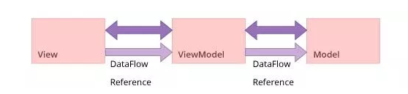

The important key point about MVVM is that View has reference to the ViewModel but not in reverse and that makes the application’s UI-Components related memory leak-proof. Each View may have a dedicated ViewModel or may be shared by multiple in case of fragments to enable sharing data cross fragments of an activity. MVVM is a more suitable candidate for automated testing.

**Question:**  What is the recommended way to perform discrete, ‘transactional’ background tasks in Android?

**Answer:**  The recommended way going forward is using WorkManager APIs, that makes it easy to specify deferrable, asynchronous tasks and when they should run under the circumstances you choose, or recurring tasks that run at a specified interval. Internally WorkManager might use JobScheduler, Firebase-JobDispatcher, Executor, and AlarmManager for running the task.

**Kotlin Android Interview Questions**

**Question:**  What are the coroutines?

**Answer:**  A coroutine in Kotlin programming language is the feature that helps to converts asynchronous background processes to the sequential code.

Managing background threads.

It helps in thread concurrency efficiently.

Replace traditional callbacks.

Maps the async code into the sequential code.

Main thread safety.

**Question:**  What's the Android main-thread threshold time to update UI?

**Answer:**  The main-thread should update the screen every 16 ms and more. It's about 60 frames per second.

**Question:**  What is a suspended function in Kotlin?

**Answer:**  By syntax, a function that has a keyword suspend is a suspended function.

A suspended function is a part of Kotlin coroutine, that is callable from a coroutine or other suspended functions.

It is used to pause-resume the coroutine execution and it helps in main -thread safety.

Suspend keyword is similar to async. However, in Kotlin, await() is implicit when calling a suspend function. For example

import kotlinx.coroutines.async

import kotlinx.coroutines.runBlocking

import java.net.URL

private suspend fun getResult(): String {

return URL("http://dummy.restapiexample.com/api/v1/employees").readText()

}

fun main() {

runBlocking<Unit> {

val deferred = async {

val result = getResult()// Here async will be suspeneded

println("result is $result")

return@async result

}

println("Post result message ${deferred.await()}")

}

}

Inside runBlocking scope you have a deferred(future expected) result and through deferred.await() we have achieved the pause-resume behavior. The same way call to remoteCall() inside getResult() will be paused-resumed through marking remoteCall() suspend. Here await is implicit.

**Question:**  What's the best way to manage the coroutines lifecycle inside Android ViewModel?

**Answer:**  This below library has added a viewModelScope as an extension function of the ViewModel class.

implementation "androidx.lifecycle:lifecycle-viewmodel-ktx:x.x.x"

The created coroutine scope will be bound to Main Dispatchers and will automatically be canceled when the ViewModel is cleared.

viewModelScope.launch will start a coroutine in the viewModelScope. This means when the job that we passed to viewModelScope gets canceled, all coroutines in this job/scope will be canceled.

If the user left the Activity before delay returned, this coroutine will automatically be canceled when onCleared is called upon the destruction of the ViewModel.

**Question:**  Suppose I have started a coroutine on Main-dispatcher and coroutine has started a suspended function that will take a few seconds to complete. Does this suspended function delay will block the Main thread?

**Answer:**  No, it will not block the main-thread as it will be suspended for the required time i.e. 1 second and will be resumed after that.

import kotlinx.coroutines.*

fun main() = runBlocking<Unit> {

launch {

// suspend this coroutine for one second

delay(1_000)

// resume in the main dispatcher

println("Coroutine resumed")

}

println("Main thread execution")

}

Output:

Main thread execution

Coroutine resumed

**Question:**  What is the difference between CoroutineScope & ViewModelScope?

**Answer:**  CoroutineScope:

CoroutineScope is the API available in Kotlin Coroutine to create a coroutine and all coroutines run inside a CoroutineScope. A scope controls the lifetime of coroutines through its job. When you cancel the job of scope, it cancels all coroutines started in that scope.

ViewModelScope:

It’s available in the below library implementation and it si specific t to Android.

“androidx.lifecycle:lifecycle-ViewModel-ktx:x.x.x”

This library has added it as viewModelScope as an extension function of the ViewModel class.

This scope is bound to Dispatchers.Main and will automatically be canceled when the ViewModel is cleared.

**Question:**  Describe the optimistic usages for different Dispatchers in Kotlin coroutines.

**Answer:**  Main:

Main is used to perform UI kind operations like Main-thread in Android.

IO:

The IO dispatcher is optimized for IO work like reading from the network or disk.

Default:

The Default dispatcher is optimized for CPU intensive tasks.

**Question:**  Suppose you have a simple class A, what are the different ways you can call coroutine builder methods?

**Answer:**  Method-1:

You can create a coroutine by calling the builder method with GlobalScope. Just keep in mind the life cycle of the coroutine will be associated with the application lifecycle.

GlobalScope.launch {

delay(1000)

println("Thread Name-1 ${Thread.currentThread().name}")

}

Method-2:

If you wanted to create a coroutine with a blocking-mode then you can call runBlocking{}.

runBlocking {

//Do what ever wanted to do.

}

Method-3:

The third option you can achieve by delegation to the CoroutineScope.

class CoroutineLightWeight : CoroutineScope by MainScope(){

fun downloadNetworkData(){

launch {

// Code inside coroutine

}

}

**Question:**  Does a coroutine started at UI-thread, blocks UI-thread while suspended?

**Answer:**  No, A coroutine started on Dispatchers.Main won't block the main thread while suspended.

**Question:**  How coroutines provide Main-safety?

**Answer:**  Previously, It was a headache to make sure the threads-safety while calling a network request or database operations. Then after operation completion, we should make sure either we are on Main-thread to update our UI.

Coroutines can easily switch threads at any time and pass results back to the original thread, it's a good idea to start UI-related coroutines on the Main thread.

A coroutine started on Dispatchers.Main won’t block the main thread while suspended.

Libraries like Room and Retrofit offer main-safety out of the box when using coroutines, so you don’t need to manage threads to make network or database calls. This can often lead to a substantially simpler code.

**Question:**  How uncaught exception propagation differs between launch & async?

**Answer:**  First of all, let's understand the rule of thumb, 'launch' will always propagate the uncaught exception to its caller. It means if you are calling 'launch' from a non-coroutine then the exception will be propagated to default exception handler and your app will be crashed.

'async' will not propagate the uncaught exception to its caller. It means if you are calling 'async' from a non-coroutine then the exception will not be propagated to default exception handler and your app will not be crashed. Unless async is called with await() function.

All other combinations will rely on these mentioned rule of thumb, Lets understand a few of them:

#1:

The launch is called from a non-coroutine,

It will propagate the uncaught exception to its caller. It will crash your app.

GlobalScope.launch {

throw IndexOutOfBoundsException("Index Out of bound")

}

#2:

async is called from a non-coroutine

This will not propagate the uncaught exception to its caller. It will not crash the app.

GlobalScope.async {

throw IndexOutOfBoundsException("Index Out of bound")

}

#3:

async is called from a coroutine without await. It will not crash the app.

GlobalScope.launch {

GlobalScope.async {

launch {

throw IndexOutOfBoundsException("Index Out of bound")

}.join()

}

}

#4:

async is called from a coroutine with await, it will propagate the uncaught exception to its caller. It will crash the app.

GlobalScope.launch {

GlobalScope.async {

launch {

throw IndexOutOfBoundsException("Index Out of bound")

}

}.await()

}

**Question:**  How to handle the exception inside coroutines?

**Answer:**  With try-catch:

GlobalScope.launch {

try {

GlobalScope.async {

launch {

throw IndexOutOfBoundsException("Index Out of bound")

}

}.await()

}catch (e : IndexOutOfBoundsException){

println("Inline " + e.message)

}

}

With coroutineExceptionHandler:

Add exception handler reference object to the coroutine builder method.

GlobalScope.launch(exceptionHander) {

GlobalScope.async {

launch {

throw IndexOutOfBoundsException("Index Out of bound")

}

}.await()

}

var exceptionHander: CoroutineExceptionHandler = CoroutineExceptionHandler { coroutineContext, throwable ->

println("Error Received -> " + throwable.message)

}

**Question:**  What is NonCancelable context in Kotlin coroutines?

**Answer:**  By default running a suspended function inside a canceled coroutine throws CancellationException. In rare cases when you required to execute a suspended function inside a finally block of the canceled coroutine, then we can use a NonCancelable context that will prevent us to cancel our suspended functions.

val job = launch {

try {

repeat(1000) { i ->

println("job: I'm sleeping $i ...")

delay(500L)

}

} finally {

withContext(NonCancellable) {

println("job: I'm running finally")

delay(1000L)

println("job: And I've just delayed for 1 sec because I'm non-cancellable")

}

}

}

delay(1300L) // delay a bit

println("main: I'm tired of waiting!")

job.cancelAndJoin() // cancels the job and waits for its completion

println("main: Now I can quit.")

Output:

job: I’m sleeping 0 …

job: I’m sleeping 1 …

job: I’m sleeping 2 …

main: I’m tired of waiting!

job: I’m running finally

job: And I’ve just delayed for 1 sec because I’m non-cancellable

main: Now I can quit.

**Question:**  What is the difference between withTimeout & withTimeoutOrNull functions. What is their basic purpose of use?

**Answer:**  The basic purpose of the use is to start a coroutine with a time out constraints. It's the easiest way to constraint a coroutine with a time out.

withTimeout:

On timeout, the exception will be a thrown & we need to handle the exception explicitly otherwise will be propagated to the caller.

try {

withTimeout(1_000) {

val job = launch(Dispatchers.Default) {

// Some long running operations

}

}

} catch (e: Exception) {

println(e.message)

}

withTimeoutOrNull:

This withTimeoutOrNull function that is similar to withTimeout but returns null on timeout instead of throwing an exception. No need to use exception handling here.

withTimeoutOrNull(1_000){

val job = launch(Dispatchers.Default) {

// Your code

}

}

**Question:**  What are coroutines channels? what is the difference between buffered & unbuffered channels?

**Answer:**  Briefly, Channels are the structures used for communication between coroutines.

As we know for async coroutine builder deferred values provide a convenient way to transfer a single value between coroutines. Channels provide a way to transfer a stream of values.

Un-Buffered Channels:

By default, the channels have no buffer. Unbuffered channels transfer elements when the sender and receiver meet each other. If send is invoked first, then it is suspended until receive is invoked, if receive is invoked first, it is suspended until send is invoked.

Buffered Channels:

Both Channel() factory function and produce builder take an optional capacity parameter to specify buffer size. Buffer allows senders to send multiple elements before suspending, similar to the BlockingQueue with a specified capacity, which blocks when the buffer is full.

val channel = Channel<Int>(4) // create buffered channel

val sender = launch { // launch sender coroutine

repeat(10) {

println("Sending $it") // print before sending each element

channel.send(it) // will suspend when buffer is full

}

}

// don't receive anything... just wait....

delay(1000)

sender.cancel() // cancel sender coroutine

**Question:**  What is a primary constructor in Kotlin?

**Answer:**  The primary constructor is part of the class header. Unlike Java, you don't need to declare a constructor in the body of the class. Here's an example:

class Person(val firstName: String, var age: Int) {

// class body

}

The main idea is by removing the constructor keyword, our code gets simplified and easy to understand.

**Question:**  What is a data class in Kotlin?

**Answer:**  We frequently create classes whose main purpose is to hold data. In Kotlin, this is called a data class and is marked as data:

data class User(val name: String, val age: Int)

To ensure consistency and meaningful behavior of the generated code, data classes have to fulfill the following requirements:

The primary constructor needs to have at least one parameter;

All primary constructor parameters need to be marked as val or var;

Data classes cannot be abstract, open, sealed or inner;

**Question:**  Explain the Null safety in Kotlin

**Answer:**  Kotlin's type system is aimed at eliminating the danger of null references from code, also known as the The Billion Dollar Mistake.

One of the most common pitfalls in many programming languages, including Java, is that accessing a member of a null reference will result in a null reference exception. In Java this would be the equivalent of a NullPointerException or NPE for short.

In Kotlin, the type system distinguishes between references that can hold null (nullable references) and those that can not (non-null references). For example, a regular variable of type String can not hold null:

var a: String = "abc"

a = null // compilation error

To allow nulls, we can declare a variable as nullable string, written String?:

var b: String? = "abc"

b = null // ok

print(b)

**Question:**  How are extensions resolved in Kotlin and what doest it mean?

**Answer:**  Extensions do not actually modify classes they extend. By defining an extension, you do not insert new members into a class, but merely make new functions callable with the dot-notation on variables of this type.

The extension functions dispatched statically. That means the extension function which will be called is determined by the type of the expression on which the function is invoked, not by the type of the result of evaluating that expression at runtime. In short, they are not virtual by receiver type.

Consider:

open class BaseClass

class DerivedClass : BaseClass()

fun BaseClass.someMethod(){

print("BaseClass.someMethod")

}

fun DerivedClass.someMethod(){

print("DerivedClass.someMethod")

}

fun printMessage(base : BaseClass){

base.someMethod()

}

printMessage(DerivedClass())

This will print

BaseClass.someMethod

because the extension function being called depends only on the declared type of the parameter base in printMessage method, which is the BaseClass class. This is different from runtime polymorphism as here it is resolved statically but not at the runtime.

**Question:**  What is a purpose of Companion Objects in Kotlin?

**Answer:**  Unlike Java or C#, Kotlin doesn’t have static members or member functions. If you need to write a function that can be called without having a class instance but needs access to the internals of a class, you can write it as a member of a companion object declaration inside that class.

class EventManager {

companion object FirebaseManager {

}

}

val firebaseManager = EventManager.FirebaseManager

The companion object is a singleton. The companion object is a proper object on its own, and can have its own supertypes - and you can assign it to a variable and pass it around. If you're integrating with Java code and need a true static member, you can annotate a member inside a companion object with @JvmStatic

**Question:**  What is Lateinit in Kotlin and when would you use it?

**Answer:**  lateinit means late initialization. If you do not want to initialize a variable in the constructor instead you want to initialize it later on and if you can guarantee the initialization before using it, then declare that variable with lateinit keyword. It will not allocate memory until initialized. You cannot use lateinit for primitive type properties like Int, Long etc.

lateinit var test: String

fun doSomething() {

test = "Some value"

println("Length of string is "+test.length)

test = "change value"

}

There are a handful of use cases where this is extremely helpful, for example:

Android: variables that get initialized in lifecycle methods;

Using Dagger for DI: injected class variables are initialized outside and independently from the constructor;

Setup for unit tests: test environment variables are initialized in a @Before - annotated method;

Spring Boot annotations (eg. @Autowired).

**Question:**  Explain lazy initialization in Kotlin

**Answer:**  lazy means lazy initialization. Your variable will not be initialized unless you use that variable in your code. It will be initialized only once after that we always use the same value.

lazy() is a function that takes a lambda and returns an instance of lazy which can serve as a delegate for implementing a lazy property: the first call to get() executes the lambda passed to lazy() and remembers the result, subsequent calls to get() simply return the remembered result.

val test: String by lazy {

val testString = "some value"

}

**Question:**  When to use lateinit over lazy initialization in Kotlin?

**Answer:**  There are some simple rules to determined if you should use one or the other for properties initialisation:

* If properties are mutable (i.e. might change at a later stage) use **lateInit**
* If properties are set externally (e.g. need to pass in some external variable to set it), use **lateinit**. There’s still workaround to use lazy but not as direct.
* If they are only meant to initialized once and shared by all, and it’s more internally set (dependent on variable internal to the class), then use **lazy**. Tactically, you could still use lateinit, but using** lazy** would better encapsulate your initialization code.

Also compare:

|  |  |
| --- | --- |
| **lateinit** var | by **lazy** |
| Can be initialized from anywhere the object seen from. | Can only be initialized from the initializer lambda. |
| Multiple initialization possible. | Only initialize single time. |
| Non-thread safe. It’s up to user to initialize correctly in a multi-threaded environment. | Thread-safety by default and guarntees that the initializer is invoked by once. |
| Can only be used for var. | Can only be used for val. |
| Not eligible for nonnull properties. | Not eligible for nonnull properties. |
| An isInitialized method added to check whether the value has been initialized before. | Property never able to un-initialized. |
| Not allowed on properties of primitive types. | Allowed on properties of primitive types. |

**Question:**  May you briefly compare Kotlin vs Java?

**Answer:**

| Java vs Kotlin | Java | Kotlin |
| --- | --- | --- |
| Null Safe | In Java, NullPointerExceptions causes huge frustration for developers. It allows users to assign null to any variables but while accessing an object reference having null value raises a null pointer exception which user needs to handle. | In Kotlin, By default, all types of variables are non-null able (i.e. we can’t assign null values to any type of variables/objects). If we try to assign or return null values, Kotlin code will fail during compile-time. If we really want a variable to have a null value, we can declare as follows: value num: Int? = null |
| Extension Functions | In Java, If we want to extend the functionality of existing class we need to create a new class and inherit the parent class. So Extension functions are not available in Java | Kotlin provides developers the ability to extend an existing class with new functionality. We can create extend functions by prefixing the name of a class to name of the new function. |
| Coroutines Support | In Java, whenever if we initiate a long-running network I/0 or CPU Intensive operations, the corresponding thread will be blocked. As Android is a single-threaded by default. Java provides the ability to create multiple threads in the background and run but managing them is a complex task. | In Kotlin, We can create multiple threads to run these long-running intensive operations but we have coroutines support, which will suspend execution at a certain point without blocking threads while executing long-running intensive operations. |
| No checked exceptions | In Java, We have checked exceptions support which makes developers declare and catch the exception which ultimately leads to robust code with good error handling. | In Kotlin, we don’t have checked exceptions. So developers don’t need to declare or catch the exceptions, which have advantages and disadvantages. |
| Data classes | In Java, suppose we need to have a class which needs to hold data but nothing else. For this we need to define constructors, variables to store data, getter and setter methods, hashcode(), toString(), and equals() functions | In Kotlin, If we need to have classes which need to hold data we can declare a class with keyword “data” in the class definition then the compiler will take care of all of this work such as creating constructors, getter, setter methods for different fields. |
| Smart casts | In Java, We need to check the type of variables and cast according to our operation. | In Kotlin, smart casts will handle these casting checks with keyword “is-checks” which will check for immutable values and performs implicit casting. |
| Type inference | In Java, we need to specify a type of each variable explicitly while declaring. | In Kotlin, we don’t need to specify the type of each variable explicitly based on assignment it will handle. If we want to specify explicitly we can do. |
| Functional Programming | Java doesn’t have functional programming support till Java 8 but while developing Android applications it supports the only subset of Java 8 features. | Kotlin is a mix of procedural and functional programming language which consists of many useful methods such as lambda, operator overloading, higher-order functions, and lazy evaluation, etc. |

**Question:**  What are coroutines in Kotlin?

**Answer:**  Unlike many other languages with similar capabilities, async and await are not keywords in Kotlin and are not even part of its standard library.

kotlinx.coroutines is a rich library for coroutines developed by JetBrains. It contains a number of high-level coroutine-enabled primitives, including launch, async and others. Kotlin Coroutines give you an API to write your asynchronous code sequentially.

The documentation says Kotlin Coroutines are like lightweight threads. They are lightweight because creating coroutines doesn’t allocate new threads. Instead, they use predefined thread pools, and smart scheduling. Scheduling is the process of determining which piece of work you will execute next.

Additionally, coroutines can be suspended and resumed mid-execution. This means you can have a long-running task, which you can execute little-by-little. You can pause it any number of times, and resume it when you’re ready again.

**Question:**  How to initialize an array in Kotlin with values?

**Answer:**  In Java an array can be initialized such as:

int numbers[] = new int[] {10, 20, 30, 40, 50}

How does Kotlin's array initialization look like?

Answer:

val numbers: IntArray = intArrayOf(10, 20, 30, 40, 50)

**Question:**  What is the difference between var and val in Kotlin?

* **var** is like general variable and it's known as a *mutable* variable in kotlin and can be assigned multiple times.
* **val** is like Final variable and it's known as *immutable* in Kotlin and can be initialized only single time.

+----------------+-----------------------------+---------------------------+

| | val | var |

+----------------+-----------------------------+---------------------------+

| Reference type | Immutable(once initialized | Mutable(can able to change|

| | can't be reassigned) | value) |

+----------------+-----------------------------+---------------------------+

| Example | val n = 20 | var n = 20 |

+----------------+-----------------------------+---------------------------+

| In Java | final int n = 20; | int n = 20; |

+----------------+-----------------------------+---------------------------+

**Question:**  How to correctly concatenate a String in Kotlin?

**Answer:**  In Kotlin, you can concatenate

using string interpolation / templates

val a = "Hello"

val b = "World"

val c = "$a $b"

using the + / plus() operator

val a = "Hello"

val b = "World"

val c = a + b // same as calling operator function a.plus(b)

val c = a.plus(b)

print(c)

using the StringBuilder

val a = "Hello"

val b = "World"

val sb = StringBuilder()

sb.append(a).append(b)

val c = sb.toString()

print(c)

**Question:**  What is basic difference between fold and reduce in Kotlin? When to use which?

**Answer:**  fold takes an initial value, and the first invocation of the lambda you pass to it will receive that initial value and the first element of the collection as parameters.

listOf(1, 2, 3).fold(0) { sum, element -> sum + element }

The first call to the lambda will be with parameters 0 and 1.

Having the ability to pass in an initial value is useful if you have to provide some sort of default value or parameter for your operation.

reduce doesn't take an initial value, but instead starts with the first element of the collection as the accumulator (called sum in the following example)

listOf(1, 2, 3).reduce { sum, element -> sum + element }

The first call to the lambda here will be with parameters 1 and 2.

**Question:**  What is the idiomatic way to remove duplicate strings from array?

**Answer:**  How to remove duplicates from an Array<String?> in Kotlin?

**Answer:** Use the distinct extension function:

val a = arrayOf("a", "a", "b", "c", "c")

val b = a.distinct() // ["a", "b", "c"]

You can also use:

* toSet, toMutableSet
* toHashSet - if you don't need the original ordering to be preserved

These functions produce a Set instead of a List and should be a little bit more efficient than distinct.

**Question:**  How to create singleton in Kotlin?

**Answer:**  Just use object.

object SomeSingleton

The above Kotlin object will be compiled to the following equivalent Java code:

public final class SomeSingleton {

public static final SomeSingleton INSTANCE;

private SomeSingleton() {

INSTANCE = (SomeSingleton)this;

System.out.println("init complete");

}

static {

new SomeSingleton();

}

}

This is the preferred way to implement singletons on a JVM because it enables thread-safe lazy initialization without having to rely on a locking algorithm like the complex double-checked locking.

**Question:**  Components of Android application

**Answer:**  Android application architecture has the list of components given below. They are as follows:

* Services − It will be used to perform background functionalities.
* Activities - It is a single screen that represents GUI(Graphical User Interface) with which users can interact in order to do something like dial the phone, view email, etc.
* Broadcast receivers - Broadcast receiver is a mechanism used for listening to system-level events like listening for incoming calls, SMS, etc. by the host application.
* Content providers − This will share the data between various applications.

**Question:**  Scope of Android

**Answer:**  We need Android in the mobile market because it helps smartphone users to download applications that can give different services.

Android developers can publish their apps on different platforms like SlideME, Mobango, Amazon app store, Opera mobile store, etc. Most of these platforms or markets are free. Such platforms are creating a huge market for Android mobile application development in India.

**Question:**  Advantages of Android

**Answer:**  Open-source: It means no license, development, and distribution fee.

* Platform-independent: Android development platform(Android studio & Android SDK) is platform-independent. Android applications can be developed on any operating system with the help of Android studio & Android SDK.
* Highly optimized virtual machine: Android uses a highly optimized virtual machine i.e, DVM (Dalvik Virtual Machine) for mobile devices. Replacing DVM, ART(Android RunTime) virtual machine was introduced to execute android apps from Android lollipop 5.0 version (API level 21).
* Supports various technologies: It supports camera, speech, BlueTooth, Wifi, EDGE, etc. technologies.
* Millions of available apps: Millions of Android apps are available that you can install on the device from the Google Play store as well as from other alternative stores.

**Question:**  Disadvantages of Android

**Answer:**  Fake applications: There are thousands of fake applications available on the market, which when installed may try to steal your data.

* Streamlining issues:
  + There are various kinds of Android devices available in the market with different screen sizes and dimensions, but more importantly, different Android operating systems.
  + An application that runs smoothly on one version of the Android OS might crash on another Android OS.
* Background processes:
  + In the older version of Android, most applications always run in the background and come to the foreground as they wish. From the Android 8.0 version, apps that are running in the background now have limits on how freely they can access background services.
  + As few apps run in the background, they consume mobile battery and your device battery vanishes quickly.
* Poor data connection: Android phones have a large number of background processes that keep on running in the background and it results in excess usage of data and poor internet speed. Sometimes it can be very annoying.

**Question:**  What is Android?

**Answer:**  Android is an open-sourced operating system that is used on mobile devices, such as mobiles and tablets. The Android application executes within its own process and its own instance of Dalvik Virtual Machine(DVM) or Android RunTime(ART).

**Question:**  What are the features of Android architecture?

**Answer:**  Android architecture refers to the various layers in the Android stack. It consists of operating systems, middleware, and applications. Each layer in the Android architecture gives different services to the layer just above it.

The five layers present in the Android stack are:

* Linux Kernel - It is responsible for device drivers, device management, memory management, power management, and resource access.
* Libraries - There are a set of libraries having open-source Web browser engine WebKit, well-known library libc, libraries to play and record audio and video, SQLite database for sharing of application data and storage, SSL libraries for internet security, etc.
* Android Runtime - There are core libraries along with DVM (Dalvik Virtual Machine) or ART(Android RunTime) as runtime which is helpful for running an Android application. DVM is optimized for mobile devices. DVM provides fast performance and consumes less memory. Replacing DVM, ART(Android RunTime) virtual machine was introduced to execute android apps from Android lollipop 5.0 version (API level 21).
* Android Framework - It consists of Android APIs like UI (User Interface), resources, content providers (data), locations, telephony, and package managers. It provides interfaces and classes for the development of Android applications.
* Android Applications - Applications like home, games, contacts, settings, browsers, etc. uses the Android framework that will make use of Android runtime and libraries.
* 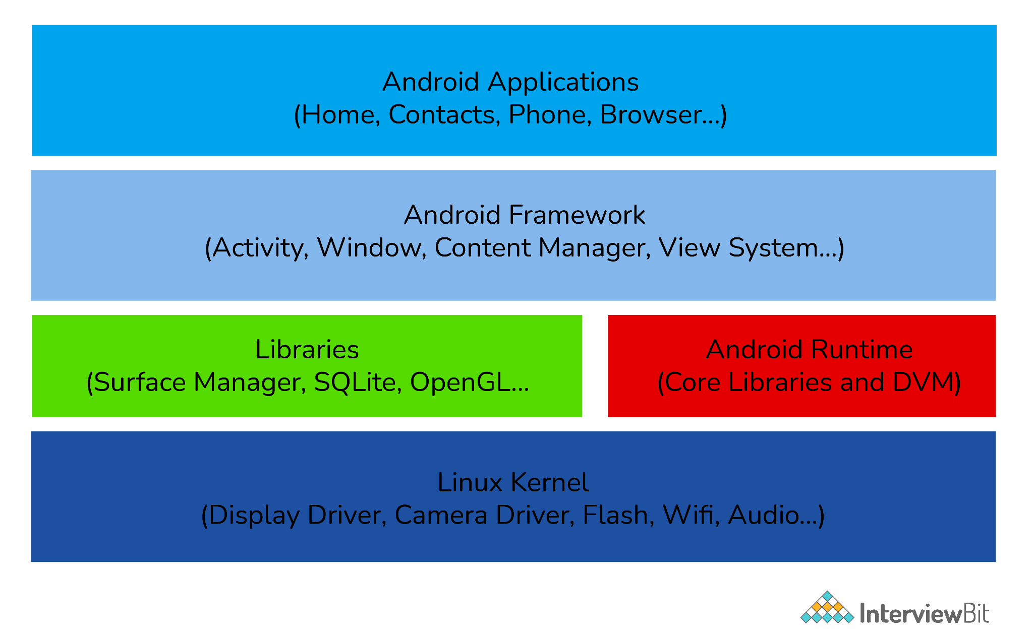

**Question:**  List the languages used to build Android.

**Answer:**  The most popular programming languages that can be used to develop applications in Android are:

* Java: It has always been a starting point for new developers and used by the majority of people who work with Android development. Eclipse, NetBeans, and IntelliJ IDE are the most popular IDE’s(Integrated Development Environment) used for developing an Android application using java.
* Kotlin: Kotlin is a relatively new, modern, safe, and object-oriented cross-platform programming language used in developing an Android application. IDE’s used with kotlin are Android studio, Eclipse IDE, etc.
* C#: Developers can build native iOS and Android mobile applications by using the C# language. Visual Studio is the best tool for developing an Android application using C#.
* Python: It is a dynamic and object-oriented programming language. It is very popular in machine learning. Pydroid 3, Dcoder, spck code editor is some of the code editors for Python.
* Other languages which can be used in Android development are C++, HTML 5. C4droid, CppDroid, AIDE, etc. are IDE’s for C++. Acode, spck code editor, etc. are examples of IDE’s used with HTML.

**Question:**  What is an activity?

**Answer:**  Activity in java is a single screen that represents GUI(Graphical User Interface) with which users can interact in order to do something like dial the phone, view email, etc.

For example, the Facebook start page where you enter your email/phone number and password to log in acts as an activity.

**Question:**  What is a service in Android?

**Answer:**  Service is an application component that facilitates an application to run in the background in order to perform long-running operations without user interaction. A service can run continuously in the background even if the application is closed or even after the user switches to another application.

**Question:**  Differentiate Activities from Services.

**Answer:**  Activities can be terminated or closed anytime the user wishes. On the other hand, services are designed to run in the background, and they can act independently.

Most of the services run continuously, irrespective of whether there are certain or no activities being executed.

| **Activities** | **Services** |
| --- | --- |
| They are designed to run in the foreground. | These are mainly designed to run in the background. Foreground services are also available. |
| Used when the user interface is necessary. | Used when the user interface is not necessary. |
| They are dependent. | They act independently. |

**Question:**  What is Google Android SDK? Which are the tools placed in Android SDK?

**Answer:**  The Google Android SDK is a toolset used by developers to write applications on Android-enabled devices.

The tools placed in Android SDK are given below:

* Android Emulator - Android Emulator is a software application that simulates Android devices on your computer so that you can test the application on a variety of devices and Android API levels without having each physical device.
* DDMS(Dalvik Debug Monitoring Services) - It is a debugging tool from the Android software development kit (SDK) which provides services like message formation, call spoofing, capturing screenshots, etc.
* ADB(Android Debug Bridge) - It is a command-line tool used to allow and control communication with the emulator instance.
* AAPT(Android Asset Packaging Tool) - It is a build tool that gives the ability to developers to view, create, and update ZIP-compatible archives (zip, jar, and apk).

**Question:**  What is the use of Bundle in Android?

**Answer:**  Bundles are used to pass the required data between various Android activities. These are like HashMap that can take trivial data types. Below code shows how to transfer a piece of data by using bundle:

Bundle b=new Bundle();

b.putString("Email","abc@xyz.com");

i.putExtras(b); // where i is intent

**Question:**  What is an Adapter in Android?

**Answer:**  An adapter in Android acts as a bridge between an AdapterView and the underlying data for that view. The adapter holds the data and sends the data to the adapter view, the view can take the data from the adapter view and shows the data on different views like a spinner, list view, grid view, etc.

**Question:**  What is AAPT?

**Answer:**  AAPT stands for Android Asset Packaging Tool. It is a build tool that gives the ability to developers to view, create, and update ZIP-compatible archives (zip, jar, and apk). It parses, indexes, and compiles the resources into a binary format that is optimized for the platform of Android.

**Question:**  What is portable Wi-Fi hotspot?

**Answer:**  Portable Wi-Fi Hotspot permits you to share your mobile internet connection with other wireless devices. For example, using your Android phone as a Wi-Fi hotspot, you can use your laptop to connect to the internet using that access point.

**Question:**  What is Android Debug Bridge(ADB)?

**Answer:**  Android Debug Bridge is a command-line tool used to allow and control communication with an emulator instance. It gives the power for developers to execute remote shell commands to run applications on an emulator.

**Question:**  What is DDMS?

**Answer:**  DDMS(Dalvik Debug Monitor Server) is a debugging tool in the Android platform. It gives the following list of debugging features:

* Port forwarding services.
* Thread and heap information.
* Logcat.
* Screen capture on the device.
* Network traffic tracking.
* Incoming call and SMS spoofing.
* Location data spoofing.

**Question:**  What is AIDL? Which data types are supported by AIDL?

**Answer:**  AIDL(Android Interface Definition Language) is a tool that handles the interface requirements between a client and a service for interprocess communication(IPC) to communicate at the same level.

The process involves dividing an object into primitives that are understood by the Android operating system. Data Types supported by AIDL is as follows:

* String
* List
* Map
* CharSequence
* Java data types (int, long, char, and boolean)

**Question:**  What is the life cycle of Android activity?

**Answer:**  **iate Questions**

### 15. What is the life cycle of Android activity?

* OnCreate(): It is called when activity is created. Using this, the views are created and data is collected from bundles.
* OnStart(): It is called if the activity is becoming visible to the user. It may be succeeded by onResume() if the activity comes to the foreground, or onStop() if it becomes hidden.
* OnResume(): It is called when the activity will start an interaction with the user.
* OnPause(): This is called when the activity is moving to the background but hasn’t been killed yet.
* OnStop(): This is called when an activity is no longer visible to the user.
* OnDestroy(): This is called when the activity is finished or destroyed.
* OnRestart(): This is called after the activity has been stopped, prior to it being started again.

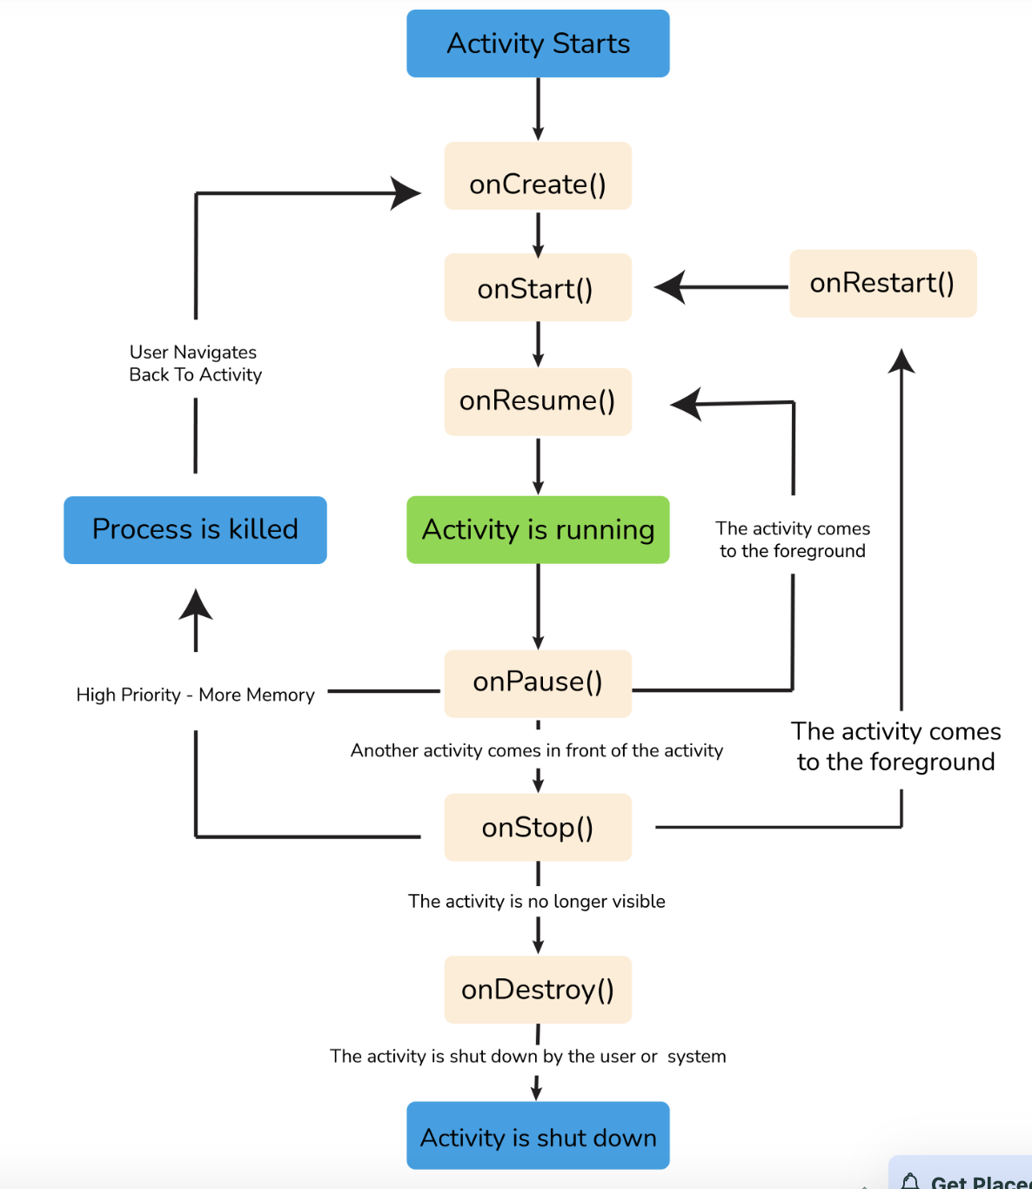

Life Cycle of Android

**Question:**  Explain Sensors in Android.

**Answer:**  Android-based devices have a collection of built-in sensors in them, which measure certain parameters like motion, orientation, and many more through their high accuracy. The sensors can be both hardware and software based on nature. There are three prominent categories of sensors in Android devices. They are:

* Position Sensor: It is used for measuring the physical position of the Android device. This has orientation sensors and magnetometers.
* Motion Sensors: These sensors consist of gravity, rotational activity, and acceleration sensors which measure the rotation of the device or the acceleration, etc.
* Environmental Sensor: It includes sensors that measure temperature, humidity, pressure, and other environmental factors.

**Question:**  Explain the dialog boxes supported on Android.

**Answer:**  Android supports four dialog boxes. They are:

* AlertDialog:
  + The AlertDialog supports 0-3 buttons, along with a list of selectable items such as checkboxes and radio buttons.
  + It is used when you want to ask the user about taking a decision between yes or no in response to any particular action taken by the user, by remaining in the same activity and without changing the screen.
* DatePickerDialog:
  + It is used for selecting the date by the user.
* TimePickerDialog:
  + Used for selecting the time by the user.
* ProgressDialog:
  + It is an extension of the AlertDialog and is used to display a progress bar. It also supports the addition of buttons.
  + This class was deprecated in API level 26 because it prevents the user from interacting with the application. Instead of this class, we can use a progress indicator such as ProgressBar, which can be embedded in the user interface of your application.

**Question:**  What is AndroidManifest.xml file and why do you need this?

**Answer:**  The AndroidManifest.xml file contains information regarding the application that the Android system must know before the codes can be executed.

* This file is essential in every Android application.
* It is declared in the root directory.
* This file performs several tasks such as:
  + Providing a unique name to the java package.
  + Describing various components of the application such as activity, services, and many more.
  + Defining the classes which will implement these components.

**Question:**  What is an intent?

**Answer:**  An intent is a messaging object that is used to request an action from other components of an application. It can also be used to launch an activity, send SMS, send an email, display a web page, etc.

It shows notification messages to the user from within an Android-enabled device. It alerts the user of a particular state that occurred. There are two types of intents in Android:

* Implicit Intent- Used to invoke the system components.
* Explicit Intent- Used to invoke the activity class.

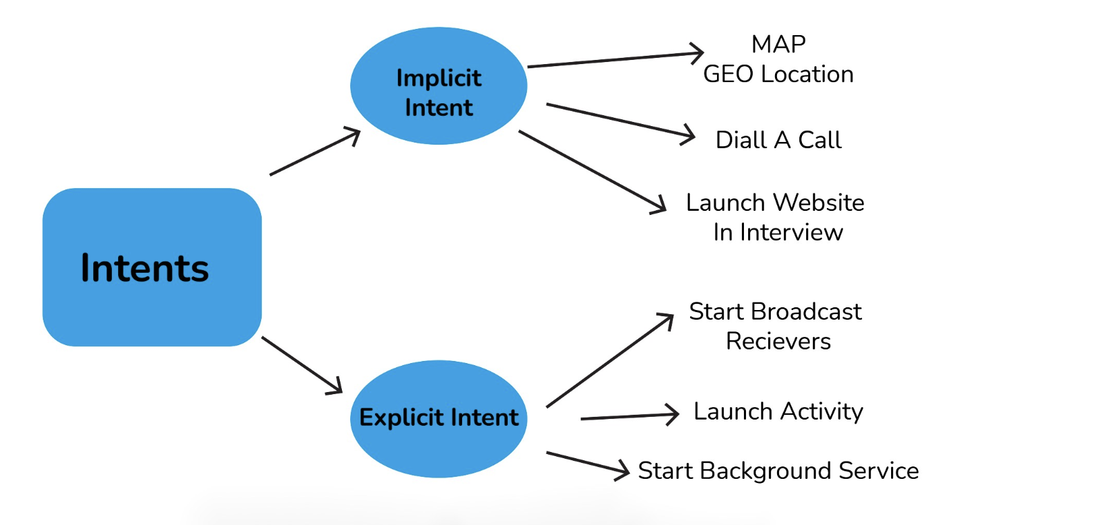

**Question:**  Mention the difference between class, file and activity in Android?

**Answer:**  The difference between them is as follows:

* Class is a compiled form of a .java file that Android uses to produce an executable .apk file.
* A file is a block of arbitrary information or resources used for storing information. It can be of any file type.
* Activity is a single screen that represents GUI(Graphical User Interface) with which users can interact in order to do something like dial the phone, view email, etc.

**Question:**  What is a Toast? Write its syntax.

**Answer:**  Toast is a message that pops up on the screen. It is used to display the message regarding the status of the operation initiated by the user and covers only the expanse of space required for the message while the user’s recent activity remains visible and interactive.

Toast notification automatically fades in and out and it does not accept interaction events.

Syntax:

Toast.makeText(ProjectActivity.this, "Your message here", Toast.LENGTH_LONG).show();

**Question:**  What is context?

**Answer:**  The context in Android is the context of the current state of the application or object. The context comes with services like giving access to databases and preferences, resolving resources, and more.

There are two types of context. They are:

Activity context

* This activity context is attached to the lifecycle of an activity.
* The activity context can be used when you are passing the context in the scope of an activity or you need the context whose lifecycle is attached to the context of the activity.

Application context:

* This application context is attached to the lifecycle of an application.
* The application context should be used where you need a context whose lifecycle is separate from the current context or when you are passing a context beyond the scope of activity.

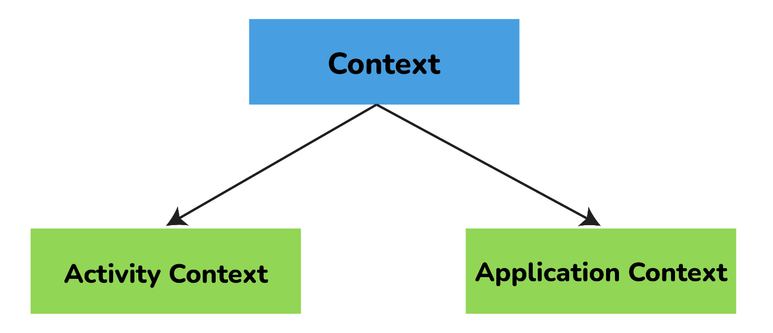

**Question:**  Explain the difference between Implicit and Explicit Intent.

**Answer:**  The difference between the implicit and explicit Intents are given below:

Explicit Intent:

An Explicit Intent is where you inform the system about which activity should handle this intent. Here target component is defined directly in the intent.

For example,

Intent i = new Intent(this, Activitytwo.class); #ActivityTwo is the target component

i.putExtra("Value1","This is ActivityTwo");

i.putExtra("Value2","This Value two for ActivityTwo");

startactivity(i);

Implicit Intent:

An Implicit Intent permits you to declare the action you want to carry out. Further, the Android system will check which components are registered to handle that specific action based on intent data. Here target component is not defined in the intent.

For example,

Intent i = new Intent(ACTION_VIEW,Uri.parse("http://www.interview bit.com"));

startActivity(i);

**Question:**  What is ANR in Android? What are the measures you can take to avoid ANR?

**Answer:**  ANR(Application is Not Responding) is a dialog box that appears when the application is not responding. This ANR dialogue is displayed whenever the main thread within an application has been unresponsive for a long time under the following conditions:

* When there is no response to an input event even after 5 seconds.
* When a broadcast receiver has not completed its execution within 10 seconds.

Following measures can be taken to avoid ANR:

* An application should perform lengthy database or networking operations in separate threads to avoid ANR.
* For background task-intensive applications, you can lessen pressure from the UI thread by using the IntentService.

**Question:**  What are the troubleshooting techniques you can follow if an application is crashing frequently?

**Answer:**  If an Android application is crashing frequently, you can follow the below-given techniques:

Compatibility Check:

It is not possible to test an application for all kinds of devices and operating systems. There might be a possibility that an application is not compatible with your OS.

Memory Management:

* Some apps run perfectly on one mobile device but might crash on other devices. This is where processing power, memory management, and CPU speed are considered.
* As there is a limited amount of memory space on mobile devices, you can free up memory space for the application to function properly.
* If an application is frequently crashing, you can delete the application’s data, which will clear its cache memory and allow some free space on your device and might boost the app’s performance.

**Question:**  Explain different launch modes in Android.

**Answer:**  The different launch modes in Android are given below:

Standard:

* This launch mode generates an activity’s new instance in the task from which it originated.
* It is possible to create several instances for the same activity.
* For Example, suppose our current stack is A -> B -> C. Now, if we launch activity B again with the “standard” launch mode, then the new stack will be A -> B -> C -> B.

SingleTop:

* This launch mode is similar to the Standard launch mode except if there exists an activity’s previous instance on the top of the stack, then a new instance will not be created.
* But the intent will be sent to the activity’s existing instance.
* For example, suppose our current stack is A -> B -> C. Now, if we launch the activity B again with “singleTop” launch mode,then the new stack will be A -> B -> C -> B.
* Consider another example, where the current stack is A -> B -> C. Now, if we launch activity C again with the “singleTop” launch mode, then the stack will remain the same i.e., A -> B -> C. The intent will be passed to the onNewIntent() method.

SingleTask:

* This launch mode will create a new task and push a new instance to the task as the root.
* For example, suppose our current stack is A -> B -> C -> D. Now, if we launch activity B again with the “singleTask” launch mode, then the new stack will be A -> B. Here, a callback has been received on the old instance and C and D activities are destroyed.

SingleInstance:

* This launch mode is similar to the SingleTask launch mode. But the system doesn’t support launching any new activities in the same task.
* In a situation where the new activity is launched, it is launched in a separate task.
* For example, Suppose our current stack is A -> B -> C. Now, if we launch the activity D with the “singleInstance” launch mode, then there will be two stacks:
  + A -> B -> C
  + D, If you call activity E, then it will be added to the first stack.
  + A -> B -> C -> E
  + D

Again if you Call the activity D, then it will call the same activity from the 2nd stack and pass the intent to onNewIntent().

**Question:**  What are containers?

**Answer:**  Containers carry objects and widgets together, based on which specific items are required and in what particular arrangement is needed. Containers may hold labels, buttons, fields, or even child containers, etc. For example, if you want a form with fields on the left and labels on the right, you will need a container. If you want the OK and Cancel buttons to be below the rest of the form, next to one another, and flush to the right side of the screen, you will need a container. If you have several widgets, you will need a container to have a root element to place the widgets inside.

Android provides a collection of view classes that serve as containers for views. These container classes are called layouts, which are defined in the form of XML files that cannot be changed by our code during execution. The layout managers provided by Android SDK are LinearLayout, RelativeLayout, FrameLayout, AbsoluteLayout, GridLayout, and TableLayout.

**Question:**  What is the role of Dalvik in Android development?

**Answer:**  Dalvik serves as a virtual machine, and it is responsible for running every Android application. Because of Dalvik, a device will have the ability to execute multiple instances of virtual machines efficiently through better memory management.

**Question:**  What is the latest version of Android? List all the versions of Android.

**Answer:**  The latest version is Android 11.0 released in September 2020. Most of the Android version has been named after either sweet or desserts. The following table represents the different versions, Android name, API level, and the year of release. Here API level is the integer value that identifies the API framework revision given by the version of the android platform.

| **Version** | **Android Name** | **API Level** | **Year of Release** |
| --- | --- | --- | --- |
| Android 1.0 | No Codename | 1 | 2008 |
| 1.1 | No Codename | 2 | 2009 |
| 1.5 | Cupcake | 3 | 2009 |
| 1.6 | Donut | 4 | 2009 |
| 2.0 - 2.1 | Eclair | 5 - 7 | 2009 |
| 2.2 – 2.2.3 | Froyo | 8 | 2010 |
| 2.3 – 2.3.7 | Gingerbread | 9 - 10 | 2010 |
| 3.0 – 3.2.6 | Honeycomb | 11 - 13 | 2011 |
| 4.0 – 4.0.4 | Ice Cream Sandwich | 14 - 15 | 2011 |
| 4.1 – 4.3.1 | Jelly Bean | 16 - 18 | 2012 |
| 4.4 – 4.4.4 | Kitkat | 19 - 20 | 2013 |
| 5.0 – 5.1.1 | Lollipop | 21 - 22 | 2014 |
| 6.0 – 6.0.1 | Marshmallow | 23 | 2015 |
| 7.0 – 7.1.2 | Nougat | 24 - 25 | 2016 |
| 8.0 – 8.1 | Oreo | 26 - 27 | 2017 |
| 9.0 | Pie | 28 | 2018 |
| 10.0 | Android 10 | 29 | 2019 |
| 11.0 | Android 11 | 30 | 2020 |

Android 1.0 (API 1): There were numerous loopholes in this Android version including the necessity of physical keyboards or hardware buttons. Important features are:

* Browser, Google maps, and calendar.
* Camera and scroll down the notification bar.
* Wireless supports Wi-Fi and BlueTooth.
* Contacts, Gmail integration, and Google synchronization.

Android 1.1 (API 2): This version was released with API changes and resolved issues found in 1.0. Important features of this version are:

* Display details as well as reviews for locations.
* Gives detailed information by clicking on the business.
* Add save an attachment in the message.

Android 1.5 Cupcake (API 3): It brought the third-party app widgets that were the most distinguishing and valuable feature. Important features of this version are:

* Video recordings, copy and paste facility.
* Supports MPEG4 and 3GP formats.
* Search function and on-screen keyboard.
* Uploading images and videos.

Android 1.6 Donut (API 4): It had valuable changes including the ability to operate on various screen resolutions and sizes. Donut provides the text and voice entry search including bookmark history and capacity to select multiple images for deletion. Important features of this version are:

* Camera quick toggling features and gallery.
* WVGA screen resolution speed.
* Power control widget for handling Wi-Fi, GPS, BlueTooth, etc.
* Technology support for CDMA/EVDO, VPNs, 802.1x, and a text-to-speech engine.
* Searching applications and speed improvements for cameras.
* Supports quick search Box.

Android 2.0-2.1 Eclair (API 5-API 7): It was released with multiple email account synchronizations and contacts. Many new features were added including flash support, color effect, scene mode, white balance, macro focus, and digital zoom. Android 2.1 version brought bug fixes and stability improvements. The most valuable feature introduced was real-time traffic information and voice-guided turn by turn navigation. Important features are:

* Updated UI.
* Minor API changes.
* Support Bluetooth 2.1.
* Improved Google map.
* Supports live and animated Wallpapers.
* Has the ability to add contact’s photo and select to call, message or email.

Android 2.2-2.2.3 Froyo (API 8): It was released with memory, speed, and performance improvements. It was introduced with the enhanced Bluetooth functionality and also compatibility with docks, portable Wi-Fi hotspot for 3G connection sharing. Features are:

* Upload file support in the browser.
* Supports alphanumeric and numeric passwords to enhance security.
* Support for animated GIF and multiple keyboard languages.
* Increased compatibility with headsets and car kits.

Android 2.3-2.3.7 Gingerbread (API 9-API 10): The main enhanced feature was the introduction of gaming API with improved graphical intense gaming. Features are:

* Updated UI.
* Support for VP8 and WebM video format.
* Improvement in copy and paste facility.
* Easier use of keyboard with faster and intuitive typing.
* Supports video calling and social networking.

Android 3.0-3.2.6 Honeycomb (API 11-API 13): It was a tablet-only release to launch the Motorola Xoom. It was suitable for those mobiles having a larger view than current smartphones. Features will include:

* Updated 3D UI and encrypted storage.
* Gmail, camera, contacts, and gallery improvements.
* Supports passwords with complex characters.
* Supports multiprocessors and recent applications for easy visual multitasking.
* Media sync from SD card.
* Talk video chat and google eBooks.
* Support adobe flashes in the browser.
* More sensor support.
* High-performance Wi-Fi connections.
* Action bar for application control and system bar for global status and notifications
* Chinese handwriting and redesigned keyboard.

Android 4.0-4.0.4 Ice Cream Sandwich (API 14-API 15): It is released with many enhanced features to enter the era of modern design. The snapshot was introduced to take screenshots by holding the power and volume button. Ice cream sandwich widgets are more robust and resizable compared to all older versions. Supported features are:

* Unlocking with face-fixing.
* Card-like appearance for app-switching.
* Better camera performance and improved video recording with high resolution.
* Spelling check feature, Wi-Fi direct.
* On-screen buttons and better camera performance.
* Ability to open up to 16 tabs in the web browser.

Android 4.1-4.3.1 Jelly Bean (API 16-API 18): It is released with Google digital assistant technology accessible from the home screen. The spectacular predictive intelligence utility gives expandable and interactive notifications. Users can enjoy multi-user support(Only for tablets). Supported features are:

* Power control, support USB audio.
* The improved camera app, security improvements.
* Voice search and typing, panorama.
* Expandable notifications, daydream as a screensaver.
* Google displays relevant content based on search history.
* Native emoji support, new gestures, and accessibility features
* 4k resolution support, supporting Bluetooth with low energy.
* Bi-directional text and different language support.
* Set or adjust the volume of incoming calls and show a message alert as well.

Android 4.4-4.4.4 KitKat (API 19-API 20): It is released with more focus on better user experience. Supported features are:

* GPS Support, smarter caller ID.
* Offline music support, screen recording.
* Contact prioritization.
* Cartoonish ideograms and emojis to the Google keyboard.
* UI updates for Google map navigations and alarm.
* ‘OK, Google’ feature allows access to Google to the users without touching your smartphones.

Android 5.0-5.1.1 Lollipop (API 21-API 22): It was released with a redesigned user interface and built with “material design”. It is having many amazing features including support for better notification management. Supported features are:

* Support ART, better and improved UI.
* Better device protection, built-in battery saver feature.
* Notification can be flicked away from the lock screen.
* The revamped navigation bar supports multiple SIM cards.
* The high definition of a voice call.

Android 6.0-6.0.1 Marshmallow (API 23): Google used “Macadamia Nut Cookie” to describe Android version 6.0 before the official announcement of Marshmallow. Supported features are:

* Support for fingerprint readers, type-C USB support.
* Multi-window experience, clear permission system.
* ’Sleep Mode’ for saving the life of the battery.
* Custom Google tabs and improved copy-pasting.

Android 7.0-7.1.2 Nougat (API 24-API 25): It was released with a native split-screen mode, data saver functionality, and a “bundled-by-app” system to organize notifications. Supported features are:

* Multitasking and split-screen mode.
* Storage manager enhancements, quick setting toggles.
* Display touch enhancements, better setting application.
* Inline reply to message and notification without opening an application.

Android 8.0-8.1 Oreo (API 26-API 27): It is having notification snoozing options, native picture-in-picture mode, and better control over how applications can alert you by notifications. Supported features are:

* Password autofill, auto-enable Wi-Fi.
* Downloadable fonts, multi-display support.
* Support picture-in-picture.
* Adaptive icons and smart text selection.
* Notification channels and snooze notifications.
* Google play support and new emoji styling.

Android 9.0 Pie (API 28): It is having plenty of amazing features according to the user interests and requirements. Supported features are:

* HDR, HD audio, multiple Bluetooth connections.
* Much more information about notification and easier text selection.
* Sound amplifier with select to speak option.
* Artificial Intelligence(AI) compatibility.
* Adaptive battery and brightness with the background restrictions.
* Supports for multi-camera with external camera compatibility.
* New shortcut key for screenshot and accessibility menu.
* Improved security features for protection.
* Android backups, privacy enhancements.
* Easier screen rotation, edge-to-edge screens support.
* Volume and sound enhancements, selectable dark mode.

Android 10.0 (API 29): It is released with enhanced features and functionalities with higher API levels. Supported features are:

* Support for foldable smartphones with a flexible display.
* Dark mode for the comfortability of eyes.
* Navigation control over gesture quicker and intuitive ever.
* Smart reply suggestions for all messaging applications.
* Live caption for media playing on a smartphone device.
* Undo removal of the app.
* Better notification control with many options.
* Sound amplifier with much more clear sound.

Android 11.0 (API 30): Android developers are continuously working to provide more advanced applications as per the user requirements. Important features included are:

* Native screen recording.
* Auto revokes app permission.
* Mute notifications during the video.
* Increase in touch sensitivity.
* Notification history.

**Question:**  What are broadcast receivers? How is it implemented?

**Answer:**  A broadcast receiver is a mechanism used for listening to system-level events like listening for incoming calls, SMS, etc. by the host application. It is implemented as a subclass of BroadcastReceiver class and each message is broadcasted as an intent object.

public class MyReceiver extends BroadcastReceiver

{

public void onReceive(context,intent){}

}

**Question:**  Explain in detail about the important file and folders used when you create a new Android application.

**Answer:**  App:

It describes the basic characteristics of the application and defines each of its components.

java:

* This contains the .java source files and .kt(source code written in Kotlin) source files of your project. By default, it includes a MainActivity.java or MainActivity.kt source file.
* You create all the activities which have .java and .kt extensions under this file and also it includes all the code behind the application.

res:

* It is used to store the values for the resources that are used in various Android projects to include features of color, styles, dimensions, etc.
* It is a directory for files like styles.xml, strings.xml, colors.xml, dimens.xml, etc.

Scripts:

This is an auto-generated file that consists of compileSdkVersion, buildToolsVersion, minSdkVersion, targetSdkVersion, applicationId, versionCode, and versionName. For example, build.gradle is a script file placed in the root project directory, defines build configurations that will be applied to all modules in your project

**Question:**  What is the difference between Serializable and Parcelable? Which is the best approach in Android?

**Answer:**  While developing applications usually it needs to transfer data from one activity to another. This data needs to be added into a corresponding intent object. Some additional actions are required to make the data suitable for transfer. For doing that the object should be either serializable or parcelable.

Serializable:

* Serializable is a standard Java interface. In this approach, you simply mark a class Serializable by implementing the interface and java will automatically serialize it.
* Reflection is used during the process and many additional objects are created. This leads to plenty of garbage collection and poor performance.

Parcelable:

* Parcelable is an Android-specific interface. In this approach, you implement the serialization yourself.
* Reflection is not used during this process and hence no garbage is created.
* Parcelable is far more efficient than Serializable since it gets around some problems with the default Java serialization scheme. Also, it is faster because it is optimized for usage on the development of Android, and shows better results.

**Question:**  What database is used in Android? How it is different from client-server database management systems?

**Answer:**  SQLite is the open-source relational database used in Android. The SQLite engine is serverless, transactional, and also self-contained. Instead of the client-server relationship of most database management systems, the SQLite engine is integrally linked with the application. The library can be called dynamically and it can make use of simple function calls that reduce latency in database access.

**Question:**  What are the differences between Service and Thread?

**Answer:**  The main difference between Service and Thread is given below:

| **Service** | **Thread** |
| --- | --- |
| Service is an application component that facilitates an application to run in the background in order to perform long-running operations without user interaction. | A Thread is a concurrent unit of execution. |
| It exposes few functionalities to other applications by calling Context.bindService(). | Google has brought in handlers and loopers into threads. |
| When an application is killed, service is not killed. | When an application is killed, the thread is killed. |

**Question:**  What is the content provider? How it is implemented?

**Answer:**  Content provider is one of the primary building blocks of Android applications, which manages access to a central repository of data. It acts as a standard interface that connects data in one process with code running in another process. So it can be used to share the data between different applications.

They are responsible for encapsulating the data and providing mechanisms for defining data security. It is implemented as a subclass of ContentProviderclass and must implement a set of APIs that will enable other applications to perform transactions.

public class MyContentprovider extends ContentProvider

{

public void onCreate(){}

}

**Question:**  What is the significance of the .dex file?

**Answer:**  Android programs are compiled into a .dex file (Dalvik Executable file) by DVM, which are then zipped into a .apk file on the device. .dex files are created by translating compiled applications written in java. .dex is a format that is optimized for effective storage and memory-mappable executions

**Question:**  What is the difference between compileSdkVersion and targetSdkVersion?

**Answer:**  compileSdkVersion:

* The compileSdkVersion is the version of API the application is compiled against. You can use Android API features involved in that version of the API (as well as all previous versions).
* For example, if you try and use API 15 features but set compileSdkVersion to 14, you will get a compilation error. If you set compileSdkVersion to 15 you can still run the app on an API 14 device as long as your app’s execution paths do not attempt to invoke any APIs specific to API 15.

targetSdkVersion:

* The targetSdkVersion indicates that you have tested your app on (presumably up to and including) the version you specify. This is like a certification or sign-off you are giving the Android OS as a hint to how it should handle your application in terms of OS features.
* For example, setting the targetSdkVersion value to “11” or higher permits the system to apply a new default theme (Holo) to the application when running on Android 3.0 or higher. It also disables screen compatibility mode when running on larger screens (because support for API level 11 implicitly supports larger screens).

**Question:**  Explain about java classes related to the use of sensors on Android.

**Answer:**  Android sensor API provides many classes and interface for the use of sensors on Android. The important classes and interfaces of sensor API are given below:

* Sensor class: This class helps you to create an instance of a specific sensor. It provides methods that let you determine a sensor’s capabilities.
* SensorManager class: This class is used to create an instance of the sensor service. It provides methods to access and list sensors, to register and unregister sensor listeners, etc.
* SensorEvent class: This Java class is used to create a sensor event object. It provides information about the sensor event including raw sensor data, the accuracy of data, type of sensor, timestamp of event, etc.
* SensorEventListener interface: This interface is used to create two callback methods that receive sensor event notifications when sensor value changes or when sensor accuracy changes. Those two methods are void onAccuracyChanged(Sensor sensor, int accuracy) which is called when sensor accuracy is changed and  
  void onSensorChanged(SensorEvent event) which is called when sensor values are changed.

**Question:**  What is JobScheduler?

**Answer:**  The JobSchedular API is used for scheduling different types of jobs against the framework that will be executed in your app’s own process. This allows your application to perform the given task while being considerate of the device’s battery at the cost of timing control.

The JobScheduler supports batch scheduling of jobs. The Android system can combine jobs for reducing battery consumption. JobManager automatically handles the network unreliability so it makes handling uploads easier.

Here is some example of a situation where you would use this job scheduler:

* Tasks that should be done when the device is connected to a power supply.
* Tasks that require a Wi-Fi connection or network access.
* Tasks should run on a regular basis as a batch where the timing is not critical.

**Question:**  Why does an Android App lag?

**Answer:**  we will learn why an Android App lags. I believe that every Android Developer should know the reason for the low performance of the Android app.

I will start with the following statement:

*Garbage Collector: The TAX on Android App Performance*

The main reason for the Android App lag or for the low performance of the Android app is that it runs GC very frequently.

Simple in one line: The time for which GC is running the actual app is not running.

Basically, when the Android App runs, it allocates many objects on the basis of your code, and when the objects are no longer referred to, the system calls GC when there is memory pressure to deallocate those objects.

So, if the object allocation and deallocation occur on the regular basis, it means that the GC will run on a regular basis to release memory.

Here, the important point is that the time for which the GC runs, your app does not run for that time. So, it seems that the app is lagging. And hence, a bad experience for the user of the application. Let's understand it deeply.

The Android app updates its UI every 16ms (considering 60FPS -> 1000ms/60 = 16.67ms ~ 16ms) for smooth UI rendering.

Frame per second (FPS) is the measurement of the number of frames that appear within a second.

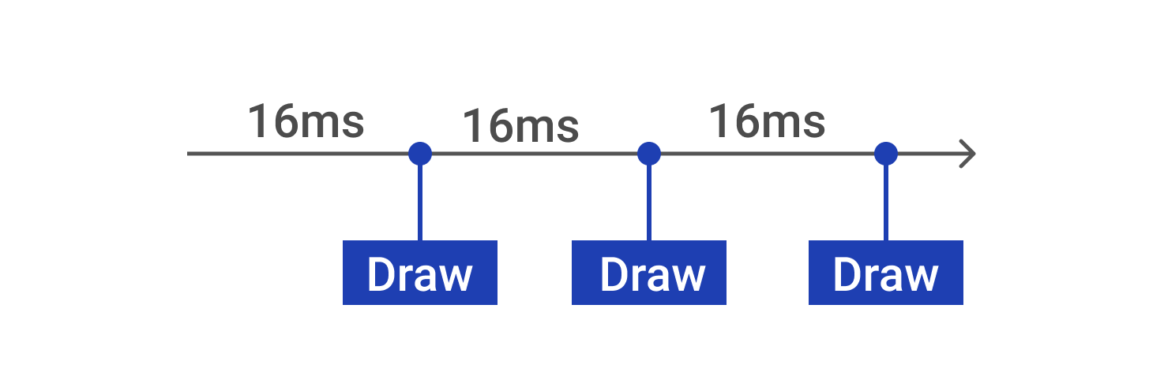

So, if the GC runs for more time, the app will be unable to update UI and it will skip a few frames, so it will seem that the app is lagging. That is one of the reasons for the app lag.

Another reason is that the app is doing too much on the main thread. For example, at that time if any method/task is taking more time than 16ms, the app will be unable to update UI, which means lag will be there in the app for that time.

Basically, the system tries to redraw the UI every 16ms, and what if our task on the main thread takes more than 16ms? For example, if our task takes 26ms. The system tries to update the UI, but it wasn't ready. In that case, it will not refresh anything. And, that caused the UI to be refreshed after 32ms instead of 16ms. Ultimately, there will be a frame drop.

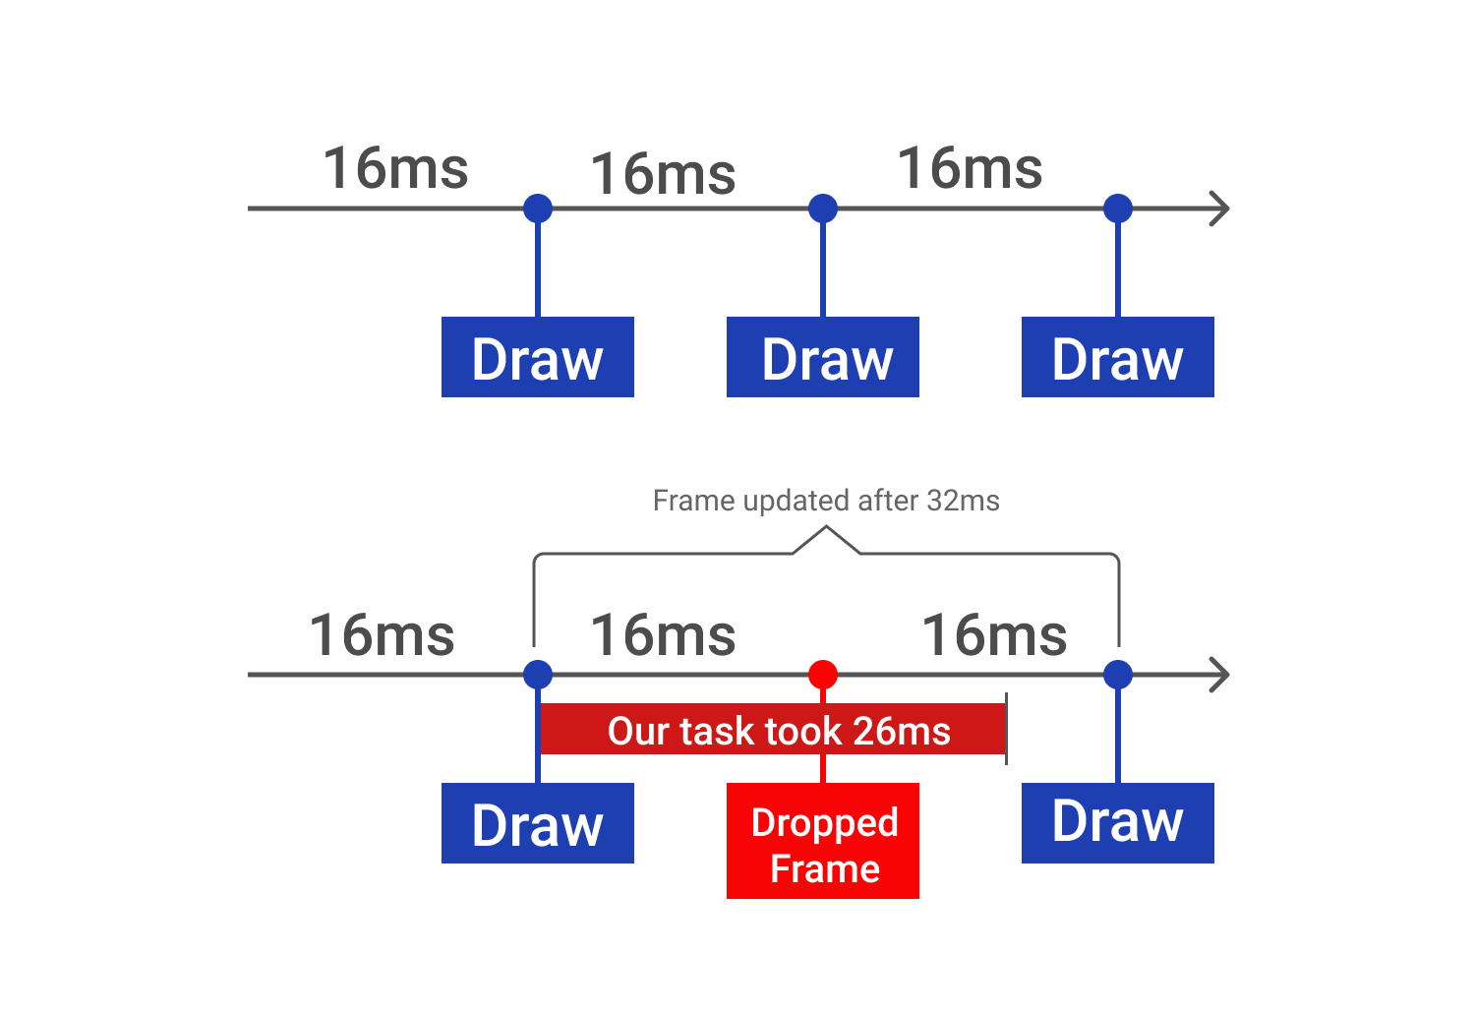

So, due to the frame drop, the user finds the app laggy.

Even if there is one dropped frame, the animation will not be smooth. The user will find it laggy.

Now, we have understood the two most important reasons because of why the Android Apps lag which are as follows:

* GC running frequently
* Doing too much work on the main thread

In order to fix this lag issue, we need to focus on the following:

* Reduce GC running time
* Do not do too much on the main thread

Steps to be taken to improve the performance:

* Do not allocate any object if it is not required. Do not allocate objects early, allocate objects only when it is required. Use lazy initialization.
* Avoid Auto-Boxing as Integer, Boolean, etc takes more memory as classes like Integer takes more memory so use int where ever possible instead of Integer.
* Use ArrayMap and SparseArray. Refer to this [article](https://amitshekhar.me/blog/optimization-using-arraymap-and-sparsearray), this will show why and when to use ArrayMap and SparseArray to optimize your Android Applications.
* Use the concept of object pools to avoid memory churn. Learn about the [bitmap pool](https://amitshekhar.me/blog/bitmap-pool).
* Keep heavy work away from the main thread. Transfer it to the background thread.
* Use static final for constants or [const val in Kotlin](https://amitshekhar.me/blog/const-in-kotlin).
* Avoid Internal Getters/Setters wherever not necessary (direct field access is 3x faster)
* Don't leak contexts in inner classes.
* Use static inner classes over non-static.
* Use LRU cache for the bitmap to avoid redundant decoding of bitmap, it reduces GC calling again and again.
* Use [StrictMode](https://amitshekhar.me/blog/strictmode-in-android-development) to find things you did by mistake like an accidental disk or network access or database query on the application's main thread in Android Development.
* Use Profile GPU Rendering: It gives a quick visual representation of how much time it takes to render the frames of a UI window relative to the 16ms benchmark. You can enable it from Settings -> Developer Options -> Monitoring Section -> Select Profile GPU Rendering.
* And finally, do not allocate a large number of unnecessary objects.

**Question:**  What is Context in Android?

**Answer:**  The Context in Android is actually the context of what we are talking about and where we are currently present. This will become more clear as we go along with this.

Few important points about the context:

* It is the context of the current state of the application.
* It can be used to get information regarding the activity and application.
* It can be used to get access to resources, databases, and shared preferences, and etc.
* Both the Activity and Application classes extend the Context class.

Context is almost everywhere in Android Development and it is the most important thing in Android Development, so we must understand to use it correctly.

Wrong use of Context can easily lead to memory leaks in an android application.

As there are different types of context in Android, we as an Android Developer often get confused about which context to use at which place. So let’s understand what are those, how to use those, and when to use which one.

Mainly two types of context:

* Application Context: It is the application and we are present in Application. For example - MyApplication(which extends Application class). It is an instance of MyApplication only.
* Activity Context: It is the activity and we are present in Activity. For example - MainActivity. It is an instance of MainActivity only.

## Application Context

It is an instance that is the singleton and can be accessed in activity via getApplicationContext(). This context is tied to the lifecycle of an application. The application context can be used where you need a context whose lifecycle is separate from the current context or when you are passing a context beyond the scope of activity.

Example Use: If you have to create a singleton object for your application and that object needs a context, always pass the application context.

If you pass the activity context here, it will lead to the memory leak as it will keep the reference to the activity and activity will not be garbage collected.

In case, when you have to initialize a library in an activity, always pass the application context, not the activity context.

You only use getApplicationContext() when you know you need a Context for something that may live longer than any other likely Context you have at your disposal.

## Activity Context

This context is available in an activity. This context is tied to the lifecycle of an activity. The activity context should be used when you are passing the context in the scope of an activity or you need the context whose lifecycle is attached to the current context.

Example Use: If you have to create an object whose lifecycle is attached to an activity, you can use the activity context.

The app hierarchy looks like the following:

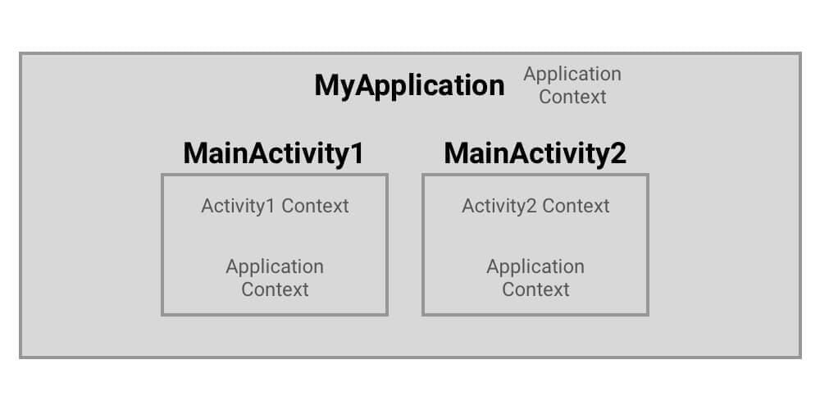

* MyApplication [Here we have only Application context present] [Nearest Context is Application Context]
* MainActivity1 [Here we have both Activity(MainActivity1) context and Application context present] [Nearest Context is Activity Context]
* MainActivity2 [Here we have both Activity(MainActivity2) context and Application context present] [Nearest Context is Activity Context]

## getContext() in ContentProvider

This context is the application context and can be used as the application context. You can get it using the getContext() method.

## When to use which Context?

Let's learn which context to use at which place with an example:

Suppose we have our class MyApplication(which extends the Application class). And, another class MyDB which is Singleton. And MyDB(which is Singleton) needs context. Which context will we be passing?

The answer is Application Context because if we pass the Activity Context (for example MainActivity1), even if MainActivity1 is not in use, the MyDB will be keeping the reference unnecessary which will lead to the memory leaks.

So always remember, in case of Singleton(lifecycle is attached to the application lifecycle), always use the Application Context.

So, now when to use the Activity Context. Whenever you are in Activity, for any UI operations like showing toast, dialogs, and etc, use the Activity Context.

Always try to use the nearest context which is available to you. When you are in Activity, the nearest context is Activity context. When you are in Application, the nearest context is the Application context. If Singleton, use the Application Context.

## When not to use getApplicationContext() ?

* It’s not a complete Context, supporting everything that Activity does. Various things you will try to do with this Context will fail, mostly related to the GUI.
* It can create memory leaks if the Context from getApplicationContext() holds onto something created by your calls on it that you don’t clean up. With an Activity, if it holds onto something, once the Activity gets garbage collected, everything else flushes out too. The Application object remains for the lifetime of your process.

## The Rule of Thumb

* In most cases, use the Context directly available to you from the enclosing component you’re working within. You can safely hold a reference to it as long as that reference does not extend beyond the lifecycle of that component. As soon as you need to save a reference to a Context from an object that lives beyond your Activity or Service, even temporarily, switch that reference you save over to the application context.

**Question:**  What is Application class?

**Answer:**  The Application class in Android is the base class within an Android app that contains all other components such as activities and services. The Application class, or any subclass of the Application class, is instantiated before any other class when the process for your application/package is created.

**Question:**  What is onSavedInstanceState() and onRestoreInstanceState() in activity?

**Answer:**  onSavedInstanceState() - This method is used to store data before pausing the activity.

* onRestoreInstanceState() - This method is used to recover the saved state of an activity when the activity is recreated after destruction. So, the onRestoreInstanceState() receive the bundle that contains the instance state information.

**Question:**  singleTask launchMode in Android

**Answer:**  we will learn about the singleTask launchMode in Android.

We use launchMode to give instructions to the Android operating system about how to launch the activity.

There are various types of launchMode in Android, but for this blog, we are focusing on singleTask.

## singleTask launchMode

When we use launchMode="singleTask", the following cases are possible:

* If an Activity does not exist in an already created Task, then it starts the new Activity in a new Task with the Activity's new instance at the root of that Task.
* If an Activity exists in an already created Task, the Task is brought forward with the Activity's last state restored and this Activity receives the new intent through the onNewIntent() method.
* Only one instance of the Activity can exist at a time.

Now, let's understand the above points with examples.

Assume we have the Activities as A, B, C, D, and E. And, we have added launchMode="singleTask" for Activity C.

Example 1

Let's say we have the state of the Activity Stack before launching Activity C as follows:

A > B

Here, we navigated from Activity A to Activity B. And now we want to navigate to Activity C from Activity B.

Keep this in mind that we have launchMode="singleTask" for Activity C.

Now, after the launch of Activity C from Activity B, the state of the Activity Stack will become as follows:

A > B > C

Here, Activity C gets launched as usual.

Example 2

Let's say we have the state of the Activity Stack before launching Activity C as follows:

A > B > C > D > E

Here, we navigated from Activity A to Activity B to Activity C to Activity D to Activity E. And now we want to navigate to Activity C from Activity E.

Keep this in mind that we have launchMode="singleTask" for Activity C.

Now, after the launch of Activity C from Activity E, the state of the Activity Stack will become as follows:

A > B > C

Two important things to note here:

* Here, Activity C is the old instance only that gets the extras data through onNewIntent().
* Activities D and E get destroyed.

Now, we have understood about the singleTask launchMode in Android.

**Question:**  Why fragments, and when to use fragments instead of activities?

**Answer:**  Fragments are Android's solution to creating reusable user interfaces. You can achieve some of the same things using activities and layouts (for example by using includes). However; fragments are wired in to the Android API, from HoneyComb, and up. Let me elaborate;

* The ActionBar. If you want tabs up there to navigate your app, you quickly see that ActionBar.TabListener interface gives you a FragmentTransaction as an input argument to the onTabSelected method. You could probably ignore this, and do something else and clever, but you'd be working against the API, not with it.
* The FragmentManager handles «back» for you in a very clever way. Back does not mean back to the last activity, like for regular activities. It means back to the previous fragment state.
* You can use the cool ViewPager with a FragmentPagerAdapter to create swipe interfaces. The FragmentPagerAdapter code is much cleaner than a regular adapter, and it controls instantiations of the individual fragments.
* Your life will be a lot easier if you use Fragments when you try to create applications for both phones and tablets. Since the fragments are so tied in with the Honeycomb+ APIs, you will want to use them on phones as well to reuse code. That's where the compatibility library comes in handy.
* You even could and should use fragments for apps meant for phones only. If you have portability in mind. I use ActionBarSherlock and the compatibility libraries to create "ICS looking" apps, that look the same all the way back to version 1.6. You get the latest features like the ActionBar, with tabs, overflow, split action bar, viewpager etc.

Bonus 2

The best way to communicate between fragments are intents. When you press something in a Fragment you would typically call StartActivity() with data on it. The intent is passed on to all fragments of the activity you launch.

**Question:**  When should you use a Fragment rather than an Activity?

**Answer:**  When you have some UI components to be used across various activities

* When multiple view can be displayed side by side just like viewPager

**Question:**  What is the difference between FragmentPagerAdapter vs FragmentStatePagerAdapter?

**Answer:**  FragmentPagerAdapter: Each fragment visited by the user will be stored in the memory but the view will be destroyed. When the page is revisited, then the view will be created not the instance of the fragment.

* FragmentStatePagerAdapter: Here, the fragment instance will be destroyed when it is not visible to the user, except the saved state of the fragment.

**Question:**  Basic difference between add() and replace() method of Fragment

**Answer:**  The important difference is:

replace removes the existing fragment and adds a new fragment..

but add retains the existing fragments and adds a new fragment that means existing fragment will be active and they wont be in 'paused' state hence when a back button is pressed onCreateView() is not called for the existing fragment(the fragment which was there before new fragment was added).

**Question:**  What is retained Fragment?

**Answer:**  By default, Fragments are destroyed and recreated along with their parent Activity’s when a configuration change occurs. Calling setRetainInstance(true) allows us to bypass this destroy-and-recreate cycle, signaling the system to retain the current instance of the fragment when the activity is recreated.

**Question:**  What is the meaning of addToBackStack with null parameter?

**Answer:**  What is the meaning of addToBackStack(null) followed by a commit()?

Quoting docs:

By calling addToBackStack(), the replace transaction is saved to the back stack so the user can reverse the transaction and bring back the previous fragment by pressing the Back button.

If you add multiple changes to the transaction (such as another add() or remove()) and call addToBackStack(), then all changes applied before you call commit() are added to the back stack as a single transaction and the Back button will reverse them all together.

The order in which you add changes to a FragmentTransaction doesn't matter, except:

You must call commit() last. If you're adding multiple fragments to the same container, then the order in which you add them determines the order they appear in the view hierarchy.

So you have to commit at the last.

Why you need to pass a null parameter to addToBackStack?

It don't need to be null, it can be a string. If you don't want, just pass null.

public abstract FragmentTransaction addToBackStack (String name)

Added in API level 11 Add this transaction to the back stack. This means that the transaction will be remembered after it is committed, and will reverse its operation when later popped off the stack.

Parameters name An optional name for this back stack state, or null.

Concerning:

Seems like this code is useless as I ran the code without the last line .addToBackStack(null).commit() and it ran without any problems

If you want to navigate to previous fragment add it to backstack. So it depends on whether you want to add the fragment to the backstack.

How to get that fragment after being added like this?

You already have the fragment instance firstFragment. So I don't know what you mean by get the fragment later.

More information @

<http://developer.android.com/guide/components/fragments.html>

<http://developer.android.com/reference/android/app/FragmentTransaction.html#addToBackStack(java.lang.String)>

**Question:**  Android : Difference between View.GONE and View.INVISIBLE?

**Answer:**  ***View.GONE*** This view is invisible, and it doesn't take any space for layout purposes.

***View.INVISIBLE*** This view is invisible, but it still takes up space for layout purposes.

**Question:**  Do you know what is the view tree? How can you optimize its depth?

**Answer:**  <https://developer.android.com/reference/android/view/ViewTreeObserver>

**Question:**  What is the difference between ListView and RecyclerView?

**Answer:**  RecyclerView was created as a ListView improvement, so yes, you can create an attached list with ListView control, but using RecyclerView is easier as it:

1. **Reuses cells while scrolling up/down** - this is possible with implementing View Holder in the ListView adapter, but it was an optional thing, while in the RecycleView it's the default way of writing adapter.
2. **Decouples list from its container** - so you can put list items easily at run time in the different containers (linearLayout, gridLayout) with setting LayoutManager.

*Example:*

mRecyclerView = (RecyclerView) findViewById(R.id.my_recycler_view); mRecyclerView.setLayoutManager(new LinearLayoutManager(this)); //or mRecyclerView.setLayoutManager(new GridLayoutManager(this, 2));

1. **Animates common list actions** - Animations are decoupled and delegated to ItemAnimator.

There is more about RecyclerView, but I think these points are the main ones.

So, to conclude, RecyclerView is a more flexible control for handling "list data" that follows patterns of delegation of concerns and leaves for itself only one task - recycling items.

**Question:**  What is the ViewHolder pattern? Why should we use it?

**Answer:**  Understand how listview recycling works

[How ListView's recycling mechanism works](https://stackoverflow.com/questions/11945563/how-listviews-recycling-mechanism-works)

You cannot recycle a row that is presently in use. The above link explains how listview recycling mechanism works

So What is the benefit of using ViewHolder?

Quoting docs

Your code might call findViewById() frequently during the scrolling of ListView, which can slow down performance. Even when the Adapter returns an inflated view for recycling, you still need to look up the elements and update them. A way around repeated use of findViewById() is to use the "view holder" design pattern.

public View getView(int position, View convertView, ViewGroup parent) { ViewHolder holder; if (convertView == null) { // if convertView is null convertView = mInflater.inflate(R.layout.mylayout, parent, false); holder = new ViewHolder(); // initialize views convertView.setTag(holder); // set tag on view } else { holder = (ViewHolder) convertView.getTag(); // if not null get tag // no need to initialize } //update views here return convertView; }

You missed the important part convertView.setTag(holder) and holder = (ViewHolder) ConvertView.getTag()

<http://developer.android.com/training/improving-layouts/smooth-scrolling.html>

**Question:**  RecyclerView Optimization - Scrolling Performance Improvement

**Answer:**  we are going to learn how to optimize the RecyclerView performance in Android. With these optimizations, we can make the RecyclerView scrolling smooth.

When we implement RecyclerView in our Android Application, sometimes, we face problems like: The RecyclerView items are not scrolling smoothly. It leads to bad user experience as it seems that our Android App is laggy.

Let's see what are the things which we can do to improve the performance of the RecyclerView and hence, we get the smooth scrolling.

RecyclerView Optimization Techniques

Let's get started

## Use Image-Loading Library

As the Garbage Collection(GC) runs on the main thread, one of the reasons for unresponsive UI is the continuous allocation and deallocation of memory, which leads to the very frequent GC run. By using the [bitmap pool](https://amitshekhar.me/blog/android-image-loading-library-use-bitmap-pool-for-responsive-ui) concept, we can avoid it.

The best part is that Image-Loading libraries like Glide, Fresco uses this bitmap pool concept. So, always use Image-Loading libraries.

Delegate all the image-related tasks to these libraries.

If you are curious to know: [How The Android Image Loading Library Glide and Fresco Works? Read here](https://amitshekhar.me/blog/android-image-loading-library-use-bitmap-pool-for-responsive-ui).

## Set Image Width and Height

If our image width and height are dynamic(not fixed), and we are getting the imageUrl from the server.

If we do not set the correct image width and height prior, the UI will flicker during the transition of loading(downloading of image) and setting of the image into the ImageView(actually making it visible when downloading completes).

So, we should ask our backend developer to send the image size or the aspect ratio, accordingly, we can calculate the required width and height of the ImageView.

Then, we will be able to set the width and height prior only. Hence no flickering. Problem Solved!

## Do less in onBindViewHolder method

Our onBindViewHolder method should do very less work. We should check our onBindViewHolder method and optimize it. We can see the improvement in our RecyclerView by doing so.

## Use Notify Item RecyclerView API

Whenever we have the use-case of the removal, the updation, the addition of item, use the Notify Item API.

adapter.notifyItemRemoved(position)

adapter.notifyItemChanged(position)

adapter.notifyItemInserted(position)

adapter.notifyItemRangeInserted(start, end)

In case, we are forced to use notifyDataSetChanged() based on our use-case, we can try the setHasStableIds(true).

adapter.setHasStableIds(true)

It indicates whether each item in the data set can be represented with a unique identifier of type Long.

Even if we call the notifyDataSetChanged(), it does not have to handle the complete re-ordering of the whole adapter because it can find if the item at a position is the same as before and do less work.

## Avoid a nested view

If possible, we should avoid a nested view and try to create a flat view wherever possible. Nesting reduces RecyclerView performance. Flat View improves performance.

## Use setHasFixedSize

We should use this method if the height of all the items is equal. Add the below and check the performance.

recyclerView.setHasFixedSize(true)

## Use setRecycledViewPool for Optimizing Nested RecyclerView

As we know that the RecyclerView works on the principle of "Reuse View Using Pool" wherever possible.

If we have the use-case of Nested RecyclerView.

- OuterRecyclerView

- InnerRecyclerViewOne

- InnerRecyclerViewTwo

But by default, the optimization works for that particular RecyclerView because that particular RecyclerView has its own View Pool.

The pool does not get shared between two RecyclerViews having the same types of views.

So, what we can do is that we can create a single ViewPool and pass it to all the inner RecyclerViews so that it gets shared like below:

class OuterRecyclerViewAdapter() : RecyclerView.Adapter<RecyclerView.ViewHolder>() {

*// code removed for brevity*

private val viewPool = RecyclerView.RecycledViewPool()

override fun onCreateViewHolder(parent: ViewGroup, viewType: Int): RecyclerView.ViewHolder {

*// code removed for brevity*

viewHolderOne.innerRecyclerViewOne.setRecycledViewPool(viewPool)

*// code removed for brevity*

viewHolderTwo.innerRecyclerViewTwo.setRecycledViewPool(viewPool)

}

*// code removed for brevity*

}

This will improve scrolling performance as it will start reusing the view from the shared ViewPool.

## Use setItemViewCacheSize

We can experiment by setting the ItemView Cache Size.

recyclerView.setItemViewCacheSize(cacheSize)

As per the official documentation: It sets the number of offscreen views to retain before adding them to the potentially shared recycled view pool. The offscreen view cache stays aware of changes in the attached adapter, allowing a LayoutManager to reuse those views unmodified without needing to return to the adapter to rebind them.

It means that when we scroll the RecyclerView such that there's a view that is just barely completely off-screen, the RecyclerView will keep it around so that we can scroll it back into view without having to call the onBindViewHolder() again.

Generally, we do not change the size of the View Cache, but experiment with it, if it works for you, implement it.

**Question:**  Use setRecycledViewPool for Optimizing Nested RecyclerView

**Answer:**  we will learn about how can we optimize the scrolling performance of the Nested RecyclerView using the setRecycledViewPool.

When we use RecyclerView, it reuses the items from the recycled view pool wherever possible for performance optimization.

But suppose we have a Nested RecyclerView as below:

- OuterRecyclerView

- InnerRecyclerViewOne

- InnerRecyclerViewTwo

And we have similar view types in both the InnerRecyclerViewOne and InnerRecyclerViewTwo.

The optimization works for that particular RecyclerView because that particular RecyclerView has its own View Pool. Here InnerRecyclerViewOne and InnerRecyclerViewTwo are independent of each other in terms of the recycled view pool.

It means that the InnerRecyclerViewOne will not share anything with the InnerRecyclerViewTwo although they have similar view types. The pool does not get shared between the two RecyclerViews even though they are having similar types of views.

If they can share the recycled view pool, it will lead to better performance.

For that, we use the setRecycledViewPool.

So, we create a single view pool and pass it to the both RecyclerViews using the setRecycledViewPool so that it gets shared as below:

class OuterRecyclerViewAdapter() : RecyclerView.Adapter<RecyclerView.ViewHolder>() {

*// code removed for brevity*

private val viewPool = RecyclerView.RecycledViewPool()

override fun onCreateViewHolder(parent: ViewGroup, viewType: Int): RecyclerView.ViewHolder {

*// code removed for brevity*

viewHolderOne.innerRecyclerViewOne.setRecycledViewPool(viewPool)

*// code removed for brevity*

viewHolderTwo.innerRecyclerViewTwo.setRecycledViewPool(viewPool)

}

*// code removed for brevity*

}

This will improve the scrolling performance as it will start reusing the view from the shared view pool.

This is how we can use the setRecycledViewPool to improve the scrolling performance while having the Nested RecyclerView.

**Question:**  SnapHelper

**Answer:**  we will learn how to use SnapHelper in RecyclerView in Android Application.

What is SnapHelper?

SnapHelper is a helper class that helps in snapping any child view of the RecyclerView. For example, you can snap the firstVisibleItem of the RecyclerView as you must have seen in the play store application that the firstVisibleItem will be always completely visible when scrolling comes to the idle position.

View the GIF here.

Android already provides a helper class to do the same. The class is LinearSnapHelper which will only enable the center snapping.

You just need to do the following changes in your code:

SnapHelper snapHelper = new LinearSnapHelper();

snapHelper.attachToRecyclerView(yourRecyclerView);

View the GIF here.

Now, how to do start snapping like below?

View the GIF here.

First of all, you will have to create a class let say StartSnapHelper which will be extending LinearSnapHelper and mainly override the following methods:

1. calculateDistanceToFinalSnap

Override this method to snap to a particular point within the target view or the container view on any axis. This method is called when the SnapHelper has intercepted a fling and it needs to know the exact distance required to scroll by in order to snap to the target view.

2. findSnapView

Override this method to provide a particular target view for snapping. This method is called when the SnapHelper is ready to start snapping and requires a target view to snap to. It will be explicitly called when the scroll state becomes idle after a scroll. It will also be called when the SnapHelper is preparing to snap after a fling and requires a reference view from the current set of child views. If this method returns null, SnapHelper will not snap to any view.

import android.support.annotation.NonNull;

import android.support.annotation.Nullable;

import android.support.v7.widget.LinearLayoutManager;

import android.support.v7.widget.LinearSnapHelper;

import android.support.v7.widget.OrientationHelper;

import android.support.v7.widget.RecyclerView;

import android.view.View;

/**

* Created by amitshekhar on 15/01/17.

*/

public class StartSnapHelper extends LinearSnapHelper {

private OrientationHelper mVerticalHelper, mHorizontalHelper;

public StartSnapHelper() {

}

@Override

public void attachToRecyclerView(@Nullable RecyclerView recyclerView)

throws IllegalStateException {

super.attachToRecyclerView(recyclerView);

}

@Override

public int[] calculateDistanceToFinalSnap(@NonNull RecyclerView.LayoutManager layoutManager,

@NonNull View targetView) {

int[] out = new int[2];

if (layoutManager.canScrollHorizontally()) {

out[0] = distanceToStart(targetView, getHorizontalHelper(layoutManager));

} else {

out[0] = 0;

}

if (layoutManager.canScrollVertically()) {

out[1] = distanceToStart(targetView, getVerticalHelper(layoutManager));

} else {

out[1] = 0;

}

return out;

}

@Override

public View findSnapView(RecyclerView.LayoutManager layoutManager) {

if (layoutManager instanceof LinearLayoutManager) {

if (layoutManager.canScrollHorizontally()) {

return getStartView(layoutManager, getHorizontalHelper(layoutManager));

} else {

return getStartView(layoutManager, getVerticalHelper(layoutManager));

}

}

return super.findSnapView(layoutManager);

}

private int distanceToStart(View targetView, OrientationHelper helper) {

return helper.getDecoratedStart(targetView) - helper.getStartAfterPadding();

}

private View getStartView(RecyclerView.LayoutManager layoutManager,

OrientationHelper helper) {

if (layoutManager instanceof LinearLayoutManager) {

int firstChild = ((LinearLayoutManager) layoutManager).findFirstVisibleItemPosition();

boolean isLastItem = ((LinearLayoutManager) layoutManager)

.findLastCompletelyVisibleItemPosition()

== layoutManager.getItemCount() - 1;

if (firstChild == RecyclerView.NO_POSITION || isLastItem) {

return null;

}

View child = layoutManager.findViewByPosition(firstChild);

if (helper.getDecoratedEnd(child) >= helper.getDecoratedMeasurement(child) / 2

&& helper.getDecoratedEnd(child) > 0) {

return child;

} else {

if (((LinearLayoutManager) layoutManager).findLastCompletelyVisibleItemPosition()

== layoutManager.getItemCount() - 1) {

return null;

} else {

return layoutManager.findViewByPosition(firstChild + 1);

}

}

}

return super.findSnapView(layoutManager);

}

private OrientationHelper getVerticalHelper(RecyclerView.LayoutManager layoutManager) {

if (mVerticalHelper == null) {

mVerticalHelper = OrientationHelper.createVerticalHelper(layoutManager);

}

return mVerticalHelper;

}

private OrientationHelper getHorizontalHelper(RecyclerView.LayoutManager layoutManager) {

if (mHorizontalHelper == null) {

mHorizontalHelper = OrientationHelper.createHorizontalHelper(layoutManager);

}

return mHorizontalHelper;

}

}

Now, attach this to your RecyclerView.

SnapHelper startSnapHelper = new StartSnapHelper();

startSnapHelper.attachToRecyclerView(yourRecyclerView);

**Question:**  What is Dialog in Android?

**Answer:**  <https://developer.android.com/develop/ui/views/components/dialogs>

**Question:**  What is Toast in Android?

**Answer:**  <https://developer.android.com/guide/topics/ui/notifiers/toasts>

**Question:**  What the difference between Dialog and Dialog Fragment?

**Answer:**  Dialog: A dialog is a small window that prompts the user to make a decision or enter additional information.

DialogFragment: A DialogFragment is a special fragment subclass that is designed for creating and hosting dialogs. It allows the FragmentManager to manage the state of the dialog and automatically restore the dialog when a configuration change occurs.

**Question:**  What is a BroadcastReceiver?

**Answer:**  <https://developer.android.com/guide/components/broadcasts>

**Question:**  What is the function of an IntentFilter?

**Answer:**  <https://developer.android.com/reference/android/content/IntentFilter>

**Question:**  What is a Sticky Intent?

**Answer:**  Sticky Intents allows communication between a function and a service. sendStickyBroadcast() performs a sendBroadcast(Intent) known as sticky, i.e. the Intent you are sending stays around after the broadcast is complete, so that others can quickly retrieve that data through the return value of registerReceiver(BroadcastReceiver, IntentFilter). For example, if you take an intent for ACTION_BATTERY_CHANGED to get battery change events: When you call registerReceiver() for that action — even with a null BroadcastReceiver — you get the Intent that was last Broadcast for that action. Hence, you can use this to find the state of the battery without necessarily registering for all future state changes in the battery.

**Question:**  Describe how broadcasts and intents work to be able to pass messages around your app?

**Answer:**  No offense, but your question is still damn vague. So, I'm going to outline a whole mess of scenarios and hope that one of them actually hits whatever problem you think you have.

## Scenario A: Only The Activity

If you only need to receive the broadcast when you have an activity in the foreground, have the activity register the BroadcastReceiver using registerReceiver(). As @MisterSquonk indicated, you would register the receiver in onResume() and unregister it in onPause().

## Scenario B: Activity If In Foreground, Else Other; Ordered Broadcast

If you want the foreground activity to handle the broadcast, but you want something else to happen if that activity is not in the foreground (e.g., raise a Notification), and the broadcast is an ordered broadcast (e.g., incoming SMS), then you would still use the Scenario A solution, but with a higher-priority IntentFilter (see setPriority()). In addition, you would register a BroadcastReceiver via a <receiver> element in the manifest, with a lower-priority <intent-filter> for the same broadcast. In the activity's BroadcastReceiver, call abortBroadcast() to consume the event and prevent it from reaching your manifest-registered BroadcastReceiver.

## Scenario C: Activity If In Foreground, Else Other; Regular Broadcast

If Scenario B almost fits, but the broadcast you are listening for is not an ordered broadcast, you will need to start with Scenario B. However, have the broadcast that both receivers have in their respective filters be one of your own, using a private action string as @MisterSquonk suggested. In addition, have *another* BroadcastReceiver registered in the manifest, whose <intent-filter> is for the real broadcast you're listening for. That receiver would simply call sendOrderedBroadcast() to send out the ordered broadcast that the other receivers are listening on.

## Scenario D: Activity Regardless of Foreground

If some activity of yours needs to know about the broadcast, and it does not matter whether or not it is in the foreground, you need to rethink what you mean by that. Usually, this really means that the broadcast affects your data model in some way, in which case your concern should *not* be to let the activities know, but rather to update your data model, and use your already-existing "let the activities know about the data model change" logic handle the rest.

If, however, you are convinced that this is not part of your data model, you can implement Scenario B or Scenario C, plus stick some information in a static data member. Your activities can examine that static data member in onResume() to pick up the information about the broadcast when they return to the foreground.

If you're thinking "but, what if my process is terminated between the broadcast and the other activity coming to the foreground?", then your broadcast really **is** updating your data model, per the opening paragraph of this scenario.

If you're thinking "but, I want to update an activity that is doing work in the background", then the activity in question is broken. Activities should never be doing work in the background. That work should be delegated to some form of service, and there's a whole related set of scenarios for getting a broadcast to the service.

**Question:**  What is a PendingIntent?

**Answer:**  If you want someone to perform any Intent operation at future point of time on behalf of you, then we will use Pending Intent.

**Question:**  What are the different types of Broadcasts?

**Answer:**  <https://developer.android.com/guide/components/broadcasts>

**Question:**  What is Service?

**Answer:**  <https://developer.android.com/guide/components/services>

**Question:**  What is a JobScheduler?

**Answer:**  <https://developer.android.com/reference/android/app/job/JobScheduler>

**Question:**  How can two distinct Android apps interact?

**Answer:**  <https://developer.android.com/training/basics/intents>

**Question:**  Is it possible to run an Android app in multiple processes? How?

**Answer:**  You can specify android:process=":remote" in your manifest to have an activity/service run in a seperate process.

The "remote" is just the name of the remote process, and you can call it whatever you want. If you want several activities/services to run in the same process, just give it the same name.

<activity android:name=".RemoteActivity" android:label="@string/app_name" android:process=":RemoteActivityProcess"/>

**Question:**  What is AIDL? Enumerate the steps in creating a bounded service through AIDL.

**Answer:**  <https://developer.android.com/guide/components/aidl>

**Question:**  What can you use for background processing in Android?

**Answer:**  <https://developer.android.com/guide/background>

**Question:**  What is a ContentProvider and what is it typically used for?

**Answer:**  <https://developer.android.com/guide/topics/providers/content-provider-basics>

<https://developer.android.com/guide/topics/providers/content-providers>

**Question:**  How to run parallel tasks in Java or Android, and get callback when all complete?

**Answer:**  we will learn about how to run long tasks in parallel with Kotlin Flow in Android.

This blog is a part of the series I have written on Flow API in Kotlin:

* [Mastering Flow API in Kotlin](https://amitshekhar.me/blog/flow-api-in-kotlin)
* [Creating Flow Using Flow Builder in Kotlin](https://amitshekhar.me/blog/creating-flow-using-flow-builder-in-kotlin)
* [Terminal Operators in Kotlin Flow](https://amitshekhar.me/blog/terminal-operators-in-kotlin-flow)
* [Cold Flow vs Hot Flow](https://amitshekhar.me/blog/cold-flow-vs-hot-flow)
* [StateFlow and SharedFlow](https://amitshekhar.me/blog/stateflow-and-sharedflow)
* Long-running tasks in parallel with Kotlin Flow - YOU ARE HERE
* [Retry Operator in Kotlin Flow](https://amitshekhar.me/blog/retry-operator-in-kotlin-flow)
* [Retrofit with Kotlin Flow](https://amitshekhar.me/blog/retrofit-with-kotlin-flow)
* [Room Database with Kotlin Flow](https://amitshekhar.me/blog/room-database-with-kotlin-flow)
* [Kotlin Flow Zip Operator for Parallel Multiple Network Calls](https://amitshekhar.me/blog/kotlin-flow-zip-operator-parallel-multiple-network-calls)
* [Instant Search Using Kotlin Flow Operators](https://amitshekhar.me/blog/instant-search-using-kotlin-flow-operators)
* [Exception Handling in Kotlin Flow](https://amitshekhar.me/blog/exception-handling-in-kotlin-flow)
* [callbackFlow - Callback to Flow API in Kotlin](https://amitshekhar.me/blog/callback-to-flow-api-in-kotlin)
* [Unit Testing ViewModel with Kotlin Flow and StateFlow](https://amitshekhar.me/blog/unit-testing-viewmodel-with-kotlin-flow-and-stateflow)

I will be using the following project for the implementation part. The project follows a basic MVVM Architecture for simplicity. You can find the complete code for the implementation mentioned in this blog in the project itself.

**Question:**  Why should you avoid to run non-ui code on the main thread?

**Answer:**  <https://developer.android.com/guide/background>

**Question:**  What is ANR? How can the ANR be prevented?

**Answer:**  <https://developer.android.com/topic/performance/vitals/anr.html>

**Question:**  When would you use java thread instead of an AsyncTask?

**Answer:**  or long-running or CPU-intensive tasks, there are basically two ways to do this: Java threads, and Android's native AsyncTask.

Neither one is necessarily better than the other, but knowing when to use each call is essential to leveraging the system's performance to your benefit.

**Use AsyncTask for:**

1. Simple network operations which do not require downloading a lot of data
2. Disk-bound tasks that might take more than a few milliseconds

**Use Java threads for:**

1. Network operations which involve moderate to large amounts of data (either uploading or downloading)
2. High-CPU tasks which need to be run in the background
3. Any task where you want to control the CPU usage relative to the GUI thread

And there are lot of good resources over internet which may help you:

<http://www.vogella.com/articles/AndroidBackgroundProcessing/article.html>

**Question:**  What is the relationship between the life cycle of an AsyncTask and an Activity? What problems can this result in? How can these problems be avoided?

**Answer:**  An AsyncTask is not tied to the life cycle of the Activity that contains it. So, for example, if you start an AsyncTask inside an Activity and the user rotates the device, the Activity will be destroyed (and a new Activity instance will be created) but the AsyncTask will not die but instead goes on living until it completes.

* Then, when the AsyncTask does complete, rather than updating the UI of the new Activity, it updates the former instance of the Activity (i.e., the one in which it was created but that is not displayed anymore!). This can lead to an Exception (of the type java.lang.IllegalArgumentException: View not attached to window manager if you use, for instance, findViewById to retrieve a view inside the Activity).
* There’s also the potential for this to result in a memory leak since the AsyncTask maintains a reference to the Activity, which prevents the Activity from being garbage collected as long as the AsyncTask remains alive.
* For these reasons, using AsyncTasks for long-running background tasks is generally a bad idea . Rather, for long-running background tasks, a different mechanism (such as a service) should be employed.
* Note: AsyncTasks by default run on a single thread using a serial executor, meaning it has only 1 thread and each task runs one after the other.

**Question:**  How do you handle bitmaps in Android as it takes too much memory?

**Answer:**  <https://developer.android.com/topic/performance/graphics/load-bitmap>

<https://developer.android.com/topic/performance/graphics/manage-memory>

**Question:**  What is the difference between a regular Bitmap and a nine-patch image?

**Answer:**  In general, a Nine-patch image allows resizing that can be used as background or other image size requirements for the target device. The Nine-patch refers to the way you can resize the image: 4 corners that are unscaled, 4 edges that are scaled in 1 axis, and the middle one that can be scaled into both axes.

**Question:**  Tell about the Bitmap pool.

**Answer:**  we will learn about the bitmap pool in Android.

Image heavy applications have to decode many images, so there will be continuous allocation and deallocation of memory in application. This results in frequent calling of the Garbage Collector (GC). And if you call the GC too many times, your application UI freezes.

If you want to read more about the mechanics of UI freezes and how to avoid them, here’s a good primer.

Glide and Fresco use the Bitmap Pool Concept to reduce GC calls as much as possible and make the UI responsive.

By using the Bitmap pool, they avoid continuous allocation and deallocation of memory in our application and reduce GC overhead.

Let's understand what is bitmap pooling.

What is bitmap pooling?

Bitmap pooling is an implementation that tries to reuse the memory of the bitmaps already available instead of allocating new memory every time. Suppose we need to load a bitmap, we first check our pool to see if there is any bitmap available. If it is available, we take a bitmap from the pool and reuse its memory to load our new bitmap otherwise we create a new bitmap. In case, if we do not need any bitmap, we put that bitmap into that pool instead of recycling it so that we can reuse the memory of that bitmap when needed for a new bitmap.

We put constraints on the memory size of the pool as we put constraints on the memory size of a cache.

This is possible by using the inBitmap property of the Bitmap. (which reuses bitmap memory).

Let's say we have to load two bitmaps (bitmapOne, bitmapTwo) one by one. When we load bitmapOne, it will allocate the memory for bitmapOne. Then if when we no longer need bitmapOne, we do not recycle the bitmap (as recycling involves calling GC). Instead, we use this bitmapOne as an inBitmap for bitmapTwo. This way, the same memory can be reused for bitmapTwo.

Let's say, we are showing a bitmapOne into the imageView.

Bitmap bitmapOne = BitmapFactory.decodeFile(filePathOne);

imageView.setImageBitmap(bitmapOne);

Now, let's say, we do not need image bitmapOne and we have to set another bitmap in imageView.

final BitmapFactory.Options options = new BitmapFactory.Options();

options.inJustDecodeBounds = true;

BitmapFactory.decodeFile(filePathTwo, options);

options.inMutable = true;

options.inBitmap = bitmapOne;

options.inJustDecodeBounds = false;

Bitmap bitmapTwo = BitmapFactory.decodeFile(filePathTwo, options);

imageView.setImageBitmap(bitmapTwo);

Note:

On API Level 19+, the Bitmap needs to be the same size or larger than the Bitmap that we are trying to decode. Otherwise, the Bitmap will be ignored and we will get a new Bitmap.

On older devices, the Bitmap needs to be the same size (resolution) as the Bitmap that we are trying to decode. Otherwise, the Bitmap will be ignored and we will get a new Bitmap.

This way we are not allowing the GC to be called again and again as we are not leaving off the reference of the bitmapOne, instead we are loading the bitmapTwo in the memory of bitmapOne.

These libraries create a bitmap pool of bitmaps.

We can say that the bitmap pool is a list of bitmaps that are no longer needed but are available for reuse to load the new bitmap into the same memory.

When any bitmap is available for recycling, these libraries just push the bitmap into that bitmap pool.

When these libraries have to load the new bitmap, they just get a bitmap that can be reused to load the new one to reuse the same memory from that bitmap pool. Hence no recycling, and no GC calls.

And we have responsive UI.

This is how Bitmap pooling helps us. I hope you must have understood the bitmap pool in Android.

**Question:**  How would you preserve Activity state during a screen rotation?

**Answer:**  Have you tried using: its work around ,

<activity name= ".YourActivity" android:configChanges="orientation|screenSize"/>

in Manifest file?

It does not work by default because , when you change the orientation onCreate will be called again and it redraws your view.

If you write this parameter no need to handle in Activity , the framework will take care of rest of things. It will retain the state of the screen or layout if orientation is changed.

NOTE If you are using a different layout for landscape mode , by adding these parameters the layout for landscape mode will not be called.

**Question:**  What is commit() and apply() in SharedPreferences?

**Answer:**  commit() returns a boolean value of success or failure immediately by writing data synchronously.

* apply() is asynchronous and it won't return any boolean response. If you have an apply() outstanding and you are performing commit(), then the commit() will be blocked until the apply() is not completed.

**Question:**  What is a SpannableString?

**Answer:**  A SpannableString has immutable text, but its span information is mutable. Use a SpannableString when your text doesn't need to be changed but the styling does. Spans are ranges over the text that include styling information like color, heighliting, italics, links, etc

**Question:**  What is the onTrimMemory() method?

**Answer:**  <https://developer.android.com/topic/performance/memory>

**Question:**  What is Doze? What about App Standby?

**Answer:**  <https://developer.android.com/training/monitoring-device-state/doze-standby>

**Question:**  What is overdraw?

**Answer:** [**https://developer.android.com/topic/performance/rendering/overdraw.html**](https://developer.android.com/topic/performance/rendering/overdraw.html)

**Question:**  How do you support different types of resolutions?

**Answer:**  <https://developer.android.com/guide/topics/large-screens/support-different-screen-sizes>

**Question:**  What is the NDK and why is it useful?

**Answer:**  we will be comparing Android NDK and RenderScript. Both NDK and RenderScript share the common goal of improving the performance of applications. Each has its own advantages and drawbacks.

## What’s NDK?

As per official documentation, The Native Development Kit (NDK) is a set of tools that allow you to leverage C and C++ code in your Android app. You can use it to build from your own source code or to take advantage of existing prebuilt libraries.

I must say that the NDK is not that easy for those who have just started with Android Development as when it comes to implementation, NDK brings complexity to the development process.

But it can be useful in cases in which you need to:

* Get the extra performance out of a device for computationally intensive applications like games or physics simulations.
* Reuse your C or C++ libraries.

## What’s RenderScript?

RenderScript is a framework for running computationally intensive tasks at high performance on Android.

RenderScript mainly uses for the data-parallel computation, however, the serial computationally intensive workloads can benefit as well.

The RenderScript runtime will parallelize work across all processors available on a device such as multi-core CPUs and GPUs allowing you to focus on expressing algorithms rather than scheduling work or load balancing.

RenderScript is especially useful for applications performing image processing, computational photography, or computer vision.

To begin with RenderScript, there are two main concepts you should understand:

* High-performance compute kernels are written in a C99-derived language.
* A Java API is used for managing the lifetime of RenderScript resources and controlling kernel execution.

## How NDK and RenderScript differ

As we know both NDK and RenderScript share the common goal of improving the performance of applications. However, each has its own advantages and drawbacks.

Advantages of NDK over RenderScript:

* C++ code can be shared between Android and IOS, whereas RenderScript code can be used only in Android.
* Easy integration with other C++ libraries.
* No API limitations, while Android provides only a few API for RenderScript.
* Debugging is easier.

Advantages of RenderScript over NDK:

* RenderScript can use CPU, GPU, or other processing units, which leads to a huge performance benefit.
* Android architecture independence across x86, mips, and intel, whereas NDK code, needs to be compiled for each different architecture.
* Easier parallel execution.
* Best for image processing, computational photography, 3D rendering, or computer vision.

**Question:**  What is Android Runtime?

**Answer:**  we will learn about the terms Dalvik, ART, JIT, and AOT in Android.

We, Android Developers keep hearing these terms when we talk about optimization, and performance but have little or no idea about them.

* Dalvik
* ART
* JIT
* AOT

Do not worry, today we will learn about each of them in detail.

These terms are related to Android Runtime, so first we must understand what is Android Runtime.

### What is Android Runtime?

We write code in Kotlin/Java, and when we build the APK, it gets converted to bytecode.

In our APK, we will have the .dex files that contain bytecode.

Our Android devices can't run the bytecode directly, so it needs to be translated to the machine code. This translation is done by Android Runtime.

*Kotlin/Java > bytecode(.dex files in APK) > machine code*

So, now that we know what is Android Runtime, it's time to learn about the different types of Android Runtime and their evolution.

* Dalvik
* ART

Let's first learn about the Dalvik.

### Dalvik

Dalvik, our first Android Runtime is based on the JIT compilation.

JIT compilation means Just In Time compilation.

As the .dex contain the bytecode, it needs to be translated to the machine code to be run.

In Dalvik Android Runtime, as it is JIT based, it gets translated when we run the app. As we keep on using the app, only that part of the bytecode gets converted to the machine code. Also, the most frequently used code gets cached so that we don't have to translate them again.

This process is repeated every single time when we open the app using the CPU cycles and hence impacting the battery life.

Disadvantage: Low performance and decreases battery performance.

The performance of the application was not up to the mark as the translation was happening during the application run and it happens every time when we run the app.

So, we needed a solution to make the apps more performant.

In Android L, we were introduced to the new Android Runtime: ART.

Till now, we have learned about the Dalvik and JIT, now it's time to learn about the ART and AOT.

### ART

ART, our next Android Runtime is based on the AOT compilation.

AOT compilation means Ahead of Time compilation.

Again, as the .dex contain the bytecode, it needs to be translated to the machine code to be run.

In ART Android Runtime, as it is AOT based, it gets translated before we run the app. It gets translated at the time of app installation only. Basically, when we install the app, it translates the bytecode into the machine code and stores it on the disk.

So, by ART, the problem related to the low performance of Dalvik got solved. Now we have a high-performance application because there is no need for translation during the app run.

Advantage: High Performance

But, we should also talk about the disadvantages.

One disadvantage is more installation time as it translates the bytecode to the machine code at the time of app installation only.

Another disadvantage of ART is that it needs more space as it translates the bytecode into machine code and stores it on the disk. The pre-compiled binary occupies more space than the DEX bytecode. So, it takes more space as compared to the Dalvik runtime.

The last disadvantage is that the boot time is more as compared to the Dalvik as the cache is built during the boot. You might see an "Optimizing apps" dialog box while booting your Android devices.

Disadvantages:

* More install time
* More space on the disk
* More boot time

**Question:**  What is DEX?

**Answer:**  <https://developer.android.com/reference/dalvik/system/DexFile>

**Question:**  Why Bundle class is used for data passing and why cannot we use simple Map data structure?

**Answer:**  <https://developer.android.com/guide/components/activities/parcelables-and-bundles>

**Question:**  How do you troubleshoot a crashing application?

**Answer:**  <https://developer.android.com/topic/performance/vitals/crash>

**Question:**  What is AAPT?

**Answer:**  <https://developer.android.com/tools/aapt2>

**Question:**  What is the best way to update the screen periodically?

**Answer:**

I'm doing something similar in my android app; I update some data in my interface every 10 seconds. There are many ways to do this, but I chose to use a Handler because it's very simple to implement:

Thread timer = new Thread() { public void run () { for (;;) { // do stuff in a separate thread uiCallback.sendEmptyMessage(0); Thread.sleep(3000); // sleep for 3 seconds } } }); timer.start(); ... private Handler uiCallback = new Handler () { public void handleMessage (Message msg) { // do stuff with UI } };

As you may know, you cannot run periodic functions like this in the UI thread, because it will block the UI. This creates a new Thread that sends a message to the UI when it is done, so you can update your UI with the new results of whatever your periodic function does.

If you do not need to update the UI with the results of this periodic function, you can simply ignore the second half of my code example, and just spawn a new Thread as shown. Beware, however: if you are modifying variables shared by this new Thread and the UI, you are going to run into problems if you don't synchronize. In general, threading is not an area where you want to ignore "good programming practices" because you'll get strange, non-predictable errors and you'll be cursing your program.

**Question:**  Explain OkHttp Interceptor

**Answer:**  we will learn how to work with the OkHttp Interceptors. We will also see the real use cases where we can use it and how we can use it to get the most out of it. In Android, we have many use cases that can be done using the OkHttp Interceptors.

Today, we will cover the following topics to master it:

What are Interceptors?

Types of Interceptors.

How to add Interceptors in OkHttpClient?

Creating the Interceptor.

Real use cases using the Interceptors.

What are Interceptors?

According to documentation, Interceptors are a powerful mechanism that can monitor, rewrite, and retry the API call. So basically, when we do some API call, we can monitor the call or perform some tasks.

In simple words, Interceptors are like the security personnel in the security check process at the Airport. They check our boarding pass, put a stamp on it, and then allow us to pass.

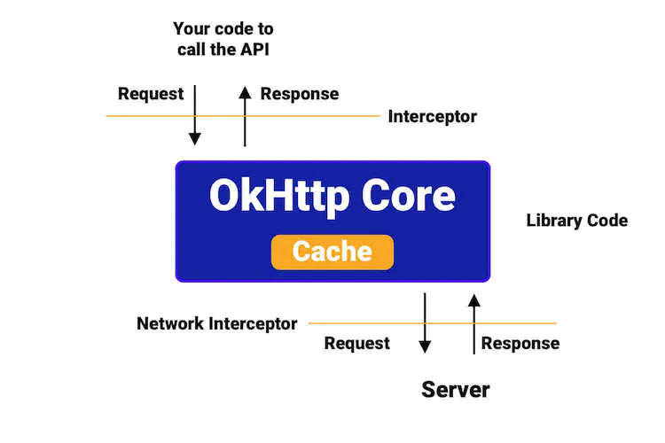

okhttp interceptor explain

We can use the interceptors to do so many things, for example, centrally monitor API calls. Generally, we need to add the logger for each network call, but by using the interceptor, we can add one logger centrally and that will work for all the network calls. Another use case can be caching the response of network calls to build the offline-first app, we will learn it later in this blog in detail.

Types of Interceptors

We have two types of interceptors as follows:

Application Interceptors: These are interceptors that are added between the Application Code(our written code) and the OkHttp Core Library. These are the ones that we add using addInterceptor().

Network Interceptors: These are interceptors that are added between the OkHttp Core Library and the Server. These can be added to OkHttpClient using addNetworkInterceptor().

How to add interceptors in OkHttpClient?

While building the OkHttpClient object, we can add the interceptor as below:

fun myHttpClient(): OkHttpClient {

val builder = OkHttpClient().newBuilder()

.addInterceptor(/*our interceptor*/)

return builder.build()

}

Here, in addInterceptor, we pass the interceptor that we have created. Now, let's see how to create the Interceptor.

Creating the Interceptor

To create the interceptor, we need to create a class by implementing the Interceptor interface as below:

class MyInterceptor : Interceptor {

override fun intercept(chain: Interceptor.Chain): Response {

/**

* Our API Call will be intercepted here

*/

}

}

Here, in the intercept(), we can perform any action which we want inside it.

And to use the interceptor, we can use as below:

fun myHttpClient(): OkHttpClient {

val builder = OkHttpClient().newBuilder()

.addInterceptor(MyInterceptor())

return builder.build()

}

We can add the MyInterceptor in addInterceptor().

Now, let's discuss more real use cases where we can use the Interceptors.

Real use-cases using the Interceptors

The following are the common use cases in Android:

Logging the errors centrally

First, we need to create the ErrorInterceptor as below:

class ErrorInterceptor : Interceptor {

override fun intercept(chain: Interceptor.Chain): Response {

val request: Request = chain.request()

val response = chain.proceed(request)

when (response.code()) {

400 -> {

//Show Bad Request Error Message

}

401 -> {

//Show UnauthorizedError Message

}

403 -> {

//Show Forbidden Message

}

404 -> {

//Show NotFound Message

}

// ... and so on

}

return response

}

}

First, we get the request from the chain.request()

Then, we get the response returned from the server, by passing the request in the chain.proceed(request)

Now, we can check for the response code and perform an action.

We can pass the error to the view.

Let's say we get a 401 error i.e. Unauthorized then we can perform an action to clear the app data/log out the user or any action which we want to perform.

Now, to use this ErrorInterceptor in our OkHttpClient, we can add as below:

.addInterceptor(ErrorInterceptor())

This is how we can create a centralized Error Logger using the Interceptor.

OkHttp has a built-in logger which is very useful for debugging.

Note: If we want to log the details for the redirection of the URL, consider using the interceptor at the network layer using the addNetworkInterceptor().

Caching the response

If we want to cache the response of the API call so that if we call the API again, the response comes out from Cache.

Let's say we have the API call from Client to Server and Cache-Control header is enabled from the server, then OkHttp Core will respect that header and cache the response for a certain time being which was sent from the server.

But what if the Cache-Control is not enabled from the server? We still can cache the response from OkHttp Client using Interceptor.

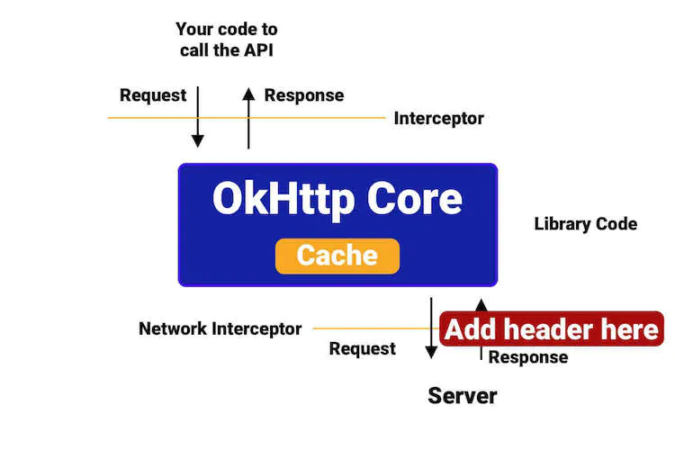

okhttp cache control explain

Just see the above image. Here, what we have to do is that we have to intercept the Response before going inside the OkHttp Core and add the header (Cache-Control), so it will be treated as if the response(with the Cache-Control header) has come from the server. Okhttp Core will respect that and cache the response.

We will create an interceptor as below:

class CacheInterceptor : Interceptor {

override fun intercept(chain: Interceptor.Chain): Response {

val response: Response = chain.proceed(chain.request())

val cacheControl = CacheControl.Builder()

.maxAge(10, TimeUnit.DAYS)

.build()

return response.newBuilder()

.header("Cache-Control", cacheControl.toString())

.build()

}

}

Here, we have a CacheControl which is used to provide the header for Cache-Control.

Finally, we can add as below:

val okHttpClient = OkHttpClient().newBuilder()

.cache(Cache(File(applicationContext.cacheDir, "http-cache"), 10L * 1024L * 1024L)) // 10 MiB

.addNetworkInterceptor(CacheInterceptor())

.build();

Here, if we see, we are not using the addInterceptor() but using addNetworkInterceptor() for the use case. This is because in this case, the operation is happening at the network layer.

But, there is something important, we need to consider while building the offline-first app.

The cached response will be returned only when the Internet is available as OkHttp is designed like that.

When the Internet is available and data is cached, it returns the data from the cache.

Even when the data is cached and the Internet is not available, it returns the error "no internet available".

What to do now?

We can use the following ForceCacheInterceptor at the Application layer in addition to the above one (CacheInterceptor, only if not enabled from the server). To implement in the code, we will create a ForceCacheInterceptor as below:

class ForceCacheInterceptor : Interceptor {

override fun intercept(chain: Interceptor.Chain): Response {

val builder: Request.Builder = chain.request().newBuilder()

if (!IsInternetAvailable()) {

builder.cacheControl(CacheControl.FORCE_CACHE);

}

return chain.proceed(builder.build());

}

}

We can add the Interceptor in OkHttpClient as below:

val okHttpClient = OkHttpClient().newBuilder()

.cache(Cache(File(applicationContext.cacheDir, "http-cache"), 10L * 1024L * 1024L)) // 10 MiB

.addNetworkInterceptor(CacheInterceptor()) // only if Cache-Control header is not enabled from the server

.addInterceptor(ForceCacheInterceptor())

.build();

Here, we are adding the ForceCacheInterceptor to OkHttpClient using addInterceptor() and not addNetworkInterceptor() as we want it to work on the Application layer.

Adding the Header like Access Token centrally

Let's say that we have to make the API calls and we have to add the Authorization Header in all the API calls. Either we can use it individually or we can centralize that using the Interceptor.

class AuthTokenInterceptor : Interceptor {

override fun intercept(chain: Interceptor.Chain): Response {

val originalRequest = chain.request()

val requestBuilder = originalRequest.newBuilder()

.header("Authorization", "AuthToken")

val request = requestBuilder.build()

return chain.proceed(request)

}

}

First, we get the token for the header from our local storage like a SharedPreference.

Here, we intercept the original request which we triggered from the application using chain.request() and set it to originalRequest.

Then, we build the request again by adding the Header with the key and value which is required to make the network call.

Then, we will build the request again and return the response using chain.proceed(request) by passing the new request which is having the Authorization header.

This is how we can centralize the Header which is common in all the API Calls. Now to use it in the OkHttpClient, we will do as below:

.addInterceptor(AuthTokenInterceptor())

Let's go to another use case.

Refreshing the Access Token at Single Place

Let us say we have a use-case that when we get a 401 error in the Error Interceptor and we need to refresh the auth token as we have an Unauthorized error. We can do that using the below:

override fun intercept(chain: Interceptor.Chain): Response {

val accessToken = //our access Token

val request = chain.request().newBuilder()

.addHeader("Authorization", accessToken)

.build()

val response = chain.proceed(request)

if (response.code() == 401) {

val newToken: String = //fetch from some other source

if (newToken != null) {

val newRequest = chain.request().newBuilder()

.addHeader("Authorization", newToken)

.build()

return chain.proceed(newRequest)

}

}

return response

}

If we get the response.code() as 401 i.e. Unauthorized, we will refresh the token here, then modify the request by adding the new header and make the new request to the server.

And, this should be synchronized to avoid the concurrency issue.

Note: Another way that is more flexible when it comes to refreshing the Access Token is to use the Authenticator interface of OkHttp.

Now, let's move to another use case.

Enabling Gzip at Android End

Gzip is used for data compression. In Android as well, we can use the Gzip for the compression using the interceptor.

So, while getting a response, OkHttp automatically respects the header (content encoding) and decompresses the data and returns, but let's say when we have to send compressed data to a server, then we have to write our own interceptor.

We can create the GzipRequestInterceptor class as below (taken from the OkHttp repository).

public class GzipRequestInterceptor implements Interceptor {

@Override

public Response intercept(Chain chain) throws IOException {

Request originalRequest = chain.request();

if (originalRequest.body() == null || originalRequest.header("Content-Encoding") != null) {

return chain.proceed(originalRequest);

}

Request compressedRequest = originalRequest.newBuilder()

.header("Content-Encoding", "gzip")

.method(originalRequest.method(), forceContentLength(gzip(originalRequest.body())))

.build();

return chain.proceed(compressedRequest);

}

private RequestBody forceContentLength(final RequestBody requestBody) throws IOException {

final Buffer buffer = new Buffer();

requestBody.writeTo(buffer);

return new RequestBody() {

@Override

public MediaType contentType() {

return requestBody.contentType();

}

@Override

public long contentLength() {

return buffer.size();

}

@Override

public void writeTo(BufferedSink sink) throws IOException {

sink.write(buffer.snapshot());

}

};

}

private RequestBody gzip(final RequestBody body) {

return new RequestBody() {

@Override

public MediaType contentType() {

return body.contentType();

}

@Override

public long contentLength() {

return -1; // We don't know the compressed length in advance!

}

@Override

public void writeTo(BufferedSink sink) throws IOException {

BufferedSink gzipSink = Okio.buffer(new GzipSink(sink));

body.writeTo(gzipSink);

gzipSink.close();

}

};

}

}

To use the interceptor we can use as below:

.addInterceptor(GzipRequestInterceptor())

So, these are the real use cases, how can we use the interceptors in our Android App. We can do a lot of things with interceptors. Let's start making the most of it.

**Question:**  OkHttp - HTTP Caching

**Answer:**  we are going to learn how to cache HTTP responses in Android using OkHttp Interceptor and Retrofit for building offline-first Android apps.

Read more about the OkHttp Interceptor: OkHttp Interceptor

Let's understand how caching is going to help us in our Android applications.

When we make a network call to fetch the data from the server.

For the very first time, it will get the data from the server and it will cache the HTTP response on the client.

Then, if we make the same API call again, it will return the data from the cache instantly.

This way, our Android applications can do two very important things:

Work even if there is no internet connection. This will helps us in building the offline-first apps.

Work faster as the response is cached locally.

Now, let's learn how to enable caching in OkHttp and Retrofit. Before that, we need to understand that Retrofit uses the OkHttp client for HTTP operations, which means that whatever we have to do to enable caching, we need to do with the OkHttp. We do not have to do anything extra for Retrofit as it will use our configured OkHttp client.

Things become easier when we already have the Cache-Control header enabled from the server, then OkHttp will respect that header and cache the response for a specific time that is being sent from the server.

But what if the Cache-Control is not enabled from the server? We can still cache the response from OkHttp Client using Interceptor. We will learn how.

For this, we need to implement Interceptor like below:

class CacheInterceptor : Interceptor {

override fun intercept(chain: Interceptor.Chain): Response {

val response: Response = chain.proceed(chain.request())

val cacheControl = CacheControl.Builder()

.maxAge(10, TimeUnit.DAYS)

.build()

return response.newBuilder()

.header("Cache-Control", cacheControl.toString())

.build()

}

}

Here, we created CacheInterceptor by implementing Interceptor and we have a CacheControl builder that is used to provide the header for the Cache-Control.

Then, we need to add this CacheInterceptor to the OkHttpClient using addNetworkInterceptor.

val okHttpClient = OkHttpClient().newBuilder()

.cache(Cache(File(applicationContext.cacheDir, "http-cache"), 10L * 1024L * 1024L)) // 10 MiB

.addNetworkInterceptor(CacheInterceptor())

.build();

After that, we can use this okHttpClient directly or with Retrofit.

But, there is a catch that we need to understand while building the offline-first app.

OkHttp is designed in such a way that it returns the cached response only when the Internet is available.

It returns the data from the cache only when the Internet is available and the data is cached.

It returns with the error "no internet available" even when the data is cached and but the Internet is not available.

How to solve this issue?

We can create a ForceCacheInterceptor in addition to the above one (CacheInterceptor, only if Cache-Control header is not enabled from the server).

class ForceCacheInterceptor : Interceptor {

override fun intercept(chain: Interceptor.Chain): Response {

val builder: Request.Builder = chain.request().newBuilder()

if (!IsInternetAvailable()) {

builder.cacheControl(CacheControl.FORCE_CACHE);

}

return chain.proceed(builder.build());

}

}

Then, add the interceptor in OkHttpClient like below:

val okHttpClient = OkHttpClient().newBuilder()

.cache(Cache(File(applicationContext.cacheDir, "http-cache"), 10L * 1024L * 1024L)) // 10 MiB

.addNetworkInterceptor(CacheInterceptor()) // only if Cache-Control header is not enabled from the server

.addInterceptor(ForceCacheInterceptor())

.build();

Here, we need to notice that we are adding ForceCacheInterceptor to OkHttpClient using addInterceptor() and not addNetworkInterceptor().

addInterceptor: used to add the interceptor at the application level.

addNetworkInterceptor: As the name says, used to add the interceptor at the network level.

After that, we can use this okHttpClient directly or with Retrofit and it will work as expected.

This is how we can cache HTTP responses in Android using OkHttp Interceptor and Retrofit for building offline-first Android apps.

**Question:**  FlatMap Vs Map Operator

**Answer:**  we will learn about the Map vs FlatMap Operator in RxJava.

RxJava is the most important library which is popular among Android developers. It makes our life easy.

We use RxJava for multithreading, managing background tasks, and removing callback hells. We can solve so many complex use cases with the help of RxJava. It enables us to do complex things very simply. It provides us the power.

With great power comes great responsibility

Let’s see the components of the RxJava.

Observable -> Speaker

Operator -> Translator

Observer -> Listener

The above table describes what each component does.

Operator: An operator is like a translator who translates/modifies data from one form to another form.

RxJava has so many operators. In order to use them correctly, we must know about them. Here, we will discuss the Map and the FlatMap.

Map

Map transforms the items emitted by an Observable by applying a function to each item.

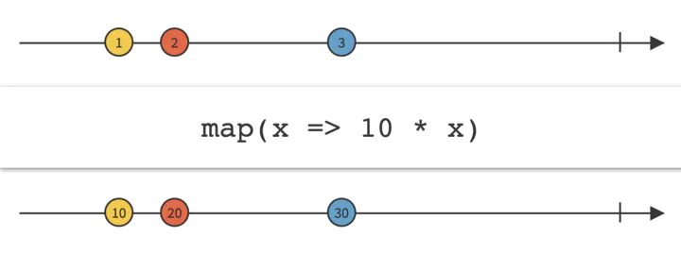

RxJava Map marble diagram

FlatMap

FlatMap transforms the items emitted by an Observable into Observables.

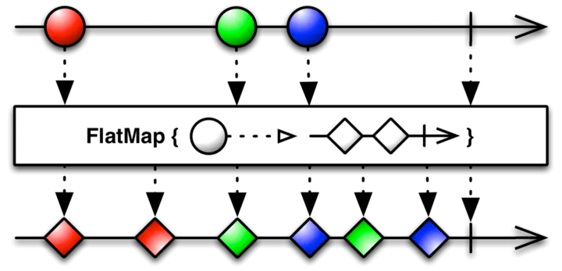

RxJava FlatMap marble diagram

So, the main difference between Map and FlatMap is that FlatMap mapper returns an observable itself, so it is used to map over asynchronous operations.

Very important: FlatMap is used to map over asynchronous operations.

Let’s see the example code.

Map Example:

getUserObservable()

.map(new Function<ApiUser, User>() {

@Override

public User apply(ApiUser apiUser) throws Exception {

// here we get the ApiUser from the server

User user = new User(apiUser);

// then by converting it into the user, we are returning

return user;

}

})

.subscribeOn(Schedulers.io())

.observeOn(AndroidSchedulers.mainThread())

.subscribe(getObserver());

Here, the observable gives us ApiUser object which we are converting into User object by using the map operator.

FlatMap Example:

getUserObservable()

.flatMap(new Function<ApiUser, ObservableSource<UserDetail>>() {

@Override

public ObservableSource<UserDetail> apply(ApiUser apiUser) throws Exception {

return getUserDetailObservable(apiUser);

}

})

.subscribeOn(Schedulers.io())

.observeOn(AndroidSchedulers.mainThread())

.subscribe(getObserver());

Here, we are getting the ApiUser and then we are making a network call to get the UserDetail for that apiUser by using the getUserDetailObservable(apiUser). The flatMap mapper returns an observable itself. The getUserDetailObservable is an asynchronous operation.

This is how we should use the Map and the FlatMap operators in RxJava.

**Question:**  When to use Create operator and when to use fromCallable operator of RxJava?

**Answer:**  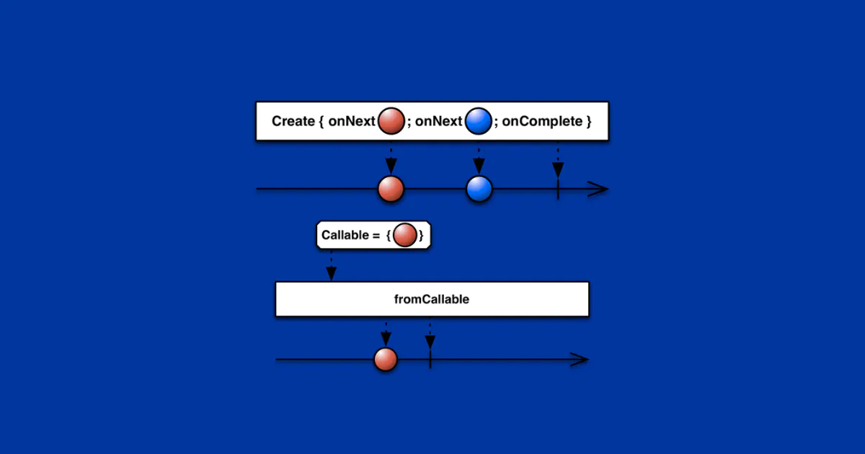

we are going to learn about the RxJava Create and fromCallable Operators. We will understand when to use the Create operator and when to use the fromCallable operator depending on our use case. Most of the time, we do mistakes while using RxJava Operators. Let's understand it clearly to avoid the mistake.

We will learn the following operators with examples.

Create

fromCallable

Create Operator of RxJava

Create Operator: create an Observable from scratch by means of a function.

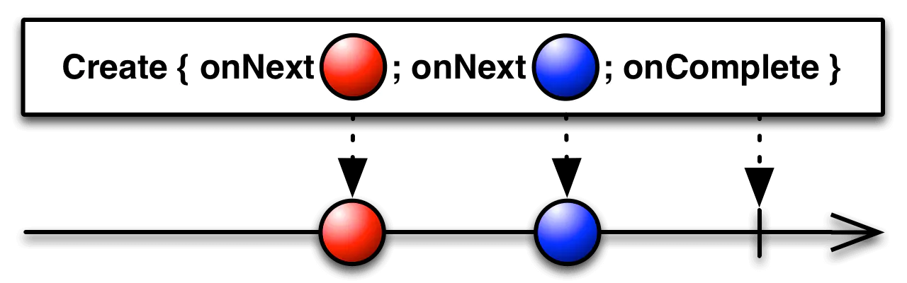

rxjava create

Using Create Operator, we can do a task and keep emitting values one by one and finally completes. Let's see with an example

Observable.create<String> { emitter ->

// do something and emit first item

if (!emitter.isDisposed) {

emitter.onNext("One")

}

// do something and emit second item

if (!emitter.isDisposed) {

emitter.onNext("Two")

}

// on complete

if (!emitter.isDisposed) {

emitter.onComplete()

}

}

.subscribeOn(Schedulers.io())

.subscribe { item ->

Log.d("CreateExample", "item : $item")

}

It will print "One" and "Two".

fromCallable Operator of RxJava

fromCallable Operator: Create an Observable from scratch but can emit only one item means fromCallable return an item.

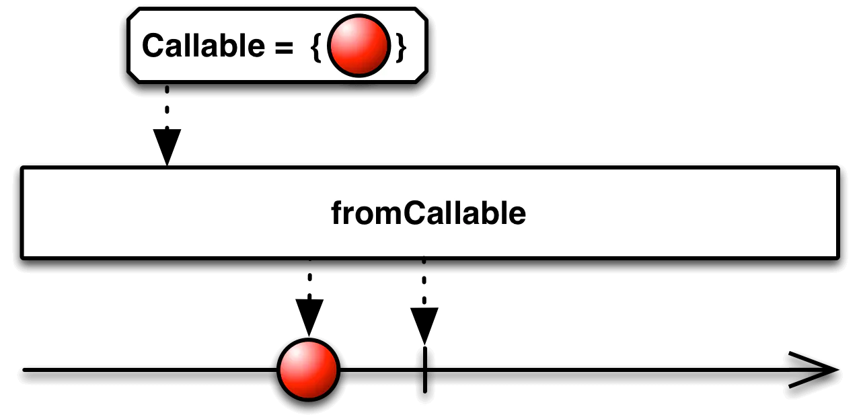

rxjava fromcallable

Using fromCallable, we can do a task and can emit only one item. Let's see with an example

Observable.fromCallable<String> {

// do something and return

return@fromCallable "Amit"

}

.subscribeOn(Schedulers.io())

.subscribe { item ->

Log.d("FromCallableExample", "item : $item")

}

It will print "Amit".

This does not mean that fromCallable is like Single. We will see later how it actually differs.

Both Create and fromCallable defer the execution of the task we specify until an observer subscribes to the ObservableSource. Means, it makes the task "lazy."

So, the following are the major differences between Create and fromCallable Operators:

Create can emit multiple items whereas fromCallable can emit only one item.

There is no simple way to check if isDisposed in fromCallable as present in Create. So if it emits item after disposal, the throwable is delivered to the global error handler via RxJavaPlugins.onError as UndeliverableException. It means it will crash the application. This is how it is different from Single.

This way we can use RxJava Create and fromCallable Operators to solve the interesting problem.

**Question:**  When to use defer operator of RxJava?

**Answer:**  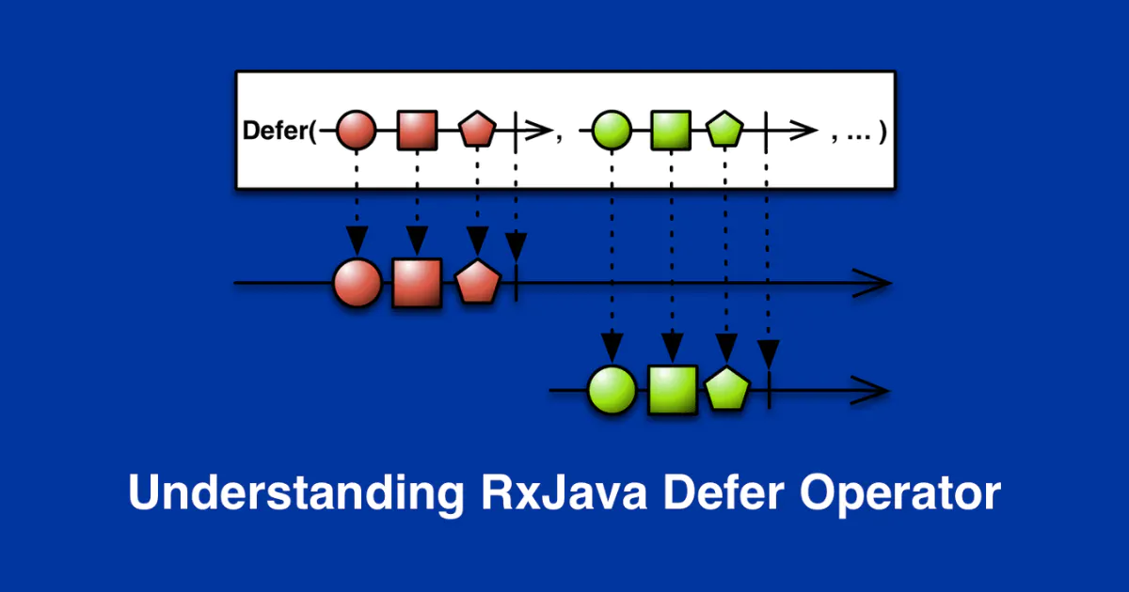

we will learn about the Defer operator of RxJava. We will understand when to use the Defer operator depending on our use case. Most of the time, we do mistakes while using the RxJava Defer Operator. Let's understand it clearly to avoid the mistake.

As per documentation:

Defer: do not create the Observable until the observer subscribes, and create a fresh Observable for each observer

So here, we will be taking an example to learn the Defer Operator of RxJava.

Let say we have a class Car as below:

class Car {

var brand: String = "DEFAULT"

fun getBrandObservable(): Observable<String> {

return Observable.just(brand)

}

fun getBrandDeferObservable(): Observable<String> {

return Observable.defer {

return@defer Observable.just(brand)

}

}

}

In the above Car class, we have two methods as below:

getBrandObservable(): It returns the Observable<String> by just using Observable.just(brand).

getBrandDeferObservable(): It returns the Observable<String> by using Observable.just(brand) but wrapped inside the Observable.defer().

Now, let's try to use both the method and see the difference.

val car = Car()

val brandObservable = car.getBrandObservable()

val brandDeferObservable = car.getBrandDeferObservable()

car.brand = "BMW"

brandObservable

.subscribe { brand ->

Log.d("DeferExample", "brandObservable : $brand")

}

brandDeferObservable

.subscribe { brand ->

Log.d("DeferExample", "brandDeferObservable : $brand")

}

Here, first, we are creating the car object. Then using the car object, we are calling both the methods which are getBrandObservable and getBrandDeferObservable to get the observables. Then, we are setting the brand of car as "BMW". After that, we are subscribing to both the observables to get the brand of the car.

It will print the following:

DeferExample: brandObservable : DEFAULT

DeferExample: brandDeferObservable : BMW

Here we can see that the brandObservable is getting the "DEFAULT" as the brand of the car and the brandDeferObservable is getting "BMW" as the brand of the car.

brandObservable is returning the old value which is "DEFAULT" as it has not used the defer operator.

brandDeferObservable is returning the latest value which is "BMW" as it has used the defer operator.

It means that Defer does not create the Observable until the observer subscribes, and create a fresh Observable for each observer.

Two important things to keep in mind:

Defer does not create the Observable until the observer subscribes.

Defer creates a fresh observable for each observer.

This way we can use RxJava Defer Operator to solve the interesting problem.

**Question:**  How are Timer, Delay, and Interval operators used in RxJava?

**Answer:**  we will learn about the Interval Operator of RxJava.

RxJava has operators for every use case. One of the very useful operators of RxJava is Interval Operator.

What is Interval Operator?

Interval Operator creates an Observable that emits a sequence of integers spaced by a given time interval.

We use the Interval operator when we want to do a task again and again after some interval.

The best way to understand is by taking an example. Let's take an example to understand the Interval Operator.

val disposable =

Observable.interval(0, 2, TimeUnit.SECONDS)

.flatMap {

return@flatMap Observable.create<String> { emitter ->

emitter.onNext("Amit Shekhar")

emitter.onComplete()

}

}

.observeOn(AndroidSchedulers.mainThread())

.subscribe {

println(it)

}

compositeDisposable.add(disposable)

Let's understand the parameters of the interval(long initialDelay, long period, TimeUnit unit):

initialDelay: the initial delay time to wait before emitting the first value

period: the period of time between emissions of the subsequent numbers

unit: the time unit for both initialDelay and period

So, in our example, it will start immediately as the provided initialDelay is 0, then, the task will be done again and again after 2 seconds of interval.

It will keep on printing the following forever:

Amit Shekhar

Amit Shekhar

Amit Shekhar

Amit Shekhar

Amit Shekhar

Amit Shekhar

Amit Shekhar

Amit Shekhar

...

As it will keep going on forever, there must be a way to stop it.

There are two ways to stop which are as follows:

Using the compositeDisposable.dispose()

Using the take(n) operator as below

Observable.interval(0, 2, TimeUnit.SECONDS)

.take(5)

.flatMap {

return@flatMap Observable.create<String> { emitter ->

emitter.onNext("Amit Shekhar")

emitter.onComplete()

}

}

.observeOn(AndroidSchedulers.mainThread())

.subscribe {

println(it)

}

Here, we have passed 5 as a parameter to the take() operator. It means that the task will be done only 5 times.

This will print the following:

Amit Shekhar

Amit Shekhar

Amit Shekhar

Amit Shekhar

Amit Shekhar

We must keep in mind that the Interval Operator runs on the Schedulers.computation(). So, we do not have to worry about the Schedulers.

Use case of Interval Operator: To do the task again and again with a particular time interval.

This way we can use RxJava Interval Operator to solve any problem in a very simple way.

**Question:**  How to make two network calls in parallel using RxJava?

**Answer:**  we will learn the RxJava Zip Operator with an example.

As per the RxJava official documentation,

Zip combine the emissions of multiple Observables together via a specified function and emit single items for each combination based on the results of this function.

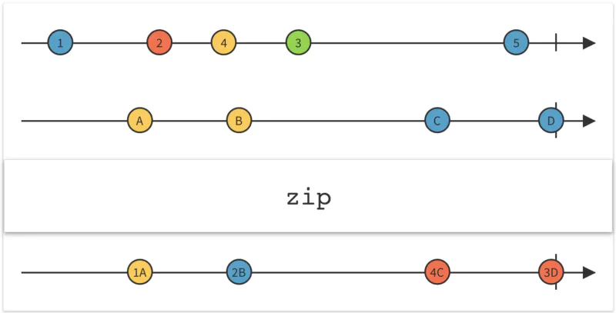

zip operator rxjava marble diagram

Zip operator allows us to get the results from multiple observables at a time.

Suppose that we have two network observables as follows:

CricketFansObservable - A network observable which returns the list of users who are cricket fans.

FootballFansObservable - A network observable which returns the list of users who are football fans.

CricketFansObservable as below:

fun getCricketFansObservable(): Observable<List<User>> {

return networkService.getCricketFansObservable()

}

FootballFansObservable as below:

fun getFootballFansObservable(): Observable<List<User>> {

return networkService.getFootballFansObservable()

}

And our NetworkService as below:

class NetworkService {

fun getCricketFansObservable(): Observable<List<User>> {

return Observable.create<List<User>> { emitter ->

if (!emitter.isDisposed) {

// fetch data from network

val data = fetchUserListFromNetwork()

emitter.onNext(data)

emitter.onComplete()

}

}.subscribeOn(Schedulers.io())

}

fun getFootballFansObservable(): Observable<List<User>> {

return Observable.create<List<User>> { emitter ->

if (!emitter.isDisposed) {

// fetch data from network

val data = fetchUserListFromNetwork()

emitter.onNext(data)

emitter.onComplete()

}

}.subscribeOn(Schedulers.io())

}

private fun fetchUserListFromNetwork(): List<User> {

return listOf()

}

}

An Observer as below:

private fun getObserver(): Observer<List<User>> {

return object : Observer<List<User>> {

override fun onSubscribe(d: Disposable) {

println("onSubscribe")

}

override fun onNext(userList: List<User>) {

println("onNext : $userList")

}

override fun onError(e: Throwable) {

println("onError : ${e.message}")

}

override fun onComplete() {

println("onComplete")

}

}

}

A utility function to filter the user who loves both

private fun filterUserWhoLovesBoth(cricketFans: List<User>,

footballFans: List<User>): List<User> {

val userWhoLovesBoth = ArrayList<User>()

for (footballFan in footballFans) {

if (cricketFans.contains(footballFan)) {

userWhoLovesBoth.add(footballFan)

}

}

return userWhoLovesBoth

}

Let's connect all together to understand zip operator.

Observable.zip(

getCricketFansObservable(),

getFootballFansObservable(),

BiFunction<List<User>, List<User>, List<User>> { cricketFans, footballFans ->

// here we get both the results at a time.

return@BiFunction filterUserWhoLovesBoth(cricketFans, footballFans)

})

.subscribeOn(Schedulers.io())

.observeOn(AndroidSchedulers.mainThread())

.subscribe(getObserver())

First, we are making two network calls(in parallel as we are using Zip Operator), then after getting the results, we are filtering the users who love both.

By zipping two observables using the RxJava Zip operator, both the network calls run in parallel. And we get the result of both the observables when both finish. In this way, we get the results of both the observables at a time.

Advantages of Zip Operator:

Run all the tasks in parallel when Schedulers are correctly provided to each observable.

Return the results of all the tasks in a single callback when all the tasks are completed.

This way we can use RxJava Zip Operator to solve the interesting problem.

**Question:**  Tell the difference between Concat and Merge

**Answer:**  we will learn about the Concat operator of RxJava.

RxJava has operators for every use case. One of the very useful operators of RxJava is Concat Operator.

What is Concat Operator?

The Concat operator emits the emissions from two or more observables without interleaving them.

It maintains the order of the observables while emitting the items. It means that it will emit all the items of the first observable and then it will emit all the items of the second observable and so on.

First, let's understand it through the marble diagram of the Concat operator.

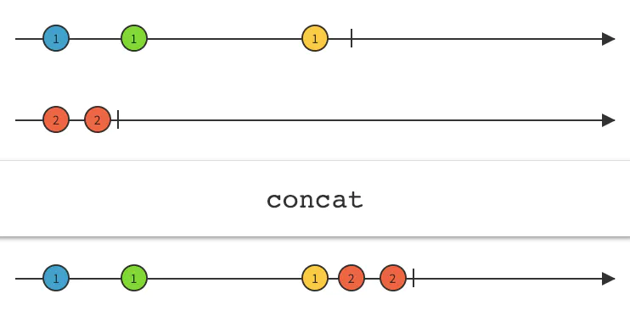

RxJava Concat marble diagram

In the above diagram:

We have two source observables.

The first observable is emitting the items as 1, 1, and 1.

The second observable is emitting items as 2 and 2.

After applying the Concat operator, it is emitting all the items of the first observable and then all the items of the second observable. Hence, it is maintaining the order of the observables in which they were added.

Now, it's time to see the example code.

Our Observer:

fun getObserver(): Observer<String> {

return object : Observer<String> {

override fun onSubscribe(d: Disposable) {

}

override fun onNext(value: String) {

println(value)

}

override fun onError(e: Throwable) {

}

override fun onComplete() {

}

}

}

Our Observables:

val observableA = Observable.fromArray("A1", "A2", "A3", "A4")

val observableB = Observable.fromArray("B1", "B2", "B3", "B4")

Applying Concat operator:

Observable.concat(observableA, observableB)

.subscribe(getObserver())

Here the output will be the following:

A1

A2

A3

A4

B1

B2

B3

B4

As we have used the Concat Operator, it maintained the order and emitted the values as A1, A2, A3, A4, B1, B2, B3, and B4.

Now we have understood the Concat Operator of RxJava.

Note: Concat Operator maintains the order of the observables while emitting the items.

This way we can use RxJava Concat Operator to solve any problem in a very simple way.

**Question:**  Explain Subject in RxJava?

**Answer:**  we will learn about the RxJava Subject - Publish, Replay, Behavior, and Async.

This article is all about the Subject available in RxJava.

Publish Subject

Replay Subject

Behavior Subject

Async Subject

As we already have the sample project based on RxJava2 to learn RxJava (many developers have learned from this sample project), So I have included the Subject examples in the same project. Fork, clone, build, run, and learn RxJava.

Project Link: RxJava2-Android-Samples

What is Subject?

From the official documentation:

A Subject is a sort of bridge or proxy that is available in some implementations of ReactiveX that acts both as an observer and as an Observable. Because it is an observer, it can subscribe to one or more Observables, and because it is an Observable, it can pass through the items it observes by re-emitting them, and it can also emit new items.

I believe: learning by examples is the best way to learn.

Let's learn it through the Professor-Student analogy.

Observable: Assume that a professor is an observable. The professor teaches a topic to the students.

Observer: Assume that a student is an observer. The student observes the topic that is being taught by the professor.

Publish Subject

It emits all the subsequent items of the source Observable at the time of subscription.

Here, if a student entered late into the classroom, he just wants to listen from that point of time when he entered the classroom. So, Publish will be the best for this use case.

See the below example:

PublishSubject<Integer> source = PublishSubject.create();

// It will get 1, 2, 3, 4 and onComplete

source.subscribe(getFirstObserver());

source.onNext(1);

source.onNext(2);

source.onNext(3);

// It will get 4 and onComplete for second observer also.

source.subscribe(getSecondObserver());

source.onNext(4);

source.onComplete();

Replay Subject

It emits all the items of the source Observable, regardless of when the subscriber subscribes.

Here, if a student entered late into the classroom, he wants to listen from the beginning. So, here we will use Replay to achieve this.

See the below example:

ReplaySubject<Integer> source = ReplaySubject.create();

// It will get 1, 2, 3, 4

source.subscribe(getFirstObserver());

source.onNext(1);

source.onNext(2);

source.onNext(3);

source.onNext(4);

source.onComplete();

// It will also get 1, 2, 3, 4 as we have used replay Subject

source.subscribe(getSecondObserver());

Behavior Subject

It emits the most recently emitted item and all the subsequent items of the source Observable when an observer subscribes to it.

Here, if a student entered late into the classroom, he wants to listen to the most recent things(not from the beginning) being taught by the professor so that he gets the idea of the context. So, here we will use Behavior.

See the below example:

BehaviorSubject<Integer> source = BehaviorSubject.create();

// It will get 1, 2, 3, 4 and onComplete

source.subscribe(getFirstObserver());

source.onNext(1);

source.onNext(2);

source.onNext(3);

// It will get 3(last emitted)and 4(subsequent item) and onComplete

source.subscribe(getSecondObserver());

source.onNext(4);

source.onComplete();

Async Subject

It only emits the last value of the source Observable(and only the last value) only after that source Observable completes.

Here, if a student entered the classroom at any point in time, and wants to listen only to the last thing(and only the last thing) being taught after class is over. So, here we will use Async.

See the below example:

AsyncSubject<Integer> source = AsyncSubject.create();

// It will get only 4 and onComplete

source.subscribe(getFirstObserver());

source.onNext(1);

source.onNext(2);

source.onNext(3);

// It will also get only get 4 and onComplete

source.subscribe(getSecondObserver());

source.onNext(4);

source.onComplete();

So, whenever you are stuck with these types of cases, the RxJava Subject will be your best friend

**Question:**  What are the types of Observables in RxJava?

**Answer:**  we will learn about the different types Of Observables in RxJava.

Before jumping into the types of Observables. Let's see the components of RxJava.

Observable

Operator

Observer

An Observable is like a speaker that emits a value. It does some work and emits some values.

An Operator is like a translator which translates/modifies data from one form to another form.

An Observer gets those values.

Observable -> Speaker

Operator -> Translator

Observer -> Listener

Types of Observables in RxJava

The following are the different types of Observables in RxJava:

Observable

Flowable

Single

Maybe

Completable

As there are different types of Observables, there are different types of Observers also.

So, the following are the different types of Observers in RxJava:

Observer

SingleObserver

MaybeObserver

CompletableObserver

Now, let’s see how they are different and when to use which one.

Observable

This is the simplest Observable which can emit more than one value.

Example use-case: Let’s say you are downloading a file and you have to push the current status of download percentage. Here, you will have to emit more than one value.

Creating a simple Observable

fun getDownloadObservable(): Observable<Int> {

return Observable.create { emitter ->

// your downloading code

// start downloading

if (!emitter.isDisposed) {

// send progress

emitter.onNext(10)

}

// downloading...

if (!emitter.isDisposed) {

// send progress

emitter.onNext(75)

}

// download complete

if (!emitter.isDisposed) {

// send progress

emitter.onNext(100)

// send onComplete

emitter.onComplete()

}

}

}

Observer for the Observable

fun getObserver(): Observer<Int> {

return object : Observer<Int> {

override fun onSubscribe(d: Disposable) {

println("onSubscribe")

}

override fun onNext(progress: Int) {

println("onNext : $progress")

}

override fun onError(e: Throwable) {

println("onError : ${e.message}")

}

override fun onComplete() {

println("onComplete")

}

}

}

Flowable

Flowable comes into picture when there is a case that the Observable is emitting huge numbers of values that can’t be consumed by the Observer.

In this case, the Observable needs to skip some values on the basis of some strategy else it will throw an exception.

The Flowable Observable handles the exception with a strategy.

The strategy is called BackPressureStrategy and the exception is called MissingBackPressureException.

Creating a Flowable Observable

Similar to normal Observable, you can create Flowable using Flowable.create().

Observer for Flowable Observable

The Observer for Flowable is exactly the same as normal Observer.

Single

Single is used when the Observable has to emit only one value like a response from a network call.

Creating a Single Observable

fun getSingleObservable(): Single<String> {

return Single.create { emitter ->

// do some task here

if (!emitter.isDisposed) {

emitter.onSuccess("Amit")

}

}

}

SingleObserver for Single Observable

fun getSingleObserver(): SingleObserver<String> {

return object : SingleObserver<String> {

override fun onSubscribe(d: Disposable) {

println("onSubscribe")

}

override fun onSuccess(data: String) {

println("onSuccess : $data")

}

override fun onError(e: Throwable) {

println("onError : ${e.message}")

}

}

}

Maybe

Maybe is used when the Observable has to emit a value or no value.

Creating a Maybe Observable

fun getMaybeObservable(): Maybe<String> {

return Maybe.create { emitter ->

// do some task here

if (!emitter.isDisposed) {

emitter.onSuccess("Amit")

}

}

}

MaybeObserver for Maybe Observable

fun getMaybeObserver(): MaybeObserver<String> {

return object : MaybeObserver<String> {

override fun onSubscribe(d: Disposable) {

println("onSubscribe")

}

override fun onSuccess(data: String) {

println("onSuccess : $data")

}

override fun onError(e: Throwable) {

println("onError : ${e.message}")

}

override fun onComplete() {

println("onComplete")

}

}

}

Completable

Completable is used when the Observable has to do some task without emitting a value.

Creating a Completable Observable

fun getCompletableObservable(): Completable {

return Completable.create { emitter ->

// do some task here

if (!emitter.isDisposed) {

emitter.onComplete()

}

}

}

CompletableObserver for Completable Observable

fun getCompletableObserver(): CompletableObserver {

return object : CompletableObserver {

override fun onSubscribe(d: Disposable) {

println("onSubscribe")

}

override fun onError(e: Throwable) {

println("onError : ${e.message}")

}

override fun onComplete() {

println("onComplete")

}

}

}

Now, you can think when to use which Observable depending upon your use-cases.

This was all about the types of Observable in RxJava.

**Question:**  How to implement search feature using RxJava in your application?

**Answer:**  we will learn how to implement the instant search feature using RxJava operators in Android applications.

Nowadays, most of the applications that we use in our daily life come with a search feature which provides us a facility to get things very quickly we are looking for.

So, having a search feature is very important. And, we as a developer have a responsibility to implement it in a better way.

Let’s see how to implement it in a better way using the RxJava Operators.

Don’t forget: There is an operator for everything in RxJava.

I personally believe that we can solve any complex problem very easily with RxJava which can be very difficult without RxJava. RxJava is just awesome.

The following are the things of RxJava that we will be using to implement this search feature:

Publish Subject: I have provided the simplest introduction to the RxJava Subject, please refer this blog to know more about the Subject in RxJava.

Filter Operator

Debounce Operator

DistinctUntilChanged Operator

SwitchMap Operator

We will discuss all the above one by one.

Let’s begin

First of all, you will have to make the SearchView observable. Let’s make the SearchView observable by using the PublishSubject. I am using the Android SearchView. The view can be anything like EditText. It is just that you will have to make that view observable by implementing the text change listener.

public class RxSearchObservable {

public static Observable<String> fromView(SearchView searchView) {

final PublishSubject<String> subject = PublishSubject.create();

searchView.setOnQueryTextListener(new SearchView.OnQueryTextListener() {

@Override

public boolean onQueryTextSubmit(String s) {

subject.onComplete();

return true;

}

@Override

public boolean onQueryTextChange(String text) {

subject.onNext(text);

return true;

}

});

return subject;

}

}

Then, on that SearchView observable, you will have to apply all the operators like below:

RxSearchObservable.fromView(searchView)

.debounce(300, TimeUnit.MILLISECONDS)

.filter(new Predicate<String>() {

@Override

public boolean test(String text) {

if (text.isEmpty()) {

textViewResult.setText("");

return false;

} else {

return true;

}

}

})

.distinctUntilChanged()

.switchMap(new Function<String, ObservableSource<String>>() {

@Override

public ObservableSource<String> apply(String query) {

return dataFromNetwork(query)

.doOnError(throwable -> {

// handle error

})

// continue emission in case of error also

.onErrorReturn(throwable -> "");

}

})

.subscribeOn(Schedulers.io())

.observeOn(AndroidSchedulers.mainThread())

.subscribe(new Consumer<String>() {

@Override

public void accept(String result) {

textViewResult.setText(result);

}

});

Now, it’s time to learn why these operators are being used and how they work in combination.

Debounce: Here, the debounce operator is used with a time constant. The debounce operator handles the case when the user types “a”, “ab”, “abc”, in a very short time. So there will be too much network calls. But the user is finally interested in the result of the search “abc”. So, you must discard the results of “a” and “ab”. Ideally, there should be no network calls for “a” and “ab” as the user typed those in very short time. So, the debounce operator comes to the rescue. The debounce will wait for the provided time for doing anything, if any other search query comes in between that time, it will ignore the previous item and start waiting for that time again with the new search query. If nothing new comes in that given constant time, it will proceed with that search query for further processing. So, debounce only emit an item from an Observable if a particular timespan has passed without it emitting an another item.

Filter: The filter operator is used to filter the unwanted string like empty string in this case to avoid the unnecessary network call.

DistinctUntilChanged: The distinctUntilChanged operator is used to avoid the duplicate network calls. Let say the last on-going search query was “abc” and the user deleted “c” and again typed “c”. So again it’s “abc”. So if the network call is already going on with the search query “abc”, it will not make the duplicate call again with the search query “abc”. So, distinctUntilChanged suppress duplicate consecutive items emitted by the source Observable.

SwitchMap: Here, the switchMap operator is used to avoid the network call results which are not needed more for displaying to the user. Let say the last search query was “ab” and there is an ongoing network call for “ab” and the user typed “abc”. Then you are no more interested in the result of “ab”. You are only interested in the result of “abc”. So, the switchMap comes to the rescue. It only provides the result for the last search query(most recent) and ignores the rest.

Returns a new Observable by applying a function that you supply to each item emitted by the source Observable that returns an Observable, and then emitting the items emitted by the most recently emitted of these Observables.

Yeah, we have done it. Just imagine how much complex the search implementation would have been without RxJava.

**Question:**  Pagination In RecyclerView Using RxJava Operators

**Answer:**  we will learn how to implement pagination in RecyclerView using RxJava operators.

Nowadays, most of the applications that we use in our daily life come with a scrolling feature. They fetch data as we scroll down more from the data sources like networks, databases, etc. They load the data on demand. As we scroll down it loads more data.

So, having the scrolling feature in the Android application is very common. And, we as a developer have the responsibility to implement the pagination in a better way.

Let’s see how to implement it in a better way using the RxJava Operators.

Don’t forget: There is an operator for everything in RxJava.

I believe that we can easily solve any complex problem with RxJava which can be very difficult without RxJava. RxJava is just awesome.

Let’s jump directly into implementing the Pagination in RecyclerView using the RxJava Operators.

First of all, create a simulation of the data source for the example purpose.

public class PaginationActivity extends AppCompatActivity {

/**

* Simulation of network data

*/

private Single<List<String>> dataFromNetwork(final int page) {

return Single.just(true)

.delay(2, TimeUnit.SECONDS)

.map(value -> {

List<String> items = new ArrayList<>();

for (int i = 1; i <= 10; i++) {

items.add("Item " + (page * 10 + i));

}

return items;

});

}

}

Then, create a very simple adapter for the RecyclerView.

public class PaginationAdapter extends RecyclerView.Adapter<RecyclerView.ViewHolder> {

List<String> items = new ArrayList<>();

public PaginationAdapter() {

}

void addItems(List<String> items) {

this.items.addAll(items);

}

@Override

public RecyclerView.ViewHolder onCreateViewHolder(ViewGroup parent, int viewType) {

return ItemViewHolder.create(parent);

}

@Override

public void onBindViewHolder(RecyclerView.ViewHolder holder, int position) {

((ItemViewHolder) holder).bind(items.get(position));

}

@Override

public int getItemCount() {

return items.size();

}

private static class ItemViewHolder extends RecyclerView.ViewHolder {

ItemViewHolder(View itemView) {

super(itemView);

}

static ItemViewHolder create(ViewGroup parent) {

return new ItemViewHolder(

LayoutInflater.from(parent.getContext()).inflate(R.layout.item_pagination, parent, false));

}

void bind(String content) {

((TextView) itemView).setText(content);

}

}

}

Then set up the loadMoreListener on the RecyclerView and subscribe for the data.

public class PaginationActivity extends AppCompatActivity {

// removed for brevity..

private PublishProcessor<Integer> paginator = PublishProcessor.create();

private ProgressBar progressBar;

private boolean loading = false;

private int pageNumber = 1;

private final int VISIBLE_THRESHOLD = 1;

private int lastVisibleItem, totalItemCount;

@Override

protected void onCreate(Bundle savedInstanceState) {

// removed for brevity...

paginationAdapter = new PaginationAdapter();

recyclerView.setAdapter(paginationAdapter);

setUpLoadMoreListener();

subscribeForData();

}

/**

* setting listener to get callback for load more

*/

private void setUpLoadMoreListener() {

recyclerView.addOnScrollListener(new RecyclerView.OnScrollListener() {

@Override

public void onScrolled(RecyclerView recyclerView,

int dx, int dy) {

super.onScrolled(recyclerView, dx, dy);

totalItemCount = layoutManager.getItemCount();

lastVisibleItem = layoutManager

.findLastVisibleItemPosition();

if (!loading

&& totalItemCount <= (lastVisibleItem + VISIBLE_THRESHOLD)) {

pageNumber++;

paginator.onNext(pageNumber);

loading = true;

}

}

});

}

/**

* subscribing for data

*/

private void subscribeForData() {

Disposable disposable = paginator

.onBackpressureDrop()

.doOnNext(page -> {

loading = true;

progressBar.setVisibility(View.VISIBLE);

})

.concatMapSingle(page -> dataFromNetwork(page)

.subscribeOn(Schedulers.io())

.doOnError(throwable -> {

// handle error

})

// continue emission in case of error also

.onErrorReturn(throwable -> new ArrayList<>()))

.observeOn(AndroidSchedulers.mainThread())

.subscribe(items -> {

paginationAdapter.addItems(items);

paginationAdapter.notifyDataSetChanged();

loading = false;

progressBar.setVisibility(View.INVISIBLE);

});

compositeDisposable.add(disposable);

paginator.onNext(pageNumber);

}

//removed for brevity...

}

Now, you are all set to build and run the sample app which will load the data using the pagination implementation.

This is how we should implement the pagination in RecyclerView using the operators in RxJava.

**Question:**  How The Android Image Loading Library Glide and Fresco Works?

**Answer:**  we are going to learn how the Android Image Loading library optimizes memory usage.

This blog is a part of the series - "How does the Android Image Loading library work internally?"

How does the Android Image Loading library use the bitmap pool for responsive UI? - READ FROM HERE

How does the Android Image Loading library solve the slow loading issue? - READ FROM HERE

How does the Android Image Loading library optimize memory usage? - YOU ARE HERE

The out-of-memory issue is the biggest nightmare that is attached to the life of all Android developers. As Android developers, we must have faced OutOfMemoryError(OOM Error). How do these libraries solve this OOM Error?

These concepts are important when it comes to Android Interviews.

So, I was reading the source code of various Image Loading libraries in Android like Glide, Fresco, etc.

These libraries do a lot of things internally for us so that we can just use them and get our tasks done easily. They make our life easier.

One of the things that they do is that they optimize memory usage. It means that they try to use as much less memory as they can use.

Let's learn how the Android Image Loading library optimizes memory usage.

Let's take Glide as an example. To optimize memory usage and use less memory, Glide does downsampling.

Downsampling means scaling the bitmap(image) to a smaller size which is actually required by the view.

Assume that we have an image of size 2000*2000, but the view size is 400*400. So why load an image of 2000*2000, Glide down-samples the bitmap to 400*400, and then show it into the view.

We use Glide like this:

Glide.with(fragment)

.load(url)

.into(imageView);

As we are passing the imageView as a parameter to the Glide, it knows the dimension of the imageView.

Glide down-samples the image without loading the whole image into the memory.

This way, the bitmap takes less memory, and the out-of-memory error is solved. Similarly, other Image Loading libraries like Fresco also do it.

This was all about how the Android Image Loading library optimizes memory usage.

**Question:**  When to call dispose and clear on CompositeDisposable in RxJava?

**Answer:**  we will learn about the dispose method and the clear method of CompositeDisposable that is present in the RxJava.

I have realized that many developers are having confusion about when to use the dispose() method and when to use the clear() method of CompositeDisposable. So, I will clarify it for you.

For that, let's take an example.

private val disposables = CompositeDisposable()

private fun sampleObservable(): Observable<String> {

return Observable.defer {

// Do some long running operation

SystemClock.sleep(2000)

return@defer Observable.just("one", "two", "three", "four", "five")

}

}

// adding an Observable to the disposable

disposables.add(

sampleObservable()

.subscribeOn(Schedulers.io())

.observeOn(AndroidSchedulers.mainThread())

.subscribeWith(object : DisposableObserver<String>() {

override fun onNext(value: String) {

}

override fun onError(e: Throwable) {

}

override fun onComplete() {

}

})

)

Now, we have two methods available with the CompositeDisposable:

clear() - When we use the clear() method, it will clear all the disposables but can accept a new disposable.

disposables.clear()

dispose() - When we use the dispose() method, it will clear all the disposables and set isDisposed = true, so it will not accept any new disposable.

disposables.dispose()

This must have given you clarity. Now, you can decide which one to use when based on your requirement.

This was all about the dispose method and the clear method of CompositeDisposable that is present in the RxJava.

**Question:**  What is Flow in Kotlin?

**Answer:**  we are going to learn what is Flow API in Kotlin. Kotlin provides many features out of the box that we can use to perform various tasks in our project.

When it comes to Android Development, the Flow API in Kotlin is very useful.

This article is for anyone who is curious about the Flow API in Kotlin but has no idea what it is exactly. The goal is to make you understand what is Flow API in Kotlin. If you understand what Flow API is, then my mission will be accomplished. If you read this article completely, I am sure my mission will be accomplished.

This blog is a part of the series I have written on Flow API in Kotlin:

Mastering Flow API in Kotlin - YOU ARE HERE

Creating Flow Using Flow Builder in Kotlin

Terminal Operators in Kotlin Flow

Cold Flow vs Hot Flow

StateFlow and SharedFlow

Long-running tasks in parallel with Kotlin Flow

Retry Operator in Kotlin Flow

Retrofit with Kotlin Flow

Room Database with Kotlin Flow

Kotlin Flow Zip Operator for Parallel Multiple Network Calls

Instant Search Using Kotlin Flow Operators

Exception Handling in Kotlin Flow

callbackFlow - Callback to Flow API in Kotlin

Unit Testing ViewModel with Kotlin Flow and StateFlow

Let's begin with the Flow API in Kotlin.

Flow is an asynchronous data stream(which generally comes from a task) that emits values to the collector and gets completed with or without an exception.

This will make more sense when we go through the example. Let's take a standard example of image downloading.

Assume that we have a task: To download an image, emit the items(values) which are the percentage of the image downloading like 1%, 2%, 3%, and so on. It can get completed with or without an exception. If everything goes well, the task will be completed without an exception. But, in case of network failure, the task will be completed with an exception.

So, there will be a task that will be done and will emit some values which will be collected by the collector.

Now, let's discuss the major components of Flow.

The major components of Flow are as below:

Flow Builder

Operator

Collector

Let's understand this with the following analogy.

Flow Builder -> Speaker

Operator -> Translator

Collector -> Listener

Flow Builder

In simple words, we can say that it helps in doing a task and emitting items. Sometimes it is just required to emit the items without doing any task, for example, just emit a few numbers (1, 2, 3). Here, the flow builder helps us in doing so. We can think of this as a Speaker. The Speaker will think(do a task) and speak(emit items).

Operator

The operator helps in transforming the data from one format to another.

We can think of the operator as a Translator. Assume that the Speaker is speaking in French and the Collector(Listener) understands English only. So, there has to be a translator to translate French into English. That translator is an Operator.

Operators are more than this actually, using the operator, we can also provide the thread on which the task will be done. We will see this later.

Collector

The collector collects the items emitted using the Flow Builder which are transformed by the operators.

We can think of a collector as a Listener. Actually, Collector also comes under the operator which is known as Terminal Operator. The collector is a Terminal Operator. For now, we will skip the Terminal Operator as that is not needed for this blog on Flow API.

Flow API Source Code

The Flow interfaces look like the below in the source code of Coroutines:

public fun interface FlowCollector<in T> {

public suspend fun emit(value: T)

}

public interface Flow<out T> {

public suspend fun collect(collector: FlowCollector<T>)

}

Hello World of Flow

flow {

(0..10).forEach {

emit(it)

}

}.map {

it * it

}.collect {

Log.d(TAG, it.toString())

}

flow { } -> Flow Builder

map { } -> Operator

collect {} -> Collector

Let's go through the code.

First, we have a flow builder which is emitting 0 to 10.

Then, we have a map operator which will take each and every value and square(it * it). The map is Intermediate Operator.

Then, we have a collector in which we get the emitted values and print them as 0, 1, 4, 9, 16, 25, 36, 49, 64, 81, 100.

Note: When we actually connect both the Flow Builder and the Collector using the collect method, then only, it will start executing.

Now it's time to learn more about the Flow Builder.

Types of flow builders

There are 4 types of flow builders:

flowOf(): It is used to create flow from a given set of items.

asFlow(): It is an extension function that helps to convert type into flows.

flow{}: This is what we have used in the Hello World example of Flow.

channelFlow{}: This builder creates flow with the elements using send provided by the builder itself.

Examples:

flowOf()

flowOf(4, 2, 5, 1, 7)

.collect {

Log.d(TAG, it.toString())

}

asFlow()

(1..5).asFlow()

.collect {

Log.d(TAG, it.toString())

}

flow{}

flow {

(0..10).forEach {

emit(it)

}

}

.collect {

Log.d(TAG, it.toString())

}

channelFlow{}

channelFlow {

(0..10).forEach {

send(it)

}

}

.collect {

Log.d(TAG, it.toString())

}

At the end of this article, we will also learn to create Flow using Flow Builder. Now we need to learn about the flowOn operator.

flowOn Operator

flowOn Operator is very handy when it comes to controlling the thread on which the task will be done.

Usually, in Android, we do a task on a background thread and show the result on the UI thread.

Let's see this with an example: We have added a delay of 500 milliseconds inside the flow builder to simulate delay.

val flow = flow {

// Run on Background Thread (Dispatchers.Default)

(0..10).forEach {

// emit items with 500 milliseconds delay

delay(500)

emit(it)

}

}

.flowOn(Dispatchers.Default)

CoroutineScope(Dispatchers.Main).launch {

flow.collect {

// Run on Main Thread (Dispatchers.Main)

Log.d(TAG, it.toString())

}

}

Here the task inside the flow builder will be done on the background thread which is Dispatchers.Default.

Now, we need to switch it to the UI thread. To achieve that, we need to wrap our collect API inside the launch with Dispatchers.Main.

This is how the flowOn operator can be used to control the thread.

flowOn() is like subscribeOn() in RxJava

Dispatchers: They help in deciding the thread on which the work has to be done. There are majorly three types of Dispatchers which are IO, Default, and Main. IO dispatcher is used for network and disk-related tasks. Default is used for CPU-intensive work. The Main is the UI thread of Android.

Now, we will learn how to create our Flow using the Flow builder. We can create our Flow for any task using the Flow Builder.

Creating Flow Using Flow Builder

Let's learn it through examples.

1. Move File from one location to another location

Here, we will create our Flow using the Flow Builder for moving the file from one location to another in the background thread and send the completion status on Main Thread.

val moveFileflow = flow {

// move file on background thread

FileUtils.move(source, destination)

emit("Done")

}

.flowOn(Dispatchers.IO)

CoroutineScope(Dispatchers.Main).launch {

moveFileflow.collect {

// when it is done

}

}

2. Downloading an Image

Here, we will create our Flow using the Flow Builder for downloading the Image which will download the Image in the background thread and keep sending the progress to the collector on the Main thread.

val downloadImageflow = flow {

// start downloading

// send progress

emit(10)

// downloading...

// ......

// send progress

emit(75)

// downloading...

// ......

// send progress

emit(100)

}

.flowOn(Dispatchers.IO)

CoroutineScope(Dispatchers.Main).launch {

downloadImageflow.collect {

// we will get the progress here

}

}

This is how we can create our Flow.

In Kotlin, Coroutine is just the scheduler part of RxJava but now with Flow API coming alongside it, it can be an alternative to RxJava in Android

So, now we have a good knowledge of Flow API in Kotlin. We have understood what exactly is Flow API in Kotlin.

**Question:**  Describe MVVM

**Answer:**  <https://amitshekhar.me/blog/mvvm-architecture-android>

**Question:**  Design Uber App.

**Answer:**  <https://github.com/amitshekhariitbhu/ridesharing-uber-lyft-app>

**Question:**  Design File Downloader

**Answer:**  <https://github.com/amitshekhariitbhu/PRDownloader>

**Question:**  Design an Image Loading Library

**Answer:**  <https://amitshekhar.me/blog/android-image-loading-library-optimize-memory-usage>

**Question:**  HTTP Request vs HTTP Long-Polling vs WebSockets

**Answer:**  <https://amitshekhar.me/blog/http-request-long-polling-websocket-sse>

**Question:**  How do Voice And Video Call Work?

**Answer:**  <https://amitshekhar.me/blog/voice-and-video-call>

**Question:**  What is Espresso?

**Answer:**  <https://developer.android.com/training/testing/espresso>

**Question:**  What is Robolectric?

**Answer:**  <https://robolectric.org/>

**Question:**  What are the disadvantages of using Robolectric?

**Answer:**  **Update Apr-2015**: Gradle build tools and Android Studio [now officially support unit testing](http://tools.android.com/tech-docs/unit-testing-support) and prevent android.jar from throwing stub (no real implementation) error. So, yes its possible to run tests on Java VM, when stubs are appropriately mocked. Its a start but is still not comparable with Robolectric's power. There is also a third alternative, Scroll to bottom of this answer.

Now, about Robolectric :

**Pros**: here are a few points about how it has proved to be useful in unit testing:

1. You need not run an emulator, So you can test some of the project's non UI parts without requiring an emulator or device. This also applies to running tests on continuous integration/ build servers, no emulator instances need be launched.
2. With Android Studio, you can quickly run one particular test class, when you are working on the implementation to satisfy the test cases. You can debug as you write code. This is a massive productivity gain.
3. Can fake almost every android related thing as shadow objects, even SQLite. Plus each shadow object exposes many useful functions which their normal android counterparts don't offer. With shadow counterparts of android Object, you can do internal checking or call special methods.
4. Really shines when testing multi threaded code like AsyncTasks, Loopers and Handlers etc. You can pause and fast-forward thread Loopers, even main thread. Excellent for Handler based callback testing.
5. JUnit 4 format supported. Android is still holding onto JUnit 3 last time I checked.
6. Can be combined with other test tools like Mockito, Espresso etc etc.
7. Supports mock Activity instance creationRobolectric.buildActivity() and its control via ActivityController. Fragment/View manipulation also works on such mock activity instances.
8. There are now provided [add-on modules](http://robolectric.org/using-add-on-modules/) that cover multi-dex, v4-support, play services, maps and http client as well. So, its now easy to test code using these library functions as well.

**Cons**: Where I found it not so good:

1. Robolectric excels at aiding Unit testing, but does not cover all the functionality a real device or emulator can offer. For example sensors, gps, open-gl etc etc.
2. You'll need an emulator or real device when doing integration or UI testing, so that Activities and services can interact with full android environment (other apps, like using camera app to get a picture for your app), not a limited one. Here you'll need to use the default test framework as it has functions to test UI as well.
3. JNI loading seems not to be supported. So code with native dependency can't be tested.
4. As of now, Robolectric has a hard wired dependency on google maps jar to work. And will download another android.jar from maven. So, project setup may require a bit of a tinkering. *Update: as of v3 it seems to pull all dependencies via Gradle without much fuss.*
5. Newer Android tools support coverage and reports generation etc, but only when test are run on a device. So with Robolectric you'll have to create extra Gradle tasks (run Jacoco) to do it for you. *Update: Gradle 2.9 + ships with jacoco plugin.*
6. As both gradle and android build tools are shipping out newer build versions at a fast rate, stable Robolectric versions will sometimes start having problems with the changed build tooling. Most typical problems include: sdk version incompatible, manifest not found, build output paths mismatch, resources not loading, build config issues etc. Some issues are also related to bugs in android tools. At times you may even have to write your own custom test runner or apply workarounds till next version fixes those issues. Check out [open issues](https://github.com/robolectric/robolectric/issues) and configure tests accordingly.

Another alternative is simply mock stuff on your own, no frameworks involved. Its the "hard way" but the most customizable way. Its plain JUnit with [JMockit](http://jmockit.github.io/):

@RunWith(JMockit.class) public class OtherTest { public void testHandlerCallback(@Mocked final FragmentTransaction transaction, @Mocked final FragmentManager manager, @Mocked final Activity activity, @Mocked final LayoutInflater inflater, @Mocked final ViewGroup parent) { final List<Fragment> fragments = new ArrayList<>(); new Expectations() {{ activity.getFragmentManager(); result = manager; manager.beginTransaction(); result = transaction; transaction.add(withCapture(fragments), anyString); transaction.commit(); result = new Delegate<Void>() { public int commit() { View v = fragments.get(0).onCreateView(inflater,parent,null); Deencapsulation.invoke(v,"onMeasure",0,0); return 0; } }; }}; } }

Above is a crude and inline example. You can actually create proper re-usable classes (say FragmentTestHarness) that will take a component (say a Fragment) under test and wrap it in completely isolated environment, preparing it for tests.

**Question:**  What is UI-Automator?

**Answer:**  <https://developer.android.com/training/testing/other-components/ui-automator>

**Question:**  Explain unit test.

**Answer:**  <https://developer.android.com/training/testing/local-tests>

**Question:**  Explain instrumented test.

**Answer:**  <https://developer.android.com/training/testing/instrumented-tests>

**Question:**  Why Mockito is used?

**Answer:**  <https://site.mockito.org/>

**Question:**  What is ADB?

**Answer:**  <https://developer.android.com/tools/adb>

**Question:**  What is DDMS and what can you do with it?

**Answer:**  <https://developer.android.com/studio/profile/monitor>

**Question:**  What is the StrictMode?

**Answer:**  we will learn about the StrictMode in Android Development.

As long as we are human, we are bound to make mistakes.

Mistakes are always forgivable, if one has the courage to admit them : Bruce Lee

So, how do you know and correct your mistakes done during android app development? Android provides a tool for that.

StrictMode to the rescue!

StrictMode is a developer tool that detects things you might be doing by accident and brings them to your attention so you can fix them.

StrictMode is most commonly used to catch accidental disk or network access on the application’s main thread, where UI operations are received and animations take place. Keeping disk and network operations off the main thread makes for much smoother, more responsive applications. By keeping your application’s main thread responsive, you also prevent ANR dialogs from being shown to users.

So how do you use the method? Well it’s pretty simple:

Example code to enable from early in your Application, Activity, or other application component’s onCreate() method:

public void onCreate() {

if (DEVELOPER_MODE) {

StrictMode.setThreadPolicy(new StrictMode.ThreadPolicy.Builder()

.detectDiskReads()

.detectDiskWrites()

.detectNetwork() // or .detectAll() for all detectable problems

.penaltyLog()

.build());

StrictMode.setVmPolicy(new StrictMode.VmPolicy.Builder()

.detectLeakedSqlLiteObjects()

.detectLeakedClosableObjects()

.penaltyLog()

.penaltyDeath()

.build());

}

super.onCreate();

}

You can decide what should happen when a violation is detected. For example, using penaltyLog() you can watch the output of adb logcat while you use your application to see the violations as they happen.

Few methods are:

penaltyDeath(): Crash the whole process on violation.

penaltyDeathOnNetwork(): Crash the whole process on any network usage.

penaltyDialog(): Show an annoying dialog to the developer on detected violations.

penaltyFlashScreen(): Flash the screen during a violation.

penaltyLog(): Log detected violations to the system log.

If you find violations that you feel are problematic, there are a variety of tools to help solve them: threads, Handler, AsyncTask, IntentService, etc. But don’t feel compelled to fix everything that StrictMode finds. In particular, many cases of disk access are often necessary during the normal activity lifecycle. Use StrictMode to find things you did by accident.

StrictMode can be used to enable and enforce various policies that can be checked for and reported upon. These policies generally include best-practice types coding issues, such as monitoring for actions done on the main thread that shouldn’t be and other naughty or lazy coding practices.

StrictMode has various policies. Each policy has various rules. Each policy also has various methods of showing when a rule is violated.

So, start using StrictMode from now onwards.

**Question:**  Can you access your database of SQLite Database for debugging?

**Answer:**  <https://github.com/amitshekhariitbhu/Android-Debug-Database>

**Question:**  What is the difference between a constructor and a method?

**Answer:**  The name of the constructor is same as that of the class name, whereas the name of the method can be anything.

* + There is no return type of a constructor.
  + When you make an object of a class, then the constructor of that class will be called automatically. But for methods, we need to call it explicitely.
  + Constructors can't be inherited but you can call the constructor of the parent class by calling super().
  + Constructor and a method they both run a block of code but the difference is in calling them.
  + We can call method directly using their name.

Constructor Syntax -  
public class SomeClassName{

SomeClassName(parameter_list){

...

}

...

* + }
  + Note: In the above syntax, the name of the constructor is the same as that of class and it has no return type.

Method Syntax  
public class SomeClassName{

public void someMethodName(parameter_list){

...

}

// call method

someMethodName(parameter_list)

* + }
* Differences between abstract classes and interfaces?
  + An abstract class, is a class that contains both concrete and abstract methods (methods without implementations). An abstract method must be implemented by the abstract class sub-classes. Abstract classes cannot be instantiated and need to be extended to be used.
  + An interface is like a blueprint/contract of a class (or it may be thought of as a class with methods, but without their implementation). It contains empty methods that represent, what all of its subclasses should have in common. The subclasses provide the implementation for each of these methods. Interfaces are implemented.
* What is the difference between iterator and enumeration in java?
  + In Enumeration we don't have remove() method and we can only read and traverse through a collection.
  + Iterators can be applied to any collection. In Iterator, we can read and remove items from a collection.
* Do you agree we use composition over inheritance?
* Difference between method overloading and overriding.  
  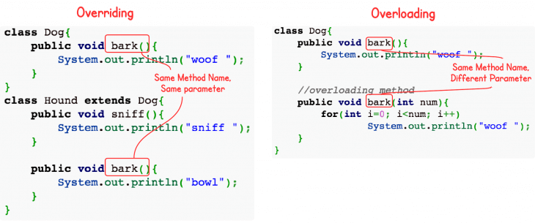
  + Overloading happens at compile-time while Overriding happens at runtime: The binding of overloaded method call to its definition happens at compile-time however binding of overridden method call to its definition happens at runtime. More info on static vs. dynamic binding: [StackOverflow](https://stackoverflow.com/questions/19017258/static-vs-dynamic-binding-in-java).

Static methods can be overloaded which means a class can have more than one static method of same name. Static methods cannot be overridden, even if you declare a same static method in child class it has nothing to do with the same method of parent class as overridden static methods are chosen by the reference class and not by the class of the object.  
So, for example:  
public class Animal {

public static void testClassMethod() {

System.out.println("The static method in Animal");

}

public void testInstanceMethod() {

System.out.println("The instance method in Animal");

}

}

public class Cat extends Animal {

public static void testClassMethod() {

System.out.println("The static method in Cat");

}

public void testInstanceMethod() {

System.out.println("The instance method in Cat");

}

public static void main(String[] args) {

Cat myCat = new Cat();

myCat.testClassMethod();

Animal myAnimal = myCat;

myAnimal.testClassMethod();

myAnimal.testInstanceMethod();

}

}  
Will output:  
The static method in Cat // testClassMethod() is called from "Cat" reference

The static method in Animal // testClassMethod() is called from "Animal" reference,

// ignoring actual object inside it (Cat)

The instance method in Cat // testInstanceMethod() is called from "Animal" reference,

* + // but from "Cat" object underneath  
    The most basic difference is that overloading is being done in the same class while for overriding base and child classes are required. Overriding is all about giving a specific implementation to the inherited method of parent class.  
    Static binding is being used for overloaded methods and dynamic binding is being used for overridden/overriding methods. Performance: Overloading gives better performance compared to overriding. The reason is that the binding of overridden methods is being done at runtime.  
    Private and final methods can be overloaded but they cannot be overridden. It means a class can have more than one private/final methods of same name but a child class cannot override the private/final methods of their base class.  
    Return type of method does not matter in case of method overloading, it can be same or different. However in case of method overriding the overriding method can have more specific return type (meaning if, for example, base method returns an instance of Number class, all overriding methods can return any class that is extended from Number, but not a class that is higher in the hierarchy, like, for example, Object is in this particular case).  
    Argument list should be different while doing method overloading. Argument list should be same in method Overriding. It is also a good practice to annotate overridden methods with @Override to make the compiler be able to notify you if child is, indeed, overriding parent's class method during compile-time.

**Question:**  What are the access modifiers you know? What does each one do?

**Answer:**  There are four access modifiers in Java language (from strictest to the most lenient):

* 1. private *variables*, *methods*, *constructors* or *inner classes* are only visible to its' containing class and its' methods. This modifier is most commonly used, for example, to allow variable access only through getters and setters or to hide underlying implementation of classes that should not be used by user and therefore maintain encapsulation. Singleton constructor is also marked private to avoid unwanted instantiation from outside.
  2. Default (no keyword is used) this modifier can be applied to *classes*, *variables*, *constructors* and *methods* and allows access from classes and methods inside the same package.
  3. protected can be used on *variables*, *methods* and *constructors* therefore allowing access only to subclasses and classes that are inside the same package as protected members' class.
  4. public modifier is widely-used on *classes*, *variables*, *constructors* and *methods* to grant access from any class and method anywhere. It should not be used everywhere as it implies that data marked with public is not sensitive and can not be used to harm the program.

**Question:**  Can an Interface implement another Interface?

**Answer:**  Yes, an interface can implement another interface (and more than one), but it needs to use extends, rather than implements keyword. And while you can not remove methods from parent interface, you can add new ones freely to your sub-interface.

**Question:**  What is Polymorphism? What about Inheritance?

**Answer:**  Polymorphism in Java has two types: Compile time polymorphism (static binding) and Runtime polymorphism (dynamic binding). Method overloading is an example of static polymorphism, while method overriding is an example of dynamic polymorphism.  
An important example of polymorphism is how a parent class refers to a child class object. In fact, any object that satisfies more than one IS-A relationship is polymorphic in nature.  
For instance, let’s consider a class Animal and let Cat be a subclass of Animal. So, any cat IS animal. Here, Cat satisfies the IS-A relationship for its own type as well as its super class Animal.

Inheritance can be defined as the process where one class acquires the properties (methods and fields) of another. With the use of inheritance the information is made manageable in a hierarchical order.  
The class which inherits the properties of other is known as subclass (derived class, child class) and the class whose properties are inherited is known as superclass (base class, parent class).  
Inheritance uses the keyword extends to inherit the properties of a class. Following is the syntax of extends keyword.  
class Super {

.....

.....

}

class Sub extends Super {

.....

.....

}

**Question:**  What does it means to say that a String is immutable?

**Answer:**  It means that once created, String object's char[] (its' containing value) is declared final and, therefore, it can not be changed during runtime.

**Question:**  What is String.intern()? When and why should it be used?

**Answer:**  String.intern() is used to mange memory in Java code. It is used when we have duplicates value in different strings. When you call the String.intern(), then if in the String pool that string is present then the equals() method will return true and it will return that string only.

**Question:**  Can you list 8 primitive types in java?

**Answer:**  byte

* short
* int
* long
* float
* double
* char
* String
* boolean

**Question:**  What is the difference between an Integer and int?

**Answer:**  int is a primitive data type (with boolean, byte, char, short, long, float and double), while Integer (with Boolean, Byte, Character, Short,Long, Float and Double) is a [wrapper](https://docs.oracle.com/javase/tutorial/java/data/numberclasses.html) class that encapsulates primitive data type, while providing useful methods to perform different tasks with it.

**Question:**  What is Autoboxing and Unboxing?

**Answer:**  Autoboxing and Unboxing is the process of automatic wrapping (putting in a box) and unwrapping (getting the value out) of primitive data types, that have "wrapper" classes. So int and Integer can (almost always) be used interchangeably in Java language, meaning a method void giveMeInt(int i) { ... } can take int as well as Integer as a parameter.

**Question:**  Typecast in Java

**Answer:**  In Java, you can use casts to polymorph one class into another, compatible one. For example:  
 long i = 10l;

int j = (int) i;

long k = j;  
Here we see, that, while narrowing (long i -> int j) requires an explicit cast to make sure the programmer realizes, that there may be some data or precision loss, widening (int j -> long k) does not require an explicit cast, because there can be no data loss (long can take larger numbers than int allows).

**Question:**  Do objects get passed by reference or value in Java? Elaborate on that.

**Answer:**  In Java all primitives and objects are passed by value, meaning that their copy will be manipulated in the receiving method. But there is a caveat - when you pass an object reference into a method, a *copy of this reference* is made, so it still points to the same object. This means, that any changes that you make to the insides of this object are retained, when the method exits.  
public class Pointer {

int innerField;

public Pointer(int a) {

this.innerField = a;

}

}  
public class ValueAndReference {

public static void main(String[] args) {

Pointer a = new Pointer(0);

int b = 1;

print("Before:");

print("b = " + b);

print("a.innerField = " + a.innerField);

exampleMethod(a, b);

print("After:");

print("b = " + b);

print("a.innerField = " + a.innerField);

}

static void exampleMethod(Pointer a, int b) {

a.innerField = 2;

b = 10;

}

static void print(String text) {

System.out.println(text);

}

}

Will output:  
 Before:

b = 1

a.innerField = 0

After:

b = 1 // a new local int variable was created and operated on, so "b" didn't change

a.innerField = 2 // Pointer a got its' innerField variable changed

// from 0 to 2, because method was operating on

* // the same reference to an instance

**Question:**  What the difference between local, instance and class variables?

**Answer:**  Local variables exist only in methods that created them, they are stored separately in their respected Thread Stack (for more information, see question about Java Memory Model) and cannot have their reference passed outside of the method scope. That also means that they cannot be assigned any access modifier or made static - because they only exist during enclosing method's execution and those modifiers just do not make sense, since no other outside method can get them anyway.

* Instance variables are the ones, that are declared in classes and their value can be different from one instance of the class to another, but they always require that class' instance to exist.
* Class variables are those, that are marked with static keyword in their class' body. They can only have one value across all instances of that class (changing it in one place will change it in their class and, therefore, in all instances) and can even be retrieved without that class' instance (if their access modifier allows it).

**Question:**  What is garbage collector? How does it work?

**Answer:**  All objects are allocated on the heap area managed by the JVM. As long as an object is being referenced, the JVM considers it alive. Once an object is no longer referenced and therefore is not reachable by the application code, the garbage collector removes it and reclaims the unused memory.

**Question:**  What is a ThreadPoolExecutor?

**Answer:**  we will learn about the thread pools, thread pool executors, and their use within Android. We’ll cover these topics thoroughly, with lots of example code.

Although nowadays, we all use RxJava, Kotlin-Coroutines for background task execution, it is important to know about the ThreadPoolExecutor as all of these libraries are made on top of ThreadPoolExecutor.

Thread Pools

A thread pool manages a pool of worker threads (the exact number varies depending upon its implementation).

A task queue holds tasks waiting to be executed by anyone of the idle threads in the pool. Tasks are added to the queue by producers, whereas the worker threads act as consumers by consuming the tasks from the queue whenever there’s an idle thread ready to perform a new background execution.

ThreadPoolExecutor

The ThreadPoolExecutor executes a given task using one of its threads from the thread pool.

ThreadPoolExecutor threadPoolExecutor = new ThreadPoolExecutor(

int corePoolSize,

int maximumPoolSize,

long keepAliveTime,

TimeUnit unit,

BlockingQueue<Runnable> workQueue

);

What are these parameters?

corePoolSize: The minimum number of threads to keep in the pool. Initially, there are zero threads in the pool. But as tasks are added to the queue, new threads are created. If there are idle threads — but the thread count is lower than the corePoolSize — then new threads will keep on being created.

maximumPoolSize: — The maximum number of threads allowed in the pool. If this exceeds the corePoolSize — and the current number of threads is >= corePoolSize — then the new worker threads will be created only if the queue is full.

keepAliveTime: When the number of threads is greater than the core, the noncore threads (excess idle threads) will wait for a new task, and if they don’t get one within the time defined by this parameter, they will terminate.

unit: The unit of time for keepAliveTime.

workQueue: The task queue, which will only hold runnable tasks. It will have to be a BlockingQueue.

Why use Thread Pool Executor in an Android or JAVA application?

It’s a powerful task execution framework as it supports task addition in a queue, task cancellation, and task prioritization.

It reduces the overhead associated with thread creation, as it manages a required number of threads in its thread pool.

Using ThreadPoolExecutor in Android

First of all, create a PriorityThreadFactory:

public class PriorityThreadFactory implements ThreadFactory {

private final int mThreadPriority;

public PriorityThreadFactory(int threadPriority) {

mThreadPriority = threadPriority;

}

@Override

public Thread newThread(final Runnable runnable) {

Runnable wrapperRunnable = new Runnable() {

@Override

public void run() {

try {

Process.setThreadPriority(mThreadPriority);

} catch (Throwable t) {

}

runnable.run();

}

};

return new Thread(wrapperRunnable);

}

}

Create a MainThreadExecutor:

public class MainThreadExecutor implements Executor {

private final Handler handler = new Handler(Looper.getMainLooper());

@Override

public void execute(Runnable runnable) {

handler.post(runnable);

}

}

Create a DefaultExecutorSupplier:

/*

* Singleton class for default executor supplier

*/

public class DefaultExecutorSupplier{

/*

* Number of cores to decide the number of threads

*/

public static final int NUMBER_OF_CORES = Runtime.getRuntime().availableProcessors();

/*

* thread pool executor for background tasks

*/

private final ThreadPoolExecutor mForBackgroundTasks;

/*

* thread pool executor for light weight background tasks

*/

private final ThreadPoolExecutor mForLightWeightBackgroundTasks;

/*

* thread pool executor for main thread tasks

*/

private final Executor mMainThreadExecutor;

/*

* an instance of DefaultExecutorSupplier

*/

private static DefaultExecutorSupplier sInstance;

/*

* returns the instance of DefaultExecutorSupplier

*/

public static DefaultExecutorSupplier getInstance() {

if (sInstance == null) {

synchronized(DefaultExecutorSupplier.class){

sInstance = new DefaultExecutorSupplier();

}

return sInstance;

}

/*

* constructor for DefaultExecutorSupplier

*/

private DefaultExecutorSupplier() {

// setting the thread factory

ThreadFactory backgroundPriorityThreadFactory = new

PriorityThreadFactory(Process.THREAD_PRIORITY_BACKGROUND);

// setting the thread pool executor for mForBackgroundTasks;

mForBackgroundTasks = new ThreadPoolExecutor(

NUMBER_OF_CORES * 2,

NUMBER_OF_CORES * 2,

60L,

TimeUnit.SECONDS,

new LinkedBlockingQueue<Runnable>(),

backgroundPriorityThreadFactory

);

// setting the thread pool executor for mForLightWeightBackgroundTasks;

mForLightWeightBackgroundTasks = new ThreadPoolExecutor(

NUMBER_OF_CORES * 2,

NUMBER_OF_CORES * 2,

60L,

TimeUnit.SECONDS,

new LinkedBlockingQueue<Runnable>(),

backgroundPriorityThreadFactory

);

// setting the thread pool executor for mMainThreadExecutor;

mMainThreadExecutor = new MainThreadExecutor();

}

/*

* returns the thread pool executor for background task

*/

public ThreadPoolExecutor forBackgroundTasks() {

return mForBackgroundTasks;

}

/*

* returns the thread pool executor for light weight background task

*/

public ThreadPoolExecutor forLightWeightBackgroundTasks() {

return mForLightWeightBackgroundTasks;

}

/*

* returns the thread pool executor for main thread task

*/

public Executor forMainThreadTasks() {

return mMainThreadExecutor;

}

}

Note: The number of threads available for different thread pools will depend on your requirements.

Now use it as below in your code

/*

* Using it for Background Tasks

*/

public void doSomeBackgroundWork(){

DefaultExecutorSupplier.getInstance().forBackgroundTasks()

.execute(new Runnable() {

@Override

public void run() {

// do some background work here.

}

});

}

/*

* Using it for Light-Weight Background Tasks

*/

public void doSomeLightWeightBackgroundWork(){

DefaultExecutorSupplier.getInstance().forLightWeightBackgroundTasks()

.execute(new Runnable() {

@Override

public void run() {

// do some light-weight background work here.

}

});

}

/*

* Using it for MainThread Tasks

*/

public void doSomeMainThreadWork(){

DefaultExecutorSupplier.getInstance().forMainThreadTasks()

.execute(new Runnable() {

@Override

public void run() {

// do some Main Thread work here.

}

});

}

In this way, we can create a different thread pool for network tasks, I/O tasks, heavy background tasks, and other tasks.

How do I cancel a task?

To cancel a task, you have to get the future of that task. So instead of using execute, you would need to use submit, which will return the future. Now, this future can be used to cancel the task.

/*

* Get the future of the task by submitting it to the pool

*/

Future future = DefaultExecutorSupplier.getInstance().forBackgroundTasks()

.submit(new Runnable() {

@Override

public void run() {

// do some background work here.

}

});

/*

* cancelling the task

*/

future.cancel(true);

How to set the priority of a task?

Let’s say there are 20 tasks in a queue, and the thread pool only holds 4 threads. We execute new tasks based on their priority since the thread pool can only execute 4 at a time.

But let’s say we need the last task that we have pushed in the queue to be executed first. We would need to set the IMMEDIATE priority for that task so that when the thread takes a new task from the queue, it executes this task first (since it has the highest priority).

To set the priority of a task, we need to create a thread pool executor.

Create an ENUM for Priority:

/**

* Priority levels

*/

public enum Priority {

/**

* NOTE: DO NOT CHANGE ORDERING OF THOSE CONSTANTS UNDER ANY CIRCUMSTANCES.

* Doing so will make ordering incorrect.

*/

/**

* Lowest priority level. Used for prefetches of data.

*/

LOW,

/**

* Medium priority level. Used for warming of data that might soon get visible.

*/

MEDIUM,

/**

* Highest priority level. Used for data that are currently visible on screen.

*/

HIGH,

/**

* Highest priority level. Used for data that are required instantly(mainly for emergency).

*/

IMMEDIATE;

}

Create a PriorityRunnable:

public class PriorityRunnable implements Runnable {

private final Priority priority;

public PriorityRunnable(Priority priority) {

this.priority = priority;

}

@Override

public void run() {

// nothing to do here.

}

public Priority getPriority() {

return priority;

}

}

Create a PriorityThreadPoolExecutor, which extends ThreadPoolExecutor. We have to create PriorityFutureTask, which will implement Comparable<PriorityFutureTask>

public class PriorityThreadPoolExecutor extends ThreadPoolExecutor {

public PriorityThreadPoolExecutor(int corePoolSize, int maximumPoolSize, long keepAliveTime,

TimeUnit unit, ThreadFactory threadFactory) {

super(corePoolSize, maximumPoolSize, keepAliveTime, unit,new PriorityBlockingQueue<Runnable>(), threadFactory);

}

@Override

public Future<?> submit(Runnable task) {

PriorityFutureTask futureTask = new PriorityFutureTask((PriorityRunnable) task);

execute(futureTask);

return futureTask;

}

private static final class PriorityFutureTask extends FutureTask<PriorityRunnable>

implements Comparable<PriorityFutureTask> {

private final PriorityRunnable priorityRunnable;

public PriorityFutureTask(PriorityRunnable priorityRunnable) {

super(priorityRunnable, null);

this.priorityRunnable = priorityRunnable;

}

/*

* compareTo() method is defined in interface java.lang.Comparable and it is used

* to implement natural sorting on java classes. natural sorting means the the sort

* order which naturally applies on object e.g. lexical order for String, numeric

* order for Integer or Sorting employee by there ID etc. most of the java core

* classes including String and Integer implements CompareTo() method and provide

* natural sorting.

*/

@Override

public int compareTo(PriorityFutureTask other) {

Priority p1 = priorityRunnable.getPriority();

Priority p2 = other.priorityRunnable.getPriority();

return p2.ordinal() - p1.ordinal();

}

}

}

First of all, in DefaultExecutorSupplier, instead of ThreadPoolExecutor, use PriorityThreadPoolExecutor like this:

public class DefaultExecutorSupplier{

private final PriorityThreadPoolExecutor mForBackgroundTasks;

private DefaultExecutorSupplier() {

mForBackgroundTasks = new PriorityThreadPoolExecutor(

NUMBER_OF_CORES * 2,

NUMBER_OF_CORES * 2,

60L,

TimeUnit.SECONDS,

backgroundPriorityThreadFactory

);

}

}

Here’s an example of how we can set HIGH priority to a task:

/*

* do some task at high priority

*/

public void doSomeTaskAtHighPriority(){

DefaultExecutorSupplier.getInstance().forBackgroundTasks()

.submit(new PriorityRunnable(Priority.HIGH) {

@Override

public void run() {

// do some background work here at high priority.

}

});

}

In this way, a task can be prioritized.

The above implementation is also applicable to any JAVA applications.

**Question:**  What is serialization? How do you implement it?

**Answer:**  Serialization is the process of converting an object into a stream of bytes in order to store an object into memory, so that it can be recreated at a later time, while still keeping the object's original state and data. In Android you may use either the Serializable, Externalizable (implements Serializable) or Parcelable interfaces.

* While Serializable is the easiest to implement, Externalizable may be used if you need to insert custom logic into the process of serialization (although it is almost never used nowadays as it is considered a relic from early versions of Java). But it is highly recommended to use Parcelable in Android instead, as Parcelable was created exclusively for Android and it performs about 10x faster than Serializable, because Serializable uses reflection, which is a slow process and tends to create a lot of temporary objects and it may cause garbage collection to occur more often.

To use Serializable all you have to do is implement the interface:  
// Implementing the Serializable interface is all that is required

public class User implements Serializable {

private String name;

private String email;

public User() {

}

public String getName() {

return name;

}

public void setName(final String name) {

this.name = name;

}

public String getEmail() {

return email;

}

public void setEmail(final String email) {

this.email = email;

}

* }

Parcelable requires a bit more work:  
 public class User implements Parcelable {

private String name;

private String email;

/**

* Interface that must be implemented and provided as a public CREATOR field

* that generates instances of your Parcelable class from a Parcel.

*/

public static final Creator<User> CREATOR = new Creator<User>() {

/**

* Creates a new USer object from the Parcel. This is the reason why

* the constructor that takes a Parcel is needed.

*/

@Override

public User createFromParcel(Parcel in) {

return new User(in);

}

/**

* Create a new array of the Parcelable class.

* @return an array of the Parcelable class,

* with every entry initialized to null.

*/

@Override

public User[] newArray(int size) {

return new User[size];

}

};

public User() {

}

/**

* Parcel overloaded constructor required for

* Parcelable implementation used in the CREATOR

*/

private User(Parcel in) {

name = in.readString();

email = in.readString();

}

public String getName() {

return name;

}

public void setName(final String name) {

this.name = name;

}

public String getEmail() {

return email;

}

public void setEmail(final String email) {

this.email = email;

}

@Override

public int describeContents() {

return 0;

}

/**

* This is where the parcel is performed.

*/

@Override

public void writeToParcel(final Parcel parcel, final int i) {

parcel.writeString(name);

parcel.writeString(email);

}

* }
* Note: For a full explanation of the describeContents() method see [StackOverflow](https://stackoverflow.com/questions/4076946/parcelable-where-when-is-describecontents-used/4914799#4914799). In Android Studio, you can have all of the parcelable code auto generated for you, but like with everything else, it is always a good thing to try and understand everything that is happening.

**Question:**  Why would you not call abstract method in constructor?

**Answer:**  This code demonstrates why you should *never* call an abstract method, or any other overridable method, from a constructor:

abstract class Super { Super() { doSubStuff(); } abstract void doSubStuff(); } class Sub extends Super { String s = "Hello world"; void doSubStuff() { System.out.println(s); } } public static void main(String[] args) { new Sub(); }

When run, this prints null. This means the only "safe" methods to have in a constructor are private and/or final ones.

On the other hand, your code doesn't actually call an abstract method from a constructor. Instead, you pass an uninitialized object to another thread for processing, which is worse, since the thread you're starting may be given priority and execute before your Base finishes its initialization.

**Question:**  What are these final, finally and finalize keywords?

**Answer:**  final is a keyword in the java language. It is used to apply restrictions on class, method and variable. Final class can't be inherited, final method can't be overridden and final variable value can't be changed.  
class FinalExample {

public static void main(String[] args) {

final int x=100;

x=200;//Compile Time Error because x is final

}

}

finally is a code block and is used to place important code, it will be executed whether exception is handled or not.  
class FinallyExample {

public static void main(String[] args) {

try {

int x=300;

}catch(Exception e) {

System.out.println(e.getMessage()); }

finally {

System.out.println("finally block is executed");

}

}

* }

Finalize is a method used to perform clean up processing just before object is garbage collected.  
class FinalizeExample {

public void finalize() {

System.out.println("finalize called");

}

public static void main(String[] args) {

FinalizeExample f1=new FinalizeExample();

FinalizeExample f2=new FinalizeExample();

f1=null;

f2=null;

System.gc();

}

* }

**Question:**  What is the difference between "throw" and "throws" keyword in Java?

**Answer:**  throws is just used to indicated which exception is to be thrown. But the throw keyword is used to throw some exception from any static block or any method.

**Question:**  What does the static word mean in Java?

**Answer:**  In case of static variable it means that this variable (its' value or the object it references) spans across all instances of enclosing class (changing it in one instance affects all others), while in case of static methods it means that these methods can be invoked without an instance of their enclosing class. It is useful, for example, when you create util classes that need not be instantiated every time you want to use them.

**Question:**  Can a static method be overridden in Java?

**Answer:**  While child class can override a static method with another static method with the same signature (return type can be down-casted), it is not truly overridden - it becomes "hidden", but both methods can still be accessed under right circumstances (see question about overloading/overriding above).

**Question:**  When is a static block run?

**Answer:**  Code inside static block is executed only once: the first time you make an object of that class or the first time you access a static member of that class (even if you never make an object of that class).

**Question:**  What is reflection?

**Answer:**  You can inspect classes, interfaces, fields, and method at runtime with the help of reflection and the best part is that you need not know the names of these classes, methods, etc.

**Question:**  How is a StringBuilder implemented to avoid the immutable string allocation problem?

**Answer:**  By using a char array. You can see this in the JDK source. In JDK 1.8 (the one I have the source for handy), StringBuilder is built on top of AbstractStringBuilder which uses this to hold the data:

char[] value; int count;

([Karol Dowbecki says](https://stackoverflow.com/a/54023886/157247) that JDK 9 "sometimes" uses byte instead of char; I have no reason to doubt him. :-) )

count tells the class how much of value is actual data vs. just available space in the array. It starts out with a char[16] (unless you tell it in advance what capacity you may require) and reallocates and copies as needed.

It only creates a string when you call toString, using the [String(char[],int,int) constructor](https://docs.oracle.com/javase/10/docs/api/java/lang/String.html#%3Cinit%3E(char%5B%5D,int,int)) (or presumably one accepting byte[] sometimes JDK9) to make a copy of the portion of the array's contents that are actually used:

public String toString() { // Create a copy, don't share the array return new String(value, 0, count); }

**Question:**  Android Development Best Practices.

**Answer:**  Let’s explore some of the best practices in designing and developing Android apps.

For starters, when you develop an Android Application, you should prepare it to be run on a wide variety of devices and under different circumstances.

Every Android device is a family in itself. When one member of the family goes haywire, it means the rest of the family is also likely to be affected.

Did you know that when any single application asks for memory, if there isn’t any free memory, Android will respond by closing other apps so it can provide that memory? Then if the user switches to that application, it will have to be restarted.

When any single application takes up more memory, using more CPU and GPU, or consuming more battery, every other application suffers as a result. And this has the potential to wreck the user experience for the entire device. Hence, performance matters.

*Beware of little expenses. A small leak will sink a great ship. — Benjamin Franklin*

Here are some of the best practices you should follow when building Android apps:

## Use the recommended Android architecture

When you start the Android Development, you do not maintain the coding standard and do not follow any architecture. After adding more and more features, you start facing the following problems:

* Difficulties in the addition of new features.
* Introduction of more bugs.
* Overall slow development.

These problems can be avoided by following the coding standard and following some architecture in your Android project. Learn about the Android Application Architecture from the following resource:

* [MVVM Architecture](https://amitshekhar.me/blog/mvvm-architecture-android)

## Always maintain the code quality

Quality matters a lot. It’s not only about MVP/MVVM/MVC/etc., but also about each piece of code in each part of your app. Learn about the Android Code Style And Guidelines.

Read other's code: Start reading other's code to learn the best practices. Believe me, reading and learning from other's codes is the best way of improving yourself.

Read open-source project to learn:

* Coding style
* Language specific features
* Architecture Design
* Utility function
* Naming convention
* Optimization done

## Use the Android Architecture Components

The Android Architecture Components provide a set of guidelines for organizing your app's code into a clean, modular, and testable architecture. This includes the ViewModel, LiveData, and Room components, which can help you write more maintainable and reliable code.

## Detect and Fix memory leaks in Android App

Android devices come in all shapes and sizes, with varying levels of performance, memory, and storage. To ensure your app performs well on all devices, you should optimize your code for performance, minimize resource usage, and avoid memory leaks. Learn to detect and fix memory leaks.

## Use Proguard in your release version

This will remove all your unused code, which will reduce APK size.

## Use debugging tools

I highly recommend using [Android Debug Database](https://github.com/amitshekhariitbhu/Android-Debug-Database). This library will be your best friend. It is a powerful library for debugging databases and shared preferences in Android applications. It’s a very simple tool for viewing databases and shared preferences directly in your browser.

## Use strings.xml

Adding text as string resources are always useful in the long-run, especially when support for new languages needs to be added.

## Create separate layouts for UI elements that will be re-used

Use the include tag in xml. Another handy tag is the merge tag. It acts as a pseudo parent and helps get rid of an unneeded root ViewGroup.

## Place launcher icons in mipmap-folders

When we build separate APKs for different densities, for the APK of the particular density, the drawable folders for other densities get stripped. This will make the icons appear blurry on devices that use launcher icons of higher density. Since mipmap folders do not get stripped, it’s always best to use them for including the launcher icons.

## Use shapes and selectors instead of images as much as possible

Using shapes and selectors will further reduce APK size.

## Avoid deep levels in layouts

A deep hierarchy of views makes your UI slow, not to mention making it harder to manage your layouts. Deep hierarchies can mostly be avoided by using the correct ViewGroup. Use Constraint Layout.

## Use HTTP library

Use 3rd party HTTP like Retrofit or [Fast Android Networking](https://github.com/amitshekhariitbhu/Fast-Android-Networking), depending on your use case.

## Use the Parcelable class instead of Serializable when passing data in Intents or Bundles

The serialization of an object that implements the Parcelable interface is much faster than using Java’s default serialization. A class that implements the Serializable interface is marked as serializable, and Java serializes it using reflection (which makes it slow). When using the Parcelable interface, the whole object doesn’t get serialized automatically. Rather, you can selectively add data from the object to a Parcel using which the object is later deserialized. Similarly, you can consider the Parcelable in Kotlin.

## Perform file operations off the UI thread

File operations should always be performed on a background thread, typically by using RxJava, [Kotlin-Coroutines](https://amitshekhar.me/blog/kotlin-coroutines). They take time, and if done on the UI thread can make the interface feel sluggish. In situations where they block the UI thread for 5 seconds, an Application Not Responding warning will be triggered and shown to the user.

## Understand Bitmaps

As it takes a huge amount of memory, it can lead to OOM easily. Users love content! Especially when the content is well-formatted and looks nice. Images, for instance, are extremely nice content, mainly due to their property of conveying a thousand words per image. They also consume a lot of memory. A lot of memory!.

* [Bitmap pool](https://amitshekhar.me/blog/bitmap-pool)
* [How does the Android Image Loading library work internally?](https://amitshekhar.me/blog/android-image-loading-library-use-bitmap-pool-for-responsive-ui)

## Understand the Context in Android

Learning what is the Context in Android and using it correctly is important to avoid memory leaks in Android. Learn from [here](https://amitshekhar.me/blog/context-in-android-application).

## Use styles to avoid duplicate attributes in layout XMLs

If you want to avoid duplicate attributes, use styles.

## Use Activity LifeCycle correctly

When you use the Activity lifecycle correctly, you can solve most of the problems in Android App Development.

## Always include unit tests

Testing is an essential part of the development process, and it is especially important for Android apps, which run on a wide range of devices with different configurations. Use both unit tests and instrumented tests to ensure your code works as intended, and make sure to test your app on a variety of devices and Android versions. I recommend running unit tests on the JVM because it’s much faster than running them on the Android device itself or an emulator. If you need to mock some objects while testing, use Mockito. Use the Dependency Injection Framework(Dagger) in your Android Project to make testing easier.

## Always include functional UI tests

Functional tests check the functionality of your app from the user’s point of view. They launch your app and test its functionality. Here you can use Android Instrumentation if your application is not going to interact with other applications, as it runs only with your application. If there is an interaction with other apps use UIAutomator for testing this functionality.

## Optimize your build speed

Long build times slow down your development process. Start optimizing for the build speed.

## Secure your Android Application

As you all know that, any Android app can be easily decompiled, reverse-engineered. It’s your responsibility to make your Android app secure as much as you can. By making your app more secure, you help preserve user trust and device integrity.

## Make your Android application bug-free

Always integrate a crash reporting library like Firebase Crashlytics in your application. Develop the ability to read through the crash reports to evolve a better and bug-free app for the users.

## Use proven libraries instead of your own solutions

In general, use proven libraries instead of your own solutions. It is easy to get carried away and over-engineer your app with complex architecture patterns, custom views, and endless abstractions. While these can be useful in certain circumstances, they can also make your codebase challenging to maintain and slow down the development process. Stick to simple, easy-to-understand solutions whenever possible.

## Add Analytics to Your Android Application

Check if you have added the correct analytics at all the places where you had meant. The best way to check is that just think of what data you need and what are the metrics you want to measure, see if you can get those data and metrics from the analytics that you have added or not. If you are able to get all of those then you are good to go.

## Design for Multiple Screen Sizes and Resolutions

One of the biggest challenges in Android development is the wide range of screen sizes and resolutions supported by the platform. To ensure your app looks good on all devices, you should design your UI using flexible layouts and take advantage of the Android Support Library to provide compatibility for older versions of Android. You should also test your app on a variety of devices to ensure it looks and functions as intended.

## Use the Latest SDKs and Libraries

Keep your development environment up-to-date by using the latest Android SDKs, libraries, and tools. This will ensure your apps are built with the latest features and optimizations and take advantage of bug fixes and security updates.

## Test on various OS versions

And again, finally, keep testing on various OS versions.

In conclusion, following these best practices will help you develop high-quality, reliable, and maintainable Android apps that provide a great user experience. However, it is important to keep in mind that every app is different and may require a unique approach. Stay flexible, experiment with new tools and techniques, and keep learning to continue improving your skills as an Android developer.

**Question:**  What are the metrics that you should measure continuously while android application development?

**Answer:**  we will learn about the metrics that we should measure continuously while android application development.

## Frames Per Second

This metric is very important as it tells, how your android application is being experienced by the end user. So tracking this metric and improving will lead to a better user experience. If the FPS is coming below 60, the end user will see your application lagging.

How do you measure this metric?

1. On your mobile device, go to Settings -> Developer Options.
2. In the Monitoring section, select Profile GPU Rendering.
3. In the Profile GPU Rendering popup, choose On screen as bars to overlay the graphs on the screen of your mobile device.
4. Go to the app that you want to profile.

## CPU

This metric is important as it will tell you how much CPU is being used by your application. More the CPU consumption, more the battery consumption. So, you must track and improve this metric.

The real-time CPU usage can be directly seen in the monitor tab of the Android Studio.

## Memory

The metric tells you about how much memory is being used by your application while running. If your application is taking more memory, then it can easily go out of memory error. So, you should track and reduce memory usage as much as possible. This metric can also be tracked from the Android Studio’s monitors tab. Soon I will write an article on how to reduce memory usage.

## Network Traffic

Network Traffic metric tells you about the network request being made from your apps. So, monitor all the traffic generated by your app, make sure to remove all unnecessary requests and stop draining your user’s data. The transmit and receive of data can be tracked from the Android Studio’s monitors tab.

There are many ways to measure this metric like by adding the NetworkInterceptor in the OkHttpClient ([How to add](https://amitshekhar.me/blog/okhttp-interceptor)?).

## Disk

This metric is also very important as using more space on disk leads to the uninstall. So, reducing disk memory consumption leads to the higher user retention time. So start tracking and keep reducing the disk memory usage.

So, now we know the metrics that we should measure continuously while android application development.

**Question:**  How does the Kotlin Multiplatform work?

**Answer:**  The Kotlin Multiplatform feature is very promising. In this blog, we will learn how the Kotlin Multiplatform works. When we know how it works, we can get the most out of it. I love investing my time in learning these hard things the hard way and then sharing them with all of you. Let's get started.

When I say the Kotlin Multiplatform feature is very promising, there is a strong reason behind it, Kotlin Multiplatform let us reuse the business logic and does not impose any restrictions on how we build our App's UI. So, the appearance, behavior, and most importantly, the performance, all remain native. Native UI helps in providing the best user experience to the customers.

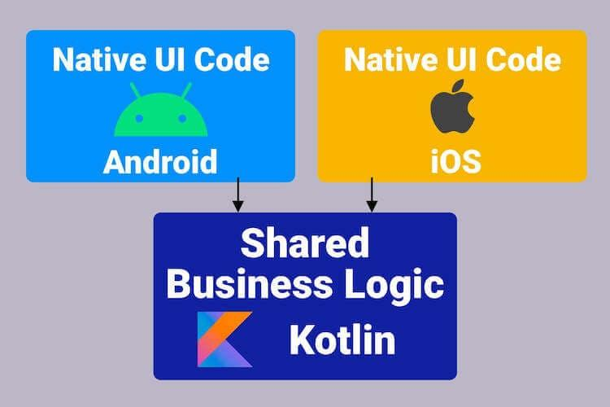

When we consider the Kotlin Multiplatform just for the two platforms which are Android and iOS, we write the business logic code once which runs on both the platforms.

## How does it work?

First, we write the shared code in Kotlin. For Android, it gets converted to the Java bytecode that can be executed in the JVM. So, Android already has a Virtual Machine(VM) that is easily capable of running it.

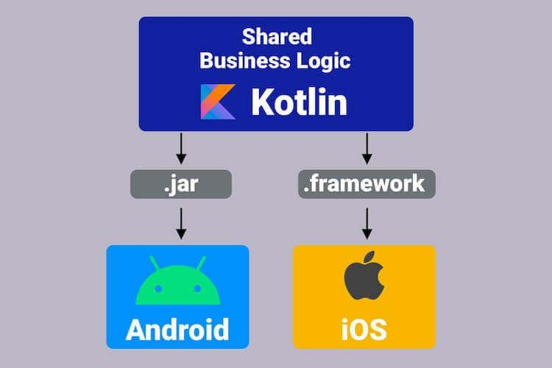

But what about iOS, how can it run Kotlin? Can we do it without the Virtual Machine(VM)? Have you ever wondered how it works?

For iOS, Kotlin code must be converted to the source code(native code executable on iOS) that goes inside the framework. That source code works on iOS.

How does the Kotlin code get converted to the source code that is capable of running on iOS?

Here comes the Kotlin Compiler into the picture. It has two parts as follows:

* Frontend - It converts the Kotlin Code into the IR (Intermediate Representation). That IR is capable of getting converted into the native code that is machine-executable using the backend which is described below.
* Backend - It converts the IR into the native code that is machine-executable. This is possible because of the Kotlin/Native Infrastructure built by JetBrains.For Android, it converts the IR to Java Bytecode and for iOS, it converts IR to the iOS native machine-executable code.

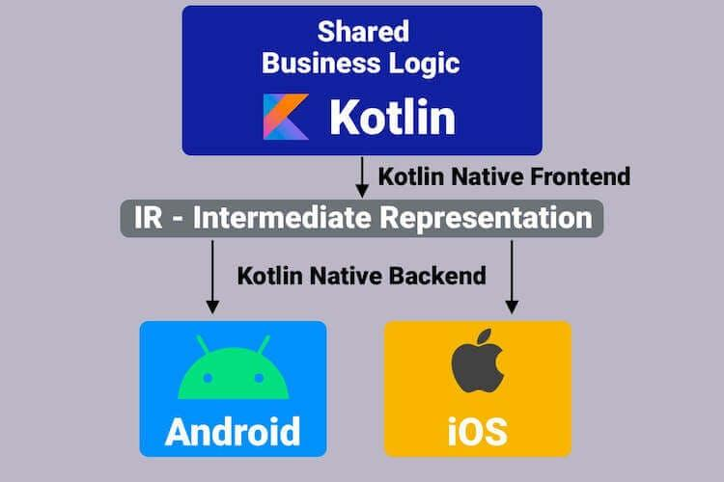

It is important to note that we are able to run the shared business logic code written in Kotlin on a platform like iOS without the Virtual Machine(VM).

Here, Kotlin/Native plays an important role. What exactly is Kotlin/Native?

From the official documentation:

*Kotlin/Native is an LLVM backend for the Kotlin compiler, runtime implementation, and native code generation facility using the LLVM toolchain.*

*Kotlin/Native is primarily designed to allow compilation for platforms where virtual machines are not desirable or possible (such as iOS or embedded targets), or where a developer is willing to produce a reasonably-sized self-contained program without the need to ship an additional execution runtime.*

Now, the next question arises in our mind, what is LLVM?

We can say that LLVM is a library for programmatically creating the machine native code from the Intermediate Representation(IR).

We first create the Intermediate Representation(IR) which is needed by the LLVM and then LLVM does its magic.

Summary:

Kotlin Code > Intermediate Representation(IR) > Machine-Executable Native Code.

This way, the Kotlin Multiplatform works.

**Question:**  Who is the founder of Android?

**Answer:**  Andy Rubin.

**Question:**  What are the advantages of Android?

**Answer:**  **Open-source:** It means no license, distribution and development fee.

**Platform-independent:** It supports Windows, Mac, and Linux platforms.

**Supports various technologies:** It supports camera, Bluetooth, wifi, speech, EDGE etc. technologies.

**Highly optimized Virtual Machine:** Android uses a highly optimized virtual machine for mobile devices, called DVM (Dalvik Virtual Machine).

**Question:**  Does android support other languages than java?

**Answer:**  Yes, an android app can be developed in C/C++ also using android NDK (Native Development Kit). It makes the performance faster. It should be used with Android SDK.

**Question:**  What are the core building blocks of android?

**Answer:**  The core building blocks of Android are:

* Activity
* View
* Intent
* Service
* Content Provider
* Fragment etc.

<https://www.javatpoint.com/android-core-building-blocks>

**Question:**  What is activity in Android?

**Answer:**  Activity is like a frame or window in java that represents GUI. It represents one screen of android.

**Question:**  What are the life cycle methods of android activity?

**Answer:**  There are 7 life-cycle methods of activity. They are as follows:

onCreate()

onStart()

onResume()

onPause()

onStop()

onRestart()

onDestroy()

<https://www.javatpoint.com/android-life-cycle-of-activity>

**Question:**  What is intent?

**Answer:**  It is a kind of message or information that is passed to the components. It is used to launch an activity, display a web page, send SMS, send email, etc. There are two types of intents in android:

1. Implicit Intent
2. Explicit Intent

**Question:**  How are view elements identified in the android program?

**Answer:**  View elements can be identified using the keyword findViewById.

**Question:**  Define Android toast.

**Answer:**  An android toast provides feedback to the users about the operation being performed by them. It displays the message regarding the status of operation initiated by the user.

**Question:**  Give a list of impotent folders in android

**Answer:**  The following folders are declared as impotent in android:

AndroidManifest.xml

build.xml

bin/

src/

res/

assets/

**Question:**  Explain the use of 'bundle' in android?

**Answer:**  We use bundles to pass the required data to various subfolders.

**Question:**  What is an application resource file?

**Answer:**  The files which can be injected for the building up of a process are called as application resource file.

**Question:**  What is the use of LINUX ID in android?

**Answer:**  A unique Linux ID is assigned to each application in android. It is used for the tracking of a process.

**Question:**  Can the bytecode be written in java be run on android?

**Answer:**  No

**Question:**  List the various storages that are provided by Android.

**Answer:**  The various storage provided by android are:

* Shared Preferences
* Internal Storage
* External Storage
* SQLite Databases
* Network Connection

**Question:**  How are layouts placed in Android?

**Answer:**  Layouts in Android are placed as XML files.

**Question:**  Where are layouts placed in Android?

**Answer:**  Layouts in Android are placed in the layout folder.

**Question:**  What is the implicit intent in android?

**Answer:**  The Implicit intent is used to invoke the system components.

**Question:**  What is explicit intent in android?

**Answer:**  An explicit intent is used to invoke the activity class.

**Question:**  How to call another activity in android?

**Answer:**  Intent i = new Intent(getApplicationContext(), ActivityTwo.class);

startActivity(i);

**Question:**  What is service in android?

**Answer:**  A service is a component that runs in the background. It is used to play music, handle network transaction, etc.

<https://www.javatpoint.com/android-service-tutorial>

**Question:**  What is the name of the database used in android?

**Answer:**  SQLite: An opensource and lightweight relational database for mobile devices.

<https://www.javatpoint.com/android-sqlite-tutorial>

**Question:**  What is AAPT?

**Answer:**  AAPT is an acronym for android asset packaging tool. It handles the packaging process.

**Question:**  What is a content provider?

**Answer:**  A content provider is used to share information between Android applications.

**Question:**  What is fragment?

**Answer:**  The fragment is a part of Activity by which we can display multiple screens on one activity.

**Question:**  What is ADB?

**Answer:**  ADB stands for Android Debug Bridge. It is a command line tool that is used to communicate with the emulator instance.

**Question:**  What is NDK?

**Answer:**  NDK stands for Native Development Kit. By using NDK, you can develop a part of an app using native language such as C/C++ to boost the performance.

**Question:**  What is ANR?

**Answer:**  ANR stands for Application Not Responding. It is a dialog box that appears if the application is no longer responding.

**Question:**  What is the Google Android SDK?

**Answer:**  The Google Android SDK is a toolset which is used by developers to write apps on Android-enabled devices. It contains a graphical interface that emulates an Android-driven handheld environment and allows them to test and debug their codes.

**Question:**  What is an APK format?

**Answer:**  APK is a short form stands for Android Packaging Key. It is a compressed key with classes, UI's, supportive assets and manifest. All files are compressed to a single file is called APK.

**Question:**  Which language does Android support to develop an application?

**Answer:**  Android applications are written by using the java (Android SDK) and C/C++ (Android NDK).

**Question:**  What is ADT in Android?

**Answer:**  ADT stands for Android Development Tool. It is used to develop the applications and test the applications.

**Question:**  What is View Group in Android?

**Answer:**  View Group is a collection of views and other child views. It is an invisible part and the base class for layouts.

**Question:**  What is the Adapter in Android?

**Answer:**  An adapter is used to create a child view to present the parent view items.

**Question:**  What is nine-patch images tool in Android?

**Answer:**  We can change bitmap images into nine sections with four corners, four edges, and an axis.

**Question:**  Which kernel is used in Android?

**Answer:**  Android is a customized Linux 3.6 kernel.

**Question:**  What is application Widgets in Android?

**Answer:**  Application widgets are miniature application views that can be embedded in other applications and receive periodic updates.

**Question:**  Which types of flags are used to run an application on Android?

**Answer:**  Following are two types of flags to run an application in Android:

* FLAG_ACTIVITY_NEW_TASK
* FLAG_ACTIVITY_CLEAR_TOP

**Question:**  What is a singleton class in Android?

**Answer:**  A singleton class is a class which can create only an object that can be shared by all other classes.

**Question:**  What is sleep mode in Android?

**Answer:**  In sleep mode, CPU is slept and doesn't accept any commands from android device except Radio interface layer and alarm.

**Question:**  What do you mean by a drawable folder in Android?

**Answer:**  In Android, a drawable folder is compiled a visual resource that can use as a background, banners, icons, splash screen, etc.

**Question:**  What is DDMS?

**Answer:**  DDMS stands for Dalvik Debug Monitor Server. It gives the wide array of debugging features:

1. Port forwarding services
2. Screen capture
3. Thread and heap information
4. Network traffic tracking
5. Location data spoofing

**Question:**  Define Android Architecture?

**Answer:**  The Android architecture consists of 4 components:

1. Linux Kernal
2. Libraries
3. Android Framework
4. Android Applications

**Question:**  What is a portable wi-fi hotspot?

**Answer:**  The portable wi-fi hotspot is used to share internet connection to other wireless devices.

**Question:**  Name the dialog box which is supported by Android?

**Answer:**  Alert Dialog

* Progress Dialog
* Date Picker Dialog
* Time picker Dialog

**Question:**  Name some exceptions in Android?

**Answer:**  Inflate Exception

* Surface.OutOfResourceException
* SurfaceHolder.BadSurfaceTypeException
* WindowManager.BadTokenException

**Question:**  What are the basic tools used to develop an Android app?

**Answer:**  JDK

* Eclipse+ADT plugin
* SDK Tools

**Question:**  What Is the Google Android SDK?

**Answer:**  The Google Android SDK is a toolset that developers need in order to write apps on Android enabled devices. It contains a graphical interface that emulates an Android driven handheld environment, allowing them to test and debug their codes.

**Question:**  What is the importance of having an emulator within the Android environment?

**Answer:**  The emulator lets developers “play” around an interface that acts as if it were an actual mobile device. They can write and test codes, and even debug. Emulators are a safe place for testing codes especially if it is in the early design phase.

**Question:**  What is the use of an activityCreator?

**Answer:**  An activityCreator is the first step towards the creation of a new Android project. It is made up of a shell script that will be used to create new file system structure necessary for writing codes within the Android IDE.

**Question:**  Describe Activities.

**Answer:**  Activities are what you refer to as the window to a user interface. Just as you create windows in order to display output or to ask for an input in the form of dialog boxes, activities play the same role, though it may not always be in the form of a user interface.

**Question:**  What are Intents?

**Answer:**  Intents displays notification messages to the user from within the Android enabled device. It can be used to alert the user of a particular state that occurred. Users can be made to respond to intents.

**Question:**  Differentiate Activities from Services.

**Answer:**  Activities can be closed, or terminated anytime the user wishes. On the other hand, services are designed to run behind the scenes, and can act independently. Most services run continuously, regardless of whether there are certain or no activities being executed.

**Question:**  What items are important in every Android project?

**Answer:**  These are the essential items that are present each time an Android project is created:

* AndroidManifest.xml
* build.xml
* bin/
* src/
* res/
* assets/

**Question:**  What is the importance of XML-based layouts?

**Answer:**  The use of XML-based layouts provides a consistent and somewhat standard means of setting GUI definition format. In common practice, layout details are placed in XML files while other items are placed in source files.

**Question:**  What are containers?

**Answer:**  Containers, as the name itself implies, holds objects and widgets together, depending on which specific items are needed and in what particular arrangement that is wanted. Containers may hold labels, fields, buttons, or even child containers, as examples.

**Question:**  What is Orientation?

**Answer:**  Orientation, which can be set using setOrientation(), dictates if the LinearLayout is represented as a row or as a column. Values are set as either HORIZONTAL or VERTICAL.

**Question:**  What is the importance of Android in the mobile market?

**Answer:**  Developers can write and register apps that will specifically run under the Android environment. This means that every mobile device that is Android enabled will be able to support and run these apps. With the growing popularity of Android mobile devices, developers can take advantage of this trend by creating and uploading their apps on the Android Market for distribution to anyone who wants to download it.

**Question:**  What do you think are some disadvantages of Android?

**Answer:**  Given that Android is an open-source platform, and the fact that different Android operating systems have been released on different mobile devices, there’s no clear cut policy to how applications can adapt with various OS versions and upgrades. One app that runs on this particular version of Android OS may or may not run on another version. Another disadvantage is that since mobile devices such as phones and tabs come in different sizes and forms, it poses a challenge for developers to create apps that can adjust correctly to the right screen size and other varying features and specs.

**Question:**  What is adb?

**Answer:**  Adb is short for Android Debug Bridge. It allows developers the power to execute remote shell commands. Its basic function is to allow and control communication towards and from the emulator port.

**Question:**  What are the four essential states of an activity?

**Answer:**  Active – if the activity is at the foreground

* Paused – if the activity is at the background and still visible
* Stopped – if the activity is not visible and therefore is hidden or obscured by another activity
* Destroyed – when the activity process is killed or completed terminated

**Question:**  What is ANR?

**Answer:**  ANR is short for Application Not Responding. This is actually a dialog that appears to the user whenever an application have been unresponsive for a long period of time.

**Question:**  Which elements can occur only once and must be present?

**Answer:**  Among the different elements, the “and” elements must be present and can occur only once. The rest are optional, which can occur as many times as needed.

**Question:**  How are escape characters used as attribute?

**Answer:**  Escape characters are preceded by double backslashes. For example, a newline character is created using ‘\\n’

**Question:**  What is the importance of settings permissions in app development?

**Answer:**  Permissions allow certain restrictions to be imposed primarily to protect data and code. Without these, codes could be compromised, resulting to defects in functionality.

**Question:**  What is the function of an intent filter?

**Answer:**  Because every component needs to indicate which intents they can respond to, intent filters are used to filter out intents that these components are willing to receive. One or more intent filters are possible, depending on the services and activities that is going to make use of it.

**Question:**  Enumerate the three key loops when monitoring an activity

**Answer:**  Entire lifetime – activity happens between onCreate and onDestroy

* Visible lifetime – activity happens between onStart and onStop
* Foreground lifetime – activity happens between onResume and onPause

**Question:**  When is the onStop() method invoked?

**Answer:**  A call to onStop method happens when an activity is no longer visible to the user, either because another activity has taken over or if in front of that activity.

**Question:**  Is there a case wherein other qualifiers in multiple resources take precedence over locale?

**Answer:**  Yes, there are actually instances wherein some qualifiers can take precedence over locale. There are two known exceptions, which are the MCC (mobile country code) and MNC (mobile network code) qualifiers.

**Question:**  What are the different states wherein a process is based?

**Answer:**  There are 4 possible states:

* foreground activity
* visible activity
* background activity
* empty process

**Question:**  How can the ANR be prevented?

**Answer:**  One technique that prevents the Android system from concluding a code that has been responsive for a long period of time is to create a child thread. Within the child thread, most of the actual workings of the codes can be placed, so that the main thread runs with minimal periods of unresponsive times.

**Question:**  What role does Dalvik play in Android development?

**Answer:**  Dalvik serves as a virtual machine, and it is where every Android application runs. Through Dalvik, a device is able to execute multiple virtual machines efficiently through better memory management.

**Question:**  What is the AndroidManifest.xml?

**Answer:**  This file is essential in every application. It is declared in the root directory and contains information about the application that the Android system must know before the codes can be executed.

**Question:**  What is the proper way of setting up an Android-powered device for app development?

**Answer:**  The following are steps to be followed prior to actual application development in an Android-powered device:

-Declare your application as “debuggable” in your Android Manifest.  
-Turn on “USB Debugging” on your device.  
-Set up your system to detect your device.

**Question:**  Enumerate the steps in creating a bounded service through AIDL.

**Answer:**  1. create the .aidl file, which defines the programming interface

2. implement the interface, which involves extending the inner abstract Stub class as well as implanting its methods.

3. expose the interface, which involves implementing the service to the clients.

**Question:**  What is the importance of Default Resources?

**Answer:**  When default resources, which contain default strings and files, are not present, an error will occur and the app will not run. Resources are placed in specially named subdirectories under the project res/ directory.

**Question:**  When dealing with multiple resources, which one takes precedence?

**Answer:**  Assuming that all of these multiple resources are able to match the configuration of a device, the ‘locale’ qualifier almost always takes the highest precedence over the others.

**Question:**  When does ANR occur?

**Answer:**  The ANR dialog is displayed to the user based on two possible conditions. One is when there is no response to an input event within 5 seconds, and the other is when a broadcast receiver is not done executing within 10 seconds.

**Question:**  What is AIDL?

**Answer:**  AIDL, or Android Interface Definition Language, handles the interface requirements between a client and a service so both can communicate at the same level through interprocess communication or IPC. This process involves breaking down objects into primitives that Android can understand. This part is required simply because a process cannot access the memory of the other process.

**Question:**  What data types are supported by AIDL?

**Answer:**  AIDL has support for the following data types:

-string

-charSequence

-List

-Map

-all native Java data types like int,long, char and Boolean

**Question:**  What is a Fragment?

**Answer:**  A fragment is a part or portion of an activity. It is modular in a sense that you can move around or combine with other fragments in a single activity. Fragments are also reusable.

**Question:**  What is a visible activity?

**Answer:**  A visible activity is one that sits behind a foreground dialog. It is actually visible to the user, but not necessarily being in the foreground itself.

**Question:**  When is the best time to kill a foreground activity?

**Answer:**  The foreground activity, being the most important among the other states, is only killed or terminated as a last resort, especially if it is already consuming too much memory. When a memory paging state has been reach by a foreground activity, then it is killed so that the user interface can retain its responsiveness to the user.

**Question:**  Is it possible to use or add a fragment without using a user interface?

**Answer:**  Yes, it is possible to do that, such as when you want to create a background behavior for a particular activity. You can do this by using add(Fragment,string) method to add a fragment from the activity.

**Question:**  How do you remove icons and widgets from the main screen of the Android device?

**Answer:**  To remove an icon or shortcut, press and hold that icon. You then drag it downwards to the lower part of the screen where a remove button appears.

**Question:**  What are the core components under the Android application architecture?

**Answer:**  There are 5 key components under the Android application architecture:

– services  
– intent  
– resource externalization  
– notifications  
– content providers

**Question:**  What composes a typical Android application project?

**Answer:**  A project under Android development, upon compilation, becomes an .apk file. This apk file format is actually made up of the AndroidManifest.xml file, application code, resource files, and other related files.

**Question:**  What is a Sticky Intent?

**Answer:**  A Sticky Intent is a broadcast from sendStickyBroadcast() method such that the intent floats around even after the broadcast, allowing others to collect data from it.

**Question:**  Do all mobile phones support the latest Android operating system?

**Answer:**  Some Android-powered phone allows you to upgrade to the higher Android operating system version. However, not all upgrades would allow you to get the latest version. It depends largely on the capability and specs of the phone, whether it can support the newer features available under the latest Android version.

**Question:**  What is portable wi-fi hotspot?

**Answer:**  Portable Wi-Fi Hotspot allows you to share your mobile internet connection to other wireless device. For example, using your Android-powered phone as a Wi-Fi Hotspot, you can use your laptop to connect to the Internet using that access point.

**Question:**  What is an action?

**Answer:**  In Android development, an action is what the intent sender wants to do or expected to get as a response. Most application functionality is based on the intended action.

**Question:**  What is the difference between a regular bitmap and a nine-patch image?

**Answer:**  In general, a Nine-patch image allows resizing that can be used as background or other image size requirements for the target device. The Nine-patch refers to the way you can resize the image: 4 corners that are unscaled, 4 edges that are scaled in 1 axis, and the middle one that can be scaled into both axes.

**Question:**  What language is supported by Android for application development?

**Answer:**  The main language supported is Java programming language. Java is the most popular language for app development, which makes it ideal even for new Android developers to quickly learn to create and deploy applications in the Android environment.

These interview questions will also help in your viva(orals)

**Question:**  What is an Activity? Which method is implemented by all subclasses of an Activity?

**Answer:**  An Activity is the screen representation of an application in Android.

It serves as an entry point for the user’s interaction. Each activity has a layout file where you can place your UI. An application can have different activities. For example, facebook start page where you enter your email/phone and password to login acts as an activity.

Below are the two methods which almost all subclasses of Activity will implement:

onCreate(Bundle): It is a method where your initialization is done. Under this, you will callsetContentView(int) with a layout resource which defines your UI. Also, you can retrieve the widgets in that UI by using findViewById(Int). These are required to interact programmatically.

onPause(): It is a method which deals with the user whenever it leaves the activity. So any changes made by the user should be commited which is done by the ContentProvider that holds the data.

An activity is implemented as a subclass of Activity class as follows:

public class MainActivity extends Activity {

}

**Question:**  What are the features of Android?

**Answer:**  Google has changed the lives of everyone by launching a product that improves the mobile experience for everyone. Android helps in understanding your tastes and needs, by giving various features such as having wallpapers, themes, and launchers which completely change the look of your device’s interface.

Android has plenty of features. Some of the features are listed below:

Android - Android Interview Questions - EdurekaOpen-source

Customizable operating System

Variety of apps can be developed.

Reduces overall complexity

Supports messaging services, web browser, storage(SQLite), connectivity,media and many more.

**Question:**  Which programming language is used for Android App development?

**Answer:**  Java is the official programming language for Android App development. It is also possible to develop in C/ c++ language using NDK (Android Native Development). However, the major parts of Android are written in Java programming language and the APIs are also designed primarily from Java.

**Question:**  What is APK format?

**Answer:**  The APK file or Android application package is the compressed file format that is used to distribute and install application software and middleware onto Google’s Android operating system. The file has .apk extension and has all the application code, resource files, certificates, and other files, compressed in it.

**Question:**  What is the life cycle of android activity?

**Answer:**  User navigates between different screen or app, it goes through different states in their lifecycle. So an activity lifecycle consists of 7 different methods of android.app.Activity class i.e :

onCreate() : In this state, the activity is created.

onStart(): This callback method is called when the activity becomes visible to the user.

onResume(): The activity is in the foreground and the user can interact with it.

onPause(): Activity is partially obscured by another activity. Other activity that’s in the foreground is semi-transparent.

onStop(): The activity is completely hidden and not visible to the user.

onDestroy(): Activity is destroyed and removed from the memory.

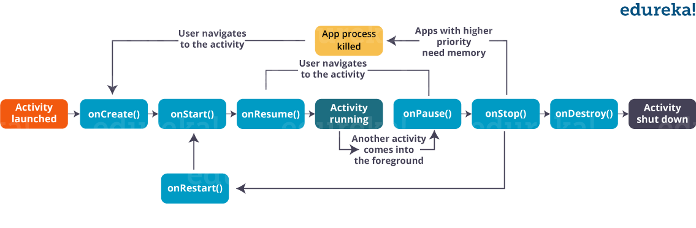

**Question:**  Define intents in Android. What are the different types of intents?

**Answer:**  An Intent is an “intention” to do an action. An intent is a messaging object you can use to request an action from another app component.

Methods are used to deliver intents to different components:

Flutter Application Development Course

context.startActivity() – To start an activity

context.startService() – To start a service

context.sendBroadcast() – To deliver a broadcast

Types of Intent:

Implicit Intent: Implicit intent is when the target component is not defined in the intent and the android system has to evaluate the registered components based on the intent data.

Explicit Intent: Explicit intent is when an application defines the target component directly in the intent.

**Question:**  What is the difference between an implicit intent and explicit intent?

**Answer:**  Implicit Intent is used whenever you are performing an action. For example, send email, SMS, dial number or you can use a Uri to specify the data type. For example:

Intent i = new Intent(ACTION_VIEW,Uri.parse("<a href="http://www.edureka.co">http://www.edureka.co</a>"));

startActivity(i);

Explicit, on the other hand, helps you to switch from one activity to another activity(often known as the target activity). It is also used to pass data using putExtra method and retrieved by other activity by getIntent().getExtras() methods.

For example:

Intent i = new Intent(this, Activitytwo.class); #ActivityTwo is the target component

i.putExtra("Value1","This is ActivityTwo");

i.putExtra("Value2","This Value two for ActivityTwo");

startactivity(i);

**Question:**  What is an Android Framework?

**Answer:**  Android Framework is an essential part of the Android Architecture. It is a set of APIs that allows developers to write apps and has the following components:

| *Services* | Components that conduct long-running operations in the background, without the inclusion of a user interface. |
| --- | --- |
| *Intent* | Objects that initiate actions from other app components, either within your program (explicit intents) or through another piece of software on the device (implicit intents). |
| *Activities* | Components that provide users with screens on which they can interact with objects and perform actions. This is the base from which Intents can be deployed. |
| *Content Providers* | Components that enable users to access data within an app such as audio, video, images, contact information, etc. |
| *Others* | App widgets and Processes and Threads |

**Question:**  What is the difference between File, Class, and Activity in android?

**Answer:**  The difference between them are as follows:

File is a block of arbitrary information or resources for storing information. It can be any file type.

Class is a compiled from of .Java file which Android uses to produce an executable apk.

Activity is the equivalent of a Frame/Window in GUI toolkits. It is not a file or a file type but just a class that can be extended in Android to load UI elements on view.

**Question:**  What is Google Android SDK? What are the tools placed in android SDK?

**Answer:**  The Google Android SDK is a toolset that provides a developer the API libraries and tools required to build, test, and debug apps for Android in Windows, Mac or Linux. The tools placed in Android SDk are:

Android Emulator

DDMS – Dalvik Debug Monitoring Services

AAPT – Android Asset Packaging tool

ADB – Android debug bridge

**Question:**  What is a Toast? Write its syntax.

**Answer:**  Toast notification is a message that pops up on the window.

It only covers the expanse of space required for the message and the user’s recent activity remains visible and interactive.

The notification automatically fades in and out and does not accept interaction events.

Syntax:

Toast.makeText(ProjectActivity.this, "Your message here", Toast.LENGTH_LONG).show();

**Question:**  What is an ANR? What are some measures you can take to avoid ANR?

**Answer:**  ANR stands for ‘*Application Not Responding*’. This dialogue is displayed if the main thread in the application has been unresponsive for a long time and in the following conditions:

* When there is no response to an input event after 5 seconds.
* When a broadcast receiver is not done executing within 10 seconds.

Following measures can be taken to avoid ANR:

* To avoid ANR, an app should perform a lengthy database or networking operations in separate threads.
* One technique is to create a child thread to prevent the Android system from concluding a code that has been unresponsive for a long period of time. Most of the actual workings of the codes can be placed within the child thread to ensure that the main thread runs with minimal unresponsive time.
* For background task-intensive apps, you can alleviate pressure from the UI thread by using the IntentService.

**Question:**  What is AAPT?

**Answer:**  AAPT is short for Android Asset Packaging Tool. This tool provides developers with the ability to deal with zip-compatible archives, which includes creating, extracting as well as viewing its contents.

**Question:**  What are broadcast receivers? How is it implemented?

**Answer:**  Broadcast Receiver is a mechanism using which host application can listen for System level events.

* Broadcast receiver is used by the application whenever they need to perform the execution based on system events. Like listening for Incoming call, sms etc.
* Broadcast receivers helps in responding to broadcast messages from other application or from the system.
* It is used to handle communication between Android operating system and applications.

It is implemented as a subclass of BroadcastReceiver class and each message is broadcaster as an Intent object.

public class MyReceiver extends BroadcastReceiver {

Public void onReceive(context,intent){}

}

**Question:**  How will you pass data to sub-activities?

**Answer:**  We can use Bundles to pass data to sub-activities.

There are like HashMaps that and take trivial data types. These Bundles transport information from one Activity to another

Bundle b=new Bundle();

b.putString("Email","abc@xyz.com");

i.putExtras(b); // where I is intent

**Question:**  What is the use of WebView in Android?

**Answer:**  WebView is a view that display web pages inside your application. According to Android, “this class is the basis upon which you can roll your own web browser or simply display some online content within your Activity. It uses the WebKit rendering engine to display web pages and includes methods to navigate forward and backward through a history, zoom in and out, perform text searches and more. In order to add WebView to your application, you have to add <WebView>element to your XML layout file.

**Question:**  What are the different kinds of context in Android?

**Answer:**  Context defines the current state of an App. Context provides access to creating new activity instance, access databases, start a service, etc. There is a base class ApplicationContext, and subclasses for components: Activity, Service.

**Question:**  Explain in brief about the important file and folder when you create a new app?

**Answer:**  App – It describes the fundamental characteristics of the app and defines each of its components.

* java – This contains the .java source files for your project. By default, it includes an *MainActivity.java* source file. Under this, you create all the activities which have .java extensions and all the code behind the application. MainActivity.java is the actual file which gets converted to a dalvik executable and runs your app.
* res – It is a directory for files that define your app’s user interface. You can add *TextView, button etc t*o build the GUI and use its various attributes like *android:layout_width*, *android:layout_height* etc which are used to set its width and height.
* Gradle Scripts – This is an auto-generated file which contains compileSdkVersion, buildToolsVersion, applicationId, minSdkVersion, targetSdkVersion, versionCode and versionName

### components- android interview questions - edureka

**Question:**  What are the different storage methods in Android?

**Answer:**  Android offers several options to see persistent application data. They are:

* Shared Preferences – Store private primitive data in key-value pairs
* Internal Storage – Store private data on the device memory
* External Storage – Store public data on the shared external storage
* SQLite Databases – Store structured data in a private database

**Question:**  Can you deploy executable JARs on android? Which package is supported by it?

**Answer:**  No, Android does not support JAR deployments. Applications are packed into Android Package(.apk) using Android Asset Packaging Tool (APT) and then deployed on to the Android platform.

**Question:**  What is a Service? How is it implemented?

**Answer:**  A service in android is a background process which is used to perform long-running operations. Let’s say, a service of location is active in the background while the user is in a different application. So it does not disturb the user interaction with an activity. Now, services are classified into two types, namely:

Local: This service is accessed from within the application.

Remote – This service is accessed remotely from other applications running on the same device.

It is implemented as a subclass of Service class as follows :

public class MyService extends Service {

}

**Question:**  What is a Sticky Intent?

**Answer:**  A Sticky Intent is a broadcast from sendStickyBroadcast() method which floats around even after the broadcast, allowing others to collect data from it.

**Question:**  Explain Folder, File & Description of Android Apps

**Answer:**  src: contains the .java source files for your project.

* gen: contains the .R file, a compiler-generated file that references all the resources found in your project.
* bin: contains the Android package files .apk built by the ADT during the build process and everything else needed to run an Android application.
* res/drawable-hdpi: this is a directory for drawable objects that are designed for high-density screens.
* res/layout: this is a directory for files that define your app’s user interface.
* res/values: this is a directory for other various XML files that contain a collection of resources, such as strings and colors definitions.
* AndroidManifest.xml: this is the manifest file which describes the fundamental characteristics of the app and defines each of its components.

**Question:**  How does Manifest file plays an integral role in App development?

**Answer:**  Manifest file plays an integral role as it provides the essential information about your app to the Android system, which the system must have before it can run any of the app’s code. Manifest file performs various tasks such as:

It names the Java package for the app as the package name serves as a unique identifier for the application.

It protects the application by declaring permissions in order to access protected parts of the API and interact with other applications.

Manifest file declares the minimum level of the android API and list the libraries which is linked with the application.

Manifest file list the instrumentation classes. These classes provide profiling and other information as the application runs, but this information is removed as soon the application is publishes. It remains only till the application is in development mode.

Structure of a manifest file: The structure of a manifest file consists of various elements such as action, activity, activity-alias and many more. Refer to the below screenshot which shows the general structure of the manifest file.

<?xml version="1.0" encoding="utf-8"?>

cmanifest xmlns:android="<a class="Xx" rel="nofollow noreferrer noopener" href="https://www.google.com/url?q=<a href="http://schemas.android.com/apk/res/android&sa=D&source=hangouts&ust=1556291767429000&usg=AFQjCNH7OW4Zi9NULaQDs71WDEo-67ZouA">http://schemas.android.com/apk/res/android&sa=D&source=hangouts&ust=1556291767429000&usg=AFQjCNH7OW4Zi9NULaQDs71WDEo-67ZouA</a>" target="_blank" tabindex="-1" data-display="<a href="http://schemas.android.com/apk/res/android">http://schemas.android.com/apk/res/android</a>" data-sanitized="<a href="https://www.google.com/url?q=http://schemas.android.com/apk/res/android&sa=D&source=hangouts&ust=1556291767429000&usg=AFQjCNH7OW4Zi9NULaQDs71WDEo-67ZouA">https://www.google.com/url?q=http://schemas.android.com/apk/res/android&sa=D&source=hangouts&ust=1556291767429000&usg=AFQjCNH7OW4Zi9NULaQDs71WDEo-67ZouA</a>"><a href="http://schemas.android.com/apk/res/android">http://schemas.android.com/apk/res/android</a>"

package="com.example.aayushi.myapplication">

<application android:allowBackup-"true" android:icon="@mipmap/ic_launcher android:label="My Application android: roundIcon="@mipmap/ic launcher round" android:supportsRtl="true android:theme="style/AppTheme">

<activity android:name=".MainActivity">

<intent-filter>

<action android:name="android.intent.action.MAIN >

<category android:name="android.intent.category. LAUNCHER" />

</intent-filter>

</activity>

</applications

</manifest>

**Question:**  What is the difference between a fragment and an activity?

**Answer:**  Activity is typically a single, focused operation that a user can perform such as dial a number, take a picture, send an email, view a map etc.

Fragment is a modular section of an activity, with its own lifecycle and input events, and which can be added or removed at will. Also, a fragment’s lifecycle is directly affected by its host activity’s lifecycle i.e. when the activity is paused, so are all fragments in it, and when the activity is destroyed, so are all of its fragments.

**Question:**  Can you change the name of an application after its deployment?

**Answer:**  It is not recommended to change the application after its deployment. This may break some functionality.

**Question:**  What database is used in Android? How does it differ from client-server database management systems?

**Answer:**  SQLite is the open-source relational database. The SQLite engine is serverless, transactional, and self-contained. Instead of the typical client-server relationship of most database management systems, the SQLite engine is integrally linked with the application. The library can also be called dynamically and makes use of simple function calls that reduce latency in database access.

**Question:**  What is DDMS?

**Answer:**  DDMS stands for *Dalvik Debug Monitor Server*. It gives the following array of debugging features:

* Port forwarding services
* Screen capture on the device
* Thread and heap information
* Logcat
* Incoming call and SMS spoofing
* Network traffic tracking
* Location data spoofing

**Question:**  What is the difference between Service and Thread?

**Answer:**

| Service | Thread |
| --- | --- |
| Service is like an Activity but has no interface. | A Thread is a concurrent unit of execution. |
| A Service is not a separate process. It works in background until the service or someone else explicitly stop it. | By default, all components of the same application run in the same process and thread (called the “main” thread). |
| Service is not killed when an application is killed. | Thread is killed when an Application is killed. |
| It expose some of its functionality to other applications by calling [Context.bindService()](https://developer.android.com/reference/android/content/Context.html). | GOOGLE has brought in Handlers and loopers into android threads. |

**Question:**  What are the containers?

**Answer:**  Containers, holds objects and widgets together, depending on which specific items are needed and in what particular arrangement that is wanted. Containers may hold labels, fields, buttons, or even child containers, as examples.

**Question:**  What are some of the disadvantages of Android?

**Answer:**  Android being an open-source platform, and considering that different Android operating systems have been released on different mobile devices, there’s no clear cut policy to how applications can adapt with various OS versions and upgrades. An app that runs on one version of Android OS may or may not run on another version.

Another disadvantage is that it can be challenging for developers to create apps that can adjust correctly to the right screen size and other varying features and specs of various Android devices.

**Question:**  What is an Android Runtime?

**Answer:**  Android Runtime consists of Dalvik Virtual machine and Core Java libraries.

* DVM is optimized for low processing power and low memory environments.
* Unlike JVM, the Dalvik Virtual Machine doesn’t run .class files, instead it runs .dex files.
* Android 2.2 “Froyo“ brought trace-based just-in-time (JIT) compilation into Dalvik, optimizing the execution of applications and dynamically compiling frequently executed short segments of their bytecode into native machine code.

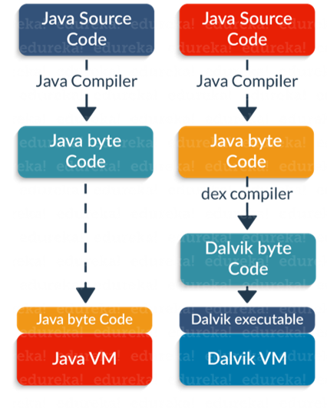

**Question:**  What is the importance of an emulator in Android?

**Answer:**

* The emulator lets you play around an interface that acts as if it were an actual device.
* It let you write and test codes, and even debug.
* It acts as a safe place for testing codes especially if its in the early design phase.

**Question:**  Name the four essential states of an activity.

**Answer:**  The four essential states of activity are:

Active – if the activity is at the foreground

Paused – if the activity is at the background and still visible

Stopped – if the activity is not visible and therefore is hidden or obscured by another activity

Destroyed – when the activity process is killed or completed terminated

**Question:**  What is the difference between a regular bitmap and a nine-patch image?

**Answer:**  A nine-patch image, unlike bitmap, can be resized and used as background or other image sizes for the target device. The Nine-patch refers to the way you can resize the image: 4 corners that are unscaled, 4 edges that are scaled in 1 axis, and the middle one that can be scaled into both axes. This is what differentiates a nine-patch image from a regular bitmap.

**Question:**  What are the core building blocks of android?

**Answer:**

* Activity : An Activity is the screen representation of any application in Android. Each activity has a layout file where you can place your UI.
* Content Provider: Content providers share data between applications.
* Service: It is a component that runs in the background to perform long-running operations without interacting with the user and it even works if application is destroyed.
* Broadcast Receivers: It respond to broadcast messages from other applications or from the system itself. These messages are sometime called events or intents.

**Question:**  What are the dialog boxes that are supported in Android?

**Answer:**

Android supports four dialog boxes:

* AlertDialog: An alert dialog box supports zero to three buttons and a list of selectable elements, including checkboxes and radio buttons. Among the other dialog boxes, the most suggested dialog box is the alert dialog box.
* ProgressDialog: This dialog box displays a progress wheel or a progress bar. It is an extension of AlertDialog and supports adding buttons.
* DatePickerDialog: This dialog box is used for selecting a date by the user.
* TimePickerDialog: This dialog box is used for selecting time by the user.

**Question:**  What does APK stand for?

**Answer:**  APK stands for Android Packaging Kit. The Android packaging key is compressed with classes, UI’s, supportive assets and manifest. All these files are compressed to a single file which is called APK.

**Question:**  What is a sticky broadcast? Give an example.

**Answer:**  A sticky broadcast is used for communicating between applications. These broadcasts happen without the user being notified. The Android OS normally treats each application as if it were a separate user. Here’s an example: When you call registerReceiver() for that action — even with a null BroadcastReceiver — you get the Intent that was last broadcast for that action. Hence, you can use this to find the state of the battery without necessarily registering for all future state changes in the battery.

**Question:**  What is Dalvik Virtual Machine (DVM)?

**Answer:**  Dalvik is the name of Android’s virtual machine.

* The Dalvik VM is an interpreter-only virtual machine that executes files in the Dalvik Executable (.dex) format.
* The virtual machine is register-based and can run classes compiled by Java language compiler that have been altered into its native format using the included ‘dx’ tool.
* The Dalvik core class library is envisioned to provide a familiar development base for those used to programming with Java Standard Edition, but is geared explicitly for the needs of a small mobile device.

**Question:**  What are the exceptions in android?

**Answer:**  InflateException: When error conditions occur this exception is thrown.

Surface.OutOfResourceException: When a Surface is not created or resized, this exception is thrown.

SurfaceHolder.BadSurfaceTypeException: When invoked on a Surface ‘SURFACE_TYPE_PUSH_BUFFERS’, this exception is thrown from lockCanvas() method.

WindowManager.BadTokenException: This exception is thrown at the time of trying to view an invalid WindowManager.LayoutParamstoken

**Question:**  What is a content provider? How is it implemented?

**Answer:**  Content providers manage access to a structured set of data. It is the standard interface that connects data in one process with code running in another process.

They encapsulate the data and provide mechanisms for defining data security.

Content providers are used to share the data between different applications.

It is implemented as a subclass of ContentProviderclass and must implement a standard set of APIs that enable other applications to perform transactions.

public class MyContentprovider extends ContentProvider {

public void onCreate(){}

}

**Question:**  What is the significance of the .dex files?

**Answer:**  Android programs are compiled into ‘.dex’ (Dalvik Executable) files, which are zipped into a single .apk file on the device.

* ‘.dex’ files can be created by translating compiled applications written in Java.
* (.dex) is a format that is optimized for effective storage and memory-mappable executions.

**Question:**  How are escape characters used as attribute?

**Answer:**  Escape characters are preceded by double backslashes. For example – a newline character is created using ‘n’.

**Question:**  What does ADB stand for?

**Answer:**  ADB stands for Android Debug Bridge. It is a command line tool that is used to communicate with the emulator instance. ADB can control your device over USB from a computer, copy files back and forth, install and uninstall apps, run shell commands, and more.

It is a client-server program that includes three components:  
• Client – which runs on your development machine. You can invoke a client from a shell by issuing an ADB command. Other Android tools such as DDMS also create ADB clients.  
• Server, which runs as a background process on your development machine. The server manages communication between the client and the ADB daemon running on an emulator or device.  
• Daemon, which runs as a background process on each emulator or device instance.

**Question:**  Can you list and explain the four Java classes related to using sensors on the Android platform?

**Answer:**  Sensor Manager: This class provides methods regarding the registration of sensor event listeners, the management of data acquisition, and calibration. It also provides methods for accessing and listing sensors.

Sensor: This class creates an instance of a specific sensor, providing methods that allow you to determine its capabilities.

SensorEvent: This class provides information on a sensor event by creating a sensor event object.

SensorEventListener: This interface provides two callback methods that can receive notifications of sensor events.

**Question:**  What is Orientation in android? How is it done?

**Answer:**  Orientation helps to represent the layout in a row or column.

<activity android name=".activity" android: screenOrientation="portrait">

**Question:**  What is AIDL? What are the datatypes supported by AIDL ?

**Answer:**  AIDL stands for Android Interface Definition Language.  
– It handles the interface requirements between a client and a service to communicate at the same level through interprocess communication.  
– The process involves breaking down objects into primitives that are Android understandable.

Data Types:

* String
* List
* Map
* CharSequence
* Native Java data types (int, long, char and Boolean)

**Question:**  Explain the characteristics of Android.

**Answer:**

| Criteria | Characteristics |
| --- | --- |
| Type of operating system | Open source |
| OS fragmentation | Multiple OS versions and interoperability concerns |
| Customization | Heightened customization possible |

**Question:**  Why cannot you run the standard Java bytecode on Android?

**Answer:**  Android uses Dalvik virtual machine (DVM) which requires a special bytecode. First of all, we have to convert Java class files into Dalvik executable files using an Android tool called ‘dx’. In normal circumstances, developers will not be using this tool directly; build tools will care for the generation of DVM compatible files.

**Question:**  Can Android applications only be programmed in Java?

**Answer:**  No, not necessarily. We can program Android apps using the Native Development Kit (NDK) in C/C++. The NDK is a toolset that allows us to implement parts of our app using native code languages such as C and C++. Typically, good use cases for NDK are CPU-intensive applications such as game engines, signal processing, and physics simulation.

**Question:**  Where will you declare your activity so the system can access it?

**Answer:**  Activity is to be declared in the manifest file. For example:

<manifest></manifest>

<application></application>

<activity android:name=”.MyIntellipaat”>

**Question:**  What is a NinePatch (9-patch) image?

**Answer:**  It is a resizable bitmap resource that can be used for backgrounds or other images on a device. NinePatch class permits drawing a bitmap in nine sections. The 9-patch images have an extension as .9.png. It allows extensions in 9 ways, i.e., 4 corners that are unscaled, 4 edges that are scaled in 1 axis, and the middle one that can be scaled into both axes.

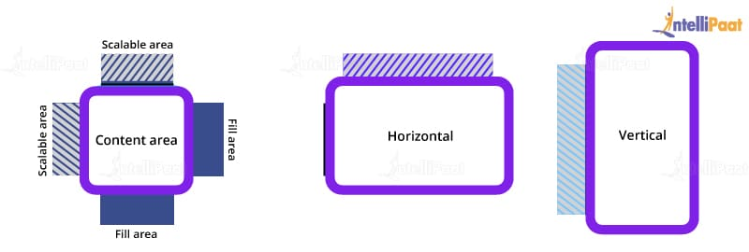

**Question:**  What is the difference between an implicit intent and an explicit intent?

**Answer:**  There are two types of intents: implicit intent and explicit intent. Let us see the differences between them.

Implicit intent: It is when we call system default intent like send e-mail, send SMS, or dial number.

For example:

Intent sendIntent = new Intent();

sendIntent.setAction(Intent.ACTION_SEND);

sendIntent.putExtra(Intent.EXTRA_TEXT, textMessage);

sendIntent.setType("text/plain")

startactivity(sendIntent);

Explicit intent: It is when we call our own application activity. We can also pass the information from one activity to another using explicit intent.

For example, from the first activity to the second activity:

Intent intent = new Intent(first.this, second.class);

startactivity(intent);

**Question:**  Where can you define the icon for your activity?

**Answer:**  The icon for an activity is defined in the manifest file.

Syntax:

<activity android:icon="@drawable/app_icon" android:name=".MyTestActivity"></activity>

This means that we have to open AndroidManifest.xml. Right under the root ‘manifest’ node of the XML, we can see the ‘application’ node. We have added this attribute to ‘application’. (The ‘icon’ in ‘@drawable/icon’ refers to the file name of the icon.)

android:icon="@drawable/icon"

**Question:**  What is ADB?

**Answer:**  ADB stands for Android Debug Bridge. It is a command-line tool that is used to communicate with the emulator instance. ADB can control our device over USB from a computer, copy files back and forth, install and uninstall apps, run shell commands, and more.

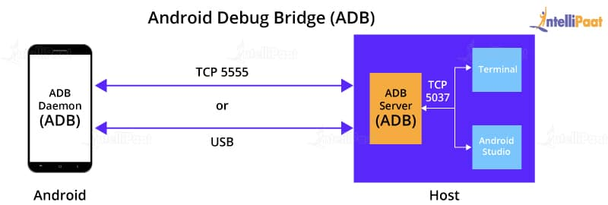

It is a client–server program that includes three components:

* A client, which runs on our development machine. We can invoke a client from a shell by issuing an ADB command. Other Android tools such as DDMS also create ADB clients.
* A server, which runs as a background process on our development machine. The server manages communication between the client and the ADB daemon running on an emulator or device.
* A daemon, which runs as a background process on each emulator or device instance.

**Question:**  What are the different storage methods in Android?

**Answer:**  Android offers several different options for data persistence. Shared Preferences – Store private primitive data in key-value pairs. This sometimes gets limited as it offers only key-value pairs. You cannot save your own java types. Internal Storage – Store private data on the device memory.

**Question:**  What is action in Android?

**Answer:**  In Android, an action is a description of something that an intent sender desires.

Syntax:

<action android:name="string" />

Contained in:

<intent-filter>

Description:

It adds an action to an intent filter. An <intent-filter> element must contain one or more <action> elements. If it doesn’t contain any, no Intent objects will get through the filter.

**Question:**  What is an ANR notification in Android?

**Answer:**  ANR is a short form for ‘Application Not Responding’. Android systems show this dialog if an application is performing too many tasks on the main thread and has been unresponsive for a long time.

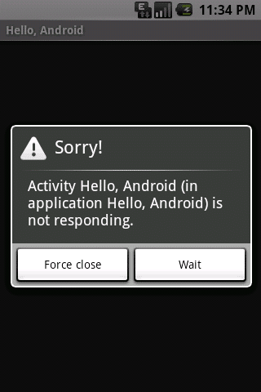

**Question:**  Define the three key loops when monitoring an activity.

**Answer:**

Entire lifetime: An activity that happens between onCreate and onDestroy

• Visible lifetime: An activity that happens between onStart and onStop

• Foreground lifetime: An activity that happens between onResume and onPause

**Question:**  How do you find a view element in your program?

**Answer:**  Findviewbyid is a method that is used to find a view that is identified by the ID attribute from the XML processed inActivity.OnCreate(Bundle).

Syntax:

[Android.Runtime.Register("findViewById", "(I)Landroid/view/View;", "GetFindViewById_IHandler")]

public virtual View FindViewById (Int32 id)

**Question:**  Which dialog boxes can you use in your Android application?

**Answer:**  AlertDialog: It is an alert dialogue box that supports 0 to 3 buttons and a list of selectable elements.

ProgressDialog: It is an extension to AlertDialog. We can add buttons to it. It shows a progress wheel or a progress bar.

DatePickerDialog: It is used for selecting a date by the user.

TimePickerDialog: It is used for selecting time by the user.

**Question:**  Name the resource that is a compiled visual resource, which can be used as a background, title, or in other parts of the screen.

**Answer:**  Drawable is the virtual resource that can be used as a background, title, or in other parts of the screen. It is compiled into an android.graphics.drawable subclass. A drawable resource is a general concept for a graphic that can be drawn. The simplest case is a graphical file (bitmap), which would be represented in Android via a BitmapDrawable class.

Drawable is stored as an individual file in one of the res/drawable folders. The ADT project creation wizard creates these folders by default. You would store bitmaps for different resolutions in the -mdpi, -hdpi, -xhdpi, and -xxhdpi subfolders of res/drawable. If these bitmaps are provided in a different folder, the Android system selects the correct one automatically based on the device configuration.

**Question:**  How can two Android applications share the same Linux user ID and the VM?

**Answer:**  The applications must sign in with the same certificate in order to share the same Linux user ID and the VM.

**Question:**  Can you deploy executable JARs on Android? Which packaging is supported by Android?

**Answer:**  No, the Android platform does not support JAR deployments. Applications are packed into Android Package (.apk) using Android Asset Packaging Tool (AAPT) and then deployed onto the Android platform. Google provides Android Development Tools for Eclipse that can be used to generate the Android Package.

**Question:**  Is it okay to change the name of an application after its deployment?

**Answer:**  It is not recommended to change the application name after its deployment because this action may break some functionality. For example, shortcuts will not work if you change the application name.

**Question:**  How can ANR be prevented?

**Answer:**  One technique that prevents the Android system from concluding a code that has been unresponsive for a long period of time is to create a child thread. Within the child thread, most of the actual tasks of the codes can be placed so that the main thread runs with minimal periods of unresponsive time.

**Question:**  How can your application perform actions that are provided by another application, e.g., sending an email?

**Answer:**  Intents are created to define an action that we want to perform, and they launch the appropriate activity from another application.

Syntax:

Intent intent = new Intent(Intent.ACTION_SEND);intent.putExtra(Intent.EXTRA_EMAIL, recipientArray);

startActivity(intent);

**Question:**  How will you pass data to sub-activities?

**Answer:**  We can use bundles to pass data to sub-activities. There are HashMaps that take trivial data types. These bundles transport information from one activity to another.

Syntax:

Bundle b=new Bundle();

b.putString(“Email”, “abc@xyz.com”);

i.putExtras(b); //where I is intent

**Question:**  For starters, what’s Android anyway?

**Answer:**  [Android](https://www.simplilearn.com/android-app-development-fundamentals-article) is a Linux-based, open-sourced operating system commonly found on mobile devices, such as smartphones and tablets. It’s a kernel-based system that gives developers the flexibility to design and deploy simple and/or advanced apps.

**Question:**  What database is used for the Android platform?

**Answer:**  SQLite, an open-source, self-contained, serverless database, is embedded in Android by default.

**Question:**  What is an android application architecture?

**Answer:**  The Android architecture consists of:

Android Framework

Android Applications

Linux Kernel

Libraries

**Question:**  Can you change an application’s name after you have deployed it?

**Answer:**  Although you CAN change it, the real question should be “SHOULD you”? Changing an application’s name risks breaking some of its functionality.

**Question:**  Name the basic tools for developing an Android App

**Answer:**  The tools used for development are:

* JDK
* SDK Tools
* Eclipse+ADT Plugin

**Question:**  List of Android’s advantages.

**Answer:**  The four main advantages of Linux are:

* Open source, so it’s free
* It’s platform-independent, so it supports Windows, Linux, and Mac
* It supports a number of different technologies, such as Bluetooth, speech, cameras, Wi-Fi, etc.
* It employs DVM (Dalvik Virtual Machine), a highly optimized virtual machine

**Question:**  Explain the Android SDK.

**Answer:**  This is a set of tools that Android developers use in order to develop or write apps. It features a graphical user interface that emulates a handheld, Android-driven environment, making it easier for developers to create, test, and debug their code.

The tools include:

Dalvik Debug Monitoring Services

Android Emulator

Android Asset Packaging Tool

Android Debug Bridge

**Question:**  Speaking of emulators, why is it so important for developers to have access to one?

**Answer:**  Since emulators function like an actual hand-held device, developers have a good dedicated “sandbox” to safely create, edit, test, and debug new applications, seeing how they would function on a real device without having to actually risk a real device.

**Question:**  What languages does Android use?

**Answer:**  Android-primarily uses Java, but it also supports C/C++, which, if used with Android SDK, will run faster.

**Question:**  What’s an android framework?

**Answer:**  It’s a set of APIs that permits developers to create apps, and consists of:

* Intent
* Activities
* Content Providers
* Others

**Question:**  What’s an intent in the context of Android? Describe the different types.

**Answer:**  Much what it sounds like, it’s the intention to perform an action, a message that is passed between components. Intents request actions from a different component, such as sending an email, opening a web page, or launch a given activity. The two types are:

* Implicit Intent  
  This is where the intent doesn’t define the target component, requiring the Android system to conduct an evaluation of the components.
* Explicit Intent  
  On the other hand, the explicit intent directly identifies the target component.

**Question:**  What’s a sticky intent?

**Answer:**  This is a broadcast using the send sticky broadcast() method. The intent sticks around after the broadcast, which allows others to collect data from it.

**Question:**  What are Activities?

**Answer:**  These are the parts of a mobile app that a user sees and interacts with. It represents a Graphic User Interface (GUI), representing one Android screen.

**Question:**  What are the four essential activity states?

**Answer:**  The four states are:

* Active: The activity is at the top of the stack, running in the foreground
* Paused: The activity is still visible but cannot receive user input events; it’s in the background
* Stopped: The activity is invisible and consequently is paused, and obscured or hidden by a different activity
* Destroyed: The activity’s process has been killed, completed, or terminated

**Question:**  What’s a content provider?

**Answer:**  Content providers share information between different Android applications. They allow users to access data within an application. Examples include contact information, images, video, and audio.

**Question:**  Explain Android Toast.

**Answer:**  Toast, in this case, is a pop-up box (hence the word) giving feedback regarding an operation that the users initiated, informing the user of the current status of said operation. For instance, when a smartphone user sends a message to a friend, a toast is displayed saying “sending message”.

**Question:**  What’s the difference between mobile testing and mobile application testing?

**Answer:**  Mobile Testing is performed on the mobile device itself, specifically on the device’s features like Contacts, SMS, the browsers, and it’s Calling function. Mobile Application Testing tests the features and functions of the apps loaded onto a mobile device.

**Question:**  What’s a “bundle” in Android?

**Answer:**  Bundles are used to pass the required data to sub-folders.

**Question:**  How do you identify view elements in an android program?

**Answer:**  Use the keyword findViewById.

**Question:**  Does Android have any drawbacks?

**Answer:**  Android’s weaknesses stem from one of its advantages, namely that it’s everywhere and can run on a huge number of devices.

First of all, developers can encounter difficulty in creating apps that easily adjust the display to accommodate the widely disparate screen sizes of all these different devices.

Secondly, the large number of devices has given rise to a large number of custom-made Android versions to suit them, thus there is no central set of policies governing upgrades, or parameters for running on many operating systems. It’s anarchy out there!

**Question:**  Can Bytecode that is written in Java run on Android?

**Answer:**  No, it cannot.

**Question:**  What is AAPT?

**Answer:**  This is an acronym for Android Asset Packaging Tool. The tool gives developers the ability to deal with zip-compatible archives, including content viewing, creation, and extraction.

**Question:**  What does APK mean?

**Answer:**  It’s short for Android Packaging Kit. Every file in the Android packaging key is compressed into a single file, the APK.

**Question:**  Explain ANR.

**Answer:**  This is an acronym for Application Not Responding, a pop-up or notification that kicks in when the application is experiencing lag time for the user due to too many functions being performed simultaneously.

**Question:**  How do you place layouts in Android? Where are they placed?

**Answer:**  They’re placed as XML files, in the layout folder.

**Question:**  Give some examples of Android exceptions.

**Answer:**  Exceptions include:

* Inflate Exception
* Surface.OutOfResourceException
* SurfaceHolder.BadSurfaceTypeException
* WindowManager.BadTokenException

**Question:**  What are the four essential items in every Android project?

**Answer:**  The four essential items are:

* AndroidManifest.xml
* build.xml
* bin/
* src/
* res/
* assets/

**Question:**  List the four Android supported dialogue boxes.

**Answer:**  The four dialogue boxes are:

Alert Dialog: Features selectable elements such as radio buttons and/or checkboxes

Progress Dialog: Shows progress, either via a progress wheel or bar

Date Picker Dialog: Lets the user select a date

Time picker Dialog: Lets the user select a time

**Question:**  An Android application keeps crashing. How do you resolve the issue?

**Answer:**  When an application crashes often, these are the best ways to fix it -

It could be a memory space issue. Make sure there’s enough memory space.

Clear the app data by clearing the cache memory using “settings” under Application Manager.

Not all apps run the same on assorted machines, so you may have to tinker with memory management.

It may be a matter of compatibility; a problem that can be headed off by testing the app on as many of your devices as possible beforehand.

**Question:**  What is An android manifest file?

**Answer:**  Every application must have an AndroidManifest.xml file (with precisely that name) in its root directory. The manifest file presents essential information about your app to the Android system, information the system must have before it can run any of the app's code.

**Question:**  What are the tools are placed in An Android SDK?

**Answer:**  Android SDK collaborated with Android Emulator,DDMS(Dalvik Debug Monitoring Services),AAPT(Android Asset Packaging tool) and ADB(Android debug bridge)

**Question:**  What is viewGroup in android?

**Answer:**  View group is a collection of views and other child views, it is an invisible part and the base class for layouts.

**Question:**  What is a service in android?

**Answer:**  The Service is like as an activity to do background functionalities without UI interaction.

**Question:**  What is a content provider in android?

**Answer:**  A content provider component supplies data from one application to others on request. Such requests are handled by the methods of the ContentResolver class. A content provider can use different ways to store its data and the data can be stored in a database, in files, or even over a network.

**Question:**  What are the notifications available in android?

**Answer:**  Toast Notification − It will show a pop up message on the surface of the window

Status Bar Notification − It will show notifications on status bar

Dialogue Notification − It is an activity related notification.

**Question:**  What is container in android?

**Answer:**  The container holds objects,widgets,labels,fields,icons,buttons.etc.

**Question:**  What is an Adapter in android?

**Answer:**  The Adapter is used to create child views to represent the parent view items.

**Question:**  What is shared preferences in android?

**Answer:**  Shared preferences are the simplest mechanism to store the data in XML documents.

**Question:**  What does the intent filter do in android?

**Answer:**  Intent filters are filter out the intents.

**Question:**  Where layouts are placed in android?

**Answer:**  In The Layout folder, layouts are placed as XML files

**Question:**  How many dialog boxes do support in android?

**Answer:**  AlertDialog, ProgressDialog,DatePickerDialog, and TimePickerDialog

**Question:**  What are the exceptions available in android?

**Answer:**  InflateException,Surface.OutOfResourceException,SurfaceHolder.BadSurfaceTypeException,and WindowManager.BadTokenException

**Question:**  What is the order of dialog-box in android?

**Answer:**  Positive, Neutral, Negative.

**Question:**  What are the different storages available in android?

**Answer:**  Shared Preferences,Internal Storage,External Storage,SQLite Databases and Network Connection

**Question:**  What is a Sticky Intent in android?

**Answer:**  Sticky Intent is also a type of intent which allows the communication between a function and a service for example,sendStickyBroadcast() is perform the operations after completion of intent also.

**Question:**  How to Translate in Android?

**Answer:**  Android uses Google translator to translate data from one language into another language and placed as a string while development

**Question:**  How is the use of web view in Android?

**Answer:**  WebView is UI component that can display either remote web-pages or static HTML

**Question:**  Why can't you run java byte code on Android?

**Answer:**  Android uses DVM (Dalvik Virtual Machine ) rather using JVM(Java Virtual Machine), if we want, we can get access to .jar file as a library.

**Question:**  How does android track the application on process?

**Answer:**  Android provides a Unique ID to all applications is called as Linux ID,this ID is used to track each application.

**Question:**  How to change application name after its deployment?

**Answer:**  It's not truly recommended to change application name after it's deployment, if we change, it will impact on all other internal components.

**Question:**  Define the application resource file in android?

**Answer:**  JSON,XML bitmap.etc are application resources.You can injected these files to build process and can load them from the code.

**Question:**  How do you pass the data to sub-activities android?

**Answer:**  Using with Bundle, we can pass the data to sub activities.

Bundle bun = new Bundle();

bun.putString("EMAIL", "contact@tutorials.com");

**Question:**  What is singleton class in android?

**Answer:**  A class which can create only an object, that object can be share able to all other classes.

**Question:**  What is fragment in android?

**Answer:**  Fragment is a piece of activity, if you want to do turn your application 360 degrees, you can do this by fragment

**Question:**  What is sleep mode in android?

**Answer:**  Sleep mode mean CPU will be sleeping and it doesn't accept any commands from android device except Radio interface layer and alarm.

**Question:**  Which kernal is used in android?

**Answer:**  Android is customized Linux 3.6 Kernel

**Question:**  How to update UI from a service in android?

**Answer:**  Use a dynamic broadcast receiver in the activity, and send a broadcast from the service. Once the dynamic receiver is triggered update UI from that receiver.

**Question:**  What folders are impotent in android project?

**Answer:**  AndroidManifest.xml

build.xml

bin/

src/

res/

assets/

**Question:**  What are application Widgets in android?

**Answer:**  App Widgets are miniature application views that can embedded in other applications (such as the Home screen) and receive periodic updates. These views has referred to as Widgets in the user interface, and you can publish one with an App Widget provider

**Question:**  How do you find any view element into your program?

**Answer:**  Using with findViewById we can find view element

**Question:**  What is drawable folder in android?

**Answer:**  A compiled visual resource that can used as a backgrounds,banners, icons,splash screen etc.

**Question:**  What are the type of flags to run an application in android?

**Answer:**  FLAG_ACTIVITY_NEW_TASK

FLAG_ACTIVITY_CLEAR_TOP.

**Question:**  What is the difference between Mobile Application Testing and Mobile Testing?

**Answer:**  Mobile app testing is the testing of applications on a device which mainly focuses on functions and features of the application.

And Mobile Testing is the testing of the actual mobile device and focuses on mobile features like Call, SMS, Contacts, Media Player, inbuilt browsers, etc.

**Question:**  What is meant by Services?

**Answer:**  Service is an Android component that runs in the background and acts independently. It does not provide any user interface.

Though the services are running behind the scene, a user can continue their work on different apps. Most of the time, the users are not aware of the services which are running in the background. These services allow the system to kill the process without interrupting the user’s ongoing work.

**A service is implemented as a subclass of Service class:**

Public class MainService extends Service  
{  
}

**Question:**  What is the importance of setting up permission in app development?

**Answer:**  Once the permissions are set for the app development, then the data and code are restricted to the authorized users only.

If the code is kept without any restriction or if it is accessible to anyone then there are chances of compromise of code which results in defect leakage.

**Question:**  What is .apk extension in Android?

**Answer:**  It is a default file format that is used by the Android Operating System. Application Package Kit (APK) is used for the installation of mobile apps. The .apk contains resource file, certificate, manifest file, and other code.

APK files are archive files in the zip format with .apk extension.

**Question:**  What is ActivityCreator?

**Answer:**  ActivityCreator is a batch file and shell script which was used to create a new Android project. It is now replaced by the “Create New Project” in Android SDK.

**Question:**  What is Orientation?

**Answer:**  Orientation is the key feature in Smartphones nowadays. It has the ability to rotate the screen between Horizontal or Vertical mode.

**Android supports two types of screen Orientations as mentioned below:**

* **Portrait**: When your device is vertically aligned.
* **Landscape**: When your device is horizontally aligned.

setOrientation() is a method using which you can set a screen alignments. HORIZONTAL and VERTICAL are two values that can be set in the setOrientation() method. Whenever there is a change in the display orientation i.e. from Horizontal to Vertical or vice versa then onCreate() method of the Activity gets fired.

Basically, when the orientation of the Android mobile device gets changed then the current activity gets destroyed and then the same activity is recreated in the new display orientation. Android developers define the orientation in the AndroidManifest.xml file.

**Question:**  What is AIDL?

**Answer:**  In the Android platform, there are remote methods that facilitate the use of methods from one program to another. To create and implement the remote methods the first step is to define the communication interface in AIDL.

AIDL stands for Android Interface Definition Language. It facilitates communication between the client and the service. It also communicates the information through inter-process communication.

For communication between processes, the data is broken down into chunks which are easily understandable by the Android platform.

**Question:**  What are the data types supported by AIDL?

**Answer:**  Data Types supported by AIDL are as follows:

String

List

Map

charSequence

Java data types such as INT, Long, Char, Boolean, etc

**Question:**  Explain the AndroidManifest.xml file and why do you need this?

**Answer:**  Every application must have an AndroidManifest.xml file in the root directory. It contains information about your app and provides the same to the Android system.

The information includes the package name, Android components such as Activity, Services, Broadcast Receivers, Content Providers, etc. Every Android system must have this information before running any app code.

AndroidManifest.xml file performs the following tasks:

It provides a name to the Java package and this name is a unique identifier for the application.

It describes the various components of the application which include Activity, Services, Content Providers, etc. Also, it defines the classes which implement these components.

It is responsible to protect the application and it declares the permission for accessing the protected part of the app.

It also declares the Android API which is going to be used by the application.

It contains the library file details which are used and linked to the application.

**Question:**  Which tools are used for debugging on the Android platform?

**Answer:**  To understand the cause of the failure or cause of any issue, debugging is important. On the Android platform **Android Monitor.bat** utility is used while on the iOS platform, iPhone Configuration utility is used for debugging purposes.

**There are different tools for debugging which include:** Android DDMS, Android Debug Bridge, iOS simulator, Debugging from Eclipse with ADT, Remote debugging on Android with Chrome, etc.

**Question:**  Which scenario can test only on real devices but not on an emulator?

**Answer:**  Emulators are used for performing similar kinds of testing which is performed on the real devices. Basically, emulators are used as a replacement for real devices as sometimes real devices are not available for testing, the use of real mobile devices for testing purposes is costlier at times.

But there are few scenarios that cannot be tested using emulator, these can be tested only using real devices. These scenarios are interrupted scenarios i.e. message, phone call interruption while using the app, low battery, Bluetooth, memory card mount and unmount, etc.

**Question:**  Name the mobile automation tools that are available in the market.

**Answer:**  There are quite a few mobile automation testing tools that are available in the market but these are used only if the project requires it and if the application supports the automation.

These tools are paid as well as free tools, hence analysis needs to be done within the project team and then the appropriate mobile automation tool needs to be selected. Silk Mobile, SeeTest, Ranorex are the paid mobile automation tool while Appium, KIF, Robotium, Calabash are few free tools.

**Question:**  How do you troubleshoot the android application which is crashing frequently?

**Answer:**  **Given below are the few steps that we need to follow while troubleshooting the crashing issue:**

* **Free up memory space**: There is only limited space available on mobile devices for mobile apps. To avoid crashing issues or memory-related issues, you need to first check the memory space.
* **Clear app data usage**: You can clear the app data using the Application Manager under “Settings”. This will clear the cache memory and allow some free space to install another app or it will boost up your current app.
* **Memory Management**: Some apps run perfectly on one type of mobile device but the same app may not work on another type of device as for such devices the processing power, memory management, and CPU speed is different. For any app to run properly on any type of mobile device, you should manage the memory on the device.
* **Compatibility issue**: It is always not possible to test mobile apps on all mobile devices, browsers, operating systems, etc. So you need to test your mobile app on as many mobile devices as you can in order to avoid any compatibility issue.

**Question:**  How do you find memory leaks in the mobile app on the Android platform?

**Answer:**  Android Studio is using Android Device Manager (ADM), this ADM is used to detect the memory leaks in the Android platform.

When you open ADM in the Android Studio then on the left-hand side of the ADM, you will find your device or emulator in which a heap sign will be displayed. When you are running any mobile app then you will see the heap size, memory analysis and other statistics displayed on it.

**Question:**  What is DDMS?

**Answer:**  Android Studio has debugging tools known as DDMS i.e. Dalvik Debug Monitor Server.

**It has wide debugging features which include:**

* Port forwarding services.
* Screen capture on the device.
* Thread and Heap information.
* Incoming call and SMS spoofing.
* Logcat
* Radio state information.
* Location data spoofing.

DDMS is integrated with the Android studio. To launch the DDMS, you need to open the Android Device Monitor (ADM) first and then click on the DDMS menu button. Once DDMS is launched, then on the left-hand side the list of connected devices is displayed along with the processes which are running on each device.

With the help of DDMS, you can debug both on real devices and emulators.

**Question:**  What are the different data storage options available on the Android platform?

**Answer:**  Android platform provides a wide range of data storage options. These options must be used based on the need such as data is secure and used with permission only or can be accessed publicly.

**Below is the list of data storage options on the Android platform:**

* **SharedPreference**: It stores data in XML files. It is the simplest way to store private data in the key-value pair.
* **SQLite**: It stores structured data in the private database.
* **Internal Storage**: It stores data in the device file system and any other app cannot read this data.
* **External Storage**: Data is stored in the file system but it is accessible to all apps in the device

**Question:**  Explain Sensors in Android.

**Answer:**  Android-enabled devices have built-in sensors that measure orientation, motion, and other conditions.

These sensors provide data with high accuracy, which will help to monitor the positioning and movement of the device. Some of the sensors are hardware-based and few are software-based.

**There are three categories of sensors as mentioned below:**

* **Motion Sensors**: These sensors measure the rotational & acceleration forces and it includes gravity sensors, rotational vector sensors, accelerometers, etc.
* **Environmental Sensors**: It measures air temperature, pressure, humidity, etc.
* **Position Sensors**: It measures the physical position of the device and includes orientation sensors and magnetometers.

**There are four types of Java Classes as shown below:**

* Sensor Manager
* Sensor
* SensorEvent
* SensorEventListener

**Question:**  How are permissions managed in Android?

**Answer:**  Android permissions control how users access sensitive data held within the applications. As an Android developer, it is your job to limit information access while maintaining functionality. List some best practices for Android permissions, such as setting default handlers or selecting third-party SDKs that also have limited permissions.

**Question:**  What are the launch modes available for the activity in Android?

**Answer:**  Launch modes help you launch activities with specific sets of instructions and attendant navigation requirements. There are four launch modes that you should reference if asked this interview question:

Standard

SingleTop

SingleTask

SingleInstance

Each launch mode has its own role to play in allowing navigation across any possible configuration, so compare and contrast the benefits and drawbacks to achieve full marks.

**Question:**  What is the difference between fragment and activity?

**Answer:**  The code for an activity is far more in-depth than for a fragment. Be sure to mention to your interviewer that due to the extended work, activities should only be used for swapping entire screens, while fragments are used for everything else. If possible, list some use cases in which you almost always use a fragment rather than an activity (e.g. when you use components or data that must persist across varied activities).

**Question:**  What are the examples of design patterns used in Android applications?

**Answer:**  Design patterns are reusable templates that solve problems (think repetitive code). When presented with this question in an interview, be sure to outline the common Android pattern categories (Creational, Structural, and Behavioral) and give some use cases. Earn some bonus points by explaining how you resolved a problem from a previous project with a design pattern.

**Question:**  What types of Android app architectural patterns are there?

**Answer:**  Architecture patterns are applied to structure a project and make it modular. There are three main Android architectural patterns that developers use and that you should mention:

* MVC (Model — View — Controller)
* MVP (Model — View — Presenter)
* MVVM (Model — View — ViewModel)

Since each architectural pattern involves a wealth of information, consider this a more broad coding question. Offer detail when possible, but use this question to show your extended grasp of Android programming.

**Question:**  What additional libraries do you use in Android app development?

**Answer:**  Libraries let you take advantage of the work of other developers for better performance as you create apps. There are several popular libraries that you can talk about (Glide, Retrofit, Picasso, Dagger, Koin), but take the opportunity to explain the library you prefer or have used in the past with great success.

**Question:**  What is PendingIntent in Android?

**Answer:**  A PendingIntent passes a future intent to a different application that will perform execution. PendingIntents are a crucial part of the Android framework because they can specify actions to another app. It is good if your answer to this Android coding interview question touches upon implementation details and the new changes within Android 12 regarding mutability.

**Question:**  What is a content provider in Android?

**Answer:**  A content provider controls access to an app's data. Other applications will use a provider client object, creating an interface to handle communication. As a programming question, be ready to explain how you would access data from a content provider in addition to supplying information on creating a content provider within your own app. Since accessing data can block a main thread, note how you would perform data queries on a separate thread.

**Question:**  What kind of services are available on Android?

**Answer:**  A service is an application component that does not need a UI to work (think of a music service playing music or downloading files). Services are mechanisms for background work. In your interview, make sure you discuss the three types of services:

* ForegroundService: Operations a user can recognize
* BackgroundService: Operations unnoticed by the user
* BoundService: Bound services that provide a client-server interface for component interactions

The more details you can provide the better, so including information about threads vs services, intent services, or how a service starts, can all help your case.

**Question:**  Explain flavors in Android

**Answer:**  With this question, the interviewer wants to know if you can differentiate between product flavors and build types, as they are often mixed up. Also, convey how developer customization to apps across different codebases is tedious and causes errors, so using product flavors is ideal since you can create app variants with a single code base. Mention these details in addition to explaining Gradle, as it creates build type variants.

**Question:**  How do you handle a long-running process in an Android app?

**Answer:**  Processes are defined as long-running by Android if they take longer than 10 minutes to complete (such as large uploads and downloads or user-specified tasks). In such cases, you must create a long-running worker with WorkManager (assuming you can’t chunk workloads).

**Question:**  How do you protect an Android app from reverse engineering?

**Answer:**  Android application development interview questions will focus on the latest trends and topics. That will include discussions about security and data privacy. With the popularity and open-sourced nature of Android, you need to offer direct methods for protecting user data from reverse engineering. A business always wants to mitigate the negative impacts of security hacks or breaches, so your answers here are important.

Make sure you are well aware of prevention tactics and tools such as tamper detection, ProGuard Assistance, and SafetyNet. List other best practices such as using C++ for important code, securing user credentials, server-side database encryption, and altering Android's shared library loading process.

**Question:**  What is Android Jetpack and what are its libraries?

**Answer:**  Android Jetpack is a suite of tools and libraries that can help you build high-quality apps. While the software offers many benefits regarding build complexity and writing boilerplate code, it also addresses several challenges such as limiting memory leaks or managing configuration changes. Jetpack offers four categories of components (Foundation, Architecture, Behavior, and UI) and a host of libraries. In the interview, list a few and explain how they helped you in the past.

**Question:**  What are the new updates and features in Android 13?

**Answer:**  Android 13 is the latest release of the Android mobile operating system, expected to reach platform stability in June/August of 2022. Android 13 beta is already out and offers some quality-of-life upgrades and privacy and security improvements. As an Android developer, it is your job to stay near the edge of continual innovation, so having an awareness of upcoming upgrades is a crucial opportunity to demonstrate your expertise.

**Question:**  How do you publish an Android app to the Play Store?

**Answer:**  Android job interview questions are not always the hardest, technical-based queries. But this deceptively simple question can include plenty of varied factors about configuring your app and signing release versions. Be prepared to explain some common tasks involved with app publishing.

**Question:**  What is needed to run code as coroutine?

**Answer:**  This is a more technical Android interview question, and it pertains specifically to Kotlin coroutines. Kotlin creates fluid server-side or mobile applications by providing coroutines at the language level, leading to asynchronous programming. Display your understanding of Kotlin syntax, threads, and sequential code in Android architecture components to impress your interviewer.

**Question:**  How do you test an Android application?

**Answer:**  As the interview progresses, you will receive more senior-level Android engineer interview questions. Advanced questions are an opportunity to showcase your advanced knowledge, and also your leadership skills and creativity. In this case, lay out some testing fundamentals to start (functional, performance, accessibility, and compatibility test types), and then shift into a discussion of your preferred testing approaches to demonstrate your problem-solving capabilities.

**Question:**  What’s the purpose of RxJava?

**Answer:**  Different paradigms help solve different problems, and RxJava helps simplify asynchronous programming. As a top Android interview question, here is your chance to explain your understanding of programming libraries and functional reactive programming in Android. Explain how it can take complex implementation of asynchronous behaviors and simplify mobile programming.

**Question:**  What are the benefits of MVVM?

**Answer:**  As a recommended architecture approach by Google, MVVM has become a standard in Android development. This question allows you to show an understanding of problems that MVVM solves, knowledge of other styles such as MVC/MVP, the pros and cons of each, and how to choose between them when starting a new project.

**Question:**  How do you provide dependencies between different parts of the app?

**Answer:**  Persistent avoidance of "dependency hell" is one of the essential parts of clean code. Knowledge of inversion of the control pattern and its different implementations (ServiceLocator, Dependency injection, etc.) can help to provide robust and testable solutions. Be ready to provide possible solutions based on Android SDK and third-party libraries.

**Question:**  Why is XML used for frontend development in Android?

**Answer:**  XML stands for **Extensible Markup Language**. XML is a markup language much like HTML used to describe data. XML itself is well readable both by humans and machines. Also, it is scalable and simple to develop. In Android, we use XML for designing our layouts because XML is a lightweight language, so it doesn’t make our layout heavy.

**Question:**  What is the Dalvik Virtual Machine?

**Answer:**  DVM is a virtual machine to execute Android applications. The Java bytecode**(.class file)** generated by the javac compiler is converted into **Dalvik bytecode** to make the application source files executable on the DVM. Since Android devices have a definite processing capacity, memory, and battery life, the DVM design principle aims to optimize itself so that it can load fastly and run smoothly even on low memory/powered devices. This virtual machine is very efficient in running multiple instances on the same device.

**Question:**  What are the differences between Dalvik and ART?

**Answer:**

| **DALVIK VIRTUAL MACHINE** | **ANDROID RUN TIME** |
| --- | --- |
| Faster Booting time | Rebooting is significantly longer |
| Cache builds up overtime | The cache is built during the first boot |
| Occupies less space due to JIT | Consumes a lot of storage space internally due to AOT |
| Works best for small storage devices | Works best for Large storage devices |
| Stable and tested virtual machine | Experimental and new – not much app support comparatively |
| Longer app loading time | Extremely Faster and smoother Faster and app loading time and lower processor usage |
| Uses JIT compiler(JIT: Just-In-Time)  Thereby resulting in lower storage space consumption | Uses AOT compiler(Ahead-Of-Time) thereby compiling apps when installed |
| Application lagging due to garbage collector pauses and JIT | Reduced application lagging and better user experience |
| App installation time is comparatively lower as the compilation is performed later | App installation time is longer as compilation is done during installation |
| DVM converts bytecode every time you launch a specific app. | ART converts it just once at the time of app installation. That makes CPU execution easier.  Improved battery life due to faster execution. |

**Question:**  How Does an Android App Work?

**Answer:**  Developing an android application involves several processes that happen sequentially. After writing the source code files, when developers click the Run button on the Android studio, plenty of operations and processes start at the backend.

* **Building the APK File**
  + Code Compilation
  + Conversion into Dalvik bytecodes
  + Generating .apk file
  + App Distribution
* **Deploy the Application**
  + Establish the ADB Server
  + Transfer .apk file to the Device
* **Run the Application**
  + App launch request
  + Conversion of the .dex code to native OAT format

**Question:**  What is Toast in Android?

**Answer:**  A **Toast** is a short alert message shown on the Android screen for a short interval of time. Android **Toast** is a short popup notification that is used to display information when we perform any operation in our app. It disappears automatically. If the user wants a permanently visible message, then a **notification** can be used.

***To read more, refer* to *the article:*** [Toast](https://www.geeksforgeeks.org/android-tutorial/#Toast)

**Question:**  What’s Broadcast Receiver in android?

**Answer:**  Broadcast in android is the system-wide event that can occur when the device starts, when a message is received on the device, when incoming calls are received, or when a device goes to airplane mode, etc. Broadcast Receivers are used to respond to these system-wide events. Broadcast Receivers allow us to register for the system and application events, and when that event happens, then the registered receivers get notified. There are mainly two types of Broadcast Receivers:

* **Static Broadcast Receivers:** These types of Receivers are declared in the manifest file and work even if the app is closed.
* **Dynamic Broadcast Receivers:** These types of receivers work only if the app is active or minimized.

***To read more, refer* to *the article:*** [Broadcast Receiver in Android](https://www.geeksforgeeks.org/broadcast-receiver-in-android-with-example/)

**Question:**  What’s Gradle and write down its usage in Android?

**Answer:**  Gradle is a build system (open source) that is used to automate building, testing, deployment, etc. “Build.gradle” are scripts where one can automate the tasks. For example, the simple task to copy some files from one directory to another can be performed by Gradle build script before the actual build process happens.

**Usage:** Every Android project needs a Gradle for generating an apk from the *.java* and *.xml* files in the project. Simply put, a Gradle takes all the source files (java and XML) and applies appropriate tools, e.g., converts the java files into dex files and compresses all of them into a single file known as apk that is actually used.

***To read more, refer* to *the articles:*** [build.gradle file](https://www.geeksforgeeks.org/android-build-gradle/), [Introduction to Gradle](https://www.geeksforgeeks.org/introduction-to-gradle/)

**Question:**  What’s Fragment in android?

**Answer:**  In Android, the fragment is the part of Activity that represents a portion of the User Interface(UI) on the screen. It is the modular section of the android activity that is very helpful in creating UI designs that are flexible in nature and auto-adjustable based on the device screen size. There are mainly 3 types of fragments:

* Single Fragment
* List Fragment
* Fragment Transaction

***To read more, refer* to *the article:*** [Introduction to Fragments](https://www.geeksforgeeks.org/introduction-fragments-android/)

**Question:**  What’s RecyclerView in Android & How it works?

**Answer:**  RecyclerView is a ViewGroup added to the Android Studio as a successor of the GridView and ListView. It is an improvement on both of them. It has been created to make possible construction of any lists with **XML** layouts as an item that can be customized vastly while **improving the efficiency of ListViews and GridViews**. This improvement is achieved by recycling the views which are out of the visibility of the user. For example, if a user scrolled down to a position where items 4 and 5 are visible; items 1, 2, and 3 would be cleared from the memory to reduce memory consumption.

***To read more, refer* to *the article:*** [RecyclerView in Android with Example](https://www.geeksforgeeks.org/android-recyclerview/)

**Question:**  What’s the Difference Between Intent and Intent filters?

**Answer:**  An Intent is an object passed to **Context.startActivity(), Context.startService() or Activity.startActivityForResult()** etc. to launch an activity or get an existing activity to do something new. On the other hand, an Intent filter describes the capability of the component(like activities, services, and broadcast receivers).

***To read more, refer* to *the article:*** [Difference Between Implicit Intent and Explicit Intent in Android](https://www.geeksforgeeks.org/difference-between-implicit-intent-and-explicit-intent-in-android/)

**Question:**  What is the AndroidManifest.xml?

**Answer:**  Every project in Android includes a manifest file, which is AndroidManifest.xml, stored in the root directory of its project hierarchy. The manifest file is an important part of our app because it defines the structure and metadata of our application, its components, and its requirements. This file includes nodes for each of the Activities, Services, Content Providers, and Broadcast Receivers that make the application and using Intent Filters and Permissions determines how they coordinate with each other and other applications. The manifest file also specifies the application metadata, which includes its icon, version number, themes, etc., and additional top-level nodes can specify any required permissions, unit tests, and define hardware, screen, or platform requirements.

***To read more, refer* to *the article:*** [The Application Manifest File](https://www.geeksforgeeks.org/application-manifest-file-android/)

**Question:**  What’s Android SDK and its Components?

**Answer:**  **Android SDK** stands for **Android Software Development Kit** which is developed by Google for Android Platform. With the help of Android SDK, we can create Android Apps easily. Android SDK is a collection of libraries and Software Development tools that are essential for Developing Android Applications. Whenever Google releases a new version or update of Android Software, a corresponding SDK also releases with it. In the updated or new version of SDK, some more features are included which are not present in the previous version. Android SDK consists of some tools which are very essential for the development of Android Application. These tools provide a smooth flow of the development process from developing and debugging. Android SDK is compatible with all operating systems such as Windows, Linux, macOS, etc.

**Components:**

* Android SDK Build tool.
* Android Emulator.
* Android SDK Platform-tools.
* Android SDK Tools.

***To read more, refer* to *the article:*** [Android SDK and its Components](https://www.geeksforgeeks.org/android-sdk-and-its-components/)

**Question:**  Disadvantages of Android

**Answer:**  Fragmentation provides a very intuitive approach for user experience, but it has some drawbacks, where the development team needs time to adjust with the various screen sizes of mobile smartphones that are now available in the market and invoke the particular features in the application.

* The Android devices might vary broadly. So the testing of the application becomes more difficult.
* As the development and testing consume more time, the cost of the application may increase, depending on the application’s complexity and features.

**Question:**  Explain the Activity Lifecycle in brief.

**Answer:**  These are the different stages of the Activity Lifecycle:

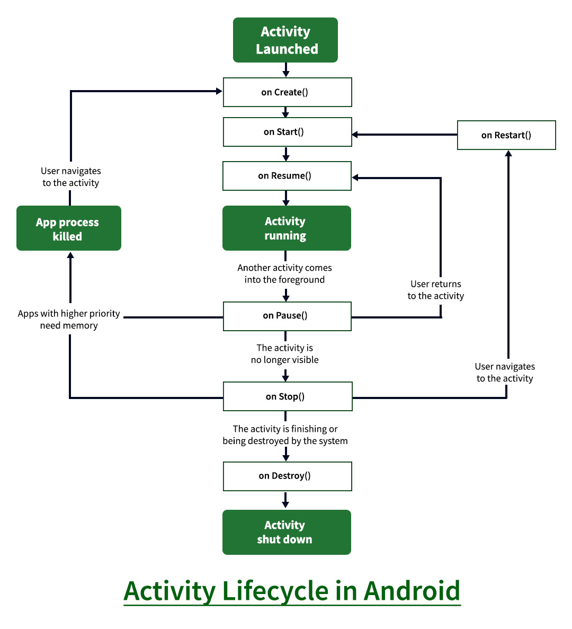

* **onCreate()**: It is called when the activity is first created. This is where all the static work is done like creating views, binding data to lists, etc.
* **onStart()**: It is invoked when the activity is visible to the user. It is followed by onResume() if the activity is invoked from the background.
* **onRestart()**: It is invoked after the activity has been stopped and prior to its starting stage and thus is always followed by onStart() when any activity is revived from background to on the screen.
* **onResume()**: It is invoked when the activity starts interacting with the user. At this point, the activity is at the top of the activity stack, with a user interacting with it.
* **onPause()**: It is invoked when an activity is going into the background but has not yet been killed. It is a counterpart to onResume()
* **onStop()**: It is invoked when the activity is not visible to the user. It is followed by onRestart() when the activity is revoked from the background, followed by onDestroy() when the activity is closed or finished, and nothing when the activity remains on the background only.
* **onDestroy()**: The final call received before the activity is destroyed. This can happen either because the activity is finished (when finish() is invoked) or because the system is temporarily destroying this instance of the activity to save space.

***To read more, refer* to *the article:*** [Activity Lifecycle in Android with Demo App](https://www.geeksforgeeks.org/activity-lifecycle-in-android-with-demo-app/)

**Question:**  Why do we need to call setContentView() in onCreate() of Activity class?

**Answer:**  The reason for doingso is that the activity life cycle onCreate() method is called only once. And this is the big reason we need to call the setContentView() in onCreate(). And it will be inefficient to call this function in onResume(), onStart(), and somewhere else because those methods are called more than once.

**Question:**  Explain the Fragment Lifecycle in Brief.

**Answer:**  These are the different stages of the Activity Lifecycle:

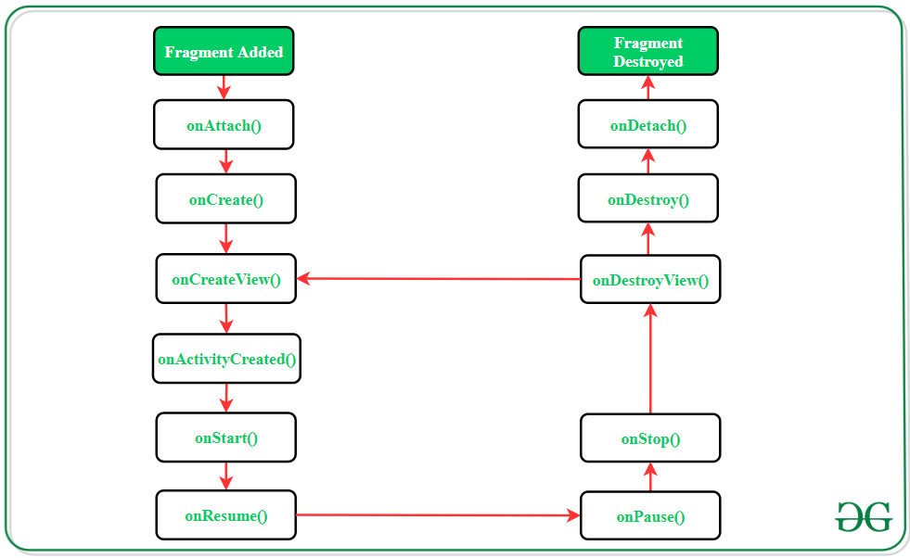

| **Methods** | **Description** |
| --- | --- |
| onAttach() | The very first method to be called when the fragment has been associated with the activity. This method executes only once during the lifetime of a fragment. |
| onCreate() | This method initializes the fragment by adding all the required attributes and components. |
| onCreateView() | System calls this method to create the user interface of the fragment. The root of the fragment’s layout is returned as the View component by this method to draw the UI. |
| onActivityCreated() | It indicates that the activity has been created in which the fragment exists. View hierarchy of the fragment also instantiated before this function call. |
| onStart() | The system invokes this method to make the fragment visible on the user’s device. |
| onResume() | This method is called to make the visible fragment interactive. |
| onPause() | It indicates that the user is leaving the fragment. System calls this method to commit the changes made to the fragment. |
| onStop() | Method to terminate the functioning and visibility of fragments from the user’s screen. |
| onDestroyView() | System calls this method to clean up all kinds of resources as well as view hierarchy associated with the fragment. |
| onDestroy() | It is called to perform the final clean-up of the fragment’s state and its lifecycle. |
| onDetach() | The system executes this method to disassociate the fragment from its host activity. |

***To read more, refer* to *the article:*** [Fragment Lifecycle in Android](https://www.geeksforgeeks.org/fragment-lifecycle-in-android/)

**Question:**  What is the difference between a Fragment and an Activity?

**Answer:**

| **Activity** | **Fragment** |
| --- | --- |
| Activity is an application component that gives a user interface where the user can interact. | The fragment is only part of an activity, it basically contributes its UI to that activity. |
| Activity is not dependent on fragment | Fragment is dependent on activity. It can’t exist independently. |
| we need to mention all activity it in the manifest.xml file | Fragment is not required to mention in the manifest file |
| We can’t create multi-screen UI without using fragment in an activity, | After using multiple fragments in a single activity, we can create a multi-screen UI. |
| Activity can exist without a Fragment | Fragment cannot be used without an Activity. |
| Creating a project using only Activity then it’s difficult to manage | While Using fragments in the project, the project structure will be good and we can handle it easily. |
| Lifecycle methods are hosted by the OS. The activity has its own life cycle. | Lifecycle methods in fragments are hosted by hosting the activity. |
| Activity is not light weight. | The fragment is the lite weight. |

***To read more, refer* to *the article:*** [Difference Between a Fragment and an Activity in Android](https://www.geeksforgeeks.org/difference-between-a-fragment-and-an-activity-in-android/)

**Question:**  What’s Context in Android?

**Answer:**  The context in Android can be understood as something which gives us the context of the current state of our application. We can break the context and its use into three major points:

* It allows us to access resources.
* It allows us to interact with other Android components by sending messages.
* It gives you information about your app environment.

There are mainly two types of context available in Android.

1. Application Context and
2. Activity Context

***To read more, refer* to *the article:*** [What is Context in Android?](https://www.geeksforgeeks.org/what-is-context-in-android/)

**Question:**  Top Image Loading Libraries in Android.

**Answer:**  Picasso

* Glide
* Fresco
* COIL (Coroutine Image Loader)
* UIL (Universal Image Loader)

***To read more, refer* to *the article:*** [Top Image Loading Libraries in Android](https://www.geeksforgeeks.org/top-5-image-loading-libraries-in-android/)

**Question:**  What is View in Android?

**Answer:**  The view is a class that represents the basic building block for UI components. A View occupies a rectangular area on the screen and is responsible for drawing and event handling. It is a superclass for all the UI components. The most common UI components are:

* TextView
* EditText
* ImageView
* Button
* ProgressBar
* CheckBox, etc.

**Question:**  Difference Between View and ViewGroup in Android

**Answer:**

| **View** | **ViewGroup** |
| --- | --- |
| View is a simple rectangle box that responds to the user’s actions. | ViewGroup is the invisible container. It holds View and ViewGroup |
| View is the SuperClass of All component like TextView, EditText, ListView, etc | ViewGroup is a collection of Views(TextView, EditText, ListView, etc..), somewhat like a container. |
| A View object is a component of the user interface (UI) like a button or a text box, and it’s also called a widget. | A ViewGroup object is a layout, that is, a container of other ViewGroup objects (layouts) and View objects (widgets) |
| Examples are EditText, Button, CheckBox, etc. | For example, LinearLayout is the ViewGroup that contains Button(View), and other Layouts also. |
| View refers to the android.view.View class | ViewGroup refers to the android.view.ViewGroup class |
| android.view.View which is the base class of all UI classes. | ViewGroup is the base class for Layouts. |

***To read more, refer* to *the article:*** [Difference Between View and ViewGroup in Android](https://www.geeksforgeeks.org/difference-between-view-and-viewgroup-in-android/)

**Question:**  What is Kotlin Coroutine on Android?

**Answer:**  The Kotlin team defines coroutines as “**lightweight threads**”. They are sort of tasks that the actual threads can execute. Kotlin coroutines introduce a new style of concurrency that can be used on Android to simplify async code. **The official documentation says that coroutines are lightweight threads. By lightweight,** **it means that creating coroutines doesn’t allocate new threads. Instead, they use predefined thread pools and smart scheduling for the purpose of which task to execute next and which tasks later**.

***To read more, refer* to *the article:*** [Kotlin Coroutines on Android](https://www.geeksforgeeks.org/kotlin-coroutines-on-android/)

**Question:**  How Garbage Collector Works in Android?

**Answer:**  Garbage Collector in Android has no compacting. This means the address of objects in the heap never changed after their creation. So garbage collection can be triggered when an allocation fails when an

* OutOfMemoryError is about to be triggered,
* When the size of the heap hits some soft limit, and
* When a GC was explicitly requested.

**Question:**  MVC vs MVP vs MVVM architecture and which one we should choose?

**Answer:**

| **MVC(MODEL VIEW CONTROLLER)** | **MVP(MODEL VIEW PRESENTER)** | **MVVM(MODEL VIEW VIEWMODEL)** |
| --- | --- | --- |
| One of the oldest software architecture | Developed as the second iteration of software architecture which is advanced from MVC. | Industry-recognized architecture pattern for applications. |
| UI(**View**) and data-access mechanism(**Model**) are tightly coupled. | It resolves the problem of having a dependent **View** by using **Presenter** as a communication channel between **Model** and **View**. | This architecture pattern is more event-driven as it uses data binding and thus makes easy separation of **core business logic** from the **View**. |
| **Controller** and **View** exist with the one-to-many relationship. One Controller can select a different view based upon the required operation. | A one-to-one relationship exists between **Presenter** and **View** as one Presenter class manages one View at a time. | Multiple **View** can be mapped with a single **ViewModel** and thus, the one-to-many relationship exists between View and ViewModel. |

**Which one should we choose?**

* **MVC:** Ideal for small-scale projects only.
* **MVP:** Ideal for simple and complex applications.
* **MVVM:** Ideal for big-scale projects. But not ideal for small-scale projects.

***To read more, refer* to *the article:*** [Difference Between MVC, MVP and MVVM Architecture Pattern in Android](https://www.geeksforgeeks.org/difference-between-mvc-mvp-and-mvvm-architecture-pattern-in-android/)

**Question:**  How to Reduce APK size in android?

**Answer:**  Remove unused sources

* Use of Vector Drawables
* Reuse your code
* Compress PNG and JPEG files
* Use of Lint
* Use images in WebP file format
* Use of proguard
* Use of ShrinkResources
* Limit the usage of external libraries
* Use the Android Size Analyzer tool
* Generate App Bundles instead of APK
* Use of Resconfigs

***To read more, refer* to *the article:*** [How to Reduce APK Size in Android?](https://www.geeksforgeeks.org/how-to-reduce-apk-size-in-android/)

**Question:**  What’s the Android jetpack and its Key Benefits?

**Answer:**  Jetpack is nothing but a set of software components, libraries, tools, and guidance to help in developing great Android apps. Google launched **Android Jetpack** in 2018. Key Benefits of Android Jetpack

* Forms a recommended way for app architecture through its components
* Eliminate boilerplate code
* Simplify complex task
* Provide backward compatibility as libraries like support are unbundled from Android API and are re-packaged to **androidx.* package**
* Inbuilt productivity feature of the Kotlin Integration

***To read more, refer* to *the article:*** [Introduction to Android Jetpack](https://www.geeksforgeeks.org/introduction-to-android-jetpack/)

**Question:**  What are the different software components of Android Jetpack?

**Answer:**  The software components of Android Jetpack has been divided into 4 categories:

* **Foundation Components:** AppCompat, Android KTX, Test, Multidex
* **Architecture Components:** Room, WorkManager, Lifecycle, ViewModel, Paging, Navigation
* **Behavior Components:** DownloadManager, Permissions, Sharing, Slices
* **UI Components:** Animation & Transition, Auto, Fragment, Palette, Layout

**Question:**  What’s Jetpack Compose and its Benefits?

**Answer:**  Jetpack Compose is a modern UI toolkit recently launched by Google which is used for building native Android UI. It simplifies and accelerates the UI development with less code, Kotlin APIs, and powerful tools.

* Declarative
* Compatible
* Increase development speed
* Concise and Idiomatic Kotlin
* Easy to maintain
* Written in Kotlin

***To read more, refer* to *the article:*** [Jetpack Compose in Android](https://www.geeksforgeeks.org/basics-of-jetpack-compose-in-android/)

**Question:**  What are the Architecture Components of Android?

**Answer:**  **Architecture Components** could be classified as follows:

* Room
* WorkManager
* Lifecycle
* ViewModel
* LiveData
* Navigation
* Paging
* Data Binding

***To read more, refer* to *the article:*** [Jetpack Architecture Components in Android](https://www.geeksforgeeks.org/jetpack-architecture-components-in-android/)

**Question:**  How to Improve RecyclerView Scrolling Performance in Android?

**Answer:**  Set a specific width and height to ImageView in RecyclerView items

* Avoid using NestedView
* Use the setHasFixedsize method
* Use the image loading library for loading images
* Do less work in the OnBindViewHolder method
* Use the NotifyItem method for your RecyclerView

***To read more, refer* to *the article:*** [How to Improve RecyclerView Scrolling Performance in Android?](https://www.geeksforgeeks.org/how-to-improve-recyclerview-scrolling-performance-in-android/)

**Question:**  Volley Library in Android

**Answer:**  **Volley** is an **HTTP library** that makes networking very easy and fast, for Android apps. It was developed by Google and introduced during Google I/O 2013. It was developed because there is an absence in Android SDK, of a networking class capable of working without interfering with the user experience. Although Volley is a part of the Android Open Source Project(AOSP), Google announced in January 2017 that Volley will move to a standalone library. It manages the processing and caching of network requests, and it saves developers valuable time from writing the same network call/cache code again and again.

***To read more, refer* to *the article:*** [Volley Library in Android](https://www.geeksforgeeks.org/volley-library-in-android/)

**Question:**  What’s Retrofit in Android?

**Answer:**  Retrofit is a type-safe REST client built by square for Android and Java which intends to make it simpler to expand RESTful web services. Retrofit uses OkHttp as the system’s administration layer and is based on it. Retrofit naturally serializes the JSON reaction utilizing a POJO (PlainOldJavaObject) which must be characterized as cutting edge for the JSON Structure. To serialize JSON we require a converter to change it into Gson first. Retrofit is much simpler than other libraries; we don’t have to parse our JSON. It directly returns objects but there is one disadvantage: it doesn’t provide support to load images from the server, but we can use Picasso for the same.

***To read more, refer* to *the article:*** [Introduction to Retrofit](https://www.geeksforgeeks.org/introduction-retofit-2-android-set-1/)

**Question:**  Describe MVVM

**Answer:**  **Model — View — ViewModel (MVVM)** is the industry-recognized software architecture pattern that overcomes all drawbacks of MVP and MVC design patterns. MVVM suggests separating the data presentation logic(Views or UI) from the core business logic part of the application.

#### The separate code layers of MVVM are:

* **Model:** This layer is responsible for the abstraction of the data sources. Model and ViewModel work together to get and save the data.
* **View:** The purpose of this layer is to inform the ViewModel about the user’s action. This layer observes the ViewModel and does not contain any kind of application logic.
* **ViewModel:** It exposes those data streams which are relevant to the View. Moreover, it serves as a link between the Model and the View.

***To read more, refer* to *the article:*** [MVVM (Model View ViewModel) Architecture Pattern in Android](https://www.geeksforgeeks.org/mvvm-model-view-viewmodel-architecture-pattern-in-android/)

**Question:**  What are the reasons your android app is legging?

**Answer:**  You are doing too much on the main thread

* Your asset files are huge
* You are using an outdated SDK version
* You are using bad libraries
* The speed of the network
* Chatty conversations
* Your code is inefficient

***To read more, refer* to *the article:*** [What are the reasons your android app is legging?](https://www.geeksforgeeks.org/7-major-reasons-why-your-android-app-is-performing-slow-must-read-for-developers/)

**Question:**  What is ANR and How can it be Prevented in Android?

**Answer:**  **ANR stands for Application Not Responding**. An ANR will occur if you’re running a process on the UI thread **which takes an extended time**, usually around 5 seconds. During this point, the GUI (Graphical User Interface) will lock up which can end in anything the user presses won’t be actioned. After the 5 seconds approx. has occurred, if the thread still hasn’t recovered then an ANR dialogue box is shown informing the user that the appliance isn’t responding and can give the user the choice to either wait, in the hope that the app will eventually recover, or to force close the app.

Stop doing heavy tasks on the main thread. Instead, use worker threads such as IntentService, AsyncTask Handler, or another Thread simply. **Detecting where ANRs happen is straightforward if it’s a permanent block** (deadlock acquiring some locks for instance), but harder if it’s just a short-lived delay. First, re-evaluate your code and appearance for vulnerable spots and long-running operations.

***To read more, refer* to *the article:*** [What is ANR and How it Can be Prevented in Android?](https://www.geeksforgeeks.org/what-is-anr-and-how-it-can-be-prevented-in-android/)

**Question:**  What is Android NDK and why is it useful?

**Answer:**  The NDK (Native Development Kit) is a tool that allows you to program in C/C++ for Android devices. It provides platform libraries one can use to manage native activities and access physical device components, such as sensors and touch input. NDK can be useful for cases in which you need to do one or more of the following:

* Squeeze extra performance out of a device to achieve low latency or run computationally intensive applications, such as games or physics simulations.
* Reuse your own or other developers’ C or C++ libraries.

**Question:**  Explain the JUnit test in brief.

**Answer:**  **JUnit** is a “**Unit Testing**” framework for Java Applications which is already included by default in android studio. It is an automation framework for Unit as well as UI Testing. It contains annotations such as **@Test,** **@Before**, **@After**, etc. Here we will be using only **@Test** annotation to keep the article easy to understand.

***To read more, refer* to *the article:*** [Unit Testing in Android using JUnit](https://www.geeksforgeeks.org/unit-testing-in-android-using-junit/)

**Question:**  What’s Dagger and When to use Dagger?

**Answer:**  Dagger is a **Dependency Injection** framework that will generate a lot of boilerplate code for you to achieve the goal of **Dependency injection** in Android development. Not that one must have a good understanding of **Dependency Injection** before answering this question.

**When to use a dagger?**

| **Project Size** | Small | Medium | Large |
| --- | --- | --- | --- |
| **Tool to use** | Manual DI Service Locator Dagger | Dagger | Dagger |

**Question:**  What’s LiveData in Android Architecture Component and its Advantages?

**Answer:**  LiveData component is an observable data holder class i.e, the contained value can be observed. LiveData is a lifecycle-aware component and thus it performs its functions according to the lifecycle state of other application components. Further, if the observer’s lifecycle state is active i.e., either STARTED or RESUMED, only then LiveData updates the app component. LiveData always checks the observer’s state before making any update to ensure that the observer must be active to receive it. If the observer’s lifecycle state is destroyed, LiveData is capable of removing it, and thus it avoids memory leaks. It makes the task of data synchronization easier.

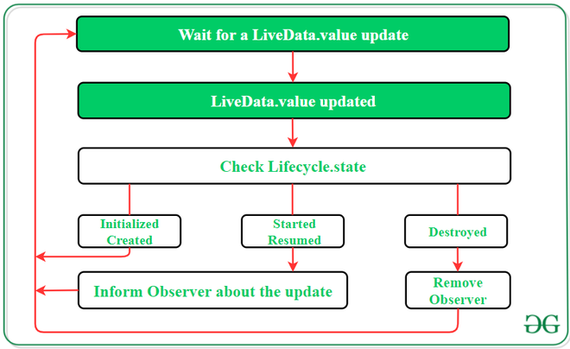

**Advantages of LiveData component:**

* UI is updated as per the appropriate change in the data
* It removes the stopped or destroyed activities which reduce the chance of app crash
* No memory leaks as LiveData is a lifecycle-aware component.

***To read more, refer* to *the article:*** [Jetpack Architecture Components in Android](https://www.geeksforgeeks.org/jetpack-architecture-components-in-android/)

**Question:**  What’s Data Binding in Android?

**Answer:**  Data Binding library is a support library that provides the feature of binding UI components in an activity/fragment to the data sources of the application. The library carries out this binding task in a declarative format and not in a programmatic way. Below is an example to understand the working of this library accurately:

To find a TextView widget and bind it to the userName property of the ViewModel variable, the **findViewById()** method is called:

*TextView textView = findViewById(R.id.sample_text);*

*textView.setText(viewModel.getUserName());*

After using the Data Binding library, the above code changes by using the assignment expression as follows:

*<TextView*

*android:text=”@{viewmodel.userName}” />*

**Advantages of Data Binding Component:**

* Make code simpler and easy to maintain by removing UI frameworks called in the activity.
* Allows classes and methods to observe changes in data
* Allows to make objects and fill which works as collection observables.

***To read more, refer* to *the article:*** [Jetpack Architecture Components in Android](https://www.geeksforgeeks.org/jetpack-architecture-components-in-android/)

**Question:**  Room in Android Architecture Component.

**Answer:**  The requirement of a database in Android is fulfilled by SQLite from the very beginning. However, it comes with some severe drawbacks like not checking the queries at compile-time, it does not save plain-old-Java Objects(commonly referred to as POJOs). Developers also need to write a lot of boilerplate code to make the SQLite database work in the Android OS environment. The Room component comes into the picture as an **SQLite Object Mapping Library** which overcomes all the mentioned challenges. Room converts queries directly into objects, checks errors in queries at the compile-time, and is also capable of persisting the Java POJOs.

Moreover, it produces LiveData results/observables from the given query result. Because of this versatile nature of the Room component, Google officially supports and recommends developers to use it. The Room consists of the following sub-components:

1. **Entity:** It is the annotated class for which the Room creates a table within the database. The field of the class represents columns in the table.
2. **DAO(Data Access Object):** It is responsible for defining the methods to access the database and to perform operations.
3. **Database:** It is an abstract class that extends **RoomDatabase** class and it serves as the main access point to the underlying app’s relational data.

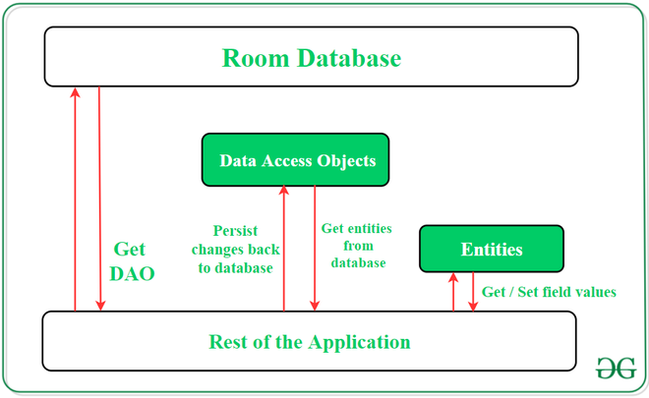

***To read more, refer* to *the article:*** [Jetpack Architecture Components in Android](https://www.geeksforgeeks.org/jetpack-architecture-components-in-android/)

**Question:**  ViewModel in Android.

**Answer:**  ViewModel is one of the most critical classes of the Android Jetpack Architecture Component that support data for UI components. Its purpose is to hold and manage the UI-related data. Moreover, its main function is to maintain the integrity and allows data to be serviced during configuration changes like screen rotations. Any kind of configuration change in Android devices tends to recreate the whole activity of the application. It means the data will be lost if it has not been saved and restored properly from the activity which was destroyed. To avoid these issues, it is recommended to store all UI data in the ViewModel instead of an activity.

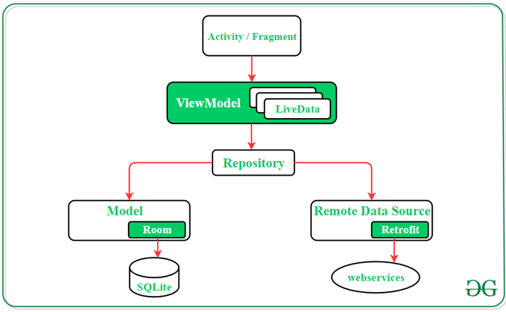

***To read more, refer* to *the article:*** [Jetpack Architecture Components in Android](https://www.geeksforgeeks.org/jetpack-architecture-components-in-android/)

**Question:**  What’s Android KTX?

**Answer:**  KTX library is the only one among the foundation components which was introduced for the first time with the release of the Jetpack. Android KTX is a collection of Kotlin extensions that are designed to facilitate developers to remove boilerplate code as well as to write concise code while developing android applications with Kotlin language. Here **KTX** in the name stands for **Kotlin Extensions**. Below is an example of a piece of code without using and after using the Android KTX library:

**Code snippet of SQLite without using KTX library:**

*db.beginTransaction()*

*try {*

*// insert data*

*db.setTransactionSuccessful()*

*}*

*finally {*

*db.endTransaction()*

*}*

**Above code after using KTX library:**

*db.transaction {*

*// insert data*

*}*

***To read more, refer* to *the article:*** [Foundation Components of Android Jetpack](https://www.geeksforgeeks.org/foundation-components-of-android-jetpack/)

**Question:**  What is Lint? What is it used for?

**Answer:**  As an Android Developer, we all use Android Studio for developing our applications. There are many other editors that can be used for Android app development but the best part that attracts me to use Android Studio is the support that it provides to the Android developers. The support can be in the form of auto-suggestion or it can be of the form of showing errors in our code(in all the files present in our project).

So, in this blog, we will see one of the best features of Android Studio that helps us to improve our way of writing errorless code and that feature is Lint. The topics that will be discussed in this blog are:

* What is Lint?
* Configuration of lint
* Helping Lint
* Using Baseline
* Manually run inspections
* Conclusion

So, Let’s get started.

#### What is Lint?

Lint is a code scanning tool provided by the Android Studio to identify, suggest and correct the wrong or the risky code present in the project.

***Lint is like a full-fledged stack analysis framework***

We all have been using the Lint since we started using the Android Studio because by default Android studio provides the support for Lint in our every project. The problems detected in your code by the Lint will be reported to you with some suggestions and a warning level. You can use the suggestion to correct your code. The best part of Lint is that you can use Lint as per your need. If you want to see a particular type of error in your project then the Lint will only show you that type of error. Lint is customizable in nature. By default Android Studio runs the inspection process whenever you build your project but apart from this, you can inspect your code with the help of Lint manually or from the command line.

The following image shows the working of Lint:

***Picture courtesy: Android Developer website***

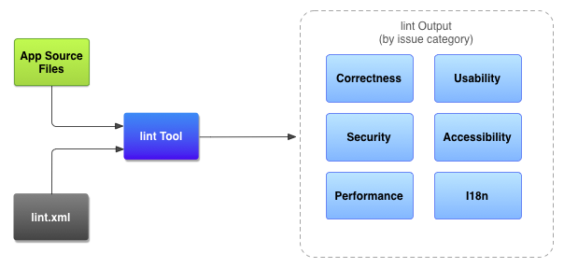

The whole process of lint can be summarized in three steps:

1. **Making lint.xml file:** You can customize the Lint checks in the ***lint.xml*** file. In this file, you can write the checks that you want to include and ignore the checks that you don’t want to include. For example, if you want to check the issue of unused variable and don’t want to check for naming issues then you can do this is lint.xml file. Apart from this, you can customize the Lint checks manually also. We will see how to do manual Lint checks in the next part of this blog.
2. **Application source file:** The next step is to select the source files on which you want to perform the Lint check. It can be your **.java** file or **.kt** file or any **xml** file of your project.
3. **The Lint tool:** Finally, the lint tool takes the source and lint.xml files and checks for structural code problems and suggest some improvements in the code if any. It is suggested to use the lint suggestion before publishing our app.

#### When to use Lint?

If you want to publish your app on the play store or any app store then you would like to have an error free app. For this purpose, you have to perform so many testing on your app manually. But if you want to get rid of some of the manual testing, you can use Lint in your project. You can inspect each and every file of your code to find some error and Lint will identify the errors and suggest some answers. That errors or warnings can be of:

* Unused variables
* Unhanded exceptions
* Imports that are not used in the project, and many more

So, before publishing your app, you should use Lint to inspect your code fully.

Also, you can configure lint checking for different levels of your project:

* Globally (entire project)
* Project module
* Production module
* Test module
* Open files
* Class hierarchy
* Version Control System (VCS) scopes

#### Configuration of Lint

In order to use Lint or simply run inspections in your project, you can add Lint inspection in the lint.xml file or you can manually select the list of issues to be configured by the lint in your project by using Android Studio.

* **Configure the lint file:** In order to specify manual checks in your app, add the list of issues to be configured in the lint.xml file. If you are making a new lint.xml file then make sure to put it into the root directory of your Android project.

Following is an example of lint.xml file:

<?xml version="1.0" encoding="UTF-8"?>

<lint>

<!-- Disable the given check in **this** project -->

<issue id="IconMissingDensityFolder" severity="ignore" />

<!-- Ignore the ObsoleteLayoutParam issue in the specified files -->

<issue id="ObsoleteLayoutParam">

<ignore path="res/layout/activation.xml" />

<ignore path="res/layout-xlarge/activation.xml" />

</issue>

<!-- Ignore the UselessLeaf issue in the specified file -->

<issue id="UselessLeaf">

<ignore path="res/layout/main.xml" />

</issue>

<!-- Change the severity of hardcoded strings to "error" -->

<issue id="HardcodedText" severity="error" />

</lint>

* **Configure the lint manually:** By default, lint checks for a number of issues but not all the issues. This is not done because if you will run all the issue check that lint can check for, then the performance of the Android Studio will be slowed down. So, only a limited number of lint checks are used in Android Studio by default. But you can add more checks and remove checks from the lint by following the steps below:

Go to ***Files > Settings > Editor > Inspections*** and then check the issue checks that you want to be performed by the lint

#### Helping Lint

There are many times when you are writing a risky or error full code but the lint is not showing any error or warning to your code. For example, write the below code in Android Studio:

fun **updateUi**() {

*// code goes here*

networkRequest()

}

fun **networkRequest**() {

*// code goes here*

}

The above lines of code will not show you some error, but logically it should show some error because, during the update of UI, network request should not be called. So, what you can do here is to help the lint.

*Help Lint helps you*

Yes, if you will help the lint then lint will also help you. So, in order to help the lint understand the code in a more precise way, always try to use annotations in your project. Now write the same some that you have written previously and then check for error:

**@UiThread**

fun **updateUi**() {

*// code goes here*

networkRequest()

}

**@WorkerThread**

fun **networkRequest**() {

*// code goes here*

}

So, help Lint by using Annotations in your code.

#### Using Baseline

If you are working on a very big project and interested in finding the future errors that might come while adding some more codes to your project then you can add a baseline to your project and by doing so the lint will generate the errors that have occurred after that baseline. So, lint will ignore the previous code issues and will warn you only about the new lines of code added after the baseline.

To add a baseline in your project, add the below line in your project’s ***build.gradle*** file:

android {

lintOptions {

baseline **file**("lint-baseline.xml")

}

}

This will create a **lint-baseline.xml** that will establish a baseline of your project. To add another baseline, delete the file and the lint again.

Another thing that you can do here is, you can enable any type of issue check here only. For example, in order to enable the *Kotlin Interoperability* check, write the below code:

android {

lintOptions {

baseline **file**("lint-baseline.xml")

}

}

enable "Interoperability"

#### Manually run inspections

In order to manually inspect a file in Android Studio, follow the below steps:

**Step 1:** Go to the file you want to inspect.

**Step 2:** Right click and then go to **Analyze > Inspect Code.** Below window will be opened:

Picture courtesy: Android Developer website

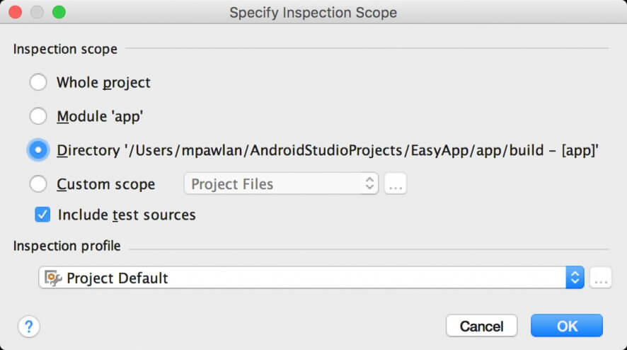

Here you can select your inspection scope i.e. whole project or module or simply a file. After selecting the scope click on **OK.**

The following window will be opened:

Picture courtesy: Android Developer website

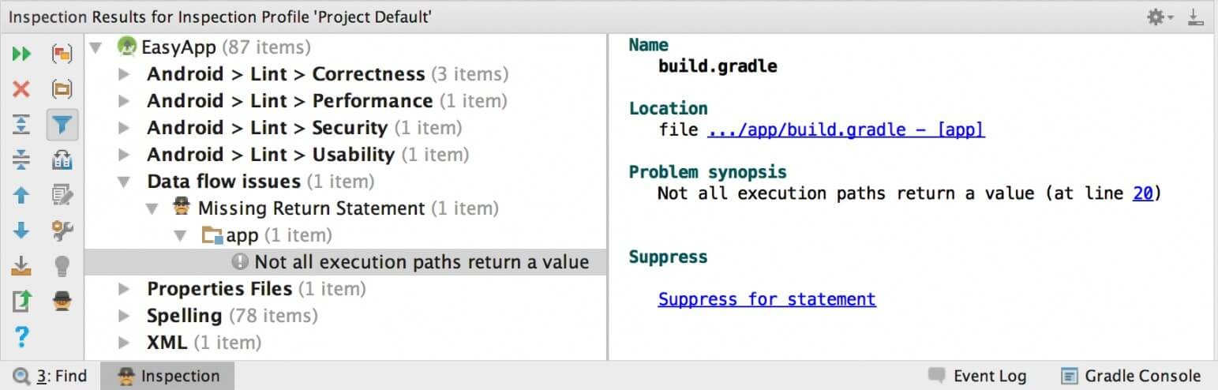

A list of error categories, types and issues will be there. You can view the inspection result by expanding the error in the left pane tree view.

In the other pane i.e. the right pane displays the inspection report for the selected error.

#### Conclusion

In this blog, we learned how to use the Lint in Android Studio. We saw that if we want to analyze our code then we need not do it manually. Android Studio provides a code checking tool Lint, that helps us to clean our code and use the necessary and right code for Application development.

**Question:**  Kotlin Multiplatform

**Answer:**  The Kotlin Multiplatform technology is designed to simplify the development of cross-platform projects. It reduces time spent writing and maintaining the same code for [different platforms](https://kotlinlang.org/docs/multiplatform.html#kotlin-multiplatform-use-cases) while retaining the flexibility and benefits of native programming.

## Kotlin Multiplatform use cases

### Android and iOS applications

Sharing code between mobile platforms is one of the major Kotlin Multiplatform use cases. With Kotlin Multiplatform for mobile, you can build cross-platform mobile applications and share common code between Android and iOS, such as business logic, connectivity, and more.

Check out the [Get started with Kotlin Multiplatform for mobile](https://kotlinlang.org/docs/multiplatform-mobile-getting-started.html) and [Create a multiplatform app using Ktor and SQLDelight](https://kotlinlang.org/docs/multiplatform-mobile-ktor-sqldelight.html) tutorials, where you will create applications for Android and iOS that include a module with shared code for both platforms.

### Full-stack web applications

Another scenario when code sharing may bring benefits is a connected application where the logic can be reused on both the server and the client side running in the browser. This is covered by Kotlin Multiplatform as well.

See [Build a full-stack web app with Kotlin Multiplatform](https://kotlinlang.org/docs/multiplatform-full-stack-app.html) tutorial, where you will create a connected application consisting of a server part, using Kotlin/JVM and a web client, using Kotlin/JS.

### Multiplatform libraries

Kotlin Multiplatform is also useful for library authors. You can create a multiplatform library with common code and its platform-specific implementations for JVM, JS, and Native platforms. Once published, a multiplatform library can be used in other cross-platform projects as a dependency.

See the [Create and publish a multiplatform library](https://kotlinlang.org/docs/multiplatform-library.html) tutorial, where you will create a multiplatform library, test it, and publish it to Maven.

### Common code for mobile and web applications

One more popular case for using Kotlin Multiplatform is sharing the same code across Android, iOS, and web apps. It reduces the amount of business logic coded by frontend developers and helps implement products more efficiently, decreasing the coding and testing efforts.

See the [RSS Reader](https://github.com/Kotlin/kmm-production-sample/tree/c6a0d9182802490d17729ae634fb59268f68a447) sample project — a cross-platform application for iOS and Android with desktop and web clients implemented as experimental features.

## How Kotlin Multiplatform works

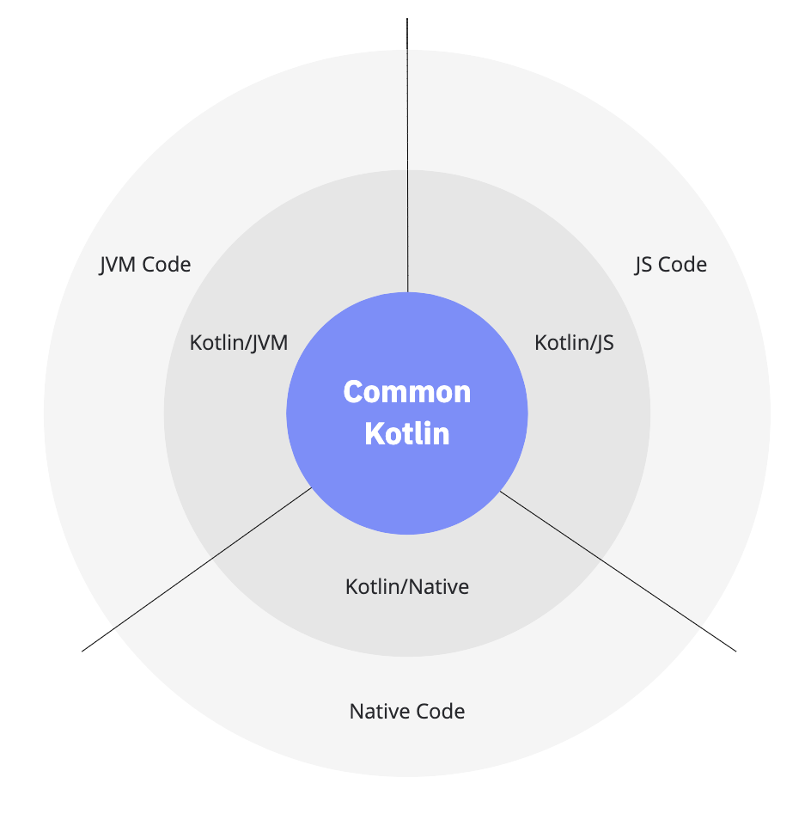

* Common Kotlin includes the language, core libraries, and basic tools. Code written in common Kotlin works everywhere on all platforms.
* With Kotlin Multiplatform libraries, you can reuse the multiplatform logic in common and platform-specific code. Common code can rely on a set of libraries that cover everyday tasks such as [HTTP](https://ktor.io/clients/http-client/multiplatform.html), [serialization](https://github.com/Kotlin/kotlinx.serialization), and [managing coroutines](https://github.com/Kotlin/kotlinx.coroutines).
* To interop with platforms, use platform-specific versions of Kotlin. Platform-specific versions of Kotlin (Kotlin/JVM, Kotlin/JS, Kotlin/Native) include extensions to the Kotlin language, and platform-specific libraries and tools.
* Through these platforms you can access the platform native code (JVM, JS, and Native) and leverage all native capabilities.

### Code sharing between platforms

With Kotlin Multiplatform, spend less time on writing and maintaining the same code for [different platforms](https://kotlinlang.org/docs/multiplatform-dsl-reference.html#targets) – just share it using the mechanisms Kotlin provides:

* [Share code among all platforms used in your project](https://kotlinlang.org/docs/multiplatform-share-on-platforms.html#share-code-on-all-platforms). Use it for sharing the common business logic that applies to all platforms.
* [Share code among some platforms](https://kotlinlang.org/docs/multiplatform-share-on-platforms.html#share-code-on-similar-platforms) included in your project but not all. Do this when you can reuse much of the code in similar platforms:  
  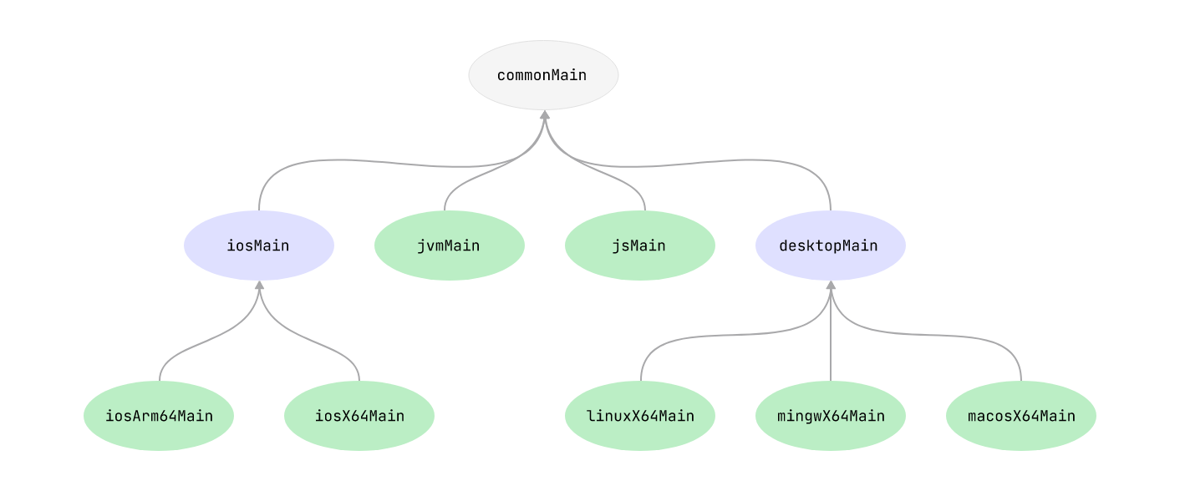
* If you need to access platform-specific APIs from the shared code, use the Kotlin mechanism of [expected and actual declarations](https://kotlinlang.org/docs/multiplatform-connect-to-apis.html).

**Question:**  You have to know more about doze mode

**Answer:**  I got inspired to present my views on this topic because I would like to share my learnings, which I have consolidated from the mistake’s I have made so far, by doing amendments during my learning phase, here I wish to provide you specific knowledge about this topic. I hope after going through this article you will surely save your valuable time.

“Time has no value. We can not buy time”

In android, API level 23 onwards Google introduces Doze Mode. You can read more about it [here](https://developer.android.com/training/monitoring-device-state/doze-standby.html).

***What is Doze mode?***

Doze mode is a feature in Marshmallow, which prevents certain tasks from running if your device is in idle state. Doze in devices reduces power consumption by deferring background CPU and Network activity for applications.

***What is idle state?***

When an Android device is left in idle state, it will first dim the screen, then turn off the screen, and finally turn off the CPU. This prevents the device battery from quickly being drained or simply idle state is when you are not using device.

***What is the problem?***

When an application wants to perform any network activity from background service and device is in idle state, the device does not execute any network call due to activation of doze mode. Device blocks all the network activity, which is executing in idle state

Suppose application wants to share user location after rebooting device by calling location API on the network. The application should have permission for [android.Manifest.permission.RECEIVE_BOOT_COMPLETED](https://developer.android.com/reference/android/Manifest.permission.html#RECEIVE_BOOT_COMPLETED) to wake up on device boot. Application registers boot receiver by using android.intent.action._BOOT_COMPLETED . The application got a BootCompleted callback, so ideally after successfully booting up device, application have to share location by calling API. However, due to activation of doze mode, that network activity is blocked by device. This network activity is not executed and gives UnknownHostException.

When application is running in foreground and doing some network activity by explicitly calling BootCompleted, then this API will be executed without any problem, because during that, time device is not in idle state.

As you read, you will find that Google defines the Doze mode above API level 23. Now you are aware of Doze mode and idle state. Recently I found the same issue below API level 23.

***How doze mode is active in below api level 23?***

I researched and found some interesting answers. Therefore, I decided to share it with you.

Some manufacturers (e.g. Xiaomi) have already developed Doze mode in their own devices. Actually, they want to show user that they are concerned about battery consumption. In normal android-device user at least uses 40 application (this is my observation). In which each application is doing too much network calls on background service. Therefore, it totally affects the device battery. As we know that network activity needs more battery consumption. So each application is consuming more battery on calls to network activity from background service. So that is the reason some manufacturers decided to give options to user to give running priority to individual application. This is called as ‘SmartManager’.

The ‘SmartManager’ have kind of battery manager that kills application or give lower priority to application. It does the same thing as in Doze mode.

E.g. Suppose application schedules one alarm from alarm-service and user kills application from recent tasks, then that scheduled alarm will not be fired, because of restriction by power manager.

Therefore, if application wants to do any background task on network activity, the application needs permission from ‘SmartManager’, which means your application should be added in white-list by user.

***What is application whitelisting?***

The goal of whitelisting is to protect device from potentially harmful applications. Application whitelisting is for specify application that user trusts.

I have found one of the best document [here](http://searchsecurity.techtarget.com/definition/application-whitelisting).

You can manage whitelist application from [here](https://support.google.com/a/answer/6328701?hl=en)

For more information you can read it [here](https://source.android.com/devices/tech/config/perms-whitelist)

**Question:**  how to use foreign key in Room persistence library

**Answer:**  Just to summarize the above posts for future readers:

The foreign key syntax in Kotlin is

@Entity(foreignKeys = arrayOf(ForeignKey(entity = ParentClass::class,

parentColumns = arrayOf("parentClassColumn"),

childColumns = arrayOf("childClassColumn"),

onDelete = ForeignKey.CASCADE)))

The foreign key syntax in Java is:

@Entity(foreignKeys = {@ForeignKey(entity = ParentClass.class,

parentColumns = "parentClassColumn",

childColumns = "childClassColumn",

onDelete = ForeignKey.CASCADE)

})

Note: foreignKeys is an array, so in Java enclose @ForeignKey elements in { and }

You can refer to the official documentation for more information. https://developer.android.com/reference/androidx/room/ForeignKey

**Question:**  Realm VS SQLite: Which database is better for Android apps?

**Answer:**  **When creating an Android app, every developer faces a lot of issues. And when thinking through the client-side, like an eye-catching design and usability, it’s also crucial to figure out what will be under the hood. The first and foremost question is how to store information. It is vital for every Android developer to choose the right database that will fit the product and not destroy it.**

*Guest blog post by Vitaly Kuprenko for the* [*Bitrise Blog*](https://blog.bitrise.io/realm-vs-sqlite-which-database-is-better-for-android-apps?utm_source=medium&utm_medium=web&utm_campaign=realmsqlite)*.*

*Vitaly is a technical writer at Cleveroad, a web and app development company in Ukraine. He enjoys telling about tech innovations and digital ways to boost businesses.*

# Popular solutions

When developers start looking for the best database, they can find a plethora of solutions, especially when they want to store all needed information on the server. But when data needs to be saved on user’s device, there are 2 major options that will come in handy. There are Realm and SQLite. Let’s take a closer look at both databases.

## SQLite

This embedded database remains the most widely utilized SQL DB engine. It was developed back in 2000 by Richard Hipp who also created Fossil version control system. SQLite is primarily geared toward storing all data on devices and moving away from common client-server architecture. Thousands of mobile apps were built using this tool.

## Realm

This tool positions itself as a DB management system that can easily replace SQLite. It is absolutely free of charge. Realm appeared much later than SQLite. Its development began in 2010, its first name was TightDB. In 2014 its creators renamed it to Realm and released the beta version of their brainchild. Created from scratch, this tool works on its own persistence engine. Realm is widely used for [mobile development](https://www.cleveroad.com/services/mobile-development), especially among newbies in Android development. This DB works seamlessly with Java, Swift, Objective-C, Xamarin, React Native.  
Now, this tool continues to gain popularity among mobile developers. Let’s find out the main reasons why Realm now bypasses time-tested SQLite.

# SQLite drawbacks

Even the most powerful tools have drawbacks. In case your project is not so complicated, you can opt for SQLite. This database perfectly fits small apps. Otherwise, you may face the following challenges:

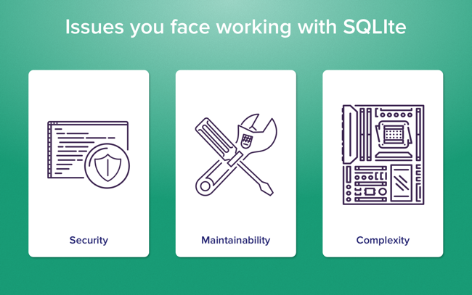

## Scalability

There is no denying that the longer your app is on market, the more data need to be stored. If you want your application to work seamlessly with a big scope of data, it is a necessity to write complex queries. Newbie developers have problems with this because of a lack of experience with using SQL.

Another weak side is data migration. The first and foremost con is the inability to rename or delete the column in a few lines of code. When you eager to do the migration, you have to take several steps.

First, create a new table based on the old one. Then copy info from one table to another. After get rid of the old table and change the name of the new one. The process is quite similar if you want to add or delete constraints.

## Security

Even though its long development process, SQLite still has a couple of security issues. Since security is of a great importance for any mobile application, you should definitely know about this issues before using SQLite.

**1. Sometimes journal files are not deleted**

Temporary journal files allow you to rollback when something went wrong. As a rule, they are kept for a certain period of time and deleted after a transaction. But sometimes they stay, and it may cause data corruption.

You may think that turning journal off can be a good solution. But bear in mind that in this case app crash will cause irreparable damage to the database.

**2. SQLite DB is stored in a single file**

Developers can put SQLite DB file wherever they want in the directory hierarchy. It may appear to be beneficial. But in practice, it is a high risk to lose data when any rogue process will open and rewrite the database file. To prevent that, protect the database on the file level. Don’t put this file into the web root and think twice when you set a file permission. To solve this problem, add several SQLite extensions or encrypt information right before it is put it on the journal.

## Complexity

Experienced SQL coders will have no difficulties with solving upcoming problems. But when you start using SQLite for developing Android apps, applying this tool may turn into a nightmare. Massive structure and complexity of SQLite forced developers to search for a simpler alternative that won’t rest upon SQL. And here’s Realm comes to rescue.

# Realm vs. SQLite

Appeared not long ago, Realm is a good alternative for SQLite. This tool is used by such big companies like IBM, CISCO, Amazon, Google, and Intel. Developers have already found several advantages of Realm over SQLite. Cleveroad has also tried out this brand new tool. And here are the results of our comparison:

## 1. What is easier to use?

In contrast to its predecessor, Realm is much easier. Consider the following examples. Assume you’ve chosen SQLite for your project. To create a table, add the following lines to your code:

private static final String SQL_CREATE_FAVOURITE = "CREATE TABLE " + FavouritesDBContract.FavouritesEntry.TABLE_NAME + " (" + FavouritesDBContract.FavouritesEntry._ID + INTEGER_TYPE + " PRIMARY KEY AUTOINCREMENT," +FavouritesDBContract.FavouritesEntry.COLUMN_NAME_TITLE + TEXT_TYPE + COMMA_SEP + FavouritesDBContract.FavouritesEntry.COLUMN_NAME_IMAGE_URL + TEXT_TYPE + " )";

public void onCreate(SQLiteDatabase db) {

db.execSQL(SQL_CREATE_FAVOURITE);

}

In case you opted for Realm, you should just inherit RealmObject.

public class Favourites extends RealmObject{

String title;

String imageLink;

@Nullable

ImageResponse image;

public Favourites(String title, String imageLink, @NullableImageResponse image) {

this.title = title;

this.imageLink = imageLink;

this.image = image;

}

}

Move forward to another task: create the query to see the list of results. Here is how the code looks like on SQLite.

@Override

public void getFavorites(int page, GetFavouritesCallBack callback)

List<Favourites> favourites = new ArrayList<>();

try {

Cursor cursor = mDb.query(

FavouritesDBContract.FavouritesEntry.TABLE_NAME, null, null, null, null, null, null);

if (cursor != null && cursor.getCount() > 0) {

while (cursor.moveToNext()) {

String title = cursor.getString(cursor.getColumnIndexOrThrow(FavouritesDBContract.FavouritesEntry.COLUMN_NAME_TITLE));

String imagePath =cursor.getString(cursor.getColumnIndexOrThrow(FavouritesDBContract.FavouritesEntry.COLUMN_NAME_IMAGE_URL));

Favourites favourite = new Favourites(title, imagePath, null);

favourites.add(favourite);

}

}

} catch (IllegalStateException e) {

callback.onDataNotAvailable();

}

}

Code written on Realm is more laconic:

public List<Favourites> getFavorites() {

Realm realm = getRealm();

List<Favourites> favourites = realm.where(Favourites.class).findAll();

favourites = realm.copyFromRealm(favourites);

realm.close();

return favourites;

}

Return back to data migration. Previously we’ve mentioned how to perform it using SQLite. Now let’s find out how to do it with Realm. Use this code:

public class FavouritesMigration implements RealmMigration {

@Override

public void migrate(DynamicRealm realm, long oldVersion, long newVersion) {

RealmSchema schema = realm.getSchema();

if (oldVersion == 1) {

schema.get("Favourites")

.removeField("image");

oldVersion++;

}

}

}

And don’t forget to add a few lines in config:

private static final RealmConfiguration mConfig = new RealmConfiguration.Builder()

.schemaVersion(FAVOURITES_SCHEMA_VERSION)

.migration(new FavouritesMigration())

.build();

Apart from this, it is worth saying about the simplicity of the Realm’s implementation. It is ORM platform with a wide range of features. It is quite easy to save, read and add objects to the DB. A newbie Android developer will quickly puzzle out how to use this tool. What’s more, you need not think about internal collections. Realm creators have done it for you.

## 2. Which tool is faster?

Realm is also better than SQLite when we talk about speed. And this fact was proved by the research published on the Realm’s official website. It was stated that Realm is 10 times faster than the raw SQLite. For example, Realm allows inserting 20 thousand records in one second. SQLite allows inserting only 9 thousand records.

## 3. Which tool has better documentation?

Both tools have exceptionally good documentation. When you have questions about using one of these tools, you can go to official websites and see the documentation available online for everybody.

## 4. What about accessibility?

As for Realm, this tool allows developers to copy objects and still have access to them outside the Realm database. But this database has certain limitations. Its files cannot be accessed by several processes in parallel.

## 5. What extra features do they have?

Now Realm has a great variety of features that can facilitate the development process. For instance, this tool supports JSON file format. Data change notifications allow you to track every change in your database, while encryption support keeps user’s data secure.

## 6. What about data synchronization?

Realm doesn’t copy information. Instead, this database works on live objects. Queries allow getting a list of object references. Thus, it works on original Realm data. SQLite copies data from DB when a developer sends a query. So to save all changes, a developer should write them back to DB again.

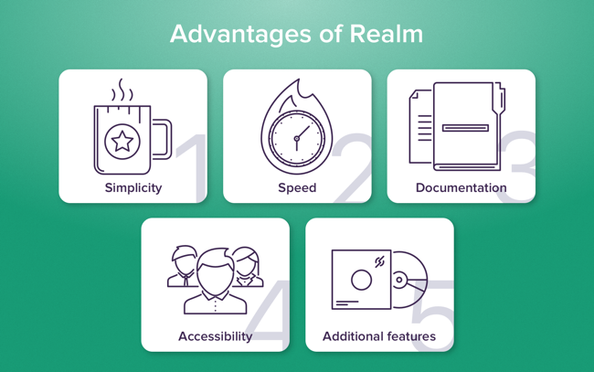

It is clear for now why more developers choose Realm for Android development. This simple and fast development tool can be used by both newbies and professionals in mobile development.

2017 witnessed the arrival of Room persistent library that became a real game changer on the competition between Realm and SQLite.

# What is Room?

This library was introduced at Google I/O 2017. It is an abstraction layer over SQLite to solve several problems with this database. Room allows SQLite to catch up and overtake Realm in some cases.

* Room requires storage space of 50 KB while Realm’s size can reach 4MB. So when talking about size, Room is far ahead.
* Room enables using LiveData class without delays and interruptions.
* Problems with SQLite security we’ve mentioned above was partly solved by Room. Room enables developers to implement an SQLite extension which supports encryption. For instance, you can plug in SQLCipher.
* Room has finally solved the problem with data migration.
* Multithreading is an issue of Realm, while it is a commonplace for Room.
* Talking about method count, Realm uses approximately 2000 methods, while Room has only 300 in it. One point to Room!

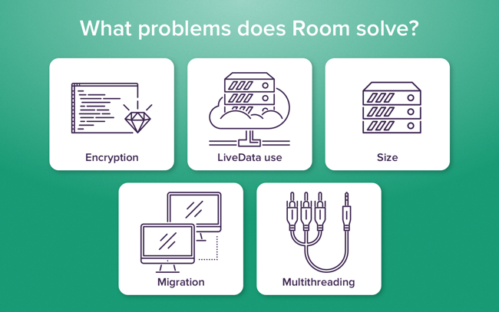

# Summing up

Each option listed above has both its strong and weak sides. SQLite can scare newbie developer by its complexity, that’s why more beginners use Realm for their first Android projects.

Realm can work smoothly without any additional settings, while SQLite may require a long time to choose the right configuration for the particular project. But when your projects will become more complex an large-scale, you will understand that using SQLite coupled with Room is a better option for you.

So when you choose between these two databases, primarily take into consideration the architecture of the project and the level of your coding skills.

**Question:**  Add a NavHost to an activity

**Answer:**  <https://developer.android.com/guide/navigation/navigation-getting-started#add-navhost>

**Question:**  Receive cloud messages in an Android app

**Answer:** [**https://firebase.google.com/docs/cloud-messaging/android/receive**](https://firebase.google.com/docs/cloud-messaging/android/receive)

**Question:**  Service vs IntentService in the Android platform

**Answer:**  Tejas Lagvankar wrote a nice [post](http://techtej.blogspot.com.es/2011/03/android-thread-constructspart-4.html) about this subject. Below are some key differences between Service and IntentService.

**When to use?**

* The *Service* can be used in tasks with no UI, but shouldn't be too long. If you need to perform long tasks, you must use threads within Service.
* The *IntentService* can be used in long tasks usually with no communication to Main Thread. If communication is required, can use Main Thread handler or broadcast intents. Another case of use is when callbacks are needed (Intent triggered tasks).

**How to trigger?**

* The *Service* is triggered by calling method startService().
* The *IntentService* is triggered using an Intent, it spawns a new worker thread and the method onHandleIntent() is called on this thread.

**Triggered From**

* The *Service* and *IntentService* may be triggered from any thread, activity or other application component.

**Runs On**

* The *Service* runs in background but it runs on the Main Thread of the application.
* The *IntentService* runs on a separate worker thread.

**Limitations / Drawbacks**

* The *Service* may block the Main Thread of the application.
* The *IntentService* cannot run tasks in parallel. Hence all the consecutive intents will go into the message queue for the worker thread and will execute sequentially.

**When to stop?**

* If you implement a *Service*, it is your responsibility to stop the service when its work is done, by calling stopSelf() or stopService(). (If you only want to provide binding, you don't need to implement this method).
* The *IntentService* stops the service after all start requests have been handled, so you never have to call stopSelf().

**Question:**  Services in Android with Example

**Answer:**  Services in Android are a special component that facilitates an application to run in the background in order to perform long-running operation tasks. The prime aim of a service is to ensure that the application remains active in the background so that the user can operate multiple applications at the same time. A user-interface is not desirable for android services as it is designed to operate long-running processes without any user intervention. A service can run continuously in the background even if the application is closed or the user switches to another application. Further, application components can bind itself to service to carry out inter-process communication(IPC). There is a major difference between android services and threads, one must not be confused between the two. Thread is a feature provided by the Operating system to allow the user to perform operations in the background. While service is an android component that performs a long-running operation about which the user might not be aware of as it does not have UI.

Types of Android Services

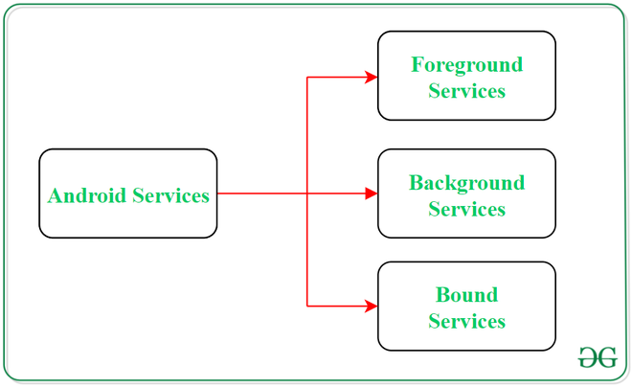

1. Foreground Services:

Services that notify the user about its ongoing operations are termed as Foreground Services. Users can interact with the service by the notifications provided about the ongoing task. Such as in downloading a file, the user can keep track of the progress in downloading and can also pause and resume the process.

2. Background Services:

Background services do not require any user intervention. These services do not notify the user about ongoing background tasks and users also cannot access them. The process like schedule syncing of data or storing of data fall under this service.

3. Bound Services:

This type of android service allows the components of the application like activity to bound themselves with it. Bound services perform their task as long as any application component is bound to it. More than one component is allowed to bind themselves with a service at a time. In order to bind an application component with a service bindService() method is used.

The Life Cycle of Android Services

In android, services have 2 possible paths to complete its life cycle namely Started and Bounded.

1. Started Service (Unbounded Service):

By following this path, a service will initiate when an application component calls the startService() method. Once initiated, the service can run continuously in the background even if the component is destroyed which was responsible for the start of the service. Two option are available to stop the execution of service:

By calling stopService() method,

The service can stop itself by using stopSelf() method.

2. Bounded Service:

It can be treated as a server in a client-server interface. By following this path, android application components can send requests to the service and can fetch results. A service is termed as bounded when an application component binds itself with a service by calling bindService() method. To stop the execution of this service, all the components must unbind themselves from the service by using unbindService() method.

The life cycle of Android service

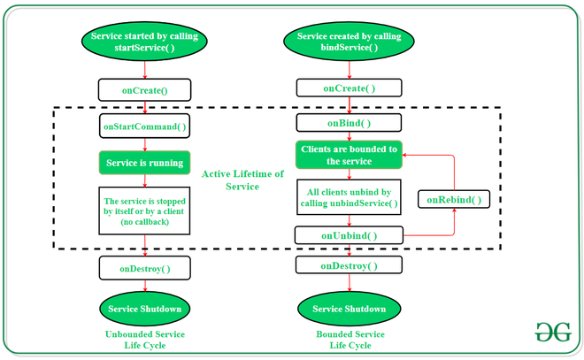

To carry out a downloading task in the background, the startService() method will be called. Whereas to get information regarding the download progress and to pause or resume the process while the application is still in the background, the service must be bounded with a component which can perform these tasks.

Fundamentals of Android Services

A user-defined service can be created through a normal class which is extending the class Service. Further, to carry out the operations of service on applications, there are certain callback methods which are needed to be overridden. The following are some of the important methods of Android Services:

Methods

Description

onStartCommand()

The Android service calls this method when a component(eg: activity)

requests to start a service using startService(). Once the service is started,

it can be stopped explicitly using stopService() or stopSelf() methods.

onBind()

This method is mandatory to implement in android service and is invoked

whenever an application component calls the bindService() method in order to

bind itself with a service. User-interface is also provided to communicate

with the service effectively by returning an IBinder object.

If the binding of service is not required then the method must return null.

onUnbind()

The Android system invokes this method when all the clients

get disconnected from a particular service interface.

onRebind()

Once all clients are disconnected from the particular interface of service and

there is a need to connect the service with new clients, the system calls this method.

onCreate()

Whenever a service is created either using onStartCommand() or onBind(),

the android system calls this method. This method is necessary to perform

a one-time-set-up.

onDestroy()

When a service is no longer in use, the system invokes this method

just before the service destroys as a final clean up call. Services must

implement this method in order to clean up resources like registered listeners,

threads, receivers, etc.

Example of Android Services

Playing music in the background is a very common example of services in android. From the time when a user starts the service, music play continuously in the background even if the user switches to another application. The user has to stop the service explicitly in order to pause the music. Below is the complete step-by-step implementation of this android service using a few callback methods.

Note: Following steps are performed on Android Studio version 4.0

Step 1: Create a new project

Click on File, then New => New Project.

Choose Empty activity

Select language as Java/Kotlin

Select the minimum SDK as per your need.

Step 2: Modify strings.xml file

All the strings which are used in the activity are listed in this file.

<resources>

<string name="app_name">Services_In_Android</string>

<string name="heading">Services In Android</string>

<string name="startButtonText">Start the Service</string>

<string name="stopButtonText">Stop the Service</string>

</resources>

Step 3: Working with the activity_main.xml file

Open the activity_main.xml file and add 2 Buttons in it which will start and stop the service. Below is the code for designing a proper activity layout.

<?xml version="1.0" encoding="utf-8"?>

<androidx.constraintlayout.widget.ConstraintLayout

xmlns:android="http://schemas.android.com/apk/res/android"

xmlns:app="http://schemas.android.com/apk/res-auto"

xmlns:tools="http://schemas.android.com/tools"

android:layout_width="match_parent"

android:layout_height="match_parent"

android:background="#168BC34A"

tools:context=".MainActivity">

<LinearLayout

android:id="@+id/linearLayout"

android:layout_width="match_parent"

android:layout_height="wrap_content"

android:layout_centerVertical="true"

android:orientation="vertical"

app:layout_constraintBottom_toBottomOf="parent"

app:layout_constraintEnd_toEndOf="parent"

app:layout_constraintStart_toStartOf="parent"

app:layout_constraintTop_toTopOf="parent"

app:layout_constraintVertical_bias="1.0"

tools:ignore="MissingConstraints">

<TextView

android:id="@+id/textView1"

android:layout_width="match_parent"

android:layout_height="wrap_content"

android:layout_marginBottom="170dp"

android:fontFamily="@font/roboto"

android:text="@string/heading"

android:textAlignment="center"

android:textAppearance="@style/TextAppearance.AppCompat.Large"

android:textColor="@android:color/holo_green_dark"

android:textSize="36sp"

android:textStyle="bold" />

<Button

android:id="@+id/startButton"

android:layout_width="match_parent"

android:layout_height="match_parent"

android:layout_marginStart="20dp"

android:layout_marginTop="10dp"

android:layout_marginEnd="20dp"

android:layout_marginBottom="20dp"

android:background="#4CAF50"

android:fontFamily="@font/roboto"

android:text="@string/startButtonText"

android:textAlignment="center"

android:textAppearance="@style/TextAppearance.AppCompat.Display1"

android:textColor="#FFFFFF"

android:textStyle="bold" />

<Button

android:id="@+id/stopButton"

android:layout_width="match_parent"

android:layout_height="match_parent"

android:layout_marginStart="20dp"

android:layout_marginTop="10dp"

android:layout_marginEnd="20dp"

android:layout_marginBottom="20dp"

android:background="#4CAF50"

android:fontFamily="@font/roboto"

android:text="@string/stopButtonText"

android:textAlignment="center"

android:textAppearance="@style/TextAppearance.AppCompat.Display1"

android:textColor="#FFFFFF"

android:textStyle="bold" />

<ImageView

android:id="@+id/imageView"

android:layout_width="match_parent"

android:layout_height="wrap_content"

android:layout_marginTop="80dp"

app:srcCompat="@drawable/banner" />

</LinearLayout>

</androidx.constraintlayout.widget.ConstraintLayout>

Step 4: Creating the custom service class

A custom service class will be created in the same directory where the MainActivity class resides and this class will extend the Service class. The callback methods are used to initiate and destroy the services. To play music, the MediaPlayer object is used. Below is the code to carry out this task.

import android.app.Service;

import android.content.Intent;

import android.media.MediaPlayer;

import android.os.IBinder;

import android.provider.Settings;

import androidx.annotation.Nullable;

public class NewService extends Service {

// declaring object of MediaPlayer

private MediaPlayer player;

@Override

// execution of service will start

// on calling this method

public int onStartCommand(Intent intent, int flags, int startId) {

// creating a media player which

// will play the audio of Default

// ringtone in android device

player = MediaPlayer.create( this, Settings.System.DEFAULT_RINGTONE_URI );

// providing the boolean

// value as true to play

// the audio on loop

player.setLooping( true );

// starting the process

player.start();

// returns the status

// of the program

return START_STICKY;

}

@Override

// execution of the service will

// stop on calling this method

public void onDestroy() {

super.onDestroy();

// stopping the process

player.stop();

}

@Nullable

@Override

public IBinder onBind(Intent intent) {

return null;

}

}

Step 5: Working with the MainActivity file

Now, the button objects will be declared and the process to be performed on clicking these buttons will be defined in the MainActivity class. Below is the code to implement this step.

import androidx.appcompat.app.AppCompatActivity;

import android.content.Intent;

import android.os.Bundle;

import android.view.View;

import android.widget.Button;

public class MainActivity extends AppCompatActivity implements View.OnClickListener {

// declaring objects of Button class

private Button start, stop;

@Override

protected void onCreate(Bundle savedInstanceState) {

super.onCreate( savedInstanceState );

setContentView( R.layout.activity_main );

// assigning ID of startButton

// to the object start

start = (Button) findViewById( R.id.startButton );

// assigning ID of stopButton

// to the object stop

stop = (Button) findViewById( R.id.stopButton );

// declaring listeners for the

// buttons to make them respond

// correctly according to the process

start.setOnClickListener( this );

stop.setOnClickListener( this );

}

public void onClick(View view) {

// process to be performed

// if start button is clicked

if(view == start){

// starting the service

startService(new Intent( this, NewService.class ) );

}

// process to be performed

// if stop button is clicked

else if (view == stop){

// stopping the service

stopService(new Intent( this, NewService.class ) );

}

}

}

Step 6: Modify the AndroidManifest.xml file

To implement the services successfully on any android device, it is necessary to mention the created service in the AndroidManifest.xml file. It is not possible for a service to perform its task if it is not mentioned in this file. The service name is mentioned inside the application tag.

<?xml version="1.0" encoding="utf-8"?>

<manifest xmlns:android="http://schemas.android.com/apk/res/android"

package="com.example.services_in_android">

<application

android:allowBackup="true"

android:icon="@mipmap/ic_launcher"

android:label="@string/app_name"

android:roundIcon="@mipmap/ic_launcher_round"

android:supportsRtl="true"

android:theme="@style/AppTheme">

<activity android:name=".MainActivity">

<intent-filter>

<action android:name="android.intent.action.MAIN" />

<category android:name="android.intent.category.LAUNCHER" />

</intent-filter>

</activity>

<meta-data

android:name="preloaded_fonts"

android:resource="@array/preloaded_fonts" />

<!-- Mention the service name here -->

<service android:name=".NewService"/>

</application>

</manifest>

**Question:**  Broadcast Receiver in Android With Example

**Answer:**  Broadcast in android is the system-wide events that can occur when the device starts, when a message is received on the device or when incoming calls are received, or when a device goes to airplane mode, etc. Broadcast Receivers are used to respond to these system-wide events. Broadcast Receivers allow us to register for the system and application events, and when that event happens, then the register receivers get notified. There are mainly two types of Broadcast Receivers:

Static Broadcast Receivers: These types of Receivers are declared in the manifest file and works even if the app is closed.

Dynamic Broadcast Receivers: These types of receivers work only if the app is active or minimized.

Since from API Level 26, most of the broadcast can only be caught by the dynamic receiver, so we have implemented dynamic receivers in our sample project given below. There are some static fields defined in the Intent class which can be used to broadcast different events. We have taken a change of airplane mode as a broadcast event, but there are many events for which broadcast register can be used. Following are some of the important system-wide generated intents:-

android.intent.action.BATTERY_LOW : Indicates low battery condition on the device.

android.intent.action.BOOT_COMPLETED This is broadcast once after the system has finished booting

android.intent.action.CALL To perform a call to someone specified by the data

android.intent.action.DATE_CHANGED Indicates that the date has changed

android.intent.action.REBOOT Indicates that the device has been a reboot

android.net.conn.CONNECTIVITY_CHANGE The mobile network or wifi connection is changed(or reset)

android.intent.ACTION_AIRPLANE_MODE_CHANGED This indicates that airplane mode has been switched on or off.

The two main things that we have to do in order to use the broadcast receiver in our application are:

Creating the Broadcast Receiver:

class AirplaneModeChangeReceiver:BroadcastReceiver() {

override fun onReceive(context: Context?, intent: Intent?) {

// logic of the code needs to be written here

}

}

Registering a BroadcastReceiver:

IntentFilter(Intent.ACTION_AIRPLANE_MODE_CHANGED).also {

// receiver is the broadcast receiver that we have registered

// and it is the intent filter that we have created

registerReceiver(receiver,it)

}

Example

Below is the sample project showing how to create the broadcast Receiver and how to register them for a particular event and how to use them in the application.

Step 1: Create a New Project

To create a new project in Android Studio please refer to How to Create/Start a New Project in Android Studio.

Step 2: Working with the activity_main.xml file

Go to the activity_main.xml file and refer to the following code. Below is the code for the activity_main.xml file.

XML

<?xml version="1.0" encoding="utf-8"?>

<androidx.constraintlayout.widget.ConstraintLayout

xmlns:android="http://schemas.android.com/apk/res/android"

xmlns:tools="http://schemas.android.com/tools"

android:layout_width="match_parent"

android:layout_height="match_parent"

tools:context=".MainActivity">

</androidx.constraintlayout.widget.ConstraintLayout>

Step 3: Working with the MainActivity file

Go to the MainActivity file and refer to the following code. Below is the code for the MainActivity file. Comments are added inside the code to understand the code in more detail.

Kotlin

import android.content.Intent

import android.content.IntentFilter

import android.os.Bundle

import androidx.appcompat.app.AppCompatActivity

class MainActivity : AppCompatActivity() {

// register the receiver in the main activity in order

// to receive updates of broadcasts events if they occur

lateinit var receiver: AirplaneModeChangeReceiver

override fun onCreate(savedInstanceState: Bundle?) {

super.onCreate(savedInstanceState)

setContentView(R.layout.activity_main)

receiver = AirplaneModeChangeReceiver()

// Intent Filter is useful to determine which apps wants to receive

// which intents,since here we want to respond to change of

// airplane mode

IntentFilter(Intent.ACTION_AIRPLANE_MODE_CHANGED).also {

// registering the receiver

// it parameter which is passed in registerReceiver() function

// is the intent filter that we have just created

registerReceiver(receiver, it)

}

}

// since AirplaneModeChangeReceiver class holds a instance of Context

// and that context is actually the activity context in which

// the receiver has been created

override fun onStop() {

super.onStop()

unregisterReceiver(receiver)

}

}

Java

import androidx.appcompat.app.AppCompatActivity;

import android.content.Intent;

import android.content.IntentFilter;

import android.os.Bundle;

public class MainActivity extends AppCompatActivity {

AirplaneModeChangeReceiver airplaneModeChangeReceiver = new AirplaneModeChangeReceiver();

@Override

protected void onCreate(Bundle savedInstanceState) {

super.onCreate(savedInstanceState);

setContentView(R.layout.activity_main);

}

@Override

protected void onStart() {

super.onStart();

IntentFilter filter = new IntentFilter(Intent.ACTION_AIRPLANE_MODE_CHANGED);

registerReceiver(airplaneModeChangeReceiver, filter);

}

@Override

protected void onStop() {

super.onStop();

unregisterReceiver(airplaneModeChangeReceiver);

}

}

Step 4: Create a new class

Go to app > java > your package name(in which the MainActicity is present) > right-click > New > Kotlin File/Class and name the files as AirplaneModeChangeReceiver. Below is the code for the AirplaneModeChangeReceiver file. Comments are added inside the code to understand the code in more detail.

Kotlin

import android.content.BroadcastReceiver

import android.content.Context

import android.content.Intent

import android.widget.Toast

// AirplaneModeChangeReceiver class extending BroadcastReceiver class

class AirplaneModeChangeReceiver : BroadcastReceiver() {

// this function will be executed when the user changes his

// airplane mode

override fun onReceive(context: Context?, intent: Intent?) {

// intent contains the information about the broadcast

// in our case broadcast is change of airplane mode

// if getBooleanExtra contains null value,it will directly return back

val isAirplaneModeEnabled = intent?.getBooleanExtra("state", false) ?: return

// checking whether airplane mode is enabled or not

if (isAirplaneModeEnabled) {

// showing the toast message if airplane mode is enabled

Toast.makeText(context, "Airplane Mode Enabled", Toast.LENGTH_LONG).show()

} else {

// showing the toast message if airplane mode is disabled

Toast.makeText(context, "Airplane Mode Disabled", Toast.LENGTH_LONG).show()

}

}

}

Java

import android.content.BroadcastReceiver;

import android.content.Context;

import android.content.Intent;

import android.provider.Settings;

import android.widget.Toast;

public class AirplaneModeChangeReceiver extends BroadcastReceiver {

@Override

public void onReceive(Context context, Intent intent) {

if (isAirplaneModeOn(context.getApplicationContext())) {

Toast.makeText(context, "AirPlane mode is on", Toast.LENGTH_SHORT).show();

} else {

Toast.makeText(context, "AirPlane mode is off", Toast.LENGTH_SHORT).show();

}

}

private static boolean isAirplaneModeOn(Context context) {

return Settings.System.getInt(context.getContentResolver(), Settings.Global.AIRPLANE_MODE_ON, 0) != 0;

}

}

**Question:**  BroadcastReceiver

**Answer:**  <https://developer.android.com/reference/android/content/BroadcastReceiver#summary>

**Question:**  MVC vs MVP vs MVVM architecture in Android

**Answer:**  **What is Architecture?**

If you are building an application in an organized manner with some set of rules, describe proper functionalities and implement it with proper protocols, then it is called an Architecture.

#### Role of Architecture

Let us say if we are not using any architecture and we are writing our code in a class/activity/ fragment in an unorganized manner then the problems we will face are-

* The number of lines of code will increase that it will become complex to understand.
* It decreases readability and increases the number of bugs. Thus, it is difficult to test and reduces the quality of the product.

So, to provide clear data flow which will increase robustness, scalability, bug resistant, increase readability, easy to modify and increase productivity and provide a quality app. Thus, we should use proper architecture, suitable to work in a team.

#### Some principles for good Architecture in Android

To get good architecture there are some basic concepts we should follow. They are:-

* **Separation of concern:** Component should do what it is required. Shown in the diagram.

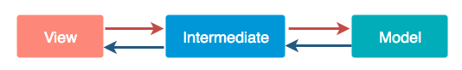

This we can achieve by *Architecture pattern* .

* **No Hard dependency:** It should be fixed if every component should work on some limited amount of dependency. All dependencies should be provided from outside. Use *Dependency Injections.* Here are the links-

[Dependency Injection and Dagger2 basic concepts](https://blog.mindorks.com/dependency-injection-with-dagger2)

[Dagger2 Advance concepts](https://blog.mindorks.com/dependency-injection-with-dagger2-advance)

* **Manage lifecycle and data persistence** : It can be achieved by *Architecture Component.* (We will read about Architecture Component in upcoming blogs)

#### Architecture pattern:

Software Architectural Design pattern promotes organized programming. Separates application functionality which is easy to test and provides low-cost maintenance. MVC, MVP, MVVM are some popular architecture patterns.  
Let’s explore them, one by one:

#### MVC:

It is a Model-View-Controller. The most commonly used architecture. These are the three components used in MVC.

***Model*** *- It is business logic and Data State. Getting and manipulating the data, communicates with the controller, interacts with the database, sometimes update the views.*

***View*** *- What we see. User Interface consists of HTML/CSS/XML. It communicates with the controller and sometimes interacts with the model. It passed some dynamic views through the controller.*

***Controller*** *- It is Activity/Fragment. It communicates with view and model. It takes the user input from view/REST services. Process request Get data from the model and passes to the view.*

As shown in the figure:

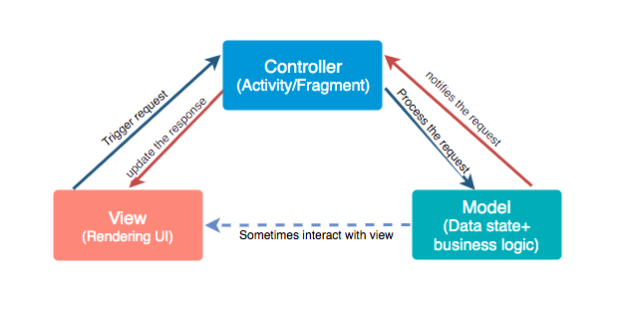

Advantages

* It keeps business logic separate in the model.
* Support asynchronous techniques
* The modification does not affect the entire model
* Faster development process

Disadvantages

* Due to large code controller is unmanageable.
* Hinders the Unit testing
* Increased Complexity

Here are some examples where it is used- RubyOn Rails, Codeigniter, Angular, Django, etc. You can find out code sample for MVC: [MVC Sample code](https://github.com/vandanasri/MVC-Sample-Android)

#### MVP:

It as Model-View-Presenter. For the phase of developing time or for the phase of developers it is vital to divide the architecture into layers. It breaks the dependency on what we have on view.

***Model*** *- It is business logic and Data State. Getting and manipulating the data, communicates with the presenter, interacts with the database. It doesn't interact with the view.*

***View*** *- Consists of UI, activity, and fragment. It interacts with the presenter.*

***Presenter*** *- It presents the data from the model. Control all the behavior that want to display from the app. It drives the view. It tells view what to do. Any interaction between the model and the view is handled by the presenter. Saves the data back to the model.*

As shown in the figure:

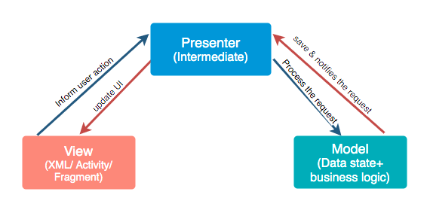

Advantages

* It makes view dumb so that you can swap the view easily.
* Reusable of View and Presenter
* Code is more readable and maintainable
* Easy testing as business logic separated from UI

Disadvantages

* Tight coupling between View and Presenter
* Huge amount of interfaces for interaction between layers.
* The code size is quite excessive.

You can find out code sample for MVP: [MVP Sample Code](https://github.com/vandanasri/MVP-Sample-Android)

#### MVVM:

It is a Model-View-ViewModel. It losses the tight coupling between each component and reduces the glue classes. Works on the concept of observables. Children don't have reference to the parent, they only have reference by observables.

***Model*** *- It has business logic, local and remote data source and repository.Repository: communicate with local or remote data sources according to the request from ViewModel.*

***View*** *- Only user interaction i.e.XML, no business logic. Direct send user action to view model but does not directly get a response. To get a response view observes some data which ViewModel exposes.*

***ViewModel*** *- Most of the user interface logic center it here. It is a bridge between a view and a business logic. It does not have any clue which view has to use it. As it does not have a direct reference to the view. Thus, good in testing and has loose coupling. But still, it needs to update the UI this interaction done by observables. When data changes observable notifies.*

As shown in the figure:

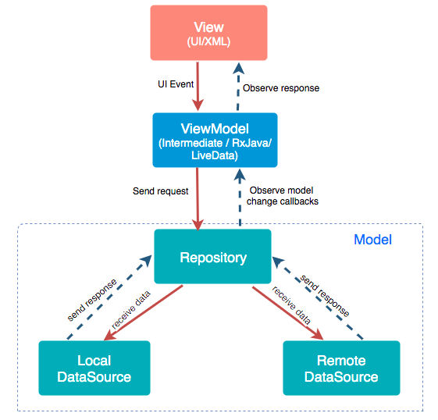

Advantages

* No tight coupling between the view and view model
* No interfaces between view and model.
* Easy to unit testing and code is event-driven.

Disadvantage

* You have to create observables for each UI component.
* The code size is quite excessive.

You can find out code sample for MVP: [MVVM Sample Code](https://github.com/vandanasri/MVVM-Sample-Android)

**Question:**  AndroidViewModel vs ViewModel

**Answer:**  **AndroidViewModel provides Application context**

If you need to use context inside your Viewmodel you should use AndroidViewModel (AVM), because it contains the application context. To retrieve the context call getApplication(), otherwise use the regular ViewModel (VM).

AndroidViewModel has **application context**. We all know *having static context instance is evil as it can cause memory leaks!!* However, **having static Application instance is not as bad as you might think** because there is only one Application instance in the running application.

Therefore, using and having Application instance in a specific class is not a problem in general. But, if an Application instance references them, it is a problem because of the reference cycle problem.

[See Also about Application Instance](https://www.philosophicalhacker.com/2015/07/14/why-static-references-to-application-contexts-are-probably-not-the-best-idea/)

# AndroidViewModel Problematic for unit tests

AVM provides application context which is problematic for unit testing. Unit tests should not deal with any of the Android lifecycle, such as context.

**Question:**  What is Context in Android?

**Answer:**  Android Applications are popular for a long time and it is evolving to a greater level as users’ expectations are that they need to view the data that they want in an easier smoother view. Hence, the android developers must know the important terminologies before developing the app. In Android Programming we generally come across the word Context. So what exactly is this Context and why is it so important? To answer this question let’s first see what the literal meaning of Context is:

The Circumstances that form the setting for an Event, Statement, or Idea, and in terms of which it can be fully understood.

Looking at this definition we come across two things:

The Context tells us about the surrounding information.

It is very important to understand the environment which we want to understand.

Similarly when we talk about Android Programming Context can be understood as something which gives us the Context of the current state of our application. We can break the Context and its use into three major points:

It allows us to access resources.

It allows us to interact with other Android components by sending messages.

It gives you information about your app environment.

The code has been given in both Java and Kotlin Programming Language for Android.

Understanding Context by a Real World Example

Let’s a person visit a hotel. He needs breakfast, lunch, and dinner at a suitable time. Except for these things there are also many other things, he wants to do during his time of stay. So how does he get these things? He will ask the room-service person to bring these things for him. Right? So here the room-service person is the Context considering you are the single activity and the hotel to be your app, finally, the breakfast, lunch & dinner have to be the resources.

How Does this Work?

1. It is the Context of the current/active state of the application.

Usually, the app got multiple screens like display/inquiry/add/delete screens(A general requirement of a basic app). So when the user is searching for something, the Context is an inquiry screen in this case.

2. It is used to get information about the activity and application.

The inquiry screen’s Context specifies that the user is in inquiry activity, and he/she can submit queries related to the app

3. It is used to get access to resources, databases, shared preferences, etc.

Via Rest services, API calls can be consumed in android apps. Rest Services usually hold database data and provide the output in JSON format to the android app. The Context for the respective screen helps to get hold of database data and the shared data across screens

4. Both the Activity and Application classes extend the Context class.

In android, Context is the main important concept and the wrong usage of it leads to memory leakage. Activity refers to an individual screen and Application refers to the whole app and both extend the Context class.

Types of Context in Android

There are mainly two types of Context that are available in Android.

Application Context and

Activity Context

The Overall view of the App hierarchy looks like the following:

Mockup Screen Of Application And Activity

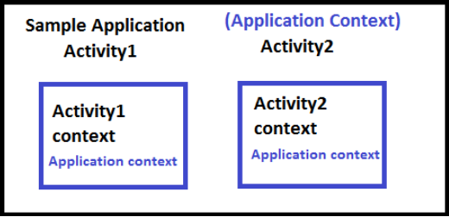

It can be seen in the above image that in “Sample Application”, the nearest Context is Application Context. In “Activity1” and “Activity2”, both Activity Context (Here it is Activity1 Context for Activity1 and Activity2 Context for Activity2) and Application Context.The nearest Context to both is their Activity Context only.

Application Context

This Context is tied to the Lifecycle of an Application. Mainly it is an instance that is a singleton and can be accessed via getApplicationContext(). Some use cases of Application Context are:

If it is necessary to create a singleton object

During the necessity of a library in an activity

getApplicationContext():

It is used to return the Context which is linked to the Application which holds all activities running inside it. When we call a method or a constructor, we often have to pass a Context and often we use “this” to pass the activity Context or “getApplicationContext” to pass the application Context. This method is generally used for the application level and can be used to refer to all the activities. For example, if we want to access a variable throughout the android app, one has to use it via getApplicationContext().

Example:

Java

import android.app.Application;

public class GlobalExampleClass extends Application {

private String globalName;

private String globalEmail;

public String getName() {

return globalName;

}

public void setName(String aName) {

globalName = aName;

}

public String getEmail() {

return globalEmail;

}

public void setEmail(String aEmail) {

globalEmail = aEmail;

}

}

Kotlin

import android.app.Application

class GlobalExampleClass : Application() {

private var globalName: String? = null

private var globalEmail: String? = null

fun getName(): String? {

return globalName

}

fun setName(aName: String?) {

globalName = aName

}

fun getEmail(): String? {

return globalEmail

}

fun setEmail(aEmail: String?) {

globalEmail = aEmail

}

}

Inside the activity class, set the name and email of GlobalExampleClass, which can be accessed from another activity. Let us see via the below steps.

Syntax:

// Activity 1

public class <your activity1> extends Activity {

........

........

private <yourapplicationname> globarVar;

........

@Override

public void onCreate(Bundle savedInstanceState) {

.......

final GlobalExampleClass globalExampleVariable = (GlobalExampleClass) getApplicationContext();

// In this activity set name and email and can reuse in other activities

globalExampleVariable.setName("getApplicationContext example");

globalExampleVariable.setEmail("xxxxxx@gmail.com");

.......

}

// Activity 2

public class <your activity2> extends Activity {

........

........

private <yourapplicationname> globarVar;

.......

@Override

public void onCreate(Bundle savedInstanceState) {

.......

final GlobalExampleClass globalExampleVariable = (GlobalExampleClass) getApplicationContext();

// As in activity1, name and email is set, we can retrieve it here

final String globalName = globalExampleVariable.getName();

final String globalEmail = globalExampleVariable.getEmail();

.......

}

So, whenever the variable scope is required throughout the application, we can get it by means of getApplicationContext(). Following is a list of functionalities of Application Context.

List of functionalities of Application Context:

Load Resource Values

Start a Service

Bind to a Service

Send a Broadcast

Register BroadcastReceiver

Activity Context

It is the activity Context meaning each and every screen got an activity. For example, EnquiryActivity refers to EnquiryActivity only and AddActivity refers to AddActivity only. It is tied to the life cycle of activity. It is used for the current Context. The method of invoking the Activity Context is getContext().

Some use cases of Activity Context are:

The user is creating an object whose lifecycle is attached to an activity.

Whenever inside an activity for UI related kind of operations like toast, dialogue, etc.,

getContext():

It returns the Context which is linked to the Activity from which it is called. This is useful when we want to call the Context from only the current running activity.

Example:

Java

@Override

public void onItemClick(AdapterView<?> parent, View view, int pos, long id) {

// view.getContext() refers to the current activity view

// Here it is used to start the activity

Intent intent = new Intent(view.getContext(), <your java classname>::class.java);

intent.putExtra(pid, ID);

view.getContext().startActivity(intent);

}

Kotlin

fun onItemClick(parent: AdapterView<*>?, view: View, pos: Int, id: Long) {

// view.getContext() refers to the current activity view

// Here it is used to start the activity

val intent = Intent(view.context, <your java classname>::class.java)

intent.putExtra(pid, ID)

view.context.startActivity(intent)

}

List of Functionalities of Activity Context:

Load Resource Values

Layout Inflation

Start an Activity

Show a Dialog

Start a Service

Bind to a Service

Send a Broadcast

Register BroadcastReceiver

From the functionalities of both Application and Activity, we can see that the difference is that the Application Context is not related to UI. It should be used only to start a service or load resource values etc. Apart from getApplicationContext() and getContext(), getBaseContext() or this are the different terminologies used throughout the app development. Let us see with an example

getBaseContext():

The base Context is set by the constructor or setBaseContext().This method is only valid if we have a ContextWrapper. Android provides a ContextWrapper class that is created around an existing Context using:

ContextWrapper wrapper = new ContextWrapper(context);

The benefit of using a ContextWrapper is that it lets you “modify behavior without changing the original Context”.

Syntax:

public <YourHandler>(Context ctx) {

// if the context is instanceof ContextWrapper

while (ctx instanceof ContextWrapper) {

// use getBaseContext()

final Context baseContext = ((ContextWrapper)context).getBaseContext();

if (baseContext == null) {

break;

}

// And then we can assign to context and reuse that

ctx = baseContext;

}

}

this:

“this” argument is of a type “Context”. To explain this Context let’s take an example to show a Toast Message using “this”.

Example:

Java

import android.os.Bundle;

import android.widget.Toast;

import androidx.appcompat.app.AppCompatActivity;

// Show a simple toast message, that can be done after doing some activities

// Toast.makeText(this, "Action got completed", Toast.LENGTH_SHORT).show();

public class ExampleActivity extends AppCompatActivity {

@Override

protected void onCreate(Bundle savedInstanceState) {

super.onCreate(savedInstanceState);

setContentView(R.layout.activity_main_example);

// Displaying Toast with Hello Javatpoint message

Toast.makeText(this,"Action done",Toast.LENGTH_SHORT).show();

}

}

Kotlin

import android.os.Bundle

import android.widget.Toast

import androidx.appcompat.app.AppCompatActivity

// Show a simple toast message, that can be done after doing some activities

// Toast.makeText(this, "Action got completed", Toast.LENGTH_SHORT).show();

class ExampleActivity : AppCompatActivity() {

override fun onCreate(savedInstanceState: Bundle?) {

super.onCreate(savedInstanceState)

setContentView(R.layout.activity_main_example)

// Displaying Toast with Hello Javatpoint message

Toast.makeText(this, "Action done", Toast.LENGTH_SHORT).show()

}

}

Another example to start the activity using “this”:

Java

import androidx.appcompat.app.AppCompatActivity;

import android.content.Intent;

import android.os.Bundle;

import android.view.View;

import android.widget.EditText;

public class FirstActivity extends AppCompatActivity {

public static final String newMessage = "Your message to go for next screen";

@Override

protected void onCreate(Bundle savedInstanceState) {

super.onCreate(savedInstanceState);

setContentView(R.layout.activity_first);

}

// There must be some button and on click of

// that below method can be invoked

public void sendMessageToNextScreen(View view) {

// Here it is used with "this"

Intent intent = new Intent(this, SecondActivity.class);

EditText editText = (EditText) findViewById(R.id.editText);

String message = editText.getText().toString();

intent.putExtra(newMessage, message);

// Start the SecondActivity

startActivity(intent);

}

}

Kotlin

import android.content.Intent

import android.os.Bundle

import android.view.View

import android.widget.EditText

import androidx.appcompat.app.AppCompatActivity

class FirstActivity : AppCompatActivity() {

private var newMessage = "Your message to go for next screen"

override fun onCreate(savedInstanceState: Bundle?) {

super.onCreate(savedInstanceState)

setContentView(R.layout.activity_first)

}

// There must be some button and on click of

// that below method can be invoked

fun sendMessageToNextScreen(view: View?) {

// Here it is used with "this"

val intent = Intent(this, SecondActivity::class.java)

val editText: EditText = findViewById(R.id.editText)

val message = editText.text.toString()

intent.putExtra(newMessage, message)

// Start the SecondActivity

startActivity(intent)

}

}

**Question:**  What are fragments?

**Answer:**  You may use fragments often as an Android developer. Knowing the definition and when to use them can improve your answer during your interview. In your answer, you can explain several features of them and the ways you’ve utilized them in your own work to demonstrate your familiarity.

Example: “A fragment is a section of the user interface. You can use multiple fragments within one activity. It is possible to remove or add fragments while an activity runs. A fragment has a separate lifecycle but is always used within an activity. I sometimes use fragments to organize the User Interface of the content and functions of an app so that it can be easily navigated.”

**Question:**  Can you explain when to use a fragment compared to an activity?

**Answer:**  As a developer, you often need to know when you should use a fragment and when you should use an activity. An effective answer would list different scenarios where you would use either one.

Example: “The code that builds an activity is more involved than the code that builds a fragment. You must pause, stop or destroy the old activity while you create the new activity. Using an activity only when you need to switch the entire screen is a smart technique. Otherwise, you should use fragments in all other cases. Developers often use fragments when using a navigational method or if the user would benefit from putting two layouts next to each other.”

**Question:**  When replacing a fragment, how do you know the user can get back to the last fragment when they press the back button?

**Answer:**  Understanding the life cycle of fragments is essential as a developer. You may need to explain that you know this as well as what the back stack is because this function may be necessary to use daily.

Example: “You should save each fragment transaction to the back stack to have the back button get the user to the last fragment. You can do this by calling ‘addToBackStack()’ before you commit that transaction.”

**Question:**  What are the advanced features of Android, and what are their benefits?

**Answer:**  Android is popular among developers as it has a variety of advanced features. You can list a few of these in addition to what advantages you think Android has. Your answer can define specific applications and explain why they are useful.

Example: “There are many advantages to using Android. ThreadPool is where a group of worker threads and a task queue run numerous parallel instances of a certain task. This ability increases the performance of an application when you use it correctly. Using ThreadPool is also more efficient compared to having various operations waiting to run for one thread. This also helps you prevent the tedious overhead of building and then destroying a thread each time you need a worker thread.”

**Question:**  What are potential errors you may encounter?

**Answer:**  Encountering errors is a normal part of being a developer. Even the most experienced developers may run into issues, but knowing how to address these issues is what makes an effective and productive developer. You can give an example of a specific error and how you would fix it.

Example: “A common Android error is an Application Not Responding error. When I see this in my work, I know not to perform long or intense operations on the main thread. This error occurs when the UI is unresponsive for more than five seconds due to something blocking the main thread. A solution to this is to move the majority of work off the main thread.”

**Question:**  What are views and how are they used?

**Answer:**  Views are an essential part of Android development. You can explain what they are, what the process for creating them is and how you can optimize their usage.

Example: “A view is part of the Android User Interface that responds to user inputs. When creating a view, you should subclass the view that is closest to the custom component you want to build. Once you extend the class, you can build a res/values/attrs.xml file and declare the attributes you intend to use with the custom view.

You can optimize view usage by checking for excessive overdraw by installing the app on an Android device. Next, you can enable the “Debug GPU Overview” option. Another way is to flatten the view hierarchy. You can do this by inspecting the view hierarchy by using the “Hierarchy Viewer” tool in Android Studio.”

**Question:**  Do you know how to create a bound service?

**Answer:**  Developers often use bound services in Android applications. You can explain how you would build one and give specific steps involved. You can also frame your explanation of the process by demonstrating how you’ve built a bound service in the past.

Example: “The first step when creating a bound service through Android Interface Definition Language is defining the AIDL interface for a .aidl file. You then save the file in the src/ directory of the application that hosts the activity and any other application necessary to bind the service. Next, you can build the application and use Android SDK tools to create the IBinder interface file that goes in the gen directory.”

**Question:**  What’s the difference between an explicit and an implicit intent?

**Answer:**  You may use different intents in an Android application depending on what function you are creating. You can explain what the difference is between implicit intent and explicit intent and when you would use each.

Example: “An explicit intent tells the system which system component or activity you should use to respond to the intent. Implicit intent is where you state what action you want to perform. The Android system then checks what registered components can control that action. The majority of the time, you will likely use an explicit intent to begin components in your application. You would use implicit intents when you are trying to communicate with other components from a third-party application.”

**Question:**  What is a layout in Android, and what are its different types?

**Answer:**  A layout in Android is a collection of UI(User Interface) controls. UI controls can be buttons, text fields, images, and other widgets, that are arranged on the screen. A layout defines how these UI controls are positioned and sized on the screen. It provides the structure for the user interface of an Android application.

There are several types of layouts in Android:

1. LinearLayout
2. RelativeLayout
3. ConstraintLayout
4. FrameLayout
5. TableLayout

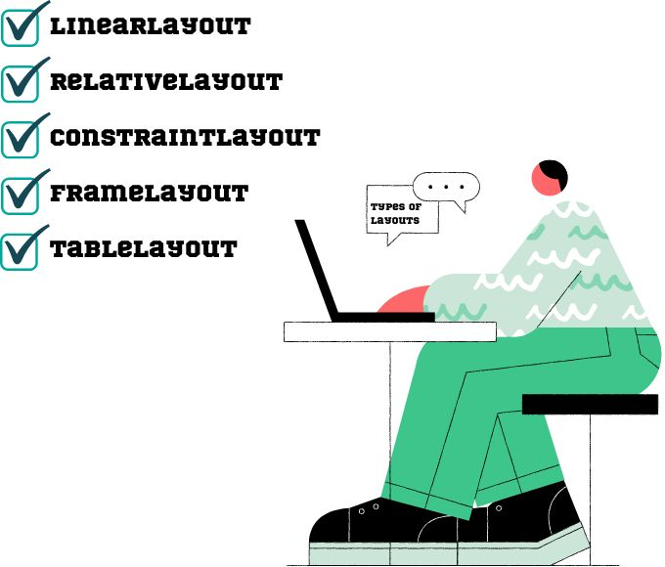

**Question:**  Explain the differences between Serializable and Parcelable interfaces in Android.

**Answer:**  Serializable and Parcelable are interfaces in Android. They allow you to serialize and deserialize objects. So they can be passed between different components of an application. However, there are some differences between them, which are mentioned below.

| **Serializable interface** | **Parcelable interface** |
| --- | --- |
| When you serialize an object using Serializable, it creates a lot of temporary objects, which can negatively impact performance in some cases. | Parcelable is generally faster than Serializable because it generates less garbage and involves less reflection. It is designed to be more efficient and can be faster in situations where performance is a concern. |
| It is less efficient than the Parcelable interface because it carries huge data streams. | It is more efficient than Serializable. It generally produces smaller data streams. |
| When you implement Serializable, you don't have to write any special methods, but the serialization and deserialization process is handled entirely by the Java serialization system. | It requires you to write custom code to handle the serialization and deserialization process. This gives you more control over how the object is serialized and can allow you to optimize the process for performance. |
| Serializable is compatible with Java, so you can use it to pass objects between Android and non-Android systems. | It is specific to Android and can only be used within the Android framework. |

**Question:**  What is the Android Manifest file, and what is its purpose?

**Answer:**  The Android Manifest file is an XML(Extensible Markup Language) file. It provides essential information about an Android app for the Android OS. It is named "AndroidManifest.xml" and is located in the root directory of an Android project.

The Android Manifest file has several purposes, including

* Declaring the app's package name.
* Specifying the app's components.
* Defining app permissions.
* Specifying hardware and software requirements.
* Declaring app metadata.

**Question:**  What do you mean by AsyncTask in Android?

**Answer:**  AsyncTask in Android is a class that allows developers to perform background tasks or operations on a separate thread from the main UI thread. It is the best way to perform tasks that take a long time to complete without blocking the main thread. This can cause the UI to freeze and become unresponsive. The tasks can be network operations or heavy database transactions.

An AsyncTask in Android operates by defining a set of methods that run on the UI thread. It also defines a set of methods that run on a separate worker thread. The methods that run on the UI thread include onPreExecute(), onProgressUpdate(), and onPostExecute(), while the method that runs on the worker thread is doInBackground().

**Question:**  Explain the differences between a thread and a process in Android.

**Answer:**  A thread and a process are two distinct concepts in Android that are used for different purposes. A thread is a lightweight unit of execution within a process. On the other hand, a process is a self-contained instance of an application or service. It runs in its own memory space, with its own virtual machine (VM).

The following are the differences between them:

| **Thread** | **Process** |
| --- | --- |
| It shares resources with the parent process, which can make them more efficient in terms of resource usage. | It requires more resources (such as memory) than a thread, as each process has its own set of resources. |
| Threads within a process share the same memory space, which can make them vulnerable to bugs and security issues. | Each process is isolated from other processes, which provides better security and fault isolation. |
| Switching between threads is faster, as threads share the same memory space and VM. | Switching between processes is slower than switching between threads, as each process has its own memory space and VM. |

**Question:**  What is a content provider in Android?

**Answer:**  Content provider in Android is a component that handles a shared set of app data. It allows you to safely share data between different applications in a standardized and secure way. They enable different apps to access, query, and modify the data stored in the same database or file without exposing the underlying implementation details.

Content Providers use a set of standardized interfaces. They use them to define how data can be accessed and modified. These interfaces are based on the CRUD (Create, Read, Update, Delete) operations that are commonly used in database management. Content Providers provide a standard, secure, and well-structured way for applications to access data.

**Question:**  What is an SQLite database in android?

**Answer:**  SQLite is a lightweight RDBMS(Relational Database Management System), a software library included as a part of the Android OS. It provides a mechanism for storing and retrieving structured data. These are used in Android applications to store application data, such as user preferences, settings, and other data that needs to be persisted across application runs.

SQLite databases are stored in a file on the device's file system. Any application can have multiple SQLite databases. Each database can have multiple tables, which are used to organize the data. The data in an SQLite database is stored in rows and columns, much like in a spreadsheet.

**Question:**  What are some standard techniques for optimizing the performance of an Android application?

**Answer:**  Optimizing the performance of an Android application is very crucial for providing a good user experience.

There are some standard techniques for optimizing the performance of an Android application:

* **Reducing the number of layout hierarchies:** The more complex the layout hierarchy is, the more time it takes to draw and display the user interface. Therefore, it is essential to keep the layout hierarchy as simple as possible.
* **Avoid creating unnecessary objects:** Creating objects can be very much expensive in terms of memory and CPU time. To avoid creating unnecessary objects, you should reuse objects wherever possible.
* **Using asynchronous operations:** Long-running operations, such as network requests or database queries. These should be performed asynchronously to avoid blocking the UI thread.
* **Use the proper data structure:** Choosing the right data structure is essential for the performance of your application.
* **Reduce the memory footprint of your application:** The less memory your application uses, the less likely it is to be killed by the system.

**Question:**  Explain the differences between targetSdkVersion and compileSdkVersion?

**Answer:**  In Android development, there are two important version numbers that you need to specify in your app's build.gradle file. These are

* compileSdkVersion
* targetSdkVersion

The compileSdkVersion specifies the version of the Android SDK(Software Development Kit ) that your app is compiled against. It means that your app can use the features. It can also use APIs provided by this version of the SDK. If you try to use an API that is not available in the compileSdkVersion, then your app will fail to build.

On the other hand, the targetSdkVersion specifies the version of the Android SDK that your app is targeting. It means that your app is designed to work best with this version of the SDK. If your app uses any deprecated features or behaviors, they will still work as expected on this version of the SDK.

**Question:**  What are sensors in Android and their types?

**Answer:**  A sensor in Android is a device or component. It can detect changes in the environment and provide the data to the Android device.

These sensors are built into most modern Android devices and can include sensors such as:

* **Accelerometer:** It detects the changes in the device's acceleration and orientation.
* **Gyroscope:** It detects changes in the device's rotation and orientation.
* **Magnetometer:** It detects changes in the device's magnetic field.
* **Proximity sensor:** It detects when an object is nearby and adjusts the device's behavior accordingly.
* **Light sensor:** It detects changes in the ambient light levels and adjusts the device's brightness according to it.
* **Barometer:** It measures air pressure and can be used to determine altitude and weather conditions.
* **Temperature sensor:** It measures the temperature of the device.

These sensors can be accessed through the Android Sensor API. It provides developers with a simple and consistent way to access the data from these sensors. Developers can use this data to create various applications.

**Question:**  What do you mean by a custom view in Android?

**Answer:**  A custom view in Android is a user-defined component. It extends the capabilities of the built-in Android view classes. These views allow developers to create unique and customized UI components that are unavailable in the standard Android SDK.

A custom view is created by extending an existing view class, such as View, TextView, or Button. It implements custom drawing and interaction behavior. This can involve creating a new layout, creating custom attributes, and defining custom event-handling logic.

**Question:**  What do you understand by RecyclerView in Android?

**Answer:**  A RecyclerView in Android is a flexible and efficient view for displaying large data sets, such as lists or grids. It was introduced in Android Lollipop to improve the older ListView and GridView. It provides many benefits over these earlier implementations.

The RecyclerView is designed to be highly customizable. It provides a number of features that make it suitable for use in a variety of applications. Some of its primary key features are:

Reuse of views

Layout managers(such as LinearLayoutManager, GridLayoutManager, and StaggeredGridLayoutManager)

Item decorations

Item animations

Adapter-based data binding

**Question:**  What do you mean by an adapter in Android, and why do we need this?

**Answer:**  An adapter in Android is a necessary component that connects a data source to a view. It creates views for data items and manages the data and views binding. It provides a bridge between the data source and the UI. It is responsible for creating the views that represent the data. It also manages the data as it is displayed to the user. An adapter extends the BaseAdapter or RecyclerView.Adapter class to provide the necessary functionality.

Adapters in Android are commonly used to populate views such as ListView, GridView, and RecyclerView. They are also used in other UI components such as Spinners, AutoCompleteTextView, and SearchView.

**Question:**  What do you mean by Android NDK?

**Answer:**  The Android NDK (Native Development Kit) is a toolset. It allows developers to build Android apps using native code languages like C and C++, in addition to Java and Kotlin, which are the primary languages used for Android development.

The NDK provides a set of headers and libraries. It allows developers to write native code that can be compiled into shared libraries that can be loaded and used by an Android application. All these shared libraries can be accessed using Java Native Interface (JNI), which allows the Java code to call the native code.

There are several reasons why a developer chooses Android NDK:

* Performance
* Porting existing code
* Accessing native libraries

**Question:**  What do you mean by a job scheduler in Android?

**Answer:**  A job scheduler in Android is a system service. It allows developers to schedule tasks to run at specific times or under specific conditions, like when the device is charging or when the network is available.

With a job scheduler in Android, developers can offload tasks. It would otherwise require the app to run constantly or at specific intervals. This can help to improve battery life and reduce the amount of data the app uses.

**Question:**  Why do we use the AVD manager?

**Answer:**  AVD stands for Android Virtual Device. It is a tool used in Android development. It allows developers to create, configure, and manage virtual devices that simulate the behavior of real Android devices. The AVD Manager creates different virtual devices with different screen sizes, resolutions, and other hardware configurations. These virtual devices can help developers to test their applications across a range of devices and configurations without the need for physical devices.

This can be done by selecting the target API level. Then you need to specify the device's screen size, resolution, and other hardware configurations and add the required system images and optional features. When an AVD is created, it can be launched in the Android emulator. It will allow developers to test and debug their applications, like running an application on a physical device.

**Question:**  Explain the purpose of the Android Resource system.

**Answer:**  The Android Resource system is an essential component of the Android OS. It is used to manage and organize the resources that are used by an application. The resources can be images, text, layouts, strings, colors, and styles.

The primary purpose of the Android Resource system is to provide a centralized location. It gives the location for storing all the resources that an application needs to function correctly. It makes it easier to manage and update all these resources throughout the application's development lifecycle.

There are some features and benefits of the Android Resource system:

* It allows for localization.
* It facilitates the development of responsive applications.
* It simplifies the management of application assets.
* It enables theme customization.

**Question:**  Describe different types of Services in Android.

**Answer:**  A service is an application component that lacks a user interface and can carry out lengthy

tasks in the background. Even when the user isn't interacting with your application, it can

continue to run in the background. The three different service categories are as follows:

Foreground Services: A foreground service carries out actions that the user can notice.

For instance, we can play an audio track using a foreground service.

Background Services: A background service runs in the background without the user

being aware. It is advised to use WorkManager in these circumstances because using

background services is restricted in Android API levels 26 and higher.

Bound Service: When an application component calls the bindService() method, the

service becomes a bound service. A bound service provides a client-server interface so that

other components can communicate with it, make requests, and get responses. Only while

another application component is bound to a bound service will it continue to function.

**Question:**  Using the code below, explain Data Binding in Android.

**Answer:**  TextView textView = findViewById(R.id.sample_text); textView.setText(viewModel.getUserName());

In the code example above, a TextView widget is located and bound to the userName property of the ViewModel variable using findViewById(). The Data Binding Library is a support library that enables declarative rather than programmatic binding of UI elements in your layouts to data sources in your app. Activities frequently contain code that calls UI framework methods to define layouts. The example demonstrates how to assign text directly to the widget in the layout file using the Data Binding Library. By doing this, none of the Java code from the previous example is necessary:

<TextView

android:text="@{viewmodel.userName}" />

Here are some of the advantages of using Android Data Binding:

Reduces boilerplate code, which in turn brings

Less coupling

Stronger readability

Powerful, easy-to-implement custom attribute and a custom view

Even faster than findViewById - The binding does a single pass on the View hierarchy,

extracting the Views with IDs. This mechanism can be faster than calling findViewById for

several Views

Note: Commonly asked Android interview question for senior developers

**Question:**  Which code snippets below show the correct way to check if a Compass sensor is present on the system? Explain your answer.

**Answer:**  Snippet 1: PackageManager m = getPackageManager(); if (!m.hasSystemFeature(PackageManager.FEATURE_SENSOR_COMPASS // This device does not have a compass; turn off the compass feature }

Snippet 2: SensorManager m = getSensorManager(); if (!m.hasSystemFeature(SensorManager.FEATURE_SENSOR_COMPASS) // This device does not have a compass; turn off the compass feature }

Snippet 3: Sensor s = getSensor(); if (!s.hasSystemFeature(Sensor.FEATURE_SENSOR_COMPASS)) { // This device does not have a compass; turn off the compass feature }

The correct answer is snippet 1, the version that uses PackageManager. The Android Sensor Framework's SensorManager and Sensor are used to directly access and acquire raw sensor data. Therefore, there is no method similar to hasSystemFeature() provided by these classes, which assesses system capabilities. For every hardware or software feature accessible on a device, Android defines feature IDs in the form of ENUMs. For instance, FEATURE_SENSOR_COMPASS is the feature ID for the compass sensor. Moreover, users can be prevented from installing your app by specifying a non-negotiable dependency with an element in your app's manifest file if your application depends on a specific feature in the system function. However, you can use the PackageManager class to disable only a few parts of your application when a feature is absent. For obtaining different data about the application packages currently installed on the device, use PackageManager

**Question:**  . Under what conditions could the code below crash your application? Explain how you would modify the code to avoid this problem.

**Answer:**  Intent sendIntent = new Intent(); sendIntent.setAction(Intent.ACTION_SEND); sendIntent.putExtra(Intent.EXTRA_TEXT, textMessage); sendIntent.setType(HTTP.PLAIN_TEXT_TYPE); // "text/plain" MIME type startActivity(sendIntent);

An implicit intent specifies an action that any app can perform on the device. When your app cannot take action but other apps probably can, using an implicit intent is useful. The user can choose which application to use if more than one has been registered to handle this request. There might not, however, be any programs that can handle your intention. In this scenario, startingActivity() will cause your application to crash. To prevent this, ensure that at least one application is registered in the system that can handle the intent before calling startActivity(). We can use resolveActivity() on the intent object to achieve this: // Here we verify that there are applications registered to handle this i // (If none are registered, resolveActivity returns null ) if (sendIntent.resolveActivity(getPackageManager()) != null) { startActivity(sendIntent); }

**Question:**  How will you troubleshoot an application which crashes frequently?

**Answer:**  Free Memory: Since mobile devices typically have a limited amount of memory, you can free up some memory so that the application runs smoothly. Compatibility Check: There may be a software issue rather than a hardware one. Testing an Android app across all hardware and operating systems is not practical. The likelihood that the application won't work with your OS may be very high. You can check the compatibility on the Google Play Store page for the application to fix this. Memory management: Some mobile applications work flawlessly on one device but crash on another. Processing power, memory management, and CPU speed are all used in this area. If the application crashes frequently, you should look into its memory needs. Application Data Usage: If an application keeps crashing, you should delete the application's data. This frees up some space on your device, clears the app's cache memory, and eventually improves performance

**Question:**  . Describe a scenario where onPause() and onStop() would not be invoked.

**Answer:**  If from within the onCreate() method finish() is called, neither onPause() nor onStop() will be executed. This might happen, for instance, if you call finish() after calling onCreate() and discover an error. However, in this situation, any cleanup you anticipated being carried out in onPause() and onStop() will not be done. Although onDestroy() is an activity's final callback, it is important to note that it might not always be used and that resource destruction should not be relied upon. It is preferable to create the resources in the onStart() and onResume() functions, and to destroy them in the onStop() and onPause() functions, respectively.

**Question:**  Suppose you start a service in an Activity using the code below, where MyService serves to access a remote server using an internet connection. What issues could you encounter if the activity shows an animation to indicate progress? How would you counter these issues?

**Answer:**  Intent service = new Intent(context, MyService.class); startService(service);

Responses from a remote service over the Internet can frequently take some time due to networking latency, load on the remote server, or the time it takes for the remote service to process and respond to the request. If there is a delay, the animation of the activity (or, worse, the entire UI thread) may be blocked, giving the user the impression that everything is "frozen" while the client waits for a response from the service. This is because the service is launched on the main application thread of the activity (or UI thread). By assigning remote requests to a background thread or, when practical, making use of an asynchronous response mechanism, the issue can (and should) be avoided.

**Question:**  What are the permission protection levels in Android?

**Answer:**  Normal: A lower-risk permission with little risk to other applications, the system, or the user that grants requesting applications access to isolated application-level features. Without explicitly requesting the user's consent, the system automatically grants this kind of permission to a requesting application at installation. Dangerous: A higher-risk permission is dangerous. To prevent the user from automatically approving the use of such facilities, any risky permissions may be displayed to the user and necessitate their confirmation before proceeding. Signature: Only if the seeking application is signed with the same certificate as the application that announced the permission will the system allow it. Without informing the user or requesting their express consent, the system automatically provides the authorization if the certificates match. SignatureOrSystem: A permission that the system only allows to programs that are either signed with the same certificate as the application that requested the permission or that are in the Android system image.

**Question:**  Describe the relationship between the life cycle of an Activity and an AsyncTask. What problems can this relationship cause, and how can they be avoided?

**Answer:**  The activity's life cycle that contains an AsyncTask is unrelated to its activity. Thus, if an AsyncTask is initiated inside an Activity and the user rotates the device, the activity will be deleted (and a new activity instance will be generated). Still, the AsyncTask will continue to run until it is finished. When the AsyncTask is finished, it updates the previous instance of the activity (the one that was created but is no longer visible!) rather than the UI of the new Activity. This can result in a java.lang.IllegalArgumentException Exception. Since the AsyncTask keeps a reference to the activity, which prevents the activity from being garbage collected as long as the AsyncTask is active, there is also a chance that this will cause a memory leak. For these reasons, it is typically not a good idea to use AsyncTasks for lengthy background work. Instead, a different method (like a service) should be used for lengthy background operations

**Question:**  . Can Intent be used to provide data to a ContentProvider?

**Answer:**  The intent object is a popular method for beginning new activities and transferring data from one activity to another. However, using an Intent will not allow you to launch a ContentProvider. Instead of using the ContentProvider object in your application's Context to interact with the provider as a client when you want to access data in a ContentProvider, you must use the ContentResolver object. The provider object, an instance of a class that implements ContentProvider, and the ContentResolver object exchange information back and forth. Clients submit requests for data, which the provider object receives, processes, and then returns the results. Note: Commonly asked Android interview question for senior developers

**Question:**  Explain the difference and the relationship between a fragment and an activity.

**Answer:**  A typical activity is a single, focused action a user can take. Nothing is stopping a developer from creating an activity that is arbitrarily complex, though, at the same time. The Fragment class is an optional component that activity implementations can use to produce more modular code, create more complex user interfaces for larger screens, scale applications between small and large screens, and other things. The same fragment can frequently be used across different activities, and multiple fragments can be combined within a single activity. The main goals of this structure are to encourage code reuse and promote economies of scale. A fragment is a modular portion of an activity with its own input events and lifecycle and can be added or removed as needed. But it's important to keep in mind that the lifecycle of its host activity directly impacts a fragment's lifecycle; in other words, when the activity is paused, all of its fragments are paused as well, and when the activity is destroyed, all of its fragments are destroyed as well.

**Question:**  Mention the difference between RelativeLayout and LinearLayout?

**Answer:**  Linear Layout — Arranges elements either vertically or horizontally. i.e. in a row or column.

* Relative Layout — Arranges elements relative to parent or other elements.

**Question:**  What is the difference between Bitmap and Drawable in Android?

**Answer:**

* A Bitmap is a representation of a bitmap image (something like java.awt.Image).
* A Drawable is an abstraction of "something that can be drawn". It could be a Bitmap (wrapped up as a BitmapDrawable), but it could also be a solid color, a collection of other Drawable objects, or any number of other structures.

**Question:**  What is a difference between Spannable and String?

**Answer:**  A Spannable allows to attach formatting information like bold, italic, ... to sub-sequences ("spans", thus the name) of the characters. It can be used whenever you want to represent rich text.

**Question:**  Why is it recommended to use only the default constructor to create a Fragment?

**Answer:**  In short, Fragments need to have a no-args constructor for the Android system to instantiate them. Your Fragment subclasses need a public empty constructor as this is what's being called by the framework.

It is used in the case when device has to restore the state of a fragment. No data will be passed and a default fragment will be created and then the state will be restored. Since the system has no way to know what you passed in your constructor or your newInstance, default constructor will be used and saved bundle should be passed via onCreate after the fragment is actually instantiated with the default constructor.

**Question:**  What is Dalvik?

**Answer:**  Dalvik is a Just In Time (JIT) compiler.

By the term JIT, we mean to say that whenever you run your app in your mobile device then that part of your code that is needed for execution of your app will only be compiled at that moment and rest of the code will be compiled in the future when needed. The JIT or Just In Time compiles only a part of your code and it has a smaller memory footprint and due to this, it uses very less physical space on your device.

**Question:**  Explain the build process in Android

**Answer:**

1. First step involves compiling the resources folder (/res) using the aapt (android asset packaging tool) tool. These are compiled to a single class file called R.java. This is a class that just contains constants.
2. Second step involves the java source code being compiled to .class files by javac, and then the class files are converted to Dalvik bytecode by the “dx” tool, which is included in the sdk ‘tools’. The output is classes.dex.
3. The final step involves the android apkbuilder which takes all the input and builds the apk (android packaging key) file.

**Question:**  What is ADB and what is it used for?

**Answer:**  ADB is the acronym for Android Debug Bridge, which is part of the Android SDK (Software Development Kit). It uses a client-server-model (i.e. adbd, the ADB daemon, is running on the device and can be connected to), and in most cases is used via an USB connection. It is also possible to use it via WiFi (wireless adb).

There's nothing you need to install on your Android device, as the ADB daemon (adbd) is already integrated into the Android OS. It is usually accessed via a command line interface from the PC, where either the full Android SDK is installed (several 30 MB download archive currently), or a massively stripped-down version for "non-developers", sometimes referred to as "Mini ADB" or "ADB essentials" (for Linux, this is only the adb executable; for Windows it's adb.exe plus two or three .dll files).

**Question:**  What’s the difference between onCreate() and onStart()?

**Answer:**  The onCreate() method is called once during the Activity lifecycle, either when the application starts, or when the Activity has been destroyed and then recreated, for example during a configuration change.

* The onStart() method is called whenever the Activity becomes visible to the user, typically after onCreate() or onRestart().

**Question:**  In what situation should one use RecyclerView over ListView?

**Answer:**  RecyclerView was created as a ListView improvement, so yes, you can create an attached list with ListView control, but using RecyclerView is easier as it:

* Reuses cells while scrolling up/down - this is possible with implementing View Holder in the ListView adapter, but it was an optional thing, while in the RecycleView it's the default way of writing adapter.
* Decouples list from its container - so you can put list items easily at run time in the different containers (linearLayout, gridLayout) with setting LayoutManager.

To conclude, RecyclerView is a more flexible control for handling "list data" that follows patterns of delegation of concerns and leaves for itself only one task - recycling items.

**Question:**  What is View Group? How are they different from Views?

**Answer:**  View: View objects are the basic building blocks of User Interface(UI) elements in Android. View is a simple rectangle box which responds to the user’s actions. Examples are EditText, Button, CheckBox etc. View refers to the android.view.View class, which is the base class of all UI classes.

* ViewGroup: ViewGroup is the invisible container. It holds View and ViewGroup. For example, LinearLayout is the ViewGroup that contains Button (View), and other Layouts also. ViewGroup is the base class for Layouts.

**Question:**  How can I get the context in a Fragment?

**Answer:**  You can use getActivity(), which returns the activity associated with a fragment. The activity is a context (since Activity extends Context). You can also override the onAttach() method of fragment:

public static class DummySectionFragment extends Fragment{

...

@Override

public void onAttach(Activity activity) {

super.onAttach(activity);

DBHelper = new DatabaseHelper(activity);

}

}

**Question:**  What is Armv7?

**Answer:**  There are 3 CPU architectures in Android:

* *ARMv7* is the most common as it is optimised for battery consumption.
* *ARM64* is an evolved version of that that supports 64-bit processing for more powerful computing.
* *ARMx86*, is the least used for these three, since it is not battery friendly. It is more powerful than the other two.

**Question:**  What is the Dalvik Virtual Machine?

**Answer:**  The Dalvik Virtual Machine (DVM) is an android virtual machine optimized for mobile devices. It optimizes the virtual machine for memory, battery life and performance.

* The Dex compiler converts the class files into the .dex file that run on the Dalvik VM. Multiple class files are converted into one dex file.

**Question:**  How does the OutOfMemory happens?

**Answer:** Out of memory error is very common error when you are developing for a application that deals with multiple images sets or large bitmaps or some Animation stuff. In Android, every application runs in a Linux Process. Each Linux Process has a Virtual Machine (Dalvik Virtual Machine) running inside it. There is a limit on the memory a process can demand and it is different for different devices and also differs for phones and tablets. When some process demands a higher memory than its limit it causes a error i.e Out of memory error.

There are number of reasons why we get a Out of memory errors. Some of those are:

1. You are doing some operation that continuously demands a lot of memory and at some point it goes beyond the max heap memory limit of a process.
2. You are leaking some memory i.e you didn’t make the previous objects you allocated eligible for Garbage Collection (GC). This is called Memory leak.
3. You are dealing with large bitmaps and loading all of them at run time. You have to deal very carefully with large bitmaps by loading the size that you need not the whole bitmap at once and then do scaling.

**Question:**  Tell about Constraint Layout

**Answer:**  ConstraintLayout allows you to create large and complex layouts with a flat view hierarchy (no nested view groups). It's similar to RelativeLayout in that all views are laid out according to relationships between sibling views and the parent layout, but it's more flexible than RelativeLayout and easier to use with Android Studio's Layout Editor.

Intention of ConstraintLayout is to optimize and flatten the view hierarchy of your layouts by applying some rules to each view to avoid nesting.

**Question:**  What is a ContentProvider and what is it typically used for?

**Answer:**  A content provider manages access to a central repository of data. A provider is part of an Android application, which often provides its own UI for working with the data. However, content providers are primarily intended to be used by other applications, which access the provider using a provider client object.

Typically you work with content providers in one of two scenarios;

* you may want to implement code to access an existing content provider in another application, or
* you may want to create a new content provider in your application to share data with other applications.

**Question:**  Explain Android notification system

**Answer:**  A notification is a message that Android displays outside your app's UI to provide the user with reminders, communication from other people, or other timely information from your app. Users can tap the notification to open your app or take an action directly from the notification.

Notifications appear to users in different locations and formats, such as an icon in the status bar, a more detailed entry in the notification drawer, as a badge on the app's icon, and on paired wearables automatically. Beginning with Android 5.0, notifications can appear on the lock screen.

Starting in Android 8.0 (API level 26), all notifications must be assigned to a channel or it will not appear. By categorizing notifications into channels, users can disable specific notification channels for your app (instead of disabling all your notifications), and users can control the visual and auditory options for each channel—all from the Android system settings.

**Question:**  What is the most appropriate way to store user settings in Android application?

**Answer:**  In general SharedPreferences are your best bet for storing preferences, so in general I'd recommend that approach for saving application and user settings.

The only area of concern here is what you're saving. Passwords are always a tricky thing to store, and I'd be particularly wary of storing them as clear text. The Android architecture is such that your application's SharedPreferences are sandboxed to prevent other applications from being able to access the values so there's some security there, but physical access to a phone could potentially allow access to the values.

**Question:**  Is it possible to implement the Model–View–Controller pattern in Java for Android?

**Answer:**  In Android you don't have MVC, but you have the following:

* You define your user interface in various XML files by resolution, hardware, etc.
* You define your resources in various XML files by locale, etc.
* You extend clases like ListActivity, TabActivity and make use of the XML file by inflaters.
* You can create as many classes as you wish for your business logic.
* A lot of Utils have been already written for you - DatabaseUtils, Html.

**Question:**  What are the differences between ArrayList and ArrayMap?

**Answer:**  ArrayMap keeps its mappings in an array data structure — an integer array of hash codes for each item, and an Object array of the key -> value pairs.

Where ArrayList is a List. Resizable-array implementation of the List interface. Implements all optional list operations, and permits all elements, including null.

**Question:**  What is the difference between Handler vs AsyncTask vs Thread?

**Answer:**  56

After looking in-depth, it's straight forward.

**AsyncTask:**

It's a simple way to use a thread *without knowing anything about the java thread model*. AsyncTask gives various callbacks respective to the worker thread and main thread.

Use for small waiting operations like the following:

1. Fetching some data from web services and display over the layout.
2. Database query.
3. When you realize that running operation will never, ever be nested.

**Handler:**

When we install an application in android, then it creates a thread for that application called MAIN UI Thread. All activities run inside that thread. By the android single thread model rule, we can not access UI elements (bitmap, textview, etc..) directly for another thread defined inside that activity.

A Handler allows you to communicate back with the UI thread from other background threads. This is useful in android as android doesn’t allow other threads to communicate directly with UI thread. A handler can send and process Message and Runnable objects associated with a thread’s MessageQueue. Each Handler instance is associated with a single thread and that thread’s message queue. When a new Handler is created, it is bound to the thread/message queue of the thread that is creating it.

It's the best fit for:

1. It allows you to do message queuing.
2. Message scheduling.

**Thread:**

Now it's time to talk about the thread.

Thread is the parent of both AsyncTask and Handler. They both internally use thread, which means **you can also create your own thread model** like AsyncTask and Handler, but that requires a good knowledge of **Java's Multi-Threading Implementation**.

**Question:**  What is the difference between an IntentService and a Service?

**Answer:**  In short, a Service is a broader implementation for the developer to set up background operations, while an IntentService is useful for "fire and forget" operations, taking care of background Thread creation and cleanup.

From the docs:

**Service** A Service is an application component representing either an application's desire to perform a longer-running operation while not interacting with the user or to supply functionality for other applications to use.

**IntentService** Service is a base class for IntentService ***Services that handle asynchronous requests*** (expressed as Intents) on demand. Clients send requests through startService(Intent) calls; the service is started as needed, handles each Intent in turn using a worker thread, and stops itself when it runs out of work.

Refer this doc - <http://developer.android.com/reference/android/app/IntentService.html>

**Question:**  What is DDMS and what can you do with it?

**Answer:**  The Dalvik Debug Monitor Service allows developers to spot bugs in applications running on either an emulator or an actual Android device.

For example, by using the DDMS’ LogCat feature, developers can view log messages regarding the state of the application and the device. LogCat can pinpoint the exact line number on which an error occurred.

Another DDMS feature, known as the Emulator Control, allows developers to simulate phone states and activities. For example, it can simulate different types of networks such as GPRS, EDGE, and UTMS, which can have different network characteristics such as speed and latency.

Aside from the features mentioned earlier, the Dalvik Debug Monitor Service also provides LogCat, process, and radio state information as well as incoming call, SMS, and location data spoofing.

This debugging tool can be integrated into the Eclipse IDE by adding the ADT (Android Development Tools) plug-in. Otherwise, it can be accessed from the command line and will automatically connect to any running emulator.

**Question:**  What does LayoutInflater in Android do?

**Answer:**  The [LayoutInflater](http://developer.android.com/intl/de/reference/android/view/LayoutInflater.html) class is used to instantiate the contents of layout XML files into their corresponding View objects.

In other words, it takes an XML file as input and builds the View objects from it.

**Question:**  What are Android Annotations and what are they used for?

**Answer:**  **Android Annotations** is an annotation-driven framework that allows you to simplify the code in your applications and reduces the boilerplate of common patterns, such as setting click listeners, enforcing ui/background thread executions, etc.

You could go from having something like this:

public class MainActivity extends AppCompatActivity { @Override protected void onCreate(Bundle savedInstanceState) { super.onCreate(savedInstanceState); setContentView(R.layout.activity_main); final TextView descriptionTextView = (TextView) findViewById(R.id.tv_description); final Button hideButton = (Button) findViewById(R.id.btn_hide); hideButton.setOnClickListener(new View.OnClickListener() { @Override public void onClick(View v) { descriptionTextView.setVisibility(View.INVISIBLE); } }); } }

To something like this:

@EActivity(R.layout.activity_main) public class MainActivity extends AppCompatActivity { @ViewById(R.id.tv_description) TextView mDescriptionTextView; @Click(R.id.btn_hide) protected void onHideButtonClick() { mDescriptionTextView.setVisibility(View.INVISIBLE); } }

**How it works**

You annotate your activities and components, the annotations processor then generates classes (at compilation time) that extend your activities and components (i.e. your activities cannot be final) with an underscore suffix by default, so if you have MainActivity, now you will also have a MainActivity_ class.

This new class contains a well-written boilerplate code that does whatever the annotation specifies.

**How to implement**

I wrote this tutorial about how to integrate Android Annotations and even include an example on how integration tests get updated, [check here](https://rastadrian.com/android-annotations-in-android-studio/).

That tutorial is valid as of today, using Android Studio ~1.5.1, and it tries to explain a little bit on how the internal works.

**Should you use it?**

I would say that if you have a small-medium project its fine. **It will make your code easier to read**. But if your application is bigger and contains a lot of navigation flows with complex activity/component life cycles, it can get a little bit hard to implement or **difficult to debug and understand errors** if something is not appropriately annotated.

Because of how Android Annotations operate, they embed themselves in the life cycle and doing so, **you are now dependent of their lifecycle** (e.g. if you annotate your views with @ViewById, then you cannot reference them in onCreate(), you need to make a method and annotate it with @AfterViews and when this method gets executed then your views are ready to be used). This is not necessarily a problem, you just need to have a good understanding of Android's behaviors and well, Android Annotations behaviors as well.

In summary, as in any library, if you depend on it, well you depend on it, so you might as well understand very thoroughly how it works. Your project now depends on someone else's.

**Question:**  What is Intent Filter?

**Answer:**  An intent filter is an expression in an app's manifest file that specifies the type of intents that the component would like to receive.

When you create an implicit intent, the Android system finds the appropriate component to start by comparing the contents of the intent to the intent filters declared in the manifest file of other apps on the device. If the intent matches an intent filter, the system starts that component and delivers it the Intent object.

**AndroidManifest.xml**

<activity android:name=".HelloWorld" android:label="@string/app_name"> <intent-filter> <action android:name="android.intent.action.VIEW"/> <category android:name="android.intent.category.DEFAULT"/> <category android:name="android.intent.category.BROWSABLE"/> <data android:scheme="http" android:host="androidium.org"/> </intent-filter> </activity>

**Launch HelloWorld**

Intent intent = new Intent (Intent.ACTION_VIEW, Uri.parse("http://androidium.org")); startActivity(intent);

**Question:**  Explain String vs StringBuilder vs SpannedString vs SpannableString vs SpannableStringBuilder vs CharSequence?

**Answer:**  A String is immutable (ie, the text can’t change). It also doesn’t have any spans associated with it. (Spans are ranges over the text that include styling information like color, highlighting, italics, links, etc.) So you can use a String when your text doesn’t need to be changed and doesn’t need any styling.

* A StringBuilder has mutable text, so you can modify it without creating a new object. However, it doesn’t have any span information. It is just plain text. So use a StringBuilder when you need to change the text, but you don’t care about styling it.
* A SpannedString has immutable text (like a String) and immutable span information. It is a concrete implementation of the requirements defined by the Spanned interface. Use a SpannedString when your text has style but you don’t need to change either the text or the style after it is created.

*Note:* There is no such thing as a SpannedStringBuilder because if the text changed then the span information would also very likely have to change.

* A SpannableString has immutable text, but its span information is mutable. It is a concrete implementation of the requirements defined by the Spannable interface. Use a SpannableString when your text doesn’t need to be changed but the styling does.
* A SpannableStringBuilder has both mutable text and span information. It is a concrete implementation of the requirements defined by the Spannable and Editable interfaces (among others). Use a SpannableStringBuilder when you will need to update the text and its style.
* A CharSequence is an interface and not a concrete class. That means it just defines a list of rules to follow for any class that implements it. And all of the classes mentioned above implement it. So you can use a CharSequence when you want to generalize the type of object that you have for maximum flexibility. You can always downcast it to a String or SpannableStringBuilder or whatever later if you need to.

**Question:**  How would you communicate between two Fragments?

**Answer:**  While developing an Android application, we can communicate with one Activity or Fragment to another. Communication is one of the important part in Android app development. To share data or communicate from one Activity to others is an easy task. There are many ways of doing so, for example, we can use the ViewModel class or can declare the variables to be shared as static. Another thing that can be done is you can share the data by using Intents. But if you want to share the data or communicate between two different Fragments then things become complex. You can’t treat a Fragment same as that of Activity. Like Activity, Fragments have their own life cycle. So, you should handle the lifecycle of Fragments while using it.

In this blog, we will learn how to communicate between Fragments in our Android application. So, let’s get started.

#### A quick revision about Fragments

A Fragment represents a behavior or portion of any user interface. For example, if you are having one Activity, then your activity may have a number of Fragments that have their own life cycle. You can think of the Whatsapp application. In the main screen, you can see four fragments present in the form of tab layout i.e. camera, chat, status and call. A Fragment must be hosted in an Activity and if the Activity will be destroyed then all the Fragments present in that activity will also be destroyed. Also, every Fragment present in an Activity has its own life cycle. So, due to this, care must be taken while sending data from one Fragment to the other. So, let’s see how we can achieve this communication.

#### Fragment Communication

The communication between fragments should not be done directly. There are two ways of doing so.

1. With the help of ViewModel
2. With the help of Interface

To have a sharing of data between Fragments, either you can use a shared ViewModel that is shared between all the Fragments or you can make an Interface and then use this interface to communicate between fragments.

The ViewModel process is very simple and you can learn how to communicate between Fragments using ViewModel by reading our [Shared ViewModel](https://blog.mindorks.com/shared-viewmodel-in-android-shared-between-fragments) blog at [MindOrks](https://blog.mindorks.com/shared-viewmodel-in-android-shared-between-fragments) .

But you should know every possible way of doing so. In this blog, we will be learning about the Interface way of Fragment communication.

So, basically we will be having one Activity and in that activity, we will be having two Fragments. Our aim is to send the data from one Fragment to the other with the help if Interface.

The idea is very simple. We can summarize the whole step into the below points:

1. Make an Interface in your FragmentA
2. Implement the Interface of the FragmentA in your Activity
3. Call the Interface method from your Activity
4. In your Activity, call your FragmentB to do the required changes

So, let’s implement this one by one. Firstly, add an Interface to your FragmentA:

class FragmentA : Fragment() {

lateinit var mCallback: TextClickedListener

//defining Interface

interface TextClickedListener {

fun sendText(text: String)

}

fun setOnTextClickedListener(callback: TextClickedListener) {

this.mCallback = callback

}

fun yourMethodofSendingText() {

//here you can get the text from the edit text or can use this method according to your need

mCallback.sendText("YOUR TEXT")

}

}

}

Here, we have made one method named yourMethodofSendingText() where you can implement the code of sending the data i.e. you can get the text value form the EditText or something else.

Our next step is to use the method of the FragmentA in our MainActivity. So, we will implement the interface of FragmentA in the Activity. The code for the MainActivity will be:

class MainActivity :Activity(), FragmentA.TextClicked {

fun onAttachFragment(fragment: Fragment) {

if (fragment is FragmentA) {

fragment.setOnTextClickedListener(this)

}

}

override fun sendText(text: String) {

// Get FragmentB

val callingFragment = getSupportFragmentManager().findFragmentById(R.id.fragment_b) as FragmentB

//calling the updateText method of the FragmentB

callingFragment.updateText(text)

}

}

Here, we are calling the updateText() method of the FragmentB by finding the fragment instance with findFragmentById. updateText() method is used to update the TextView or something else.

So, code for the FragmentB will be:

class FragmentB : Fragment() {

fun updateText(text: String) {

// Here you can perform the required action

//this action can be updating the text of the TextView with the "text" string

//or any relevant action

}

}

Here, in the updateText method, you can perform your desired operation. This operation can be updating the text of the TextView present in the FragmetnB or any relevant action that you want to perform on the data received from the FragmentA.

**Question:**  What are the differences between Dalvik and ART?

**Answer:**  Our computer only understands the Machine level language but we write code in some High-level language. Same is with Android also, in Android, your Java classes will be converted into DEX bytecode and this DEX bytecode format is translated to Machine code with the help of ART or Dalvik runtimes. After that, the Android will run the Machine code. But the question that arises here is that, what is this Runtime?

So, you can think of Runtime as a software that is used to convert the High level language in to Machine level code i.e. in Android, if you are writing some Android code in Java or Kotlin then this runtime will be used to convert the Java or Kotlin code in to Machine level code and the Android system uses this Machine code. Android uses two types of runtime i.e. Dalvik and ART. So. let’s have a look at these two.

#### What is Dalvik?

Dalvik is a Just In Time (JIT) compiler. By the term JIT, we mean to say that whenever you run your app in your mobile device then that part of your code that is needed for execution of your app will only be compiled at that moment and rest of the code will be compiled in the future when needed. The JIT or Just In Time compiles only a part of your code and it has a smaller memory footprint and due to this, it uses very less physical space on your device.

Following shows the flow of execution of DVM:

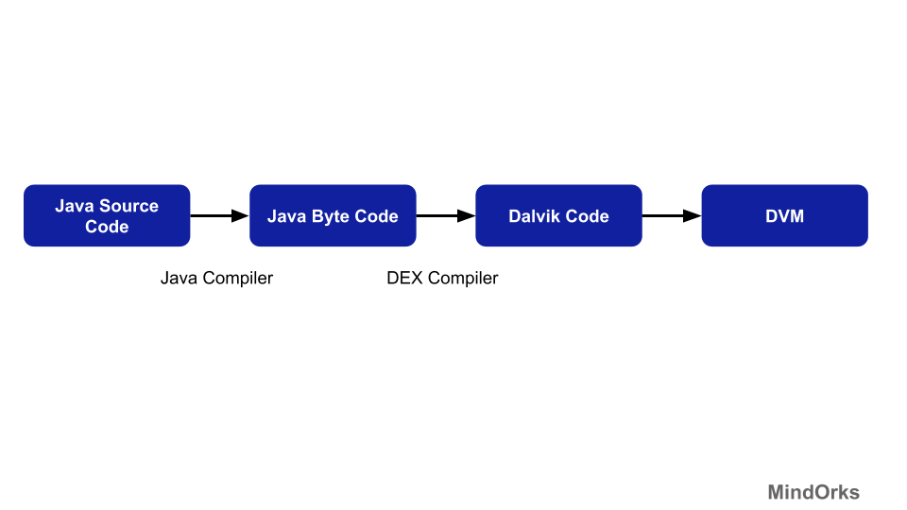

#### What is ART?

ART or Android Runtime is an Android runtime that uses Ahead Of Time(AOT). By using AOT, what is does is it converts or compiles the whole High-level language code into Machine level code and at the time of installation of the app and not dynamically as the application runs(like in case of Dalvik). By compiling the whole code during installation results in no lag that we see when we run our app on our device. By doing so, the compilation becomes very faster. Following are some of the words about ART from the Android Developers website:

ART is a new Android runtime being introduced experimentally in the 4.4 release KitKat. This is a preview of work in progress in KitKat. It is available for obtaining early developer and partner feedback.

Following shows the flow of execution of ART:

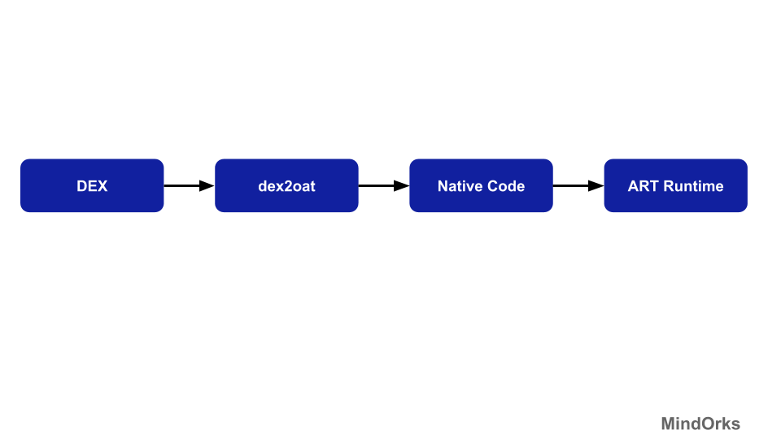

#### Difference between ART and Dalvik

1. Approach: ART uses AOT(Ahead Of Time) approach and compiles the whole code during the installation time but the Dalvik uses JIT(Just In Time) approach and complies only a part of the code during installation and rest of the code will be compiled dynamically.
2. Booting time: As compare to Dalvik, ART takes more time to reboot because the cache is built at the first time. So, the booting is slow.
3. Space: Since ART uses the AOT approach, so it needs more space during installation. While Dalvik uses the JIT approach, so for mobile phones having less storage can use the Dalvik.
4. Battery: ART increases battery performance to a large extent because of the AOT approach. While the Dalvik uses the JIT approach and this results in more battery utilization.
5. Garbage Collection: ART has better garbage collection than Dalvik.

So, DVM uses JIT and have a lot of drawbacks that were replaced by ART. So, from Android 4.4(Kitkat) ART was introduced as runtime and finally from Android 5.0(Lollipop), the Dalvik was completely replaced by ART by Android.

#### Benefits of using ART over Dalvik

1. The application will run faster as compilation is done during installation only.
2. Performance of the battery will be increased by using ART.
3. The garbage collection is also improved.
4. As the native code is directly executed, ART reduces the startup time of applications.

#### Drawbacks of ART

1. Since the compilation of the code is done once, ART requires more space or storage during installation.
2. The booting time is more as compared to Dalvik because it uses the concept of AOT.

#### Conclusion

If you are using ART, then you must have felt the difference while using the application i.e. by using ART, you will see a huge improvement in the speed and smoothness of your Android application. ART is still under development and many new features are being added to ART to give a better experience of Android to users and Android developers.

**Question:**  Android - retaining fragment?

**Answer:**  **setRetainInstance(true)**: The Fragment's state will be retained (and not destroyed!) across configuration changes (e.g. screen rotate). The state will be retained even if the configuration change causes the "parent" Activity to be destroyed. However, the view of the Fragment gets destroyed!

*Lifecycle Calls:*

* onPause() -> onStop() -> onDestroyView() -> onDetach()
* onAttach() -> onCreateView() -> onStart() -> onResume()

**setRetainInstance(false):** The Fragment's state will not be retained across configuration changes (default).

*Lifecycle Calls:*

* onPause() -> onStop() -> onDestroyView() -> onDestroy() -> onDetach()
* onAttach() -> onCreate() -> onCreateView() -> onStart() -> onResume()

**Important**: setRetainInstance(true) does not work with fragments on the back stack. setRetainInstance(true) is especially useful for long running operations inside Fragments which do not care about configuration changes.

**Question:**  When to use Android's ArrayMap instead of a HashMap?

**Answer:**  ArrayMap uses way less memory than HashMap and is recommended for up to a few hundred items, especially if the map is not updated frequently. Spending less time allocating and freeing memory may also provide some general performance gains.

Update performance is a bit worse because any insert requires an array copy. Read performance is comparable for a small number of items and uses binary search.

**Question:**  Communicating between Android apps

**Answer:**  Android inter-process communication

At the simplest level, there are two different ways for apps to interact on Android: via intents, passing data from one application to another; and through services, where one application provides functionality for others to use. There are different ways to utilize both methods, depending on what you want to accomplish and what technical challenges you face. This is a brief overview and I will avoid delving into the technical aspects.

### Intents

An [intent](http://developer.android.com/guide/components/intents-filters.html) describes an action to be performed, such as opening a file, dialing a phone number, or turning on airplane mode. The first two are actions that can be initiated by user apps, while the latter is a system-wide notification that any app can act on. For example, if you tap on a PDF in a file browser it will probably try to start up a document viewer app so you can read it. In this case, the file browser is using an intent to start an [activity](http://developer.android.com/reference/android/app/Activity.html) to view the file and passing the path to the file as part of the intent’s data. The system receives the intent and opens a different app that has registered with the system that it can view PDF files—or if you have multiple apps that are capable, you might be presented with a list to choose from. Additionally, should an app want to run an action in the background rather than requiring any user interaction, an intent can instead be used to start a [service](http://developer.android.com/reference/android/app/Service.html) rather than an activity. Any app can also utilize [broadcast receivers](http://developer.android.com/reference/android/content/BroadcastReceiver.html), which will listen to system-wide messages. An app might want stop trying to connect to the internet once airplane mode is engaged, so by registering a broadcast receiver with the system to listen for an intent with that specific action, the app can tell when it happens and act on it. Intents can also carry extra data via a [bundle](http://developer.android.com/reference/android/os/Bundle.html), which can handle any kind of serializable data. As the data in a bundle is stored using arbitrary keys, this is generally only useful if the receiving app knows the context for the incoming data.

### Services

One feature of a service is to perform an action in the background as mentioned above, similar to an activity but without user interface components. The other primary use of a service is to provide [bindings](http://developer.android.com/guide/components/bound-services.html), which lets an app expose part of its functionality to other applications. Other apps bound to the service will have a persistent connection that lets them call methods defined on the service, which can directly interact with other parts of the app. Using an example app that controls a VPN connection on the device, a service provided by the app could allow other applications to get information about the VPN connection, its current state, or even turn the connection on or off. While toggling the connection could also be handled by a simple intent action, having access to the other information provided by the service can allow apps to intelligently interact with it.

**Question:**  Why fragments, and when to use fragments instead of activities?

**Answer:**  Fragments are Android's solution to creating reusable user interfaces. You can achieve some of the same things using activities and layouts (for example by using includes). However; fragments are wired in to the Android API, from HoneyComb, and up. Let me elaborate;

* The ActionBar. If you want tabs up there to navigate your app, you quickly see that ActionBar.TabListener interface gives you a FragmentTransaction as an input argument to the onTabSelected method. You could probably ignore this, and do something else and clever, but you'd be working against the API, not with it.
* The FragmentManager handles «back» for you in a very clever way. Back does not mean back to the last activity, like for regular activities. It means back to the previous fragment state.
* You can use the cool ViewPager with a FragmentPagerAdapter to create swipe interfaces. The FragmentPagerAdapter code is much cleaner than a regular adapter, and it controls instantiations of the individual fragments.
* Your life will be a lot easier if you use Fragments when you try to create applications for both phones and tablets. Since the fragments are so tied in with the Honeycomb+ APIs, you will want to use them on phones as well to reuse code. That's where the compatibility library comes in handy.
* You even could and should use fragments for apps meant for phones only. If you have portability in mind. I use ActionBarSherlock and the compatibility libraries to create "ICS looking" apps, that look the same all the way back to version 1.6. You get the latest features like the ActionBar, with tabs, overflow, split action bar, viewpager etc.

Bonus 2

The best way to communicate between fragments are intents. When you press something in a Fragment you would typically call StartActivity() with data on it. The intent is passed on to all fragments of the activity you launch.

**Question:**  What is the difference between compileSdkVersion and targetSdkVersion?

**Answer:**  **As a oneliner guide:**

minSdkVersion <= targetSdkVersion <= compileSdkVersion

**Ideally:**

minSdkVersion (lowest possible) <= targetSdkVersion == compileSdkVersion (latest SDK)

[Read more from this great post by Ian Lake](https://medium.com/google-developers/picking-your-compilesdkversion-minsdkversion-targetsdkversion-a098a0341ebd#.bpqsg4ili)

P.S. And as clipped by @sshturma in answer below:  


**Question:**  What is Parcelable in android

**Answer:**  This concept is called [**Parcelable**](https://developer.android.com/reference/android/os/Parcelable.html)

A Parcelable is the Android implementation of the Java Serializable. It assumes a certain structure and way of processing it. This way a Parcelable can be processed relatively fast, compared to the standard Java serialization.

To allow your custom object to be parsed to another component they need to implement the android.os.Parcelable interface. It must also provide a static final method called CREATOR which must implement the Parcelable.Creator interface.

The code you have written will be your model class.

You can use Parcelable in Activity like :

intent.putExtra("student", new Student("1")); //size which you are storing

And to get this object :

Bundle data = getIntent().getExtras(); Student student = (Student) data.getParcelable("student");

Here Student is a model class name. replace this with yours.

In simple terms Parcelable is used to send a whole object of a model class to another page.

In your code this is in the model and it is storing int value *size* to Parcelable object to send and retrieve in other activity.

**Reference :**

[Tutorial 1](http://www.vogella.com/tutorials/AndroidParcelable/article.html)

[Tutorial 2](https://stackoverflow.com/questions/7181526/how-can-i-make-my-custom-objects-parcelable)

[Tutorial 3](https://dzone.com/articles/using-android-parcel)

**Question:**  Purpose of Android Support Library

**Answer:**

**When should I use the Android Support Library?**

As new versions of Android are released, some style and behaviors may change. You should use one of the support libraries when you need specific framework features that are newer than the minSdkVersion of your app or that are not available in the standard framework.

**What does support library actually do?**

There are many devices still running in Jelly bean and below versions. So you need to give the same importance for old and new devices While making an app. Otherwise, the App in old devices looks dull when compared to new ones. That may affect the app’s market. To avoid this trouble, Android introduced the Support library. These are set of code libraries provides backward compatibility

**Example:**[Fragment](https://developer.android.com/guide/components/fragments) API was introduced in API 11 [HONEYCOMB](https://developer.android.com/about/versions/android-3.0-highlights) .android.app.Fragment is the Fragment class introduced in API 11 and android.support.v4.app.Fragment is the Fragment class in the android support library,

If you want to make your app use fragments, and want to **target devices before API 11**, you must use android.support.v4.app.Fragment. However, if you want only **targeting devices >=API 11** ,you can use android.app.Fragment.Therefore, android.support.v4.app.FragmentManager is used to deliver newer features to older platforms.

For more info about android support library:[doc](https://developer.android.com/topic/libraries/support-library)

**Question:**  When to use Android Loaders

**Answer:**  The best way I can describe a Loader is a Handler that is always on. Both Loaders and Handlers pass data between objects.

I agree with what you said about the "livescore" app. The Loader monitors the source of their data and delivers new results when the content changes.

To answer your questions:

1) Loaders are best option when we want to observe a data source and change our view so it will display the new data?

A: Yes. if your data source is constantly updating. For example, like a stock-ticker app. If your data isn't constantly updating, then no, don't use a loader. For example, if your data source is only retrieved once, then there's no need for a Loader.

2) Are there any examples/app I can check dealing with that logic : monitor the data source -> get the data -> refresh UI

A: https://www.youtube.com/watch?v=3d9BeWqlfTk

**Question:**  Isn't android's Bundle functionally equivalent with a Map?

**Answer:**  First, a Map does not necessarily have String keys.

Second, while a Map can hold arbitrary objects, it cannot do so in a typesafe fashion. IOW, if you want the Map to hold strings, integers, and so forth, you will need to keep casting the results of get() calls, because your Map would have to be Map<String, Object>.

Third, Bundle implements Parcelable, which is very important for Android IPC. Map is an interface and does not extend Parcelable.

Can it be theoretically converted to a mapping?

Um, sure, though I fail to see what the benefit would be.

What is the way to do this?

Iterate over the keySet() and call get() on the Bundle for each key, putting the result into a Map<String, Object>.

**Question:**  Android : Difference between View.GONE and View.INVISIBLE?

**Answer:**  I'd like to add to the right and successful answers, that if you initialize a view with visibility as View.GONE, the view could have been not initialized and you will get some random errors.

For example if you initialize a layout as View.GONE and then you try to start an animation, from my experience I've got my animation working randomly times. Sometimes yes, sometimes no.

So before handling (resizing, move, whatever) a view, you have to init it as View.VISIBLE or View.INVISIBLE to render it (draw it) in the screen, and then handle it.

**Question:**  How to Pass data from One activity to another without using intents?

**Answer:**  You can try by using Singleton

public class Singleton{

private static Singleton instance;

private Singleton(){

}

public static Singleton getInstance(){

if (instance == null){

instance = new Singleton();

}

return instance;

}

// your fields, getter and setter here

}

Then in your 1st activity

Singleton a = Singleton.getInstance();

a.setFoo("something here");

and then your 2nd activity

Singleton b = Singleton.getInstance();

b.getFoo();

**Question:**  How to declare global variables in Android?

**Answer:**  The suggested by Soonil way of keeping a state for the application is good, however it has one weak point - there are cases when OS kills the entire application process. Here is the documentation on this - Processes and lifecycles.

Consider a case - your app goes into the background because somebody is calling you (Phone app is in the foreground now). In this case && under some other conditions (check the above link for what they could be) the OS may kill your application process, including the Application subclass instance. As a result the state is lost. When you later return to the application, then the OS will restore its activity stack and Application subclass instance, however the myState field will be null.

AFAIK, the only way to guarantee state safety is to use any sort of persisting the state, e.g. using a private for the application file or SharedPrefernces (it eventually uses a private for the application file in the internal filesystem).

**Question:**  what is the different between onCreate() and onCreateView() lifecycle methods in Fragment?

**Answer:**  onCreate is called on initial creation of the fragment. You do your non graphical initializations here. It finishes even before the layout is inflated and the fragment is visible.

onCreateView is called to inflate the layout of the fragment i.e graphical initialization usually takes place here. It is always called some time after the onCreate method.

**Question:**  Android JobScheduler — Schedule your jobs like a master!

**Answer:**  Before job schedulers, whenever I encountered a use case where I wanted to do some background processing, I had to make decisions about which android primitive to use. I had to weigh in the pros and cons of each and then proceed with it.

1. AsyncTasks
2. Combination of handlerThreads and services.

3. Java 5 executor services.

4. Combination of AlarmManager with broadcast receivers and intent services and many more.

One thing was common in all these approaches, as a developer, I had to handle lots of things apart from the business logic, such as when do we trigger this service? How to make sure the services fire even if the app is killed, how to make sure that alarms are fired at regular intervals? If work is aborted, then how will we retry? When to acquire wake locks and when to release them and many more things. I had to write lots of code for doing all these things.

After the introduction of [JobScheduler](https://developer.android.com/reference/android/app/job/JobScheduler), we as developers we have to prepare a contract of how we need the job to get scheduled and what are the conditions in which jobs will execute and hand it over to the Android framework, and we can focus on the work that needs to be done. Android will execute your job at correct times. Android system has a service running called “JobSchedulerService” which executes your requests. We will learn more about the internals of this service in upcoming posts.

If we want to know job schedulers thoroughly, we need to understand the various classes present the API and their uses. We will deal with 2 basic classes that will help us create jobs right after this article.

[JobInfo](https://developer.android.com/reference/android/app/job/JobInfo) — The class is an abstraction that hides the task that needs to be done and the conditions under which the tasks will get executed. As I explained earlier, this is our contract with the JobScheduler. We do not have to build this class directly, we have accessor methods in this class to examine the contract. We have a builder available to build instances of JobInfo. We submit job info to the job schedulers. We can post multiple work items to a single jobInfo. We will learn how to do it. Usually, related work should be kept under the same job info.

The analogy should be JobInfo is your offlice job, and each work item object ie JobWorkItem is work which you get. One JobInfo can use used to enqueue multiple JobWorkItem

[JobInfo.Builder](https://developer.android.com/reference/android/app/job/JobInfo.Builder) — Create your contract with the JobScheduler service using this builder. Now let’s understand why the APIs look like what they are.

Suppose you are exposing a service to other applications so that you can process requests coming from them. You will need to establish a contract for the kinds of requests you receive. The contract must specify,

1. The request which needs to get processed.

2. Must specify a unique identifier for each request so that requests can be accessed at any point in time.

3. Any special requests or flags which give additional information about how the requests need to be processed.

This the same with JobScheduler. JobInfo.Builder exposes a constructor that accepts jobID and the piece of work that needs to get executed. A bare minimum to create a contract!

public Builder(int jobId, @NonNull ComponentName jobService)

Through this class, we can specify criteria for our jobs, whether we need a network or not, if yes, then what type of network, the job is periodic or not, its battery requirements, delay tolerance and many more.

There are lots of constraints that we can specify and certain rules which are followed by framework while evaluating these constraints. Will will discuss that in another post.

After android Q you can just create job info without any constraint and the job scheduler happily accepts it. Before Q the app will crash. So the question is how the job will get executed then without any constraints? Majority of contraints have default values. Execution strategy will be determined by the default values of contraints. More details later on. Let’s keep our focus on!

[JobService](https://developer.android.com/reference/kotlin/android/app/job/JobService) — This is the block of work that we create and provide to the android JobSchedulerService via the JobInfo and whenever the constraints match, JobService’s callbacks are fired.

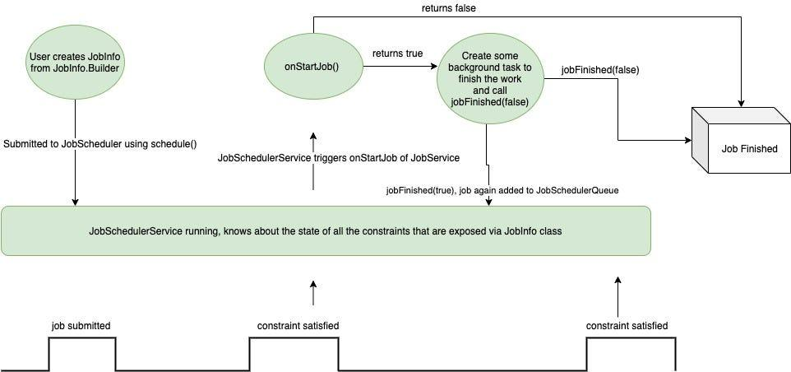

1. The basic flow diagram for JobService without multiple JobWorkItems.

For each job service we create, we need to add this permission in the android manifest.

<service android:name="MyJobServiceName"

android:permission="android.permission.BIND_JOB_SERVICE" >

...

</service>

We can execute one or more units of related work inside a JobService by enqueuing multiple work items to single JobInfo, for now, we will understand just with JobService.

The API exposes 3 methods,

1. public abstract boolean onStartJob ([JobParameters](https://developer.android.com/reference/android/app/job/JobParameters) params) -- callback from system when contraints are satisfied, start doing work

2. public abstract boolean onStopJob ([JobParameters](https://developer.android.com/reference/android/app/job/JobParameters) params) -- callback from system when contraints are not satisfied, stop and/or save work.

3. public final void jobFinished ([JobParameters](https://developer.android.com/reference/android/app/job/JobParameters) params,

boolean wantsReschedule) -- user may/maynot call this. If we return true from onStartJob() then this is used to notify the system when our work is finished, so that it can release the resources.

Once we submit our job info to the job scheduler service using schedule() call, what happens is demonstrated in diagram 1. We will call the job scheduler service as “System” from now for ease of speaking.

1. Once the System determines that the constraints, we provided are satisfied, it calls onStartJob() callback of your job service, this is where we should respond to it and do our job. The system acquires wakelock on your behalf, if we do not have to do anything computation-intensive then we can finish our work and return false from this callback.

Returning false means we say that our job is done, release all the wake-locks and other resources acquired on my behalf, and mark the job as done.

Returning true tells the system that, the job is not done right now, we do not know when it will get finished as it might be running in the background. But once the job is finished, we will let you know. Job completion, in this case, is indicated by the jobFinished() method. Till we call this method, system will hold on to all the resources for us.

2. Whenever the constraints for our jobinfo are no longer satisfied, the system gives a callback to onStopJob() of JobService. Here, we need to make sure that we stop our job entirely or we can save the state so that we can resume when the constraints are satisfied again. Once this method returns, the system will release all the resources. The return values here also convey different meanings.

Returning true means we want to job to reschedule it later when constraints are again met.

Returning false means we want to end this job entirely right now and the job scheduler will not call onStartJob() when the constraint will be satisfied again

These callbacks and methods allow us to bring in save — n — resume strategy in our approach. The best approach would be to divide the whole job into multiple granular units and mark the state of the job as and when work is done so that the next execution can pick up from where we left the last time.

I will explain this with a working example where work is mimicked by a counter task which will count till 100, each count can be considered a granular unit of work. It can be downloading an image or writing/reading a record to/from the server.

Working with Async Jobs with JobSchedulers and saving state and resuming

Code to schedule the above JobService is

val jobScheduler = getSystemService(Context.JOB_SCHEDULER_SERVICE) as JobScheduler

val jobInfo = JobInfo.Builder(123, ComponentName(this,DeepJobService::class.java))

val job = jobInfo.setRequiresCharging(false)

.setMinimumLatency(1)

.setRequiredNetworkType(JobInfo.NETWORK_TYPE_ANY)

.setOverrideDeadline(3*60*1000).build()

jobScheduler.schedule(job)

The above job should run when the network is available, when you run the above job it will start printing numbers from 0,1,2,3... When the network is disconnected by turning wifi off it stops the job and prints Job paused. When the network is again turned on, it resumes from 3,4,5... and so on.

If your job is such that you can’t break it into pieces then, finish it on onStopJob() callback by returning true from it. When the next time the constraints will be satisfied, the whole job will be re-run.

If your job does not require any background processing and asynchronous work then, no need to create async tasks or any other multi-threading primitive. Just do your work in onStartJob() itself and return false to indicate that your job is done. This is useful if you just want to send some broadcast or something of that kind.

The job scheduler provides some APIs to query, cancel, and enqueue jobs, which doesn’t require much explanation.

abstract void [cancel](https://developer.android.com/reference/android/app/job/JobScheduler#cancel(int))(int jobId)

abstract void [cancelAll](https://developer.android.com/reference/android/app/job/JobScheduler#cancelAll())()

abstract int [enqueue](https://developer.android.com/reference/android/app/job/JobScheduler#enqueue(android.app.job.JobInfo,%20android.app.job.JobWorkItem))([JobInfo](https://developer.android.com/reference/android/app/job/JobInfo) job, [JobWorkItem](https://developer.android.com/reference/android/app/job/JobWorkItem) work)

abstract [List](https://developer.android.com/reference/java/util/List)<[JobInfo](https://developer.android.com/reference/android/app/job/JobInfo)> [getAllPendingJobs](https://developer.android.com/reference/android/app/job/JobScheduler#getAllPendingJobs())()

abstract [JobInfo](https://developer.android.com/reference/android/app/job/JobInfo) [getPendingJob](https://developer.android.com/reference/android/app/job/JobScheduler#getPendingJob(int))(int jobId)

abstract int [schedule](https://developer.android.com/reference/android/app/job/JobScheduler#schedule(android.app.job.JobInfo))([JobInfo](https://developer.android.com/reference/android/app/job/JobInfo) job)

This is how we work with JobScheduler APIs. Next, we will see how we can enqueue multiple work items to a given JobInfo. It is always a good idea to tie related work into a single JobInfo.

**Question:**  Android: When should I use a Handler() and when should I use a Thread?

**Answer:**  Handlers are the best way of communication between the background and UI thread. Generally Handlers are associated with message Queue of a Thread and they are used to send messages and runnable to the Message.

**USE:**

**Thread:** To do tasks in saperate(Background) thread than UI thread. (helps to unblock the UI thread)

**Handler** Used to communicate between the UI and Background thread.

Have a look at this [article](https://blog.mindorks.com/android-core-looper-handler-and-handlerthread-bd54d69fe91a)

**Question:**  Difference between AsyncTask and Thread/Runnable

**Answer:**  [AsyncTask](http://developer.android.com/reference/android/os/AsyncTask.html) is a convenience class for doing some work on a new thread and use the results on the thread from which it got called (usually the UI thread) when finished. It's just a wrapper which uses a couple of runnables but handles all the intricacies of creating the thread and handling messaging between the threads.

AsyncTask enables proper and easy use of the UI thread. This class allows to perform background operations and publish results on the UI thread without having to manipulate threads and/or handlers.

AsyncTask is designed to be a helper class around Thread and Handler and does not constitute a generic threading framework. AsyncTasks should ideally be used for short operations (a few seconds at the most.) If you need to keep threads running for long periods of time, it is highly recommended you use the various APIs provided by the java.util.concurrent pacakge such as Executor, ThreadPoolExecutor and FutureTask.

An asynchronous task is defined by a computation that runs on a background thread and whose result is published on the UI thread. An asynchronous task is defined by 3 generic types, called Params, Progress and Result, and 4 steps, called onPreExecute, doInBackground, onProgressUpdate and onPostExecute.

The [Runnable](http://docs.oracle.com/javase/7/docs/api/java/lang/Runnable.html) interface is at the core of Java threading. The Runnable interface should be implemented by any class whose instances are intended to be executed by a thread.

Also if I quote from [this blog](http://mehdok.blogspot.in/2011/10/java-thread-vs-android-asynctask.html):

if you need SIMPLE coding use AsyncTask and if you need SPEED use traditional java Thread.

**Question:**  What is the difference between an IntentService and a Service?

**Answer:**  Service

Task with no UI,but should not use for long Task. Use Thread within service for long Task

Invoke by onStartService()

Triggered from any Thread

Runs On Main Thread

May block main(UI) thread

IntentService

Long task usually no communication with main thread if communication is needed then it is done by Handler or broadcast

Invoke via Intent

triggered from Main Thread (Intent is received on main Thread and worker thread is spawned)

Runs on separate thread

We can't run task in parallel and multiple intents are Queued on the same worker thread.

**Question:**  What is the difference between Activity and Context?

**Answer:**  As far as I understand: [Context](http://developer.android.com/reference/android/content/Context.html) is the Base Object. So every [Activity](http://developer.android.com/reference/android/app/Activity.html) same as [Application](http://developer.android.com/reference/android/app/Application.html) derives from Context. This means that every Activity and every Application IS a Context;

From developer.android.com [Activity](http://developer.android.com/reference/android/app/Activity.html#jd-content)

java.lang.Object ↳ android.content.Context ↳ android.content.ContextWrapper ↳ android.view.ContextThemeWrapper ↳ android.app.Activity

And [Application](http://developer.android.com/reference/android/app/Application.html)

java.lang.Object ↳ android.content.Context ↳ android.content.ContextWrapper ↳ android.app.Application

An Application context lasts, as long as your app is alive, while the Activity context dies with your Activity (it is not valid after onDestroy of that Activity).

So if you need the Context across Activities (i.e. in a Singleton) you will be better off using an Application context.

Usually on Android Framework methods where a context is expected, it makes no difference which one you pass. But be always aware of [MemoryLeaks](https://android-developers.googleblog.com/2009/01/avoiding-memory-leaks.html) if you're keeping long-living References to a Context

**Question:**  What is Android Data Binding?

**Answer:**  <https://developer.android.com/topic/libraries/data-binding#:~:text=The%20Data%20Binding%20Library%20is,that%20calls%20UI%20framework%20methods.>

**Question:**  What are the permission protection levels in Android?

**Answer:**  Android Developer! Welcome to my Android permission protection levels article. Today, I am going to explain different protection levels on Android. As you can guess, Permissions are one of the critical part of our applications, for this reason, when we use them, we have to be extremely careful.

Also, when choosing these permissions, we should be careful about what we need, because some kind of permissions can lead to undesirable situations which user does not want. Now, Let’s look at these protection levels.

There are three permission protection levels in Android are as follows:

1. Normal Permissions
2. Signature Permissions
3. Dangerous Permissions

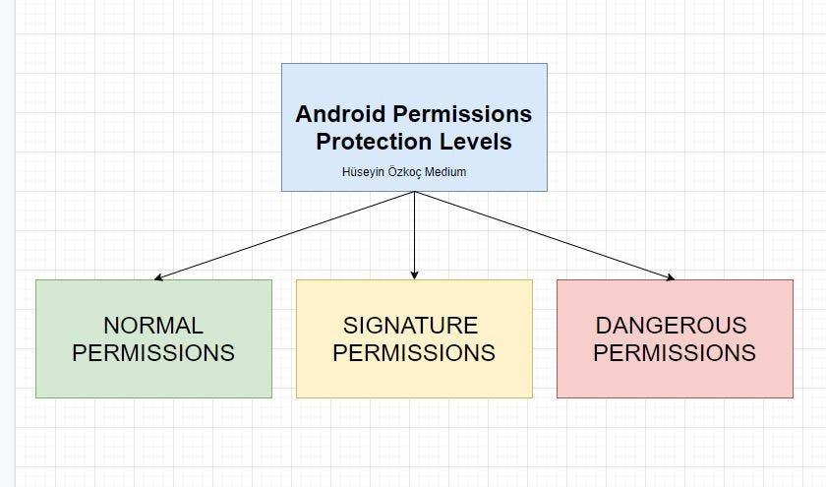

What are the different protection levels in Android?

# Normal Permissions

These types of permissions are not too risky for the user and the system. Sometimes the system automatically grants these permissions to our app.

Let’s see normal permissions:

1. ACCESS_LOCATION_EXTRA_COMMANDS
2. ACCESS_NETWORK_STATE
3. CHANGE_NETWORK_STATE
4. ACCESS_WIFI_STATE
5. CHANGE_WIFI_STATE
6. CHANGE_WIFI_MULTICAST_STATE
7. BLUETOOTH
8. BLUETOOTH_ADMIN
9. INTERNET
10. SET_ALARM
11. SET_WALLPAPER
12. VIBRATE
13. WAKE_LOCK

# Signature Permissions

The Android system gives these rights during installation, but there is a problem. The app requesting permission must be signed with the same signature as the app defining the needed permission.

Let’s see signature permissions:

1. BIND_ACCESSIBILITY_SERVICE
2. BIND_AUTOFILL_SERVICE
3. BIND_CARRIER_SERVICE
4. BIND_DEVICE_ADMIN
5. BIND_INPUT_METHOD
6. BIND_NFC_SERVICE
7. BIND_TV_INPUT
8. BIND_WALLPAPER
9. READ_VOICEMAIL
10. WRITE_SETTINGS
11. WRITE_VOICEMAIL

# Dangerous Permissions

These permissions are extremely dangerous for the user and the system because they can somehow use the user’s data.

Let’s see dangerous permissions:

1. READ_CALENDAR
2. WRITE_CALENDAR
3. CAMERA
4. READ_CALL_LOG
5. WRITE_CALL_LOG
6. READ_CONTACTS
7. WRITE_CONTACTS
8. GET_ACCOUNTS
9. ACCESS_FINE_LOCATION
10. ACCESS_COARSE_LOCATION
11. SEND_SMS
12. RECEIVE_SMS

As a conclusion, Android protection levels consist of 3 parts and all these levels are very important in relation to the application that we will develop.

**Question:**  Describe different types of Services in Android

**Answer:**  Ever thought of a music player, as a service? Yes, the music player is a service. Not sure how? Well, it runs in the background while the user happily uses some other application, isn’t it? For a better understanding, consider an online music player that uses the internet and plays music in the background. Now, let’s understand its technical part.

## What are Android Services?

Android Services are the application components that run in the background. We can understand it as a process that doesn’t need any direct user interaction. As they perform long-running processes without user intervention, they have no User Interface. They can be connected to other components and do inter-process communication (IPC).

Did you check the previous [tutorial on Android activity](https://data-flair.training/blogs/android-activity/)?

### Types of Android Services

When we talk about services, they can be of three types as shown in the figure below:

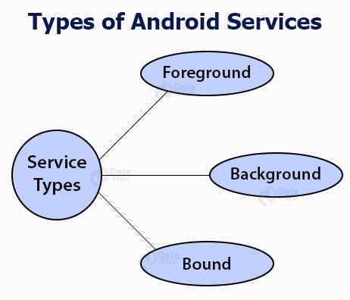

The working of these three services is below:

#### 1. Foreground Services

Foreground services are those services that are visible to the users. The users can interact with them at ease and track what’s happening. These services continue to run even when users are using other applications.

The perfect example of this is Music Player and Downloading.

#### 2. Background Services

These services run in the background, such that the user can’t see or access them. These are the tasks that don’t need the user to know them.

Syncing and Storing data can be the best example.

#### 3. Bound Services

Bound service runs as long as some other [application component](https://data-flair.training/blogs/android-application-components/) is bound to it. Many components can bind to one service at a time, but once they all unbind, the service will destroy.

To bind an application component to the service, bindService() is used.

### Lifecycle of Android Services

Android services life-cycle can have two forms of services and they follow two paths, that are:

1. Started Service
2. Bounded Service

Let us see these services and their approach.

#### 1. Started Service

A service becomes started only when an application component calls startService(). It performs a single operation and doesn’t return any result to the caller. Once this service starts, it runs in the background even if the component that created it destroys. This service can be stopped only in one of the two cases:

* By using the stopService() method.
* By stopping itself using the stopSelf() method.

#### 2. Bound Service

A service is bound only if an application component binds to it using bindService(). It gives a client-server relation that lets the components interact with the service. The components can send requests to services and get results.

This service runs in the background as long as another application is bound to it. Or it can be unbound according to our requirement by using the unbindService() method.

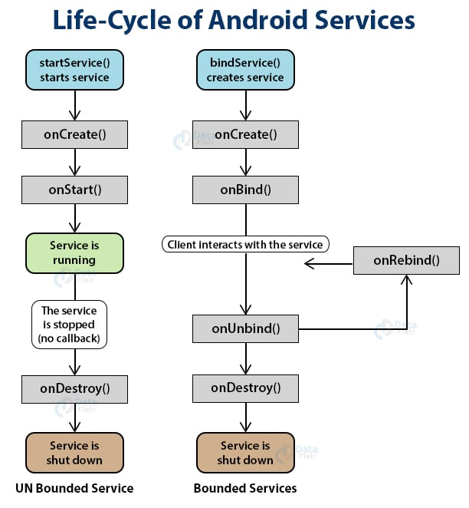

#### IntentService()

There’s an additional service class, that extends Service class, IntentService Class. It is a base class for services to handle asynchronous requests. It enables running an operation on a single background. It executes long-running programs without affecting any user’s interface interaction. Intent services run and execute in the background and terminate themself as soon as they are executed completely.

Certain important features of Intent are :

* It queues up the upcoming request and executes them one by one.
* Once the queue is empty it stops itself, without the user’s intervention in its lifecycle.
* It does proper thread management by handling the requests on a separate thread.

### Methods of Android Services

The service base class defines certain callback methods to perform operations on applications. When we talk about Android services it becomes quite obvious that these services will do some operations and they’ll be used. The following are a few important methods of Android services :

* onStartCommand()
* onBind()
* onCreate()
* onUnbind()
* onDestroy()
* onRebind()

Let us see these methods in detail:

#### 1. onStartCommand()

The system calls this method whenever a component, say an activity requests ‘start’ to a service, using startService().

Once we use this method it’s our duty to stop the service using stopService() or stopSelf().

#### 2. onBind()

This is invoked when a component wants to bind with the service by calling bindService(). In this, we must provide an interface for clients to communicate with the service. For interprocess communication, we use the IBinder object.

It is a must to implement this method. If in case binding is not required, we should return null as implementation is mandatory.

#### 3. onUnbind()

The system invokes this when all the clients disconnect from the interface published by the service.

#### 4. onRebind()

The system calls this method when new clients connect to the service. The system calls it after the onBind() method.

#### 5. onCreate()

This is the first callback method that the system calls when a new component starts the service. We need this method for a one-time set-up.

#### 6. onDestroy()

This method is the final clean up call for the system. The system invokes it just before the service destroys. It cleans up resources like [threads](https://developer.android.com/reference/java/lang/Thread), receivers, registered listeners, etc.

### Implementation of Android Services

Now we’ll implement services in our [Android Studio](https://data-flair.training/blogs/installing-android-studio/) with the following code. Along with this, we’ll see the implementation of a few of the callback methods that are required for the service implementation.

1. Now for this, we’ll create a project in our Android Studio and name it. We’re naming it as Service. Then we’ll write the following code in our activity_main.xml:

<?xml version="1.0" encoding="utf-8"?>

<LinearLayout xmlns:android="http://schemas.android.com/apk/res/android"

android:orientation="vertical" android:layout_width="match_parent"

android:layout_height="match_parent">

<TextView

android:id="@+id/textView2"

android:layout_width="wrap_content"

android:layout_height="wrap_content"

android:layout_centerHorizontal="true"

android:layout_marginLeft="100dp"

android:text="DataFlair "

android:textColor="@color/colorPrimaryDark"

android:textSize="50dp" />

<Button

android:id="@+id/btnStart"

android:layout_width="wrap_content"

android:layout_height="wrap_content"

android:layout_marginLeft="50dp"

android:layout_marginTop="50dp"

android:onClick="startService"

android:text="Start Service" />

<Button

android:id="@+id/btnstop"

android:layout_width="wrap_content"

android:layout_height="wrap_content"

android:layout_marginLeft="50dp"

android:layout_marginTop="50dp"

android:onClick="stopService"

android:text="Stop Service" />

</LinearLayout>

2. After this, we’ll write the following code in MainActivity.java:

package com.DataFlair.DataFlair_Services;

import android.content.Intent;

import android.os.Bundle;

import android.view.View;

import androidx.appcompat.app.AppCompatActivity;

public class MainActivity extends AppCompatActivity {

@Override

protected void onCreate(Bundle savedInstanceState) {

super.onCreate(savedInstanceState);

setContentView(R.layout.activity_main);

}

public void startService(View view) {

startService(new Intent(this, DataFlairService.class));

}

public void stopService(View view) {

stopService(new Intent(this, DataFlairService.class));

}

}

3. Now open the Manifest.xml file. Following code is to be written in the Manifest file:

<?xml version="1.0" encoding="utf-8"?>

<manifest xmlns:android="http://schemas.android.com/apk/res/android"

package="com.DataFlair.DataFlair_Services">

<application

android:allowBackup="true"

android:icon="@mipmap/ic_launcher"

android:label="@string/app_name"

android:roundIcon="@mipmap/ic_launcher_round"

android:supportsRtl="true"

android:theme="@style/AppTheme">

<activity android:name="com.DataFlair.DataFlair_Services.MainActivity">

<intent-filter>

<action android:name="android.intent.action.MAIN" /&gt;

<category android:name="android.intent.category.LAUNCHER" />

</intent-filter>

</activity>

<service android:name="com.DataFlair.DataFlair_Services.DataFlairService" />

</application>

</manifest>

4. And finally, we’ll create a file, a java class, and name it. We’re naming it DataFlairService.java. After this file is created, we’ll write the following code in it:

package com.DataFlair.DataFlair_Services;

import android.app.Service;

import android.content.Intent;

import android.media.MediaPlayer;

import android.os.IBinder;

import android.provider.Settings;

import android.widget.Toast;

public class DataFlairService extends Service {

private MediaPlayer player;

@Override

public IBinder onBind(Intent intent) {

return null;

}

@Override

public void onCreate() {

Toast.makeText(this, "Service was Created", Toast.LENGTH_LONG).show();

}

@Override

public int onStartCommand(Intent intent, int flags, int startId) {

player = MediaPlayer.create(this, Settings.System.DEFAULT_RINGTONE_URI);

player.setLooping(true);

player.start();

Toast.makeText(this, "Service Started", Toast.LENGTH_LONG).show();

return START_STICKY;

}

@Override

public void onDestroy() {

super.onDestroy();

player.stop();

Toast.makeText(this, "Service Stopped", Toast.LENGTH_LONG).show();

}

}

5. After we’ve written all the codes respectively, we’ll run our app now. The following would be shown to us as our output:

This is our application wherein we can Start and Stop our service.

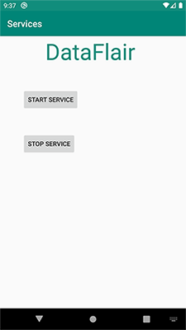

Now we’ve clicked on Start Service, therefore Service is created first.

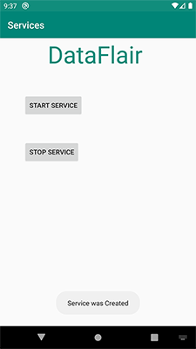

After the service is created, it will start executing.

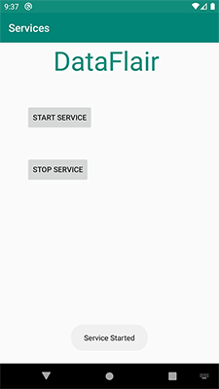

After that, we can stop our service whenever we like to stop them.

As we can see below, the service has stopped.

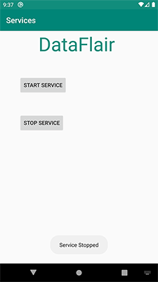

## Summary

Now that we’ve read about Android services, let us see it once again in brief. Android services are the long-running processes that don’t need user interaction. These services run in the background. They work either in Started mode or Bound mode. It has also got a few important methods that provide a few important operations.

**Question:**  What is the difference between ListView and RecyclerView?

**Answer:**  RecyclerView was created as a ListView improvement, so yes, you can create an attached list with ListView control, but using RecyclerView is easier as it:

1. Reuses cells while scrolling up/down - this is possible with implementing View Holder in the ListView adapter, but it was an optional thing, while in the RecycleView it's the default way of writing adapter.
2. Decouples list from its container - so you can put list items easily at run time in the different containers (linearLayout, gridLayout) with setting LayoutManager.

Example:

mRecyclerView = (RecyclerView) findViewById(R.id.my_recycler_view); mRecyclerView.setLayoutManager(new LinearLayoutManager(this)); //or mRecyclerView.setLayoutManager(new GridLayoutManager(this, 2));

1. Animates common list actions - Animations are decoupled and delegated to ItemAnimator.

There is more about RecyclerView, but I think these points are the main ones.

So, to conclude, RecyclerView is a more flexible control for handling "list data" that follows patterns of delegation of concerns and leaves for itself only one task - recycling items.

**Question:**  What is an Android PendingIntent?

**Answer:**  A PendingIntent is a token that you give to a foreign application (e.g. NotificationManager, AlarmManager, Home Screen AppWidgetManager, or other 3rd party applications), which allows the foreign application to use your application's permissions to execute a predefined piece of code.

If you give the foreign application an Intent, it will execute your Intent with its own permissions. But if you give the foreign application a PendingIntent, that application will execute your Intent using your application's permission.

**Question:**  What are dex files are used for?

**Answer:**  About the .dex File:

One of the most remarkable features of the Dalvik Virtual Machine (the workhorse under the Android system) is that it does not use Java bytecode. Instead, a homegrown format called DEX was introduced and not even the bytecode instructions are the same as Java bytecode instructions.

Compiled Android application code file

Android programs are compiled into .dex (Dalvik Executable) files, which are in turn zipped into a single .apk file on the device. .dex files can be created by automatically translating compiled applications written in the Java programming language.

Dex file format:

1. File Header
2. String Table
3. Class List
4. Field Table
5. Method Table
6. Class Definition Table
7. Field List
8. Method List
9. Code Header
10. Local Variable List

Android has documentation on the Dalvik Executable Format (.dex files). You can find out more over at the official docs: [Dex File Format](http://source.android.com/devices/tech/dalvik/dex-format.html)

.dex files are similar to java class files, but they were run under the Dalvik Virtual Machine (DVM) on older Android versions, and compiled at install time on the device to native code with ART on newer Android versions.

You can decompile .dex using the dexdump tool which is provided in android-sdk.

There are also some Reverse Engineering Techniques to make a jar file or java class file from a .dex file.

**Question:**  What is RenderScript and when should we (really) use it?

**Answer:**  <https://developer.android.com/guide/topics/renderscript/compute#:~:text=RenderScript%20is%20primarily%20oriented%20for,multi%2Dcore%20CPUs%20and%20GPUs.>

**Question:**  What is a LocalBroadcastManager?

**Answer:**  In Android, we use a Broadcast Receiver to send a particular message to every application that is associated with that specific Broadcast. It is same as that of Youtube channel subscription. If you have subscribed to a Youtube channel then whenever the creator of the channel will upload some video you will be notified about the same. So, in the same way, Android applications can subscribe or register to certain system events like battery low and in return, these applications will get notified whenever the subscribed event will occur. But these are Global Broadcasts and should not be used in every case because it has some demerits. So, in this blog, we will learn the concept of LocalBroadcastManager in Android. So, let’s get started.

#### How to use Broadcast?

Before getting into LocalBroadcastManager, let’s have a quick revision of how to use Broadcast in our application. The whole process of using Broadcast can be divided into two parts:

1. Register Broadcast
2. Receive Broadcast

Register Broadcast: Firstly, you have to register for a broadcast in your application. For example, if you want to receive the Battery low event, then you have to register this in your application. So, to register a particular broadcast in your application, you have two options, either you can register the event in the AndroidManifest.xml file of your application or you can register the broadcast via the Context.registerReceiver() method.

Receiver Broadcast: By extending the BroadcastReceiver abstract class, you can receive the broadcast in your application. After extending, all you need to do is override the onReceive() method and perform the required action in the onReceive() method because this onReceive() method will be called when a particular broadcast is received.

#### LocalBroadcastManager

If the communication is not between different applications on the Android device then is it suggested not to use the Global BroadcastManager because there can be some security holes while using Global Broadcastmanager and you don’t have to worry about this if you are using LocalBroadcastManager.LocalBroadcastManager is used to register and send a broadcast of intents to local objects in your process. It has lots of advantages:

1. You broadcasting data will not leave your app. So, if there is some leakage in your app then you need not worry about that.
2. Another thing that can be noted here is that other applications can’t send any kind of broadcasts to your app. So, you need not worry about security holes.

#### How to use LocalBroadcastReceiver?

To use LocalBroadcastReceiver, all you need to do is create an instance of LocalBroadcastManager, then send the broadcast and finally receive the broadcast. So, firstly, create an instance of the LocalBroadcastManager:

var localBroadcastManager = LocalBroadcastManager.getInstance(context)

Now, by using the sendBroadcast() method, you can send the broadcast as below:

val localIntent = Intent("YOUR_ACTION")

.putExtra("DATA", "MindOrks")

localBroadcastManager.sendBroadcast(localIntent)

Our final task is to receive the broadcast using the onReceive() method on MyBroadCastReceiver. You can perform the desired action after receiving the broadcast in the onReceive() method as below:

private val listener = MyBroadcastReceiver()

inner class MyBroadcastReceiver : BroadcastReceiver() {

override fun onReceive(context: Context, intent: Intent){

when (intent.action) {

"YOUR_ACTION" -> {

val data = intent.getStringExtra("DATA")

Log.d("Your Received data : ", data)

}

else -> Toast.makeText(context, "Action Not Found", Toast.LENGTH_LONG).show()

}

}

}

Now, this will print an output in Logcat,

Your Received data : MindOrks

So, these are the three basic steps that can be done to use LocalBroadcastManager in our Android application.

#### Note:

* Here, you can perform multiple action in onReceive() of the broadcast Receiver based on different actions.

**Question:**  What are the differences between onCreate(), onCreateView(), and onActivityCreated() in Fragments and what would they each be used for?

**Answer:**  **UPDATE:**

[onActivityCreated()](https://developer.android.com/reference/android/app/Fragment.html#onActivityCreated(android.os.Bundle)) is deprecated from API Level 28.

**onCreate():**

The onCreate() method in a Fragment is **called after the Activity's onAttachFragment()** but before that Fragment's onCreateView().  
In this method, you can assign variables, get Intent extras, and **anything else that doesn't involve the View hierarchy** (i.e. non-graphical initialisations). This is because this method can be called when the Activity's onCreate() is not finished, and so trying to access the View hierarchy here may result in a crash.

**onCreateView():**

After the onCreate() is called (in the Fragment), the Fragment's onCreateView() is called. You can assign your View variables and **do any graphical initialisations**. You are expected to return a View from this method, and this is the main UI view, but if your Fragment does not use any layouts or graphics, you can return null (happens by default if you don't override).

**onActivityCreated():**

As the name states, this is **called after the Activity's onCreate() has completed**. It is called after onCreateView(), and is mainly used for final initialisations (for example, modifying UI elements). This is **deprecated** from API level 28.

**To sum up...**... they are all called in the Fragment but are called at different times.  
The onCreate() is called first, for doing any non-graphical initialisations. Next, you can assign and declare any View variables you want to use in onCreateView(). Afterwards, use onActivityCreated() to do any final initialisations you want to do once everything has completed.

If you want to view the official Android documentation, it can be found here:

* [onCreate()](http://developer.android.com/reference/android/app/Fragment.html#onCreate(android.os.Bundle))
* [onCreateView()](http://developer.android.com/reference/android/app/Fragment.html#onCreateView(android.view.LayoutInflater%2C+android.view.ViewGroup%2C+android.os.Bundle))
* [onActivityCreated()](http://developer.android.com/reference/android/app/Fragment.html#onActivityCreated(android.os.Bundle))_

*There are also some slightly different, but less developed questions/answers here on Stack Overflow:*

* [onCreate() vs onCreateView()](https://stackoverflow.com/questions/27227906/where-is-the-diferent-between-oncreate-and-oncreateview)
* [onCreateView() vs onActivityCreated()](https://stackoverflow.com/questions/8041206/android-fragment-oncreateview-vs-onactivitycreated)

**Question:**  What is the difference between a Bundle and an Intent?

**Answer:**  From the source of Intent class, there really is no difference between the two. Check below code from Intent class:

public Intent putExtra(String name, String value) {

if (mExtras == null) {

mExtras = new Bundle();

}

mExtras.putString(name, value);

return this;

}

And

public Intent putExtras(Bundle extras) {

if (mExtras == null) {

mExtras = new Bundle();

}

mExtras.putAll(extras);

return this;

}

So I think, only difference is ease of use.. :) for 1st, you don't need to create your bundle explicitly.

**Question:**  What is the difference between Adapter and Loader in Android?

**Answer:**  **Both provide an abstraction for data access, but the Loader performs the query in the background whereas an Adapter executes in the current (presumably UI) thread.**

For example, a [straightforward way](http://developer.android.com/guide/topics/providers/content-provider-basics.html#DisplayResults) to access a [Content Provider](http://developer.android.com/guide/topics/providers/content-provider-basics.html) is with a SimpleCursorAdapter. But querying large amounts of data directly from an Activity may cause it to become blocked resulting in an "Application Not Responding" message. Even if it doesn't, users will see an annoying delay in the UI. To avoid these problems, you should initiate a query on a separate thread, wait for it to finish, and then display the results. This is what the [CursorLoader](http://developer.android.com/training/load-data-background/index.html) will do.

That being said, they are sometimes used in conjunction with one another. [In this example](http://developer.android.com/training/load-data-background/handle-results.html) data is first loaded with a CursorLoader and then that cursor is updated in an Adapter of an AdapterView for display.

**Question:**  How would you support different screen sizes?

**Answer:**  <https://developer.android.com/guide/topics/large-screens/support-different-screen-sizes>

**Question:**  Discuss Singletons vs. Application Context for app-global state

**Answer:**  I very much disagree with Dianne Hackborn's response. We are bit by bit removing all singletons from our project in favor of lightweight, task scoped objects which can easiliy be re-created when you actually need them.

Singletons are a nightmare for testing and, if lazily initialized, will introduce **"state indeterminism"** with subtle side effects (which may suddenly surface when moving calls to getInstance() from one scope to another). Visibility has been mentioned as another problem, and since singletons imply **"global" (= random)** access to shared state, subtle bugs may arise when not properly synchronized in concurrent applications.

I consider it an anti-pattern, it's a bad object-oriented style that essentially amounts to maintaining global state.

To come back to your question:

Although the app context can be considered a singleton itself, it is framework-managed and has a well defined *life-cycle*, scope, and access path. Hence I believe that if you do need to manage app-global state, it should go here, nowhere else. For anything else, rethink if you *really* need a singleton object, or if it would also be possible to rewrite your singleton class to instead instantiate small, short-lived objects that perform the task at hand.

**Question:**  What are some best practices to avoid memory leaks on Android?

**Answer:**  I have been an android developer for quite some time now. And I realised that most of that time, I tend to spend on adding new features to an app or working on visually enhancements of the app, rather than focusing on the core issues like performance and quality.

This was me a while back when I would be asked to optimise or refactor code

But these things have a way of catching up to you and I spent a long time wishing I had not ignored the important stuff. So in this article, I thought I would focus on one of the most important optimisation techniques in android: Memory leaks.

There are a lot of articles on memory leaks and how to fix them. But when I was learning myself, I found that none of them were in one place and it was hard to keep track of it all. So I thought I would collectively post an article on it so that it might help people in the future.

So let’s begin.

What are memory leaks?

A memory leak happens when memory is allocated but never freed. This means the garbage collector is not able to take out the trash once we are done with the takeout. Initially, this might not be a problem. But imagine if you don’t take the trash out for 2 weeks! The house starts to smell right?

Similarly, as the user keeps on using our app, the memory also keeps on increasing and if the memory leaks are not plugged, then the unused memory cannot be freed up by the Garbage Collection. So the memory of our app will constantly increase until no more memory can be allocated to our app, leading to OutOfMemoryError which ultimately crashes the app.

So how do I check if my app is leaking?

I am sure everyone on the planet is aware of it but just in case, there is an awesome library called LeakyCanary that is great for finding out the leaks in our app along with the stack trace.

So what are some of the common mistakes that lead to memory leaks?

1. Broadcast Receivers:

Consider this scenario - you need to register a local broadcast receiver in your activity. If you don’t unregister the broadcast receiver, then it still holds a reference to the activity, even if you close the activity.

How to solve this? Always remember to call unregister receiver in onStop() of the activity.

Note: As

Artem Demyanov

pointed out, if the broadcast Receiver is registered in onCreate(), then when the app goes into the background and resumed again, the receiver will not be registered again. So it is always good to register the broadcastReceiver in onStart() or onResume() of the activity and unregister in onStop().

2. Static Activity or View Reference:

Consider the below example — You are declaring a TextView as static (for whatever reason). If you reference an activity or view directly or indirectly from a static reference, the activity would not be garbage collected after it is destroyed.

How to solve this? Always remember to NEVER use static variables for views or activities or contexts.

3. Singleton Class Reference:

Consider the below example — you have defined a Singleton class as displayed below and you need to pass the context in order to fetch some files from the local storage.

The SingletonSampleClass. java

This was actually an example I had to use in an app of mine: for REST services.

How to solve this?

Option 1: Instead of passing activity context i.e. this to the singleton class, you can pass applicationContext().

Option 2: If you really have to use activity context, then when the activity is destroyed, ensure that the context you passed to the singleton class is set to null.

4. Inner Class Reference:

Consider the below example — you have defined a inner class called LeakyClass.java as displayed below and you need to pass the activity in order to redirect to a new activity.

How to solve this?

Option 1: As mentioned before never create a static variable of an inner class.

Option 2: The class should be set to static. Instances of anonymous classes do not hold an implicit reference to their outer class when they are “static”.

Option 3: Use a weakReference of any view/activity. Garbage collector can collect an object if only weak references are pointing towards it.

5. Anonymous Class Reference:

This follows the same theory as above. Sample implementation for fixing memory leak is given below:

6. AsyncTask Reference:

Consider the following example — You are using an asyncTask to get a string value which is used to update the textView in OnPostExecute().

How to solve this?

Option 1: We should always cancel the asyncTask when activity is destroyed. This is because the asyncTask will still be executing even if the activity is destroyed.

Option 2: NEVER reference a class inside the activity. If we definitely need to, we should set the class as static as static inner classes don’t hold any implicit reference to its parent activity class.

Option 3: Use a weakReference of the textview.

7. Handler Reference:

Consider the following example — You are using a Handler to redirect to a new screen after 5 seconds.

How to solve this?

Option 1: NEVER reference a class inside the activity. If we definitely need to, we should set the class as static. This is because when a Handler is instantiated on the main thread, it is associated with the Looper’s message queue. Messages posted to the message queue will hold a reference to the Handler so that the framework can call Handler#handleMessage(Message) when the Looper eventually processes the message.

Option 2: Use a weakReference of the Activity.

8. Threads Reference:

We can repeat this same mistake again with both the Thread and TimerTask classes.

How to solve this?

Option 1: Non-static anonymous classes hold an implicit reference to their enclosing class.

Option 2: Close thread in activity onDestroy() to avoid thread leak.

9. TimerTask Reference:

The same principle is as Threads can be followed for TimerTask as well. Sample implementation for fixing memory leak is given below:

How to solve this?

Option 1: Cancel timer in activity onDestroy() to avoid memory leak.

So basically to summarise:

1. Use applicationContext() instead of activity context when possible. If you really have to use activity context, then when the activity is destroyed, ensure that the context you passed to the class is set to null.

2. Never use static variables to declare views or activity context.

3. Never reference a class inside the activity. If we need to, we should declare it as static, whether it is a thread or a handler or a timer or an asyncTask.

4. Always make sure to unregister broadcastReceivers or timers inside the activity. Cancel any asyncTasks or Threads inside onDestroy().

5. Always use a weakReference of the activity or view when needed.

**Question:**  What is the difference between getContext(), getApplicationContext(), getBaseContext(), and this?

**Answer:**  The question "what is Context" is one of the most difficult questions in the Android universe.

Context defines methods that access system resources, retrieve application's static assets, check permissions, perform UI manipulations and many more. In essence, Context is an example of God Object anti-pattern in production.

When it comes to which kind of Context should we use, it becomes very complicated because except for being God Object, the hierarchy tree of Context subclasses violates Liskov Substitution Principle brutally.

[This blog post](https://web.archive.org/web/20150329210012/https://possiblemobile.com/2013/06/context/) (now from Wayback Machine) attempts to summarize Context classes applicability in different situations.

Let me copy the main table from that post for completeness:

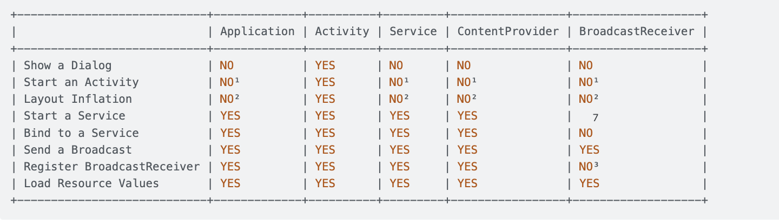

1. An application CAN start an Activity from here, but it requires that a new task be created. This may fit specific use cases, but can create non-standard back stack behaviors in your application and is generally not recommended or considered good practice.
2. This is legal, but inflation will be done with the default theme for the system on which you are running, not what’s defined in your application.
3. Allowed if the receiver is null, which is used for obtaining the current value of a sticky broadcast, on Android 4.2 and above.

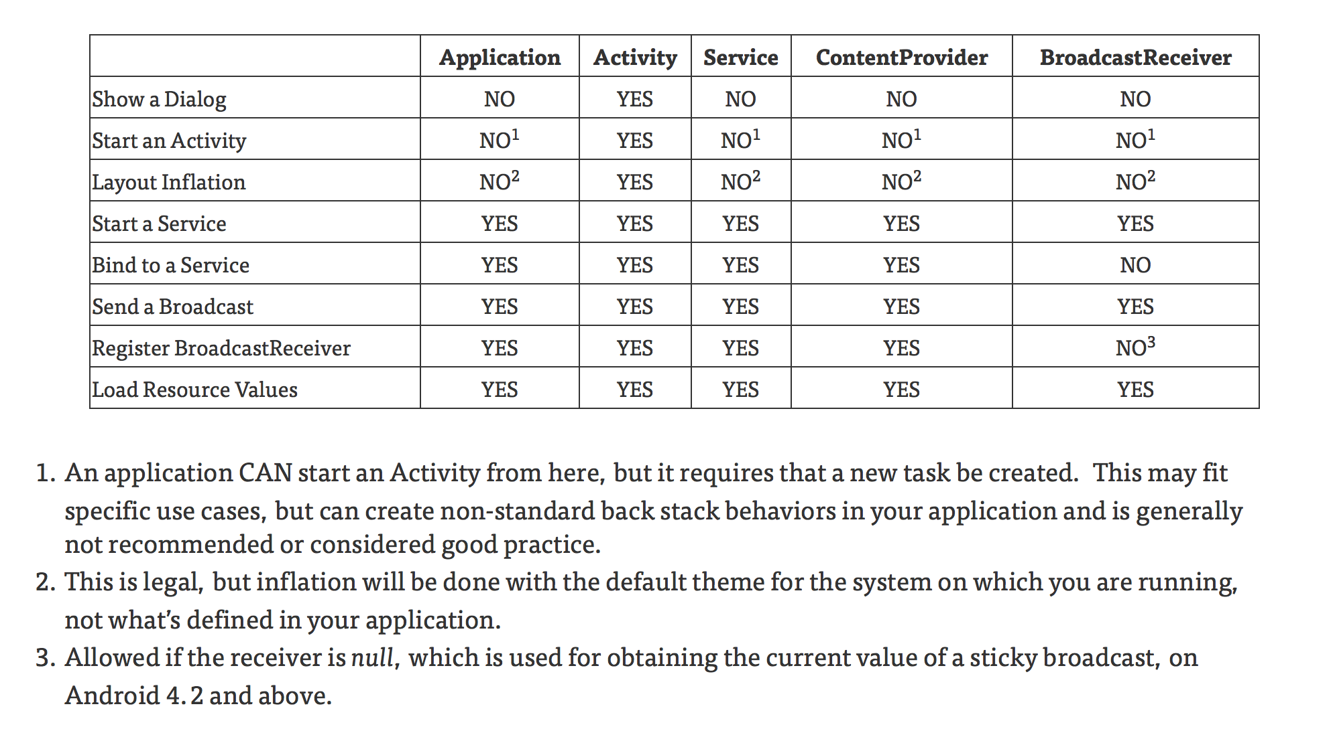

**Question:**  What are best practices for storing and protecting private API keys in applications?

**Answer:**  **Old unsecured way:**

Follow 3 simple steps to secure the API/Secret key (**Old answer**)

We can use Gradle to secure the API key or Secret key.

**1. gradle.properties (Project properties):** Create variable with key.

GoogleAPIKey = "Your API/Secret Key"

**2. build.gradle (Module: app) :** Set variable in build.gradle to access it in activity or fragment. Add below code to buildTypes {}.

buildTypes.each { it.buildConfigField 'String', 'GoogleSecAPIKEY', GoolgeAPIKey }

**3. Access it in Activity/Fragment by app's BuildConfig:**

BuildConfig.GoogleSecAPIKEY

## Update:

The above solution is helpful in the open-source project to commit over Git. (Thanks to David Rawson and riyaz-ali for your comment).

As per Matthew and Pablo Cegarra's comments, the above way is not secure and Decompiler will allow someone to view the BuildConfig with our secret keys.

**Solution:**

We can use NDK to Secure API Keys. We can store keys in the native C/C++ class and access them in our Java classes.

Please follow [this](https://medium.com/@abhi007tyagi/storing-api-keys-using-android-ndk-6abb0adcadad) blog to secure API keys using NDK.

[A follow-up on how to store tokens securely in Android](https://medium.com/google-developer-experts/a-follow-up-on-how-to-store-tokens-securely-in-android-e84ac5f15f17)

**Question:**  How do you handle Bitmaps in Android as it takes too much memory?

**Answer:**  Images are also scaled according to the density so they can use a lot of memory.

For example, if the image file is in the drawable folder (which is mdpi density) and you run it on an xhdpi device, both the width and the height would double. Maybe [**this link**](http://petrnohejl.github.io/Android-Cheatsheet-For-Graphic-Designers/) could help you, or [**this one**](http://developer.android.com/guide/practices/screens_support.html).

So in your example the bytes the image file would take are :

(1024*2)*(800*2)*4 = 13,107,200 bytes.

It would be even worse if you ran it on an xxhdpi device (like the HTC one and Galaxy S4) .

What can you do? Either put the image file in the correct density folder (drawable-xhdpi or drawable-xxhdpi) or put it in drawable-nodpi (or in the assets folder) and downscale the image according to your needs.

BTW you don't have to set options.inJustDecodeBounds = false since it's the default behavior. In fact you can set null for the bitmap options.

About down scaling you can use either [**google's way**](http://developer.android.com/training/displaying-bitmaps/index.html) or [**my way**](https://stackoverflow.com/a/17773344/878126) each has its own advantages and disadvantages.

About caching there are many ways to do it. The most common one is LRU cache. There is also an alternative I've created recently (link [here](https://stackoverflow.com/questions/17900732/how-to-cache-bitmaps-into-native-memory) or [here](https://stackoverflow.com/questions/18250951/jni-bitmap-operations-for-helping-to-avoid-oom)) that allows you to cache a lot more images and avoid having OOM but it gives you a lot of responsibility.

**Question:**  How to avoid reverse engineering of an APK file?

**Answer:**  AFAIK, there is not any trick for complete avoidance of reverse engineering.

And also very well said by @inazaruk: *Whatever you do to your code, a potential attacker is able to change it in any way she or he finds it feasible*. You basically can't protect your application from being modified. And any protection you put in there can be disabled/removed.

2. How can I protect all the app's resources, assets and source code so that hackers can't hack the APK file in any way?

You can do different tricks to make hacking harder though. For example, use obfuscation (if it's Java code). This usually slows down reverse engineering significantly.

3. Is there a way to make hacking more tough or even impossible? What more can I do to protect the source code in my APK file?

As everyone says, and as you probably know, there's no 100% security. But the place to start for Android, that Google has built in, is ProGuard. If you have the option of including **shared libraries**, you can include the needed code in C++ to verify file sizes, integration, etc. If you need to add an external native library to your APK's library folder on every build, then you can use it by the below suggestion.

Put the library in the native library path which defaults to "libs" in your project folder. If you built the native code for the **'armeabi'** target then put it under **libs/armeabi**. If it was built with **armeabi-v7a** then put it under **libs/armeabi-v7a.**

<project>/libs/armeabi/libstuff.so

**Question:**  When is it necessary, or better to use a SurfaceView instead of a View?

**Answer:**  Read more detailed [here](http://pierrchen.blogspot.com/2014/03/anroid-graphics-surfaceview-all-you.html).

Yes, the main difference is surfaceView can be updated on the background thread. However, there are more you might care.

* surfaceView has dedicate surface buffer while all the view shares one surface buffer that is allocated by ViewRoot. In another word, surfaceView cost more resources.
* surfaceView cannot be hardware accelerated (as of JB4.2) while 95% operations on normal View are HW accelerated using openGL ES.
* More work should be done to create your customized surfaceView. You need to listener to the surfaceCreated/Destroy Event, create an render thread, more importantly, synchronized the render thread and main thread. However, to customize the View, all you need to do is override onDraw method.
* The timing to update is different. Normal view update mechanism is constraint or controlled by the framework:You call view.invalidate in the UI thread or view.postInvalid in other thread to indicate to the framework that the view should be updated. However, the view won't be updated immediately but wait until next VSYNC event arrived. The easy approach to understand VSYNC is to consider it is as a timer that fire up every 16ms for a 60fps screen. In Android, all the normal view update (and display actually but I won't talk it today), is synchronized with VSYNC to achieve better smoothness. Now,back to the surfaceView, you can render it anytime as you wish. However, I can hardly tell if it is an advantage, since the display is also synchronized with VSYNC, as stated previously.

**Question:**  Is a Dalvik virtual machine instance created for each application?

**Answer:**  All apk's basic source code is in java language . When you build this project all .java files get converted to .class now the dx tool of adk converts all .class files to classes.dex file .And this classes.dex file is executed on dalvik virtual machine.

For more info on dalvik virtual machine: <http://www.slideshare.net/jserv/understanding-the-dalvik-virtual-machine>

Dalvik virtual machine is intended to run multiple VMs at a time . So every app runs in its own process, with its own instance of the Dalvik virtual machine as said by @sahilMahajanMj .

And this classes.dex file is further optimized to odex file and saved in /dalvik/dalvik-cache  
To know more about odex [click this](https://stackoverflow.com/questions/9593527/what-are-odex-files-in-android) .

If you want to know why DVM for android why not JVM [click this](http://imsciences.edu.pk/serg/wp-content/uploads/2009/07/Analysis-of-Dalvik-VM.pdf)

**Question:**  What is a Sticky Broadcast?

**Answer:**  If an Activity calls onPause with a normal broadcast, receiving the Broadcast can be missed. A sticky broadcast can be checked after it was initiated in onResume.

# Update 6/23/2020

Sticky broadcasts are deprecated.

[See sendStickyBroadcast documentation.](https://developer.android.com/reference/android/content/Context.html#sendStickyBroadcast(android.content.Intent))

This method was deprecated in API level 21.

Sticky broadcasts should not be used. They provide no security (anyone can access them), no protection (anyone can modify them), and many other problems. The recommended pattern is to use a non-sticky broadcast to report that something has changed, with another mechanism for apps to retrieve the current value whenever desired.

# Implement

Intent intent = new Intent("some.custom.action"); intent.putExtra("some_boolean", true); sendStickyBroadcast(intent);

# Resources

* Related post: [What is the difference between sendStickyBroadcast and sendBroadcast in Android?](https://stackoverflow.com/a/21829301/2253682)
* See [removeStickyBroadcast(Intent)](http://developer.android.com/reference/android/content/Context.html#removeStickyBroadcast(android.content.Intent)), and on API Level 5 +, [isInitialStickyBroadcast()](http://developer.android.com/reference/android/content/BroadcastReceiver.html#isInitialStickyBroadcast()) for usage in the Receiver's onReceive.

**Question:**  What is the difference between ANR and crash in Android?

**Answer:**  ANR stands for **A**pplication **N**ot **R**esponding.

An ANR will occur if you are running a process on the UI thread which takes a long time, usually around 5 seconds. During this time the GUI (Graphical User Interface) will lock up which will result in anything the user presses will not be actioned. After the 5 seconds approx has occurred, if the thread still hasn't recovered then an ANR dialogue box is shown informing the user that the application is not responding and will give the user the choice to either wait, in the hope that the app will eventually recover, or to force close the app.

A crash is when an exception within the app has been thrown which has not been handled. For example, if you try to set the text of an EditText component, but the EditText is null and there is no try catch statement to catch the exception that your app will crash and will be force closed. The user will not see what caused the crash, they will be shown a dialogue telling that the app has force closed unexpectedly and will give them the option to send a bug report. In this example if you were to look in the bug report you would see the error caused by java.lang.NullPointerException.

**Question:**  What is the Android NDK? How can one use it? Why should one use it?

**Answer:**  The **Android NDK** is a companion tool to the **Android SDK** that lets you build performance-critical portions of your apps in native code. It provides headers and *libraries* that allow you to build activities, handle user input, use hardware sensors, access application resources, and more, when programming in **C or C++**. If you write native code, your applications are still packaged into an .apk file and they still run inside of a virtual machine on the device. The fundamental Android application model does not change.

The following links also answers your question:

[What is NDK?](http://developer.android.com/sdk/ndk/overview.html)

[When to Develop in Native Code](http://developer.android.com/sdk/ndk/overview.html#choosing)

[NDK Download](http://developer.android.com/sdk/ndk/index.html)

[How to build NDK app](http://www.helloandroid.com/tutorials/how-build-android-ndk)

[how to work with NDK](http://www.techjini.com/blog/2009/10/26/android-ndk-an-introduction-how-to-work-with-ndk/)

[10 tips for Android NDK](http://blogs.arm.com/software-enablement/238-10-android-ndk-tips/)

**Question:**  What is Doze? What about App Standby?

**Answer:**  There's a difference between **App Standby** (where your app goes to sleep because it's lonely) and **Doze** (where the system went to sleep because users have lives).

**Doze** only works when your device remains stationary. If you pick it up or wake the screen, Doze mode is deactivated and the timer resets. It won’t ever turn on when the phone is sitting in your pocket unless you’re sitting remarkably still. Doze simply keeps your phone from burning through the battery while it’s asleep on a desk or table or something.

An app that goes into **Standby** loses all network access and all its background sync jobs are suspended. These restrictions are temporarily lifted when your phone is plugged in and for a few minutes every day or two. This gives suspended apps a chance to run any pending sync jobs, but they won’t be allowed to continue running. A high-priority push notification will also be able to wake an app from Standby for a short time.

**Note:** Google has also noted that it isn’t acceptable for apps to fire off notifications simply to remain exempt from App Standby. This sort of behavior can get an app banned from the Play Store.

For more details with testing **Doze and App Standby**, Please visit this link: <https://developer.android.com/training/monitoring-device-state/doze-standby.html>

**Question:**  What is the StrictMode?

**Answer:**  StrictMode (android.os.StrictMode) is a developer tool which detects things you might be doing wrong by accidently and brings them to your attention.

Best practice in Android says “keeping the disk and network operations off from the main thread makes applications much smoother and more responsive”. So StrictMode is use to catch the coding issues such as disk I/O or network access on the application’s main thread i.e. UI thread.

This is a debugging tool introduced in Android 2.3(API level 9) but more features were added in Android 3.0.

# StrictMode Policies

StrictMode has two types of policies and each policy has various rules.

1. Thread policy

2. VM policy

## Thread Policy

Thread policies are focused on the things which is not recommended to do in main thread like disk or network operations. The thread policy can monitor following violations:

· Disk Reads

· Disk Writes

· Network access

· Resource Mismatch

· Custom Slow Code

## VM Policy

VM policies are focused on memory leaks because of bad coding practices like forgot to close the SQLite cursor or leaks in Activities. The VM policy can monitor following violation:

· Activity leaks

· SQLite objects leaks

· Closable objects leaks

· Registration objects leaks

· Class instance limit

· File URL exposure

# Ways to notify

There are variety of different ways by which user/developer get to know when a rule you set has been violated. In terms of StrictMode it is known as Penalty. Some of them are listed below-

penaltyLog(): Log the detected violations into the system log.

penaltyDeath(): Crash the whole process when violation of rule found.

penaltyDialog(): Display a dialog for detected violations.

penaltyDeathOnNetwork(): Crash the whole process on any network usage.

penaltyDropBox(): Enable detected violations log a stacktrace and timing data to the DropBox on policy violation.

penaltyFlashScreen(): Flash the screen during a violation.

# How to use

To enable and configure the StrictMode in your application, you require to use setThreadPolicy() and setVmPolicy() methods of StrictMode. It is a good practice to set policies either in Application class or initial activity.

Here is the example of Thread Policy:

Here is the example of VM Policy:

You can decide what should happen when a violation is detected like in the above example we have used only penaltyLog() for Thread Policy but in the VM Policy we used penaltyLog() as well as penaltyDeath() to notify.

Here is the example of penaltyLog() showing the logs which explains StrictMode is warning us that we are using disk write operation on the main thread.

And here is the warning dialog looks like:

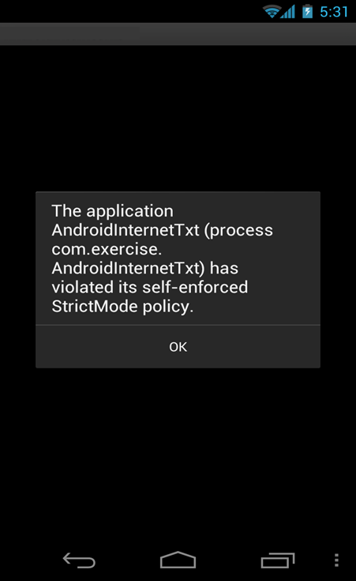

# Ignore Policies

Don’t try to fix everything that StrictMode finds. In most of the cases we access the disk to quickly read some data from Activity or main thread. It won’t create noticeable glitch or hanging behavior in the application UI. So instead use the StrictMode to find things you did by accident.

# Conclusion

As we have seen StrictMode is a very useful tool to find and fix performance issues, object leaks, and other hard-to-find runtime issues for Android developers.

If you find violations that you feel are problematic, there are a variety of tools to help solve them like threads, Handler, AsyncTask, IntentService, etc. For more info on StrictMode policies and rules, please go through [Android Official](https://developer.android.com/reference/android/os/StrictMode.html) page.

**Question:**  Can you manually call the Garbage collector?

**Answer:**  Yes you can explicitly call garbage collector using

System.gc();

But what happens is that you can't order JVM to do garbage collection immediately. JVM decides on its own when to garbage collect.Hence its not a good idea of calling it manually.

Moreover regarding OutOfMemoryException doing manual garbage collection won't help you prevent the exception, since JVM throws this exception after reclaiming all the memory it can. It has some very sophisticated algorithms to determine when and how to do perform the garbage collection. So what i suggest is that if you are getting OutOfMemoryException then recheck your program make it more efficient or increase heap space.

**Question:**  Why to consider FlatBuffers over JSON?

**Answer:**  [FlatBuffers](https://google.github.io/flatbuffers/index.html#flatbuffers_overview) is an efficient cross platform serialization library for C++, C#, C, Go, Java, JavaScript, PHP, and Python. It was originally created at Google for game development and other performance-critical applications.

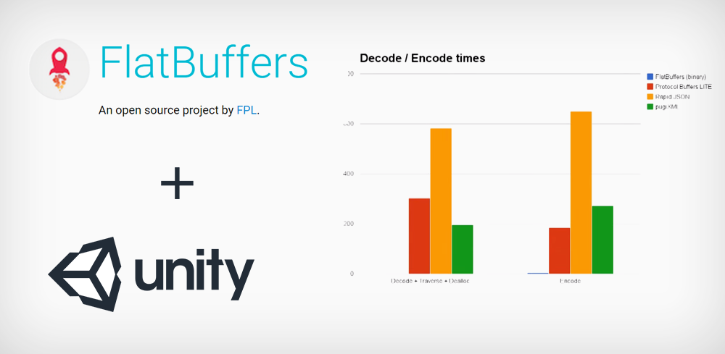

FlatBuffers Stats

## Why use FlatBuffers?

* Access to serialized data without parsing/unpacking — What sets FlatBuffers apart is that it represents hierarchical data in a flat binary buffer in such a way that it can still be accessed directly without parsing/unpacking, while also still supporting data structure evolution (forwards/backwards compatibility).
* Memory efficiency and speed — The only memory needed to access your data is that of the buffer. It requires 0 additional allocations (in C++, other languages may vary). FlatBuffers is also very suitable for use with mmap (or streaming), requiring only part of the buffer to be in memory. Access is close to the speed of raw struct access with only one extra indirection (a kind of vtable) to allow for format evolution and optional fields. It is aimed at projects where spending time and space (many memory allocations) to be able to access or construct serialized data is undesirable, such as in games or any other performance sensitive applications. See the [benchmarks](https://google.github.io/flatbuffers/flatbuffers_benchmarks.html) for details.
* Flexible — Optional fields means not only do you get great forwards and backwards compatibility (increasingly important for long-lived games: don’t have to update all data with each new version!). It also means you have a lot of choice in what data you write and what data you don’t, and how you design data structures.
* Tiny code footprint — Small amounts of generated code, and just a single small header as the minimum dependency, which is very easy to integrate. Again, see the benchmark section for details.
* Strongly typed — Errors happen at compile time rather than manually having to write repetitive and error prone run-time checks. Useful code can be generated for you.
* Convenient to use — Generated C++ code allows for terse access & construction code. Then there’s optional functionality for parsing schemas and JSON-like text representations at runtime efficiently if needed (faster and more memory efficient than other JSON parsers).
* Java and Go code supports object-reuse. C# has efficient struct based accessors.
* Cross platform code with no dependencies — C++ code will work with any recent gcc/clang and VS2010. Comes with build files for the tests & samples (Android .mk files, and cmake for all other platforms).

FlatBuffers Vs JSON

JSON — probably everyone knows this lightweight data format used in almost all modern servers. It weights less, is more human-readable and in general is more dev-friendly than old-fashined, horrible xml. JSON is language-independend data format but parsing data and transforming it to e.g. Java objects costs us time and memory resources.  
Several days ago Facebook announced big performance improvement in data handling in its Android app. It was connected with dropping JSON format and replacing it with FlatBuffers in almost entire app. [Facebook](http://facebook.com/) uses it for client-server communication in their Android app. They have a nice [article](https://code.facebook.com/posts/872547912839369/improving-facebook-s-performance-on-android-with-flatbuffers/) explaining how it speeds up loading their posts.

**Question:**  What are some difference between Parcelable and Serializable?

**Answer:**  In Parcelable, developers write custom code for marshalling and unmarshalling so it creates fewer garbage objects in comparison to Serialization. The performance of Parcelable over Serialization dramatically improves (around two times faster), because of this custom implementation.

Serializable is a marker interface, which implies that users cannot marshal the data according to their requirements. In Serialization, a marshalling operation is performed on a Java Virtual Machine (JVM) using the Java reflection API. This helps identify the Java object's member and behaviour, but also ends up creating a lot of garbage objects. **Due to this, the Serialization process is slow in comparison to Parcelable.**

**What is the meaning of marshalling and unmarshalling?**

In few words, "marshalling" refers to the process of converting the data or the objects into a byte-stream, and "unmarshalling" is the reverse process of converting the byte-stream back to their original data or object. The conversion is achieved through "serialization".

<http://www.jguru.com/faq/view.jsp?EID=560072>

**Question:**  What is the difference between Android Timer and a Handler to do action every N seconds?

**Answer:**  **Handler is better than TimerTask.**

The Java TimerTask and the Android Handler both allow you to schedule delayed and repeated tasks on background threads. However, the literature overwhelmingly recommends using Handler over TimerTask in Android (see [here](http://www.mopri.de/2010/timertask-bad-do-it-the-android-way-use-a-handler/), [here](https://guides.codepath.com/android/Repeating-Periodic-Tasks), [here](https://cemremengu.wordpress.com/2012/11/28/android-timertimertask-out-handler-in/), [here](http://saeedsiam.blogspot.com/2009/03/timer-in-android-better-way.html), [here](http://androidtrainningcenter.blogspot.in/2013/12/handler-vs-timer-fixed-period-execution.html), and [here](http://baiduhix.blogspot.com/2016/02/handler-vs-asynctask-handler-vs-timer.html)).

Some of reported problems with TimerTask include:

* Can't update the UI thread
* Memory leaks
* Unreliable (doesn't always work)
* Long running tasks can interfere with the next scheduled event

**Example**

The best source for all kinds of Android examples that I have seen is at [Codepath](https://guides.codepath.com/android/Repeating-Periodic-Tasks). Here is a Handler example from there for a repeating task.

// Create the Handler object (on the main thread by default) Handler handler = new Handler(); // Define the code block to be executed private Runnable runnableCode = new Runnable() { @Override public void run() { // Do something here on the main thread Log.d("Handlers", "Called on main thread"); // Repeat this the same runnable code block again another 2 seconds handler.postDelayed(runnableCode, 2000); } }; // Start the initial runnable task by posting through the handler handler.post(runnableCode);

**Related**

* [Handler vs Timer : fixed-period execution and fixed-rate execution android development](http://androidtrainningcenter.blogspot.in/2013/12/handler-vs-timer-fixed-period-execution.html)

**Question:**  Provide some tips to reduce battery usage in an android application

**Answer:**  The battery life of an Android phone is dependent on many factors, a few of them are, screen brightness, fast processors, apps running in the background, thin bodies, and many more. Being an app developer, all hardware constraints are out of one’s hands and cannot be changed. What an app developer can do is, make changes in the app such that it requires minimum battery usage and doesn’t drain the battery. There are many methods to do so and a few are explained below.

Lazy First

There are several operations in an app that are very intensive on the battery, they require a large amount of battery and can cause drain issues. In the lazy first method, such operations are reduced and optimized. The main steps in a lazy first method are

Defer: Any battery-intensive operation can be delayed if it’s not of utmost urgency. It can be executed when the device is plugged into power.

Reduce: Any redundant operation can be removed, it saves the battery by escaping recomputation. Data that is required often can be put into cache, instead of downloading again and again.

Coalesce: Many battery-intensive operations can be grouped into one operation. Separate execution requires waking the device again and again. Instead of this, similar types of operations can be clubbed and executed at once.

These steps should be used when the app requires CPU time, screen, internet use, etc. The lazy first method can be applied in the app to make it battery efficient.

Power saving methods

Many Power saving methods are introduced by Android in recent times. After Android 6.0 android came up with two big battery saver methods, Doze and App Standby.

Doze defers the background network activities and CPU activities of the entire device when it is unused for a long time. This helps in saving a lot of battery life. It’s similar to a device going into sleep mode.

App standby work on apps individually. The app which has not been used for a long time can save a lot of battery. This defers the background activities of such apps.

App Standby

When the user doesn’t make a touch in the app for a long time, the system determines that the app is idle now. It also allows the system to determine an app’s idleness when –

The user does not launch the app.

The app does not generate a notification.

The app doesn’t have a process running in the foreground.

It is not a device admin app. These apps always run in the background and can never be terminated or enter into the app standby state. The New Android version allows the user to keep running an app in the background for always.

When the device is plugged into power, all the stand-by apps are released. They are allowed to access network connections and to complete the job that was left before it went into standby mode. There are some exemptions from the stand-by category other than the device admin apps. These are

Instant messaging or calling app – They use Firebase Cloud Messaging ( FCM) high-priority messages to wake up the app and access the network.

Task automation app – The core function of these apps is to schedule the actions that are automated such as instant messaging and calls.

Peripheral device companion app – The core function of these types of apps is to maintain a continuous connection with the peripheral device in order to provide them with internet access. Example – Apple watch, fitness bands.

How to test the app with app standby

Get a device having Android 6.0 or later.

Connect the device to your system.

Install the app and leave it active.

Run this command to force your app on standby

$ adb shell dumpsys battery unplug

$ adb shell am set-inactive <packageName> true

Wake up the app with this command

$ adb shell am set-inactive <packageName> false

$ adb shell am get-inactive <packageName>

Confirm that the app comes out of standby mode with all functions working correctly

**Question:**  What is a ThreadPool? And is it more effective than using several separate Threads?

**Answer:**  Thread pool will provide benefits for frequent and relatively short operations by

* Reusing threads that have already been created instead of creating new ones (an expensive process)
* Throttling the rate of thread creation when there is a burst of requests for new work items (I believe this is only in .NET 3.5)
  + If you queue 100 thread pool tasks, it will only use as many threads as have already been created to service these requests (say 10 for example). The thread pool will make frequent checks (I believe every 500ms in 3.5 SP1) and if there are queued tasks, it will make one new thread. If your tasks are quick, then the number of new threads will be small and reusing the 10 or so threads for the short tasks will be faster than creating 100 threads up front.
  + If your workload consistently has large numbers of thread pool requests coming in, then the thread pool will tune itself to your workload by creating more threads in the pool by the above process so that there are a larger number of threads available to process requests
  + check [Here](http://blogs.msdn.com/pedram/archive/2007/08/05/dedicated-thread-or-a-threadpool-thread.aspx) for more in depth info on how the thread pool functions under the hood

Creating a new thread yourself would be more appropriate if the job were going to be relatively long running (probably around a second or two, but it depends on the specific situation)

@Krzysztof - Thread Pool threads are background threads that will stop when the main thread ends. Manually created threads are foreground by default (will keep running after the main thread has ended), but can be set to background before calling Start on them.

**Question:**  What is the relationship between Looper, Handler and MessageQueue in Android?

**Answer:**  A [Looper](http://developer.android.com/reference/android/os/Looper.html) is a message handling loop: it reads and processes items from a [MessageQueue](http://developer.android.com/reference/android/os/MessageQueue.html). The Looper class is usually used in conjunction with a [HandlerThread](http://developer.android.com/reference/android/os/HandlerThread.html) (a subclass of Thread).

A [Handler](http://developer.android.com/reference/android/os/Handler.html) is a utility class that facilitates interacting with a Looper—mainly by posting messages and Runnable objects to the thread's MessageQueue. When a Handler is created, it is bound to a specific Looper (and associated thread and message queue).

In typical usage, you create and start a HandlerThread, then create a Handler object (or objects) by which other threads can interact with the HandlerThread instance. The Handler must be created while running on the HandlerThread, although once created there is no restriction on what threads can use the Handler's scheduling methods (post(Runnable), etc.)

The main thread (a.k.a. UI thread) in an Android application is set up as a handler thread before your application instance is created.

Aside from the class docs, there's a nice discussion of all of this [here](http://mindtherobot.com/blog/159/android-guts-intro-to-loopers-and-handlers/).

P.S. All the classes mentioned above are in the package android.os.

**Question:**  What is the difference between Local, Normal, Ordered and Sticky broadcasts?

**Answer:**  **Normal Broadcast**

:- use sendBroadcast()

:- asynchronous broadcast

:- any receiver receives broadcast not any particular order

**Ordered Broadcast**

:- use sendOrderedBroadcast()

:- synchronous broadcast

:- receiver receives broadcast in priority base

:- we can also simply abort broadcast in this type

**Local Broadcast**

:- use only when broadcast is used only inside application

**Sticky Broadcast**

:- normal broadcast intent is not available any more after is was send and processed by the system.

:- use sendStickyBroadcast(Intent)

:- the corresponding intent is sticky, meaning the intent you are sending stays around after the broadcast is complete.

:- because of this others can quickly retrieve that data through the return value of registerReceiver(BroadcastReceiver, IntentFilter).

:- apart from this same as sendBroadcast(Intent).

**Question:**  What is Intent vs Sticky Intent vs Pending Intent?

**Answer:**  **Intent:** Intent is a message passing mechanism between components of android, except for Content Provider. You can use intent to start any component.

### PendingIntent:

A PendingIntent is a token that you give to a foreign application (e.g. NotificationManager, AlarmManager, Home Screen AppWidgetManager or other 3rd party applications), which allows the foreign application to use your application’s permissions to execute a predefined piece of code.  
If you want a foreign application to perform any Intent operation at future point of time, then we will use PendingIntent.  
Example: If you building a SMS app and you want to open your application when new message notification come. In that situation you have to use PendingIntent.

**Example:**

| 1  2  3  4  5  6  7  8  9  10  11  12  13  14  15  16  17  18  19  20  21  22  23  24  25  26  27  28  29  30  31  32  33  34  35  36  37  38  39  40  41  42  43  44  45  46  47  48 | **import** android.app.Notification;  **import** android.app.NotificationChannel;  **import** android.app.NotificationManager;  **import** android.app.PendingIntent;  **import** android.content.Intent;  **import** android.os.Build;  **import** android.os.Bundle;  **import** android.support.v7.app.AppCompatActivity;    **public** **class** MainActivity **extends** AppCompatActivity {    **private** **static** String CHANNEL_ID = "channelId";  **private** **static** String CHANNEL_NAME = "channelTest";    @Override  **protected** **void** onCreate(Bundle savedInstanceState) {  **super**.onCreate(savedInstanceState);  setContentView(R.layout.activity_main);    showNotification();  }    **private** **void** showNotification() {  Intent intent = **new** Intent(MainActivity.**this**, MainActivity.**class**);  // PendingIntent.getActivity(Context context, int requestCode, Intent intent, @Flags int flags)  PendingIntent pendingIntent = PendingIntent.getActivity(**this**, 0, intent, 0);    Notification.Builder builder = **new** Notification.Builder(MainActivity.**this**)  .setContentIntent(pendingIntent)  .setSmallIcon(R.mipmap.ic_launcher)  .setContentTitle("Title")  .setContentText("Message");    **if** (Build.VERSION.SDK_INT >= Build.VERSION_CODES.O) {  builder.setChannelId(CHANNEL_ID);  }    NotificationManager notificationManager = (NotificationManager) getSystemService(NOTIFICATION_SERVICE);    **if** (Build.VERSION.SDK_INT >= Build.VERSION_CODES.O) {  NotificationChannel mChannel = **new** NotificationChannel(CHANNEL_ID, CHANNEL_NAME, NotificationManager.IMPORTANCE_DEFAULT);  notificationManager.createNotificationChannel(mChannel);  }    **if** (Build.VERSION.SDK_INT >= Build.VERSION_CODES.JELLY_BEAN) {  notificationManager.notify(1, builder.build());  }  } |
| --- | --- |

In Android O, it’s **a must to use a channel** with your Notification Builder.

PendingIntent uses the following methods to handle the different types of intents:

| 1  2  3 | PendingIntent.getActivity() : Retrieve a PendingIntent to start an Activity  PendingIntent.getBroadcast() : Retrieve a PendingIntent to perform a Broadcast  PendingIntent.getService() : Retrieve a PendingIntent to start a Service |
| --- | --- |

**public static** PendingIntent getActivity(Context context, **int** requestCode, Intent intent, @Flags **int** flags) {**...**}

**public static** PendingIntent getService(Context context, **int** requestCode, @NonNull Intent intent, @Flags **int** flags) {...}

**public static** PendingIntent getBroadcast(Context context, **int** requestCode, Intent intent, @Flags **int** flags) {...}

### Sticky Intent:

Sticks with android, for future broadcast listeners. For example if BATTERY_LOW event occurs then that intent will be stick with android so that if any future user requested for BATTER_LOW, it will be fired.

An intent that is used with sticky broadcast, is called as sticky intent. This intent will stick with android system for future broadcast receiver requests.

sendStickyBroadcast() performs a sendBroadcast(Intent) known as sticky, i.e. the Intent you are sending stays around after the broadcast is complete, so that others can quickly retrieve that data through the return value of registerReceiver(BroadcastReceiver, IntentFilter). In all other ways, this behaves the same as sendBroadcast(Intent). One example of a sticky broadcast sent via the operating system is ACTION_BATTERY_CHANGED. When you call registerReceiver() for that action — even with a null BroadcastReceiver — you get the Intent that was last broadcast for that action. Hence, you can use this to find the state of the battery without necessarily registering for all future state changes in the battery.

***Note:******The sticky broadcast was deprecated in API level 21 and should not be used.*** *They provide no security (anyone can access them), no protection (anyone can modify them), and many other problems. The recommended pattern is to use a non-sticky broadcast to report that something has changed, with another mechanism for apps to retrieve the current value whenever desired.*

**Question:**  What happens if the user navigates away or closes the app while I still have a reference to the Activity the user just closed in my AsyncTask?

**Answer:**  Memory Leaks

As long as some part of the app like an AsyncTask still holds a reference to the Activity it will not be destroyed. It will stick around until the AsyncTask is done or releases its reference in some other way. This can have very bad consequences like your app crashing, but the worst consequences are the ones you don't notice: your app may keep reference to Activities which should have been released ages ago and each time the user does whatever leaks the Activity the memory on the device might get more and more full until seemingly out of nowhere Android kills your app for consuming too much memory. Memory leaks are the single most frequent and worst mistakes I see in Android questions on Stack Overflow

The solution

Avoiding memory leaks however is very simple: Your AsyncTask should never have a reference to an Activity, Service or any other UI component.

Instead use the listener pattern and always use a WeakReference. Never hold strong references to something outside the AsyncTask.

A few examples

Referencing a View in an AsyncTask

A correctly implemented AsyncTask which uses an ImageView could look like this:

public class ExampleTask extends AsyncTask<Void, Void, Bitmap> {

private final WeakReference<ImageView> mImageViewReference;

public ExampleTask(ImageView imageView) {

mImageViewReference = new WeakReference<>(imageView);

}

@Override

protected Bitmap doInBackground(Void... params) {

...

}

@Override

protected void onPostExecute(Bitmap bitmap) {

super.onPostExecute(bitmap);

final ImageView imageView = mImageViewReference.get();

if (imageView != null) {

imageView.setImageBitmap(bitmap);

}

}

}

This illustrates perfectly what a WeakReference does. WeakReferences allow for the Object they are referencing to be garbage collected. So in this example We create a WeakReference to an ImageView in the constructor of the AsyncTask. Then in onPostExecute() which might be called 10 seconds later when the ImageView does not exist anymore we call get() on the WeakReference to see if the ImageView exists. As long as the ImageView returned by get() is not null then the ImageView has not been garbage collected and we can therefore use it without worry! Should in the meantime the user quit the app then the ImageView becomes eligible for garbage collection immediately and if the AsyncTask finishes some time later it sees that the ImageView is already gone. No memory leaks, no problems.

Using a listener

public class ExampleTask extends AsyncTask<Void, Void, Bitmap> {

public interface Listener {

void onResult(Bitmap image);

}

private final WeakReference<Listener> mListenerReference;

public ExampleTask(Listener listener) {

mListenerReference = new WeakReference<>(listener);

}

@Override

protected Bitmap doInBackground(Void... params) {

...

}

@Override

protected void onPostExecute(Bitmap bitmap) {

super.onPostExecute(bitmap);

final Listener listener = mListenerReference.get();

if (listener != null) {

listener.onResult(bitmap);

}

}

}

This looks quite similar because it actually is quite similar. You can use it like this in an Activity or Fragment:

public class ExampleActivty extends AppCompatActivity implements ExampleTask.Listener {

private ImageView mImageView;

...

@Override

public void onCreate(Bundle savedInstanceState) {

super.onCreate(savedInstanceState);

...

new ExampleTask(this).execute();

}

@Override

public void onResult(Bitmap image) {

mImageView.setImageBitmap(image);

}

}

Or you can use it like this:

public class ExampleFragment extends Fragment {

private ImageView mImageView;

private final ExampleTask.Listener mListener = new ExampleTask.Listener() {

@Override

public void onResult(Bitmap image) {

mImageView.setImageBitmap(image);

}

};

@Override

public void onViewCreated(View view, Bundle savedInstanceState) {

super.onViewCreated(view, savedInstanceState);

new ExampleTask(mListener).execute();

}

...

}

WeakReference and its consequences when using a listener

However there is another thing you have to be aware of. A consequence of only having a WeakReference to the listener. Imagine you implement the listener interface like this:

private static class ExampleListener implements ExampleTask.Listener {

private final ImageView mImageView;

private ExampleListener(ImageView imageView) {

mImageView = imageView;

}

@Override

public void onResult(Bitmap image) {

mImageView.setImageBitmap(image);

}

}

public void doSomething() {

final ExampleListener listener = new ExampleListener(someImageView);

new ExampleTask(listener).execute();

}

Quite an unusual way to do this - I know - but something similar might sneak into your code somewhere without you knowing it and the consequences can be difficult to debug. Have you noticed by now what might be wrong with the above example? Try figuring out, otherwise continue reading below.

The problem is simple: You create an instance of the ExampleListener which contains your reference to the ImageView. Then you pass it into the ExampleTask and start the task. And then the doSomething() method finishes, so all local variables become eligible for garbage collection. There is no strong reference left to the ExampleListener instance you passed into the ExampleTask, there is just a WeakReference. So the ExampleListener will be garbage collected and when the ExampleTask finishes nothing will happen. If the ExampleTask executes fast enough the garbage collector might not have collected the ExampleListener instance yet, so it may work some of the time or not at all. And debugging issues like this can be a nightmare. So the moral of the story is: Always be aware of your strong and weak references and when objects become eligible for garbage collection.

Nested classes and using static

Another thing which probably is the cause of most memory leaks I see on Stack Overflow people using nested classes in the wrong way. Look at the following example and try to spot what causes a memory leak in the following example:

public class ExampleActivty extends AppCompatActivity {

@Override

public void onCreate(Bundle savedInstanceState) {

super.onCreate(savedInstanceState);

...

final ImageView imageView = (ImageView) findViewById(R.id.image);

new ExampleTask(imageView).execute();

}

public class ExampleTask extends AsyncTask<Void, Void, Bitmap> {

private final WeakReference<ImageView> mListenerReference;

public ExampleTask(ImageView imageView) {

mListenerReference = new WeakReference<>(imageView);

}

@Override

protected Bitmap doInBackground(Void... params) {

...

}

@Override

protected void onPostExecute(Bitmap bitmap) {

super.onPostExecute(bitmap);

final ImageView imageView = mListenerReference.get();

if (imageView != null) {

imageView.setImageAlpha(bitmap);

}

}

}

}

Do you see it? Here is another example with the exact same problem, it just looks different:

public class ExampleActivty extends AppCompatActivity {

@Override

public void onCreate(Bundle savedInstanceState) {

super.onCreate(savedInstanceState);

...

final ImageView imageView = (ImageView) findViewById(R.id.image);

final Thread thread = new Thread() {

@Override

public void run() {

...

final Bitmap image = doStuff();

imageView.post(new Runnable() {

@Override

public void run() {

imageView.setImageBitmap(image);

}

});

}

};

thread.start();

}

}

Have you figured out what the problem is? I daily see people carelessly implementing stuff like above probably without knowing what they are doing wrong. The problem is a consequence of how Java works based on a fundamental feature of Java - there is no excuse, people who implement things like above are either drunk or don't know anything about Java. Let's simplify the problem:

Imagine you have a nested class like this:

public class A {

private String mSomeText;

public class B {

public void doIt() {

System.out.println(mSomeText);

}

}

}

When you do that you can access members of the class A from inside the class B. That's how doIt() can print mSomeText, it has access to all the members of A even private ones.

The reason you can do that is that if you nest classes like that Java implicitly creates a reference to A inside of B. It is because of that reference and nothing else that you have access to all members of A inside of B. However in the context of memory leaks that again poses a problem if you don't know what you are doing. Consider the first example (I'll strip all the parts that don't matter from the example):

public class ExampleActivty extends AppCompatActivity {

public class ExampleTask extends AsyncTask<Void, Void, Bitmap> {

...

}

}

So we have an AsyncTask as a nested class inside an Activity. Since the nested class is not static we can access members of the ExampleActivity inside the ExampleTask. It doesn't matter here that ExampleTask doesn't actually access any members from the Activity, since it is a non static nested class Java implicitly creates a reference to the Activity inside the ExampleTask and so with seemingly no visible cause we have a memory leak. How can we fix this? Very simple actually. We just need to add one word and that is static:

public class ExampleActivty extends AppCompatActivity {

public static class ExampleTask extends AsyncTask<Void, Void, Bitmap> {

...

}

}

Just this one missing keyword on a simple nested class is the difference between a memory leak and completely fine code. Really try to understand the issue here, because it is at the core of how Java works and understanding this is crucial.

And as for the other example with the Thread? The exactly same issue, anonymous classes like that are also just non static nested classes and immediately a memory leak. However it is actually a million times worse. From every angle you look at it that Thread example is just terrible code. Avoid at all costs.

So I hope these example helped you understand the problem and how to write code free of memory leaks. If you have any other questions feel free to ask.

**Question:**  Explain when would you call getApplicationContext() and why?

**Answer:**  You *only* use getApplicationContext() when you *know* you need a Context for something that may live longer than any other likely Context you have at your disposal. Scenarios include:

* Use getApplicationContext() if you need something tied to a Context that itself will have global scope. I use getApplicationContext(), for example, in WakefulIntentService, for the static WakeLock to be used for the service. Since that WakeLock is static, and I need a Context to get at PowerManager to create it, it is safest to use getApplicationContext().
* Use getApplicationContext() when you bind to a Service from an Activity, if you wish to pass the ServiceConnection (i.e., the handle to the binding) between Activity instances via onRetainNonConfigurationInstance(). Android internally tracks bindings via these ServiceConnections and holds references to the Contexts that create the bindings. If you bind from the Activity, then the new Activity instance will have a reference to the ServiceConnection which has an implicit reference to the old Activity, and the old Activity cannot be garbage collected.
* Some developers use custom subclasses of Application for their own global data, which they retrieve via getApplicationContext(). That’s certainly possible.

**Question:**  Explain reasons why not to use getApplicationContext()?

**Answer:**  Here are reasons why *not* to use getApplicationContext() wherever you go:

* It’s not a complete Context, supporting everything that Activity does. Various things you will try to do with this Context will fail, mostly related to the GUI.
* It can create memory leaks, if the Context from getApplicationContext() holds onto something created by your calls on it that you don’t clean up. With an Activity, if it holds onto something, once the Activity gets garbage collected, everything else flushes out too. The Application object remains for the lifetime of your process.

**Question:**  When to use AIDL vs Messenger Queue?

**Answer:**  Noting down the points that I have collected when I have to choose a communication mechanism for IPC in our projects. May be helpful for someone.

AIDL or Messenger, AIDL is the best, it gives me freedom to sync and async calls.

**Messenger:**

* Asynchronous communication.
* A reference to a Handler that can be sent to a remote process via an Intent.
* Complexity is medium.
* Messages sent by the remote process via the messenger are delivered to the local handler.
* When using Messenger, it creates a queue of all the client requests that the Service receives one at a time. All this happens on a single thread.
* In case you want your Service to handle multiple requests simultaneously then you’ll need to make use of AIDL directly and make sure your Service is capable of multi-threading and also ensure thread-safety.

Ref:<http://codetheory.in/android-interprocess-communication-ipc-messenger-remote-bound-services/> <https://www.slideshare.net/yoni1984/ipc-aidl-sexy-not-a-curse>

**AIDL:**

* It is Synchronous and Asynchronous inter process communication. By default,the AIDL communication is synchronous. In order to make AIDL communication asynchronous, use “oneway” keyword.
* Complexity is high - AIDL interface sends simultaneous requests to the service, which must handle multi-threading.
* One to One communication
* Using the underlying Android OS Binder framework
* Requires writing thread-safe code.
* The Binder transaction buffer has a limited fixed size, currently 1Mb, which is shared by all transactions in progress for the process. <https://developer.android.com/reference/android/os/TransactionTooLargeException.html>"
* Security: AIDL is allows developers to expose their interfaces to other application. Both the client and service agree upon in order to communicate with each other.

**Question:**  What is the onTrimMemory method?

**Answer:**  onTrimMemory with TRIM_MEMORY_UI_HIDDEN level is actually called before onStop. When onStop is called, it means the activity is really stopping, and the Android OS might kill it right away if it needs to, so you should not expect any more calls to that activity's callbacks aftet that, except for onRestart and sometimes onDestroy.

* "release your UI resources" is actually about things like caches. You usually don't have to worry about managing views or UI components because the OS already does that, and that's why there are all those callbacks for creating, starting, pausing, stopping and destroying an activity. However, sometimes to improve performance you have to increase memory usage, such as caching some data used by your activities. That's the type of resource you should release when onTrimMemory is called, so your app uses less memory, even if it affects performance. You should worry about memory leaks though. If your activity stops, be sure not to keep any references to its views, because that would keep the activity from being garbage collected, which would keep the whole context from being collected, and that's bad, mostly if you want to keep your app running for hours or days (like when you implement services).
* No, there's no correspondent callback to onTrimMemory. However, you shouldn't need one. As I said before, if you keep a cache of some resources to improve performance, just empty that, and let it grow again if it needs to. If memory level keeps low, onTrimMemory may be called again soon, with that same memory level. By the way, keep in mind that onTrimMemory will be called with several different memory levels, not just TRIM_MEMORY_UI_HIDDEN.

**Question:**  What is the best way to update the screen periodically?

**Answer:**  Repeating periodic tasks within an application is a common requirement. This functionality can be used for polling new data from the network, running manual animations, or simply updating the UI. There are at least four ways to run periodic tasks:

1. **Handler** - Execute a Runnable task on the UIThread after an optional delay
2. **ScheduledThreadPoolExecutor** - Execute periodic tasks with a background thread pool
3. **AlarmManager** - Execute any periodic task in the background as a service
4. **TimerTask** - Doesn't run in UIThread and **is not reliable**. Consensus is to [never use TimerTask](http://www.mopri.de/2010/timertask-bad-do-it-the-android-way-use-a-handler/)

Recommended methods are outlined below.

### Handler

We can use a [Handler](http://developer.android.com/reference/android/os/Handler.html) to run code on a given thread after a delay or repeat tasks periodically on a thread. This is done by constructing a Handler and then "posting" Runnable code to the event message queue on the thread to be processed.

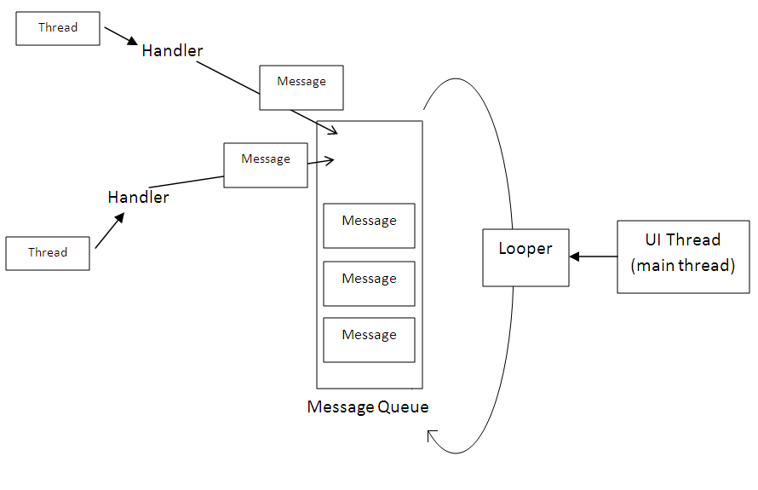

#### Executing Code After Delay

Using a Handler, we can execute arbitrary code a single time after a specified delay:

*// We need to use this Handler package*

**import** android.os.Handler**;**

*// Create the Handler object (on the main thread by default)*

Handler handler **=** **new** Handler**();**

*// Define the code block to be executed*

**private** Runnable runnableCode **=** **new** Runnable**()** **{**

@Override

**public** **void** **run()** **{**

*// Do something here on the main thread*

Log**.**d**(**"Handlers"**,** "Called on main thread"**);**

**}**

**};**

*// Run the above code block on the main thread after 2 seconds*

handler**.**postDelayed**(**runnableCode**,** 2000**);**

#### Execute Recurring Code with Specified Interval

Using a similar technique, we can also use a handler to execute a periodic runnable task as demonstrated below:

*// We need to use this Handler package*

**import** android.os.Handler**;**

*// Create the Handler object (on the main thread by default)*

Handler handler **=** **new** Handler**();**

*// Define the code block to be executed*

**private** Runnable runnableCode **=** **new** Runnable**()** **{**

@Override

**public** **void** **run()** **{**

*// Do something here on the main thread*

Log**.**d**(**"Handlers"**,** "Called on main thread"**);**

*// Repeat this the same runnable code block again another 2 seconds*

*// 'this' is referencing the Runnable object*

handler**.**postDelayed**(this,** 2000**);**

**}**

**};**

*// Start the initial runnable task by posting through the handler*

handler**.**post**(**runnableCode**);**

We can remove the scheduled execution of a runnable with:

*// Removes pending code execution*

handler**.**removeCallbacks**(**runnableCode**);**

Note that with a Handler, the Runnable executes in UIThread by default so you can safely update the user interface within the runnable code block. See [this handler post](http://www.mopri.de/2010/timertask-bad-do-it-the-android-way-use-a-handler/) and [this other handler post](http://androidtrainningcenter.blogspot.in/2013/12/handler-vs-timer-fixed-period-execution.html) for reference.

Refer to our [threads and handlers guide](https://guides.codepath.com/android/Managing-Threads-and-Custom-Services#handler-and-loopers) for a more advanced breakdown.

### ScheduledThreadPoolExecutor

A [pool of threads](http://developer.android.com/reference/java/util/concurrent/ScheduledThreadPoolExecutor.html) which can schedule commands to execute periodically in the background. Useful when multiple worker threads are needed but generally not needed. See [this guide on how they work](http://codelatte.wordpress.com/2013/11/13/49/) or [this stackoverflow post](http://stackoverflow.com/a/18606091/313399).

### AlarmManager

This should be used if the periodic tasks need to run in the background even when the app is not in the foreground. This leverages the alarm service on the phone to cause periodic executions of a service which will run continuously until stopped. See the [AlarmManager section](https://guides.codepath.com/android/Starting-Background-Services#using-with-alarmmanager-for-periodic-tasks) of the services guide for details.

**Question:**  How would you preserve Activity state during a screen rotation?

**Answer:**  When your orientation changes, you don't have to manually change to the landscape layout file. Android does this automatically for you. When orientation changes, Android destroys your current activity and creates a new activity again, this is why you are losing the text.

There are 2 parts you need to do, assuming you want a separate layout for portrait and landscape.

1. Assuming you have 2 XML layout files for portrait and landscape, put your main.xml layout file in the following folders:  
   res/layout/main.xml <-- this will be your portrait layout  
   res/layout-land/main.xml <-- this will be your landscape layout  
   That's all you need to do, you don't have to touch the manifest file to modify android:configChanges="orientation" or override the onConfigurationChanged(). Actually, it's recommended you do not touch this for what you are trying to achieve.
2. Now to save your text from the text view =) Lets assume your textview is named as MyTextView in your layout xml file. Your activity will need the following:  
   private TextView mTextView; private static final String KEY_TEXT_VALUE = "textValue"; @Override protected void onCreate(Bundle savedInstanceState) { super.onCreate(savedInstanceState); mTextView = (TextView) findViewById(R.id.main); if (savedInstanceState != null) { CharSequence savedText = savedInstanceState.getCharSequence(KEY_TEXT_VALUE); mTextView.setText(savedText); } } @Override protected void onSaveInstanceState (Bundle outState) { super.onSaveInstanceState(outState); outState.putCharSequence(KEY_TEXT_VALUE, mTextView.getText()); }

Basically, whenever Android destroys and recreates your Activity for orientation change, it calls onSaveInstanceState() before destroying and calls onCreate() after recreating. Whatever you save in the bundle in onSaveInstanceState, you can get back from the onCreate() parameter.

So you want to save the value of the text view in the onSaveInstanceState(), and read it and populate your textview in the onCreate(). If the activity is being created for the first time (not due to rotation change), the savedInstanceState will be null in onCreate(). You also probably don't need the android:freezesText="true"

You can also try saving other variables if you need to, since you'll lose all the variables you stored when the activity is destroyed and recreated.

**Question:**  What is the ViewHolder pattern? Why should we use it?

**Answer:**  Understand how listview recycling works

[How ListView's recycling mechanism works](https://stackoverflow.com/questions/11945563/how-listviews-recycling-mechanism-works)

You cannot recycle a row that is presently in use. The above link explains how listview recycling mechanism works

So What is the benefit of using ViewHolder?

Quoting docs

Your code might call findViewById() frequently during the scrolling of ListView, which can slow down performance. Even when the Adapter returns an inflated view for recycling, you still need to look up the elements and update them. A way around repeated use of findViewById() is to use the "view holder" design pattern.

public View getView(int position, View convertView, ViewGroup parent) { ViewHolder holder; if (convertView == null) { // if convertView is null convertView = mInflater.inflate(R.layout.mylayout, parent, false); holder = new ViewHolder(); // initialize views convertView.setTag(holder); // set tag on view } else { holder = (ViewHolder) convertView.getTag(); // if not null get tag // no need to initialize } //update views here return convertView; }

You missed the important part convertView.setTag(holder) and holder = (ViewHolder) ConvertView.getTag()

<http://developer.android.com/training/improving-layouts/smooth-scrolling.html>

**Question:**  How can I use AsyncTask in different Activities?

**Answer:**  One of the methods using AsynTask in different Activities, creating a callback interface.

Create a callback interface

interface AsyncTaskListener<T> {

public void onComplete(T result);

}

Then in your MainActivity and TestActivity:

public class MainActivity extends AppCompatActivity

implements AsyncTaskListener<String> {

public void onComplete(String result) {

// your staff here

}

}

public class TestActivity extends AppCompatActivity

implements AsyncTaskListener<String> {

public void onComplete(String result) {

// your staff here

}

}

And add to your AsyncTask class:

public class JSONTask extends AsyncTask<String, String, String>

private AsyncTaskListener<String> listener;

public JSONTask (AsyncTaskListener<String> callback) {

this.listener = callback;

}

protected void onPostExecute(String result) {

listener.onComplete(result); // calling onComplate interface

}

**Question:**  List out the Java classes that are related to the use of sensors on the android platform.

**Answer:**  There are four [Java](https://tekslate.com/java-tutorials) classes that are related to the use of sensors on the Android platform are as follows:

* Sensor: It provides methods to identify the capabilities that are available for a specified sensor and can create an instance of specific sensor
* Sensor Manager: It provides methods for registering sensor event listeners and calibrating sensors
* Sensor event: It is used to create a sensor event object and provides the raw sensor data, accuracy of data, type of sensor that generate the event, and timestamp for an event
* Sensor event listeners: This interface is to create two callback methods that receive notification when the sensor value changes or when sensor accuracy changes

**Question:**  What is DDMS? Mention some of its capabilities?

**Answer:**  DDMS is the Dalvik Debug Monitor Server. It is the bug monitoring server that comes along with android. It provides a wide range of debugging features such as

* Screen capture
* Port forwarding services
* Network traffic tracking
* Incoming call and SMS spoofing
* Location data spoofing
* Simulating network state, speed, and latency
* Thread and heap information

**Question:**  Which method is called only once in a fragment lifecycle?

**Answer:**  onAttached() is the method that can call only once in a fragment lifecycle.

**Question:**  What are the types of flags that are used to run the application?

**Answer:**  There are two types of flags that are used to run the application. They are as follows:

FLAG_ACTIVITY_NEW_TASK

FLAG_ACTIVITY_CLEAR_TOP

**Question:**  Name the dialog box that is supported by Android?

**Answer:**  The following are the dialog box that is supported by the Android:

* Progress dialog box
* Alert dialog box
* Date picker dialog box
* Time picker dialog box

**Question:**  What are the basic tools that are used to develop an Android application?

**Answer:**  The basic tools that are used to develop an Android application are as follows:

SDK

JDK

Eclipse+ADT plugin

**Question:**  Mention some exceptions in Android?

**Answer:**  Some exceptions in Android are as follows:

Inflate Exception

Surface.OutofResource Exception

SurfaceHolder.BadSurfaceType Exception

WindowManager. BadTokenException

**Question:**  Give a list of impotent folders in Android?

**Answer:**  The list of impotent folders are as follows:

1. AndroidManifest.xml
2. Build.xml
3. bin/
4. assets/
5. src/
6. res/

**Question:**  What are the advantages of android?

**Answer:**  The main advantages of android are as follows:

* It is an open-source application that can create, distribute, and develop the application for free.
* It supports Windows, Mac, and Linux platforms
* It supports various technologies like camera, Bluetooth, wi-fi, EDGE, etc.
* It uses a highly optimized virtual machine for mobile devices, called DVM (Dalvik Virtual Machine)

**Question:**  Why byte code cannot be run in android?

**Answer:**  Because android uses DVM (Dalvik Virtual Machine) rather than JVM (Java Virtual Machine).

**Question:**  Explain the difference between onCreate and onStart?

**Answer:**  onCreate() method is called when the application starts, once during the Activity lifecycle, or when the Activity has been destroyed and recreated, for example during the configuration change.

onStart() method is called whenever the Activity becomes visible to the user, typically after onCreate() or onRestart() method.

**Question:**  Difference between thread and Async Tasks?

**Answer:**  Threads is used to separate long running operations from main thread so that to improve the performance. But it can’t be cancelled and it can’t handle configuration changes of an android.

Async Tasks are used to handle work items shorter than 5mins duration and you can update UI unlike Java. but many long running tasks will drown the performance.

**Question:**  How will you terminate an alive thread?

**Answer:**  There is no direct way to terminate a thread but using the two following ways it can be done.

1. Calling ‘interrupt()’ method on the thread object (e.g. threadObj), this will throw an InterruptedException inside the run method of thread. This exception will indicate that we should release the resources gracefully and then exiting the ‘run’ method of thread will terminate the thread.
2. In case if the InterruptedException is swallowed by the code or ignored as well as If inside the thread’s ‘run’ method if any looping is there, if yes then adding a method check in that loop that if this thread should exit now or not, is done by checking ‘Thread.currentThread().isInterrupted()’ that returns true and then exit the run method.

**Question:**  What is MVVM?

**Answer:**  MVVM stands for Model-View-ViewModel. Android applications built using MVVM are more robust, fast, scalable and very less prone to memory leaks. In MVVM ViewModel is the key between View and Model.



The important key point about MVVM is that View has reference to the ViewModel but not in reverse and that makes the application’s UI-Components related memory leak-proof. Each View may have a dedicated ViewModel or may be shared by multiple in case of fragments to enable sharing data cross fragments of an activity. MVVM is a more suitable candidate for automated testing.

**Question:**  What is the recommended way to perform discrete, ‘transactional’ background tasks in Android?

**Answer:**  The recommended way going forward is using WorkManager APIs, that makes it easy to specify deferrable, asynchronous tasks and when they should run under the circumstances you choose, or recurring tasks that run at a specified interval. Internally WorkManager might use JobScheduler, Firebase-JobDispatcher, Executor, and AlarmManager for running the task.

**Question:**  How do you start a receiver?

**Answer:**  By using **Intent**, and **sendBroadcast()** method

**Question:**  How do you kill a receiver?

**Answer:**  abortBroadcast() method.

**Question:**  types of receivers?

**Answer:**  static receivers, dynamic receivers, ordered receivers, sticky receivers.

**Question:**  What are the life cycle methods of broacast receiver?

**Answer:**  onreceive()

**Question:**  What is database?

**Answer:**  It is a logical container of data/ information.

**Question:**  Where is database stored?

**Answer:**  Database is stored within the application, in Internal memory.

**Question:**  How to store images/ audios/ videos in a table using SQLite?

**Answer:**  by using **BLOB datatype** = binary large object .

First we have to convert images to 0101, then store in tablee using BLOB data type. Later while reading the image we will read 0101 and recreate the image by using BitMapFactory class.

**Question:**  what is primary key?

**Answer:**  unique + not null.

Primary key is used to uniquely identify each row.

**Question:**  what is foreign key?

**Answer:**  used to maintain relationship between tables. If a primary key of one tables comes to other table then it becomes foreign key.

Every RDBMS should support foreign key. But by default SQLite doesn’t have support for foreign key. To enable foreign key support below command should be issued.

db.execSQL("pragma FOREIGN KEY;");

**Question:**  how to upgrade database? (imp)

**Answer:**  a. change application version code and version name in build.gradle.

b. change database version in helper parameter.

c. go to inner helper class, go to onupgrade() method, use if-else condition and we can add/ remove/ alter tables based on the version.

**Question:**  Difference between delete and drop? (imp)

**Answer:**  delete is DML statement. drop is DDL command.

drop = delete the rows + delete the table.

delete = will delete only rows.

**Question:**  Difference between update and upgrade?

**Answer:**  update is DML statement. but upgrade is related to DDL.

update = will update the rows.

upgrade = create table/ drop table/ alter table in the future application releases.

note : upgrade terminology is used for databases.

**Question:**  how do you kill a fragment?

**Answer:**  fragmenttransaction.popBackstack() method [or]

fragmenttransaction.replace() [or]

fragmenttransaction.remove()

**Question:**  User clicks back button, which life cycle methods will be called for activity?

**Answer:**  onpause, onstop, ondestroy.

**Question:**  User clicks home button, which life cycle methods will be called for activity?

**Answer:**  onpause, onstop

**Question:**  User is looking at screen & suddenly call comes which life cycle methods will be called for an activity?

**Answer:**  onpause, onstop

**Question:**  User rotates the phone, life cycle methods of an activity? [IMP]

**Answer:**  onpause, onsaveinstancestate, onstop, ondestroy,

oncreate, onstart, onrestoreinstancestate, onresume.

same for virtual kyeboard up/down & language changes also. same for low memory also.

**Question:**  *Material Design Api classes & definitions:*

**Answer:**  **CoOrdinatorLayout :**

a. It is inherited from FrameLayout

b. It is used to place elements on one-on-top of other, with shadow/3d effect.

c. If coordinator layout is removed, then 3d layering will not happen properly.

**AppBarLayout:**

a. It is used to club ActionBar+Tabs.

b. It is used to have parallox effect on actionbar. Parallox effect means - when user scrolls up / down, then actionbar will be moved out of screen.

**ToolBar :**

a. it is introduced in android 5.0

b. it is actionbar with shadow effect.

c. toolbar can be placed anywhere on the screen.in olden days, action bar used to stick at top.

**TabLayout :**

a. it is used mostly with viewpager.

b. it inherits from horizontal scrollview.

c. mostly it is attached to actionbar/toolbar.

**FloatActionButton:**

a. it appears at right corner of the screen.

b. Most important item should be placed as FAB.

eg: gmail app places "compose mail" as FAB.

c. this is highest priority icon.

**NagivationView :**

a. It is used to attach sliding menu with actionbar.

b. it will have header and menu body portions.

**SnackBar :**

a. it is advanced version of Toast.

b. it comes with colors & buttons.

c. it can be swipe deleted. [not possible with toast

**RecyclerView :**

a. Advanced version of listview.

b. it is faster & memory efficient compared to list view.

c. It comes with viewholder design pattern.

d. can be used as listview/ gridview/ staggered grid

**CardView :**

a. it inherits from framelayout.

b. it is is used to design round cornered - cards, with 3d shadow effect.

c. mostly used along with recyclerview - to show good looking rows.

**Question:**  Imagine you need to create an Android app that supports multiple languages and cultures, what's the best approach for you to do this?

**Answer:**

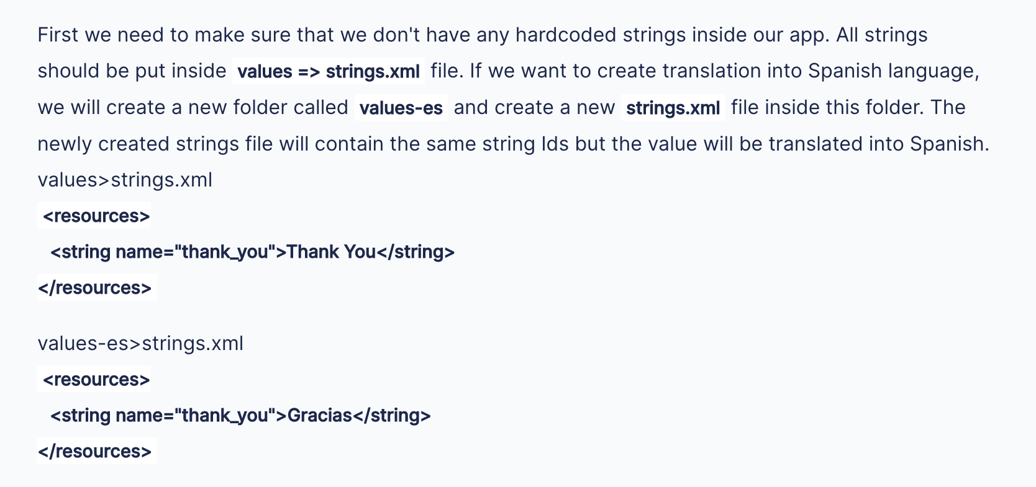

**Question:**  How to create application that support different screen sizes?

**Answer:** 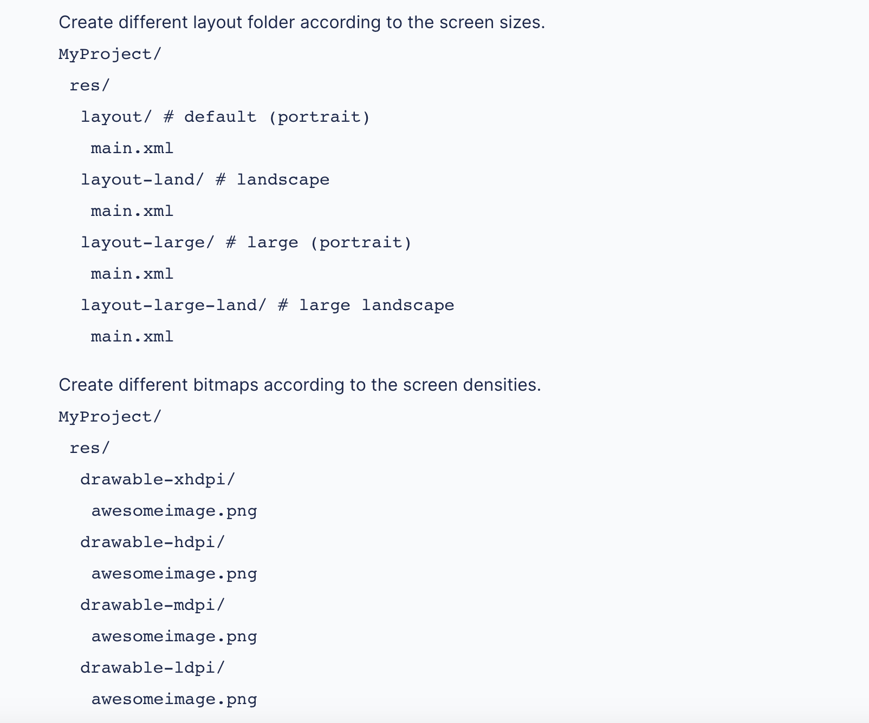

**Question:**  What is a memory leak?

**Answer:**  Memory leaks happen when you hold on to an object long after its purpose has been served. Every object has got its own lifetime, after which it needs to say goodbye and leave the memory. But if some other object(s) is holding onto this object (directly or indirectly), then the garbage collector will not be able to collect it.

**Question:**  Write some code example that will cause a java memory leak.

**Answer:**

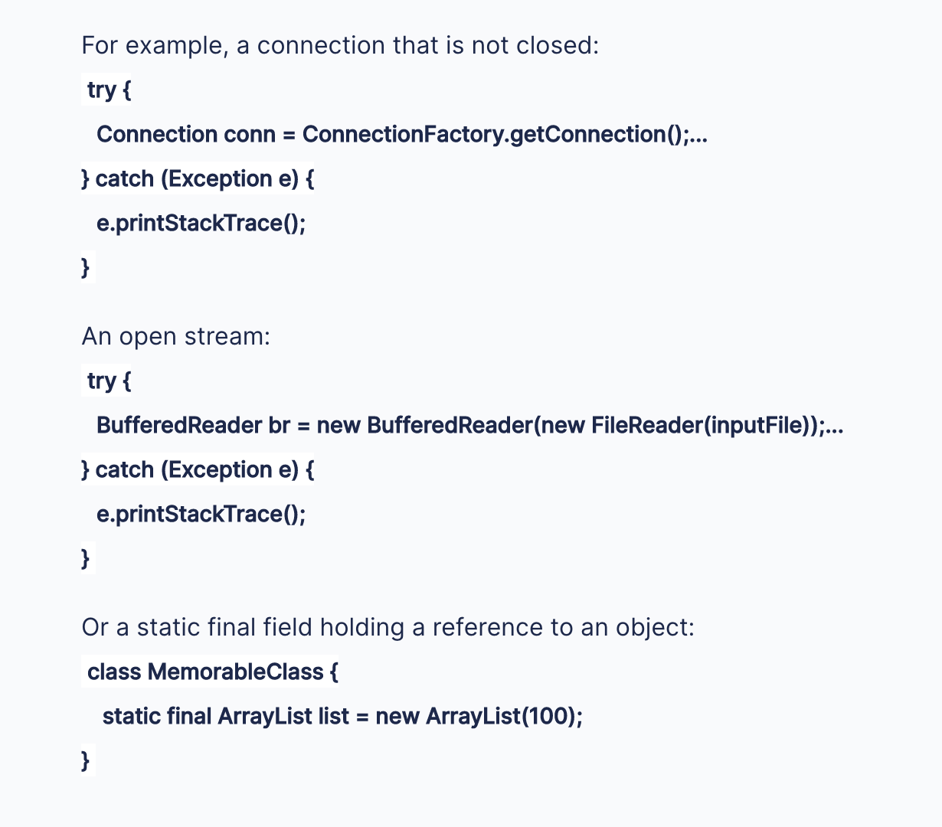

**Question:**  How would you launch an ActivityB from ActivityA and clear the back stack of activities when the new activity is called?

**Answer:**

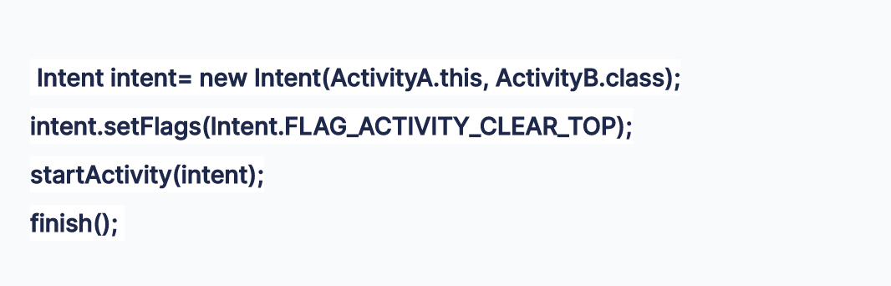

**Question:**  What kind of tests can you write to test your Android application?

**Answer:**  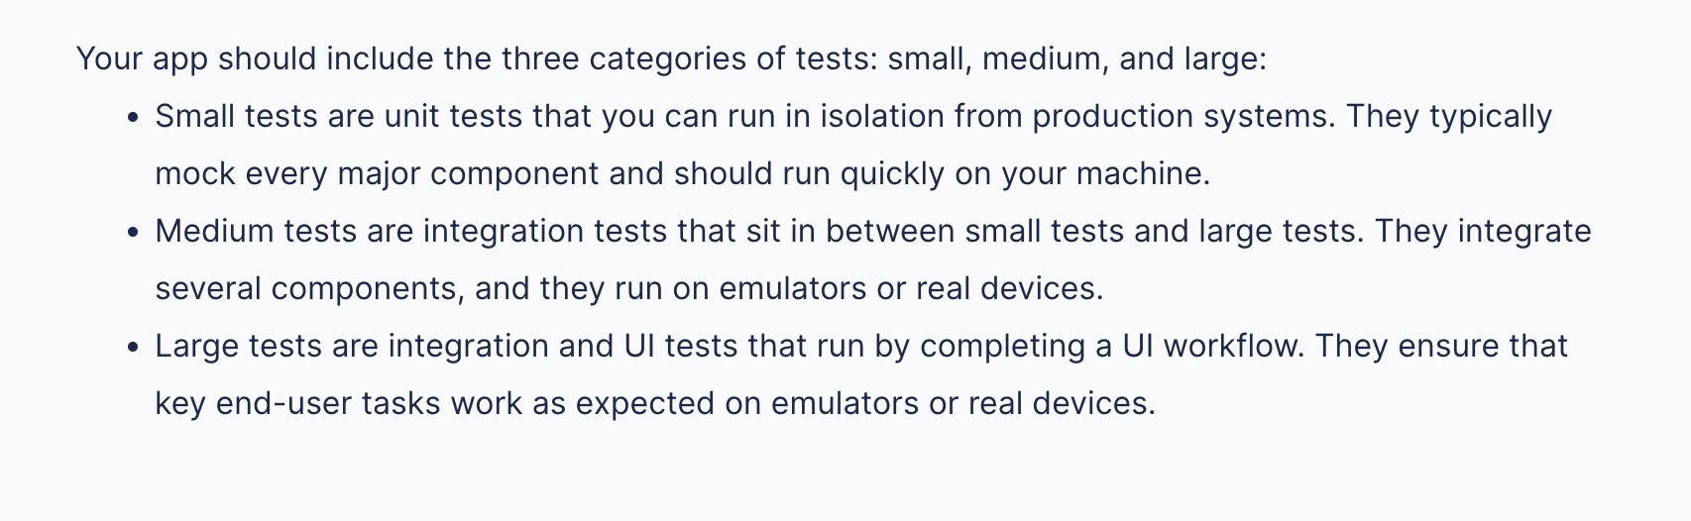

**Question:**  What Security measures you should take to prevent reverseengineering on your APK?

**Answer:**  There are several security measures we can take to make our code more difficult to reverse by an attacker, but the main answer is to use ProGuard. ProGuard is a Java obfuscator provided in most of the Android environments, which increases security in our code by performing different obfuscation techniques in our code.

**Question:**  What is the difference between a regular .png and a nine-patch image

**Answer:**  This is one of the most popular Android Interview questions, asked in several interviews ranging from 1 to 2 years of experience to 5 years. The answer is, It is a resizable bitmap resource that can be used for backgrounds or other images on the device.

The NinePatch class permits drawing a bitmap in nine sections. The nine patch images have an extension as.9.png. It allows an extension in 9 ways like 4 corners that are unscaled, 4 edges that are scaled in 1 axis, and the middle one that can be scaled into both axes.

**Question:**  What is an ANR notification in Android?

**Answer:**  ANR is short for Application Not Responding. Android systems show this dialog if the application is performing too much of a task on the main thread and have been unresponsive for a long period of time.

**Question:**  How to share content using Android Share Intent?

**Answer:**  Share intent is an easy and convenient way of sharing the content of your application with other apps

**Question:**  When does the onResume() method call?

**Answer:**  Another frequently asked android interview question. onResume() method is an activity lifecycle method. This is called when the activity comes to the foreground. You can override this method in your activity to execute code when the activity is started, restarted, or comes to the foreground.

You can further join the [**Android Java Masterclass - Become an App Developer course**](https://medium.com/javarevisited/top-5-courses-to-learn-android-for-java-programmers-667e03d995b4) on Udemy to learn more about the life-cycle of events in Android. It's a great course to learn Android for Java developers.

Here is a nice diagram that explains the sequence of different callback methods in Android, including onResume():

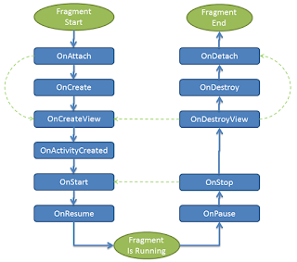

**Question:**  What is an action in Android?

**Answer:**  A description of something that an Intent sender desires is called Action in Android.

**Question:**  What is the difference between an implicit intent and explicit intent?

**Answer:**  There are two types of Intent implicit and explicit intent, let's see some more differences between them.

**1. implicit:**

Implicit intent when you call system default intent like send an email, send SMS, dial number, etc

like.:

Intent sendIntent = new Intent();

sendIntent.setAction(Intent.ACTION_SEND);

sendIntent.putExtra(Intent.EXTRA_TEXT, textMessage);

sendIntent.setType("text/plain")

startactivity(sendIntent);

**2. Explicit:-**

Explicit intent when you call you're on application activity from one activity to another

e.g. first activity to second activity

Intent intent = new Intent(first.this, second.class);

startactivity(intent);

You can also join the [**Understanding Android Application Basics** course](https://medium.com/javarevisited/top-5-frameworks-to-create-cross-platform-android-and-ios-apps-in-2020-d02edf3d01f1) on Pluralsight to learn more about Implicit and Explicit Intent. It's one of the best online courses to learn Android basics and how to create awesome Android applications using Activities on Android.

**Question:**  How Android app runs on Android mobile?

**Answer:**  Since Android code is written in Java, they are also compiled first and then executed, but the JVM for which the bytecodes are generated is different than standard JVM. The Dalvik JVM is used to run the Android app. See the answer for a more detailed discussion.

You can also join the [**Modern Android App Development with Java**](https://hackernoon.com/top-5-courses-to-learn-android-for-java-programmers-667e03d995b4), an interactive course on Educative to learn more about Android app development using Java Programming language. It's a text-based interactive course where you can learn Android without getting stuck on the setup as you can run code right on your browser online.

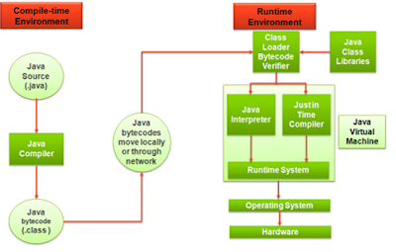

**Question:**  How do you implement Internationalization and Localization in an Android application?

**Answer:**  Localization is the process of modeling applications to a specific locale, market, or device. Localization can also be regarded as language translation.

Globalization is a term used in a wide variety of contexts such as transport and trade.

In the field of technology, globalization is defined as the process of building and developing a software product that functions in multiple cultures and locales.

In other words, the software can serve a diverse group of people.

Internationalization is the process of localizing and globalizing your application.

### Table of contents

* [Introduction](https://www.section.io/engineering-education/localization-and-internationalization-in-android/#introduction)
* [Prerequisites](https://www.section.io/engineering-education/localization-and-internationalization-in-android/#prerequisites)
* [Goals](https://www.section.io/engineering-education/localization-and-internationalization-in-android/#goals)
* [Configuration types and qualifiers values](https://www.section.io/engineering-education/localization-and-internationalization-in-android/#configuration-types-and-qualifiers-values)
* [Syntax to specify qualifier values](https://www.section.io/engineering-education/localization-and-internationalization-in-android/#syntax-to-specify-qualifier-values)
* [Localization resources in Android](https://www.section.io/engineering-education/localization-and-internationalization-in-android/#localization-resources-in-android)
* [How the SDK handles localized resources](https://www.section.io/engineering-education/localization-and-internationalization-in-android/#how-the-SDK-handles-localized-resources)
* [Localizing strings](https://www.section.io/engineering-education/localization-and-internationalization-in-android/#localizing-strings)
* [Localizing images](https://www.section.io/engineering-education/localization-and-internationalization-in-android/#localizing-images)
* [Precautions when localizing your application](https://www.section.io/engineering-education/localization-and-internationalization-in-android/#precautions-when-localizing-your-application)
* [Conclusion](https://www.section.io/engineering-education/localization-and-internationalization-in-android/#conclusion)
* [Further reading](https://www.section.io/engineering-education/localization-and-internationalization-in-android/#further-reading)

### Prerequisites

* Have [Android Studio](https://developer.android.com/studio?gclid=Cj0KCQiAk4aOBhCTARIsAFWFP9HLlfZnjvuyknAbHQ8WOk8iH2_k3M6rEnIEPkca8LdDnvA3HXbQiKAaAhMbEALw_wcB&gclsrc=aw.ds) IDE installed.
* Basic knowledge of Extensible Markup Language (XML).
* Have an understanding of the Android Studio project structure.

### Goals

At the end of the tutorial, the reader should understand the localization process in Android applications.

### Configuration types and qualifiers values

#### Configuration types

Configuration types are the factors to consider when localizing your application. They include:

* Language and region - The context in which the application is being utilized.
* Mobile country code and Mobile network code - This is a three-digit number that is always specific for a given country and network provider.
* Layout direction can be vertical or horizontally oriented.
* Time - You can use specific features for a different time range.
* Screen pixel density.
* Navigation key available.
* Primary text input method.
* Platform version.
* UI mode.

#### Qualifiers values

Qualifier values are the communication paths in Android that notify the system of the different factors to react to by providing alternate resources.

#### Syntax to specify qualifier values

<resource_name> - <config-qualifiers>

* drawable-fr - fr is a configuration qualifier for french.
* layout-sw - sw is a configuration qualifier for swahili.

### Localization resources in Android

The resource directory (res) is the parent folder to all resources in Android. Each resource is placed in a specific subdirectory.

These subdirectories are:-

* animator - This is an XML file that defines animation properties.
* anim - It is an XML file that defines tween animations.
* color - This is an XML file that defines a list of colors.
* drawable - It is a Bitmap file (png, jpg, gif) or XML file which holds pictures.
* mipmap - This is a drawable file for different launcher icon densities.
* layout - It is an XML file that defines a user interface layout.
* menu - It defines the application menus.
* raw - It holds arbitrary files that are saved in raw form.
* values - It is an XML that contains simple values such as strings, integers, and color.
* xml - This holds arbitrary XML files that can be read at runtime, by calling the resource.getXml() method.

To understand how each resource is localized, it’s crucial to know the resource groups.

How to access the resources:

##### 1. Class

[<res_directory>].<resource-type>.<Resource_name>

Examples:

* R.layout.activity-main
* R.String.main

##### 2. XML file

@<resource-type>/<resource-name>

Examples:

* @String/word
* @color/blue

### How the SDK handles localized resources

Android selects localized resources to use based on the current device settings. The procedure is as follows:

* The SDK eliminates qualifiers that contradict the device settings.
* Then identifies the next qualifier in the order. If no resource subdirectory uses the qualifier, the subdirectory is also eliminated.
* The process is repeated until the desired resource is left.

### Localizing strings

To localize strings appropriately, do not hard code them. Instead, use string-resource files to create strings value.

Follow the procedure below to localize a string:

#### Step 1 - Creating a string file

Right-click on resource subdirectory values, go to new, and select resource files.

#### Step 2 - Naming string files

Name the file similar to the available string.xml file on the wizard that appears. Then select locale on the available qualifier and navigate to the path below:

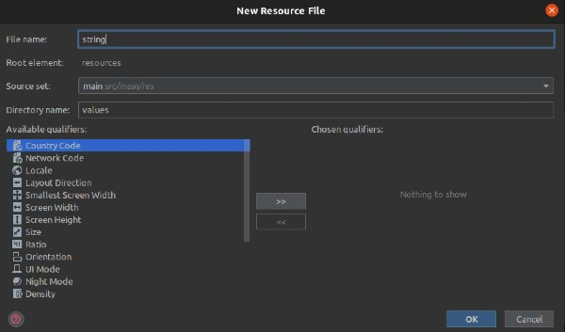

#### Step 3 - Choosing the language to localize your string

Choose the language that you wish to localize on the same wizard. You can specify the region if required, then hit OK. An empty string.xml file will be generated.

If you check the string-resource subdirectory, you will notice there are two string.xml files, with one having the specified language symbols.

#### Step 4 - Writing to the newly created string file

Finally, open your main string.xml file, copy the available strings, and paste them into the new string.xml file.

Once you have added the code, please do not change the string name to the original strings in the main file.

You should instead change the string value to your desired language.

### Localizing images

An image needs to display the right content according to the context it is being utilized. For this reason, the localization of images should be considered.

This feature can be implemented as follows:

#### Step 1 - Creating a new image subdirectory

Right-click on the resource folder and navigate to the new select android resource directory.

#### Step 2 - Naming newly created image subdirectory

To avoid confusion the image subdirectory names should be similar. Select drawable on the resource type on the wizard that appears under the available qualifier.

Next, choose locale and press the forward arrows to choose the appropriate qualifier, and then click the OK button.

You will notice that the directory name is appended with the specified qualifier symbol, as shown below:

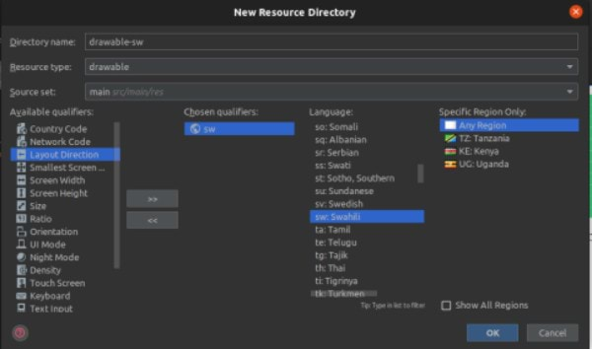

#### Step 3 - Locate the drawable subdirectory in your files and add the required image

Locate the newly created drawable subdirectory and add an image that you wish to display for the specified locale.

Ensure that the image within the new drawable folder has a similar name as that in the original drawable folder.

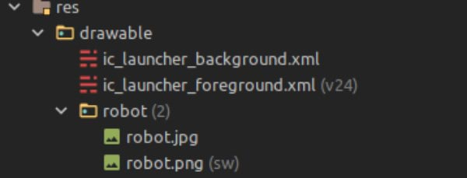

#### Step 4 - Running your localized application

When you run your application, you should see the following output:

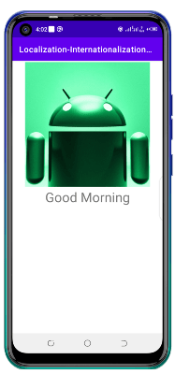

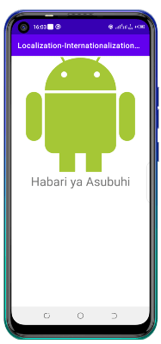

### Best practices for localization

* Provide all default resources that need to be localized in your application.
* Do not think of the localization process at the final application development stage.
* Ensure that the qualifier-naming rule is followed. The best way to stick to this naming rule is by creating an alternate resource directory.
* Avoid duplication of resources but rather use aliases instead, which reduces the APK size.
* When doing translation of strings, use professional translation services to make sure that the correct meaning is conveyed.

We also discussed the localization of strings and images, as well as the best practices to follow when localizing your application.

**Question:**  How do you find the IMEI and IMSI number of an Android device

**Answer:**  Most of us don’t pay attention to details like IMEI and IMSI numbers. When we have to, we don’t know what they are or even how to find them. Do we need to know about them or how they even differ from each other? These are important questions about your privacy and security. We are going to answer them in this post before it’s too late for you to figure out.



Many of us have heard of IMEI number as it comes in very helpful in [finding lost smartphones](https://www.guidingtech.com/track-owner-lost-iphone). But what about IMSI numbers and what is their role.

Let’s find out.

## 1. WHAT IS IMEI NUMBER

IMEI stands for International Mobile Equipment Identity. Every mobile phone (and new the mobile hotspot dongles) is assigned a unique IMEI number, which is printed on the inside, usually behind the battery pack. They are 15 digits in length. The phone makers allocate unique IMEI numbers to every phone, and these numbers remain unchanged once registered for the rest of its life. So even if you travel to other countries, the telecom operators can identify the Home country of the phone’s sale and registration.

The GSM (Global System for Mobile) Association uses IMEI numbers to store them in a global mobile database which is also central to all network operators, phone makers and other qualified industry parties. While in regular course, the number is useful to identify things like your subscription usage (voice calls, internet) and also determine if there any issues with the quality of services. The IMEI number is as important as the serial number on other products. So the IMEI numbers are used to identify the authenticity of a phone with registration through a SIM card. That means, false or incorrect IMEI number could render bar the telephony services. Also, IMEI numbers only prove the authenticity of the phone and don’t establish any direct relationship with the buyer. For instance, you may have bought a new phone to gift your parents or spouse. Though you might be the buyer (technically), the end user of the phone will be different. A little unrelated, I know, but I just wanted to make that clear.

Telecom companies often use in exceptional circumstances like detecting locked or invalid phones on the network being used for suspicious activities. In the case of CDMA phones, manufacturers use a different terminology called Mobile Equipment Identifier (MEID) or Electronic Serial Number (ESN).

The IMEI number is the first thing a telecom operator’s customer care executive asks if you lose your phone or it gets stolen.

## 2. WHAT IS IMSI NUMBER

IMSI stands for International Mobile Subscriber Identity. The telecom company assigns a unique number assigned to the SIM card that they issue to their subscribers. The IMSI numbers are 15 digits long (not always though) and can be used to find the subscriber’s country and mobile network, among other SIM-related details. It is tied to the SIM card rather than the phone itself.



It is worth noting that to protect the privacy of the subscriber, telecom operators instead use another number called TMSI (Temporary Mobile Subscriber Identity) while providing services to the SIM owner. The telecom company uses the TMSI to communicate with its subscriber. They are shorter and much easier to transmit too.

## 3. HOW TO FIND IMEI AND IMSI NUMBERS

If your phone comes with a [removable battery unit](http://mashable.com/article/why-phones-cant-have-removable-batteries-anymore/), you can find the IMEI number printed below the battery. You can also find it printed on the original box, but you threw it a long time ago, didn’t you? Alternatively, you can dial the *#06# code in your phone dialer app to reveal a pop-up with your IMEI number. It is usually 15 digits long and is programmed into the phone.

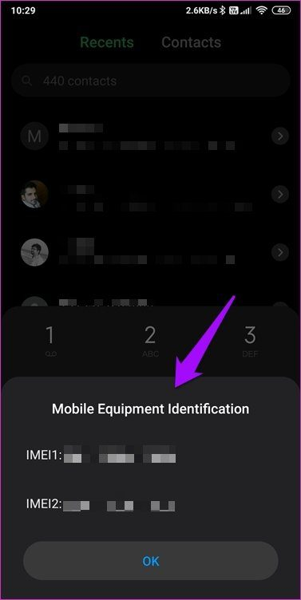

Do you notice two IMEI numbers in the screenshot above? That’s because I am using a dual SIM phone, and each has to be registered with the carrier. Usually, only the last few digits are different in such cases. It helps the carrier identify and track these phones with IMSI numbers.

Several smartphones have started showing the IMEI number in the About section under Settings. Check out if your phone displays the IMEI number there too.

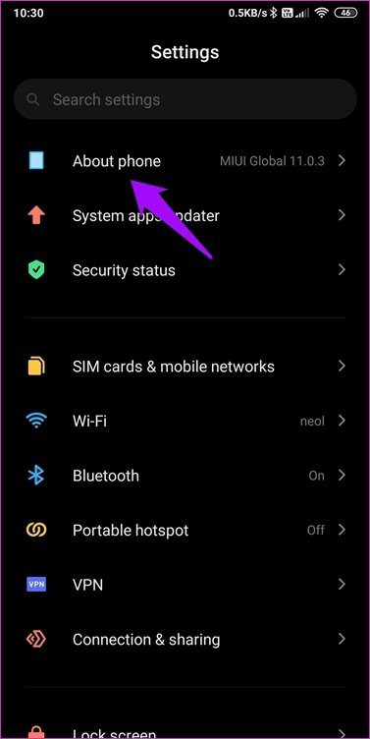

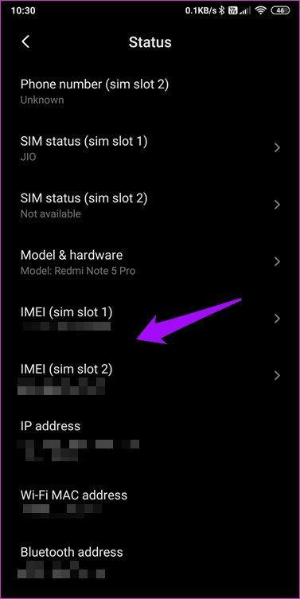

Note: Certain apps also claim to help find it, but we don’t recommend them. It’s not worth the trouble and there are chances that the information might be used to track the user in question. If you need it, call your telecom operator.

## 4. WHEN TO USE IMEI AND IMSI NUMBERS

Because IMEI numbers are unique and cannot be changed easily, they are most useful in tracking and recovering lost or stolen phones. It is used to identify the mobile as all IMEI numbers are stored in a global register called Equipment Identification Register (EIR). Your telecom provider has the power to blacklist or block the phone. When a phone is blacklisted across all networks, no SIM will ever work on it. That means the phone is pretty much useless. I think Wi-Fi should still work.

The hackers use aftermarket tools to make a quick profit by changing the IMEI number. This is called unblocking, which is a [criminal offense](https://www.guidingtech.com/tampering-imei-number-jail) in many countries. These hackers use tools to assign a new IMEI number (also known as spoofing) to the phone so that it gets unblocked and use it again with a different SIM card. You can face legal consequences of spoofing the mobile IMEI number if it gets caught up in being used for nefarious activities.



On the other hand, when you transfer your SIM card from one phone to another, the IMSI number carries itself to the new phone with the SIM. The IMEI number stays with the phone as it is tied to the phone. Telecom operators use the IMSI number to identify the customer and all the services that he/she has signed up for. That includes your calling, messaging, internet, and other services offered by the company.

## 5. SECURITY CONCERNS

It is important to protect your IMEI and IMSI from prying eyes of nefarious apps and trackers. Hackers can use the IMEI number to track and locate your movements. Heck, they can even spoof them to use financial apps after stealing your data.

On a related note, if you encounter a phone without an IMEI number, then it is either an invalid or counterfeit phone. You shouldn’t be buying that no matter how attractive the price. How do you know your IMEI number is valid? Well, you can match the one showed in the software interface with that printed at its back and the packaging box. Another way to check it is by using the [LUHN formula](https://www.geeksforgeeks.org/luhn-algorithm/).



Same way, IMSI numbers can be used by hackers to track users, intercept calls, messages, and hijack mobile data. That’s because the IMSI number is tied to the SIM card and is directly used to provide relevant services to the subscriber. Hackers can create a spoofed access point to catch the data associated with the IMSI number before relaying the same to the nearest cell tower and back again. Many Hollywood movies show that trick of tracing calls and all. However, the actual usage of such a technique is an extremely complicated process. Not impossible, though.

Because the IMSI number is tied to the SIM and used during communication with cell towers, it can also be used to track the movements of the user. In that case, the cell towers’ location is used to [triangulate your position](https://www.safetrax.in/2017/09/05/gps-cell-tower-triangulation-help-tracking-location/).

That said, the IMEI and IMSI can be extracted by mobile apps to create a personally identifiable profile based on your usage pattern. For instance, based on your browsing activities, several companies can show you specifically targeted ads. And you might wonder, how did that company know that you wanted to buy a new jacket? Well, it could be any app that you’ve blindly permitted to access any information on your phone. Why else would you think your phone is snooping on you? Well, that’s how you get “personalized targeted ads” from the personally identifiable profiles.

## FIND YOUR PHONE’S IDENTITY

IMEI is tied to the phone and is used to identify the phone. IMSI is tied to the SIM card and is used to identify the subscriber and services assigned to him/her. IMSI moves from phone to phone with the SIM, but IMEI remains with the handset. As an end-user, you will find IMEI useful for blocking lost or stolen phones.

That’s the gist of it. It is a good idea to store your IMEI number somewhere safe so that when the time comes, you can quote it. If the IMEI number is visible in the Settings’ About section, just take a screenshot and save the image in the cloud.

**Question:**  What is the difference between Serializable and Parcelable in Android?

**Answer:**  Serializable is a Java interface used to serialize objects, while Parcelable is an Android-specific interface used to serialize objects that are passed between different components of an Android application.

**Question:**  What is an Adapter in Android?

**Answer:**  An Adapter is a bridge between a user interface component and a data source. It is used to populate a user interface component such as a ListView or RecyclerView with data from a data source such as an array or database.

**Question:**  What is the difference between a View and a ViewGroup in Android?

**Answer:**  A View is a single user interface element such as a button or text field, while a ViewGroup is a container that holds other Views or ViewGroups. ViewGroup can be used to group Views together, while Views represent the individual elements.

**Question:**  What is the difference between match_parent and wrap_content in Android?

**Answer:**  match_parent is used to make a View or ViewGroup match the size of its parent element, while wrap_content is used to make a View or ViewGroup wrap its content tightly.

**Question:**  What is a Handler in Android?

**Answer:**  A Handler is an Android class used to communicate between different threads in an Android application. It is used to post messages or runnable objects to the message queue of a thread.

**Question:**  What is the difference between a Thread and a Handler in Android?

**Answer:**  A Thread is a separate execution path that can run concurrently with the main UI thread, while a Handler is a mechanism used to communicate between different threads in an Android application. A Thread is used to perform long-running operations, while a Handler is used to update the UI thread with the results of those operations.

**Question:**  What is the difference between a service and an IntentService in Android?

**Answer:**  A Service is a component of an Android application that runs in the background without a user interface, while an IntentService is a subclass of Service that performs long-running tasks on a separate thread. An IntentService is used to perform tasks such as downloading files or performing network calls.

**Question:**  What is the difference between Serializable and JSON in Android?

**Answer:**  Serializable is a Java interface used to serialize objects, while JSON is a lightweight data interchange format used to exchange data between different systems. JSON is faster and more efficient than Serializable.

**Question:**  What is the Android Application class?

**Answer:**  The Android Application class is a base class used to maintain global application state. It is used to store and access application-wide resources and objects.

**Question:**  What is the use of the Android Support Library?

**Answer:**  The Android Support Library is a set of code libraries that provide backward compatibility for newer Android features on older Android versions. It is used to make it easier to develop applications that work on a wide range of Android devices.

**Question:**  What is the difference between a FragmentPagerAdapter and a FragmentStatePagerAdapter?

**Answer:**  A FragmentPagerAdapter keeps all fragments in memory, while a FragmentStatePagerAdapter saves and restores the state of fragments as they are scrolled. FragmentStatePagerAdapter is used for large numbers of fragments.

**Question:**  What is the difference between a Serializable and a Parcelable in Android?

**Answer:**  Serializable is a Java interface used to serialize objects, while Parcelable is an Android interface used to serialize objects for inter-process communication. Parcelable is faster and more efficient than Serializable.

**Question:**  What is the difference between a ContentProvider and a SQLite Database in Android?

**Answer:**  A ContentProvider is a component of an Android application that provides a standardized interface for accessing data from different applications, while a SQLite Database is a local database used to store application data. A ContentProvider can provide access to a SQLite database, as well as other types of data.

**Question:**  What is the difference between a ViewStub and an Include tag in Android?

**Answer:**  A ViewStub is a lightweight View that is used to lazily inflate complex layouts. It does not inflate its layout until it is needed. An Include tag is used to include the contents of one layout into another layout. It is used to reuse common layout elements across different layouts.

**Question:**  What's the difference between a file, a class and an activity in android?

**Answer:**  File - It is a block of arbitrary information, or resource for storing information. It can be of any type.

Class - Its a compiled form of .Java file . Android finally used this .class files to produce an executable apk

Activity - An activity is the equivalent of a Frame/Window in GUI toolkits. It is not a file or a file type it is just a class that can be extended in Android for loading UI elements on view.

**Question:**  What is Android Runtime?

**Answer:**  Android includes a set of core libraries that provides most of the functionality available in the core libraries of the Java programming language. Every Android application runs in its own process, with its own instance of the Dalvik virtual machine. Dalvik has been written so that a device can run multiple VMs efficiently. The Dalvik VM executes files in the Dalvik Executable (.dex) format which is optimized for minimal memory footprint. The VM is register-based, and runs classes compiled by a Java language compiler that have been transformed into the .dex format by the included "dx" tool.

**Question:**  What is the Open Handset Alliance?

**Answer:**  The OHA is a consortium of 84 technology and mobile companies that have joined hands to accelerate innovation in mobile technology and at the same time offer the end users a better, cost-effective and richer mobile experience. Members of this include Google, HTC, Sony, Dell, Intel, Motorola, Qualcomm, Texas Instruments, Samsung, LG, T-Mobile, Nvidia. The OHA was started on 5 November 2007 by Google and 34 other companies. Android is the main software of the alliance.

**Question:**  What is the importance of XML-based layouts?

**Answer:**  The use of XML-based layouts provides a consistent and somewhat standard means of setting GUI definition format. In common practice, layout details are placed in XML files while other items are placed in source files.

**Question:**  What are containers?

**Answer:**  Containers, as the name itself implies, holds objects and widgets together, depending on which specific items are needed and in what particular arrangement that is wanted. Containers may hold labels, fields, buttons, or even child containers, as examples.

**Question:**  What is Orientation?

**Answer:**  Orientation, which can be set using setOrientation(), dictates if the LinearLayout is represented as a row or as a column. Values are set as either HORIZONTAL or VERTICAL.

**Question:**  What do you think are some disadvantages of Android?

**Answer:**  Given that Android is an open-source platform, and the fact that different Android operating systems have been released on different mobile devices, there’s no clear cut policy to how applications can adapt with various OS versions and upgrades. One app that runs on this particular version of Android OS may or may not run on another version. Another disadvantage is that since mobile devices such as phones and tabs come in different sizes and forms, it poses a challenge for developers to create apps that can adjust correctly to the right screen size and other varying features and specs.

**Question:**  Which elements can occur only once and must be present?

**Answer:**  Among the different elements, the and elements must be present and can occur only once. The rest are optional, and can occur as many times as needed.

**Question:**  How are escape characters used as attribute?

**Answer:**  Escape characters are preceded by double backslashes. For example, a newline character is created using ‘\\n’

**Question:**  What is the importance of settings permissions in app development?

**Answer:**  Permissions allow certain restrictions to be imposed primarily to protect data and code. Without these, codes could be compromised, resulting to defects in functionality.

**Question:**  Is there a case wherein other qualifiers in multiple resources take precedence over locale?

**Answer:**  Yes, there are actually instances wherein some qualifiers can take precedence over locale. There are two known exceptions, which are the MCC (mobile country code) and MNC (mobile network code) qualifiers.

**Question:**  What is the proper way of setting up an Android-powered device for app development?

**Answer:**  The following are steps to be followed prior to actual application development in an Android-powered device:

-Declare your application as “debuggable” in your Android Manifest.

Turn on “USB Debugging” on your device.

Set up your system to detect your device.

**Question:**  How do you remove icons and widgets from the main screen of the Android device?

**Answer:**  To remove an icon or shortcut, press and hold that icon. You then drag it downwards to the lower part of the screen where a remove button appears.

**Question:**  What is portable Wi-Fi hotspot?

**Answer:**  Portable Wi-Fi Hotspot allows you to share your mobile internet connection to other wireless device. For example, using your Android-powered phone as a Wi-Fi Hotspot, you can use your laptop to connect to the Internet using that access point.

**Question:**  Why cannot you run standard Java bytecode on Android?

**Answer:**  Android uses Dalvik Virtual Machine (DVM) which requires a special bytecode. We need to convert Java class files into Dalvik Executable files using an Android tool called “dx”. In normal circumstances, developers will not be using this tool directly and build tools will care for the generation of DVM compatible files.

**Question:**  What are the different data types used by Android?

**Answer:**  The data can be passed between many services and activities using the following data types:

– Primitive Data Types: This is used to share the activities and services of an application by using the command as Intent.putExtras(). This primitive data passes the command to show the persistent data using the storage mechanism. These are inbuilt data types that are used with the program. They provide a simple implementation of the type and easy to use commands.

– Non-Persistent Objects: It is used to share complex and non-persistent objects. These are user-defined data types that are used for short duration and are also recommended to be used. These types of objects allow the data to be unique but it creates a complex system and increases the delay.

**Question:**  What needs to be done in order to set Android development environment where Eclipse IDE is to be used?

**Answer:**  Download the Android SDK from Android homepage and set the SDK in the preferences. Windows > Preferences > Select Android and enter the installation path of the Android SDK. Alternatively, you may use Eclipse update manager to install all available plugins for the Android Development Tools (ADT)

**Question:**  Can you deploy executable JARs on Android? Which packaging is supported by Android?

**Answer:**  No. Android platform does not support JAR deployments. Applications are packed into Android Package (.apk) using Android Asset Packaging Tool (aapt) and then deployed on to Android platform. Google provides Android Development Tools for Eclipse that can be used to generate Android Package.

**Question:**  Define Android application resource files?

**Answer:**  As an Android application developer, you can inject files (XML, JSON, JPEG etc) into the build process and can load them from the code. These injected files are revered as resources.

**Question:**  Where can you define the icon for your Activity?

**Answer:**  Icon for an Activity is defined in the manifest file.

<activityandroid:icon=”@drawable/app_icon”android:name=”.MyTestActivity”></activity>

**Question:**  Android application can only be programmed in Java?

**Answer:**  False. You can program Android apps in C/C++ using NDK .

**Question:**  How does Android system track the applications?

**Answer:**  Android system assigns each application a unique ID that is called Linux user ID. This ID is used to track each application.

**Question:**  An Android application needs to access device data e.g SMS messages, camera etc. At what stage user needs to grant the permissions?

**Answer:**  Application permission must be granted by the user at install time.

**Question:**  How to get screen dimensions in pixels in Andorid Devices?

**Answer:**  intscreenHeight = getResources().getDisplayMetrics().heightPixels;

intscreenWidth = getResources().getDisplayMetrics().widthPixels;

**Question:**  What do containers hold?

**Answer:**  Containers hold objects and widgets in a specified arrangement.

They can also hold labels, fields, buttons, or child containers.

**Question:**  Tell us something about activityCreator?

**Answer:**  An **activityCreator** is the first step for creation of a new Android project.

It consists of a shell script that is used to create new file system structure required for writing codes in Android IDE.

**Question:**  Describe the SmsManager class in android.

**Answer:**  SmsManager class is responsible for sending SMS from one emulator to another or device.

You cannot instantiate this class directly; instead of , You can call the getDefault method static() to obtain an SmsManager object. Then send the SMS message using the

sendTextMessage() method:

SmsManagersms = SmsManager.getDefault();

sms.sendTextMessage(“5556”, null, “Hello from careerRide”, null, null);

sendTextMessage() method takes five argument.

– destinationAddress — Phone number of the recipient.

– scAddress — Service center address; you can use null also.

– sentIntent — Pending intent to invoke when the message is sent.

– text — Content of the SMS message that you like to send.

– deliveryIntent — Pending intent to invoke when the message has been delivered.

**Question:**  How to disable landscape mode in Android?

**Answer:**  Open AndroidManifest.xml file and set following.

*android:screenOrientation=”sensorPortait”*

**Question:**  Enumerate the three key loops when monitoring an activity

**Answer:**  Entire lifetime : The activity happens between onCreate and onDestroy

– Visible lifetime : The activity happens between onStart and onStop

– Foreground lifetime : The activity happens between onResume and onPause

**Question:**  What do intent filters do?

**Answer:**  There can be more than one intents, depending on the services and activities that are going to use them and each component wants to tell which intents they want to response to.

– Intent filters out the intents that these components are willing to respond to.

**Question:**  How can your application perform actions that are provided by other application e.g. sending email?

**Answer:**  Intents are created to define an action that we want to perform and launches the appropriate activity from another application.

*Intent intent = new Intent(Intent.ACTION_SEND);intent.putExtra(Intent.EXTRA_EMAIL, recipientArray);*

*startActivity(intent);*

**Question:**  **Name some exceptions in android?**

**Answer:**  Inflate Exception

* OutOfResourceException
* BadSurfaceTypeException
* BadTokenException

**Question:**  Is it okay to change the name of an application after its deployment?

**Answer:**  It is not recommended to change the application name after its deployment(final stage) because this action may break some functionality. For example, shortcuts will not work if you change application name.

**Question:**  When does Android start and end an application process?

**Answer:**  Android starts an application process when application’s component needs to be executed. It then closes the process when it’s no longer needed (garbage collection).

**Question:**  What type of listener is used to get the ratings from the RatingBar Widgets?

**Answer:**  onRatingBarChangeListener() is used. Click to get more details about **RatingBar** and **SeekBar**.

**Question:**  **How will you record a phone call in Android? or How to handle on Audio Stream for a call in Android?**

**Answer:**  PROCESS_OUTGOING_CALLS: Will Allows an application to monitor, modify, or abort outgoing calls. So through that we can monitor the Phone calls.

**Question:**  **As an Android developer, how will you enumerate the steps necessary to created bounded services through AIDL?**

**Answer:**  Create AIDL file to define the programming interface.

* Implement the interface and
* Expose the interface

**Question:**  **Enumerate the steps in creating a bounded service through AIDL.**

**Answer:**  create the .aidl file, which defines the programming interface

* implement the interface, which involves extending the inner abstract Stub class as well as implanting its methods.
* expose the interface, which involves implementing the service to the clients.

**Question:**   **What is needed to make a multiple choice list with a custom view for each row?**

**Answer:**  Multiple choice list can be viewed by making the CheckBox android:id value be “@android:id /text1″. That is the ID used by Android for the CheckedTextView in simple_list_item_multiple_choice.

**Question:**  What is User Events ?

**Answer:**  Event is a user interacting with the help of a Touchscreen. The Android framework maintains an Event Queue in which the events are arranged as they occur. The events are removed in First-In-First-Out (FIFO) basis.

**Question:**  What is the use of WebView in android?

**Answer:**  A WebView is an android UI component that displays webpages. It can either display a remote webpage or can also load static HTML data. This encompasses the functionality of a browser that can be integrated to application. WebView uses the WebKit rendering engine to display web pages and includes methods to navigate forward and backward through a history, zoom in and out, etc

**Question:**  **Why is emulator important in Android environment?**

**Answer:**  With emulator, it becomes easy for the developers to play around, edit and create the interface easily. Thus, it acts more like a mobile phone. With emulator it becomes easy to write and even perform the test codes and debug. It is the safest place that can be used for testing the codes

**Question:**  What is the ViewHolder-Pattern?

**Answer:**  The ViewHolder design pattern can be used to increase the speed at which a ListView renders data.

The pattern avoids the repeated lookup of view resources. The number of times which the findViewById() method is invoked is drastically reduced, existing views do not have to be garbage collected and new views do not have to be inflated. The view references for every row are stored in a simple object for later reuse.

**Question:**  What is the benefit of an Android library project?

**Answer:**  An Android library project allows the distribution of resources (e.g. layouts, themes) and manifest entries as well as Java Code (e.g. activites). It makes the process of creating multiple apps from the same code base easier.

**Question:**  What is a StateListDrawable?

**Answer:**  A StateListDrawable is a drawable object defined in the XML that allows us to show a different color/background for a view for different states. Essentially it’s used for Buttons to show a different look for each state(pressed,focused, selected, none).

**Question:**  What is the proper way of setting up an Android-powered device for app development?

**Answer:**  The following are steps to be followed prior to actual application development in an Android-powered device:

– Declare your application as “debuggable” in your Android Manifest.

– Turn on “USB Debugging” on your device.

– Set up your system to detect your device.

**Question:**  How would you create an AUTOINCREMENT field?

**Answer:**  For autoincrement, you have to declare a column of the table to be INTEGER PRIMARY KEY, then whenever you insert a NULL into that column of the table, the NULL is automatically converted into an integer which is one greater than the largest value of that column over all other rows in the table, or 1 if the table is empty.

**Question:**  What is sleep mode in Android?

**Answer:**  In sleep mode, CPU is slept and doesn’t accept any commands from android device except Radio interface layer and alarm.

**Question:**  What is the importance of settings permissions in app development?

**Answer:**  Permissions allow certain restrictions to be imposed primarily to protect data and code. Without these, codes could be compromised, resulting to defects in functionality.

**Question:**  What is a visible activity?

**Answer:**  A visible activity is one that sits behind a foreground dialog. It is actually visible to the user, but not necessarily being in the foreground itself.

**Question:**  When is the best time to kill a foreground activity?

**Answer:**  The foreground activity, being the most important among the other states, is only killed or terminated as a last resort, especially if it is already consuming too much memory. When a memory paging state has been reach by a foreground activity, then it is killed so that the user interface can retain its responsiveness to the user.

**Question:**  Is it possible to use or add a fragment without using a user interface?

**Answer:**  Yes, it is possible to do that, such as when you want to create a background behavior for a particular activity. You can do this by using add(Fragment,string) method to add a fragment from the activity.

**Question:**  What is a Sticky Intent?

**Answer:**  A Sticky Intent is a broadcast from sendStickyBroadcast() method such that the intent floats around even after the broadcast, allowing others to collect data from it.

**Question:**  Do all mobile phones support the latest Android operating system?

**Answer:**  Some Android-powered phone allows you to upgrade to the higher Android operating system version. However, not all upgrades would allow you to get the latest version. It depends largely on the capability and specs of the phone, whether it can support the newer features available under the latest Android version.

**Question:**  How can two Android applications share same Linux user ID and share same VM?

**Answer:**  The applications must sign with the same certificate in order to share same Linux user ID and share same VM.

**Question:**  Can you deploy executable JARs on Android? Which packaging is supported by Android?

**Answer:**  No, Android platform does not support JAR deployments. Applications are packed into Android Package (.apk) using Android Asset Packaging Tool (AAPT) and then deployed onto Android platform. Google provides Android Development Tools for Eclipse that can be used to generate Android Package.

**Question:**  What is the difference between TRUNCATE and DELETE commands?

**Answer:**  Both will result in deleting all the rows in the table .TRUNCATE call cannot be rolled back as it is a DDL command and all memory space for that table is released back to the server. TRUNCATE is much faster.Whereas DELETE call is an DML command and can be rolled back.

**Question:**  What is a candidate key?

**Answer:**  A table may have more than one combination of columns that could uniquely identify the rows in a table; each combination is a candidate key.

**Question:**  What is SQLite? How does it differ from client-server database management systems?

**Answer:**  SQLite is the open-source relational database of choice for Android applications. The SQLite engine is serverless, transactional, and self-contained. Instead of the typical client-server relationship of most database management systems, the SQLite engine is integrally linked with the application. The library can also be called dynamically, and makes use of simple function calls that reduce latency in database access.

**Question:**  What is the role of compatibility that is used in Android?

**Answer:**  The compatibility is defined in terms of android compatible devices that run any application. This application is written by third party developers using the Android platform that comes in the form of SDK and NDK.

– There are many filters that are used to separate devices that are there to participate in the compatibility mode for the Android applications. The devices that are compatible require the android to approve it for their trademark. The devices that are not passes the compatibility are just given in the Android source code and can use the android trademark.

– The compatibility is a way through which the user can participate in the Android application platform. The source code is free to use and it can be used by anyone.

**Question:**  How long does compatibility take?

**Answer:**  The process is automated. The Compatibility Test Suite generates a report that can be provided to Google to verify compatibility. Eventually we intend to provide self-service tools to upload these reports to a public database.

**Question:**  **Is there anyway to determine if an Intent passed into a BroadcastReceiver’s on Receive is the result of a sticky Broadcast Intent, or if it was just sent?**

**Answer:**  When you call registerReceiver( ) for that action — even with a null BroadcastReceiver — you get the Intent that was last broadcast for that action. Hence, you can use this to find the state of the battery without necessarily registering for all future state changes in the battery.

**Question:**  How to Translate in android?

**Answer:**  The Google translator translates the data of one language into another language by using XMPP to transmit data. You can type the message in English and select the language which is understood by the citizens of the country in order to reach the message to the citizens.

**Question:**  Can an application be started on power up?

**Answer:**  Yes, application can be started on power up.

**Question:**  What is the TTL (Time to Live)? Why is it required?

**Answer:**  TTL is a value in data packet of Internet Protocol. It communicates to the network router whether or not the packet should be in the network for too long or discarded. Usually, data packets might not be transmitted to their intended destination within a stipulated period of time. The TTL value is set by a system default value which is an 8 -bit binary digit field in the header of the packet. The purpose of TTL is, it would specify certain time limit in seconds, for transmitting the packet header. When the time is exhausted, the packet would be discarded. Each router receives the subtracts our when the packet is discarded, and when it becomes zero, the router tests the discarded packets and sends a message, Internet Control Protocol message back to the originating host.

**Question:**  What is Xmpp used for?

**Answer:**  Extensible Messaging and Presence Protocol (XMPP) is a communications protocol for message-oriented middleware based on XML (Extensible Markup Language).

**Question:**  What is an action?

**Answer:**  In Android development, an action refers to an explicit intent or desire expressed by a user in order to get a specific result. In other words, an action refers to a specific request that someone sends by way of functionality compared to an implicit intent that does not define the target component and invokes the Android system to evaluate. The application receives the request and produces the desired result where possible. Where that is not possible, a message will be displayed indicating that the user’s request cannot be accomplished.

**Question:**  What value does an emulator provide for an Android?

**Answer:**  An emulator permits a developer to toy with an interface as if it were an actual, live mobile device. In other words, it allows a developer to interact with an interface as if it were already functional on a mobile phone. By emulating a real-life scenario of a user navigating an interface, a developer can better detect possible flaws or areas of improvement prior to finishing development. With it, one can write code, test it, and even debug it. Essentially, emulators provide developers with a safe space to test code even, as early as, in the design phase.

**Question:**  How are activities different from services?

**Answer:**  Within the context of Android mobile development, activities are those which can be terminated or closed at any given point in time. Services, on the other hand, are made to continue functioning behind the scenes. They run independently, irrespective of whether a user has requested the execution of a particular action.

**Question:**  Do all mobile devices support the most recent Android operating system?

**Answer:**  That is entirely dependent on the mobile device. Most of them, if not all, will allow you to upgrade. However, not all upgrades imply that you are getting access to the latest version of Android. Some mobile devices will permit that, but others won’t. Your device’s ability to facilitate an upgrade to the most recent version of Android available depends on the capacity of the device to support the newest features that have been released.

**Question:**  When would you say is the best time to destroy an activity that is in the foreground?

**Answer:**  An activity that is currently in the foreground (Stage 2) should be destroyed only when it is consuming too much energy. When a page that consumes a lot of memory space arrives at Stage 2, it should be killed. Doing so will help to ensure that the graphical user interface retains its responsiveness.

**Question:**  How important is it to set up permissions in app development?

**Answer:**  During the app development phase, security is important. The best way to safeguard the integrity of your application against cybersecurity is through permissions. These restrict the data and code associated with an application to only those authorized users who have the credentials needed to access them. Failure to protect your code implies that you are leaving it open for any and everyone to access and tamper with it, a risk that you should avoid at all costs.

**Question:**  Can you think of a scenario where you can only test something on a real device and not on an emulator?

**Answer:**  Emulators serve to perform application tests almost as if they were being done on a real android-enabled device. That said, there are scenarios where emulators cannot work. These are called interrupted scenarios with the actual mobile device and refer to the following:

* Insertion and removal of memory cards;
* Incoming call when the application is active;
* Incoming messages (SMS) when the application is in use;
* Bluetooth connection;
* Low battery notification.

**Question:**  How do you source memory leaks in mobile applications using the Android platform?

**Answer:**  With Android Studio, you use the Android Device Manager (ADM). This ADM is designed to pinpoint memory leaks that may crop up in the Android platform. Once you have launched ADM in the Android Studio, on the left-hand side, a heap sign will appear. Activate it to allow the function to run.

**Question:**  What is the difference between API and SDK?

**Answer:**  API is an interface between two applications that allows software programs to interact with each other while SDK is a set of tools that are used to develop software applications.

**Question:**  What are the three key loops when monitoring an activity?

**Answer:**  One of the android interview questions may include this basic yet crucial question. There are three key loops including:

* Entire lifetime – Activity occurs between onDestroy and onCreate
* Visible lifetime – Activity occurs between onStop and onStart
* Foreground lifetime – Activity occurs between onPause and onResume

**Question:**  What is the importance of Default Resources?

**Answer:**  Default resources are those items that are not specific to any device. It contains default strings and files that are not present, an error will occur, and the app will not run. Default Resources are organized in subdirectories of the resource directory as per their resource type.

**Question:**  What is drawable folder in android?

**Answer:**  It is a compiled visual resource that can be used as a background, banners, icons, splash screen, etc. It is necessary to choose the appropriate size and resolution of images so that there is no possibility of an app crash. Android support some specific image formats such as GIF, JPG, BMP, PNG, and WebP. If the drawable folder is not present on your project, you can create it by:

* First, right-click on res folder
* Select New
* Select Android Resource Directory
* Name the directory as “”
* Add Drawable to Available Qualifiers Section
* Click ok
* Refer Drawable resource in your XML files by calling: “@drawable/filename”

**Question:**  What is Armv7?

**Answer:**  This is also one of the definition based android interview questions. ARMv7 is the most common CPU architecture in Android. Its popularity is because it is evolved and optimized for more powerful computing. It is used in ARM Cortex-A, ARM Cortex-M, ARM Cortex-R CPU families.

**Question:**  How does Activity respond when a user rotates the screen?

**Answer:**  So, this is among the most commonly asked Android interview questions. You can reply –

When a user rotates the screen, the current Activity is ended, and a new instance of Activity is created in the new orientation, and onRestart() method is invoked. Similarly, other lifecycle methods also get invoked when Activity was first created.

**Question:**  Why should you use only the default constructor to create a Fragment?

**Answer:**  It is always suggested to use only the default constructor to create a Fragment because the device has to restore the state of a fragment correctly to the same state as it was in the initial state, in instances like configuration change.

**Question:**  Can you create an activity in Android without a user interface?

**Answer:**  Yes, it can be created without any user interface, and these activities are treated as abstract activities.

**Question:**  Is it possible to change the name of an application after it is deployed?

**Answer:**  It is possible, but not suggested. This action may break some functionality.

**Question:**  How are escape characters used as attributes?

**Answer:**  Double backslashes precede escape characters.

Example: A newline character is represented as ‘\\n.’

**Question:**  What are the different states wherein a process is based?

**Answer:**  There are four possible states:

* foreground activity
* visible activity
* background activity
* empty process

**Question:**  What is the procedure to make a responsive application which is used in mobile and tablet?

**Answer:**  The application can be made responsive by designing two different layouts with same name and id’s.

res/layout/main_activity.xml # Used For phones

Copy code

res/layout/main_activity_tablet.xml # Used For tablets

Copy code

And calling it in your java class.

public class MyActivity extends Activity {

@Override protected void onCreate(Bundle savedInstanceState) {

super.onCreate();

Configuration config = getResources().getConfiguration();

if (config.smallestScreenWidthDp >= 600) {

setContentView(R.layout.main_activity_tablet);

} else {

setContentView(R.layout.main_activity);

}

}

}

**Question:**  When should you kill a foreground activity?

**Answer:**  Killing the foreground activity is the last resort when it is consuming too much memory. When a memory paging state is reached by a foreground activity, foreground activity is killed so that responsiveness of the user interface can be retained.

**Question:**  Is it possible to use or add a fragment without using a user interface?

**Answer:**  Yes, it is possible to add fragments without using a user interface, by using the ‘add(Fragment,string)’ method for adding a fragment from an activity.

**Question:**  How to get information on all the networks in Android?

**Answer:**  To get information about all the networks in Android we can use getAllNetworkInfo() method.

Syntax:

NetworkInfo[] netList = check.getAllNetworkInfo();

**Question:**  How can we implement swipe animation in Android?

**Answer:**  By using:

<set xmlns : android=”http://schemas.android.com/apk/res/android” android:shareInterpolator=”false”><translate android:fromXDelta=”-100%”

android:toXDelta=”0%”

android:fromYDelta=”0%”

android:toYDelta=”0%”

android:duration=”700″/>

</set>

**Question:**  What is the difference between Activity and AppCompatActivity?

**Answer:**  AppCompatActivity provides native ActionBar support that is consistent across the application. Also, it provides backward compatibility for other material design components till SDK version 7(ActionBar was natively available since SDK 11). Extending an Activity doesn’t provide any of these. Note: Since SDK 21 every activity by default, extends AppCompatActivity.

**Question:**  Activity, AppCompatActivity, FragmentActivity and ActionBarActivity. How are they related?

**Answer:**  Activity is the base class. FragmentActivity extends Activity. AppCompatActivity extends FragmentActivity. ActionBarActivity extends AppCompatActivity. FragmentActivity is used for fragments. Since the build version 22.1.0 of the support library, ActionBarActivity is deprecated. It was the base class of appcompat-v7. At present, AppCompatActivity is the base class of the support library. It has come up with many new features like ToolBar, tinted widgets, material design color pallets etc.

**Question:**  What is Android Support Library and why is it recommended?

**Answer:**  The android platform supports a wide variety of the versions and devices to choose from. With the release of every new version, new Android APIs are added and evolved. To make these new Android APIs available to users on older devices the Android Support Library was designed. Android Support Library provides developers with newer APIs that are compatible on older framework releases.

**Question:**  Describe the structure of Android Support Library?

**Answer:**  Android Support Library is not just a single library. It’s a collection of libraries that have different naming conventions and usages. On a higher level, it’s divided into three types;

Compatibility Libraries: These focus on back porting features so that older frameworks can take advantage of newer releases. The major libraries include v4 and v7-appcompat. v4 includes classes like DrawerLayout and ViewPager while appcompat-v7 provides classes for support ActionBar and ToolBar.

Component Libraries: These include libraries of certain modules that don’t depend on other support library dependencies. They can be easily added or removed. Examples include v7-recyclerview and v7-cardview.

Miscellaneous libraries: The Android support libraries consists of few other libraries such as v8 which provides support for RenderScript, annotations for supporting annotations like @NonNull.

**Question:**  Pressing the home button from an application invokes onPause() and onStop(). Describe a scenario where only the onPause() gets invoked.

**Answer:**  Create and launch a new activity which obscures the current activity partially. This can be done by defining the layout_width and layout_height to partially cover the screen. This would keep the first activity visible but not in the foreground. Example: define the layout_width and layout_height as 200dp each.

**Question:**  How does the activity respond when the user rotates the screen?

**Answer:**  When the screen is rotated, the current instance of the activity is destroyed a new instance of the Activity is created in the new orientation. The onRestart() method is invoked first when a screen is rotated. The other lifecycle methods get invoked in the similar flow as they were when the activity was first created.

**Question:**  The below application is designed to increment the textview value by 1 every time the button is clicked but it will crash. Why?

Given below is a sample layout of the activity_main.xml

<?xml version="1.0" encoding="utf-8"?>

<RelativeLayout xmlns:android="https://schemas.android.com/apk/res/android"

android:layout_width="match_parent"

android:layout_height="match_parent"

android:paddingBottom="@dimen/activity_vertical_margin"

android:paddingLeft="@dimen/activity_horizontal_margin"

android:paddingRight="@dimen/activity_horizontal_margin"

android:paddingTop="@dimen/activity_vertical_margin"

>

<TextView

android:layout_width="wrap_content"

android:layout_height="wrap_content"

android:text="0"

android:id="@+id/textView"

android:layout_alignParentRight="true"

android:layout_alignParentEnd="true"

android:layout_alignParentLeft="true"

android:layout_alignParentStart="true" />

<Button

android:layout_width="wrap_content"

android:layout_height="wrap_content"

android:text="Increment"

android:id="@+id/button"

android:layout_centerVertical="true"

android:layout_centerHorizontal="true" />

</RelativeLayout>

Given below is a sample MainActivity.java class;

public class MainActivity extends AppCompatActivity {

Button increment;

TextView textView;

int i=0;

@Override

protected void onCreate(Bundle savedInstanceState) {

super.onCreate(savedInstanceState);

setContentView(R.layout.activity_main);

increment=(Button)findViewById(R.id.button);

textView=(TextView)findViewById(R.id.textView);

increment.setOnClickListener(new View.OnClickListener() {

@Override

public void onClick(View v) {

i++;

textView.setText(i);

}

});

}

}

**Answer:**  The application will crash with a android.content.res.Resources$NotFoundException: String resource ID #0x1 exception since the textview expects a string value. The above code is passing the integer directly. We need to convert it into a string. This can be done in either of two ways:

textView.setText(""+i);

textView.setText(String.valueOf(i));

**Question:**  This is a follow up question to the case above. How does the above application respond when the screen orientation is changed?

**Answer:**  On-screen rotation the activity restarts and the objects are initialized again. Hence the textView counter resets to zero every time the orientation is changed.

**Question:**  How to prevent the data from reloading and resetting when the screen is rotated?

**Answer:**  The most basic approach is to add an element attribute tag `android:configChanges` inside the activity tag in the AndroidManifest.xml as shown below.

```

<activity android:name=".MainActivity"

android:configChanges="orientation|screenSize">

<intent-filter>

<action android:name="android.intent.action.MAIN" />

<category android:name="android.intent.category.LAUNCHER" />

</intent-filter>

</activity>

```

In general, the configChanges for any activity are defined as

```

android:configChanges="orientation|screenSize|keyboardHidden"

```

The `keyboardHidden` configuration is to prevent the keyboard from resetting if it's pulled out.

**Question:**  An example layout of activity_main.xml is given below. The MainActivity.java only contains the blank onCreate() method.

**Answer:**  ```

<?xml version="1.0" encoding="utf-8"?>

<RelativeLayout xmlns:android="https://schemas.android.com/apk/res/android"

android:layout_width="match_parent"

android:layout_height="match_parent"

android:paddingBottom="@dimen/activity_vertical_margin"

android:paddingLeft="@dimen/activity_horizontal_margin"

android:paddingRight="@dimen/activity_horizontal_margin"

android:paddingTop="@dimen/activity_vertical_margin"

>

<EditText

android:layout_width="wrap_content"

android:layout_height="wrap_content"

android:text="Hello World!"

android:layout_alignParentRight="true"

android:layout_alignParentEnd="true"

android:layout_alignParentLeft="true"

android:layout_alignParentStart="true" />

</RelativeLayout>

```

The configChanges are defined in the AndroidManifest.xml as `android:configChanges="orientation|screenSize|keyboardHidden"`

#### Does the input text entered in the EditText persist when the orientation is changed? Yes/No? Explain.

No. Despite the configChanges defined in the AndroidManifest.xml, the EditText input text entered resets when the orientation is changed. This is because no resource id has been defined. On orientation change, the instance of the EditText gets lost. To fix this issue to work correctly add an `android:id` attribute element in the EditText tag.

**Question:**  Why is android:configChanges not recommended? Are there more better ways to handle orientation changes?

**Answer:**  `android:configChanges` is not the recommended way by Google. Though it's the simplest way to use, it comes with its own share of drawbacks. First, the common perception that android:configChanges = "orientation" will magically retain the data is a complete misinterpretation. The orientation changes can occur from a number of other events such as changing the default language can trigger a configuration change and destroy and recreate the activity. Second, the activity can restart itself if it's in the background and Android decides to free up its heap memory by killing it. When the application returns to the foreground it'll restart it's data to the original state and the user may not like that. A better alternative of `android:configChanges` is; Saving the current state of the activity when it's being destroyed and restoring the valuable data when it's restarted can be done by overriding the methods `onSaveInstanceState()` and `onRestoreInstanceState()` of the activity class.

**Question:**  Where do onSaveInstanceState() and onRestoreInstanceState() come in the activity lifecycle? How is the data saved and restored from these methods?

**Answer:** In general the onSaveInstanceState() is invoked after onPause() and before the onStop(). But the API documentation explicitly states that the onSaveInstanceState( ) method will be called before onStop() but makes no guarantees it will be called before or after onPause(). The onRestoreInstanceState() is called after onStart() is invoked. The onRestoreInstanceState() method is invoked only when the activity was killed before. If the activity is NOT killed the onSaveInstanceState() is NOT called. When the activity is being destroyed, the onSaveInstanceState() gets invoked. The onSaveInstanceState contains a Bundle parameter. The data to be saved is stored in the bundle object in the form of a HashMap. The bundle object is like a custom HashMap object. The data is retrieved in the onRestoreInstanceState() method using the keys

**Question:**  You’ve been given a layout that contains an EditText field. Implement the onSaveInstanceState() and onRestoreInstanceState() to save and restore the current input text when the screen is rotated without declaring the android:configChanges attribute in the manifest file. The MainActivity.java is given below.

**Answer:**  ```

public class MainActivity extends AppCompatActivity {

EditText editText;

@Override

protected void onCreate(Bundle savedInstanceState) {

super.onCreate(savedInstanceState);

setContentView(R.layout.activity_main);

editText = (EditText) findViewById(R.id.editText);

}

}

```

```

public class MainActivity extends AppCompatActivity {

EditText editText;

@Override

protected void onCreate(Bundle savedInstanceState) {

super.onCreate(savedInstanceState);

setContentView(R.layout.activity_main);

editText = (EditText) findViewById(R.id.editText);

}

@Override

public void onSaveInstanceState(Bundle outState) {

super.onSaveInstanceState(outState);

outState.putString("myData", editText.getText().toString());

}

@Override

protected void onRestoreInstanceState(Bundle savedInstanceState) {

super.onRestoreInstanceState(savedInstanceState);

editText.setText(savedInstanceState.getString("myData"));

}

}

```

**Question:**  How to keep the screen orientation fixed? Also implement a mechanism so that the screen is always on for a particular activity.

**Answer:**  The screen orientation can be fixed by adding the attribute `android:screenOrientation="portrait"` or `android:screenOrientation="landscape"` in the activity tag. To keep the screen always on for a particular screen add the `android:keepScreenOn="true"` in the root tag of the activity layout.

**Question:**  How to restart an activity programmatically? Implement the method restartActivity() that restarts an Activity on a button click.

**Answer:**  Given below is the MainActivity.java class

```

public class MainActivity extends AppCompatActivity {

Button btn;

@Override

protected void onCreate(Bundle savedInstanceState) {

super.onCreate(savedInstanceState);

setContentView(R.layout.activity_main);

btn = (Button) findViewById(R.id.btn);

btn.setOnClickListener(new View.OnClickListener() {

@Override

public void onClick(View v) {

restartActivity();

}

});

}

public void restartActivity() {

//Complete the code

}

}

```

We need to invoke the recreate method on the Activity instance as shown below.

```

public void restartActivity() {

MainActivity.this.recreate();

}

```

**Question:**  Describe three common usages of intent and how are they invoked.

**Answer:**  Android Intents are used to

1. start an activity - startActivity(intent)

2. start a service - startService(intent)

3. deliver a broadcast - sendBroadcast(intent)

**Question:**  Implement two actions using intents namely calling a phone number and opening a URL.

**Answer:**  To enable calling from the application we need to add the following permission in the manifest tag of AndroidManifest.xml

```

<uses-permission android:name="android.permission.CALL_PHONE" />

```

In the MainActivity the following code invokes an action call to the given number represented as a string. The string is parsed as a URI.

```

String phone_number = "XXXXXXX" // replace it with the number

Intent intent=new Intent(Intent.ACTION_CALL,Uri.parse("tel:"+phone number);

startActivity(intent);

```

To open a URL we need to add the following permission.

```

<uses-permission android:name="android.permission.INTERNET" />

```

The intent to view a URL is defined below.

```

Intent intent = new Intent(Intent.ACTION_VIEW, Uri.parse("https://www.journaldev.com/"));

startActivity(intent);

**Question:**  What’s the difference between setFlags() and addFlags() on an Intent object?

**Answer:**  When we're using setFlags, we're replacing the old flags with a new set of Flags. When we use addFlags, we're appending more flags.

**Question:**  Mention two ways to clear the back stack of Activities when a new Activity is called using intent.

**Answer:**  The first approach is to use a `FLAG_ACTIVITY_CLEAR_TOP` flag.

```

Intent intent= new Intent(ActivityA.this, ActivityB.class);

intent.setFlags(Intent.FLAG_ACTIVITY_CLEAR_TOP);

startActivity(intent);

finish();

```

The second way is by using `FLAG_ACTIVITY_CLEAR_TASK` and `FLAG_ACTIVITY_NEW_TASK` in conjunction.

```

Intent intent= new Intent(ActivityA.this, ActivityB.class);

intent.setFlags(Intent.FLAG_ACTIVITY_NEW_TASK | Intent.FLAG_ACTIVITY_CLEAR_TASK);

startActivity(intent);

```

**Question:**  What’s the difference between FLAG_ACTIVITY_CLEAR_TASK and FLAG_ACTIVITY_CLEAR_TOP?

**Answer:**  `FLAG_ACTIVITY_CLEAR_TASK` is used to clear all the activities from the task including any existing instances of the class invoked. The Activity launched by intent becomes the new root of the otherwise empty task list. This flag has to be used in conjunction with `FLAG_ ACTIVITY_NEW_TASK`. `FLAG_ACTIVITY_CLEAR_TOP` on the other hand, if set and if an old instance of this Activity exists in the task list then barring that all the other activities are removed and that old activity becomes the root of the task list. Else if there's no instance of that activity then a new instance of it is made the root of the task list. Using `FLAG_ACTIVITY_NEW_TASK` in conjunction is a good practice, though not necessary.

**Question:**  Give one usage example where FLAG_ACTIVITY_NEW_TASK is necessary. Also, describe how the activity responds to this flag.

**Answer:**  When we're trying to launch an activity from outside the activity's context, a FLAG\_ACTIVITY\_NEW\_TASK is compulsory else a runtime exception would be thrown. Example scenarios are: launching from a service, invoking an activity from a notification click. If the activity instance is already on the task list when the flag is set, it will invoke the onNewIntent() method of that Activity. All the implementation stuff goes in that method.

**Question:**  Define the types of launchMode of an Activity and describe each of them.

**Answer:**  The `android:launchMode` of an Activity can be of the following types:

- **standard** : It's the default launch mode for an activity wherein every new instance of the activity called will be put on top of the stack as a separate entity. Hence calling startActivity() for a particular class 10 times will create 10 activities in the task list.

- **singleTop**: It differs from the standard launch mode in the fact that when the Activity instance that's invoked is already present on the top of the stack, instead of creating a new Activity, that instance will be called. In cases where the same Activity instance is not on the top of the stack or if it doesn't exist in the stack at all then a new instance of the activity will be added to the stack. Hence we need to handle the upcoming intent in both the `onCreate()` and `onNewIntent()` methods to cover all cases.

- **singleTask**: This is different from singleTop in the case that if the Activity instance is present in the stack, the onNewIntent() would be invoked and that instance would be moved to the top of the stack. All the activities placed above the singleTask instance would be destroyed in this case. When the activity instance does not exist in the stack, the new instance would be placed on the top of the stack similar to the standard mode.

- **singleInstance** : An activity with this launchMode defined would place only a singleton activity instance in the Task. The other activities of the application will be placed in a separate Task.

**Question:**  What is taskAffinity?

**Answer:**  A taskAffinity is an attribute tag defined in the activity tag in the AndroidManifest.xml for launchMode singleInstance. Activities with similar taskAffinity values are grouped together in one task. 26) You've been given an EditText that already has some text in it. How would you place the cursor at the end of the text? The current situation and the output needed are given below. [![android interview questions, taskAffinity](https://journaldev.nyc3.digitaloceanspaces.com/2016/06/edit-text-cursor-position-issue.png)](https://journaldev.nyc3.digitaloceanspaces.com/2016/06/edit-text-cursor-position-issue.png) [![android interview questions, taskAffinity](https://journaldev.nyc3.digitaloceanspaces.com/2016/06/edit-text-cursor-position-output.png)](https://journaldev.nyc3.digitaloceanspaces.com/2016/06/edit-text-cursor-position-output.png) Call the `setSelection(position)` on the EditText object with the position we need to place the cursor on. The current position is 0. To place it at the end of the current text we'll add the following code snippet in our MainActivity.

```

EditText in;

in=(EditText)findViewById(R.id.editText);

if (in != null) {

in.setSelection(Integer.parseInt(String.valueOf(in.getText().toString().length())));

}

```

The setSelection method requires an integer parameter. So we're wrapping the length of the string as an Integer using parseInt.

**Question:**  Implement an EditText that clears itself when the enter key is pressed. The image below demonstrates the requirement.

**Answer:**  [![edit text, textwatcher](https://journaldev.nyc3.digitaloceanspaces.com/2016/06/edit-text-textwatcher.gif)](https://journaldev.nyc3.digitaloceanspaces.com/2016/06/edit-text-textwatcher.gif) We'll add the TextWatcher class to the editText object. And check for the "\\n" character and clear the editText as shown below.

```

EditText in;

in=(EditText)findViewById(R.id.editText);

in.addTextChangedListener(new TextWatcher() {

@Override

public void beforeTextChanged(CharSequence s, int start, int count, int after) {

}

@Override

public void onTextChanged(CharSequence s, int start, int before, int count) {

String string = s.toString();

if (string.length() > 0 && string.charAt(string.length() - 1) == '\n') {

Toast.makeText(getApplicationContext(),"ENTER KEY IS PRESSED",Toast.LENGTH_SHORT).show();

in.setText("");

}

}

@Override

public void afterTextChanged(Editable s) {

}

});

```

**Question:**  Differentiate between LinearLayout, RelativeLayout, AbsoluteLayout.

**Answer:**  A LinearLayout arranges its children in a single row or single column one after the other. A RelativeLayout arranges it's children in positions relative to each other or relative to parent depending upon the LayoutParams defined for each view. AbsoluteLayout needs the exact positions of the x and y coordinates of the view to position it. Though this is deprecated now.

**Question:**  What’s the difference between a FrameLayout and a TableLayout.

**Answer:**  A FrameLayout stack up child views above each other with the last view added on the top. Though we can control the position of the children inside the FrameLayout using the layout\_gravity attribute. When the width and height of the FrameLayout are set to wrap\_content, the size of the FrameLayout equals the size of the largest child (plus padding). A TableLayout consists of TableRows. The children are arranged in the form of rows and columns.

**Question:**  How is data stored in Shared Preferences? What’s the difference between commit() and apply()? Which is the recommended one?

**Answer:**  Data is stored in SharedPreferences in the form of a key-value pair(HashMap). commit() was introduced in API 1 whereas apply() came up with API 9. commit() writes the data synchronously and returns a boolean value of success or failure depending on the result immediately. apply() is asynchronous and it won't return any boolean response. Also, if there is an apply() outstanding and we perform another commit(), then the commit() will be blocked until the apply() is not completed. commit() is instantaneous and performs disk writes. If we're on the main UI thread apply() should be used since it's asynchronous.

**Question:**  Which method gets invoked when the user presses back button on the screen?

**Answer:**  The onBackPressed() method of the Activity is invoked. Unless overridden it removes the current activity from the stack and goes to the previous activity.

**Question:**  How do you disable onBackPressed()?

**Answer:**  The onBackPressed() method is defined as shown below:

```

@Override

public void onBackPressed() {

super.onBackPressed();

}

```

To disable the back button and preventing it from destroying the current activity and going back we have to remove the line `super.onBackPressed();`

**Question:**  What is a StateListDrawable?

**Answer:**  A StateListDrawable is a drawable object defined in the XML that allows us to show a different color/background for a view for different states. Essentially it's used for Buttons to show a different look for each state(pressed, focused, selected, none).

**Question:**  Implement a button that using a StateListDrawable for pressed and not pressed states with curved edges and a border around the button.

**Answer:**  The selector drawable for a button is shown below.

```

<selector xmlns:android="https://schemas.android.com/apk/res/android">

<item android:state_pressed="false">

<shape android:shape="rectangle">

<solid android:color="@android:color/holo_red_dark"/>

<stroke android:color="#000000" android:width="3dp"/>

<corners android:radius="2dp"/>

</shape>

</item>

<item android:state_pressed="true">

<shape android:shape="rectangle">

<solid android:color="@android:color/darker_gray"/>

<stroke android:color="#FFFF" android:width="1dp"/>

<corners android:radius="2dp"/>

</shape>

</item>

</selector>

```

We need to add this drawable XML in the android:background attribute of the button as:

```

android:background="@drawable/btn_background"

```

The output looks like this: [![android button state list, android interview questions](https://journaldev.nyc3.digitaloceanspaces.com/2016/06/button-state-list.gif)](https://journaldev.nyc3.digitaloceanspaces.com/2016/06/button-state-list.gif)

**Question:**  What are Fragments? Describe there lifecycle methods.

**Answer:**  Fragments are a part of an activity and they contribute there own UI to the activity they are embedded in. A single activity can contain multiple fragments. Fragments are reusable across activities. The lifecycle methods of a Fragment are :

1. `onAttach(Activity)` : is called only once when it is attached with activity.

2. `onCreate(Bundle)` : it is used to initialise the fragment.

3. `onCreateView(LayoutInflater, ViewGroup, Bundle)` : creates and returns view hierarchy.

4. `onActivityCreated(Bundle)` : it is invoked after the completion of onCreate() method.

5. `onViewStateRestored(Bundle)` : it provides information to the fragment that all the saved state of fragment view hierarchy has been restored.

6. `onStart()` : makes the fragment visible.

7. `onResume()` : makes the fragment interactive.

8. `onPause()` : is called when fragment is no longer interactive.

9. `onStop()` : is called when fragment is no longer visible

10. `onDestroyView()` : it allows the fragment to clean up resources

11. `onDestroy()` : it allows the fragment to do final clean up of fragment state

12. `onDetach()` : it is called when the fragment is no longer associated with the activity

An image depicting the Fragments lifecycle is given below. [![android fragment lifecycle](https://journaldev.nyc3.digitaloceanspaces.com/2016/07/fragment-lifecycle.png)](https://journaldev.nyc3.digitaloceanspaces.com/2016/07/fragment-lifecycle.png)

**Question:**  How is the AsyncTask started from the main thread? Will it run successfully?

**Answer:**  We need to call the AsyncTask from the onCreate() using the following piece of code;

```

MyTask myTask= new MyTask();

myTask.execute();

```

No. The application will crash with a runtime exception since we're updating the UI Thread by trying to display a Toast message inside the doInBackground method. We need to get rid of that line to run the application successfully.

**Question:**  Where does the returned value of the doInBackground method go to? How do you get that returned value in the onCreate() method?

**Answer:**  The returned value of the doInBackground goes to the onPostExecute() method. We can update the main UI thread from here. To get the returned value in the onCreate() method we need to use the following code snippet.

```

MyTask myTask= new MyTask();

String result=myTask.execute().get();

```

This approach is not recommended as it blocks the main UI thread until the value is not returned. The ideal scenario to use it is when the other views of the UI thread need the value from the AsyncTask for processing.

**Question:**  Implement an AsyncTask that repeats itself after a given interval

**Answer:**  We need to use a Handler class in the onPostExecute that executes the AsyncTask recursively.

```

private class MyTask extends AsyncTask {

protected String doInBackground(String... params) {

Toast.makeText(getApplicationContext(),"Will this work?",Toast.LENGTH_LONG).show();

int count = 100;

int total = 0;

for (int i = 0; i < count/2; i++) {

total += i;

}

return String.valueOf(totalSize);

}

protected void onPostExecute(String result) {

// repeats after every 5 seconds here.

new Handler().postDelayed(new Runnable() {

@Override

public void run() {

new MyAsyncTask().execute("my String");

}

}, 5*1000);

}

}

```

**Question:**  How to start/stop a service?

**Answer:**  A service is started from an activity by executing the following code snippet.

```

startService(new Intent(this, MyService.class));

```

Though just executing the above code won't start a service. We need to register the service first in the AndroidManifest.xml file as shown below.

```

<service android:name="MyService"/>

```

To stop a service we execute `stopService()`. To stop the service from itself we call `stopSelf()`.

**Question:**  Describe the lifecycle methods of a service.

**Answer:**  - `onStartCommand()` : This method is called when startService() is invoked. Once this method executes, the service is started and can run in the background indefinitely. This method is not needed if the service is defined as a bounded service. The service will run indefinitely in the background when this method is defined. We'll have a stop the service ourselves

- `onBind()` This method needs to be overridden when the service is defined as a bounded service. This method gets called when bindService() is invoked. In this method, we must provide an interface that clients use to communicate with the service, by returning an IBinder. We should always implement this method, but if you don’t want to allow binding, then you should return null

- `onCreate()` : This method is called while the service is first created. Here all the service initialization is done

- `onDestroy()` : The system calls this method when the service is no longer used and is being destroyed. All the resources, receivers, listeners clean up are done here

[![android interview questions, android service lifecycle](https://journaldev.nyc3.digitaloceanspaces.com/2016/07/service-lifecycle.png)](https://journaldev.nyc3.digitaloceanspaces.com/2016/07/service-lifecycle.png)

**Question:**  Differentiate between Broadcast Receivers and Services.

**Answer:**  A service is used for long running tasks in the background such as playing a music or tracking and updating the user's background location. A Broadcast Receiver is a component that once registered within an application executes the onReceive() method when some system event gets triggered. The events the receiver listens to are defined in the AndroidManifest.xml in the intent filters. Types of system events that a Broadcast Receiver listens to are: changes in the network, boot completed, battery low, push notifications received etc. We can even send our own custom broadcasts using `sendBroadcast(intent)`.

**Question:**  How is a Broadcast Receiver registered in the manifest.xml?

**Answer:**  The Broadcast Receiver is defined inside the receiver tags with the necessary actions defined inside the intent filter as shown below.

```

<receiver android:name=".ConnectionReceiver" >

<intent-filter>

<action android:name="android.net.conn.CONNECTIVITY_CHANGE" />

</intent-filter>

</receiver>

```

**Question:**  Implement an ExpandableListView where all the header groups are expanded by default.

**Answer:**  We need to call the method expandGroup on the adapter to keep all the group headers as expanded.

```

ExpandableListView el = (ExpandableListView) findViewById(R.id.el_main);

elv.setAdapter(adapter);

for(int i=0; i < adapter.getGroupCount(); i++)

el.expandGroup(i);

```

**Question:**  What happens to the AsyncTask when the Activity that’s executes it, changes the orientation?

**Answer:**  The lifecycle of an AsyncTask is not tied onto the Activity since it's occurring on a background thread. Hence an orientation change won't stop the AsyncTask. But if the AsyncTask tries to update the UI thread after the orientation is changed, it would give rise to `java.lang.IllegalArgumentException: View not attached to window manager` since it will try to update the former instances of the activity that got reset.

**Question:**  What is the use of /assets and /res/raw/ folders?

**Answer:**  **/assets** folder is empty by default. We can place files such as custom fonts, game data here. Also, this folder is ideal for maintaining a custom dictionary for lookup. The original file name is preserved. These files are accessible using the AssetManager (**getAssets()**). **/res/raw** folder is used to store xml files, and files like \*.mp3, \*.ogg etc. This folder gets built using aapt and the files are accessible using R.raw.

**Question:**  What is sleep mode in Android?

**Answer:**  The Hibernation-Sleep mode puts the phone into a very low power state, but doesn't shut it all the way down. The advantage is that the Droid Bionic turns itself on faster the next time you press and hold the Power Lock button.

**Question:**  How can Activity communicate with services?

**Answer:**

* Binding services
* Using Callbacks interfaces

**Question:**  Which ORMs are you familiar with?

**Answer:**

* Room
* DBFlow
* OrmLite
* Realm

**Question:**  Why the View should be implemented with an interface in MVP?

**Answer:**  Because we want to decouple the code from the implementation view.

* We want to abstract the framework used to write our presentation layer, regardless of any external dependency.
* We want to be able to easily change the implementation of view if needed.
* We want to follow the SOLID dependency rule to improve unit testability and in order to follow the dependency rule, high-level concepts (such as the presenter implementation) can't depend on low-level details (like the implementation view).

**Question:**  Which method in fragment runs only once?

**Answer:**  According to the [documentation](https://developer.android.com/guide/components/fragments#Creating), the onCreate() method is called once a fragment is created. Within your implementation, you should initialize essential components of the fragment that you want to retain when the fragment is paused or stopped, then resumed.

**Question:**  How does the activity respond when orientation is changed?

**Answer:**  According to the [documentation](https://developer.android.com/guide/topics/resources/runtime-changes), Some device configurations can change during runtime (such as screen orientation, keyboard availability, and when the user enables multi-window mode). When such a change occurs, Android restarts the running Activity ( onDestroy() is called, followed by onCreate()). The restart behavior is designed to help your application adapt to new configurations by automatically reloading your application with alternative resources that match the new device configuration.

**Question:**  How to know configChange happens in onDestroy() function?

**Answer:**  Once an activity is in the process of finishing then isFinishing() method is returned true value, otherwise false when the system is temporarily destroying the instance of the activity.

**Question:**  How to prevent the data from reloading when orientation is changed?

**Answer:**  The most basic approach would be to use a combination of ViewModels and onSaveInstanceState(). A ViewModel is LifeCycle-Aware. In other words, a ViewModel will not be destroyed if its owner is destroyed for a configuration change (e.g. rotation). The new instance of the owner will just re-connected to the existing ViewModel. So if you rotate an Activity three times, you have just created three different Activity instances, but you only have one ViewModel. So the common practice is to store data in the ViewModel class (since it persists data during configuration changes) and use OnSaveInstanceState() to store small amounts of UI data.

**Question:**  How to handle multiple screen sizes?

**Answer:**  It's a long debate but in a very nutshell, you can do it in these ways:

* + Use flexible layout like ConstraintLayout unless create alternative layout in different layout folders. (e.g. layout-sw480, layout-sw600, layout-sw720 ...)
  + Provide different bitmap drawables for different screen densities or use vector assets.
  + Be aware of the screen orientation change approach in your application. If you don't want to handle it enforce to use just one orientation (portrait or landscape) through declaring it in the manifest file.

for complete reading, see the [official documentation](https://developer.android.com/training/multiscreen/screensizes).

**Question:**  What is the difference between margin and padding?

**Answer:**  Padding will be space added inside the container, for instance, if it is a button, padding will be added inside the button.

* Margin will be space added outside the container.

**Question:**  What is sw keyword in layout-sw600 folder meaning?

**Answer:**  The sw keywrod which stands on "smallest width" is an screen size qualifier that allow you to provide alternative layouts for screens that have a minimum width measured in dp. The smallest width qualifier specifies the smallest of the screen's two sides, regardless of the device's current orientation, so it's a simple way to specify the overall screen size available for your layout. Here is some useful values:

* 320dp: a typical phone screen (240x320 ldpi, 320x480 mdpi, 480x800 hdpi, etc).
* 480dp: a large phone screen ~5" (480x800 mdpi).
* 600dp: a 7” tablet (600x1024 mdpi).
* 720dp: a 10” tablet (720x1280 mdpi, 800x1280 mdpi, etc).

Figure below provides a more detailed view of how different screen dp widths generally correspond to different screen sizes and orientations.

**Question:**  What is the difference between sw and w and h as postfix in order to define the resources folder?

**Answer:**  sw: The smallest width qualifier specifies the smallest of the screen's two sides, regardless of the device's current orientation,

* w: The width qualifier specifies the available width. For example, if you have a two-pane layout, you might want to use that whenever the screen provides at least 600dp of width, which might change depending on whether the device is in landscape or portrait orientation. Notice that this qualifier is orientation related.
* h: The height qualifier specifies the available height. This is equivalent to w qualifier but is used when the available height is a concern.

The major difference between these qualifiers is responding to orientation change. The sw isn't orientation sensitive but the two others are orientation sensitive. It means that if the screen is 480*800 in dp, then in sw always layout-sw480 folder is loaded but in w, for portrait mode, layout-w480, and landscape mode, layout-w800 folder is loaded.

**Question:**  How to pass items to fragment?

**Answer:**  Using Bundle you can pass items to the fragment.

**Question:**  Difference between adding/replacing fragment in backstack?

**Answer:**  replace removes the existing fragment and adds a new fragment. This means when you press back button the fragment that got replaced will be created with its onCreateView being invoked.

* add retains the existing fragments and adds a new fragment that means existing fragment will be active and they wont be in 'paused' state hence when a back button is pressed onCreateView is not called for the existing fragment(the fragment which was there before new fragment was added).  
  In terms of fragment’s life cycle events onPause(), onResume(), onCreateView() and other life cycle events will be invoked in case of replace but they wont be invoked in case of add.

**Question:**  What are Handlers?

**Answer:**  Handlers are objects for managing threads. It receives messages and writes code on how to handle the message. They run outside of the activity’s lifecycle, so they need to be cleaned up properly or else you will have thread leaks. Handlers allow communicating between the background thread and the main thread.

**Question:**  What is the difference between Foreground and Background and Bounded service?

**Answer:**  Foreground Service: A foreground service performs some operation that is noticeable to the user. For example, we can use a foreground service to play an audio track. A Notification must be displayed to the user.

* + Background Service: A background service performs an operation that isn’t directly noticed by the user. In Android API level 26 and above, there are restrictions to using background services and it is recommended to use WorkManager in these cases
  + Bound Service: A service is bound when an application component binds to it by calling bindService(). A bound service offers a client-server interface that allows components to interact with the service, send requests, receive results. A bound service runs only as long as another application component is bound to it. [Read More](https://developer.android.com/guide/components/services)

**Question:**  What is contentProvider and what is typically used for?

**Answer:**  A ContentProvider provides data from one application to another, when requested. It manages access to a structured set of data. It provides mechanisms for defining data security. Learn more. For further reading see the official android documentation

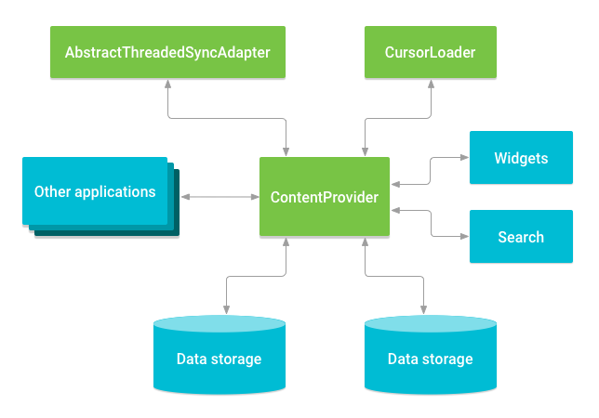

**Question:**  What is the difference between apply() and commit() in sharedPreferences?

**Answer:**  commit() writes the data synchronously and returns a boolean value of success or failure depending on the result immediately.

* apply() is asynchronous and it won’t return any boolean response. Also if there is an apply() outstanding and we perform another commit(), The commit() will be blocked until the apply() is not completed.

**Question:**  What is the difference between implementation and api?

**Answer:**  These two keywords work the same when you want to add a new library but the main difference occurs when using it in the internal library. Let's explain it with an example. Consider your app has a library called 'libraryA'. This library is also dependant on another library called 'libraryB'. the dependency flow will be : app -> libraryA -> libraryB . If the libraryB is declared in libraryA with keyword implementation, so your app module does not know anything about the classes of libraryB. So you can't access and use any classes of libraryB. If you want to do that, you must declare libraryB in the libraryA Gradle file with keyword api. For more information read this medium link.

**Question:**  What do you mean by Gradle wrapper?

**Answer:**  The Gradle wrapper is the most suitable way to initiate a Gradle build. A Gradle wrapper is a Window’s batch script which has a shell script for the OS (operating system). Once you start the Gradle build via the wrapper, you will see an auto download which runs the build.

**Question:**  What is a difference between Spannable and String?

**Answer:**  A Spannable allows to attach formatting information like bold, italic, ... to sub-sequences ("spans", thus the name) of the characters. It can be used whenever you want to represent "rich text".

**Question:**  What is View Group? How are they different from Views?

**Answer:**  View: View objects are the basic building blocks of User Interface(UI) elements in Android. View is a simple rectangle box which responds to the user’s actions. Examples are EditText, Button, CheckBox etc. View refers to the android.view.View class, which is the base class of all UI classes.

ViewGroup: ViewGroup is the invisible container. It holds View and ViewGroup. For example, LinearLayout is the ViewGroup that contains Button(View), and other Layouts also. ViewGroup is the base class for Layouts.

**Question:**  How can I get the context in a fragment?

**Answer:**  You can use getActivity(), which returns the activity associated with a fragment. The activity is a context (since Activity extends Context).

You can also override the onAttach method of fragment:

public static class DummySectionFragment extends Fragment{

...

@Override

public void onAttach(Activity activity) {

super.onAttach(activity);

DBHelper = new DatabaseHelper(activity);

}

}

**Question:**  What is Armv7?

**Answer:**  There are 3 CPU architectures in Android:

* *ARMv7* is the most common as it is optimised for battery consumption.
* *ARM64* is an evolved version of that that supports 64-bit processing for more powerful computing.
* *ARMx86*, is the least used for these three, since it is not battery friendly. It is more powerful than the other two.

**Question:**  How does the OutOfMemory happens?

**Answer:**  Out of memory error is very common error when you are developing for a application that deals with multiple images sets or large bitmaps or some Animation stuff. In Android, every application runs in a Linux Process. Each Linux Process has a Virtual Machine (Dalvik Virtual Machine) running inside it. There is a limit on the memory a process can demand and it is different for different devices and also differs for phones and tablets. When some process demands a higher memory than its limit it causes a error i.e Out of memory error.

There are number of reasons why we get a Out of memory errors. Some of those are:

1. You are doing some operation that continuously demands a lot of memory and at some point it goes beyond the max heap memory limit of a process.
2. You are leaking some memory i.e you didn’t make the previous objects you allocated eligible for Garbage Collection (GC). This is called Memory leak.
3. You are dealing with large bitmaps and loading all of them at run time. You have to deal very carefully with large bitmaps by loading the size that you need not the whole bitmap at once and then do scaling.

**Question:**  What is the most appropriate way to store user settings in Android application?

**Answer:**  In general SharedPreferences are your best bet for storing preferences, so in general I'd recommend that approach for saving application and user settings.

The only area of concern here is what you're saving. Passwords are always a tricky thing to store, and I'd be particularly wary of storing them as clear text. The Android architecture is such that your application's SharedPreferences are sandboxed to prevent other applications from being able to access the values so there's some security there, but physical access to a phone could potentially allow access to the values.

**Question:**  Is it possible to implement the model–view–controller pattern in Java for Android?

**Answer:**  In Android you don't have MVC, but you have the following:

* You define your user interface in various XML files by resolution, hardware, etc.
* You define your resources in various XML files by locale, etc.
* You extend clases like ListActivity, TabActivity and make use of the XML file by inflaters.
* You can create as many classes as you wish for your business logic.
* A lot of Utils have been already written for you - DatabaseUtils, Html.

**Question:**  What are the differences between ArrayList and ArrayMap?

**Answer:**  ArrayMap keeps its mappings in an array data structure — an integer array of hash codes for each item, and an Object array of the key -> value pairs.

Where ArrayList is a List. Resizable-array implementation of the List interface. Implements all optional list operations, and permits all elements, including null.

**Question:**  What is the difference between Handler vs AsyncTask vs Thread?

**Answer:**  The Handler class can be used to register to a thread and provides a simple channel to send data to this thread. A Handler allows you communicate back with the UI thread from other background thread.

* The AsyncTask class encapsulates the creation of a background process and the synchronization with the main thread. It also supports reporting progress of the running tasks.
* And a Thread is basically the core element of multithreading which a developer can use with the following disadvantage:
* Handle synchronization with the main thread if you post back results to the user interface
* No default for canceling the thread
* No default thread pooling
* No default for handling configuration changes in Android